SUPPLEMENTARY INFORMATION
Supplementary figures

The AP-1 adaptor complex is essential for intracellular trafficking of the ORF2 capsid protein and assembly of Hepatitis E virus

Martin Ferrié¹, Virginie Alexandre¹, Claire Montpellier¹, Peggy Bouquet², Thibault Tubiana³, Léa Mézière¹, Maliki Ankavay^{1,¶}, Cyrine Bentaleb¹, Jean Dubuisson¹, Stéphane Bressanelli³, Cécile-Marie Aliouat-Denis¹, Yves Rouillé¹, Laurence Cocquerel^{1,*}

¹Univ. Lille, CNRS, INSERM, CHU Lille, Institut Pasteur de Lille, U1019-UMR 9017-CIIL- Center for Infection and Immunity of Lille, F-59000 Lille, France.
²Unit of Clinical Microbiology, Institut Pasteur de Lille, F-59000 Lille, France
³Université Paris-Saclay, CEA, CNRS, Institute for Integrative Biology of the Cell (I2BC), Gif-sur-Yvette, France.
¶Present address: Division of Gastroenterology and Hepatology, Institute of Microbiology, Lausanne, Switzerland.

*Correspondence : Dr Laurence Cocquerel; laurence.cocquerel@ibl.cnrs.fr

Keywords: Replication, A5 membrane traffic inhibitor, PLC3 cells, Primary Human Hepatocytes, Proximity Ligation Assay, P1H1 antibody, P3H2 antibody, AlphaFold2

Figure S1: Confocal analysis of ORF2i and AP-1 staining in mock-transfected/infected hepatoma cell lines. Mock-electroporated PLC3 (a) or Huh-7.5 (b) cells were fixed at 6 d.p.e, while mock-infected Huh-7.5 cells (c) were fixed at 12 d.p.i. (d) H7-T7-IZ cells transfected with the empty pTM vector were fixed at 24 h.p.t. Cells were then permeabilized with cold methanol and 0.5% Triton X-100 and double-stained with anti-ORF2i P1H1 and anti-AP-1γ1 antibodies. Red=ORF2i; Green= AP-1γ1 (AP1); Blue=Dapi. Staining was analyzed by confocal microscopy. Scale bar, 20 μM. (a-d) On the right, line graphs show the overlap of fluorescence intensities of ORF2i and AP-1 staining measured every 50 nm across the region of interest highlighted by the white line on the “Merge” micrograph of each panel.

Figure S2: Subcellular distribution of various host cell markers in Mock-electroporated cells. Mock-electroporated PLC3 cells were fixed, then permeabilized with cold methanol and 0.5% Triton X-100 and double-stained with the indicated antibodies. Scale bar, 20 μM.

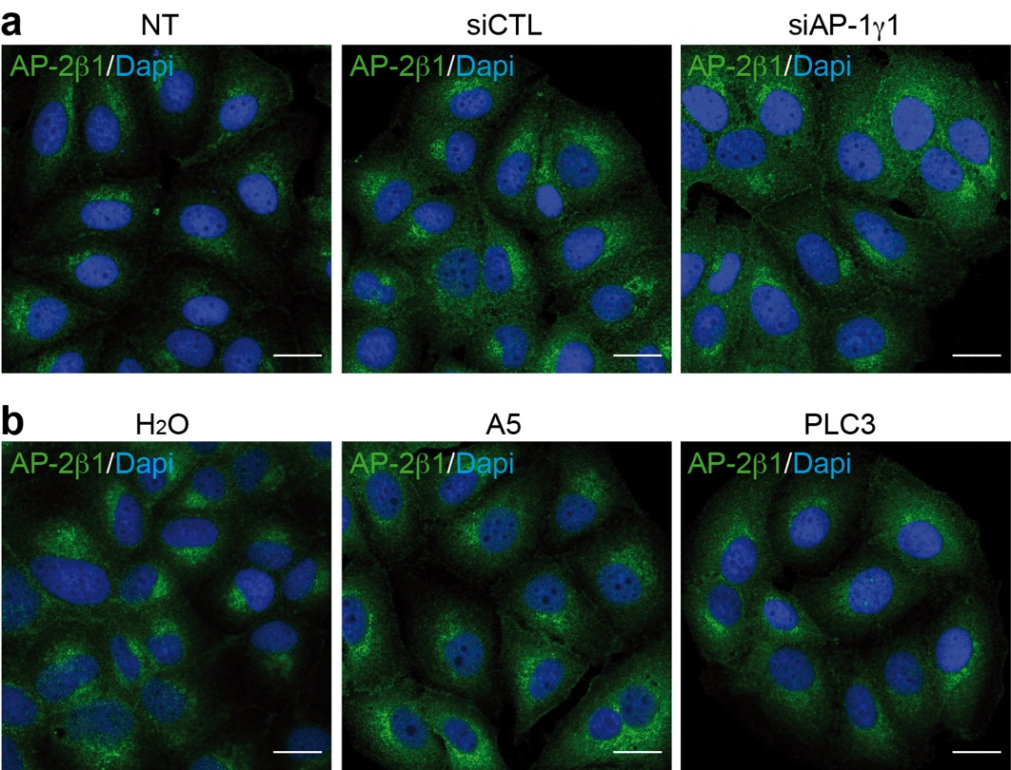

Figure S3: Impact of AP-1γ1 silencing or A5 treatment on the subcellular localization of AP-2 adaptor complex. PLC3/HEV/NT, PLC3/HEV/siCTL and PLC3/HEV/siAP-1γ1 (a) and PLC3/HEV/H₂O, PLC3/HEV/A5-150μM and PLC3 cells (b) were fixed 3 days post-treatment/transfection. Then, cells were permeabilized with 0.5% Triton X-100 and stained with a rabbit anti-AP-2β1 polyclonal antibody. Scale bar, 20 μM.

Figure S4: Impact of AP-1 complex silencing or A5 treatment on HEV replication. PLC3 cells stably replicating a p6 subgenomic replicon were transfected with siCTL and siAP-1γ1 (a-b) or siAP-1γ2 (c-d), or treated with H₂O or A5 compound (a-b). At 72 h post-transfection or post-treatment, silencing of AP-1γ1 (a) and AP-1γ2 (c) was controlled by WB. Tubulin was detected using a mouse anti-β-Tubulin antibody. (b, d) At 72 h post-transfection or post-treatment, intracellular HEV RNA levels were quantified by RT-qPCR. PLC3 mock cells were used as a negative control. PLC3 cells harboring the replicon and treated with 20 μM of sofosbuvir were used as a positive control for replication inhibition. Values are from four (c) and three (d) independent experiments. Mann-Whitney test, ****p < 0.0001, *p < 0.05

Figure S5: Impact of A5 treatment on the subcellular localization of AP-1 adaptor complex and dose-response curve of PLC3 cells treated with A5. (a) PLC3 cells were treated with H₂O or A5 (150μM) and fixed after 3 days of treatment. Then, cells were permeabilized with cold methanol and 0.5% Triton X-100 and stained with an anti-AP-1γ1 antibody and Dapi. Green= AP-1γ1; Blue=Dapi. Staining was analyzed by confocal microscopy. Scale bar, 20 μM. (b) PLC3 cell viability was assessed using an MTS based assay after 72 hours of treatment. Cells treated with the diluent (H₂O) were used as control and plot as 100% of viability.

Figure S6: Conservation of the dileucine-like motif in the ORF2 protein sequence. Fifty-six ORF2 protein sequences from HEV strains isolated from human (gt1-4), wild boar (wb), pig (sw), rabbit (rab), and rat were aligned using Clustal Omega tool from EMBL-EBI. Amino acid positions correspond to the HEV-p6 ORF2 sequence (in bold).

