The Hepatitis B virus large envelope protein initiates virion assembly by recruiting pre-assembled capsids at membrane rich domains related to late endosome

Florian Seigneuret¹, Sébastien Eymieux^{1, 2}, Vanessa Sarabia-Vega¹, Roxane Lemoine³, Julien Burlaud-Gaillard², Pierre Raynal², Christophe Hourioux^{1,2}, Camille Sureau¹, Philippe Roingeard^{1,2} and Hugues de Rocquigny¹

¹ INSERM U1259 MAVIVH, Université de Tours and CHRU de Tours, 10 boulevard Tonnellé - BP 3223 37032 Tours Cedex 1 – France.
² Plate-Forme IBiSA des Microscopies, PPF ASB, Université de Tours and CHRU de Tours, 10 boulevard Tonnellé - BP 3223 37032 Tours Cedex 1 – France.
³ Département Cytométrie et Single-Cell Immunobiologie, Plateforme Scientifique et Technique - Analyse des Systèmes Biologiques (PST-ASB), Université de Tours, 10 Boulevard Tonnellé, 37032 Tours Cedex 1 – France.

Corresponding author:

Hugues de Rocquigny

Tel: 33 (2) 47 36 60 93

Fax : 33 (2) 47 36 61 26

e-mail: hderocquigny@univ-tours.fr

ORCID : 0000-0002-6585-8505
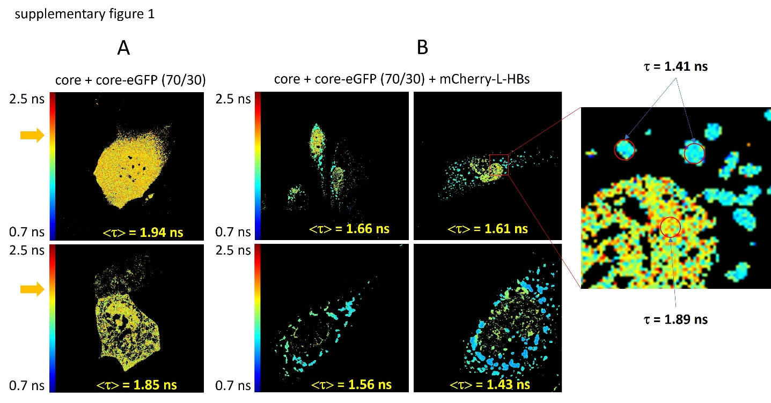
Fig S1: Intracellular core-LHBs interaction imaged by FLIM. A: Huh7 cells transfected with two plasmids expressing core and core-eGFP (70/30) (panel A) together with a plasmid expressing mCherry-LHBs (35/15/50) (panel B). 72h post transfection cells were observed by confocal (not shown) and FLIM in Leibovitz’s L-15 medium supplemented with 5% fetal bovine serum at 37°C in thermostatic chamber. The average lifetime throughout the cell is at the bottom of the image. The fluorescence lifetime  was measured pixel per pixel and converted into color using a color scale ranging from orange (0.7 ns = short fluorescence lifetime) to red (2.5 ns = long fluorescence lifetime). Enlargement shows that the long lifetime in yellow remains localized in the nucleus and corresponds to non-interacting core, while the shorter lifetime in blue is localized at the periphery of the nucleus and corresponds to the complex core-LHBs.

