The Hepatitis B virus large envelope protein initiates virion assembly by recruiting pre-assembled capsids at membrane rich domains related to late endosome

Florian Seigneuret¹, Sébastien Eymieux^{1, 2}, Vanessa Sarabia-Vega¹, Roxane Lemoine³, Julien Burlaud-Gaillard², Pierre Raynal², Christophe Hourioux^{1,2}, Camille Sureau¹, Philippe Roingeard^{1,2} and Hugues de Rocquigny¹

¹ INSERM U1259 MAVIVH, Université de Tours and CHRU de Tours, 10 boulevard Tonnellé - BP 3223 37032 Tours Cedex 1 – France.
² Plate-Forme IBiSA des Microscopies, PPF ASB, Université de Tours and CHRU de Tours, 10 boulevard Tonnellé - BP 3223 37032 Tours Cedex 1 – France.
³ Département Cytométrie et Single-Cell Immunobiologie, Plateforme Scientifique et Technique - Analyse des Systèmes Biologiques (PST-ASB), Université de Tours, 10 Boulevard Tonnellé, 37032 Tours Cedex 1 – France.

Corresponding author:

Hugues de Rocquigny

Tel: 33 (2) 47 36 60 93

Fax : 33 (2) 47 36 61 26

e-mail: hderocquigny@univ-tours.fr

ORCID : 0000-0002-6585-8505

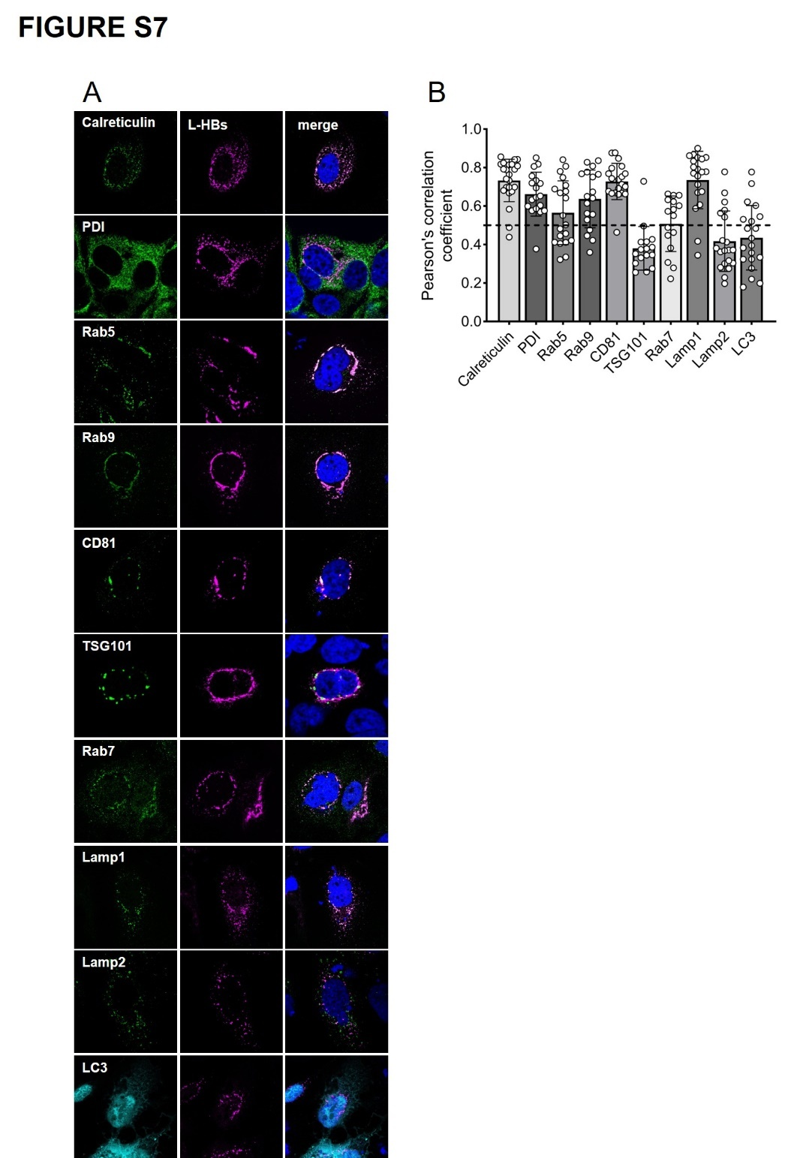

Fig S7: Co-localization LHBs with endosomal markers
Huh7 Cells were transfected with the plasmid expressing LHBs. After 72h, cells were fixed, permeabilized and immunostained. (A) In the green channel, images were obtained by immunofluorescence using anti-endosomal markers targeting endogenous proteins or using anti-HA for TSG101 or using aquamarine signal of LC3-Aquamarine protein in cyan. In the magenta channel, the goat anti-HBs monoclonal antibody (Fitzgerald 70HG15) or rabbit anti-pre S1 R271 targeting LHBs protein. DAPI nuclear staining is shown in blue in the merge panel. (B) The bar graphs show the mean values of the Pearson’s correlation coefficient (PCC) from 15–20 cells. The dots represent each cell analyzed from two independent experiments. The bars represent the mean values and the error bars the ± SD of the PCC. Representative images are shown.

