The Hepatitis B virus large envelope protein initiates virion assembly by recruiting pre-assembled capsids at membrane rich domains related to late endosome

Florian Seigneuret¹, Sébastien Eymieux^{1, 2}, Vanessa Sarabia-Vega¹, Roxane Lemoine³, Julien Burlaud-Gaillard², Pierre Raynal², Christophe Hourioux^{1,2}, Camille Sureau¹, Philippe Roingeard^{1,2} and Hugues de Rocquigny¹

¹ INSERM U1259 MAVIVH, Université de Tours and CHRU de Tours, 10 boulevard Tonnellé - BP 3223 37032 Tours Cedex 1 – France.
² Plate-Forme IBiSA des Microscopies, PPF ASB, Université de Tours and CHRU de Tours, 10 boulevard Tonnellé - BP 3223 37032 Tours Cedex 1 – France.
³ Département Cytométrie et Single-Cell Immunobiologie, Plateforme Scientifique et Technique - Analyse des Systèmes Biologiques (PST-ASB), Université de Tours, 10 Boulevard Tonnellé, 37032 Tours Cedex 1 – France.

Corresponding author:

Hugues de Rocquigny

Tel: 33 (2) 47 36 60 93

Fax : 33 (2) 47 36 61 26

e-mail: hderocquigny@univ-tours.fr

ORCID : 0000-0002-6585-8505
Supporting Information

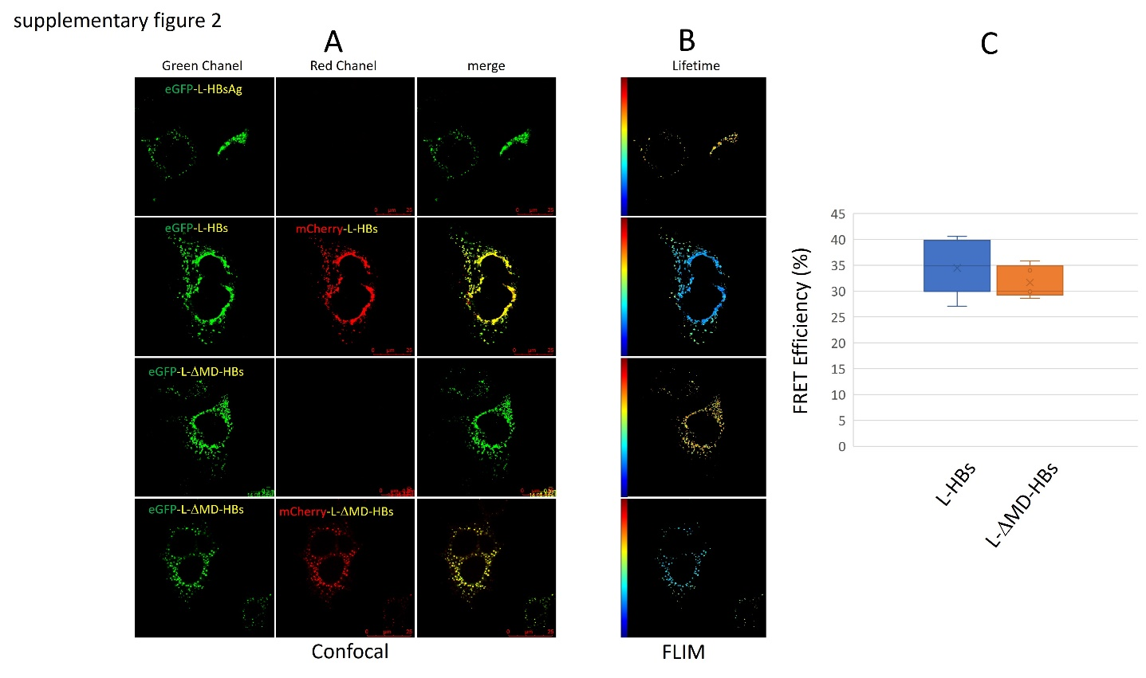

Fig S2: Self oligomerization of LHBs and L-DMD-HBs at the periphery of the nucleus.
Cells were transfected with a plasmid expressing eGFP-LHBs alone (first row) or together with mCherry-LHBs (second row) or expressing eGFP-L-MD-HBs alone (third row) or together with mCherry-L-MD-HBs (fourth row). 72h post-transfection, cells were observed by confocal microscopy (panel A) and FLIM (panel B) in Leibovitz’s L-15 medium supplemented with 5% fetal bovine serum at 37°C in thermostatic chamber. The fluorescence lifetime  was measured pixel per pixel and converted into color using a color scale ranging from orange (1.2 ns = short fluorescence lifetime) to red (2.5 ns = long fluorescence lifetime). The high FRET efficiencies calculated with eq. 1 and reflecting self-oligomerization of LHBs or of L-MD-HBs are presented as box and whisker plot (panel C). This FRET efficiency suggests that the LHBs or L-ΔMD-HBs forms tight homo-oligomers (and hetero-oligomers, not shown) independently of the presence of the matrix domain.

