The Hepatitis B virus large envelope protein initiates virion assembly by recruiting pre-assembled capsids at membrane rich domains related to late endosome

Florian Seigneuret¹, Sébastien Eymieux^{1, 2}, Vanessa Sarabia-Vega¹, Roxane Lemoine³, Julien Burlaud-Gaillard², Pierre Raynal², Christophe Hourioux^{1,2}, Camille Sureau¹, Philippe Roingeard^{1,2} and Hugues de Rocquigny¹

¹ INSERM U1259 MAVIVH, Université de Tours and CHRU de Tours, 10 boulevard Tonnellé - BP 3223 37032 Tours Cedex 1 – France.
² Plate-Forme IBiSA des Microscopies, PPF ASB, Université de Tours and CHRU de Tours, 10 boulevard Tonnellé - BP 3223 37032 Tours Cedex 1 – France.
³ Département Cytométrie et Single-Cell Immunobiologie, Plateforme Scientifique et Technique - Analyse des Systèmes Biologiques (PST-ASB), Université de Tours, 10 Boulevard Tonnellé, 37032 Tours Cedex 1 – France.

Corresponding author:

Hugues de Rocquigny

Tel: 33 (2) 47 36 60 93

Fax : 33 (2) 47 36 61 26

e-mail: hderocquigny@univ-tours.fr

ORCID : 0000-0002-6585-8505

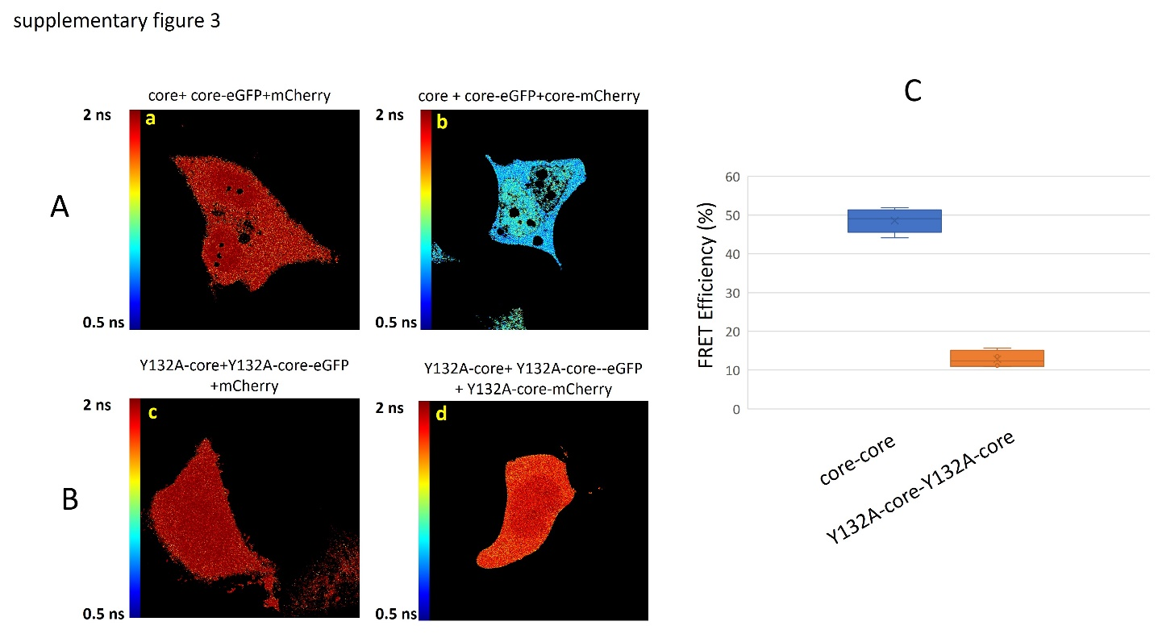

Fig S3: Y132A-core fail to properly self-assemble.
A: Huh7 cells were transfected with three plasmids expressing (a) core, core-eGFP and mCherry (70/10/20) or (b) core, core-eGFP and core-mCherry (70/10/20) or (c) Y132A-core, Y132A-core-eGFP and mCherry (70/10/20) or (d) Y132A-core, Y132A-core-eGFP and Y132A-core-mCherry (70/10/20). 72h post-transfection, live cells were observed by confocal (not shown) and FLIM in Leibovitz’s L-15 medium supplemented with 5% fetal bovine serum at 37°C in thermostatic chamber. The fluorescence lifetime  was measured pixel per pixel and converted into color using a color scale ranging from orange (0.5 ns = short fluorescence lifetime) to red (2 ns = long fluorescence lifetime). Each image is representative of 10 cells/experiment repeated three times. C: FRET efficiencies are reported as box and whisker plot. The FRET efficiency of core-core at 48.55%±2.8% drops to 13.52 %±2% with Y132A-core-Y132A-core {Rat, 2020 #454}. Note that this residual but measurable FRET suggests that Y132A-core forms low ordered oligomers in agreement with Klump et al 2015 {Klumpp, 2015 #20}.

