The Hepatitis B virus large envelope protein initiates virion assembly by recruiting pre-assembled capsids at membrane rich domains related to late endosome

Florian Seigneuret¹, Sébastien Eymieux^{1, 2}, Vanessa Sarabia-Vega¹, Roxane Lemoine³, Julien Burlaud-Gaillard², Pierre Raynal², Christophe Hourioux^{1,2}, Camille Sureau¹, Philippe Roingeard^{1,2} and Hugues de Rocquigny¹

¹ INSERM U1259 MAVIVH, Université de Tours and CHRU de Tours, 10 boulevard Tonnellé - BP 3223 37032 Tours Cedex 1 – France.
² Plate-Forme IBiSA des Microscopies, PPF ASB, Université de Tours and CHRU de Tours, 10 boulevard Tonnellé - BP 3223 37032 Tours Cedex 1 – France.
³ Département Cytométrie et Single-Cell Immunobiologie, Plateforme Scientifique et Technique - Analyse des Systèmes Biologiques (PST-ASB), Université de Tours, 10 Boulevard Tonnellé, 37032 Tours Cedex 1 – France.

Corresponding author:

Hugues de Rocquigny

Tel: 33 (2) 47 36 60 93

Fax : 33 (2) 47 36 61 26

e-mail: hderocquigny@univ-tours.fr

ORCID : 0000-0002-6585-8505

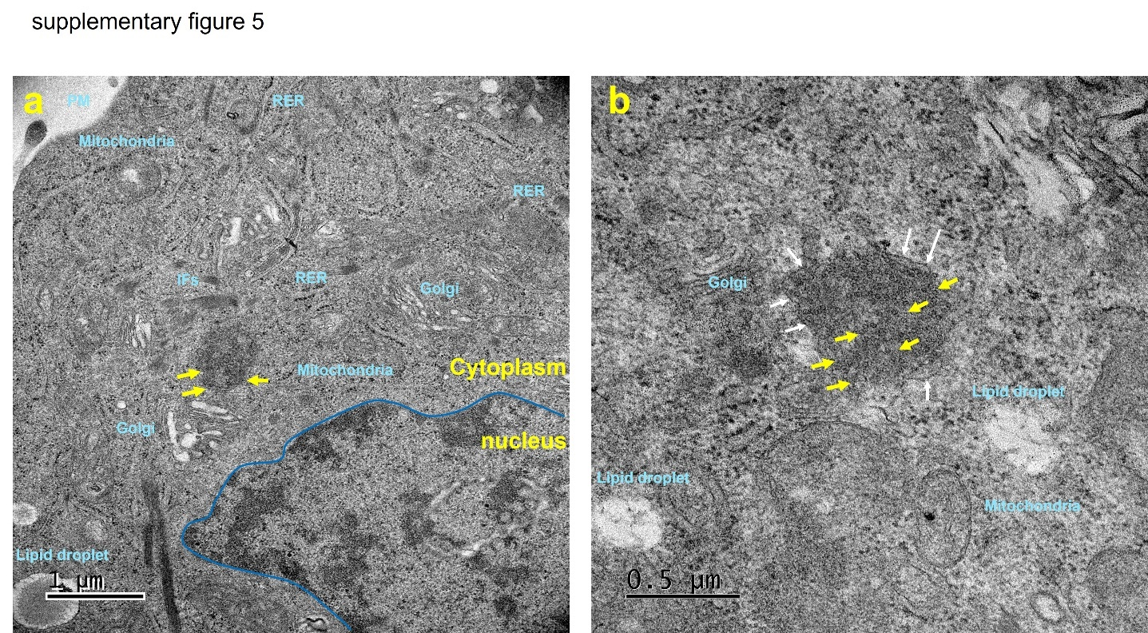
Fig S5: HBV capsids accumulate in large vesicles in the presence of LHBs
Huh7 cells transfected with the mix of plasmids expressing core, LHBs and eGFP-LHBs (50/45/5) were sorted by FACS, centrifuged and the pellet treated for observation by regular TEM. Images a and b show other examples of large cellular compartments delimited by a membrane (white arrow) containing numerous capsid (yellow arrows) and often close to the nucleus (blue line). Note that regular TEM allows the identification of various cellular organelles in turquoise.

