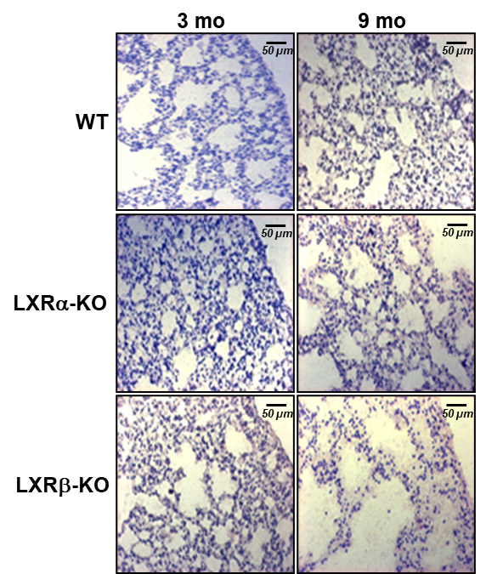
Fig S1. Absence of morphological impairment in lungs from single LXR-KO isoforms. WT, LXRα-KO and LXRβ-KO lungs from 3 and 9-month-old mice were subjected to macroscopic analysis by OR-O staining. Scale bars of all images are 50 μm. A representative image (n=5) is shown.

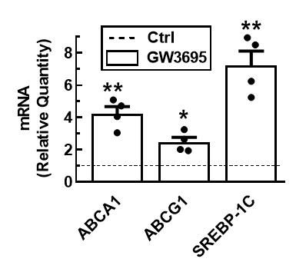
Fig S2. Analysis of LXR target gene expression in lung tissue. Expression of ABCA1, ABCG1 and SREBP-1c was analyzed by real-time qPCR in lung tissue after intraperitoneal injection of PBS (control vehicle) or GW3965 in 3-month-old WT animals. Data represent the mean and standard error of three experiments (n=4 mice). Control gene expression values were normalized to Ctrl=1. Unpaired Student’s t test with Welch's correction was used for two-group comparisons; *p < 0.05; **p < 0.01 compared to Ctrl group.

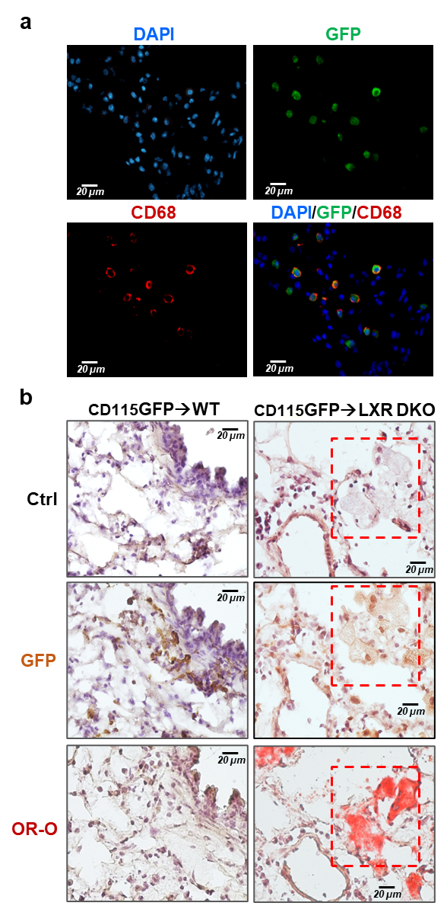

Fig S3. Successful replenishment of AMs in recipient mice. a. Analysis of GFP and CD68 expression were assessed in consecutive lung sections from mice 24 weeks after reciprocal bone marrow transplantation (CD115-GFP → LXR-DKO). Images are representative of two independent experiments with five to six mice per group. Scale bars, 20 μm. b. Analysis of GFP expression and lipidosis (Oil-Red-O staining) were assessed in consecutive lung sections from wild-type and LXR-DKO mice 24 weeks after reciprocal bone marrow transplantation (labels: donor→recipient). Images are representative of two independent experiments with six-eight mice per group. Areas marked with red dashed line indicate coinciding areas in consecutive sections Scale bars, 20 μm.

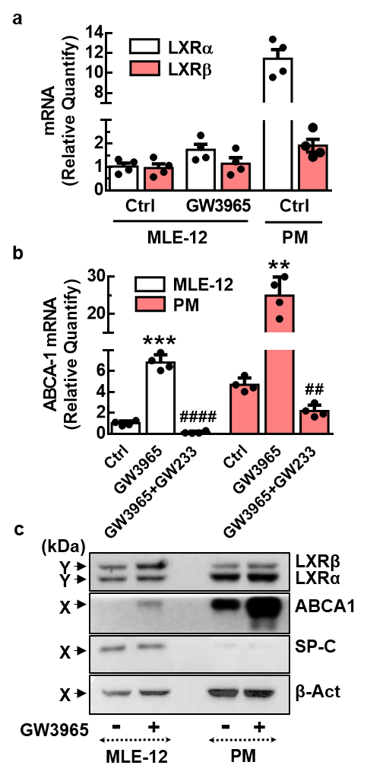
Fig S4. LXRα and LXRβ are present and active in MLE-12 cell line. a. MLE-12 cells were incubated in absence (Ctrl) or presence of LXR agonist, GW3965 (GW). Subsequently, transcript levels of LXRα and LXRβ was measured, by real-time qPCR, using peritoneal macrophage (PM) as reference cell. Data represent the mean and standard error of three experiments (n=4 mice per genotype). b. MLE-12 cells and PM were preincubated with LXR agonist GW3965 (GW) or vehicle (Ctrl), in the absence or presence of LXR antagonist GW233. Subsequently, expression of ABCA1, was analyzed by real-time qPCR. Data represent the mean and standard error of three experiments (n=4 mice per genotype). Unpaired Student’s t test with Welch's correction was used for two-group comparisons; **p < 0.01; ***p < 0.001 compared to Ctrl group; ####P<0.0001 compared to GW group. c. MLE-12 cells and PM were incubated in absence (Ctrl) or presence of LXR agonist, GW3965 (GW). Subsequently, expression of LXRα, LXRβ, ABCA1 and SP-C was analyzed by western-blot. Membranes were stripped and reprobed with β−actin antibody as loading control. A representative western blot (n=3) is shown.

Table S1: Antibodies and Dilutions Used in Western Blot (WB), Immunocytochemistry (ICQ), and Immunohistochemistry (IHQ)

Antibody | Supplier | WB | ICQ | IHQ
Rabbit anti-ABCA1 | Novus | 1:10000
Mouse anti β-actin | Santa Cruz | 1:200
Rat anti-B220 | Catlag |  |  | 1:300
Rat anti-CD3 | Hibridoma |  |  | Pure
Rat anti-CD68 | Serotec |  | 1:300 | 1:300
Rabbit anti-GFP | Abcam |  |  | 1:5000
Rabbit anti-LXR alpha-beta | Karolinska Institutet (Sweden) | 1:1000
Rabbit anti- pro-SP-C | Millipore | 1:1000
Rabbit anti‐Rat biotin | Dako |  |  | 1:150
Goat anti‐rabbit biotin | Dako |  |  | 1:150
Goat anti‐rat IgG-Alexa Fluor ®488 | Invitrogen |  | 1:400 | 1:400
Goat anti‐rat IgG-Alexa Fluor ®594 | Invitrogen |  | 1:500 | 1:500
Goat anti‐mouse HRP | Sta. Cruz | 1:10000
Goat anti‐rabbit HRP | Sta. Cruz | 1:10000
Goat anti-mouse IgA | Santa Cruz | 1:1000
Bovine anti-mouse IgG | Santa Cruz | 1:1000
Goat anti-mouse IgM | Santa Cruz | 1:1000

Table S2: Primers used for qPCR analysis.

Mouse Gene | Primers
Abca1 (ABCA1) | forward (5’ to 3’): GCAGATCAAGCATCCCAACT
Abca1 (ABCA1) | reverse (5’ to 3’): CCAGAGAATGTTTCATTGTCC
Abca3 (ABCA3) | forward (5’ to 3’): CCTTCTTCAGTAAAGCCAAC
Abca3 (ABCA3) | reverse (5’ to 3’): CCAGGCCATAGAGTGCTGAG
Abcg1 (ABCG1) | forward (5’ to 3’): TCACCC AGTTCTGCATCCTCTT
Abcg1 (ABCG1) | reverse (5’ to 3’): GCAGATGTGTCAGGACCGAGT
Acat1 (ACAT1) | forward (5’ to 3’): TTTCTCTGGGCCATCCAAT
Acat1 (ACAT1) | reverse (5’ to 3’): AGGGCATGAGCCATATGAAC
GpaT (GPAT) | forward (5’ to 3’): GGAAGGTGCTGCTATTCCTG
GpaT (GPAT) | reverse (5’ to 3’): TGGGATACTGGGGTTGAAAA
Lpcat1 (LPCAT1) | forward (5’ to 3’): GCTGGTGAGCTGTCCTTGAT
Lpcat1 (LPCAT1) | reverse (5’ to 3’): GGTGCACGTTCCTTGAAGA
Lpcat3 (LPCAT-3) | forward (5’ to 3’): TTCAGTTTGGCATGCTGGT
Lpcat3 (LPCAT-3) | reverse (5’ to 3’): ATTGTCCTGGCTCAGGATTC
Nr1h3 (LXRα) | forward (5’ to 3’): CAACAGTGTAACAGGCGCT
Nr1h3 (LXRα) | reverse (5’ to 3’): TGCAATGGGCCAAGGC
Nr1h2 (LXRβ) | forward (5’ to 3’): CCCCACAAGTTCTCTGGACACT
Nr1h2 (LXRβ) | reverse (5’ to 3’): TGACGTGGCGGAGGTACTG
Mip1b  (MIP-1β) | forward (5’ to 3’): CATGAAGCTCTGCGTGTCTG
Mip1b  (MIP-1β) | reverse (5’ to 3’): GGAGGGTCAGAGCCCATT
Mmp8 (MMP-8) | forward (5’ to 3’): AACGGGAAGACATACTTCTTCATAA
Mmp8 (MMP-8) | reverse (5’ to 3’): GGGTCCATGGATCTTCTTTG
Mmp12 (MMP-12) | forward (5’ to 3’): TGCTGATGACATACGTAACATTCA
Mmp12 (MMP-12) | reverse (5’ to 3’): TTGTCAAGGATGGGGGTTT
Sftpa1  (SP-A) | forward (5’ to 3’): CTGGAGAACATGGAGACAAGG
Sftpa1  (SP-A) | reverse (5’ to 3’): AAGCTCCTCATCCAGGTAAGC
Sftpb  (SP-B) | forward (5’ to 3’): AACCCCACACCTCTGAGAAC
Sftpb  (SP-B) | reverse (5’ to 3’): GTGCAGGCTGAGGCTTGT
Sftpc  (SP-C) | forward (5’ to 3’): GGTCCTGATGGAGAGTCCAC
Sftpc  (SP-C) | reverse (5’ to 3’): GATGAGAAGGCGTTTGAGGT
Sftpd  (SP-D) | forward (5’ to 3’): GGCCTTAAAAGGAAAACTACAGC
Sftpd  (SP-D) | reverse (5’ to 3’): CCATCAGGGAACAATGCAG
Spp1  (SPP-1) | forward (5’ to 3’): CCCGGTGAAAGTGACTGATT
Spp1  (SPP-1) | reverse (5’ to 3’): ATCTGGGTGCAGGCTGTAA
Srebf1 (SREBP-1C) | forward (5’ to 3’): TGGATCTGTACACTTTACACAGTTCCA
Srebf1 (SREBP-1C) | reverse (5’ to 3’): CCCGGTTTTCTGAAAACTCAAA

