Supplementary Material
Monitoring Heavy Metals in i-Liquids upon Vaping using Nano-Magnetic Graphene Oxide Extractor with ICP-OES Detection

Table S1 Detected levels (µg/g) of heavy metals in the atomizer and e-liquid samples before and after vapingª
# | e-liquid/stage | Ni | Cu | Hg | Pb | Cd | Co | Cr
S1 | Atomizer cotton (pre-vaping) | 10.21 | 13.73 | 0.07 | 0.42 | 0.01 | 1.45 | 6.39
S2 | Purple bomb ice brand A (pre-vaping)^{b} | 35.45 | 0.29 | ND | 0.57 | 0.06 | 0.41 | 12.67
S3 | Purple bomb ice brand A (post-vaping)^{c} | 9.9 | 15.7 | 0.06 | 1 | ND | 0.37 | 8.05
S4 | Purple bomb ice brand A (atomizer- soaked cotton post-vaping)^{d} | 9.71 | 48.79 | ND | 0.59 | 0.01 | 0.44 | 23.65
S5 | Purple bomb ice brand B (pre-vaping) | 3.81 | 0.35 | ND | 0.7 | 0.1 | 0.47 | 3.34
S6 | Purple bomb ice brand B (post-vaping) | 8.54 | 22.82 | 0.02 | 0.39 | ND | 0.73 | 3.85
S7 | Purple bomb ice brand B (atomizer soaked cotton post-vaping) | 8.38 | 26.61 | ND | 0.6 | ND | 0.46 | 3.68
S8 | Purple bomb ice brand C (pre-vaping) | 4.14 | 0.79 | 0.02 | 0.86 | 0.03 | 1.96 | 4.57
S9 | Purple bomb ice brand C (post-vaping) | 5.49 | 1.05 | ND | 0.71 | ND | 0.59 | 6.48
S10 | Purple bomb ice brand C (atomizer soaked cotton post-vaping) | 6.96 | 3.09 | 0.01 | 0.65 | ND | 0.77 | 4.46
S11 | VCT brand D (pre-vaping) | 6.29 | 5.3 | ND | 0.67 | 0.03 | 0.56 | 7.75
S12 | VCT brand D (post-vaping) | 13.64 | 1390.9 | 0.04 | 0.88 | 0.17 | 0.28 | 5.73
S13 | VCT brand D (atomizer-soaked cotton post-vaping) | 13.87 | 919.8 | 0.03 | 1.1 | ND | 0.62 | 8.74
S14 | VCT brand B (pre-vaping) | 4.59 | 10.05 | ND | 0.68 | 0.01 | 0.59 | 4.90
S15 | VCT brand B (post-vaping) | 27.1 | 53.76 | ND | 0.53 | 0.02 | 0.64 | 3.97
S16 | VCT brand B (atomizer-soaked cotton post-vaping) | 15.61 | 132.8 | ND | 0.74 | 0.08 | 0.71 | 4.19
S17 | VCT brand C (pre-vaping) | 2.99 | 2.42 | ND | 0.63 | 0.01 | 0.42 | 2.69
S18 | VCT brand C (post-vaping) | 3.83 | 0.73 | ND | 0.44 | 0.07 | 0.5 | 4.04
S19 | VCT brand C (atomizer-soaked cotton post-vaping) | 9.92 | 5.75 | ND | 0.56 | 0.02 | 0.67 | 2.43
S20 | Mango ice brand A (pre-vaping) | 5.66 | 0.38 | ND | 0.65 | ND | 0.58 | 5.16
S21 | Mango ice brand A (post-vaping) | 5.83 | 3.64 | ND | 0.21 | 0.02 | 0.69 | 4.69
S22 | Mango ice brand A (atomizer-soaked cotton post-vaping) | 29.01 | 15.57 | ND | 2.09 | ND | 0.68 | 7.5
S23 | Mango ice brand B (pre-vaping) | 5.86 | 0.48 | ND | 0.32 | ND | 0.64 | 4.03
S24 | Mango ice brand B (post-vaping) | 25.02 | 68 | ND | 0.72 | ND | 0.63 | 5.88
S25 | Mango ice brand B (atomizer-soaked cotton post-vaping) | 22.4 | 92.64 | ND | 0.45 | 0.02 | 0.62 | 6.68
- Average results were reported for three identical trails. Three common e-liquid brands obtained from different dealers were selected: Purple bomb ice, VCT, and Mango ice. I-liquids were dosed with 50 mg nicotine. Each brand was smoked using an independent and new i-cigarette device.
- E-liquids were taken from the bottles and analyzed (pre-vaping stage).
- Remaining e-liquids were analyzed after vaping. Puffing protocol, 50 puffs with 5.0s/puff (post-vaping stage).
- Metals were detected in the soaked cotton of the atomizer after vaping (atomizer-soaked cotton post-vaping stage).

Characterization of Nano-Magnetic Graphene Oxide

Detection of surface functional groups during preparation of GO from graphene and detection of functional groups of deposited Fe₃O₄ was carried out using Bruker FTIR spectrophotometer (Bruker vertex 70, Germany). Samples were prepared for IR analysis by adding 0.2 mg of dried adsorbent to 0.3 g dried KBr. The mixture was homogenized, pressed to 15 MP for IR measurement. The IR spectra of graphite, graphene oxide, and magnetic- graphene oxide are provided in Figure S1.
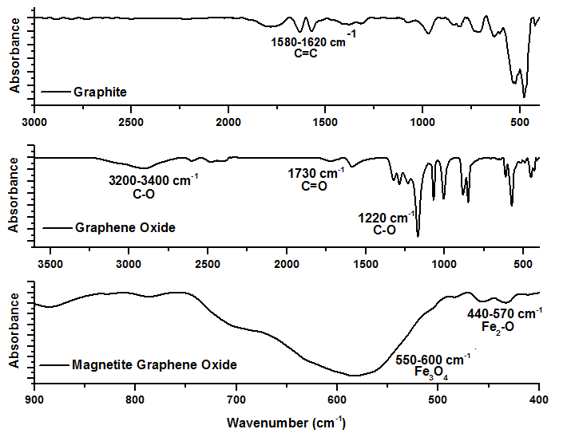
Figure S1 FTIR spectra of graphene, GO, and MGO
Fourier transform infrared spectroscopy is often employed to investigate the chemical composition and structural changes while preparation and modification of graphene oxide composites. In this research, Hummer method was used to prepare GO from graphene and deposition of Fe₃O₄ on GO surface was accomplished by simple precipitation of Fe(II) and Fe(III) ions under alkaline environment. Hence, structural changes of the original substrate (graphene) after oxidation and deposition of Fe₃O₄ was monitored using FTIR. Through Hummer method, which involves harsh oxidation and exfoliation, graphite undergoes a transformative process leading to the formation of nano-sheets of GO. The introduction of oxygen-containing functional groups, such as hydroxyl and epoxy groups, results in significant changes in the FTIR spectra as indicated in Fig S1. The IR spectra for graphite, GO, and MGO provide valuable insights into the structural of the original substrate. The spectrum of graphite evidenced the following peaks: 1580-1620 cm ¹ (C=C stretching vibrations within the hexagonal lattice structure of graphite), 1400- 1450 cm ¹ (In- plane bending vibrations of carbon-hydrogen bonds), 800-1000 cm ¹ (Out-of-plane bending vibrations of carbon-hydrogen bonds within the graphene layers), 500-700 cm ¹ (Lattice vibrations specific to graphite). The characteristic IR-peaks indicative of the conversion from graphite to GO include the appearance of peaks around 3400-3200 cm ¹ (Broad peak attributed to O-H stretching vibrations from hydroxyl groups), 1730 cm ¹ (C=O stretching of carboxyl groups), 1620 cm ¹ (C=C stretching of un-oxidized graphitic domains), and 1220 cm ¹ (C-O stretching of epoxy groups). The earlier peaks evidenced the successful oxidation and functionalization of graphite, marking the transition to graphene oxide. Magnetic graphene oxide has additional peaks associated with magnetic nanoparticles are introduced. Notable peaks may include those corresponding to metal oxides, such as Fe₃O₄ or Fe₂O around 500-600 cm⁻¹ and 440-570 cm⁻¹, respectively, depending on the characteristics of the magnetic material embedded on the surface. Deposition of magnetite is reflected in the FT-IR spectra, emphasizing the successful integration of magnetic properties into the graphene oxide framework.

Effect of solution pH on heavy metals precipitation
As known solution pH has high effect of metals precipitation as metal hydroxide. Precipitation of cationic heavy metals by OH͞ ion started as following:
M²⁺_{(aq)} + 2OH͞ _{(aq)} ↔ M(OH)_{(s)} Eq. S1
Precipitation of a metal hydroxide started when the product [M²⁺]×[OH͞ ]² is higher than the corresponding of solubility ion product constant or K_{sp} for the metal. In Table S2, the estimated [M²⁺]×[OH͞ ]² values at the examined pH along with K_{sp} of heavy metals were provided.

Table S2 Estimated [M²⁺]×[OH͞ ]² values at different pH media ª
Metal | Conc. (mol/L) | pH 4.0 | pH 5.0 | pH 6.0 | pH 7.0 | K_{sp}^{b}
Ni²⁺ | 1.70×10⁻⁶ | 1.70×10⁻²⁶ | 1.70×10⁻²⁴ | 1.70×10⁻²⁴ | 1.70×10⁻²⁰ | 2.00×10⁻¹⁵
Cu²⁺ | 1.57×10⁻⁶ | 1.57×10⁻²⁶ | 1.57×10⁻²⁴ | 1.57×10⁻²² | 1.57×10⁻²⁰ | 2.20×10⁻²⁰
Hg²⁺ | 4.99×10⁻⁷ | 4.98×10⁻²⁷ | 4.98×10⁻²⁵ | 4.98×10⁻²³ | 4.98×10⁻²¹ | 3.60×10⁻²⁶
Pb²⁺ | 4.83×10⁻⁷ | 4.82×10⁻²⁷ | 4.82×10⁻²⁵ | 4.82×10⁻²³ | 4.82×10⁻²¹ | 1.20×10⁻¹⁵
Cd²⁺ | 8.89×10⁻⁷ | 8.89×10⁻²⁷ | 8.89×10⁻²⁵ | 8.89×10⁻²³ | 8.89×10⁻²¹ | 2.50×10⁻¹⁴
Co²⁺ | 1.70×10⁻⁶ | 1.69×10⁻²⁶ | 1.69×10⁻²⁴ | 1.69×10⁻²² | 1.69×10⁻²⁰ | 1.60×10⁻¹⁵
Cr²⁺ | 1.92×10⁻⁶ | 1.92×10⁻²⁶ | 1.92×10⁻²⁴ | 1.92×10⁻²² | 1.92×10⁻²⁰ | 2.00×10⁻¹⁶
- Precipitation occurs when the product [M²⁺]×[OH͞ ]² > K_{sp}
- Reported K_{sp} constants of metal hydroxide at 25 ºC (Blais et al., 2008).

As indicated in Table S2, formation of metal hydroxide was not possible except for Hg²⁺ and at pH 50, 6.0, and 7.0. Accordingly, the metals were in their cationic form (i.e., M²⁺) when removed by MGO except for Hg²⁺ which would be available as Hg(OH)₂ at the optimum extraction (pH 6.0).

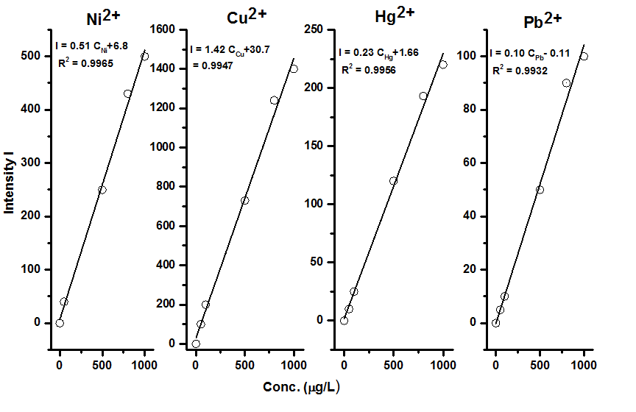
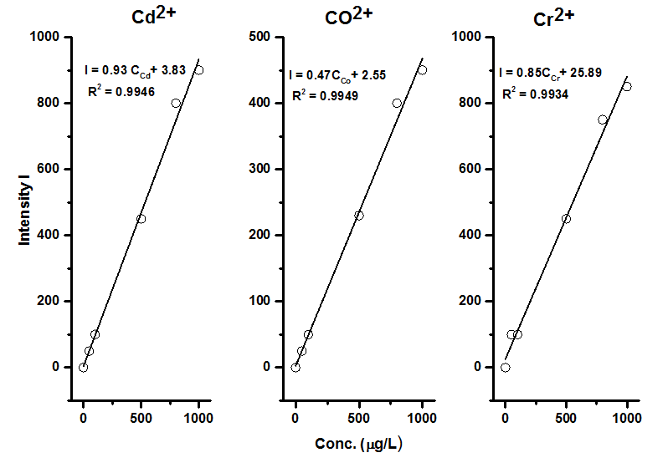
Figure S1 Calibration curves of the examined heavy metals (1-1000 µg/L) using ICP-OES

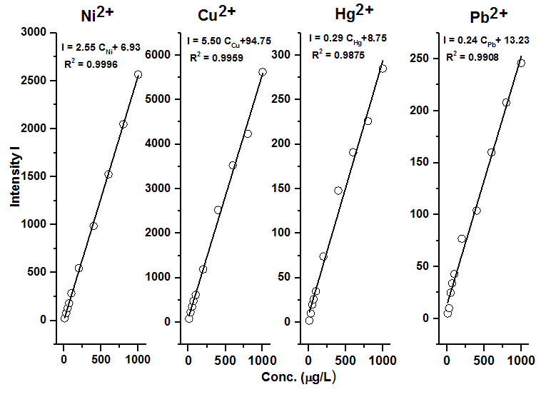
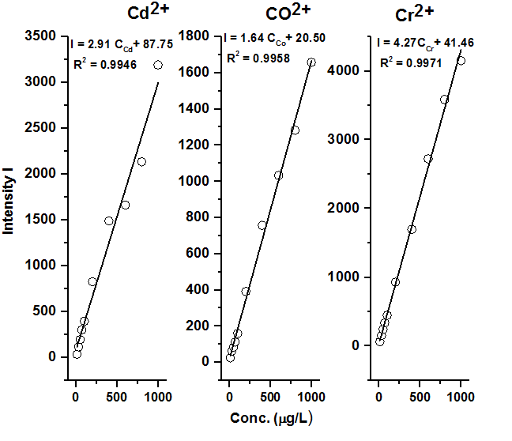
Figure S2 Calibration curves of the examined heavy metals (10-1000 µg/L) using MGO-ICP-OSE

