Supplementary Materials

Figure Captions
Figure 1: FTIR Spectra of 1a.
Figure 2: FTIR Spectra of 2b.
Figure 3: FTIR Spectra of 3c.
Figure 4: FTIR Spectra of 4a.
Figure 5: FTIR Spectra of 5b.
Figure 6: FTIR Spectra of 6c.
Figure 7: ¹H and ¹³C NMR Comp 1a.
Figure 8: ¹H and ¹³C NMR Comp 2b.
Figure 9: ¹H and ¹³C NMR Comp 3c.
Figure 10:¹H and ¹³C NMR Comp. 4a
Figure 11:¹H and ¹³C NMR Comp 5b
Figure 12:¹H and ¹³C NMR Comp 6c
Figure 13: TGA Spectra of 4a, 5b and 6c.
Figure 14. The synthesis methods of NHCs.
Figure 15. PXRD spectra of compounds 1a, 2b and 3c.
Figure 16. The mechanisms of Ag(I)-NHC a) 4a, b) 5b, and c) 6c.
Figure 17. PXRD spectra of compounds 4a, 5b and 6c
Figure 18: UV-vis Spectra of 1a.
Figure 19: UV-vis Spectra of 2b.
Figure 20: UV-vis Sectra of 3c.
Figure 21: UV-vis Spectra of 4a.
Figure 22: UV-vis Spectra of 5b.
Figure 23: UV-vis Spectra of 6c.
Figure 24: Generally Reaction.

Table Captions
Table 1:TGA-DTA of complexes 4a, 5b and 6c.
Table 2: Antimicrobial activities measured in compounds.

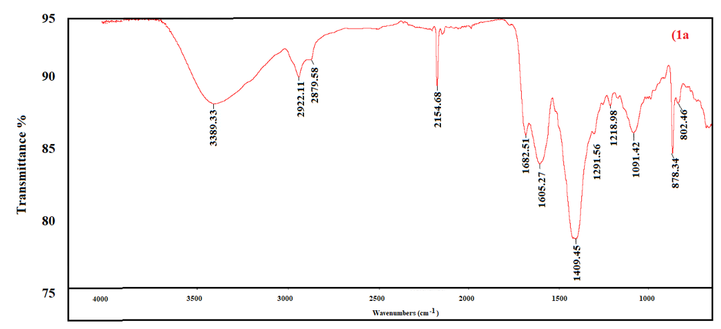

Figure 1: FTIR Spectra of 1a.

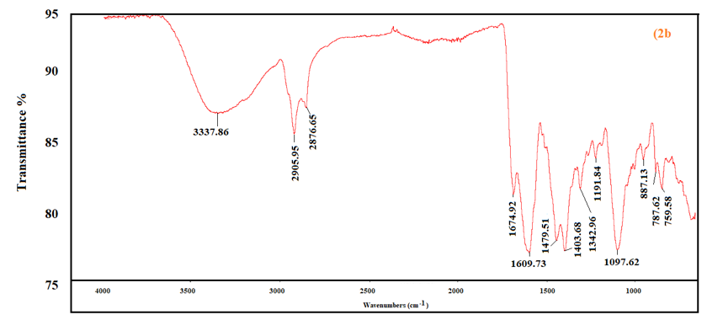
Figure 2: FTIR Spectra of 2b.

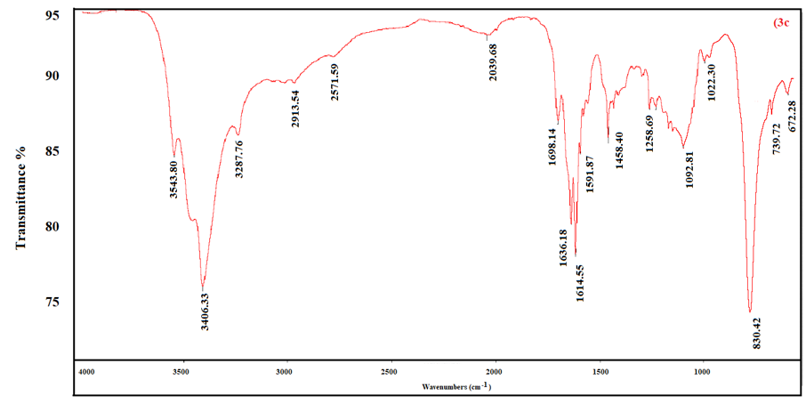
Figure 3: FTIR Spectra of 3c.
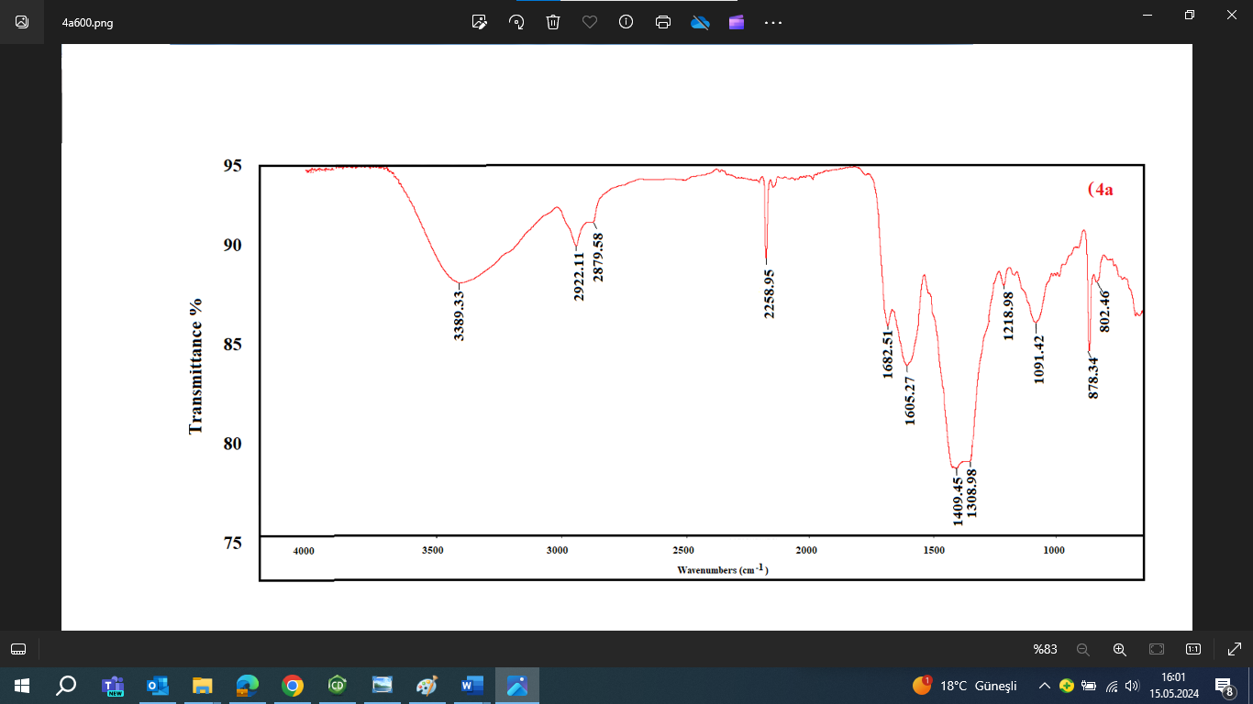
Figure 4: FTIR Spectra of 4a.

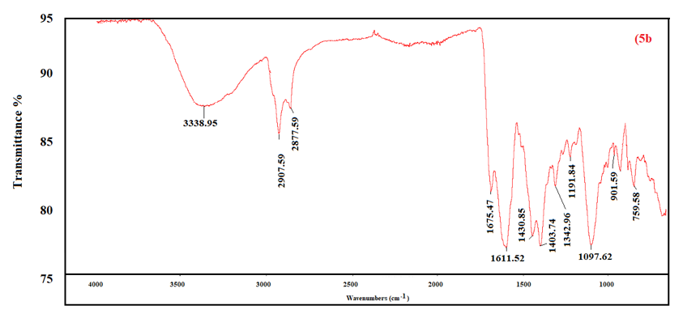
Figure 5: FTIR Spectra of 5b.

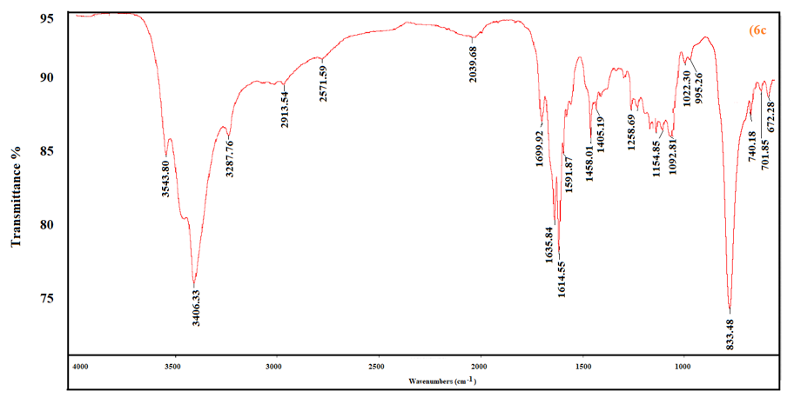
Figure 6: FTIR Spectra of 6c.

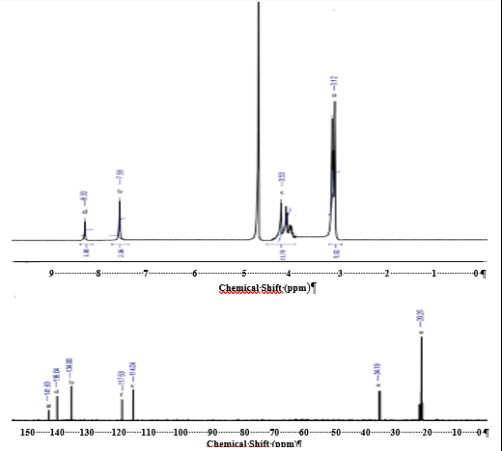
4.37
20.2
114.8
117.5
136.0
134.5
140.4
9 8 7 6 5 4 3 2 1 0
Chemical Shift (ppm)
34.1
3.12
7.98
8.30
150 140 130 120 110 100 90 80 70 60 50 40 30 20 10 0
Chemical Shift (ppm)

Figure 7: ¹H and ¹³C NMR Comp 1a.
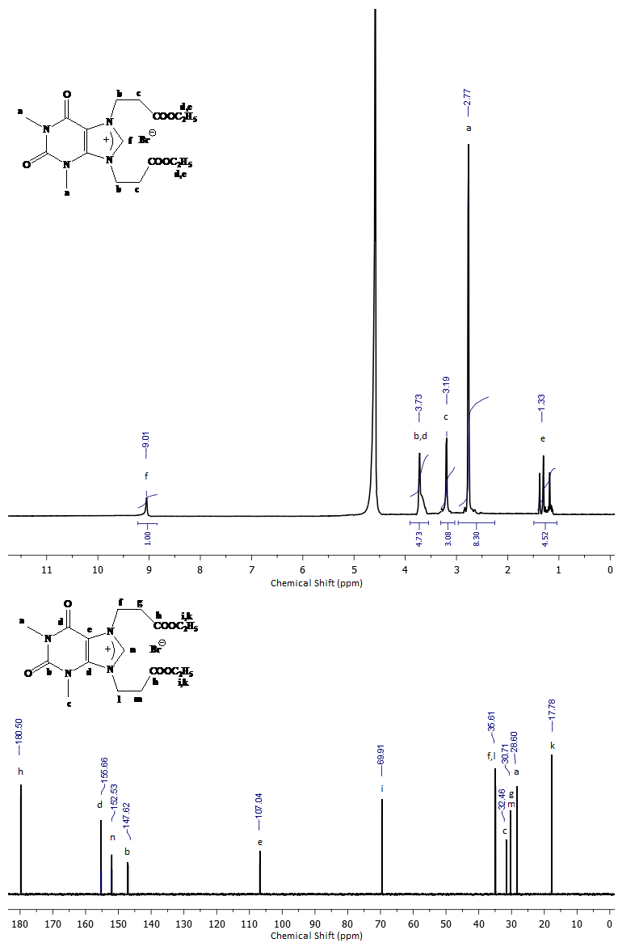
180 170 160 150 140 130 120 110 100 90 80 70 60 50 40 30 20 10 0
Chemical Shift (ppm)

2.77
3.19
3.73
1.33
9.01
152.53
147.62
180.50
156.66
107.04
17.78
26.80

30.71

30

32.48
30.71

69.91
11 10 9 8 7 6 5 4 3 2 1 0
Chemical Shift (ppm)

Figure 8: ¹H and ¹³C NMR Comp 2b.
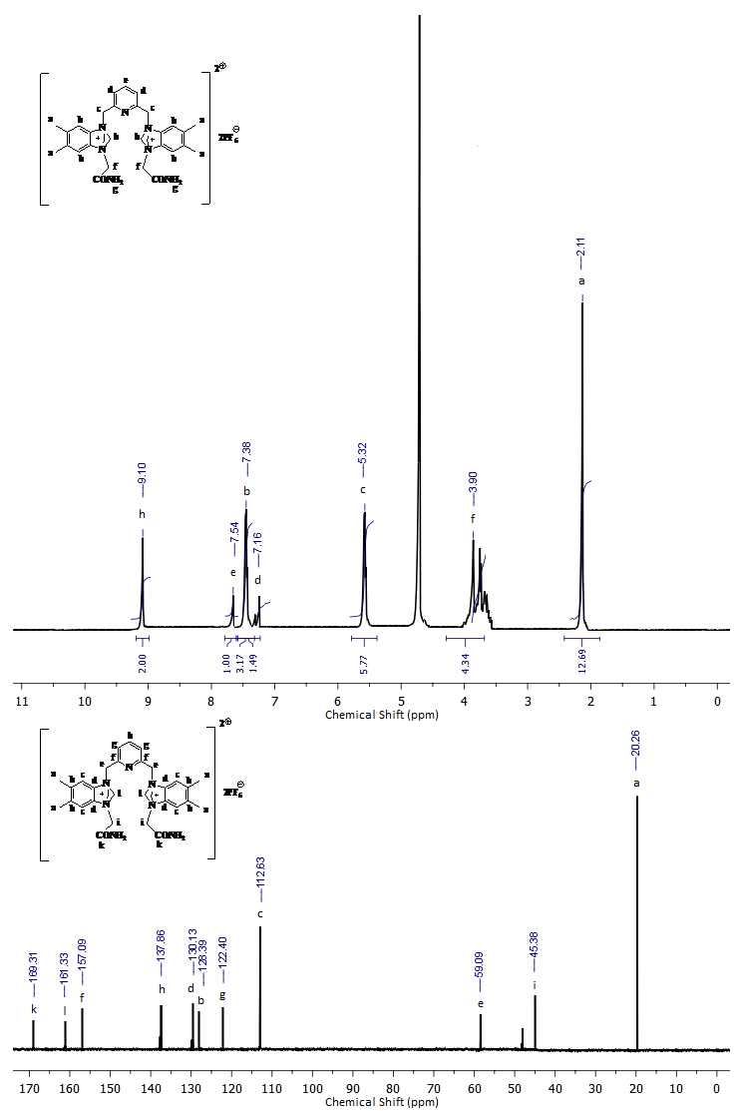

59.09
5.32
7.54
20.51
11 10 9 8 7 6 5 4 3 2 1 0
Chemical Shift (ppm)
170 160 150 140 130 120 110 100 90 80 70 60 50 40 30 20 10 0
Chemical Shift (ppm)

45.38
2.11
3.90
7.16
7.38
9.10
112.63
130.13
128.39
122.40
137.86
161.33
157.09
168.31

Figure 9: ¹H and ¹³C NMR Comp 3c.

59.09
45.38
112.63
20.26
137.86
130.13
128.39
122.40
169.31
161.33
157.09
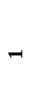
11 10 9 8 7 6 5 4 3 2 1 0
Chemical Shift (ppm)

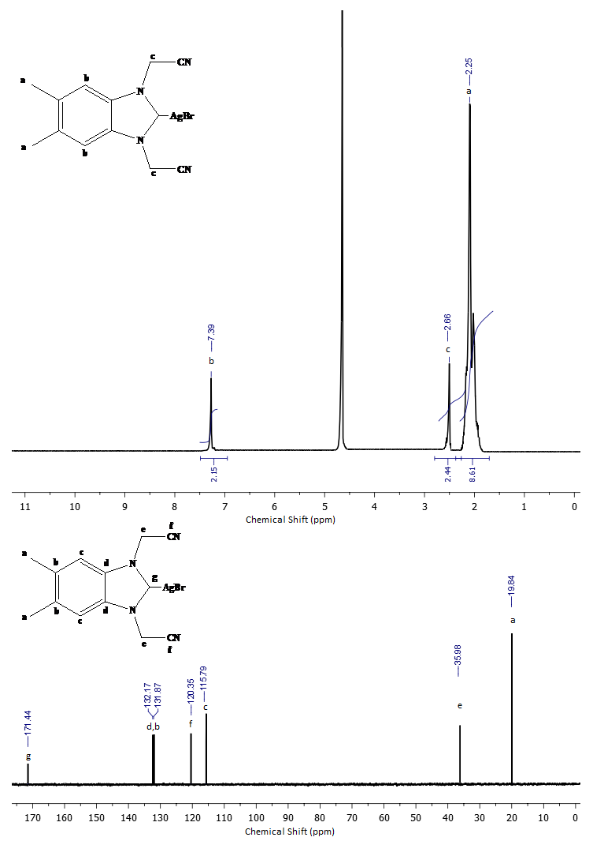
170 160 150 140 130 120 110 100 90 80 70 60 50 40 30 20 10 0
Chemical Shift (ppm)


11 10 9 8 7 6 5 4 3 2 1 0
Chemical Shift (ppm)
19.84
35.98

120.35
115.79
132.17
131.87
171.44
7.39
2.66
2.25

Figure 10:¹H and ¹³C NMR Comp. 4a.
190 180 170 160 150 140 130 120 110 100 90 80 70 60 50 40 30 20 10 0
Chemical Shift (ppm)

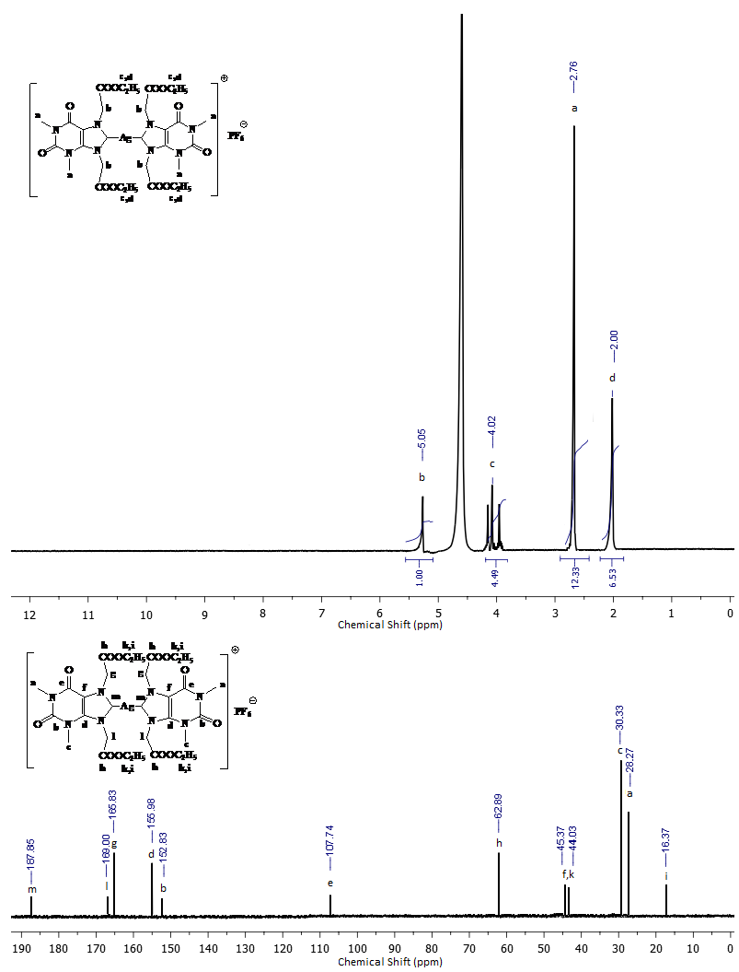
12 11 10 9 8 7 6 5 4 3 2 1 0
Chemical Shift (ppm)
190 180 170 160 150 140 130 120 110 100 90 80 70 60 50 40 30 20 10 0
Chemical Shift (ppm)

Figure 11:¹H and ¹³C NMR Comp 5b.
190 180 170 160 150 140 130 120 110 100 90 80 70 60 50 40 30 20 10 0
Chemical Shift (ppm)

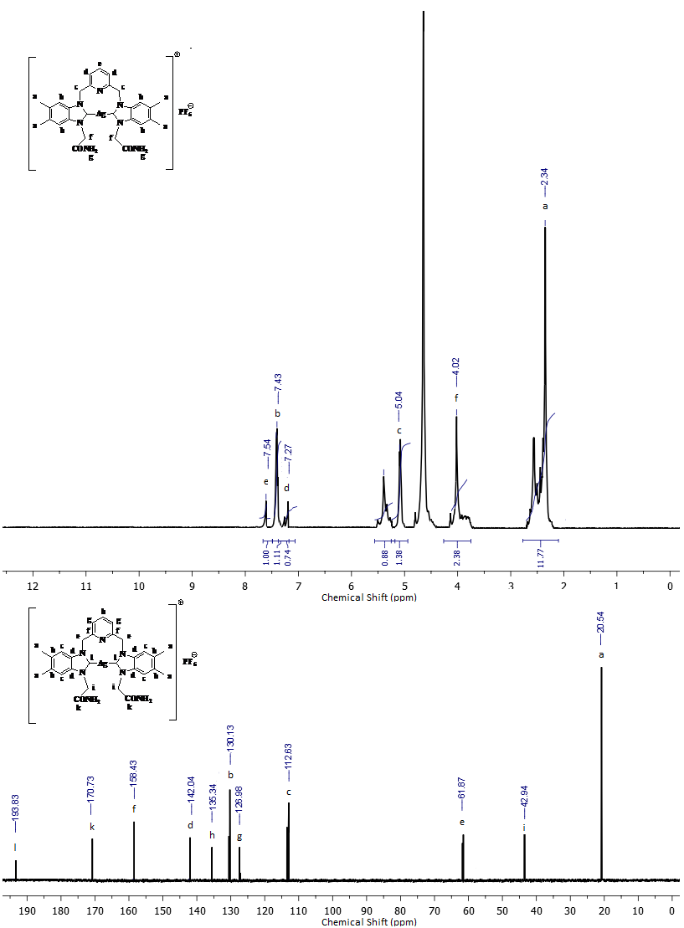
2.34
5.04
170.73
61.87

42.94
112.63
130.13
126.98
142.04
135.34
158.43
193.83
20.54
12 11 10 9 8 7 6 5 4 3 2 1 0
Chemical Shift (ppm)
4.02

7.43
7.27
7.54
190 180 170 160 150 140 130 120 110 100 90 80 70 60 50 40 30 20 10 0
Chemical Shift (ppm)

Figure 12:¹H and ¹³C NMR Comp 6c
190 180 170 160 150 140 130 120 110 100 90 80 70 60 50 40 30 20 10 0
Chemical Shift (ppm)

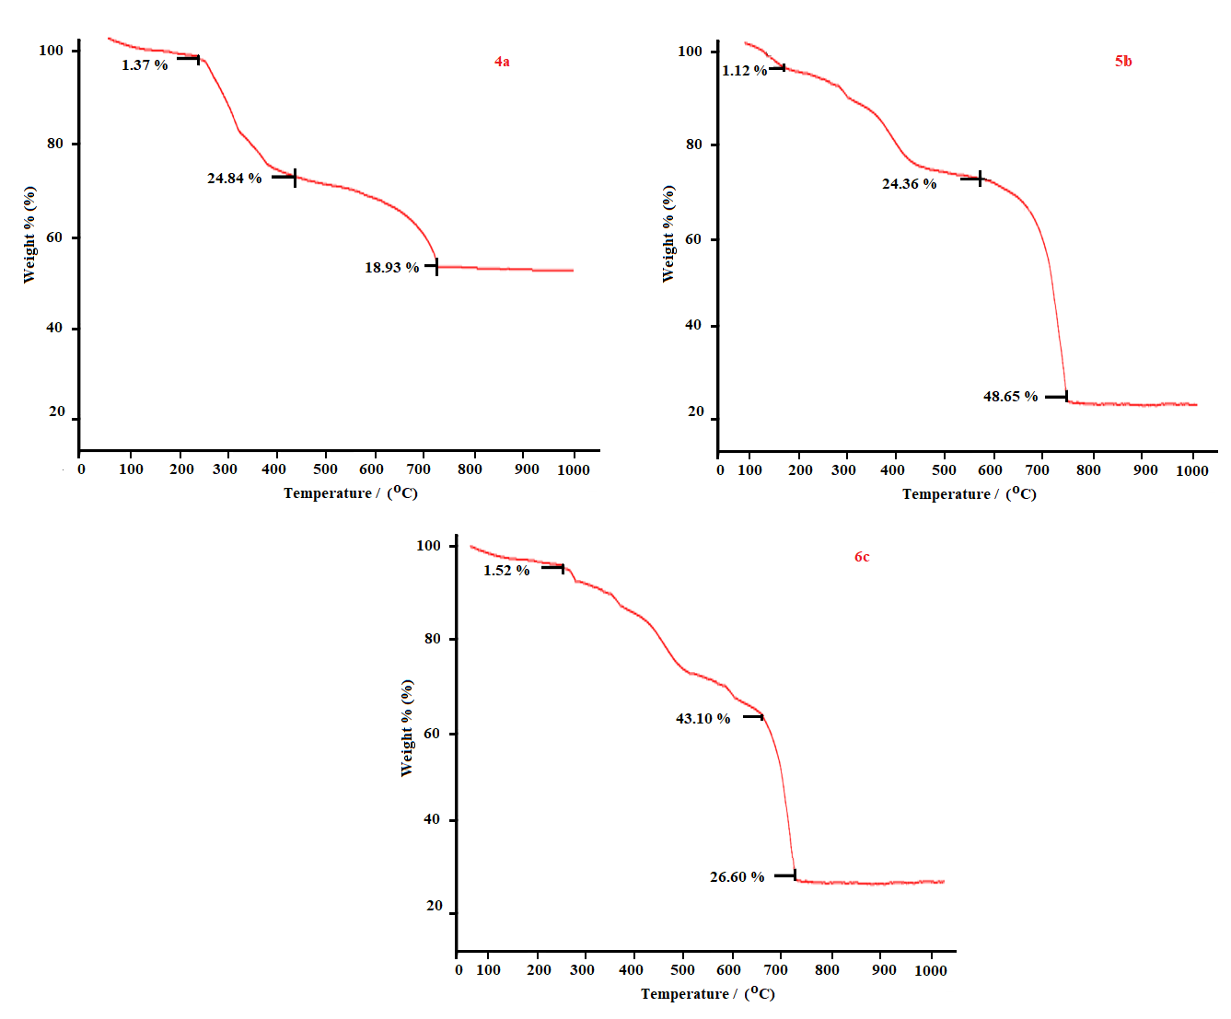
Figure 13: TGA Spectra of 4a, 5b and 6c

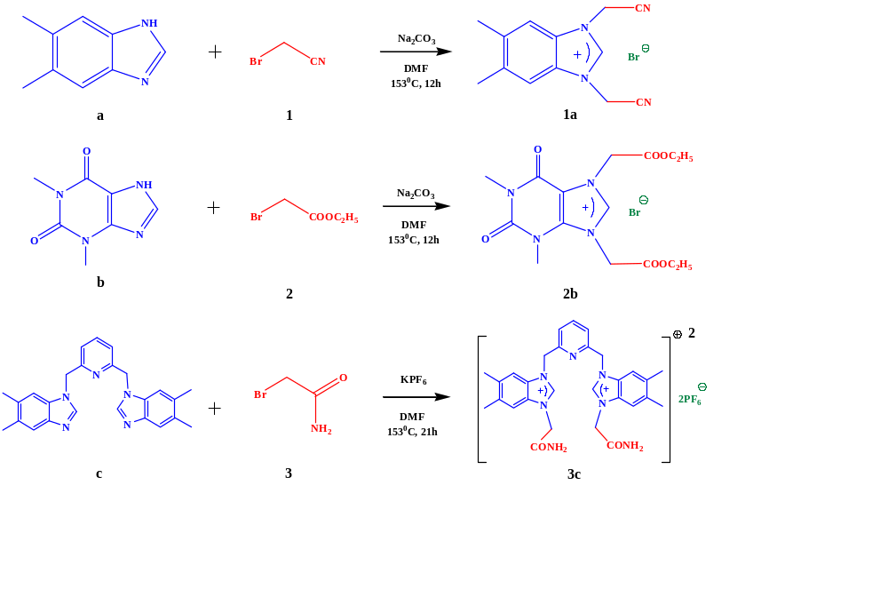
Figure 14. The synthesis methods of NHCs.
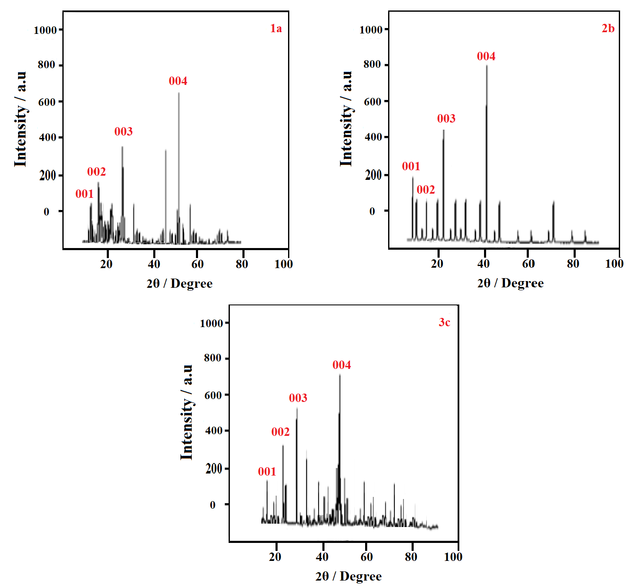
Figure 15. PXRD spectra of compounds 1a, 2b and 3c.
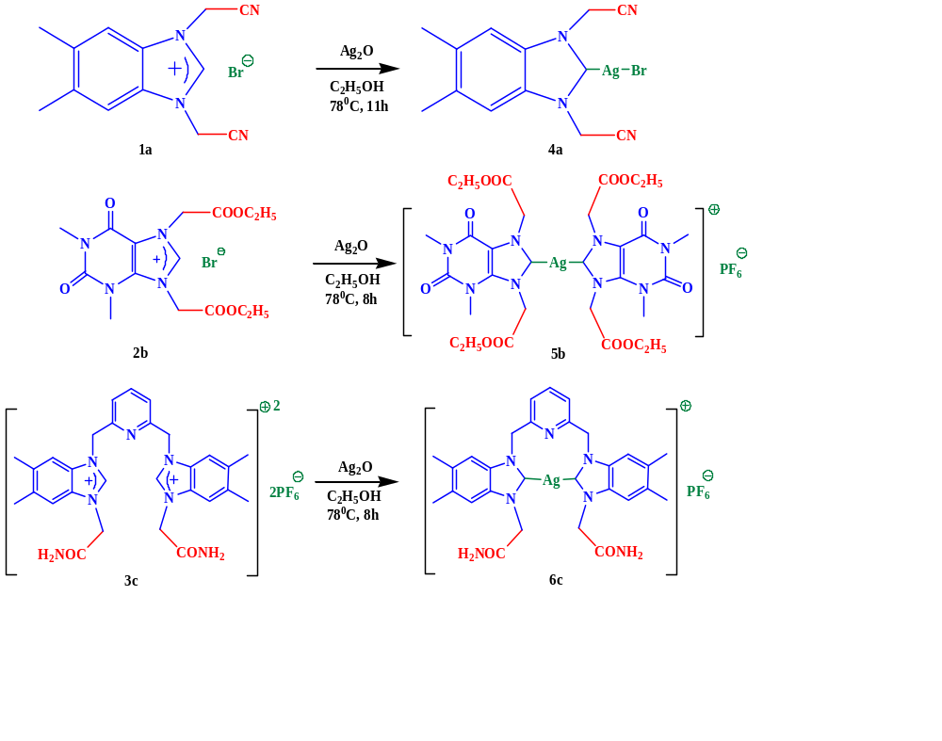
Figure 16. The mechanisms of Ag(I)-NHC a) 4a, b) 5b, and c) 6c.

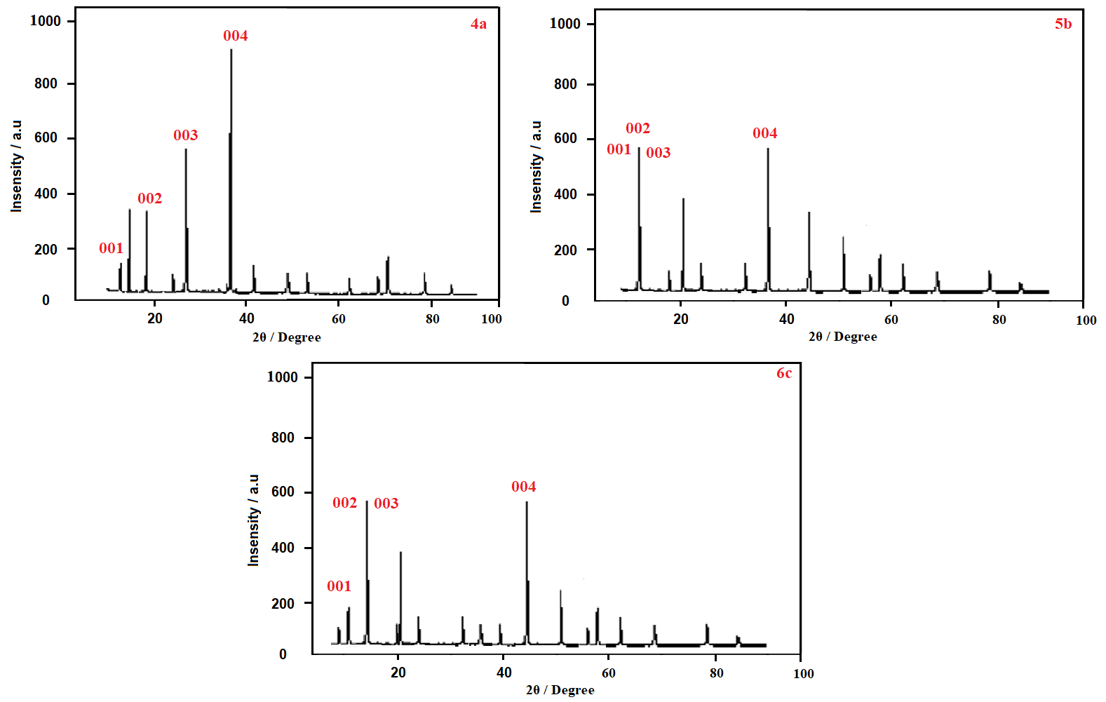
Figure 17. PXRD spectra of compounds 4a, 5b and 6c.

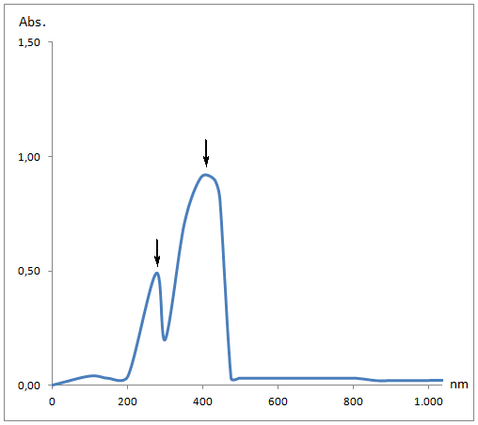
nm
0 200 400 600 800 1000

Abs.
1.50

1.00

0.50

0.00

Figure 18: UV-vis Spectra of 1a.

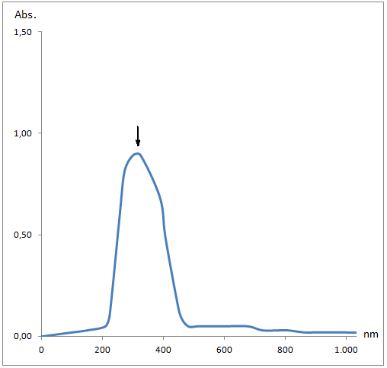
nm
0 200 400 600 800 1000

Abs.
1.50

1.00

0.50

0.00

Figure 19: UV-vis Spectra of 2b.

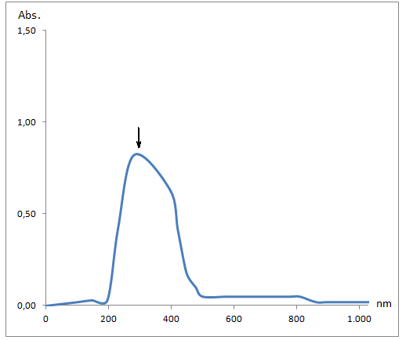

nm
0 200 400 600 800 1000

Abs.
1.50

1.00

0.50

0.00
Figure 20: UV-vis Sectra of 3c.

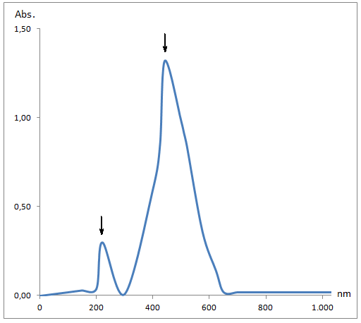
Abs.
1.50

1.00

0.50

0.00
0 200 400 600 800 1000

nm

Figure 21: UV-vis Spectra of 4a
Abs.
1.50

1.00

0.50
0.00
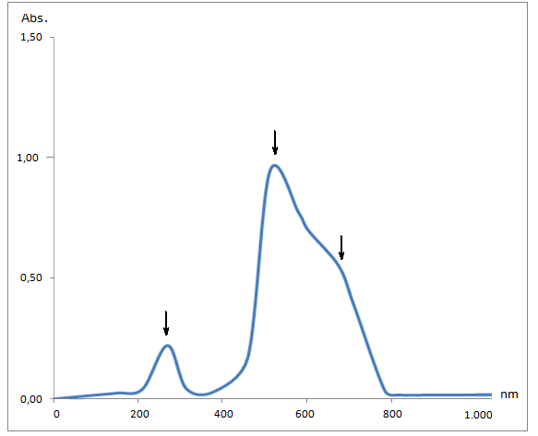
0 200 400 600 800 1000

nm

Figure 22: UV-vis Spectra of 5b
Abs.
1.50

1.00

0.50

0.00
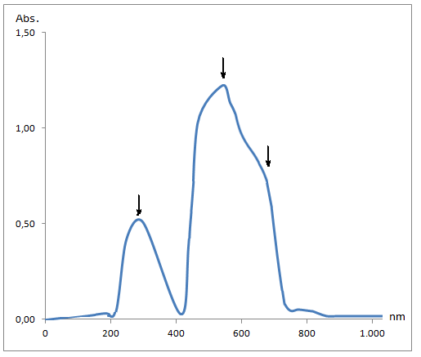
0 200 400 600 800 1000

nm

Figure 23: UV-vis Spectra of 6c.
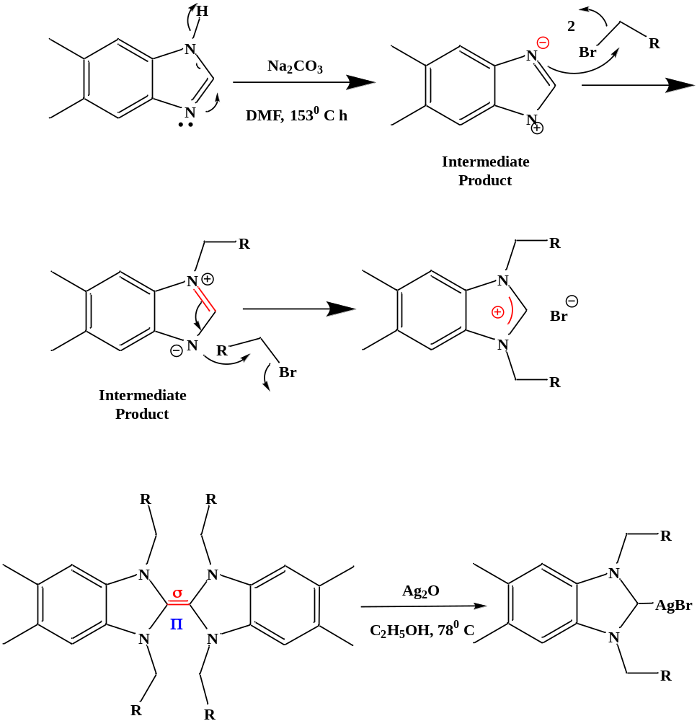
Figure 24: Generally Reaction Mechanisms.

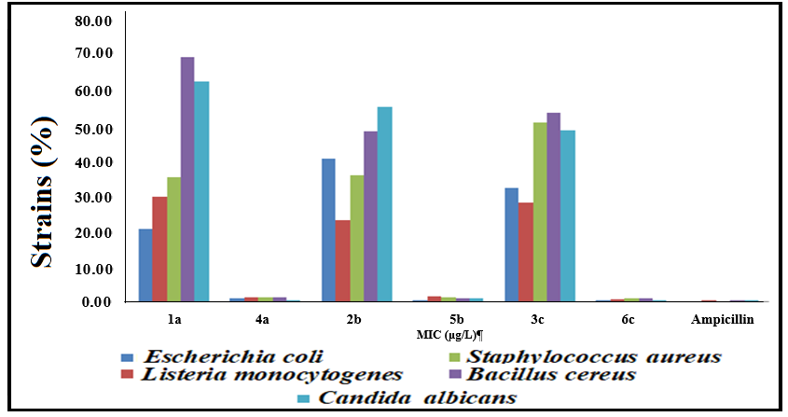
MIC
(µg/mL)
Figure 25. Antimicrobial activities of compounds 1a, 2b, 3c and 4a, 5b, 6c.

Table 1: TGA-DTA of complexes 4a, 5b and 6c.
Sample  (Weight/%) | Temperature  (0-100 °C) | Temperature  (101-399 °C) | Temperature  (400-799 °C) | Temperature  (800-1000 °C)
4a | 1.37 | 24.84 | 18.93 | 54.86
5b | 1.12 | 24.36 | 48.65 | 25.87
6c | 1.52 | 43.10 | 26.60 | 28.78

Table 2: Antimicrobial activities measured in compounds.
MIC
(µg/mL)-(µM)
Samples | Gram-negative  bacteria |  | Gram-positive  bacteria |  | Fungi
Samples | Escherichia  coli | Listeria monocytogenes | Staphylococcus aureus | Bacillus  cereus | Candida albicans
1a | 0.57-9.95 (1.17-8.75) | 0.29-9.46  (1.18-8.86) | 0.38-8.78  (1.57-7.85) | 0.63-8.96 (0.59-8.81) | 0.49-6.08  (1.15-4.87)
2b | 0.42-0.89 (0.29-3.82) | 0.28-0.47  (0.59-5.57) | 0.38-8.78  (0.57-4.85) | 0.34-5.16 (0.27-3.14) | 0.24-3.57  (0.15-5.05)
3c | 1.14-8.25 (12.25-184) | 0.29-9.46  (11.18-186) | 0.38-8.78  (9.57-108) | 0.63-8.96 (9.96-114) | 0.77-2.21  (12.1-48.7)
4a | 0.32-2.95 (1.07-5.42) | 0.68-3.68  (1.74-6.95) | 0.89-5.69  (1.17-7.85) | 0.63-8.96 (0.97-8.81) | 0.41-6.08  (1.15-4.87)
5b | 0.25-0.95 (0.26–1.16) | 0.24-0.46  (0.19-1.76 | 0.42-0.94  (1.57-1.87) | 0.32-0.92 (0.59-1.71) | 0.25-0.18  (1.85-3.72)
6c | 0.39-6.95 (1.26-10.84) | 0.29-9.46  (1.18-8.86) | 0.38-5.81  (0.17-1.03) | 0.48-6.76 (0.19-1.18) | 0.39-1.87  (0.19-1.72)
Ampicillin | 0.12-0.35 (0.06–0.96) | 0.14-0.27  (0.08-0.84) | 0.13-0.31  (0.07-0.76) | 0.12-0.48 (0.09-0.51) | 0.91-1.20  (0.43-1.01)

