Climate Variability Analysis and Forecasting Rainfall and Temperature Trends- SARIMAX Model Application for Mango farmers of Muthalamada Region, Kerala, India
John K Smitha ^{1a}. (Corresponding Author) smithajohn.k@kau.in., Suchithra M. S². , Archana K.^{1b}, Aida Treesa Sojan^{1c}, Remya E. B.¹, N. Manikandan³, Surendran U.⁴
Department of Soil Science and Agricultural Chemistry, College of Agriculture, Vellanikkara¹. 0000-0001-8265-6297ª,0009-0005-2797-4205^{b}, 0009-0003-1053-0531^{c}.
Department of Computer Science and Engineering, Indian Institute of Information Technology, Kottayam². 0000-0002-0194-1705
Department of Agricultural Meteorology, College of Agriculture, Padanakkad³. 0000-0002-6751-2700.
Remote Sensing Application Division, ICAR-National Bureau of Soil Survey and Land Use Planning, Nagpur, India⁴. 0000-0003-0908-1778
ABSTRACT
With climate change becoming increasingly evident, understanding how it affects local weather patterns is crucial. Such kind of studies provide valuable insights into how rainfall and temperature variability are changing over time, helping communities adapt to shifting climate conditions with respect to their agricultural practices. This study examines the trends in rainfall and temperature in Muthalamada, Kerala, using statistical trend analysis and forecasting using SARIMAX modeling techniques. Rainfall data spanning from 1981 to 2022 indicates an upward trend in both Chulliyar and Meenkara regions, with varying patterns across seasons. The wettest month consistently was July, while the southwest monsoon contributed significantly to annual rainfall. Predictions for the next decade suggest an increase in rainfall for both regions, except for winter. Temperature analysis reveals an upward trend in maximum and minimum temperatures across all seasons, with strong implications for mango cultivation. Maximum temperatures are anticipated to rise slightly in summer and winter but decrease in post-monsoon and pre-monsoon seasons, affecting mango flowering and fruit set. Conversely, minimum temperatures are expected to decrease across all seasons. Relative humidity is projected to increase during post-monsoon and southwest monsoon but decrease in other seasons, impacting pest populations. The performance of the SARIMAX model was evaluated using various metrics such as correlation coefficient (r), Mean Absolute Error (MAE), Mean Absolute Percentage Error (MAPE), and Root Mean Squared Error (RMSE). The analysis revealed overall accurate predictions for rainfall, temperature, and humidity, with some variability across seasons. Model performance evaluation indicates accurate predictions for rainfall, temperature, and humidity, with implications for mango farming. Implementation of appropriate mitigation strategies is crucial for Muthalamada mango farmers to adapt to climate variability and enhance production and export potential.
Key words :
SARIMAX, ARIMAX, Rainfall, Temperature, Relative Humidity,

INTRODUCTION
Climate change poses unprecedented challenges, manifesting through shifts in weather patterns and an elevated risk of extreme events, effecting routine human activities. The urgency for immediate action is underscored by the escalating threats, with better adaptation strategies. In this context, understanding the variability in rainfall and temperature becomes imperative as they are pivotal climate variables. Changes in these variables contribute to the occurrence of extreme events, including heat waves, floods and droughts, which pose heightened risks to societies and ecosystems (Arora 2019).These climate variations are causing deleterious effects on agriculture sector too, due to the vulnerability of small farmers towards climate change (Malhi et al. 2021). Climate variability accounts for nearly 60% of yield fluctuation, making it a major factor influencing food production and farmers' income (Matiu et al. 2017). Climate change affects natural resources, especially land and water, which are crucial for determining the agricultural output, especially the crop yields productivity and profitability (Arora 2019). It is predicted that climate change will decrease the amount of water available, but by 2050, agricultural water use will increase by 19% (Aryal et al.2019). Kerala has unique crops and cropping systems comprises of spices, plantations and horticultural crops and contributes a lot for Indian horticultural sector growth, however recently facing unpredictable climate fluctuations, which emphasizes the importance of researching how climate change affects livelihoods and horticulture (Giridhar et al. 2014).
Recently Kerala experienced floods during 2018 and 2019 and there is a likelihood of increased precipitation patterns, leading to greater variability in rainfall in the near future. Simultaneously, rising temperatures, combined with unpredictable rainfall, have resulted in widespread issues affecting agricultural productivity (Vijaykumar et al. 2021). Climate change has significant implications for mango cultivation, affecting various aspects of the mango growing process including growth, yield, quality, and susceptibility to pests and diseases. Rising temperatures affect mango trees' growth and flowering patterns. Higher temperatures can accelerate flowering and fruiting, leading to changes in the timing of flowering and harvest. However, extreme heat events can also stress mango trees, affecting fruit set and quality The commercial production of mangoes in Muthalamada, Palakkad region of Kerala, India is considered a promising venture for smallholder growers (Nadhika and Krishnankutty 2020). However, an analysis of mango plantation productivity from 2013 onwards reveals a declining trend attributed to the prevailing climatic variations in the region (Prasad et al. 2014). This has sparked concerns among farmers in Muthalamada.
Climate variability is one of the main reasons for the variations in mango yield in the world (Haokip et al. 2020). Despite fruit production being one of the most important activities in tropical countries, it has received little attention in the precise impact assessment of studies on climate change adaptation. For the best fruit production at each phenophase, there are specific and defined temperature ranges. Any deviation from the ideal condition is likely to have a significant impact on output and quality (Nath et al. 2019). The climate that prevails in that specific location has a significant impact on mango flowering and fruit set. Studies on climate change have recently grown in significance for comprehending mango flowering under various climatic circumstances (Bindu and Renjan 2022).
Fluctuations in weather do affect crop production due to shifts in flowering pattern, rainfall, temperature and sunlight which are the main drivers that meet the yield (Hirpo 2019). Climate variability especially temperature, rainfall, and humidity has been widely studied globally. In the areas where agriculture depends heavily on rain, these changes are creating difficulties (Praveen and Sharma 2019). Studies on analysis of climate trends and their effects on fruit crop productivity in the Himalayan region (Solan district), which is helpful for agricultural planning and strategies for adaptation to changing climate conditions(Bharti et al. 2023). Another study discusses various sustainable mango production technologies to mitigate the future climate aberrations in coastal agro climate of Maharashtra(Haldankaret al. 2020). Therefore, it is vital to evaluate the spatio-temporal dynamics of meteorological variables. This type of analysis helps the farmers to make aware of the climate induced changes and enables them to identify potential adaptation strategies.
In this present study, an attempt was made to understand the trends in observed and predicted climate variability, trends and forecast related to rainfall, temperature and relative humidity patterns in Muthalamada area of Palakkad district, which is a prominent mango growing region in Kerala. Rainfall data of 1981 to 2022 were collected from two locations of Muthalamada namely Chulliyar and Meenkara. Temperature and relative humidity data of 2003 to 2022 were collected from Mundur near Muthalamada. Statistical trend analysis was used to estimate the available data on rainfall, temperature and relative humidity.
Analyzing the trend of these climate variables in this area had not been attempted before. As a result, an effort was made to forecast the next ten years (from 2023 to 2032) in the Muthalamada area by analyzing the trend of climate variables. Based on this, a study was conducted recently and it set about the task of productive analysis and study of rainfall, temperature, and humidity trends in the Muthalamada area, and year-wise prediction of potent characteristics of rainfall, temperature, and humidity can be observed in the following years, by utilizing the empirical data provided and the machine learning model Sarimax with a seasonal auto regressive integrated moving average with exogenous factors.
DATA AND METHODOLOGY
The daily rainfall data (mm) of two locations in the Muthalamada region, namely Chulliyar and Meenkara during the period of 1980-2022 was collected for the study. The IDRB, Trivandrum, which is a Central Design and Research Organization of Irrigation (Irrigation Design and Research Board (IDRB), Trivandrum), was source of the data, is a. The normal rainfall of Chulliyar and Meenkara area was determined using the daily data (1981-2012). The qualities of life of various living beings are profoundly attuned to available water resources. Some believe good water resource management corresponds to a stable ecological state. Others argue that complex ecological phenomena are so closely related to water resources that improper water management can make the ecological situation even worse. Rainfall is the most complex of all the ecological factors that influence the intensity and the rhythm of the ecological processes. The normal rainfall of Chulliyar and Meenkara region was calculated on a monthly, seasonal, and annual basis. The collected rainfall data was subjected to variability and probability analysis. These analysis was conducted for the following periods: winter (January–February), pre-monsoon (March–May), southwest monsoon (June–September), and post-monsoon (October–December). To determine the yearly and seasonal patterns of the rainfall in these areas, a linear trend line was created. Man-Kendall rank statistics (t) were used to examine temporal changes in seasonal and annual rainfall to verify the significance of the observed trend. For various seasons from 1981 to 2022, the decade-wise shift in rainfall, or the percentage deviation from the normal rainfall, with excess and deficit years over the Muthalamada region, was also computed.
The IRTC (Integrated Rural Technology Centre), Mundur, provided the weather data on temperatures and relative humidity. From 2003 until 2022 the IRTC provided the temperature information (Max, Min) and the record of relative humidity, which was collected to record the seasonal changes of the years. . The rainfall, temperature, and relative humidity for the next 10 years was forecasted using the SARIMAX model.
SARIMAX MODEL
In time series modeling, ARIMA (Auto Regressive Integrated Moving Average) and SARIMA (Seasonal ARIMA) are widely used for weather forecasting. Although they both use the auto regressive integrated moving average (ARIMA) model as their foundation, SARIMA takes seasonality into account. They also require data in a ‘long’ format where each data point is associated with a time. Although the ARIMA model is good, SARIMAX may be very effective to incorporate seasonality and exogenous factors. We must employ an alternative model because the ARIMA model relies on the assumption that the time series is stationary. Thus, the SARIMAX model, designed to capture and model the underlying patterns and structure in time series data, encompassing trends, seasonality, and external factors (exogenous variables) that can influence the data, is used. It is mostly useful for making forecasts when the data exhibits complex temporal patterns.
UNDERSTANDING THE WORKING OF SARIMAX
The SARIMAX framework encompasses several time series forecasting models, including Autoregressive (AR), Moving Average (MA), and Autoregressive Integrated Moving Average (ARIMA) models. These models, along with ARMAX, which extends ARIMA by incorporating external variables, predict future values for a single time period.This is how the structure of SARIMAX is build:.
- Basic Building Blocks:
- Autoregressive (AR) Models: These models rely on past values of a time series to predict future values.
$$y_{t}=β+\sum_{i=1}^{p}{}φ_{i}y_{t−i}+εt$$
represents an AR(p) model, where:
- $y_{t}$ is the value at time t.
- $β$ is the intercept.
- $φ_{i}$ are coefficients for past values (lags) $y_{t−i}$ (up to p lags).
- $εt$ is the error term at time t.
- Moving Average (MA) Models: Unlike AR models, MA models focus on past error terms to predict future values. The equation
$$y_{t}=μ+\sum_{i=1}^{q}{θ_{i}}ε_{t−1}+ε_{t}$$
represents an MA(q) model, where:
- $μ$ is the mean of the series.
- $θ_{i}$ are coefficients for past error terms (lags) $ε_{t−1}$ (up to q lags).
- Combining the Power of Both:
- ARMA Models: ARMA models combine the strengths of AR and MA models.
$$y_{t}=β+\sum_{i=1}^{p}{φ_{i}}{yt}_{t−1}+\sum_{i=1}^{q}{θ_{i}}ε_{t−1}+ε_{t}$$
represents an ARMA(p, q) model, incorporating both past values and past errors.
- Handling Non-Stationary Data:
- ARIMA Models: ARIMA models address non-stationary data (data with trends or seasonality) by differencing it (taking repeated differences) to achieve stationarity.
$$(1−d)y_{t}=β+\sum_{i=1}^{p}{φ_{i}}(1−d){yt}_{t−1}+\sum_{i=1}^{q}{θ_{i}}ε_{t−1}+ε_{t}$$
represents an ARIMA(p, d, q) model, where:
- $d$ is the order of differencing used to achieve stationarity.
- Capturing Seasonality:
- SARIMA Models: SARIMA models handle seasonal patterns in data. They differ from ARIMA models by including a seasonal differencing component (denoted by Ds) and a seasonal ARMA model with lags that are multiples of the seasonality (denoted by Ps and Qs). The general form of a SARIMA(p, d, q)(P, D, Q, s) model is quite complex, but conceptually, it builds upon the ARIMA framework by incorporating seasonality.\
General Form of SARIMA(p, d, q)(P, D, Q, s) Model (complex, but conceptually builds upon ARIMA with seasonality):
$$(1−d)∆sDy_{t}=β+\sum_{i=1}^{p}{φ_{i}}(1−d)∆sD{yt}_{t−si}+\sum_{i=1}^{q}{θ_{i}}ε_{t−si}+ε_{t}$$
Where:
- $∆sD$ - seasonal differencing operator (differencing across seasonal periods)
- $s$ - seasonal period (e.g., 12 for monthly data)
- P and D - seasonal order of the AR and differencing components, respectively

5. Introducing External Factors:
ARIMAX and SARIMAX Models:
While ARIMA and SARIMA models focus on internal patterns within the time series, ARIMAX and SARIMAX models consider external factors (exogenous variables) that may influence the series. These variables are denoted by x_ti at each time step t with their corresponding coefficients γ_i. The models incorporate these variables into the forecasting equations as follows:
- ARIMAX Model:
$$(1−d)y_{t}=β+\sum_{i=1}^{p}{φ_{i}}(1−d){yt}_{t−i}+\sum_{i=1}^{q}{θ_{i}}ε_{t−i}+\sum_{i=1}^{n}{{γ_{i}x}_{i−t}}{+ ε}_{t}$$
Where:
- $y_{t}$ - value at time t
- $d$ - order of differencing
- $β$ - intercept
- $φ_{i}$ - coefficients for past values (lags) yt-i (up to p lags)
- $θ_{i}$- coefficients for past error terms (lags) εt-i (up to q lags)
- $ε_{t}$ - error term at time t
- $n$ - number of exogenous variables
- $γ_{i}$ - coefficients for the i-th exogenous variable xi_t
- $x_{i−t}$-exogenous variable at time
- SARIMAX Model:
$$(1−d){∆−s^{D}y}_{t}=β+\sum_{i=1}^{p}{φ_{i}}(1−d){∆−s^{D}y}_{t−si}+\sum_{i=1}^{q}{θ_{i}}ε_{t−si}+\sum_{i=1}^{n}{{γ_{i}x}_{i−t}}{+ ε}_{t}$$
Where:
- ${∆−s^{D}y}_{t}$ - seasonal differencing operator (differencing across seasonal periods)
- $s$ - seasonal period (e.g., 12 for monthly data)
- P and D - seasonal order of the AR and differencing components, respectively (analogous to p and d in ARIMA)
- Other terms remain the same as in the ARIMAX model definition.
By incorporating these exogenous variables, ARIMAX and SARIMAX models can potentially improve the accuracy of forecasts when the time series is influenced by external factors.
RESULTS AND DISCUSSION
RAINFALL statistics
The rainfall characteristics for the Chulliyar and Meenkara regions in Kerala for the period spanning 1981 to 2022 are given in Table 1. The Chulliyar region experiences 1348.3 mm of mean annual precipitation, with a standard deviation of 357.3 mm. The dependable annual rainfall at the 75 percent confidence level amounted to 1194 mm. The coefficient of variation (CV) for annual rainfall was 26.5 percent. Additionally, during the pre-monsoon, post-monsoon, southwest monsoon, and winter periods, the dependable seasonal rainfall at the 75 percent confidence level was 87 mm, 729 mm, 184 mm, and 0 mm, respectively. July emerged as the wettest month, receiving the highest amount of rainfall (343.71 mm), contributing to 25.49 percent of the year's total with a CV of 50.45 %. This was followed by June with 246.34 mm, August with 231.98 mm, and October with 150.08 mm, contributing 18.27 percent, 17.21 percent, and 11.13 percent to the annual rainfall, respectively. In contrast, January experienced the lowest rainfall with only 4.63 mm. Among the seasons, the southwest monsoon (June-September) made the most substantial contribution, accounting for 68.63 percent of the annual rainfall, while winter (January-February) had the smallest contribution of 0.92 per cent percent. The pre-monsoon (March-May) and post-monsoon (October-December) contributed 10.41 percent and 20.04 percent, respectively.
The mean annual rainfall in the Meenkara region was 1393 mm, with a 467.9 mm standard deviation. Pre-monsoon, southwest monsoon, post-monsoon, and winter season dependable seasonal rainfall at 75% levels are 111 mm, 727 mm, 168 mm, and 0 mm, respectively. The dependable annual rainfall at 75% level was 1074 mm. The coefficient of variation of annual rainfall was 33.6 %. The wettest month is July, which receives the most precipitation (366 mm) and contributed to 26.3 % of the year's total precipitation of 1505.5 mm, followed by June (242.3 mm), August (233 mm), and October (147.5 mm) contributing 17.4, 16.7 and 10.6 per cent respectively to the annual rainfall. The least rainfall was in the month of January with 4 mm. The south-west monsoon contributed the most to the annual rainfall (66.7%), while winter contributed the least (1.2%), among the pre-monsoon (March–May), post-monsoon (October–December), and winter (January–February). Pre and post-monsoon periods each contributed 11% and 20.9% of the total. On comparing the rainfall data of 40 years of Meenkara and Chulliyar region, it was observed that Meenkara region had received more rainfall than the Chulliyar region in all the seasons. While, the dependable annual rainfall at 75% probability as well as on every season was high for Chulliyar region when compared to that of Meenkara region. Here, the annual rainfall was 1194 mm for Chulliyar region, which was found to be more than Meenkara region (1074 mm).
Table 1. Monthly and seasonal means of rainfall (mm) over Chulliyar and Meenkara regions from 1981 to 2020
 |  | CHULLIYAR |  |  |  | MEENKARA
Season | Decade | 1981-1991 | 1991-2000 | 2001-2010 | 2011-2020 | 1981-1991 | 1991-2000 | 2001-2010 | 2011-2020
Pre-monsoon | Decadal mean | 11.87 | -22.95 | 10.72 | 51.17 | -9.42 | -26.01 | 36.21 | 24
Pre-monsoon | Excess | 4 | 1 | 4 | 6 | 4 | 1 | 4 | 3
Pre-monsoon | Deficit | 3 | 7 | 3 | 1 | 5 | 5 | 4 | 4
Southwest monsoon | Decadal mean | -4.40 | -2.3 | 6.7 | 25.13 | -20.6 | 14.54 | 8.15 | 7.97
Southwest monsoon | Excess | 1 | 4 | 4 | 5 | 0 | 3 | 4 | 4
Southwest monsoon | Deficit | 2 | 6 | 2 | 1 | 4 | 2 | 3 | 2
Post - monsoon | Decadal mean | -23.21 | 8.62 | 14.58 | -2.42 | -27.6 | 29.59 | -1.08 | -12.52
Post - monsoon | Excess | 1 | 3 | 4 | 3 | 1 | 3 | 5 | 2
Post - monsoon | Deficit | 6 | 4 | 2 | 3 | 7 | 4 | 3 | 4
Winter | Decadal mean | 42.05 | -71.91 | 30.42 | -35.47 | -30.8 | 36.63 | -3.49 | -44.53
Winter | Excess | 3 | 1 | 2 | 1 | 2 | 2 | 2 | 2
Winter | Deficit | 6 | 9 | 8 | 9 | 6 | 8 | 8 | 8

RAINFALL TRENDS
ANNUAL RAINFALL TREND
The annual rainfall trend of the Chulliyar and Meenkara regions from the year 1980 to 2022 is given in Fig. 1. For Chulliyar region, the data indicates a consistent upward trend in rainfall over these years. The wettest period occurred between 1992 to 1994, 1997,2007 to 2014, and 2018, with the highest recorded rainfall in 2018 at 2627 mm, followed closely by 1997 with 2305 mm.. For the Meenkara region, the data showed an increasing trend with the preceding years. The wettest years on record were 1998, 2007, and 2018. The year 2005 had the most rainfall of these years, measuring 2520.5 mm, followed by the year 1999 with 2503 mm. At the 0.05 level, the data was determined to be significant. When compared to the typical rainfall of 1393 mm, a 67.53 mm increase in rainfall was noted over the 42-year study period.
Fig. 1. Annual rainfall trend of Chulliyar and Meenkara from 1980-2022

SEASONAL RAINFALL TRENDS
PRE-MONSOON (MARCH-MAY)
The pre-monsoon rainfall pattern in the Chulliyar and Meenkara regions from 1980 to 2022 is depicted in Fig. 2. The Chulliyar region exhibits a distinct upward trend with highest recorded rainfall of 499 mm in 2018. This increasing trend, along with observed regression coefficient suggests a consistent rise in pre-monsoon rainfall over years. The absence of recorded rainfall in 2000 highlights the variability in precipitation patterns over the years. Similarly, the Meenkara region also shows an increasing trend in pre-monsoon rainfall, with the highest recorded rainfall of 497.5 mm in 2005. The absence of rainfall in 1997 underscores the variability in weather patterns.
The observed upward trend in pre-monsoon rainfall in both regions, suggests a changing climate patterns that can influence mango production in Muthalamada.The increased rainfall during pre-monsoon are favorable for mango trees for proper vegetative growth and development and accumulation of carbohydrates. The rise in pre-monsoon showers contribute to increased soil moisture levels, which are favourable for the proper growth of mango trees it is also necessitates adaptive measures to mitigate the potential associated with water logging, Antharcnose diseases and nutrients leaching especially, nitrogen and potassium.
Fig. 2 . Pre- monsoon rainfall trend of Chulliyar and Meenkara from 1980-2022

SOUTH-WEST MONSOON (JUNE – SEPTEMBER)
Data from 1980 to 2022 reveals notable upward trends in both Chulliyar and Meenkara regions (Fig. 3). In Chulliyar, there has been steady upward trend in rainfall with highest recorded rainfall of 1868 mm in 2018 and the lowest of 343 mm in 1999. The R-squared value was observed to be 0.0435 showing a weaker linear relationship with time and rainfall. Similarly, in Meenkara, South-West monsoon rainfall trend has also increased over time, the highest recorded rainfall of 1892 mm occurred in 2000 and the lowest of 494.1 mm in 2012.The calculated R square value was 0.0885. An increase of 73.63 mm of rainfall was observed during this south-west monsoon when compared to that of normal rainfall of 929.7 mm
The upward trend in S-W monsoon rainfall suggests a potentially beneficial environment for mango cultivation in both regions. is necessary for proper flowering and yield of mango trees. The tree accumulates sufficient moisture from these rainfall for further growth and development. So, increase in SW monsoon are favorable for the mango plantations. This favors uniform vegetative growth in the branches after canopy management in each season. But there are variabilities in rainfall as indicated by highest and lowest figures, Farmers have to take adequate management measures to manage the variability by implementing water management strategies during excess or in adequate rainfall. The delay in S-W monsoon delays all the intercultural operations like canopy management, hormonal and fertilizer applications.
Fig. 3. South west monsoon rainfall trend of Meenkara from 1980-2022

WINTER (JANUARY – FEBRUARY)
The precipitation pattern of the Chulliyar and Meenkara regions throughout the winter period spanning from 1980 to 2022 is illustrated in Fig. 4. There was a noticeable decline in rainfall in the Chulliyar region during the winter months. The year 2003 had the highest recorded precipitation of 100.5 mm, which was followed by 1985 with 72 mm. Notably, a significant portion of these winter months exhibited no rainfall. The R-square value was found to be 0.0054. In the Meenkara region, a constant trend of rainfall was observed during the winter seasons and the maximum rainfall of 182 mm was seen in the year 2000. Most of the year was found to have no rainfall during this winter period.. Compared to the normal rainfall of 17.2 mm in the winter, the study period showed a decrease of 6.14 mm.
Fig. 4. Winter rainfall trend of Chulliyar and Meenkara from 1980-2022

POST MONSOON (OCTOBER – DECEMBER)
The rainfall pattern of the Chulliyar and Meenkara regions during the post-monsoon season is illustrated in Fig. 5. In the Chulliyar region, a slight upward trend in rainfall was noted throughout the research period. The highest precipitation, amounting to 617 mm, was recorded in 2021, followed by 538 mm in 1997 and 495 mm in 1994. In contrast, the lowest rainfall occurred in 1989 with just 58 mm, and this was followed by 83 mm in 2017 and 100 mm in 1995. The R-squared value was 0.0642. During the study period in the Meenkara region, an increasing trend of rainfall was observed. The year 2000 recorded the highest rainfall of 1892 mm, which was followed by the years 2005 and 2018, with 1627 and 1567.3 mm of precipitation, respectively. While the lowest rainfall was in the year 2012 with 494.1 mm of rainfall and was followed by the years 2016 and 2002 with rainfall of 541 and 575 mm. Comparing the two regions post monsoon rainfall, it found that Chulliyar experienced a slight upward trend in rainfall, while Meenkara exhibited a more pronounced increasing trend. Comparing the two regions, it's evident that while Chulliyar experienced a slight upward trend in rainfall, Meenkara exhibited a more pronounced increasing trend. This highlights the variability in rainfall patterns effects mango flowering. The upward trend in rainfall of these period will effect mango flowering and yield will be reduced subsequently.
Fig. 5. Post monsoon rainfall trend of Chulliyar and Meenkara from 1980-2022

SHIFTS IN SEASONAL RAINFALL
Table 2 shows the number of years with excess and deficit rainfall in the Chulliyar and Meenkara regions as well as the percentage deviation of seasonal rainfall on a decade-by-decade basis. In the Chulliyar region, the mean rainfall was above normal during all the decades except in 1991-2000 in the pre-monsoon season. Four excess and three deficit periods were observed during the 1st and 3rd decade, while there were 1 excess and 7 deficit periods, and from 1991-2000 and 6 excess and 1 deficit periods from 2011-2020. While all other years in every decade was found to be normal. For the southwest monsoon season, the decadal mean was below normal in the 1st two decades and in the other two decades it was 6.7% and 25.13% respectively, which was above the normal. Over the four decades, there were 14 excess and 11 deficit periods. Whereas, it was normal for all other decades. In the post-monsoon season, the decadal mean was above normal in the decades 1991-2000 and 2001-2010 with 8.62 and 14.58% respectively. During the four decades of this period, the excess period was found to be 1, 3, 4 and 3 respectively, while the deficit was 6, 4, 2 and 3 respectively. During the winter season, the 1st and 3rd decades had a decadal mean above normal with 42.05 and 30.42% respectively. While, in the 2nd and 4th decades, it was below normal. During this season, there were 7 excess, 32 deficit, and 1 normal period.
In the Meenkara region, the mean was less than normal for the first two decades and it increased from 2001 to 2020 and reached up to 36.21 per cent during the pre-monsoon season. In this season, there were 12 excess, 18 deficit and 10 normal periods. During the period of the southwest monsoon, the decadal mean was less than normal in the first decade whereas, it was 14.54, 8.15 and 7.97 per cent more during the 2nd, 3rd, and 4th decades respectively. Also, there were 11 excess and 11 deficit periods among the four decades. For post-monsoon, except 1991-2000 (26.01 per cent) all other decades had a decadal mean less than normal. In this season, there was 12 excess, 14 deficit and 10 normal periods. During the winter season also, all the decades except 1991-2000 (36.63 per cent) had a decadal mean less than normal. Also, there was 2 excess periods in all the decades and 8 deficit periods in all the decades except the 1st decade.
Table 2: Decadal mean (% departure from normal), frequency of excess and deficit rainfall years over Chulliyar and Meenkara from 1981-2020.
Chulliyar |  |  |  |  |  | Meenkara
Month | normal rainfall | % contribution to annual rainfall | Standard deviation | CV (%) | 75% probability | normal rainfall | % contribution to annual rainfall | Standard deviation | CV (%) | 75% probability
Jan | 4.63 | 0.34 | 13.89 | 300 | 0 | 4 | 0.3 | 8.9 | 222.5 | 0
Feb | 7.83 | 0.58 | 21.19 | 270.51 | 0 | 11.2 | 0.9 | 35.8 | 271.2 | 0
Mar | 26.33 | 1.95 | 42.95 | 163.1 | 0 | 27.1 | 1.9 | 44.1 | 162.7 | 0
Apr | 45.46 | 3.37 | 40.49 | 89.06 | 22 | 52.2 | 3.7 | 63.4 | 121.5 | 15
May | 68.54 | 5.08 | 64.78 | 94.51 | 25 | 76.1 | 5.5 | 62.9 | 82.6 | 32
Jun | 246.34 | 18.27 | 120.43 | 48.89 | 179.5 | 242.3 | 17.4 | 124 | 51.2 | 162
Jul | 343.71 | 25.49 | 173.41 | 50.45 | 240 | 366 | 26.3 | 176.6 | 48.3 | 248
Aug | 231.98 | 17.21 | 88.72 | 38.24 | 181 | 233 | 16.7 | 130.1 | 55.8 | 175
Sep | 103.25 | 7.66 | 101.36 | 98.17 | 28 | 88.4 | 6.3 | 64.5 | 73 | 29.5
Oct | 150.08 | 11.13 | 90.44 | 60.26 | 87 | 147.5 | 10.6 | 135.8 | 92 | 85.6
Nov | 89.42 | 6.63 | 79.47 | 88.88 | 30 | 108.9 | 7.8 | 87.7 | 80.5 | 50
Dec | 30.7 | 2.28 | 56.22 | 183.13 | 0 | 34.2 | 2.5 | 61.1 | 178.5 | 0
Annual | 1348.28 | 100 | 357.27 | 26.5 | 1194 | 1393 | 100 | 467.9 | 33.6 | 1074
Pre monsoon | 140.34 | 10.41 | 82.37 | 58.69 | 87 | 153.4 | 11 | 107.5 | 70.1 | 111
Southwest | 925.28 | 68.63 | 307.72 | 33.26 | 729 | 929.7 | 66.7 | 325.7 | 35 | 727
Post- monsoon | 270.2 | 20.04 | 131.56 | 48.69 | 184 | 290.6 | 20.9 | 187.7 | 64.6 | 168
Winter | 12.46 | 0.92 | 25.41 | 203.93 | 0 | 17.2 | 1.2 | 37.3 | 216.9 | 0
TEMPERATURE
MAXIMUM TEMPERATURE
The maximum temperature on different seasons during the period 2002-2022 is given in Fig. 6. According to the IRTC data, the maximum temperature increased over the few years for every season—pre-monsoon, northeast monsoon, southwest monsoon, and winter. The pre-monsoon period was found to be the hottest season with the highest maximum temperature of 38.7°C in the years 2007 and 2016 followed by 38.6°C in 2013. After the pre-monsoon, the winter period has the highest maximum temperature. During the period of study, in all the years except 2009, the southwest monsoon had the lowest maximum temperature, whereas, in 2009 the northeast monsoon had the lowest maximum temperature of 24.6°C. The maximum temperature's R² values were determined to be 0.0887, 0.0677, 0.1109, and 0.2386 for the pre-monsoon, northeast monsoon, southwest monsoon, and winter, respectively.
Fig. 6. Maximum temperature on different seasons in 2003-2022 from IRTC

MINIMUM TEMPERATURE
The IRTC data showing the minimum temperature in different periods viz., pre-monsoon, northeast monsoon, southwest monsoon, and winter from 2003 to 2022 is given in Fig. 7. Over the years, every season displayed an upward trend. With the exception of 2011, when the northeast monsoon recorded the highest minimum temperature of 26.8°C, the pre-monsoon season had the highest minimum temperature in every year but that one. The highest minimum temperature of 28.9℃ was recorded during the pre-monsoon season of the year 2019, whereas the lowest of 19.6℃ was during the winter season of 2004. Compared to all seasons, the winter season had the lowest minimum temperature in all the years except 2016 and 2022 where it was lowest for the northeast monsoon. The R² value was found to be 0.2145, 0.2429, 0.6071, and 0.5901 respectively for the pre-monsoon, northeast monsoon, southwest monsoon, and winter.
Fig. 7. Minimum temperature on different seasons in 2003-2022 from IRTC

RELATIVE HUMIDITY
The IRTC data of the relative humidity during different periods viz., pre-monsoon, northeast monsoon, southwest monsoon, and winter from 2002 to 2022 is depicted in Fig. 8. All the seasons showed a decreasing trend of relative humidity over the years. From the year 2003 to 2016, the highest or lowest relative humidity was not specific for any season. From 2017 onwards, the highest relative humidity was recorded in the southwest monsoon period followed by the northeast monsoon period, while the lowest was recorded in the winter season. Among all the seasons during the study period, the highest relative humidity of 95.45% was recorded during the northeast monsoon period in 2003 while the lowest of 39.9% was in the winter season of the year 2018. The R² value was found to be 0.6305, 0.5881, 0.5999, and 0.6194 respectively for the pre-monsoon, northeast monsoon, southwest monsoon, and winter.
Fig. 8. Relative humidity on different seasons in 2003-2022 from IRTC

PREDICTION AND FORECASTING OF RAINFALL, TEMPERATURE AND HUMIDITY
RAINFALL FORECAST
The rainfall forecast is a critical aspect of weather predictions, providing valuable insights into the expected precipitation in a given region over a specified period. The anticipated precipitation patterns for Chulliyar over the next ten years (2024-2033) are depicted in Fig. 9. According to the forecasted data, a rising trend in rainfall is expected for all seasons, except winter. Projections indicate a 12.61% increase in the pre-monsoon season, an 18.23% rise during the southwest monsoon, a modest 0.85% uptick in the post-monsoon period, and a predicted decline of 11.31% in winter rainfall. The southwest monsoon season exhibits the most significant variation in precipitation among the seasons.
Fig. 9. Seasonal climate forecast and prediction for rainfall in Chulliyar for 2024-2033, (a) post-monsoon, (b) pre-monsoon, (c) southwest monsoon and (d) winter
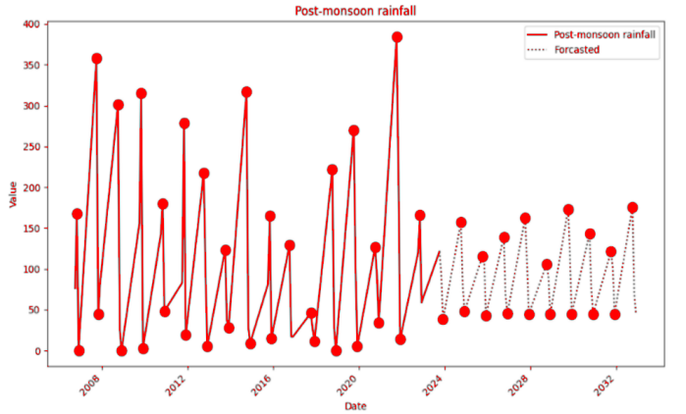  A | 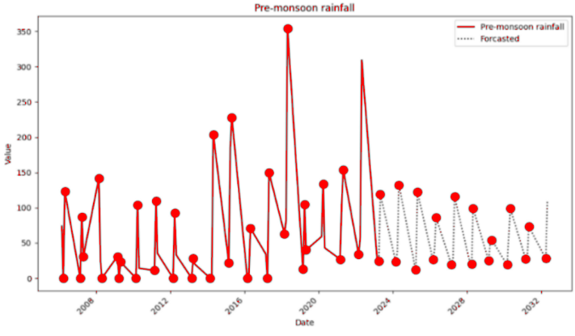  B
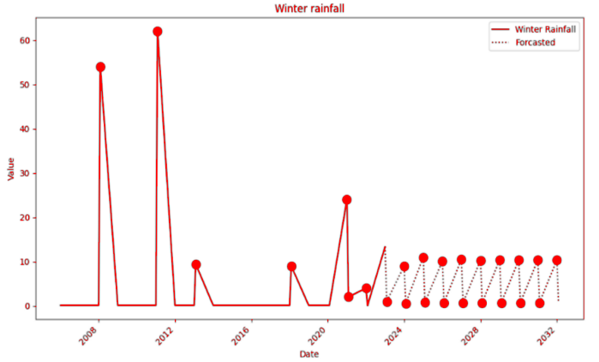  C | 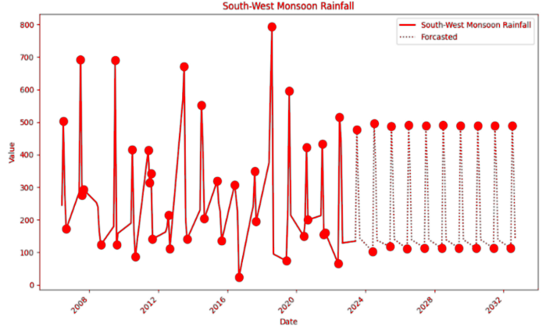  D

The expected precipitation patterns for Meenkara spanning the next ten years (2024-2033) are illustrated in Fig. 10. Based on the projected data, an upward trend in rainfall is anticipated for all seasons, except for post monsoon. Forecasts indicate a 3.94% increase during the pre-monsoon season, an 18.37% surge in the southwest monsoon, a 9.94% increase in the winter season, and a predicted decline of 5.11% in the post-monsoon period.
Fig. 10. Seasonal climate forecast and prediction for rainfall in Meenkara for 2024-2033, (a) post-monsoon, (b) pre-monsoon, (c) southwest monsoon and (d) winter
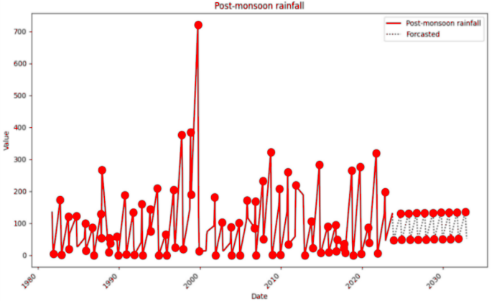  A | 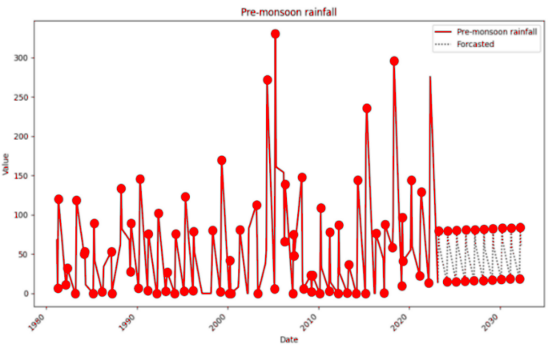  B
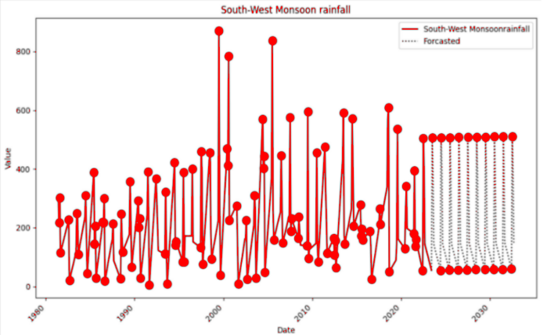  C | 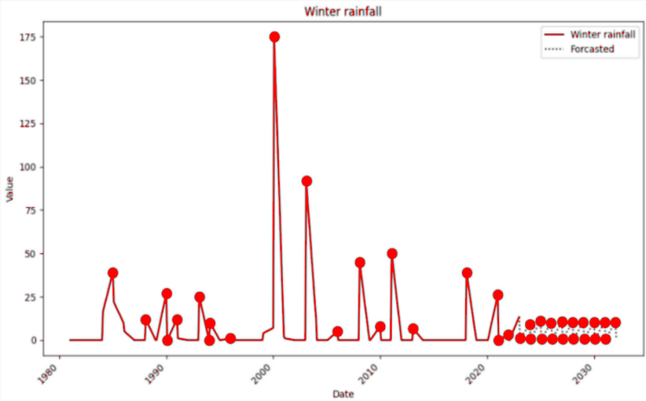  D

MAXIMUM TEMPERATURE FORECAST
The forecast of maximum temperature plays a pivotal role in anticipating and planning for agricultural operations and other climate-related impacts. The Figure 11 depicts forecasted maximum temperature levels from 2024 to 2033, utilizing data from the IRTC. Forecasts suggest that the maximum temperature will drop by 1.61°C and 0.65°C, respectively, during the pre-monsoon and post-monsoon seasons. In contrast, an increase is forecasted for the southwest monsoon and winter periods with 0.23°C and 0.13°C respectively.
Fig. 11. Seasonal climate forecast and prediction for maximum temperature in Muthalamada for 2024-2033, (a) post-monsoon, (b) pre-monsoon, (c) southwest monsoon and (d) winter
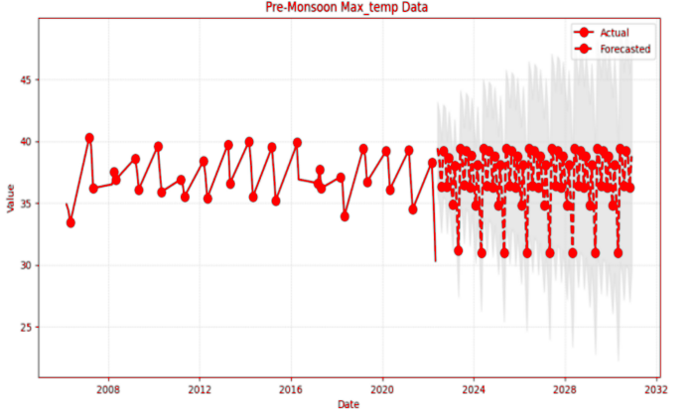  A | 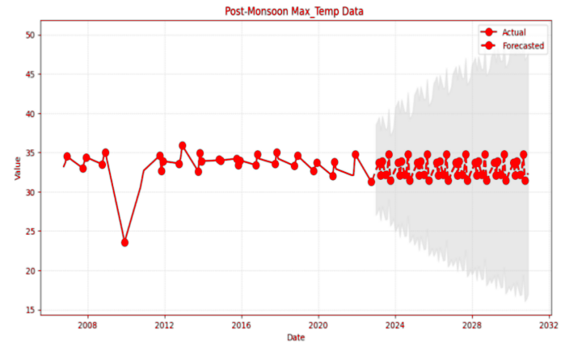  B
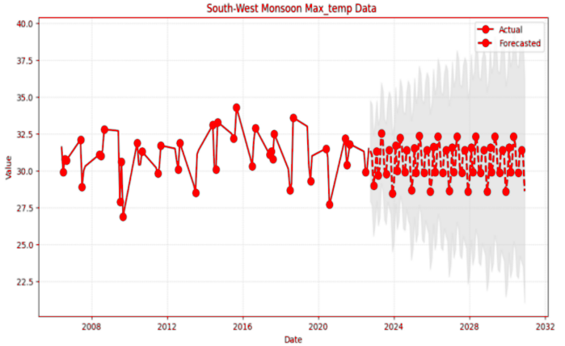  C | 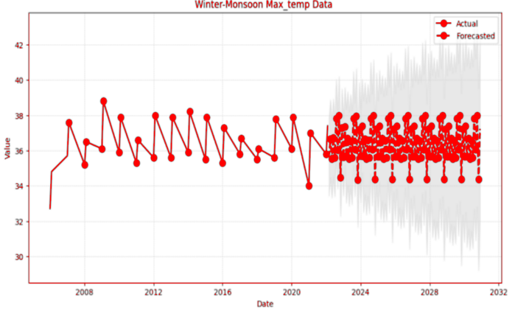  D

MINIMUM TEMPERATURE FORECAST
The Fig. 12 illustrates projected minimum temperature levels spanning from 2024 to 2030, based on data sourced from the IRTC. The forecasts suggest a likely decrease in minimum temperatures during all the seasons viz., pre-monsoon, southwest monsoon, post-monsoon and winter with the declining values of 2.74, 1.69, 2.64 and 0.86°C respectively.
Fig. 12. Seasonal climate forecast and prediction for minimum temperature in Muthalamada for 2024-2033, (a) post-monsoon, (b) pre-monsoon, (c) southwest monsoon and (d) winter
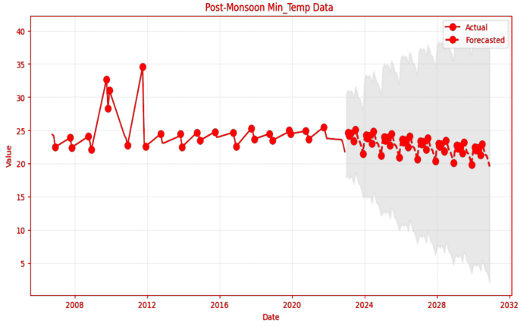  A | 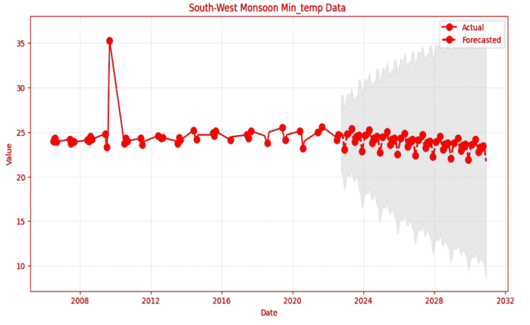  B
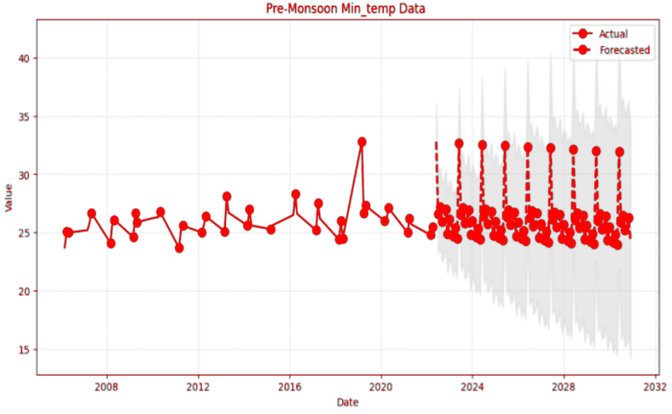  C | 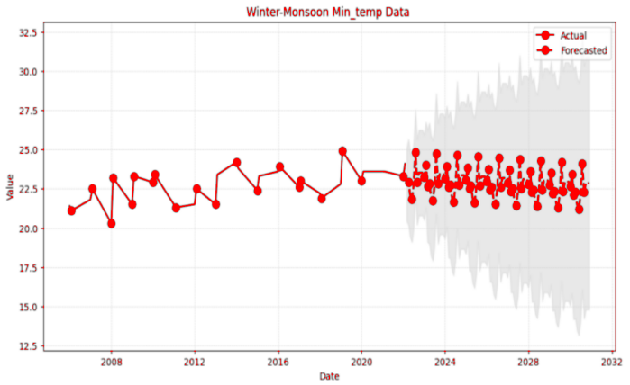  D
HUMIDITY FORECAST
Humidity prediction is a crucial aspect of weather forecasting that plays a pivotal role in understanding and preparing for atmospheric conditions. The forecasted humidity for the years 2024-2033, based on IRTC data, is illustrated in the Fig. 13. Anticipated increases in humidity are projected for the post-monsoon and southwest monsoon periods with 1.35 and 4.34 percent respectively. Conversely, a decrease was predicted for pre-monsoon and winter with 5.75 and 11.48 per cent respectively.
Fig. 13. Seasonal climate forecast and prediction for humidity in Muthalamada for 2024-2033, (a) post-monsoon, (b) pre-monsoon, (c) southwest monsoon and (d) winter
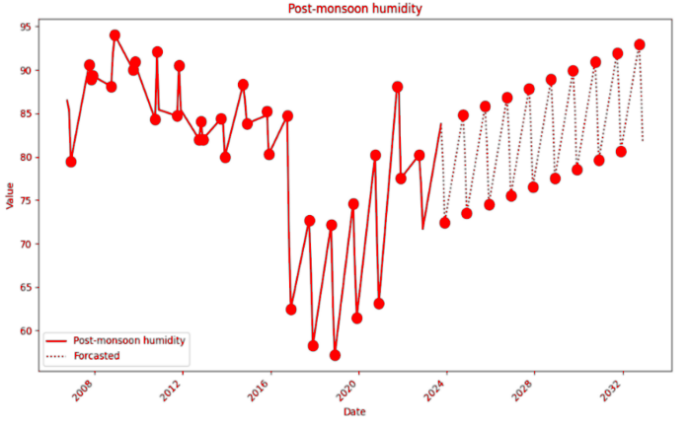  A | 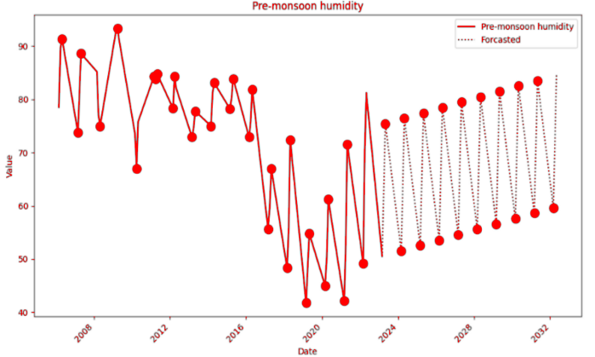  B
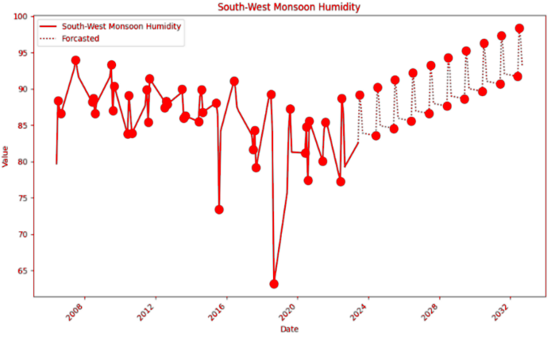  C | 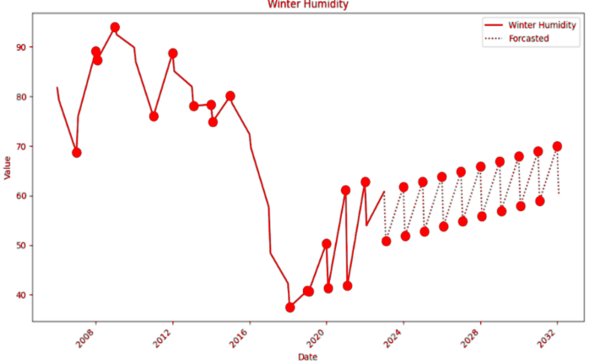  D
MODEL PERFORMANCE EVALUATION
In assessing the SARIMAX model's performance, we calculated R, MAE, MAPE, and RMSE for each variable on a seasonal basis. These metrics serve as quantitative evaluation measures for the predictive accuracy of the machine learning models. We used these error metrics to gauge the correspondence between the predicted and actual data for rainfall, temperature, and humidity. Lower values of MAE, MAPE, and RMSE, which fall within the range of zero to infinity, signify better model performance. The correlation coefficient (R) measures the degree of association between observed and predicted variables. These statistics provide valuable insights into the performance of our predictive models or monitoring systems across different seasons of rainfall, temperature and relative humidity. Among different rainfall seasons, the Winter season shows a reasonable MAE of 10.1632, indicating a relatively accurate prediction model. The Pre-monsoon season stands out with remarkably low errors, as evidenced by a minimal MAPE of 0.2957% and a high R value of 0.9882, suggesting a robust predictive model for this period. In contrast, the Post-monsoon and Southwest seasons exhibit slightly higher errors, emphasizing potential challenges in forecasting during these periods.
During the winter season, the maximum temperature predictions were highly accurate, demonstrated by a low Mean Absolute Error (MAE) of 0.153. Additionally, MAPE was exceptionally low at 0.00426%, reflecting the precision of the forecasting model. The RMSE of 0.215 further confirms the reliability of the predictions, while the R-value is impressively high at 0.959, indicating a strong positive correlation between predicted and observed values. Similar trends are observed in the Pre-monsoon Season, with a slightly higher MAE of 0.642 and RMSE of 0.742, though the R-value remains robust at 0.917. In the Post-monsoon Season, the forecasting model demonstrates remarkable accuracy, as reflected in the low MAE of 0.1, minimal MAPE of 0.00310%, and an exceptionally low RMSE of 0.1147. The R-value for this season is notably high at 0.9862, indicating an almost perfect positive correlation between predicted and observed maximum temperature. The Southwest Monsoon Season, characterized by an MAE of 0.2759, a MAPE of 0.009%, and an RMSE of 0.2759, maintains a strong predictive performance with an R-value of 0.9579.
The analysis of minimum temperature data across different seasons reveals interesting patterns and predictive accuracy metrics. During the winter season, the model exhibits high precision, with an MAE and RMSE both registering at 0.1999. The MAPE is impressively low at 0.0086%, indicating a minimal margin of error in predictions. The R-value further reinforces the reliability of the model's predictions, standing at 0.9358. Transitioning to the pre-monsoon season, while the MAE slightly increases to 0.3105, the model maintains a remarkable accuracy with a low MAPE of 0.01% and a reasonably low RMSE of 0.508. The R-value remains high at 0.9397. In the post-monsoon season, the model excels again with a reduced MAE of 0.197 and an impressive MAPE of 0.0081%. The RMSE stands at 0.1972, and the R-value reaches a peak of 0.9615. Finally, during the Southwest monsoon season, the model shows its highest precision, with a remarkably low MAE of 0.1044 and an exceptionally low MAPE of 0.0042%. The RMSE is 0.1047, and the R-value peaks at 0.968, highlighting the model's exceptional performance in predicting minimum temperatures during this season.
For relative humidity, the MAE is recorded at 1.24, indicating a relatively low level of error in the measurements for the winter season. The MAPE is impressively low at 0.371%, suggesting a high degree of precision. RMSE further supports the accuracy, with a value of 1.2899. The strong R-value of 0.9378 signifies a robust relationship between the observed and predicted relative humidity values. Transitioning to the pre-monsoon season, the MAE slightly increases to 1.726, but the MAPE remains exceptionally low at 0.0348%. The RMSE is reported at 2.18, still within an acceptable range, and the correlation coefficient rises to 0.9678, indicating a strong predictive capability. Moving to the post-monsoon season, the metrics exhibit even greater accuracy, with MAE, MAPE, and RMSE values of 0.8474, 0.0113%, and 0.8524, respectively. The R-value reaches an impressive 0.9891, emphasizing the reliability of the measurements. Lastly, during the southwest monsoon season, the metrics showcase remarkable precision, with an MAE of 0.186, a MAPE of 0.0143%, an RMSE of 0.187, and an R-value of 0.893.
The results on the climatic analysis revealed that Climate change and unseasonal rains have cast a shadow over the mango farmers of Muthalamada, renowned for their early harvest and fruit export. The delay in fruit flowering and subsequent harvest, attributed to these climate shifts, is now a pressing concern, severely hampering export prospects. Similar trends, as observed in the case of Gir Kesar Mango in Gujarat, prompt a closer examination of climate variability's impact on mango cultivation in Muthalamada (Lalitha 2020).
Rainfall emerges as a crucial factor influencing mango cultivation, with a noticeable increase over the years, particularly during the post-monsoon period, coinciding with peak flowering(Cavalcante 2022). Analysis reveals a rise in excess rainfall years, particularly in the pre-monsoon and southwest monsoon periods in Chulliyar and Meenkara regions, with a consequent impact on fruit yield due to flower production hindrance and increased disease susceptibility. Rain, foggy weather or heavy dew in the flowering season promote tree growth but impede with flower production and encourage diseases of the inflorescence (Rajan 2012) ultimately diminishing yield. Furthermore, climate change significantly alters phenological patterns, indirectly impacting reproductive and vegetative processes vital for tropical fruit production.
According to Makhmale et al. (2012), climate significantly impacts growth, with temperature being a crucial factor in the emergence of inflorescences, typically occurring right after the coldest part of winter in the region. Rising temperatures affect inflorescence emergence, with a steady increase observed across all seasons, while relative humidity declines steadily. Projections indicate an increase in rainfall for Chulliyar throughout the year, except winter, and a similar trend for Meenkara, except in the post-monsoon period, posing challenges for fruit firmness and shelf-life. In Muthalamada, maximum temperatures are expected to rise marginally in summer and winter but decrease during post-monsoon and pre-monsoon seasons, potentially affecting floral induction negatively. Conversely, cooler temperatures during flowering followed by warmer temperatures could positively impact fruit set. High temperatures induce physiological changes in mango fruit, leading to disorders like spongy tissue, primarily found in Alphonso mangoes. Minimum temperatures are forecasted to decrease across all seasons, affecting fruit development and viability. Relative humidity is projected to increase during the post-monsoon and southwest monsoon but decrease in other seasons, influencing pest populations.
Halder and Hassan (2020) reported that mango's floral induction is primarily triggered by cool temperatures, suggesting that higher temperatures during this phase may have a negative effect, while cooler temperatures during flowering followed by higher temperatures could positively impact pollen viability and fruit set. High temperature induces physiological changes in the mango fruit. Spongy tissue, a physiological disorder mainly found in Alphonso mango is induced by high temperature which will lead to tissue breakdown. Additionally, minimum temperatures are predicted to decrease across all seasons. In the study of Sukhvibul (2015), exposure to low temperatures (20/10 ℃day/night) after hand pollination significantly increased the percentage of stenospermocarpic fruit of variety Nam Dok Mai, in which embryos were aborted at some stage during early fruit development. Growth necessitates relatively higher temperature conditions, whereas inflorescence emergence begins immediately following the coldest period of winter in the region.In an annual crop plant, the ability to survive is largely irrelevant, as stress-induced developmental delays can lead to a total loss of yield (Morison and Morecroft 2006). Relative humidity is forecasted to rise during post-monsoon and southwest monsoon, with a decrease projected for the other two seasons. Pushpalatha et al. (2008) found that the hopper population showed a positive correlation with maximum temperature and a negative correlation with relative humidity.Implementing appropriate mitigation strategies based on these findings can aid Muthalamada mango farmers in adapting to climate variability and enhancing production and export potential in the coming years.
CONCLUSION
The study conducted an in-depth analysis of rainfall and temperature trends in Muthalamada, Kerala, utilizing SARIMAX modeling techniques. The data spanned from 1981 to 2022 and provided valuable insights into the climatic patterns of the region.The analysis revealed important characteristics of rainfall in the Chulliyar and Meenkara regions. Mean annual precipitation, dependable annual rainfall at 75% confidence level, and seasonal rainfall variations were documented. The study highlighted July as the wettest month and the southwest monsoon as the major contributor to annual rainfall. Notably, the Chulliyar region experienced slightly higher rainfall than Meenkara across all seasons.The trends in annual and seasonal rainfall were examined, showing an overall upward trend over the study period. Wettest years were identified, and significant variations were observed across decades. The analysis highlighted the impact of climate variability on mango cultivation, emphasizing the need for adaptive measures to mitigate potential risks associated with excessive or inadequate rainfall.The study also investigated temperature trends, including maximum and minimum temperatures across different seasons. A consistent upward trend was observed in both maximum and minimum temperatures, with implications for mango flowering and fruit set. The forecasts suggested marginal increases in maximum temperatures during summer and winter but decreases during post-monsoon and pre-monsoon seasons. Conversely, minimum temperatures were expected to decrease across all seasons. Relative humidity trends were analyzed, indicating a decreasing trend over the years. However, variations were observed across seasons, with projections suggesting increases during post-monsoon and southwest monsoon but decreases in other seasons. These trends have implications for pest populations and agricultural practices in the region.The study provided forecasts for rainfall, maximum temperature, minimum temperature, and humidity for the next decade (2024-2033). These forecasts indicated potential changes in climatic conditions, with implications for mango cultivation and other agricultural activities in Muthalamada.The SARIMAX model performance was reviewed through a number of metrics such as correlation coefficient (R), Mean Absolute Error (MAE), Mean Absolute percentage error (MAPE) and Root Mean Squared Error (RMSE). The analysis revealed overall accurate predictions for rainfall, temperature, and humidity, with some variability across seasons.The study highlighted the impact of climate change and unseasonal rains on mango farmers in Muthalamada. Changes in rainfall patterns and temperature trends have implications for mango flowering, fruit set, and yield. The study emphasized the importance of implementing appropriate mitigation strategies to adapt to climate variability and enhance production and export potential in the region. To conclude, the study provided valuable insights into the climatic dynamics of Muthalamada and highlighted the challenges and opportunities for mango cultivation in the face of climate change. The findings highlights the importance of proactive measures to ensure sustainable agricultural practices and enhance resilience to climate variability in the region. This also confirms that climate change presents substantial challenges to mango cultivation, necessitating adaptive strategies and resilience-building measures to maintain mango production amid shifting environmental conditions.
Funding: This research was funded by Directorate of Environment and Climate Change, India
Declaration
Conflict of Interest: No conflict of interest in this research work.
References
Arora, N.K., (2019). Impact of climate change on agriculture production and its sustainable solutions. Environmental Sustainability, 2(2), pp.95-96.https://doi.org/10.1007/s42398-019-00078-w.
Aryal, J.P., Sapkota, T.B., Khurana, R., Khatri-Chhetri, A., Rahut, D.B. and Jat, M.L., (2020). Climate change and agriculture in South Asia: Adaptation options in smallholder production systems. Environment, Development and Sustainability, 22(6), pp.5045-5075.https://doi.org/10.1007/s10668-019-00414-4.
Bharti, H., Panatu, A., Thakur, Y., Randhawa, S.S., Dhiman, S., Bhardwaj, S.K. and Rana, R.S., (2023). Climatic and Fruit Productivity Trends in Solan District, Himachal Pradesh, India. International Journal of Environment and Climate Change, 13(10), pp.1036-1048.https://doi.org/10.9734/ijecc/2023/v13i102749.
Bhattacharyya, T., Prabhudesai, S.S., Patil, K.D., Kasture, M.C., Patil, V.K., Chandran, P., Jagtap, D.N., Salvi, B.R., Hardikar, D.P., Burondkar, M.M. and Mahadkar, U.V., (2020). Characteristics of Konkan soils and their potential for carbon sequestration. Adv Agri Res Technol J, 4, pp.5-27.
Bindu, B. and Renjan, B., (2022). Characterization of climate resilient juicy traditional mango (mangifera indica) varieties. Journal of Krishi Vigyan, 10(2), pp.40-44.http://dx.doi.org/10.5958/2349-4433.2022.00007.1.
Cavalcante, Í.H.L., (2022). Mango Flowering: Factors Involved in the Natural Environment and Associated Management Techniques for Commercial Crops.
Giridhar, B.J., Raghavendra, K.J., Singh, D.R. and Kuriachen, P., (2022). Agricultural Vulnerability to Climate Change: A Case Study of Kerala.
Halder, S. and Hasan, M.A., (2020). Climate change and mango production. Chem. Sci. Rev. Lett, 9.https://doi.org/10.37273/chesci.cs122050121.
Haokip, S.W., Shankar, K. and Lalrinngheta, J., (2020). Climate change and its impact on fruit crops. Journal of Pharmacognosy and Phytochemistry, 9(1), pp.435-438.
Hirpo, F.H. and Gebeyehu, M.N., (2019). Review on the effects of climate change variability on horticultural productivity. International Journal of Environmental Sciences & Natural Resources, 17(4), pp.130-134.https://doi.org/10.19080/ijesnr.2019.17.555969.
Liu, X., Xiao, Y., Zi, J., Yan, J., Li, C., Du, C., Wan, J., Wu, H., Zheng, B., Wang, S. and Liang, Q., (2023). Differential effects of low and high temperature stress on pollen germination and tube length of mango (Mangifera indica L.) genotypes. Scientific Reports, 13(1), p.611.https://doi.org/10.1038/s41598-023-27917-5.
Malhi, G.S., Kaur, M. and Kaushik, P., (2021). Impact of climate change on agriculture and its mitigation strategies: A review. Sustainability, 13(3), p.1318.https://doi.org/10.3390/su13031318.
Matiu, M., Ankerst, D.P. and Menzel, A., (2017). Interactions between temperature and drought in global and regional crop yield variability during 1961-2014. PloS one, 12(5). https://doi.org/10.1371/journal.pone.0178339.
Nadhika, K. and Krishnankutty, J., (2021). Scenarios in the Small Holder Mango Production Situation in Kerala–A Futuristic Analysis.
Nath, V., Kumar, G., Pandey, S.D. and Pandey, S., (2019). Impact of climate change on tropical fruit production systems and its mitigation strategies. Climate change and agriculture in India: Impact and adaptation, pp.129-146.https://doi.org/10.1007/978-3-319-90086-5_11.
Prasad, V.L., Ramakrishnappa, V. and Ramachandra, V.A., (2014). Production and Marketing of Mangoes in India: An Analysis of Growth and Performance. Asian Journal of Research in Social Sciences and Humanities, 4(12), pp.112-125.http://dx.doi.org/10.5958/2249-7315.2014.01068.5.
Praveen, B. and Sharma, P., (2019). A review of literature on climate change and its impacts on agriculture productivity. Journal of Public Affairs, 19(4).https://doi.org/10.1002/pa.1960.
Pushpalatha, S., Kathirvelu, C. and Nachiappan, R.M., (2008). Correlation of seasonal incidence of mango hopper (Amritdusatkinsoni Leth.) and weather parameters on certain varieties of mango.
Rajan, S., (2012). Phenological responses to temperature and rainfall: A case study of mango. Bioversity International Office for South Asia, National Agricultural Science Centre, DPS Marg, Pusa Campus, New Delhi 110 012, India.
Sukhvibul, N., Whiley, A.W. and Smith, M.K., (2005). Effect of temperature on seed and fruit development in three mango (Mangifera indica L.) cultivars. Scientia Horticulturae, 105(4), pp.467-474.https://doi.org/10.1016/j.scienta.2005.02.007.
Tyagi, S., Sahay, S., Imran, M., Rashmi, K. and Mahesh, S., (2017). Pre-harvest factors influencing the postharvest quality of fruits: A review. Current Journal of Applied Science and Technology, 23(4), pp.1-12.https://doi.org/10.9734/CJAST/2017/32909.
Vijaykumar, P., Abhilash, S., Sreenath, A.V., Athira, U.N., Mohanakumar, K., Mapes, B.E., Chakrapani, B., Sahai, A.K., Niyas, T.N. and Sreejith, O.P., (2021). Kerala floods in consecutive years-Its association with mesoscale cloudburst and structural changes in monsoon clouds over the west coast of India. Weather and climate extremes, 33, p.100339.https://doi.org/10.1016/j.wace.2021.100339.

