Table 1
 | Active disease  n = 58 (52%) | Non-active disease  n = 54 (48%) | P-value
Age (year) | 45.84±11.7 | 48.37±13.2 | 0.284
Sex (Female) | 41 (71%) | 22 (41%) | 0.002

Table 2
 | Total | Disease activity | p-value
Neurologic involvement | 28 (25%) | Active disease=26 (92.9%) | 0.000
Neurologic involvement | 28 (25%) | Non-active disease=1 (3.6%) | 0.000
Vascular involvement | 21 (12.1%) | Active disease= 14 (66.7%) | 0.099
Vascular involvement | 21 (12.1%) | Non-active disease= 7 (33.3%) | 0.099
Mucocutaneous involvement | 29 (25.9%) | Active disease= 28 (100%) | 0.000
Mucocutaneous involvement | 29 (25.9%) | Non-active disease=0 | 0.000
Joints involvement | 36 (32.1%) | Active disease=36 (100%) | 0.000
Joints involvement | 36 (32.1%) | Non-active disease= 0 | 0.000
Ocular involvement | 21 (18.8%) | Active disease= 17 (81%) | 0.002
Ocular involvement | 21 (18.8%) | Non-active disease= 4 (19%) | 0.002

Table 3
 | Active disease  n = 58 (52%) | Non-active disease  n = 54 (48%) | P-value
BDAI score | 2.17±1.5 | 0.09±0.3 | < 0.001
Transformed BDAI score | 4.98±2.7 | 0.28±0.9 | < 0.001

Table 4
 | Diseased |  | Healthy |  | p-value
 | Mean | SD | Mean | SD | p-value
Monocyte Count/RDW | 40.90 | 13.14 | 37.41 | 7.79 | 0.034
Neutrophil Count/RDW | 317.31 | 69.20 | 250.99 | 141.13 | 0.001
SII | 587.31 | 541.21 | 381.71 | 174.49 | 0.004
Neutrophil/Lymphocyte ratio (NLR) | 2.37 | 2.19 | 1.66 | 0.66 | 0.015
Platelet/lymphocyte ration (PLR) | 131.13 | 72.09 | 112.32 | 31.72 | 0.063
Absolute neutrophil count (ANC) | 4307.26 | 1921.4 | 3358.61 | 948.5 | <0.001
Absolute monocyte count (AMC) | 553.40 | 175.5 | 500.23 | 104.1 | 0.037
Platelet count | 251738.74 | 63859.3 | 231426.23 | 44292.4 | 0.031

Table 5- Spearman Correlation Test- Non-parametric
 | BDAI Score |  | Transformed BDAI Score
 | Correlation Coefficient | P-value | Correlation Coefficient | P-value
SII | 0.001 | 0.989 | 0.001 | 0.988
Monocyte/PLT | -0.023 | 0.822 | -0.026 | 0.799
Monocyte/RDW | -0.082 | 0.413 | -0.082 | 0.410
Neutrophil/RDW | -0.103 | 0.286 | -0.101 | 0.294
RDW | 0.121 | 0.213 | 0.119 | 0.217
Absolute Monocyte Count | -0.035 | 0.725 | -0.036 | 0.715

Table 6
 | Ocular Involvement Existed |  | Ocular Involvement Not Existed |  | P-value
 | Mean | SD | Mean | SD | P-value
SII | 817.42 | 872.09 | 533.01 | 417.54 | 0.03
Monocyte/PLT | 23.81 | 10.09 | 22.74 | 6.50 | 0.55
Monocyte/RDW | 43.93 | 15.89 | 40.14 | 12.35 | 0.23
Neutrophil/RDW | 382.40 | 216.04 | 301.95 | 113.19 | 0.018
Absolute Monocyte Count | 599.49 | 208.57 | 541.73 | 165.46 | 0.17
Age | 44.85 | 12.23 | 47.57 | 12.51 | 0.37
RDW | 13.71 | 1.34 | 13.51 | 1.17 | 0.49
Platelet Count | 262.95 | 585.46 | 249.12 | 650.64 | 0.37
CRP | 0.22 | 0.42 | 0.11 | 0.31 | 0.21
NLR | 3.16 | 3.6 | 2.18 | 1.68 | 0.065
PLR | 146.30 | 80.06 | 127.54 | 70.09 | 0.28

Table 7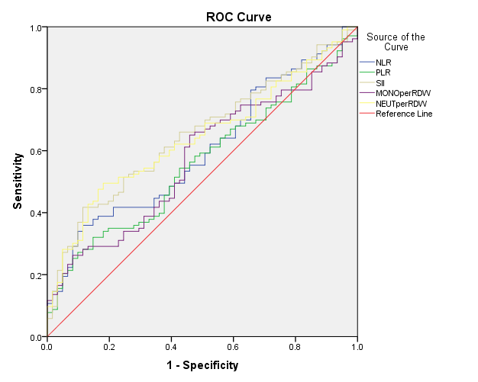
 | AUC | P-value
SII | 65.10 | 0.001
NLR | 60.0 | 0.033
PLR | 56.2 | 0.187
Monocyte/RDW | 57.4 | 0.115
Neutrophil/RDW | 64.1 | 0.003

