Supplementary Information

Effect of β nucleating agent and rotational shear on morphology and mechanical properties of polypropylene pipes
Aerman·Abudurezhake¹, Minghao Yang¹, Jiawei Gong ², Ganji Zhong¹, Zhongming Li¹, Qiang Fu¹, Xueqin Gao¹*
¹College of Polymer science and engineering, Sichuan University, Chengdu 610065, China
²Department of Mechanical Engineering, Pennsylvania State University, Erie, PA 16509, USA

Dynamic rheological testing
The samples used for dynamic rheological testing were prepared as circular discs with a diameter of 20 mm and a thickness of 1.5 mm. The blended granules were first compressed into 50 mm diameter circular discs using a press (model LP30-P, LabTech Engineering Co., Ltd). During the compression process, the hot briquetting phase took 5 minutes at 200℃, followed by the cooling phase for 3 minutes. 10 kN pressure was applied during both phases. Subsequently, the circular discs were trimmed into final specimens using a circular cutter. Dynamic rheological testing was conducted using a dynamic rheometer (Thermo Haake, Germany). The analysis was in dynamic frequency scanning mode, with a temperature set at 200℃ and across a frequency range of 0.01 to 100 Hz. The scanning started at the lowest frequency and progressed to the highest frequency. A strain of 2% was applied to ensure that the material responded within the linear viscoelastic region.

Rheological analysis
Dynamic rheological tests were conducted to investigate the effect of TMB-5 on the viscosity of the PP matrix and provided data support for flow simulation. Figure S1 shows the variation of complex viscosity with shear frequency. It can be observed that all samples exhibit a shear-thinning behavior. With increasing TMB-5 content, the viscosity of PP decreases. This may be due to the fact that TMB-5 acts as a plasticizer, weakening the van der Waals forces between polymer chains and increasing the intermolecular mobility. Therefore, the addition of TMB-5 may not only induce the formation of β crystals but also affect the rheological properties of PP, thus influencing other properties of the blend.

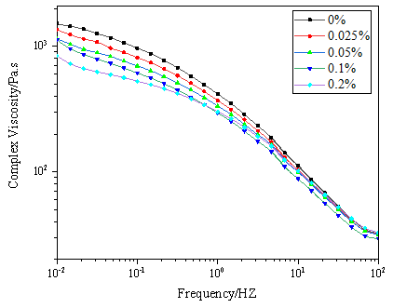
Figure S1. Complex viscosity of PP with different nucleating agent content

Flow simulation
Simulation model
The rotation of the core rod imposes shear on the melt at varying radial positions. To analyze the shear rate, we conducted rotational shear flow simulations using ANSYS Polyflow. Both physical and finite element models are depicted in Figure S2. The cylindrical pipe has a wall thickness of 3 mm and a length of 100 mm. The inner and outer diameters are 57 mm and 63 mm, respectively. Since this analysis is mainly focused on the effect of circumferential shear on the pipe, the chosen length has no effect on the simulation results. The finite element model only displays the mesh of the cross-section, which consists of structured grids with high mesh quality for more reliable simulation results. The model comprises a total of 38050 mesh elements and 45870 nodes.
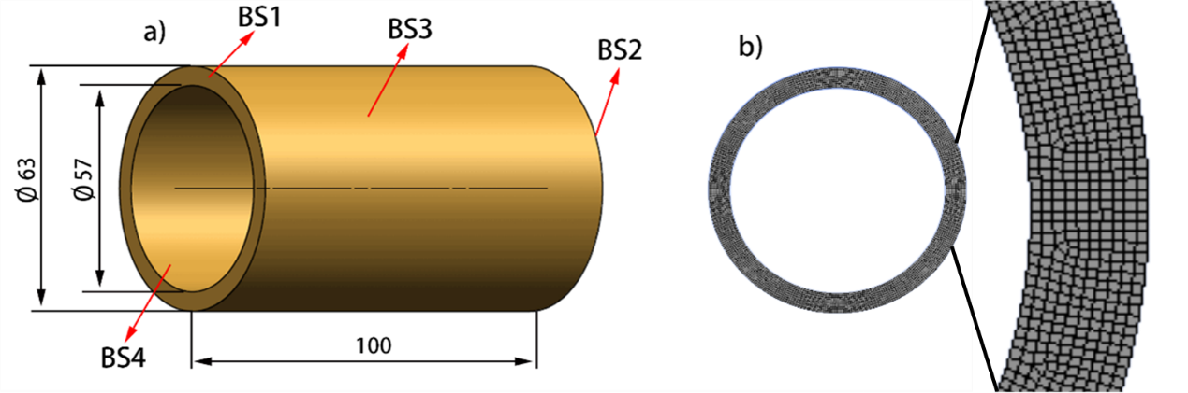
Figure S2. Rotational shear simulation model: a) Physical model; b) Finite element model

During the mesh division, boundary conditions BS1-4, are depicted in Figure S2, corresponding to the geometrical constraints of the model:
BS1-2: Both normal and tangential forces are zero, i.e., $f_{n}=0, f_{s}=0;$
BS3: Assume a no-slip condition, both normal and tangential velocities are zero, i.e., $v_{n}=0, v_{s}=0;$
BS4: Assume a Cartesian coordinate system with angular velocity, $ω=0.628 rad/s$.

The constitutive behavior of the melt is modeled using a power-law rheological equation. In the solving process, the velocity field is solved using quadratic interpolation, pressure is solved using linear non-continuous iteration, and the nonlinearities are addressed using an asymptotic approximation to ensure convergence.

Melt shear rate calculation and flow simulation results
The flow characteristics of the melt were captured by the "drag flow in an annular gap" model, where the polymer melt flows circumferentially between concentric cylinders with inner and outer diameters of $R_{1}$and $R_{2}$, respectively, and the core rod rotates at an angular velocity $ω$, generating laminar rotational flow $v_{θ}(r)$.To simplify the model, we make the following assumptions:

1) The flow is isothermal and does not generate heat due to shear.
2) Gravity is neglected.
3) There is no wall slip.
4) The melt flow is steady with a constant flow rate under laminar rotational flow conditions.

As a result, the boundary conditions are as follows:
$$\begin{aligned}At r=R_{1}{, v}_{θ}\left(R_{1}\right)={ωR}_{1}\#\left(1\right)\end{aligned}$$
$$\begin{aligned}At r=R_{2}, v_{θ}\left(R_{2}\right)=0\#\left(2\right)\end{aligned}$$
Velocity along the axial direction (z):
$\begin{aligned}v_{z}=0, v_{r}=0\#\left(3\right)\end{aligned}$
Thus, the momentum equations in cylindrical coordinates can be reduced to radial (r) and circumferential components (θ):
$$\begin{aligned}-ρ\frac{v_{θ}^{2}}{r}=-\frac{∂p}{∂r}\#\left(4\right)\end{aligned}$$
$$\begin{aligned} \frac{1}{r^{2}}\frac{∂}{∂r}\left(r^{2}τ_{rθ}\right)=0\#\left(5\right)\end{aligned}$$
Integrating equations (3) and (4), we obtain pressure distribution and shear stress:
$$\begin{aligned}p=\int{ρ\frac{ν_{θ}^{2}}{r}dr}\#\left(6\right)\end{aligned}$$
$$\begin{aligned}τ_{rθ}=\frac{C_{1}}{r^{2}}\#\left(7\right)\end{aligned}$$
We choose the commonly used power-law constitutive equation for polymer melts, which can be simplified to:
$$\begin{aligned}τ_{rθ}=K{\dot{γ}}_{rθ}^{n}=K{\left[r\frac{∂}{∂r}\left(\frac{ν_{θ}}{r}\right)\right]}^{n}\#\left(8\right)\end{aligned}$$
Substituting Equation (6) into Equation (7) and simplifying, we obtain velocity profile:
$$\begin{aligned}\frac{ν_{θ}}{r}=-\frac{n}{2}C_{2}r^{-\frac{2}{n}}+C_{3}\#\left(9\right)\end{aligned}$$
The parameters $C_{2}$ and $C_{3}$ can be obtained from the boundary conditions:
$$\begin{aligned}ν_{θ}\left(r\right)=ωr\frac{R_{2}^{- \frac{2}{n}}-r^{- \frac{2}{n}}}{R_{2}^{- \frac{2}{n}}-R_{1}^{- \frac{2}{n}}}\#\left(10\right)\end{aligned}$$
Equation (10) represents the distribution of melt flow rates.
The melt shear rate is defined as:
$$\begin{aligned}\dot{γ}\left(r\right)=-r\frac{d}{dr}\left(\frac{υ_{θ}}{r}\right)=\frac{2}{n}ω\frac{r^{- \frac{2}{n}}}{R_{1}^{- \frac{2}{n}}-R_{2}^{- \frac{2}{n}}}\#\left(11\right)\end{aligned}$$
From Equation (11), it is evident that the shear experienced by the melt is a function of angular velocity ($ω$), radial distance to the axis of rotation (r), pipe dimensions ($R_{1}$, $R_{2}$), and the polymer flow index ($n$). In this study, given pipe dimensions R₁ = 57mm, R₂ = 63mm, angular velocity $ω=6*\frac{2π}{60}=0.628 rad/s$, and the polymer flow index remains unchanged, the shear rate varies only with distance r. As the distance increases, the shear rate decreases. At the inner surface of the pipe ($R_{1}$), the shear rate reaches a maximum while at the outer layer of the pipe ($R_{2}$), the shear rate is minimum, with the flow rate being zero.

Conducting Polyflow simulations on the rotational shear of molten material can provide a deeper understanding of the distribution of shear rates. As indicated by previous calculations, the shear rate is related to the flow index n, thus prompting the selection of a power-law fluid model suitable for shear-thinning behavior: $η=K{\dot{γ}}^{n-1}$, where K is the consistency coefficient, $\dot{γ}$ is shear viscosity, n is a power law exponent. Curves obtained from a rotational rheometer were imported into the software and fitted with a power-law equation within the frequency range of 0.1-10 Hz. The resulting distributions of shear rate and flow rate are illustrated in Figure S3. It can be seen, across all samples, both shear rate and flow rate are higher in the inner layers compared to the outer layers, and they both exhibit a monotonic decrease as the distance from the core rod increases. In the inner layers near the core rod, the addition of TMB-5 leads to a decreasing trend in shear rate, with a more pronounced decrease as the content of TMB-5 increases. When reaching the highest content of TMB-5, the shear rate decreases from 4.843 s⁻¹ to 4.617 s⁻¹. This indicates that different β-PP components experience different shear force fields under the same conditions, which is also a contributing factor to the performance variations.

The relationship between shear rate and radius r was plotted as a curve, as shown in Figure S4. It is evident that the shear rate experienced by samples of each component decreases monotonically with increasing distance. The samples with lower TMB-5 content exhibit a more rapid decline in shear rate. Shear rates are higher in the inner layers and lower in the outer layers.

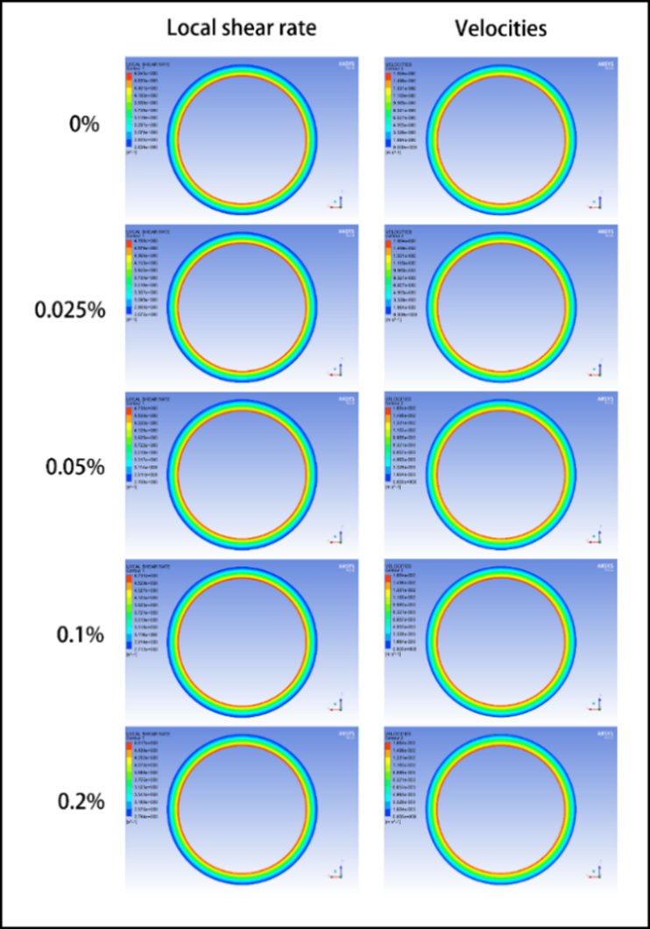
Figure S3. Simulation of shear rate distribution and velocity distribution of PP pipes with different nucleating agent contents

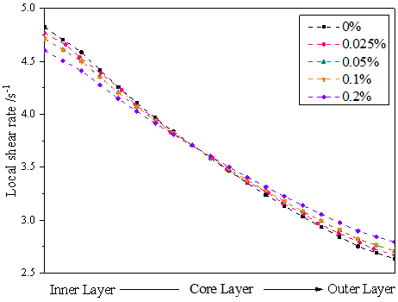
Figure S4. The distribution of shear rate within the pipe material

The simulations are based on rheological data obtained from experiments at 190°C. It is worth noting that due to the cooling, the polymer melt temperature decreases gradually during rotation, the inner layers near the core rod and the outer layers near the barrel may solidify prematurely during rotation, leading to a gradual change in the thickness of the shear layer. As a result, the melt near the core layer may not achieve the highest shear strength as indicated by the simulation. Despite these deviations , the simulated trends in shear rate variation are still valid for understanding the motion state of materials during rotation. Based on these results, given the significant differences in shear rates at various positions after rotation, we conducted characterization tests on the inner, middle, and outer layers of the rotating samples in subsequent analyses, while tests on samples without rotation were conducted only on the middle layer for characterization.

