Industrial lignins: the potential for efficient removal of Cr(VI) from wastewater
Hao Zhang, Haifeng Zhou*

Key Laboratory of Low Carbon Energy and Chemical Engineering, College of Chemical and Biological Engineering, Shandong University of Science and Technology, Qingdao, 277590, China

*Corresponding author: Haifeng Zhou
Phone: +86-532-86057766
E-mail: zhouhaifeng-qd@163.com

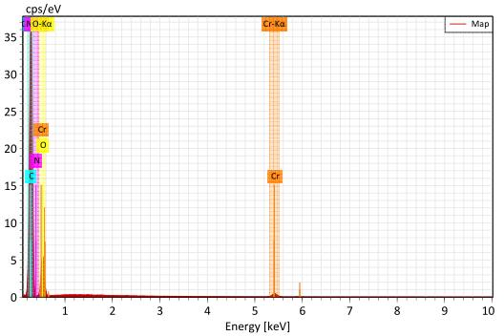
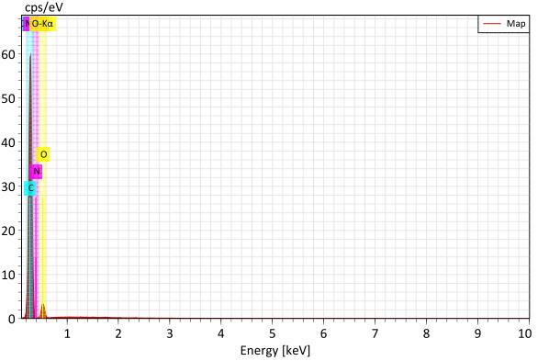
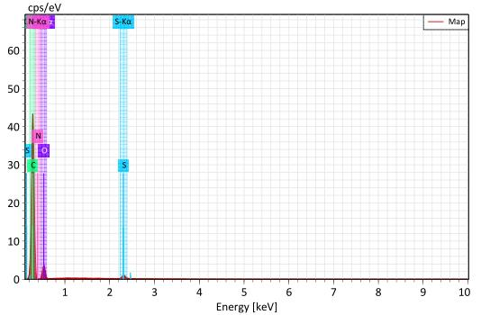
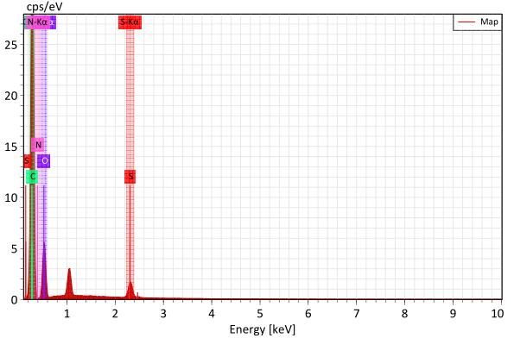
b
a
c
e

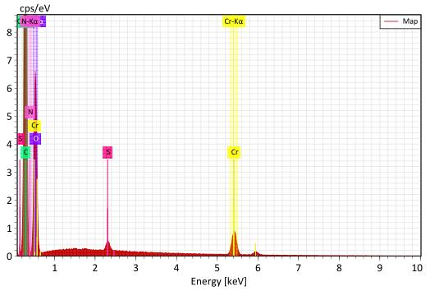
d

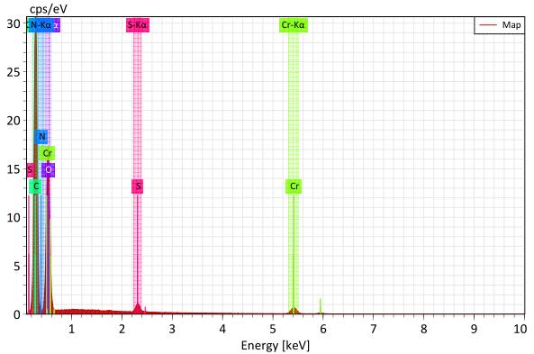
f

Fig.S1. The survey EDS spectra of ELN, BLN and FS before (a, c, e) and after (b, d, f) Cr(VI) adsorption.

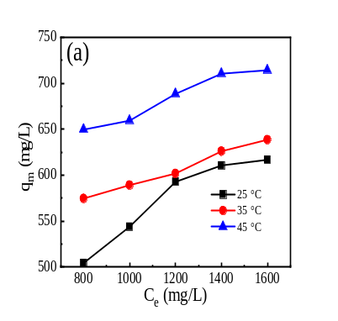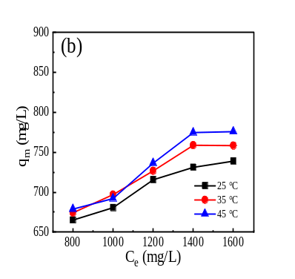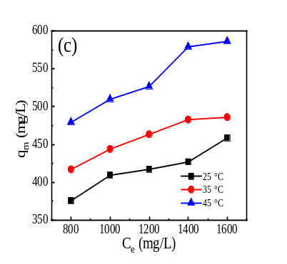
Fig.S2. Effect of temperature on the adsorption of Cr(VI) by ELN (a), BLN (b), FS (c).

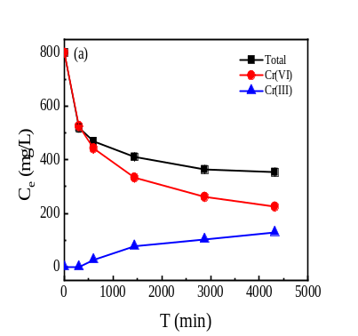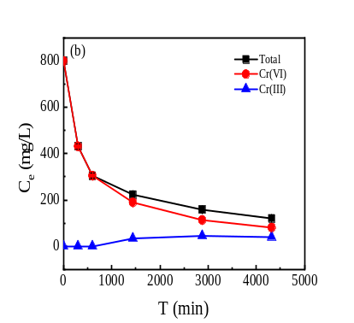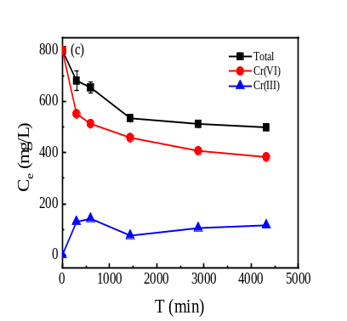
Fig.S3. Changes of Cr species in solution during ELN (a), BLN (b) and FS (c) adsorption process.
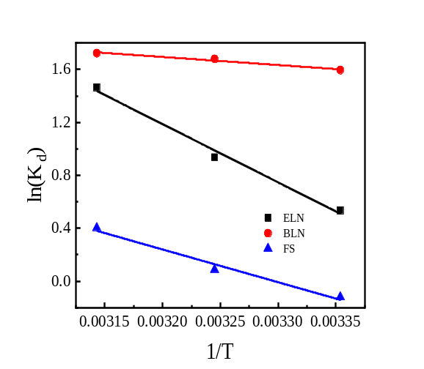
Fig. S4 .The plots of ln(K_{d}) versus 1/T.

Table S1 Fitting parameters of Langmuir isotherm model.
Temperature  /°C | Parameter | Materials
Temperature  /°C | Parameter | ELN | BLN | FS
 | q_{e} (exp) (mg g⁻¹) | 626.03 | 735.40 | 466.84
25 | K_{L} (L mg⁻¹) | 0.0036 | 0.9283 | 0.0085
25 | q_{m} (mg g⁻¹) | 638.11 | 819.29 | 477.52
25 | R² | 0.9970 | 0.9940 | 0.9146
 | q_{e} (exp) (mg g⁻¹) | 639.80 | 761.14 | 509.55
35 | K_{L} (L mg⁻¹) | 0.0245 | 1.2956 | 0.0299
35 | q_{m} (mg g⁻¹) | 689.90 | 825.53 | 619.99
35 | R² | 0.9846 | 0.9919 | 0.9654
 | q_{e} (exp) (mg g⁻¹) | 723.93 | 791.23 | 588.59
45 | K_{L} (L mg⁻¹) | 0.0266 | 1.4252 | 0.0367
45 | q_{m} (mg g⁻¹) | 765.60 | 880.57 | 721.58
45 | R² | 0.9969 | 0.9888 | 0.9459

Table S2 Fitting parameters of Freundlich isotherm model.
Temperature  /°C | Parameter | Materials
Temperature  /°C | Parameter | ELN | BLN | FS
25 | K_{F} (L g⁻¹) | 108.617 | 523.500 | 58.814
25 | 1/n | 0.2555 | 0.0504 | 0.2920
25 | R² | 0.8347 | 0.9819 | 0.8702
35 | K_{F} (L g⁻¹) | 258.696 | 576.270 | 131.168
35 | 1/n | 0.1319 | 0.0417 | 0.1902
35 | R² | 0.9491 | 0.9762 | 0.9627
45 | K_{F} (L g⁻¹) | 309.139 | 591.963 | 169.335
45 | 1/n | 0.1256 | 0.0425 | 0.1805
45 | R² | 0.9384 | 0.9806 | 0.9414

Table S3 Fitting parameters of Pseudo-first-order dynamics model
Materials | Parameter | Concentration (mg L⁻¹)
Materials | Parameter | 600 | 800 | 1000 | 1200 | 1400
FS | q_{e} (exp) (mg g⁻¹) | 379.72 | 417.04 | 443.93 | 463.37 | 482.82
FS | k₁×10⁻⁴ (min⁻¹) | 3.6090 | 4.5718 | 7.5761 | 5.8594 | 9.4919
FS | q_{e} (mg g⁻¹) | 313.24 | 304.78 | 300.96 | 262.09 | 240.26
FS | R² | 0.8676 | 0.9324 | 0.9542 | 0.9160 | 0.9483
BLN | q_{e} (exp) (mg g⁻¹) | 596.68 | 719.58 | 723.82 | 726.76 | 758.83
BLN | k₁×10⁻⁴ (min⁻¹ ) | 4.9844 | 7.9332 | 8.3541 | 8.2580 | 11.2000
BLN | q_{e} (mg g⁻¹) | 559.42 | 576.61 | 600.38 | 568.70 | 570.48
BLN | R² | 0.8260 | 0.9337 | 0.9550 | 0.9314 | 0.9642
ELN | q_{e} (exp) (mg g⁻¹) | 509.78 | 574.62 | 589.21 | 601.86 | 626.16
ELN | k₁×10⁻⁴ (min⁻¹ ) | 4.4841 | 6.2426 | 6.9176 | 7.4231 | 9.3641
ELN | q_{e} (mg g⁻¹) | 481.65 | 466.68 | 479.39 | 444.20 | 426.19
ELN | R² | 0.9199 | 0.9547 | 0.9686 | 0.9507 | 0.9400

Table S4 Fitting parameters of Pseudo- second-order dynamics model
Materials | Parameter | Concentration (mg L⁻¹)
Materials | Parameter | 600 | 800 | 1000 | 1200 | 1400
FS | q_{e} (exp) (mg g⁻¹) | 379.72 | 417.04 | 443.93 | 463.37 | 482.82
FS | k₂×10⁻⁵ (g/min⁻¹ mg⁻¹) | 1.4623 | 1.2247 | 1.2319 | 1.3140 | 1.5908
FS | q_{e} (mg g⁻¹) | 387.60 | 425.53 | 462.96 | 471.70 | 490.20
FS | R² | 0.9974 | 0.9961 | 0.9980 | 0.9972 | 0.9989
BLN | q_{e} (exp) (mg g⁻¹) | 596.68 | 719.58 | 723.82 | 726.76 | 758.83
BLN | k₂×10⁻⁶ (g/min⁻¹ mg⁻¹) | 4.9360 | 3.0566 | 3.2862 | 3.4471 | 3.6124
BLN | q_{e} (mg g⁻¹) | 649.35 | 787.40 | 806.45 | 787.40 | 819.67
BLN | R² | 0.9982 | 0.9978 | 0.9964 | 0.9996 | 0.9997
ELN | q_{e} (exp) (mg g⁻¹) | 509.78 | 574.62 | 589.21 | 601.86 | 626.16
ELN | k₂×10⁻⁶ (g/min⁻¹ mg⁻¹) | 5.5608 | 5.1397 | 4.6078 | 5.7277 | 6.0924
ELN | q_{e} (mg g⁻¹) | 540.54 | 606.06 | 625.00 | 628.93 | 653.59
ELN | R² | 0.9972 | 0.9966 | 0.9955 | 0.9977 | 0.9989

