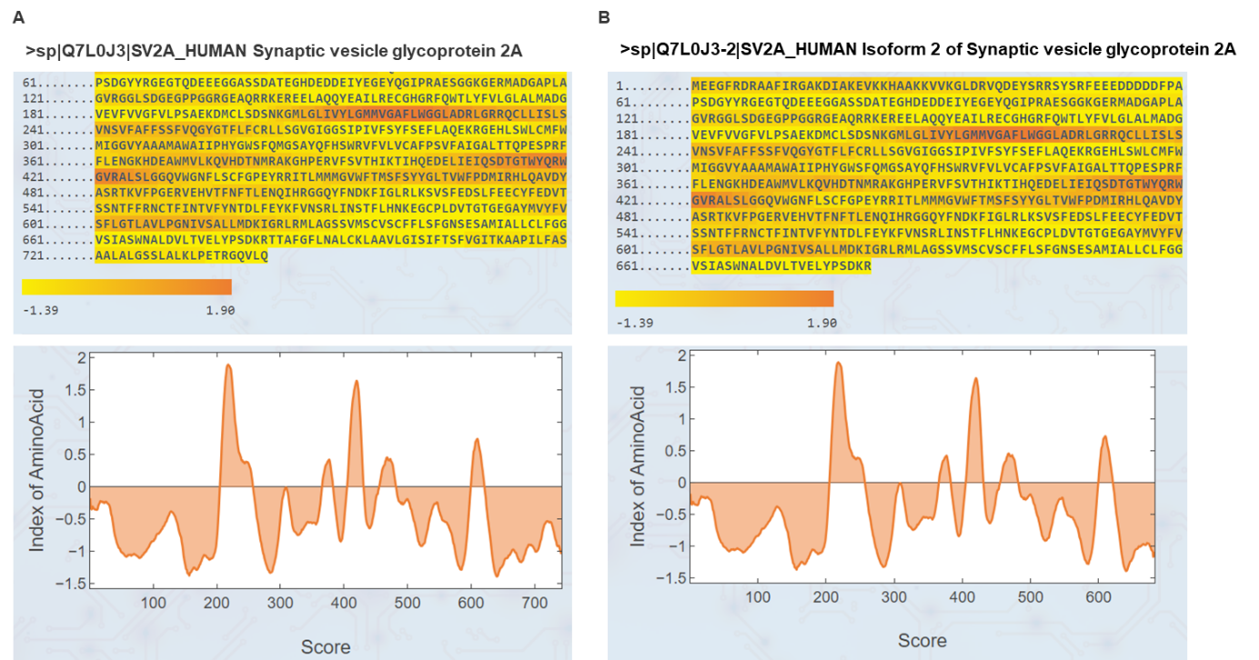
Supplementary Figure S1. The iMLP prediction shows the presence of an internal targeting signal in SVA and its isoform. A) iMTS-L propensity heatmap and its predicted iMTS-L propensity profile for SV2A and B) SV2A isoform.

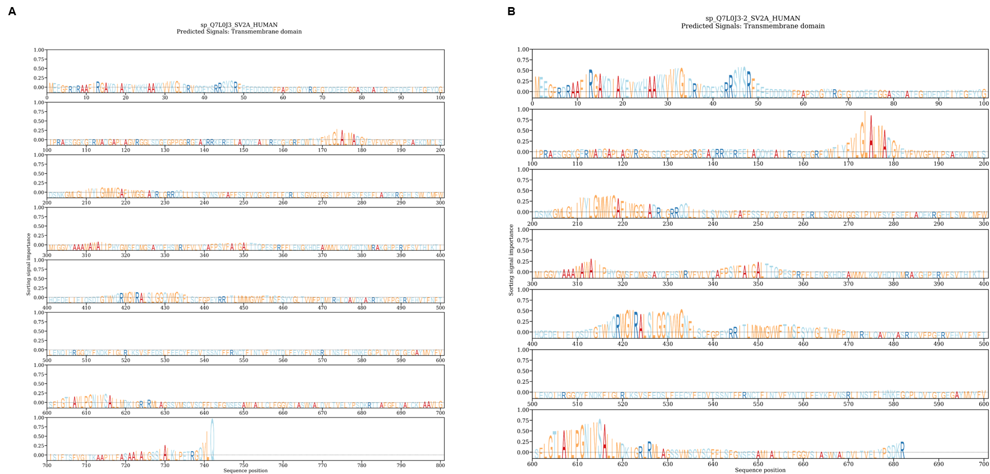
Supplementary Figure S2. Analysis of protein sequences of SV2A using DeepLoc2.0. A) The DeepLoc2.0 prediction of subcellular localization-associated sorting signals in SVA and its isoform (B).

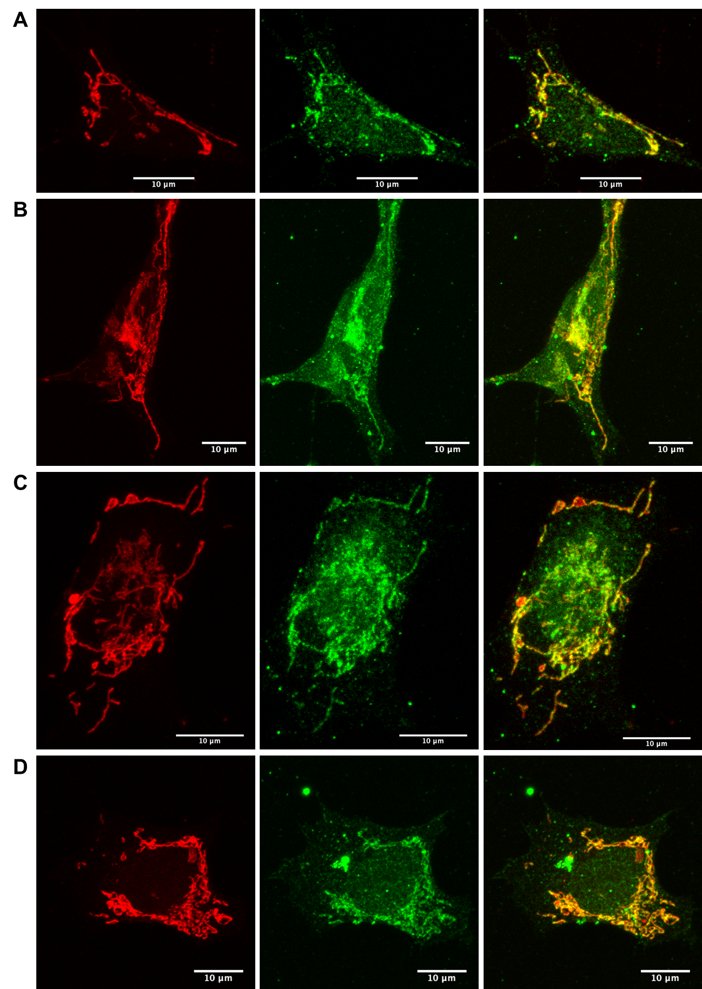
Figure S3. SV2A is localized at the outer mitochondrial membrane. Representative confocal fluorescence images of double-immunolabeled human SH-SY5Y cells stained for SV2A (green) and mitochondria (red) using MitoTracker™ Deep Red FM. Colocalization of SV2A and mitochondria is indicated by yellow spots in the merged image.

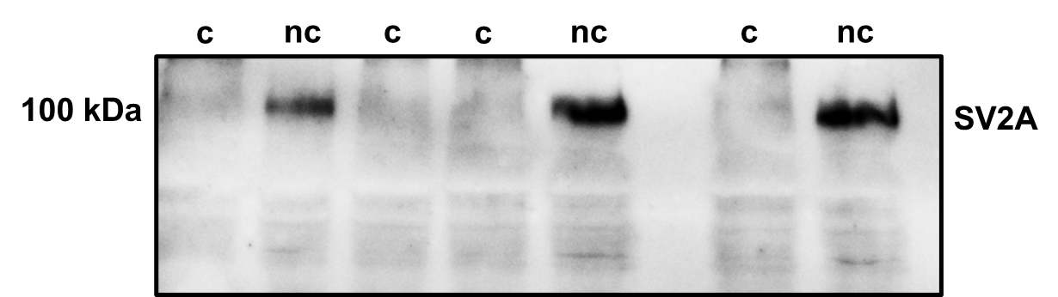
Figure S4. Determination of Blotting conditions for SV2A. Uncooked (uc) and cooked (c) samples were compared using western blotting and transferred to PVDF membrane followed by SV2A antibody staining. Non-cooked band of SV2A are significant more present compared to cooked samples.

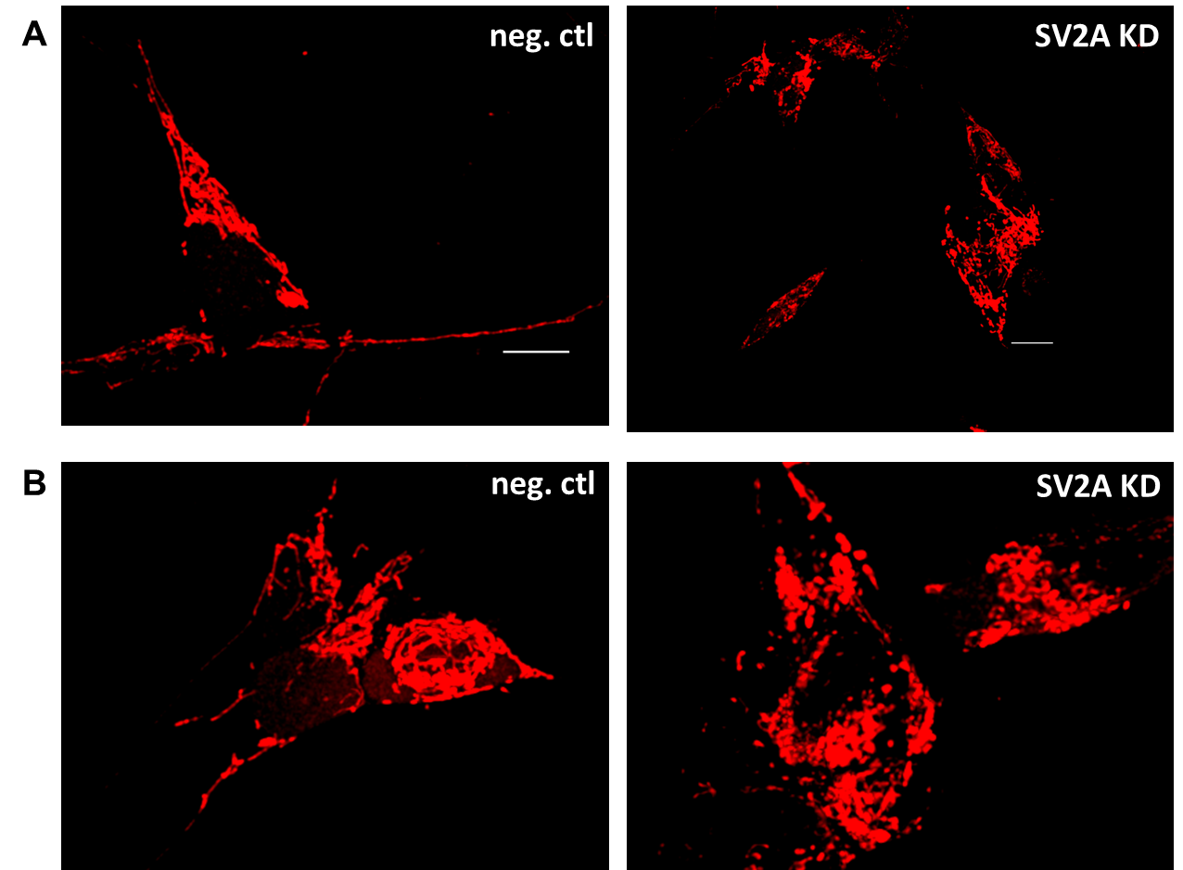
Figure S5. Effect of SV2A KD on mitochondrial morphology. A)-B) Representative confocal images of mitochondria in siRNA-induced SV2A KD cells and cells treated with scrambled siRNA (10 nM/48 h). Length distribution of mitochondria in SV2A KD cells compared to cells treated with scrambled siRNA.

Table S1: Analysis of interaction partners of SV2A using ReCLIP in HEK293 cells.
