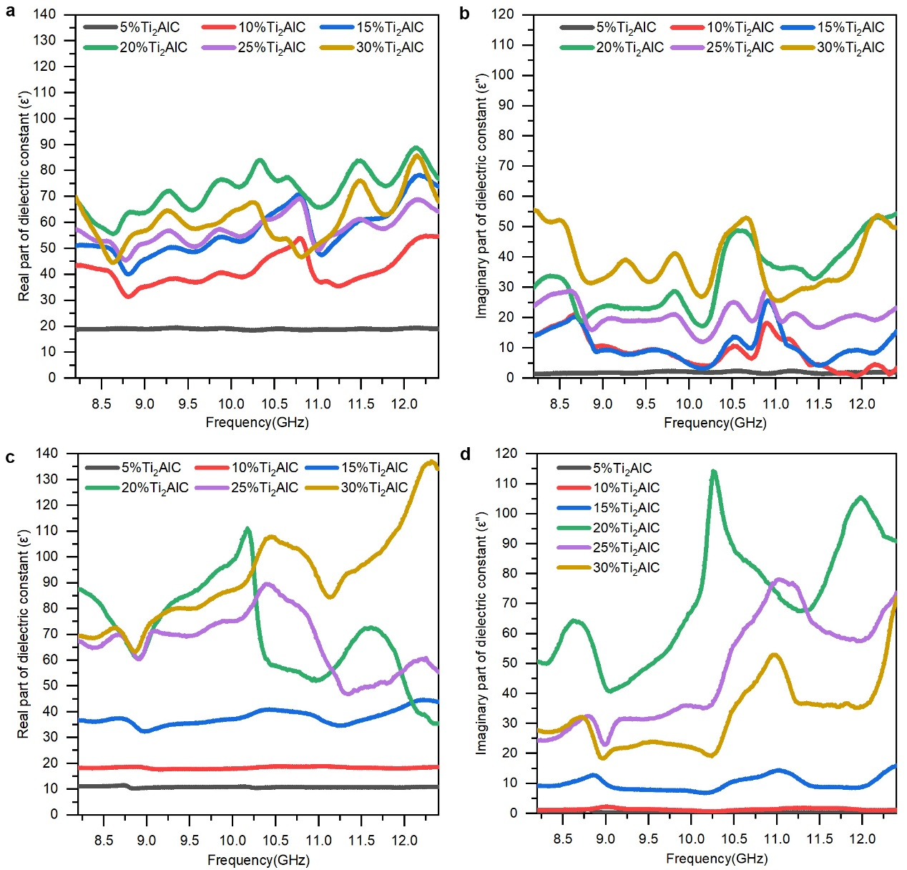

Fig.S1: The measured complex dielectric constants (ε' and εʺ) of Ti₂AlC/Al₂O₃ coatings with different Ti₂AlC contents before (a and b) and after oxidation (c and d).

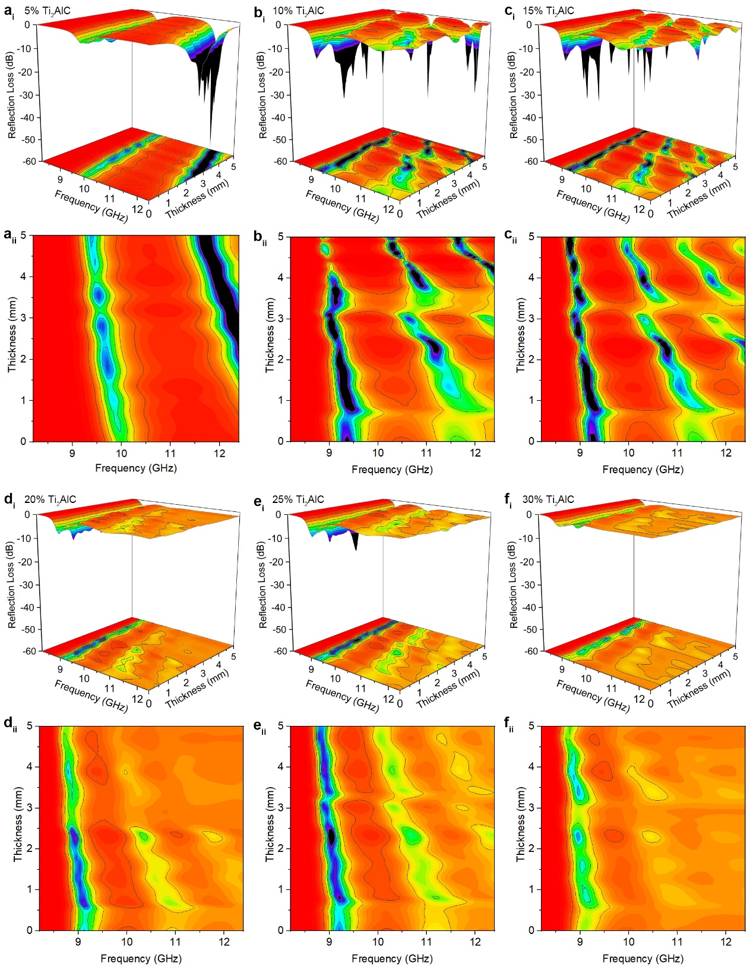

Fig.S2: The calculated RL values from the measured complex dielectric constants in Ti₂AlC/Al₂O₃ coatings different Ti₂AlC contents before oxidation. 5 wt.% Ti₂AlC/Al₂O₃ (a_{i} and a_{ii}), 10 wt.% Ti₂AlC/Al₂O₃ (b_{i} and b_{ii}), 15 wt.% Ti₂AlC/Al₂O₃ (c_{i} and c_{ii}), 20 wt.% Ti₂AlC/Al₂O₃ (d_{i} and d_{ii}), 25 wt.% Ti₂AlC/Al₂O₃ (e_{i} and e_{ii}), 30 wt.% Ti₂AlC/Al₂O₃ (f_{i} and f_{ii}).

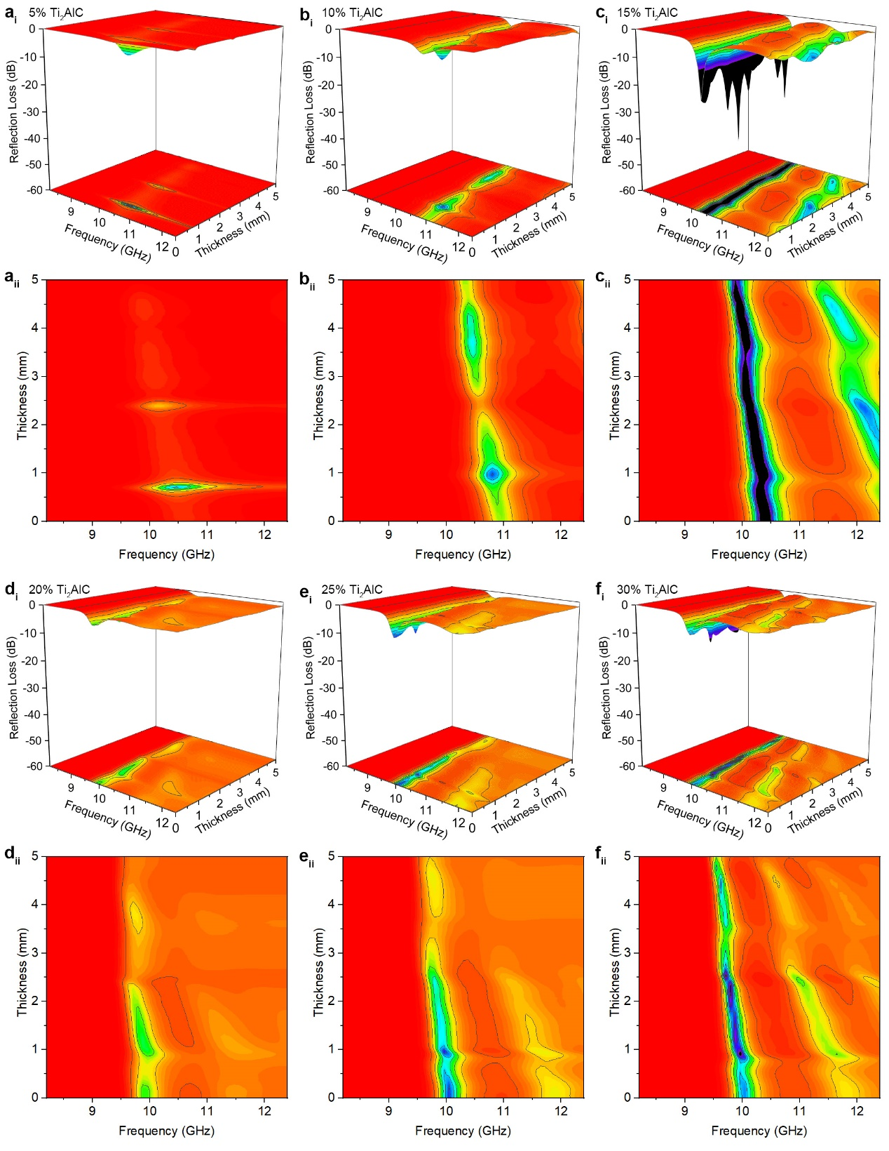

Fig.S3: The calculated RL values from the measured complex dielectric constants in Ti₂AlC/Al₂O₃ coatings different Ti₂AlC contents after oxidation. 5 wt.% Ti₂AlC/Al₂O₃ (a_{i} and a_{ii}), 10 wt.% Ti₂AlC/Al₂O₃ (b_{i} and b_{ii}), 15wt.% Ti₂AlC/Al₂O₃ (c_{i} and c_{ii}), 20wt.% Ti₂AlC/Al₂O₃ (d_{i} and d_{ii}), 25wt.% Ti₂AlC/Al₂O₃ (e_{i} and e_{ii}), 30wt.% Ti₂AlC/Al₂O₃ (f_{i} and f_{ii}).

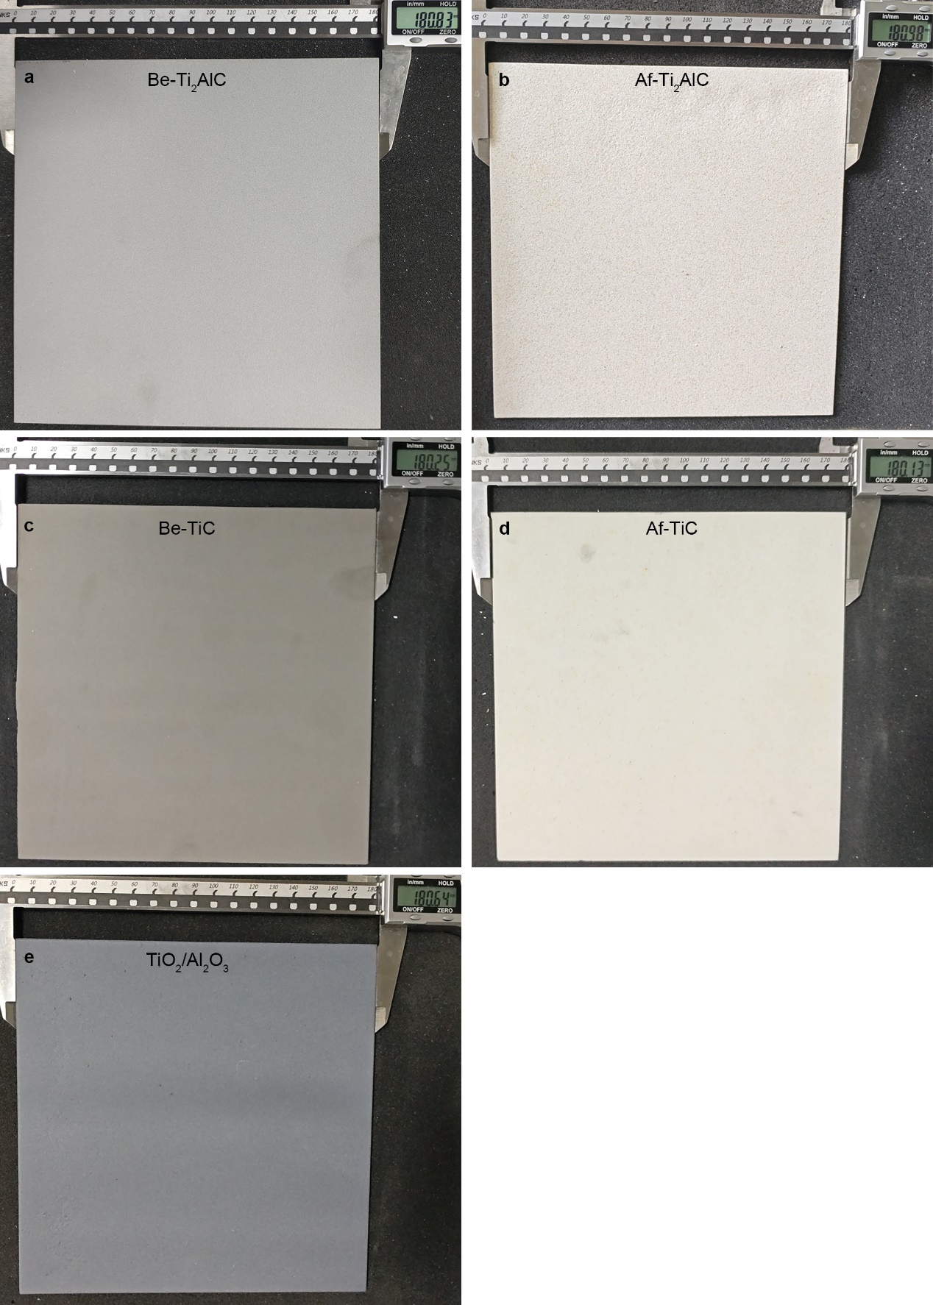

Fig.S4: The fabricated 180mm × 180mm × 1.1 mm coatings used in the measurement of radar wave reflectivity by bow method. Ti₂AlC/Al₂O₃ coating before oxidation (a, named as Be-Ti₂AlC), Ti₂AlC/Al₂O₃ coating after oxidation (b, named as Af-Ti₂AlC), TiC/Al₂O₃ coating before oxidation (c, named as Be-TiC), TiC/Al₂O₃ coating after oxidation (d, named as Af-TiC), TiO₂/Al₂O₃ coating (e).

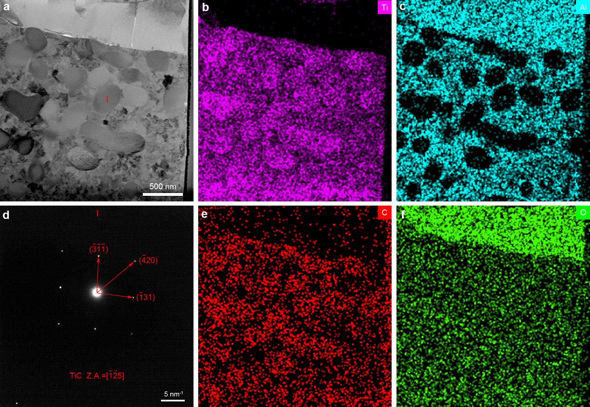

Fig.S5: The microstructures and element distribution spectrum of different elements in Be-Ti₂AlC coating. Selected area in backscattered mode (a), spectrum of Ti (b), spectrum of Al (c), SAED of area Ⅰ in a (d), spectrum of C (e), spectrum of O (f).

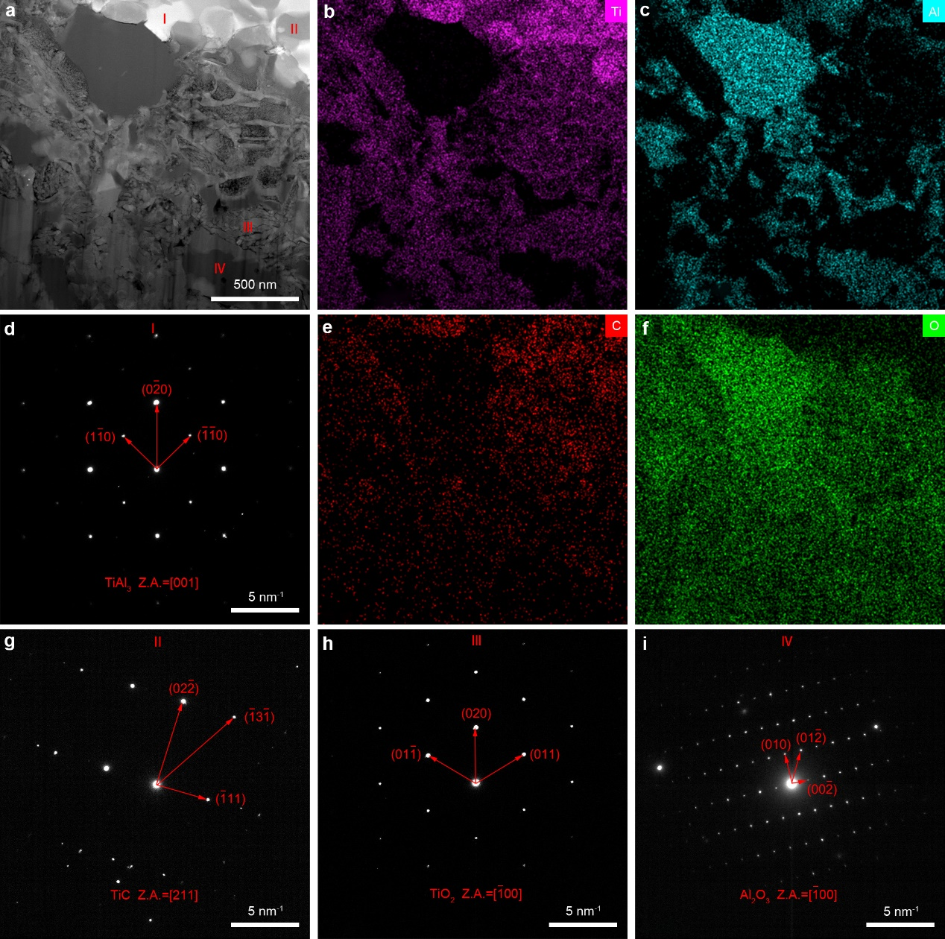

Fig.S6: The microstructures and element distribution spectrum of different elements in Af-Ti₂AlC coating. Selected area in backscattered mode (a), spectrum of Ti (b), spectrum of Al (c), SAED of area Ⅰ in a (d), spectrum of C (e), spectrum of O (f), SAED of area Ⅱ in a (g), SAED of area Ⅲ in a (h), SAED of area Ⅳ in a (i).

