Supporting Information for

Fibrosis Impairs cGAS-Mediated Response to Immunotherapy in Advanced HCC
Jianpeng Sheng^{1, 2, 3 #}, Lin Wang^{1,4,5#}, Jinyuan Song^{1, 4, 5 #}, Junlei Zhang^{1, 4, 5 #}, Zhiwei Zhou^{6#}, Yaxing Zhao¹, Chengxiang Guo^{4,5}, Jianghui Tang^{1,4,5}, Yongtao Ji^{1, 4, 5}, Taohong Li¹, Tianxing Yan⁷, Wei Shao^{8*}, Xueli Bai^{1, 4, 5*}, Kenneth D. Westover^{6*}, Qing Li^{2,9*}, Tingbo Liang^{1, 4, 5 *}

¹Zhejiang Provincial Key Laboratory of Pancreatic Disease, the First Affiliated Hospital, Zhejiang University School of Medicine, Hangzhou, China, 310002
²Center for Intelligent Oncology Designated by State Ministry of Education, Chongqing University, Chongqing, China, 400030.
³Chongqing Key Laboratory of Intelligent Oncology for Breast Cancer, Chongqing University Cancer Hospital and School of Medicine, Chongqing University, Chongqing, China, 400030.
⁴Department of Hepatobiliary and Pancreatic Surgery, the First Affiliated Hospital, Zhejiang University School of Medicine, Hangzhou, China, 310002
⁵Zhejiang University Cancer Center, Zhejiang University, Hangzhou, China, 310002
⁶Department of Radiation Oncology and Biochemistry, University of Texas Southwestern Medical Center, Dallas, TX 75390, USA
⁷Peking University Health Science Center, Beijing, China, 100871
⁸College of Computer Science and Technology, Nanjing University of Aeronautics and Astronautics, Nanjing, China, 210000
⁹College of Bioengineering, Chongqing University, Chongqing, China, 400030.
# These authors contributed equally to this work.
* Corresponding authors:
Jianpeng Sheng, The First Affiliated Hospital, Zhejiang University School of Medicine, 79 Qingchun Road, Hangzhou, China, 310000. e-mail: shengjp@zju.edu.cn.
Qing Li, College of Bioengineering, Chongqing University, Chongqing, China, 400030. e-mail: likunze88824@163.com.
Kenneth D. Westover, Department of Radiation Oncology and Biochemistry, University of Texas Southwestern Medical Center, Dallas, TX 75390, USA. e-mail: Kenneth.westover@utsouthwestern.edu.
Xueli Bai, The First Affiliated Hospital, Zhejiang University School of Medicine, 79 Qingchun Road, Hangzhou, China, 310000. e-mail: shirleybai@zju.edu.cn
Tingbo Liang, The First Affiliated Hospital, Zhejiang University School of Medicine, 79 Qingchun Road, Hangzhou, China, 310000. e-mail: liangtingbo@zju.edu.cn

Table of Contents
Figure S1. IMC analysis and pathological response in patient samples 4
Figure S2. Validation of antibody panel for highly multiplex IMC 5
Figure S3. Validation of IMC antibody panel continued. 6
Figure S4. Validation of IMC antibody panel continued. 7
Figure S5. Annotation of cell types from IMC data 8
Figure S6. Spatial concordance of immunosuppressive epithelial cells and T cells in responders vs. with fibrosis in non-responders 9
Figure S7. cGAS-STING DNA sensing pathway orchestrates immune responses 11
Figure S8. cGAS Activation and PD-L1 expression increase following DNA damage 13
Figure S9. cGAS mediated enhancement immune response in responders vs. fibrotic expansion in non-responders 15
Figure S10. PD-L1⁺ Immune suppressive epithelial cells activate T cells 17
Figure S11. Triple treatment reduces fibrosis and increases CD8⁺ T cell infiltration 18
Table S1. Summary of baseline clinical characteristics of patients 20
Table S2. Detailed clinical characteristics of patients enrolled in trial NCT04174781 21
Table S3. Imaging mass cytometry antibody panel 23
Ethics 25
mRESICST evaluation 25
Pathological evaluation 25
Animal study 25
Multiplex immunohistochemistry 26
IMC section preparation 26
IMC single cell segmentation 26
IMC preprocessing and cell type identification 26
Identification of cellular neighborhoods (CN) 27
Downstream Spatial analysis 27
Single-cell cell dissociation 27
Single-cell RNA-Seq data processing 28
In vitro experiments 28
Immunofluorescent imaging 28
Western Blot 28
Spatial transcriptome preparation 29
ST data analysis and region identification 29
Differential expression and cell-cell communication analysis for ST 29
Bulk RNAseq Analysis 29
Graph Classification Based on the Spatial Similarity of Cells 29

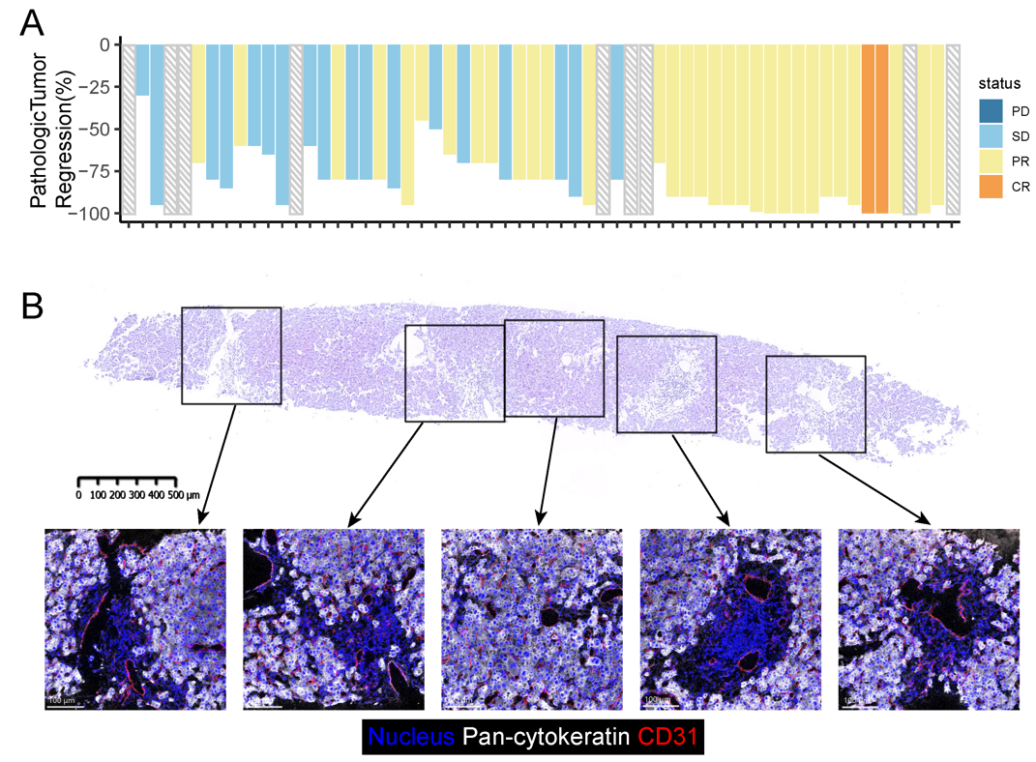
Figure S1. IMC analysis and pathological response in patient samples
A. Pathological response of patients enrolled.
B. Detailed IMC scanning process for a single tissue specimen. This figure illustrates the Imaging Mass Cytometry (IMC) scanning procedure applied to a single tissue section. To ensure a thorough and unbiased analysis, multiple regions of interest (ROIs) were strategically selected to encompass as much of the tissue sample as possible. This approach enables comprehensive data capture while minimizing the risk of selective representation.

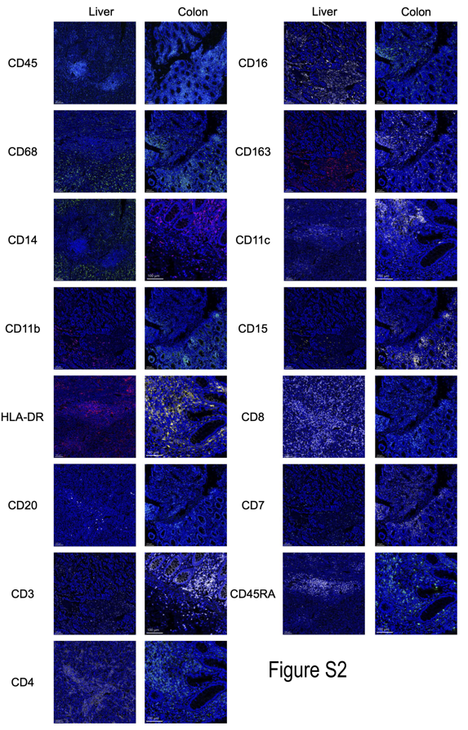
Figure S2. Validation of antibody panel for highly multiplex IMC
The panel comprises 39 antibodies targeting specific cellular markers. The validation process ensures the specifICBty and reliability of these antibodies in detecting their respective targets. The scale bars provided in the images represent a size of 50 μm, enabling the assessment of staining quality and marker detection accuracy.

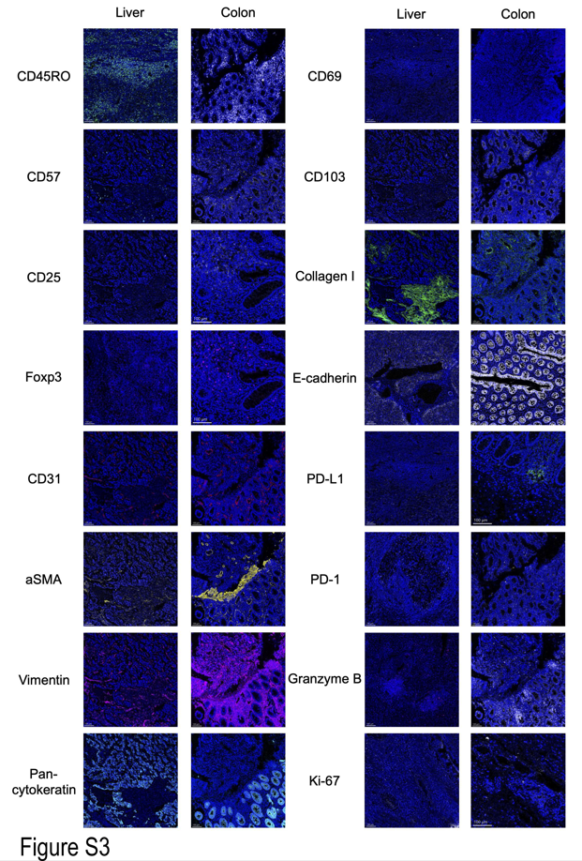
Figure S3. Validation of IMC antibody panel continued.

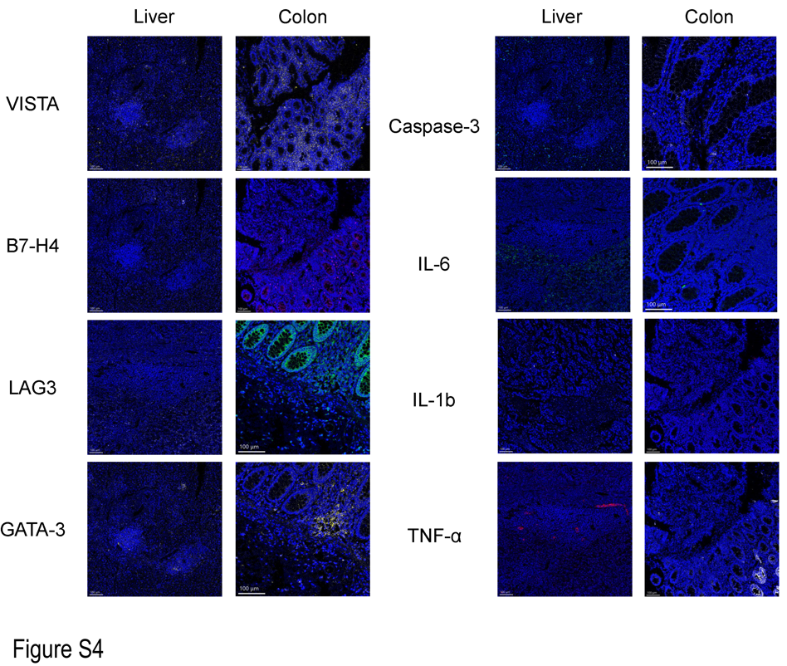
Figure S4. Validation of IMC antibody panel continued.

Figure S5. Annotation of cell types from IMC data
A. t-SNE plots are employed to visualize the expression patterns of lineage markers in the IMC data. These plots enable the identification of distinct cellular clusters based on the expression profiles of lineage markers.
B. Key lineage markers for major cellular clusters are identified and presented. These markers serve as important identifiers for different cell types within the tissue samples, aiding in the characterization and classification of the cellular populations.

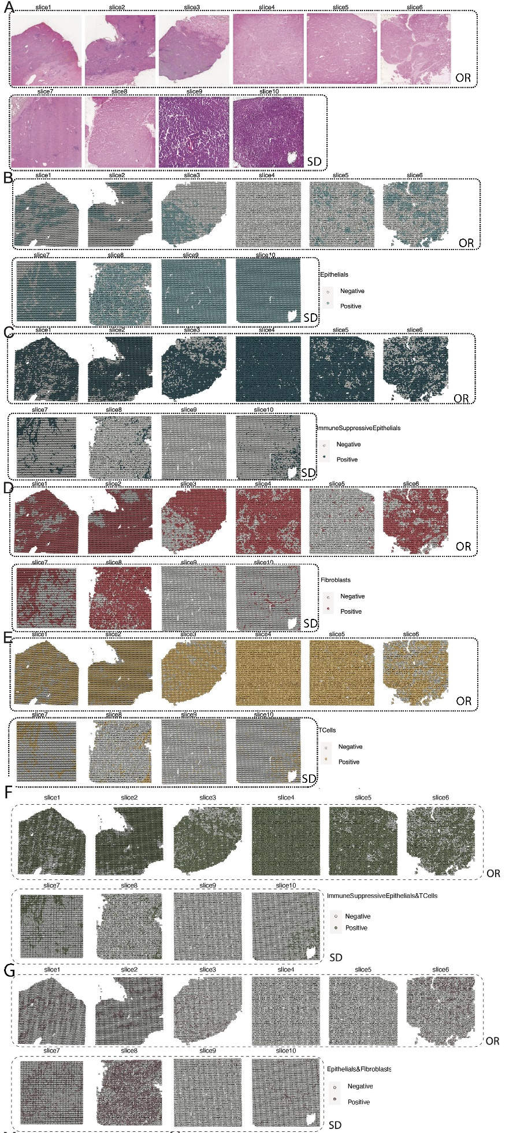

Figure S6. Spatial concordance of immunosuppressive epithelial cells and T cells in responders vs. with fibrosis in non-responders
A. Hematoxylin and eosin (HE) images of the 10 selected spatial transcriptomic samples are displayed. These images provide a visual representation of tissue morphology, guiding the subsequent identification of specific regions of interest.
B-E. Positive spots are highlighted for different enriched regions based on spatial transcriptomic data. These regions include epithelial enriched regions (Figure S5B), immune suppressive epithelial enriched regions (Figure S5C), fibroblast enriched regions (Figure S5D), and T cell enriched regions (Figure S5E). The positive spots indicate the presence of specific transcripts associated with these cell populations within the identified regions, providing insights into the spatial distribution of these cellular populations.
F-G. Identification of spots in the spatial transcriptomic samples that correspond to the ImmuneSuppressiveEpithelials&TCells (K) and Epithilals&Fibroblasts (L) regions.

Figure S7. cGAS-STING DNA sensing pathway orchestrates immune responses
A and B. Selected KEGG enrichment results for genes that are significantly up-regulated in the ImmuneSuppressiveEpithelials&TCells (M) and Epithilals&Fibroblasts (N) regions from the spatial transcriptomic data. These enrichment results provide insights into the biological processes and pathways that are activated in these specific regions, indicating their potential roles in tumor progression and immune evasion.
C. Differentially expressed genes between the OR (Objective Response) and SD (Stable Disease) groups from the bulk RNAseq data. By comparing the gene expression profiles between these two groups, we identify genes that are associated with treatment response and potentially serve as predictive biomarkers.
D. Visualization of the correlation strength between distinct pathways, as delineated in Figure S7A, was achieved by employing gene signatures specific to each pathway for Gene Set Variation Analysis (GSVA). The gene signatures served as input for calculating the GSVA scores. Analysis focused on immune suppressive epithelial and T cell spots across all pathways outlined in Figure S7A. Subsequently, these GSVA scores were utilized to compute the correlations among the pathways.
E. SCENIC analysis highlighting the key transcription factors that regulate PD-L1+ immunosuppressive epithelial cells.

Figure S8. cGAS Activation and PD-L1 expression increase following DNA damage
A. Immunofluorescence images of Cytoplasmic dsDNA, γ-H2AX, and PD-L1 in the treatment and control groups of three cell lines (Huh-7, PLC, and SK-HEP-1) that received or did not receive Epirubicin treatment. These images visualize the cellular localization of these markers and reveal potential connections between DNA damage response, immune checkpoint expression, and treatment response.
B. Comparison of the proportions of γ-H2AX⁺ cells, γ-H2AX⁺dsDNA⁺ cells, and PD-L1 expression intensity between the treatment and control groups. This analysis quantifies the extent of DNA damage, DNA damage response, and PD-L1 expression in different treatment groups.

Figure S9. cGAS mediated enhancement immune response in responders vs. fibrotic expansion in non-responders
A and B. NicheNet analysis comparing interactions between epithelial cells (senders) and fibroblasts (receivers), as well as between immunosuppressive epithelial cells (senders) and immune cells (receivers). Receptors are displayed on the Y-axis, with corresponding ligands and target genes presented on the X-axis.
A. Differentially expressed genes in the PPAR signaling pathway between positive spots of epithelial cells, fibroblasts, and others in ST data.
B. Representative mIHC images showing the expression of cGAS, PD-L1, dsDNA, Collagen I, and CD45RO in both tumor and fibroic areas of the OR and SD groups. These images provide a comprehensive view of the spatial distribution of these markers and their potential interactions within the tumor microenvironment.

Figure S10. PD-L1⁺ Immune suppressive epithelial cells activate T cells
A. mIHC Detection of PD-L1⁺ Epithelial Cells and T Cells. mIHC identifies PD-L1⁺ epithelial cells with concurrent staining for CD326, and T cells labeled with CD45RO and CD8.
B. mIHC Characterization of PD-L1⁺ Epithelial Cells with Extended T Cell Panel. PD-L1⁺ CD326⁺ epithelial cell markers are imaged along with a broader panel of T cell markers, including CD103, PD-1, and CD8, to delineate the phenotype of the T cell compartment.

Figure S11. Triple treatment reduces fibrosis and increases CD8⁺ T cell infiltration
Representative mIHC images showing the expression of CD8, Collagen I and Pan-CK in control and single, dual and triple treatment groups. These images provide a comprehensive view of the spatial distribution of these markers and their potential interactions within the tumor microenvironment. Comparative analysis of the distribution density of CD8⁺ cells and collagen I⁺ cells in the different treatment groups.

Table S1. Summary of baseline clinical characteristics of patients

Baseline clinical characteristics | N = 61; n (%)
Age (y), median (range) | 58 (26–75)
sex (male) | 52 (85)
BCLC stage
A | 27 (44)
B | 34 (56)
Child-Pugh A | 61 (100)
Etiology
Alcohol liver disease/other | 10 (16)
Hepatitis B infection | 51 (84)
Target tumor size (cm), median (range) | 7 (2–14)
Tumor number
1 | 27 (44)
2 | 25 (41)
3 | 7 (12)
5 | 2 (3)
Serum AFP≥400 ng/mL | 20 (33)

Table S2. Detailed clinical characteristics of patients enrolled in trial NCT04174781
Patient | Age  (year) | Gender | Pathology Grade | TNM Grade | BCLC grade | Imaging response | Surgery
1 | 71 | Male | Grade Ⅱ | Grade Ⅰ-T1N0M0 | A | SD | Yes
2 | 63 | Male | NA | Grade Ⅰ-T1N0M0 | B | PR | Yes
3 | 69 | Male | Grade Ⅲ | Grade Ⅱ-T2N0M0 | B | SD | Yes
4 | 65 | Female | Grade Ⅲ | Grade Ⅱ-T2N0M0 | B | PR | Yes
5 | 57 | Male | Grade Ⅱ | Grade Ⅰ-T1N0M0 | A | SD | Yes
6 | 62 | Female | Grade Ⅱ-Ⅲ | Grade Ⅰ-T1N0M0 | A | PR | Yes
7 | 52 | Male | NA | Grade Ⅰ-T1N0M0 | B | PR | Yes
8 | 69 | Male | Grade Ⅱ | Grade IIIB-T3bN0M0 | A | SD | Yes
9 | 61 | Male | NA | Grade IIIA-T3aN0M0 | B | PR | Yes
10 | 36 | Female | NA | Grade Ⅰ-T1N0M0 | A | CR | Yes
11 | 53 | Male | Grade Ⅱ-Ⅲ | Grade Ⅰ-T1N0M0 | B | SD | Yes
12 | 46 | Male | Grade Ⅱ | Grade Ⅰ-T1N0M0 | A | SD | Yes
13 | 59 | Male | Grade Ⅱ | Grade Ⅰ-T1N0M0 | B | PR | Yes
14 | 34 | Male | NA | Grade Ⅰ-T1N0M0 | B | PR | Yes
15 | 47 | Female | Grade Ⅲ | Grade IIIA-T3aN0M0 | B | PR | Yes
16 | 57 | Male | Grade Ⅲ-IV | Grade IIIA-T3aN0M0 | B | SD | Yes
17 | 39 | Male | Grade Ⅲ | Grade Ⅰ-T1N0M0 | B | PR | Yes
18 | 55 | Male | Grade Ⅱ | Grade Ⅰ-T1N0M0 | A | PR | Yes
19 | 44 | Male | Grade Ⅱ | Grade Ⅰ-T1N0M0 | A | PR | Yes
20 | 64 | Male | Grade IV | Grade Ⅰ-T1N0M0 | A | PR | Yes
21 | 71 | Female | Grade Ⅱ | Grade Ⅰ-T1N0M0 | A | PR | Yes
22 | 50 | Male | Grade Ⅱ-Ⅲ | Grade Ⅰ-T1N0M0 | B | SD | Yes
23 | 55 | Male | Grade Ⅱ | Grade Ⅰ-T1N0M0 | A | PR | Yes
24 | 56 | Male | Grade Ⅱ | Grade Ⅰ-T1N0M0 | A | PR | Yes
25 | 63 | Male | Grade Ⅱ | Grade Ⅰ-T1N0M0 | B | PR | Yes
26 | 43 | Male | Grade Ⅱ | Grade Ⅰ-T1N0M0 | A | SD | Yes
27 | 34 | Male | NA | Grade Ⅱ-T2N0M0 | B | PR | Yes
28 | 63 | Male | NA | Grade Ⅰ-T1N0M0 | B | PR | Yes
29 | 70 | Female | Grade Ⅱ | Grade Ⅰ-T1N0M0 | A | SD | Yes
30 | 65 | Male | Grade Ⅲ | Grade Ⅱ-T2N0M0 | B | SD | Yes
31 | 73 | Male | Grade Ⅱ | Grade Ⅰ-T1N0M0 | A | PR | Yes
32 | 73 | Male | Grade Ⅲ | Grade Ⅰ-T1N0M0 | B | SD | Yes
33 | 72 | Female | NA | NA | A | PR | No
34 | 50 | Male | Grade Ⅱ | Grade Ⅱ-T2N0M0 | B | PR | Yes
35 | 56 | Male | NA | NA | B | CR | No
36 | 76 | Male | NA | NA | B | PD | No
37 | 61 | Male | NA | NA | B | PR | No
38 | 35 | Male | NA | NA | B | PD | No
39 | 61 | Male | NA | NA | B | SD | No
40 | 43 | Male | NA | Grade Ⅰ-T1N0M0 | B | PR | Yes
41 | 75 | Male | NA | Grade Ⅰ-T1N0M0 | B | PR | Yes
42 | 54 | Male | Grade Ⅲ | Grade Ⅰ-T1N0M0 | A | SD | Yes
43 | 57 | Male | Grade Ⅱ | Grade Ⅰ-T1N0M0 | B | PR | Yes
44 | 63 | Male | Grade Ⅱ | Grade Ⅱ-T2N0M0 | B | SD | Yes
45 | 46 | Male | NA | NA | A | SD | Yes
46 | 61 | Male | NA | Grade Ⅱ-T2N0M0 | B | PR | Yes
47 | 72 | Male | NA | NA | B | SD | No
48 | 53 | Male | Grade Ⅱ-Ⅲ | Grade Ⅱ-T2N0M0 | B | PR | Yes
49 | 70 | Male | NA | NA | A | PR | No
50 | 26 | Male | Grade Ⅱ | Grade Ⅱ-T2N0M0 | A | SD | Yes
51 | 71 | Male | Grade Ⅱ | Grade Ⅱ-T2N0M1 | B | PR | Yes
52 | 58 | Female | Grade Ⅲ | Grade Ⅱ-T2N0M1 | A | PR | Yes
53 | 54 | Male | Grade Ⅱ | Grade Ⅱ-T2N0M1 | A | CR | Yes
54 | 65 | Male | Grade Ⅱ-Ⅲ | Grade Ⅱ-T2N0M1 | A | PR | Yes
55 | 53 | Male | NA | NA | B | PD | No
56 | 54 | Male | Grade Ⅲ | Grade Ⅱ-T2N0M1 | B | PR | Yes
57 | 63 | Male | NA | Grade Ⅱ-T2N0M1 | B | PR | Yes
58 | 63 | Female | Grade Ⅱ-Ⅲ | Grade Ⅱ-T2N0M1 | A | SD | Yes
59 | 52 | Male | Grade Ⅲ | Grade Ⅱ-T2N0M1 | B | SD | Yes
60 | 61 | Male | Grade Ⅲ | Grade Ⅱ-T2N0M1 | A | PR | Yes
61 | 62 | Male | NA | NA | A | SD | No
CR:complete response, PR: partial response, SD: stable disease, pCR: pathologic complete response; NA: No data or cannot be determined

Table S3. Imaging mass cytometry antibody panel
Antibodies | Metal | Clone | Source (antibnody) | Cat# (antibody) | Source (metal) | Cat# (metal)
CD45 | 89 Y | D9M8I | CST | 13917S | Macklin | Y820645
CD14 | 141 Pr | EPR3653 | Abcam | ab226121 | Fluidigm | 201141A
FoxP3 | 142 Pr | D6O8R | CST | 12653S | Fluidigm | 201142A
CD16 | 143 Nd | EPR16784 | Abcam | ab256582 | Fluidigm | 201143A
CD69 | 144 Nd | EPR21814 | Abcam | ab234512 | Fluidigm | 201144A
CD4 | 145Nd | EPR6855 | Abcam | ab181724 | Fluidigm | 201145A
CD8a | 146 Nd | C8/144B | Biolegend | 372902 | Fluidigm | 201146A
Collagen I | 147 Sm | EPR7785 | Abcam | ab215969 | Fluidigm | 201147A
Cleaved Caspase-3 | 148 Nd | 5A1E | CST | 9664S | Fluidigm | 201148A
CD31 | 149 Sm | 89C2 | CST | 3528S | Fluidigm | 201149A
E-cadherin | 150 Nd | DECMA-1 | Biolegend | 147302 | Fluidigm | 201150A
B7-H4 | 151 Eu | H74 | Thermofisher | 14-5949-82 | Fluidigm | 201151A
VISTA | 152 Sm | D1L2G | CST | 64953S | Fluidigm | 201152A
CD7 | 153 Eu | EPR4242 | Abcam | ab230834 | Fluidigm | 201153A
CD169 | 154 Sm | HSn 7D2 | Abcam | ab18619 | Fluidigm | 201154A
CD103 | 155 Gd | EPR4166(2) | Abcam | ab271889 | Fluidigm | 201155A
PD-L1 | 156 Gd | E1L3N | CST | 13684S | Fluidigm | 201156A
LAG3 | 158 Gd | D2G4O | CST | 15372S | Fluidigm | 201158A
CD68 | 159 Tb | C8/144B | Biolegend | 372902 | Fluidigm | 201159A
CD11b | 160 Gd | EPR1344 | Abcam | ab209970 | Fluidigm | 201160A
CD20 | 161 Dy | IGEL/773 | Abcam | ab213033 | Fluidigm | 201161A
CD11c | 162 Dy | EP1347Y | Abcam | ab216655 | Fluidigm | 201162A
CD15 | 163 Dy | HI98 | BD | 563872 | Fluidigm | 201163A
Granzyme B | 164 Dy | EPR20129-217 | Abcam | ab219803 | Fluidigm | 201164A
PD-1 | 165 Ho | D4W2J | CST | 86163S | Fluidigm | 201165A
Ki67 | 166 Er | B56 | BD | 550609 | Fluidigm | 201166A
GATA-3 | 167 Er | D13C9 | CST | 5852S | Fluidigm | 201167A
HLA-DR | 168 Er | EDHu-1 | Novus | NB110-40686 | Fluidigm | 201168A
CD45RA | 169 Tm | HI100 | Biolegend | 304143 | Fluidigm | 201169A
CD3ε | 170 Er | D7A6E | CST | 85061S | Fluidigm | 201170A
CD45RO | 173 Yb | UCHL1 | Biolegend | 304239 | Fluidigm | 201173A
CD57 | 174 Yb | NK-1 | BD | 555618 | Fluidigm | 201174A
IL-2 Receptor alpha (CD25) | 175 Lu | EPR6452 | Abcam | ab215378 | Fluidigm | 201175A
Pan-Cytokeratin | 176 Yb | AE-1/AE-3 | Biolegend | 914204 | Fluidigm | 201176A
Alpha Smooth Muscle Actin | 194 Pt | 1A4 | Biolegend | 904601 | Fluidigm | 201194
Vimentin | 198 Pt | D21H3 | CST | 5741S | Fluidigm | 201198

Ethics
The experimental protocol was established according to the ethical guidelines of the Helsinki Declaration. The Research ethic committee of the First Affiliated Hospital, College of Medicine, Zhejiang University approved all animal experiments. The Ethics Committee of the First Affiliated Hospital, Zhejiang University School of Medicine, approved studies using human specimens. Written informed consent was obtained from individual or guardian participant. Sample tissues from patients who were diagnosed with HCC were isolated by professional surgeons. All samples were diagnosed by pathological examinations. We performed H&E staining for every tissue sample, and the resulting stained samples were examined with an optical microscope (Leica DMi8, Germany) by a pathological expert to select the ROIs. We chose at least 3 ROIs for each tissue to be scanned by IMC. For experiment models, all strains of mice were used in this study were female and 6-week-old. All mice were housed in the SPF facility of the First Affiliated Hospital, Zhejiang University School of Medicine, with approval from the Institutional Animal Care & Use Committee (IACUC).

mRESICST evaluation
The response evaluation was conducted according to the modified Response Evaluation Criteria in Solid Tumors (mRECIST) guidelines ⁶¹ in solid tumors by contrast-enhanced computed tomography at the end of first treatment cycle, then every 3 months postoperatively for 2 years, and every 6 months thereafter . An illustrative case was depicted in Fig. 1D.

Pathological evaluation
Liver tumor specimens measuring 3 cm or smaller were uniformly procured in their entirety. For tumors exceeding 3 cm, dissection was performed at intervals of 0.5 cm across the greatest dimension, with careful selection of sections that typify areas of necrosis and adjacent viable tumor for analysis. Concurrently, tissue samples from the tumor margin and adjacent hepatic parenchyma were harvested for comparative purposes. A pathologic assessment was then conducted to ascertain the proportion of viable neoplastic tissue through detailed microscopic examination.

Animal study
In brief, C57BL/6 mice were purchased from the Model Animal Research Center of Nanjing University (China). To establish spontaneous HCC, mice were administered plasmids carrying PT3-EF1a-C-Myc, PT/Caggs-NRas-V12, and pCMV-SB11 in PBS at doses of 10 µg/20 g, 10 µg/20 g, and 2 µg/20 g body weight (0.1 ml/g body weight intravenous), respectively, as previously reported.⁶² Elafibranor was dissolved in a mixture of 10% DMSO and 90% corn oil and administered via gavage at a dose of 20 mg/kg/day starting from day 14. 2',3'-cGMP and PD-1 monoclonal antibody was administered at a dose of 5 mg/kg via intraperitoneal injection every other day from day 21. On day 30, tumors were collected and analyzed.

Multiplex immunohistochemistry
Multiplex immunohistochemistry was carried out using Opal PolarisTM 7-color Manual IHC Kit. Briefly, sections were blocked after deparaffinization. Tissues were then incubated with primary antibodies, followed by secondary antibody incubation and fluorescent linking. DAPI staining was performed for visualization of opal slides using the Vectra Polaris Quantitative Pathology Imaging Systems (Akoya, USA). The primary antibodies used in the multi-color immunohistochemistry (mIHC) included cGAS (Abclonal cat#:A23846), Pan-CK (Abcam cat#:ab215838), RelA (Abcam cat#: ab207297), dsDNA (Abcam cat#:ab273137), PD-L1 (Proteintech cat#:66248-1-Ig), Collagen I (Abcam cat#:ab138492), CD45RO (Abcam cat#:ab216024), and CD8 (Abcam cat#:ab217344).

IMC section preparation
The FFPE tissue samples from HCC patients were cut into 4-µm sections using the HistoCore MULTICUT system (Leica, Germany). These sections were then heated at 68°C for 1 hour. Dewaxing was carried out by incubating the sections twice in xylene at 68°C for 10 minutes each time. Following this, the sections were rehydrated in 95%, 85%, and 75% ethanol at room temperature for 5 minutes each. For antigen retrieval, the sections were subjected to heat-mediated treatment in sodium citrate solution at 100°C for 30 minutes. Once the sections had cooled naturally to room temperature, they were washed twice with PBS-TB (PBS containing 0.5% Tween-20 and 1% BSA) for 5 minutes each. SuperBlock (37515, Thermo Fisher Scientific) was then used to block the sections for 30 minutes at room temperature. After three washes with PBS-TB, the sections were incubated with an antibody cocktail overnight at 4°C. For most antibodies, metal labeling was performed using the Maxpar® X8 antibody labeling kits (Fluidigm). In summary, the antibodies were conjugated to an X8 polymer, which in turn loaded a specific metal. The final antibody panel is detailed in Supplementary Table S1. Following overnight incubation with the antibody cocktail at 4°C, the sections were washed three more times with PBS-TB. To label the cell nuclei, the sections were incubated with an Intercalator-Ir (201192B, Fluidigm) solution in PBS-TB (1.25 µM) for 30 minutes at room temperature, followed by two washes with PBS-TB and one wash with ddH₂O.

IMC single cell segmentation
We utilized the pre-trained TissueNet, which was introduced in a previous work⁶³, to perform cell segmentation on the IMC images. The TissueNet requires two channels of imaging data for its operation. The first channel corresponds to the nuclear channel, typically labeled with DAPI, which provides information about the locations of cell nuclei. The second channel represents either the membrane or cytoplasmic channel, indicating the cell boundaries. In our study, we specifically chose the membrane channels to serve as the second channel.

IMC preprocessing and cell type identification
Marker expression was firstly hyperbolic arc-sine transformed and capped at the 1st and 99th percentiles as minimum and maximum values for each channel. Max-min normalization was applied for each channel separately, followed by R package Harmony (version 0.1.0)⁶⁴ to align batch effects. Then we used Rphenograph (version 0.99.1), an R implementation of Phenograph⁶⁵ and 100 nearest neighbors to cluster cells with two rounds. Firstly all lineage-related markers including CD14, FOXP3, CD16, CD4, CD8, CollagenI, CD31, CD163, CD68, CD11b, CD11c, CD20, CD3, CD15, CD57, Pankeratin, αSMA, CD45, CD7, Vimentin, and HLA-DR were used to identify the major clusters. Then T cell subsets were further re-clustered using the following channels including FOXP3, CD69, CD4, CD8, Caspase3, B7H4, VISTA, PD-L1, LAG3, Granzyme B, PD-1, KI67, GATA3, TNFα, CD45RA, CD3, CD25, CD45RO, ECadherin, CD7, and CD103; and epithelial cells were further re-clustered using Pankeratin, B7H4, PD-L1, VISTA, LAG3, and PD-1. The cluster means of each channel were displayed as heatmap and used for annotation of cell types (CT).

Identification of cellular neighborhoods (CN)
The cellular neighborhood (CN) for each cell was captured using windows consisting of the 10 nearest neighboring cells as measured by Euclidean distance between X/Y coordinates. These windows were then clustered by their compositions concerning all cell types using kmeans clustering. With k=15, each cell was then allocated to the neighborhood (CN) that its surrounding window was. CN assignment was validated by overlaying their Voronoi allocation graphs on the original tissue IMC images.

Downstream Spatial analysis
Spatial context-based expression of Pankeratin, CollagenI, CD45RO, B7H4, PD-L1, VISTA, LAG3, and PD-1 for each cell was calculated as the mean expression of the cell itself and its 10-nearest neighbours. ComBat⁶⁶ adjusted for batch effects. Based on the spatial context-based marker expression, there are six types of areas that have been identified. These include epithelial, fibroblast, and immune areas that have an expression of Pankeratin, CollagenI and CD45RO greater than the 50% quantile across all profiles CTs respectively. ImmuneSupressiveEpithelials areas were defined as epithelial areas with any B7H4, PD-L1, VISTA, LAG3, or PD-1 greater than the 85% quantile. ImmueSupressiveEpithelials&Immune areas were defined as the overlap area of ImmuneSupressiveEpithelials and immune, while fibroblasts&epithelial areas were defined as the overlap regions between fibroblasts and epithelial. Interaction counts between center and neighbor cells were defined as for each cell of type A (center) the average number of neighbors of type B (neighbor) per region of interest (ROI) of selected areas. Differential interaction analyses were performed between the selected area and all the other areas.

Single-cell cell dissociation
Tissue was digested in culture medium supplemented with 0.6 mg/ml collagenase IV and 0.01 mg/ml DNase I at 37°C for 1 hour. Digested tissues were passed through a 0.4-µM cell strainer to obtain single-cell suspensions, followed by centrifugation at 300 g for 5 min and resuspension in 36% Percoll. After another round of centrifugation at 500 g for 5 min, cells were resuspended in 10 ml of blood lysis buffer for 10 min at RT to remove red blood cells.

Single-cell RNA-Seq data processing
For the droplet-based 10× Genomics data, the Cell Ranger Single-Cell toolkit provided by 10× Genomics was applied to align reads and generate the unique molecular identifier (UMI) matrix for each sample with Grch38 as the reference genome. Seurat (version 4.3.0) was used for downstream analysis⁶⁷. Cells with fewer than 200 and above 6,000 detected genes were filtered out, as well as cells with a high proportion of mitochondrial gene counts per cell (>25%). Batch effects across different individuals were removed by firstly identifying anchors using the FindIntegrationAnchors() function, followed by IntegrateData() to obtain a batch-corrected space. For visualization, the dimensionality was reduced using TSNE implemented by RunTSNE() function. Major Clusters were identified by a shared nearest neighbor (SNN) modularity optimization-based clustering algorithm using FindNeighbors() and FindClusters() with default settings. Cells of each major cell type including epithelial, macrophage, T, and fibroblast cells were extracted from the raw matrix and further clustering was performed to obtain the subpopulation structures. FindMarkers() was applied to identify cluster-specific higher expressed genes. These genes were used for cluster annotation together with known lineage-specific markers.

In vitro experiments
In the experimental group, Epirubicin was dissolved in a complete culture medium to the final concentration of 1μg/ml. then three cell lines including Huh-7, PLC, and SK-HEP-1 were cultured in the prepared medium and a control group was established by treating three cell lines with vehicle control, The cells were further used for immunofluorescence staining after incubation in the drug-containing medium at 37°C for 36h.

Immunofluorescent imaging
Cells were cultured in a suitable culture dish using DMEM and incubated at 37°C until they reached the desired density. Cells were suspended in a buffer containing 0.2% Triton X-100(P0096, Beyotime) and then fixed by incubating in 4% paraformaldehyde for 10 minutes at room temperature. After blocking with SuperBlock (37515, Thermofisher), primary antibodies PD-L1 (ab205921, Abcam), dsDNA (ab273137, Abcam), γ-H2AX(AP0687, Abclonal) and Phalloidin-iFluor 555 (ab176756, Abcam) followed with AF488 anti-mouse secondary antibody (4408, Cell Signaling Technology) and AF647 anti-rabbit secondary antibody (4414, Cell Signaling Technology) incubation. Then, slides were stained with DAPI for 5 min at RT. All immunofluorescent images were scanned via a four-laser scanning confocal microscope (Leica TCS SP8, Germany).

Western Blot
For western blot, tissues were lysed with RIPA lysis buffer (Beyotime Biotechnology, P0013C) containing phenylmethanesulfonyl fluoride (Beyotime Biotechnology, ST505) and Phosphatase Inhibitor Cocktail (Beyotime Biotechnology, P1081)for 30 min on ice, after which the mixture was centrifuged at 12,000×g for 15 min and the upper layer containing soluble proteins collected. Protein concentration was measured using a
bicinchoninic acid (BCA) reagent (Beyotime Biotechnology, P0012). Lysates were heated to 100 °C in NuPAGE LDS sample buffer (4×) (Thermo Fisher Scientific, NP0007) for 3–5 min. Proteins were separated by SDS–PAGE then transferred to a PVDF membrane (Millipore, IPVH00010) which was blocked in 5% milk in TBST. PVDF membrane was incubated with suitable concentration of primary antibody at 4 ℃ overnight, and then incubated with corresponding secondary antibody at room temperature for 2 hours, and corresponding bands visualized using a ChemiScopeTouch (Clinx Science Instruments, China).

Spatial transcriptome preparation
The fresh livers were immediately frozen by OCT after being cut from the patients, and then 10-μm slices were cut and pasted on the chip. After the tissues had been fixed, it was permeabilized. Next, the RNA in it was reverse-transcribed and amplified to obtain cDNA, followed by purification and library construction. Finally on the machine for sequencing.

ST data analysis and region identification
ST data (10X Genomics Visium) data were processed with SpaceRanger and subsequently normalized by SCTransform provided in Seurat. Robust Cell Type Decomposition (RCTD)²⁸ was used to estimate the proportion of each cell type in every spot. Spots with cell proportions over 50% quantile of corresponding cell type were defined as ImmuneSupressiveEpithelials, Epithelials, fibrosis, and T cell positive correspondingly. ImmuneSuppressiveEpithelials&TCells positive spots were defined as spots both positive for ImmuneSupressiveEpithelials and T cells, while Epithelials&Fibroblasts positive spots were defined as spots both positive for Epithelials and Fibroblasts.

Differential expression and cell-cell communication analysis for ST
FindMarkers() function from Seurat package was used to identify significantly highly expressed genes within ImmuneSuppressiveEpithelials&TCells and Epithelials&Fibroblasts positive spots (adjusted p-value < 0.01) and clusterProfiler⁶⁸ was applied to find enriched KEGG pathways of differential expressed genes of selected regions. NicheNet³⁷ was applied to identify cell-cell communication events between selected cell subclusters and pathways.

Bulk RNAseq Analysis
Raw reads were processed for quality controls and expression measures using the nf-core/rnaseq pipeline⁶⁹ with Grch38 as the reference genome. Differential expression analysis was performed using edgeR⁷⁰ and genes with FDR<0.05 were selected as significant.

Graph Classification Based on the Spatial Similarity of Cells
We firstly divide the segmented cells in each ROI into N=23 cell images according to the annotation results, where each cell image refers to the spatial localization for one cell type. Then, the pairwise spatial similarity between different cell types for each ROI i.e., M_i∈R^(23×23) can be calculated via the measurement of structure similarity matrix (SSIM). After that, a network classification method introduced in ⁵⁷ is applied to predict the drug efficacy on HCC and identify the distinguishing intersections among different cell types. In addition, we also compared the adopted network classification model ⁵⁷ with two sparse learning algorithms i.e., LASSO ⁷¹ and L1-SVM ⁷², where the LASSO is a regression analysis method that performs both variable selection and classification tasks, while the L1-SVM is a classic classification technique in machine learning that incorporates an L1 regularization term in the optimization process. Compared to traditional support vector machine (SVM), L1-SVM is better suited to handling high-dimensional sparse data.

Quantification and statistical analysis
Raw data obtained from FACS was copied into GraphPad software. Statistical tests were selected based on appropriate data distribution and variability characteristics assumptions. A two-tailed Student's t-test analyzed sample data to identify statistically significant differences between the two groups. The data are represented as the means ± SDs. A p-value < 0.05 indicated statistical significance.

