Supplementary Information for
Multiple cryptic lineages and restricted gene flow in the decorator worm Diopatra cuprea
Adam J. Ziegler¹, Tina M. Bell², Sarah K. Berke³, Allan Strand¹, and Erik E. Sotka¹
¹College of Charleston, Charleston, South Carolina, USA; ²George Mason University, Fairfax, Virginia, USA; ³Sienna College, Loudonville, New York, USA

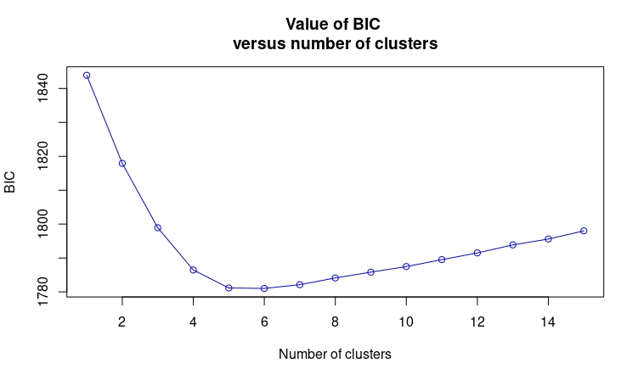

Supplemental Fig 1. K-means cluster plot used to determine the number of clusters to assign for DAPC analysis. The elbow of the curve is circled in red and found to be 5 clusters.

Supplemental Fig 2. Cross-entropy plot for SNMF plot displaying an optimal cluster size of K=6 (circled)

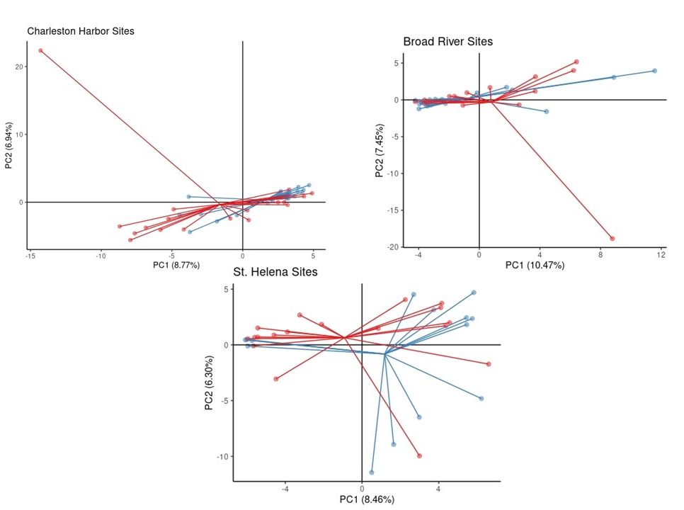
Supplemental Fig 3. PC analysis of costal (red) and inland (blue) across three South Carolina estuaries: Charleston Harbor, Broad River, and St. Helena. Variance explained by PC1 and PC2 are indicated

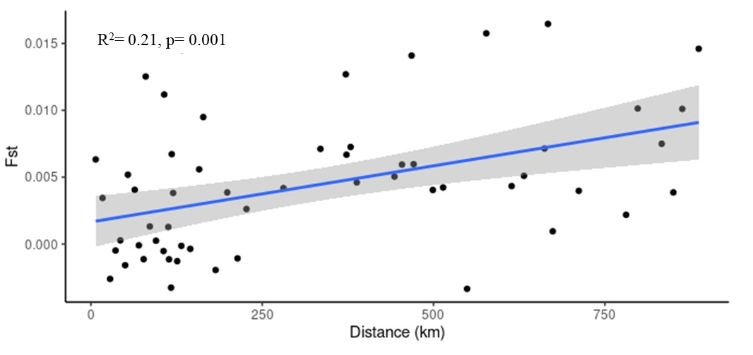
Supplemental Fig 4. Isolation by distance of populations that had greater than five samples, and excluding Massachusetts, St. Teresa, and Fort Pierce populations. IBD was performed through a linear regression followed by a Mantel test to determine significance. Broad River, Charleston Harbor, and St. Helena Sound were parsed out into coastal and inland sites

