Table 1. The sampling collection data of D. cuprea from 2009 to 2022 with latitude and longitude provided for each population in addition to the number of samples available for this study, and the collector

Table 2. AMOVA table showing the sums of square deviation (SSD), mean square deviations (MSD), degrees of freedom, Sigma 2, p-values, and Phi_{ST} for four regions (mid-Atlantic, Gulf of Mexico, southern Florida, and Massachusetts) and among populations within regions
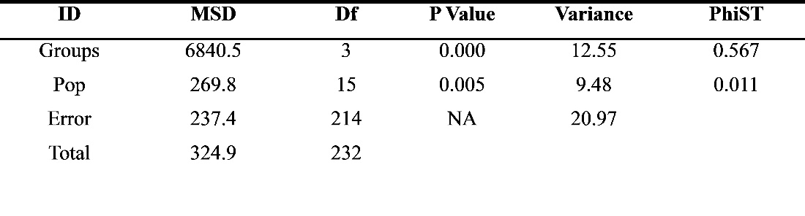

Table 3. Weir and Cockerham (1984) Phi_{ST} values for populations of D. cuprea located below the diagonal line and corresponding p-values are located above the line

