Explanation of Fig. 3.
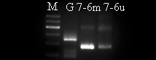
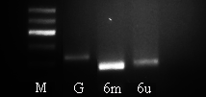
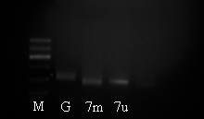
A-Blank

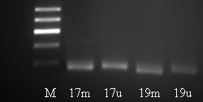
A-PE

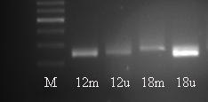
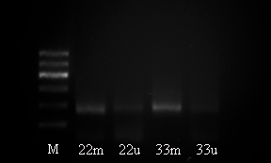
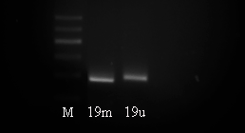
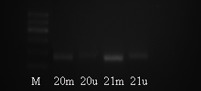
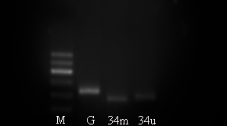
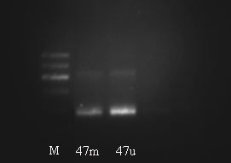
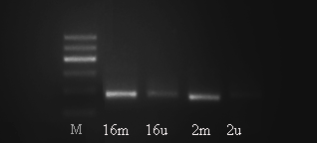
A-Control

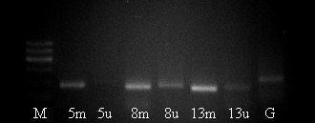
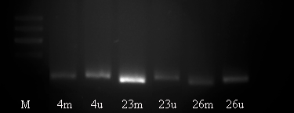
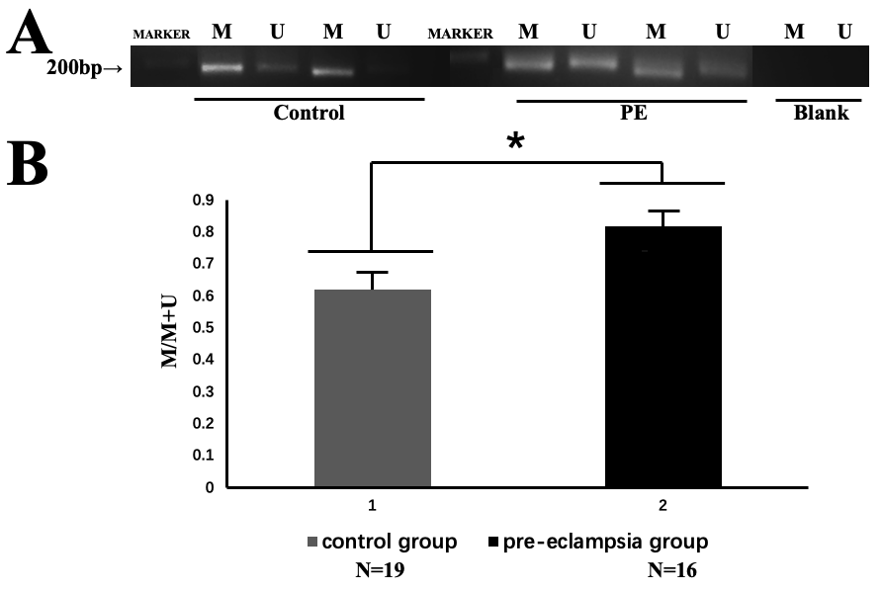
These pictures provides a visual representation of the methylation patterns found within the promoter region of the RASSF1A gene in both preeclamptic (PE) and normal control (NC) placentas. Panel A depicts the results of Methyl-Specific PCR (MSP) analysis. The presence of bands corresponding to the methylated form of RASSF1A (marked with an 'M') indicates hypermethylation, whereas those corresponding to the unmethylated form (indicated by a 'U') suggest a lack of methylation. Comparatively, PE samples show an increased presence of 'M' bands, signifying a higher methylation status, which is consistent with the hypothesis that RASSF1A hypermethylation may play a role in the pathogenesis of preeclampsia.

Panel B illustrates the quantitative aspect of this methylation. The level of promoter methylation at the CpG site is determined through a calculation that takes into account both the methylated and unmethylated states: [extent of methylation/(extent of methylation + extent of unmethylation)]. Our findings reveal a statistically significant increase in the RASSF1A promoter's methylation rate in preeclamptic placentas when compared to the control group, denoted by an asterisk (*P < 0.05).

These results highlight the potential for RASSF1A promoter hypermethylation to be utilized as a biomarker for preeclampsia. Moreover, the visibility of bands in this gel electrophoresis-based technique offers an approachable and interpretable method for assessing DNA methylation status. This adds further weight to the importance of epigenetic regulation in placental-related pathologies and sets a compelling case for deeper studies into the therapeutic potential of reversing such epigenetic modifications to mitigate preeclampsia's onset and progression.

