Supplementary Figures

Genome architecture evolution in an invasive copepod species complex

Zhenyong Du^{1,}*, Johannes Wirtz², Yifei Joye Zhou¹, Anna Jenstead¹, Taylor Opgenorth¹, Angelise Puls¹, Cullan Meyer¹, Gregory W. Gelembiuk¹, Carol Eunmi Lee^{1,}*

¹Department of Integrative Biology, 430 Lincoln Drive, Birge Hall, University of Wisconsin, Madison, WI 53706, U.S.A.
²CEFE, Université de Montpellier, CNRS, EPHE, IRD, Montpellier 34090, France

*Corresponding Authors:
Zhenyong Du, zdu53@wisc.edu; Carol E. Lee, carollee@wisc.edu
Table of Contents:
Figure S1. Phylogenetic relationships among clades of the Eurytemora affinis species complex.
Figure S2. Karyotypes of three clades of the Eurytemora affinis species complex based on fluorescent microscopy.
Figure S3. Frequency plots of k-mer coverage for the Gulf and Europe clades of the Eurytemora affinis species complex.
Figure S4. Phylogeny showing divergence times among nine copepod and daphnid species.
Figure S5. Frequency distribution of the top 5% signatures of selection within random 1 Mb intervals on each chromosome of Eurytemora carolleeae (Atlantic clade of the E. affinis complex).
Figure S6. Frequency distribution of the top 1% signatures of selection within random 1 Mb intervals on each chromosome of Eurytemora carolleeae (Atlantic clade of the E. affinis complex).
Figure S7. Distribution of signatures of selection associated with salinity adaptation on seven chromosomes of Eurytemora gulfia (Gulf clade of the E. affinis complex).
Figure S8. Hi-C contact maps for three chromosomes of the Eurytemora carolleeae genome.
Figure S9. Frequency distribution of the top 5% signatures of selection within random 1 Mb intervals on each chromosome of Eurytemora gulfia (Gulf clade of the E. affinis complex).
Figure S10. Frequency distribution of the top 1% signatures of selection within random 1 Mb intervals on each chromosome of Eurytemora gulfia (Gulf clade of the E. affinis complex).
Figure S11. Demographic history of wild populations of Atlantic and Gulf clades of the Eutytemora affinis species complex.
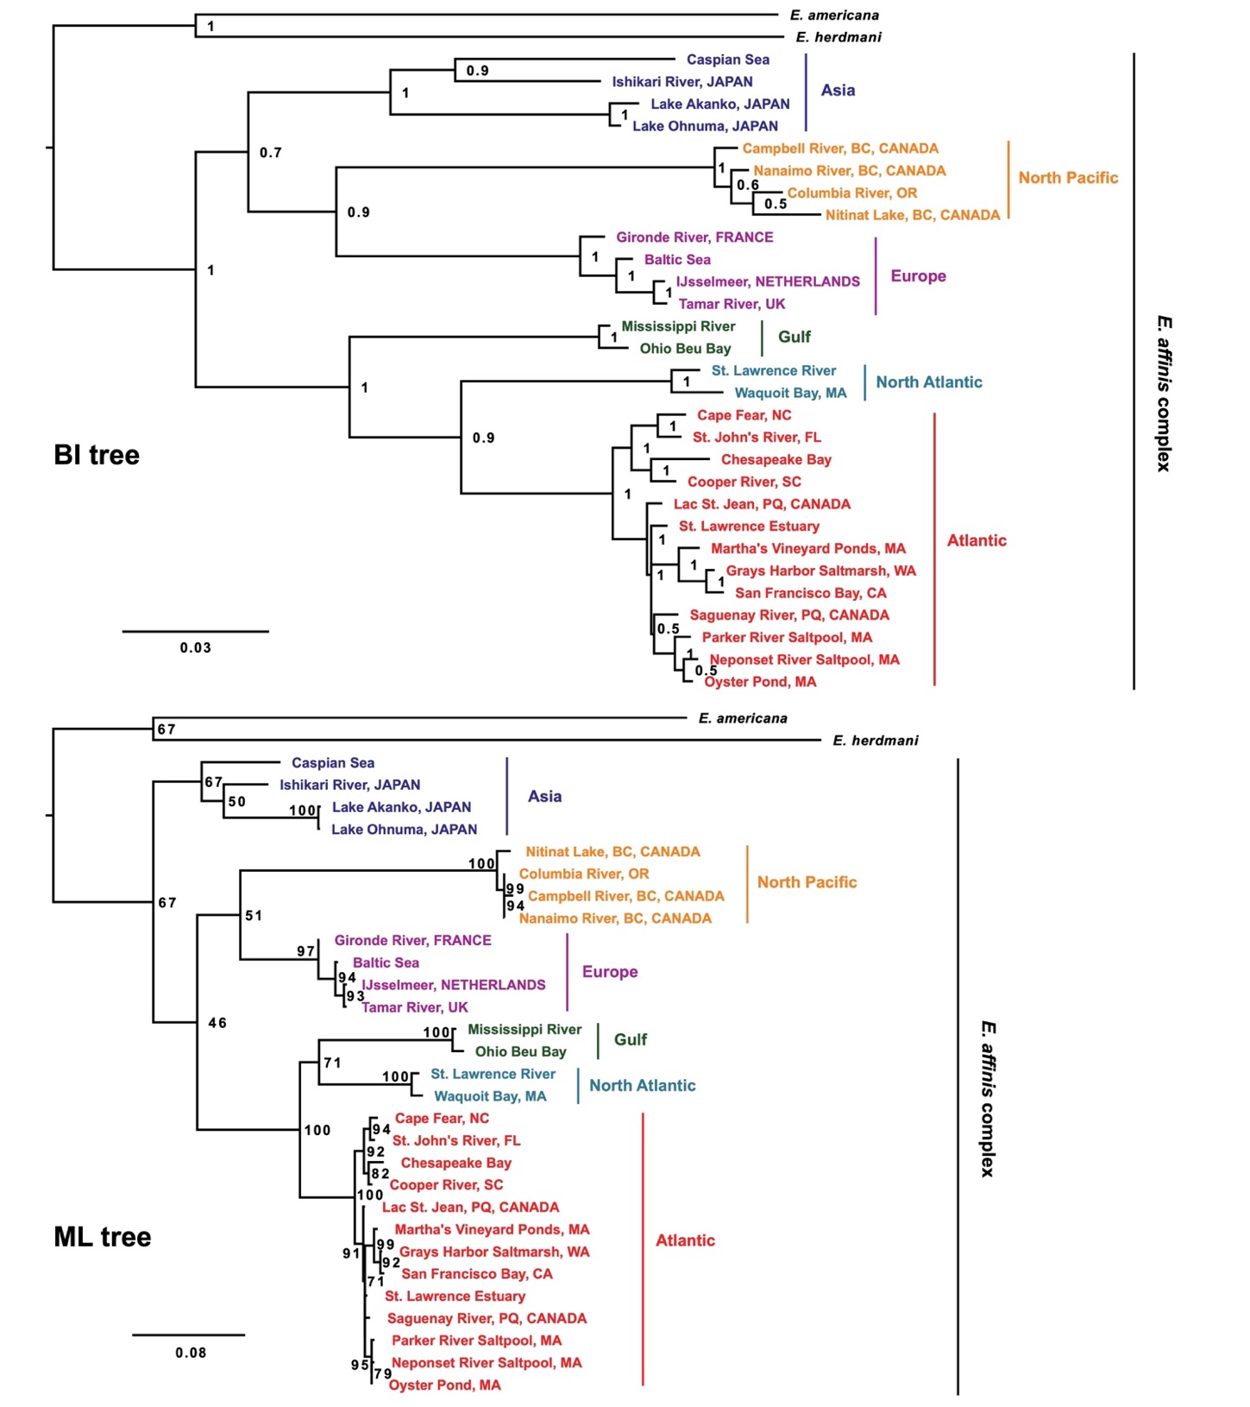

Figure S1. Phylogenetic relationships among clades of the Eurytemora affinis species complex. These two phylogenies were constructed using concatenated cytochrome c oxidase I (COI) and 16S rRNA gene sequences from Lee (2000). The top phylogeny was constructed using Bayesian inference with MrBayes software (Ronquist & Huelsenbeck, 2003). The numbers at each node are the posterior probabilities. The bottom phylogeny was generated using maximum-likelihood with IQ-Tree software (Trifinopoulos et al., 2016). The numbers at the nodes are bootstrap values for 1000 replicates.

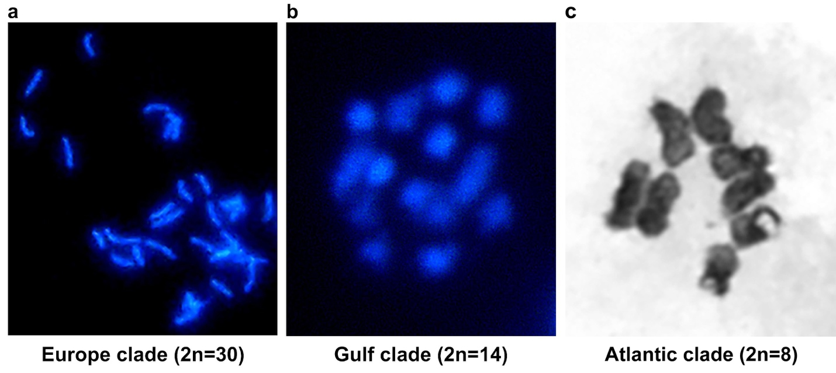
Figure S2. Karyotypes of three clades of the Eurytemora affinis species complex based on fluorescent microscopy. Karyotyping of embryos was performed to confirm chromosome counts. Embryos were dissected within 24 hours post-ovulation, treated with colchicine and a hypotonic solution, and fixed with Carnoy's fixative. Chromosomes were stained with DAPI and imaged using an Olympus BX60 epifluorescence microscope at the Newcomb Imaging Center, University of Wisconsin-Madison. The karyotype images show the chromosome counts for each clade: (a) 2n = 30 chromosomes are visible for the Europe clade, (b) 2n = 14 chromosomes for the Gulf clade, and (c) 2n = 8 chromosomes for the Atlantic clade. The chromosome counts from the karyotype results are consistent with the Hi-C scaffolding results (Figure 2).
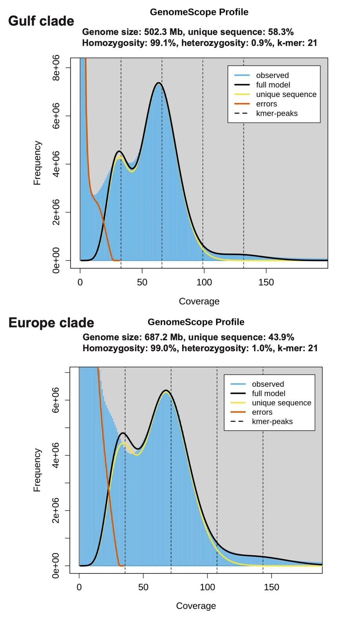
Figure S3. Frequency plots of k-mer coverage for the Gulf and Europe clades of the Eurytemora affinis species complex. The upper graph shows the k-mer coverage for the Gulf clade (E. gulfia), whereas the lower graph shows that for the Europe clade (E. affinis). Estimates of genome size, proportion of non-repetitive unique sequences, homozygosity, and heterozygosity are shown above the plots. These results indicate that the E. gulfia genome has an approximate genome size of 502 Mb, with 0.9% heterozygosity and 42% repetitive sequence, whereas the E. affinis proper genome has an approximate genome size of 687 Mb, with 1.0% heterozygosity and 56% repetitive sequence.

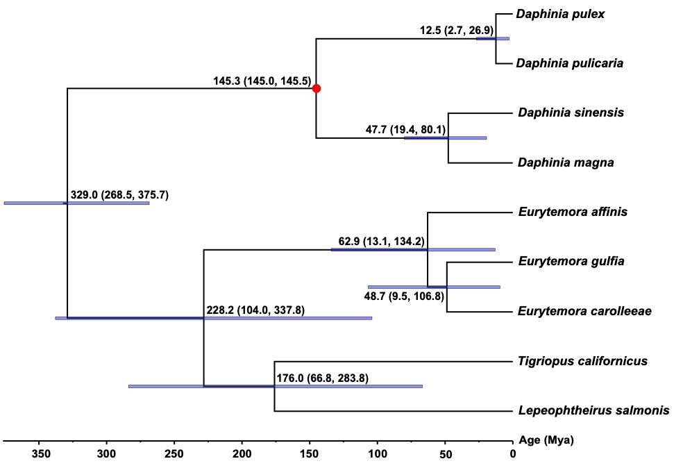

Figure S4. Phylogeny showing divergence times among nine copepod and daphnid species. Phylogenetic reconstruction of nine high-quality genomes was performed using RAxML (Stamatakis, 2014) based on concatenated single copy ortholog genes. More species, Daphinia pulicaria and D. sinnensis, were included than in Figure 3. All nodes show bootstrap values of 100%. The tree was calibrated with a credible fossil age of 145 million years ago (Mya) for the genus Daphnia (Cornetti et al., 2019). Mean divergence times estimated using MCMCTree (Yang, 2007) are shown at each node with parentheses indicating 95% highest posterior density intervals.
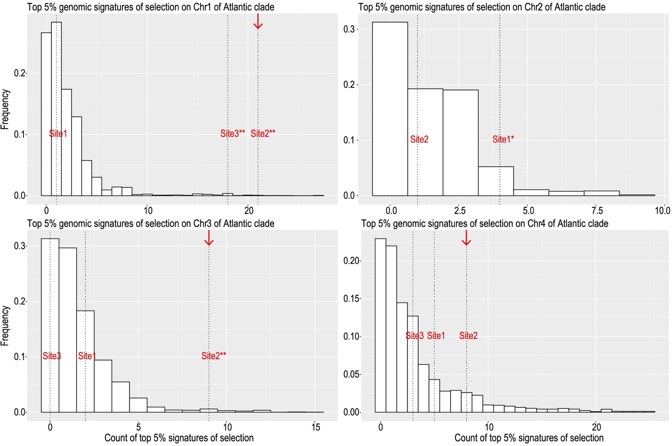
Figure S5. Frequency distribution of the top 5% signatures of selection within random 1 Mb intervals on each chromosome of Eurytemora carolleeae (Atlantic clade of the E. affinis complex). Vertical dashed lines denote the fusion sites on the chromosomes. Asterisks denote significantly higher numbers of signatures of selection compared to the background distribution on the corresponding chromosomes. Detailed statistical results can be found in Supplementary Table S12. Significance levels are indicated as follows: *** for P-value < 0.001, ** for P-value < 0.01, and * for 0.01 < P-value < 0.05. Centromeres are indicated by red arrows.
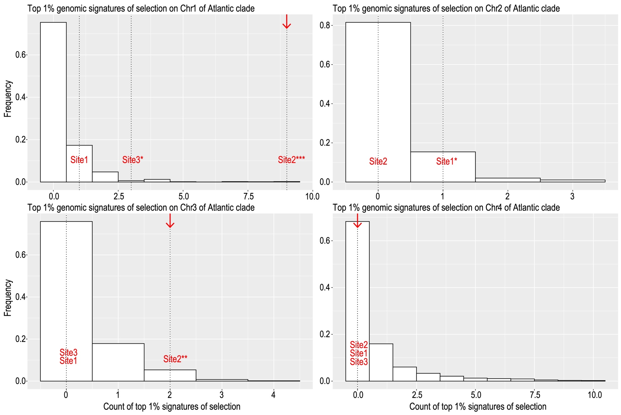
Figure S6. Frequency distribution of the top 1% signatures of selection within random 1 Mb intervals on each chromosome of Eurytemora carolleeae (Atlantic clade of the E. affinis complex). Vertical dashed lines denote the fusion sites on the chromosomes. Asterisks denote significantly higher numbers of signatures of selection compared to the background distribution on the corresponding chromosomes. Detailed statistical results can be found in Supplementary Table S12. Significance levels are indicated as follows: *** for P-value < 0.001, ** for P-value < 0.01, and * for 0.01 < P-value < 0.05. Centromeres are indicated by red arrows.
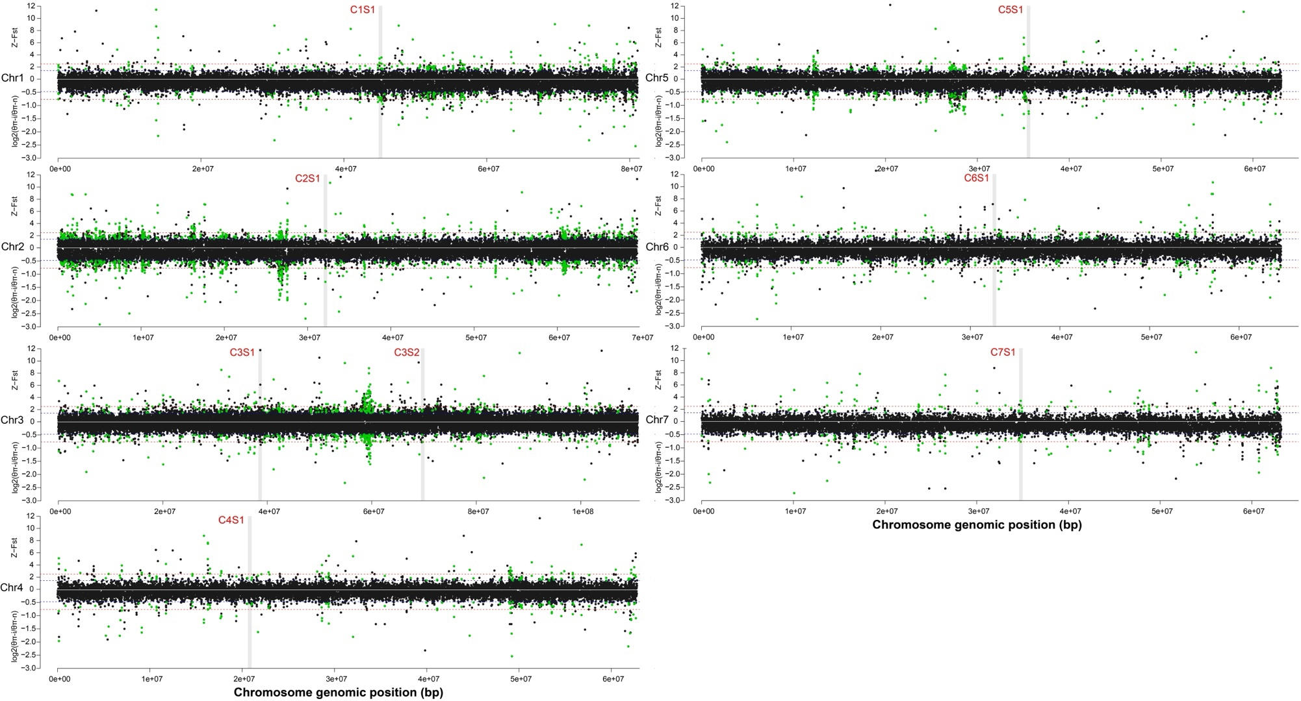

Figure S7. Distribution of signatures of selection associated with salinity adaptation on seven chromosomes of Eurytemora gulfia (Gulf clade of the E. affinis complex). These panels show the distribution of signatures of selection on each chromosome. In each panel, the upper Manhattan plots (above 0) represent signatures of selection detected by F_{ST}, with y-axis showing the values of Z-transformed F_{ST}. The lower Manhattan plots (below 0) show signatures of selection detected by nucleotide diversity, θ_{π} ratio (θ_{π-invasive}/θ_{π-native}), with the y-axis representing the values of log₂(θ_{π-invasive}/θ_{π-native}). Green dots indicate signatures of selection that are shared by the 5% highest Z-transformed F_{ST} and lowest log₂(θ_{π-invasive}/θ_{π-native}). The horizontal blue and red dashed lines denote the thresholds for the top 5% and 1% values, respectively. Vertical grey strips mark the 1 Mb regions encompassing the fusion sites on each chromosome.

Figure S8. Hi-C contact maps for three chromosomes of the Eurytemora carolleeae genome. The stars indicate the positions of the centromeres. The centromeres in the E. gulfia (Gulf clade) and E. affinis (Europe clade) genomes are not as distinct as those in the E. carolleeae (Atlantic clade) genome.
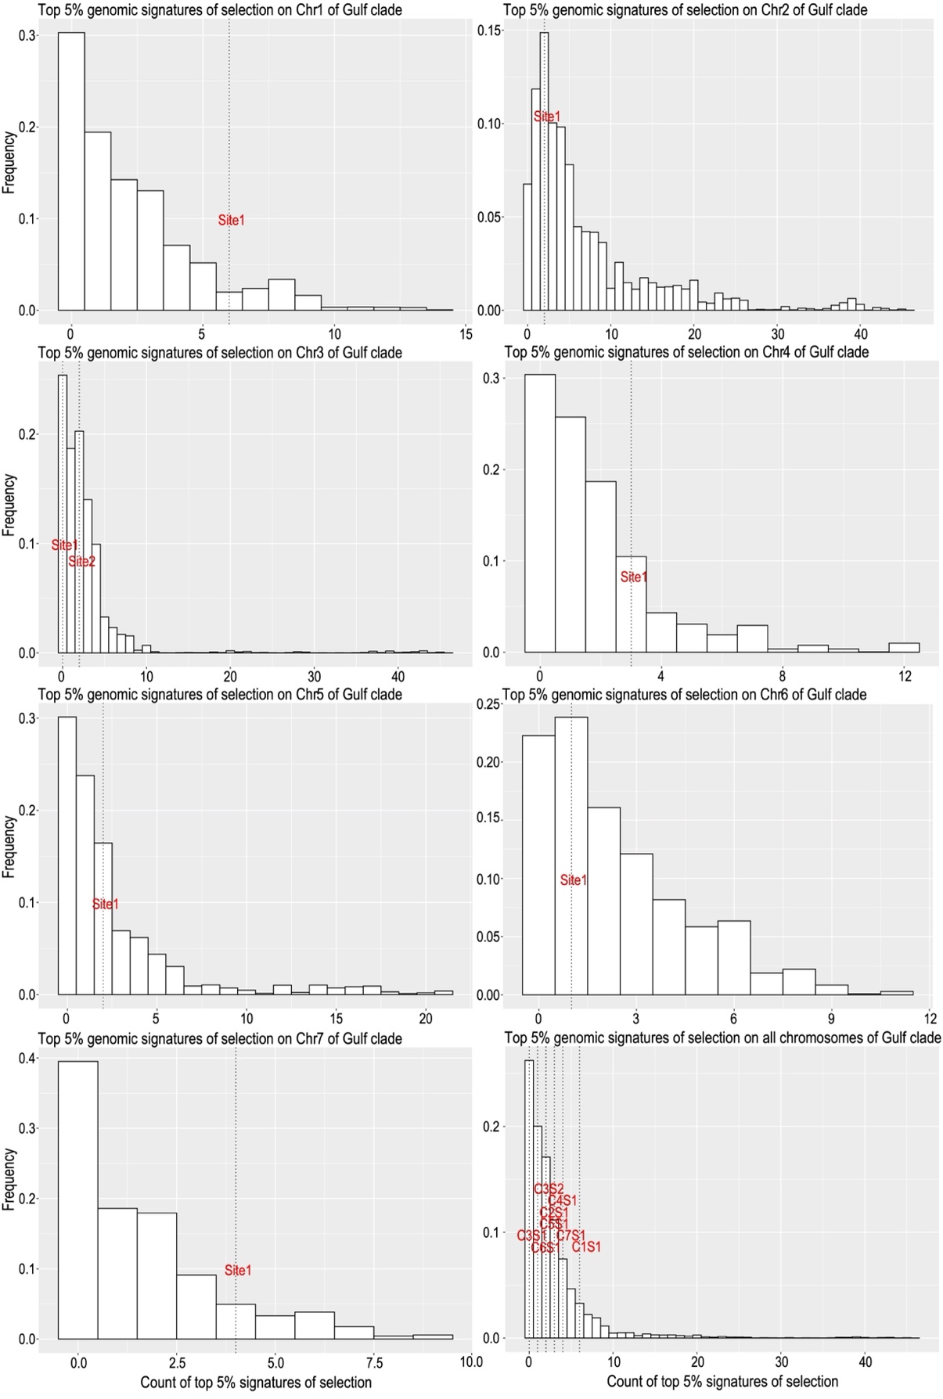
Figure S9. Frequency distribution of the top 5% signatures of selection within random 1 Mb intervals on each chromosome of Eurytemora gulfia (Gulf clade of the E. affinis complex). Vertical dashed lines denote the fusion sites on the chromosomes. Detailed statistical results can be found in Supplementary Table S13. None of these fusion sites show significantly higher numbers of signatures of selection compared to the background distribution on the corresponding chromosomes.
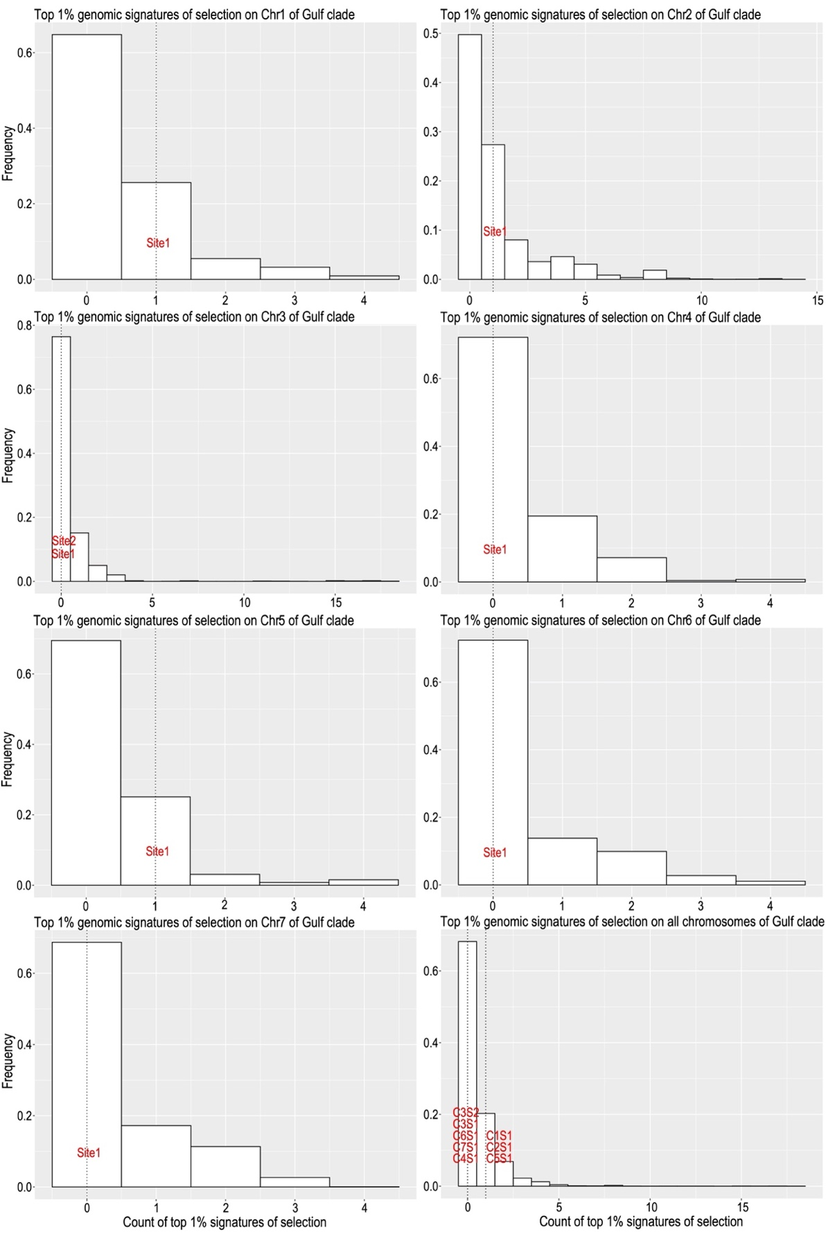
Figure S10. Frequency distribution of the top 1% signatures of selection within random 1 Mb intervals on each chromosome of Eurytemora gulfia (Gulf clade of the E. affinis complex). Vertical dashed lines denote the fusion sites on the chromosomes. Detailed statistical results can be found in Supplementary Table S13. None of these fusion sites denote significantly higher numbers of signatures of selection compared to the background distribution on the corresponding chromosomes.
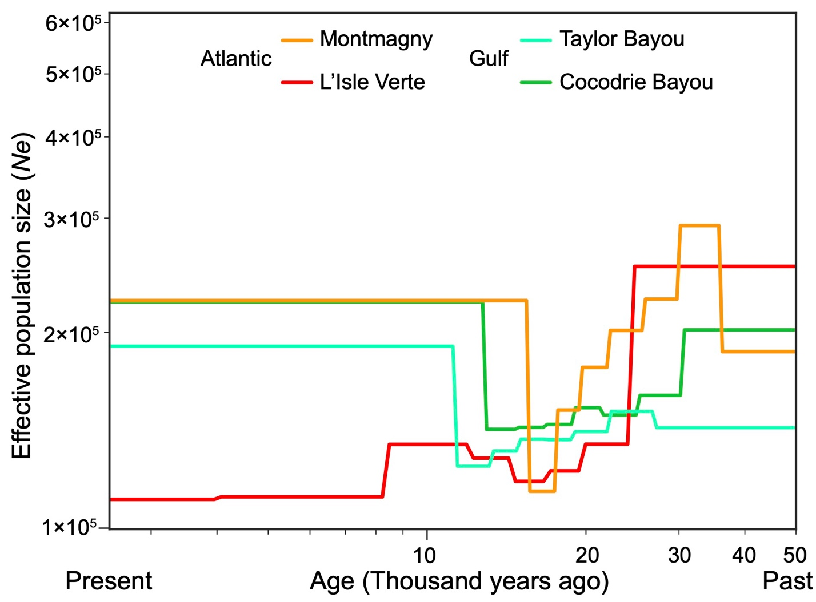

Figure S11. Demographic history of wild populations of Atlantic and Gulf clades of the Eutytemora affinis species complex. The colored lines indicate changes of effective population size (Ne) over time inferred by SMC++. This analysis suggests a decreasing of Ne during the Last Glacier Maximum (18–26 thousand years ago) in both the Atlantic and Gulf clades. Locations of these populations are shown in Stern and Lee (2020) and Supplementary Table S17.
References
Cornetti, L., Fields, P.D., Van Damme, K., and Ebert, D. (2019). A fossil-calibrated phylogenomic analysis of Daphnia and the Daphniidae. Mol. Phylogenet. Evol. 137, 250–262.
Lee, C.E. (2000). Global phylogeography of a cryptic copepod species complex and reproductive isolation between genetically proximate "populations". Evolution 54, 2014–2027.
Ronquist, F., and Huelsenbeck, J.P. (2003). MrBayes 3: Bayesian phylogenetic inference under mixed models. Bioinformatics 19, 1572–1574.
Stamatakis, A. (2014). RAxML version 8: a tool for phylogenetic analysis and post-analysis of large phylogenies. Bioinformatics 30, 1312–1313.
Stern, D.B., and Lee, C.E. (2020). Evolutionary origins of genomic adaptations in an invasive copepod. Nat. Ecol. Evol. 4, 1084–1094.
Terhorst, J., Kamm, J.A., and Song, Y.S. (2017). Robust and scalable inference of population history from hundreds of unphased whole genomes. Nat. Genet. 49, 303–309
Yang, Z. (2007). PAML 4: phylogenetic analysis by maximum likelihood. Mol. Biol. Evol. 24, 1586–1591.

