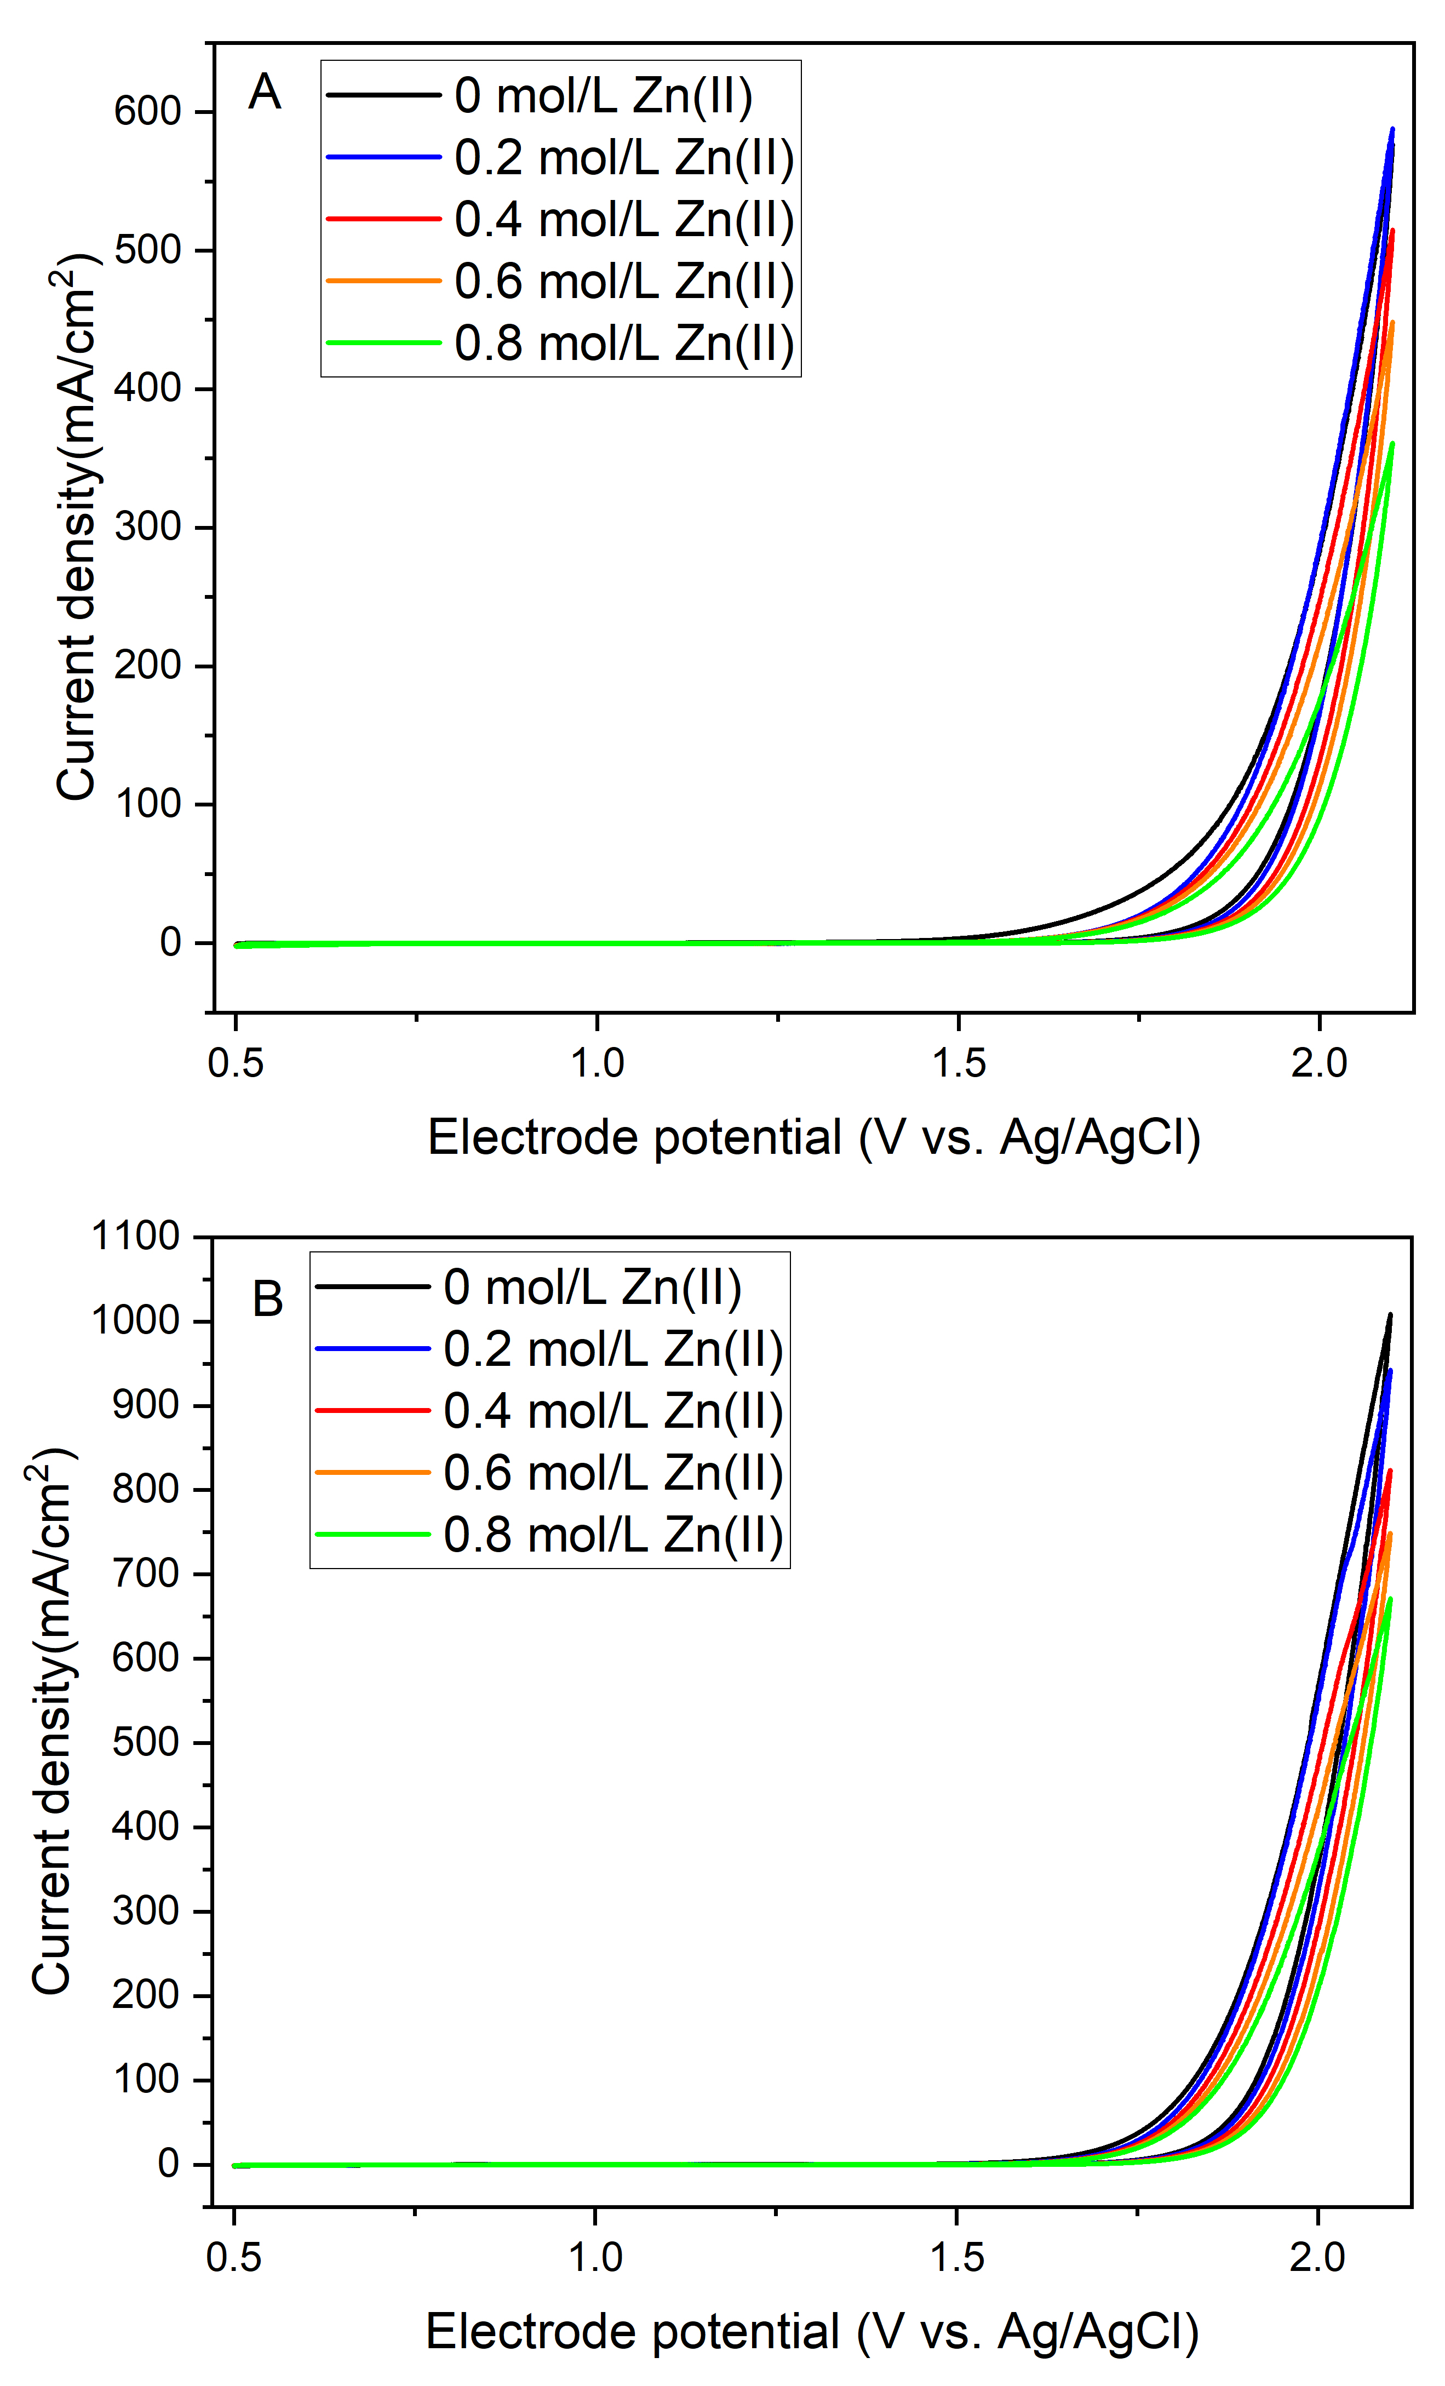

Figure 1. Effect of zinc(II) methanesulfonate addition on the cyclic voltammograms for the oxygen evolution reaction in (A) 4 mol/L MSA and (B) 2/0.5 MA in the absence of Ce(III)/Ce(IV) ions. Scan rate = 50 mV/s.

