Proteogenomics in cerebrospinal fluid and plasma reveals new biological fingerprint of cerebral small vessel disease
SUPPLEMENTARY APPENDIX
Table of content
1. Extended figures 2
2. Supplementary methods 8
3. References 10

Extended figures
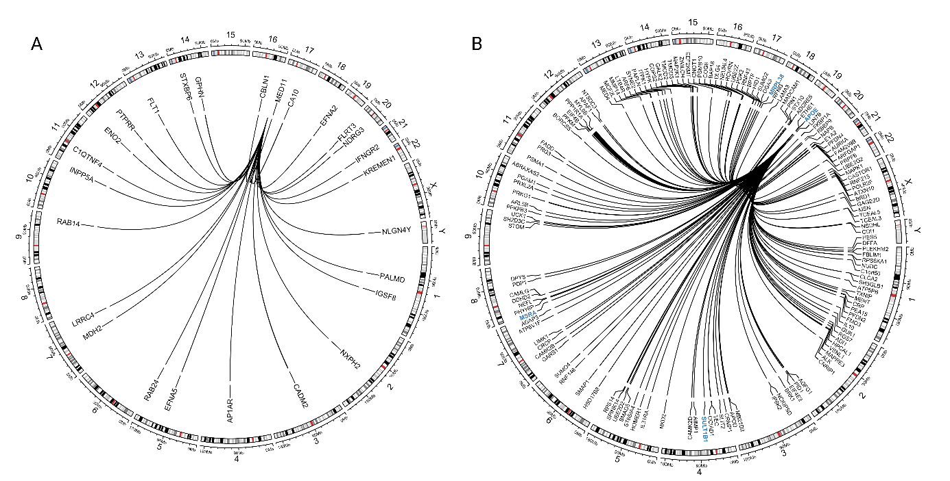

Extended data Fig.1 Pleiotropic regions: hotspots of protein regulation associated with WMH. Circos plot showing genomic locations of protein-coding genes whose proteins are regulated by A. chr16q24 and B. APOE regions. Blue genes correspond to genes found associated with WMH and/or extreme-cSVD in previously published GWAS.

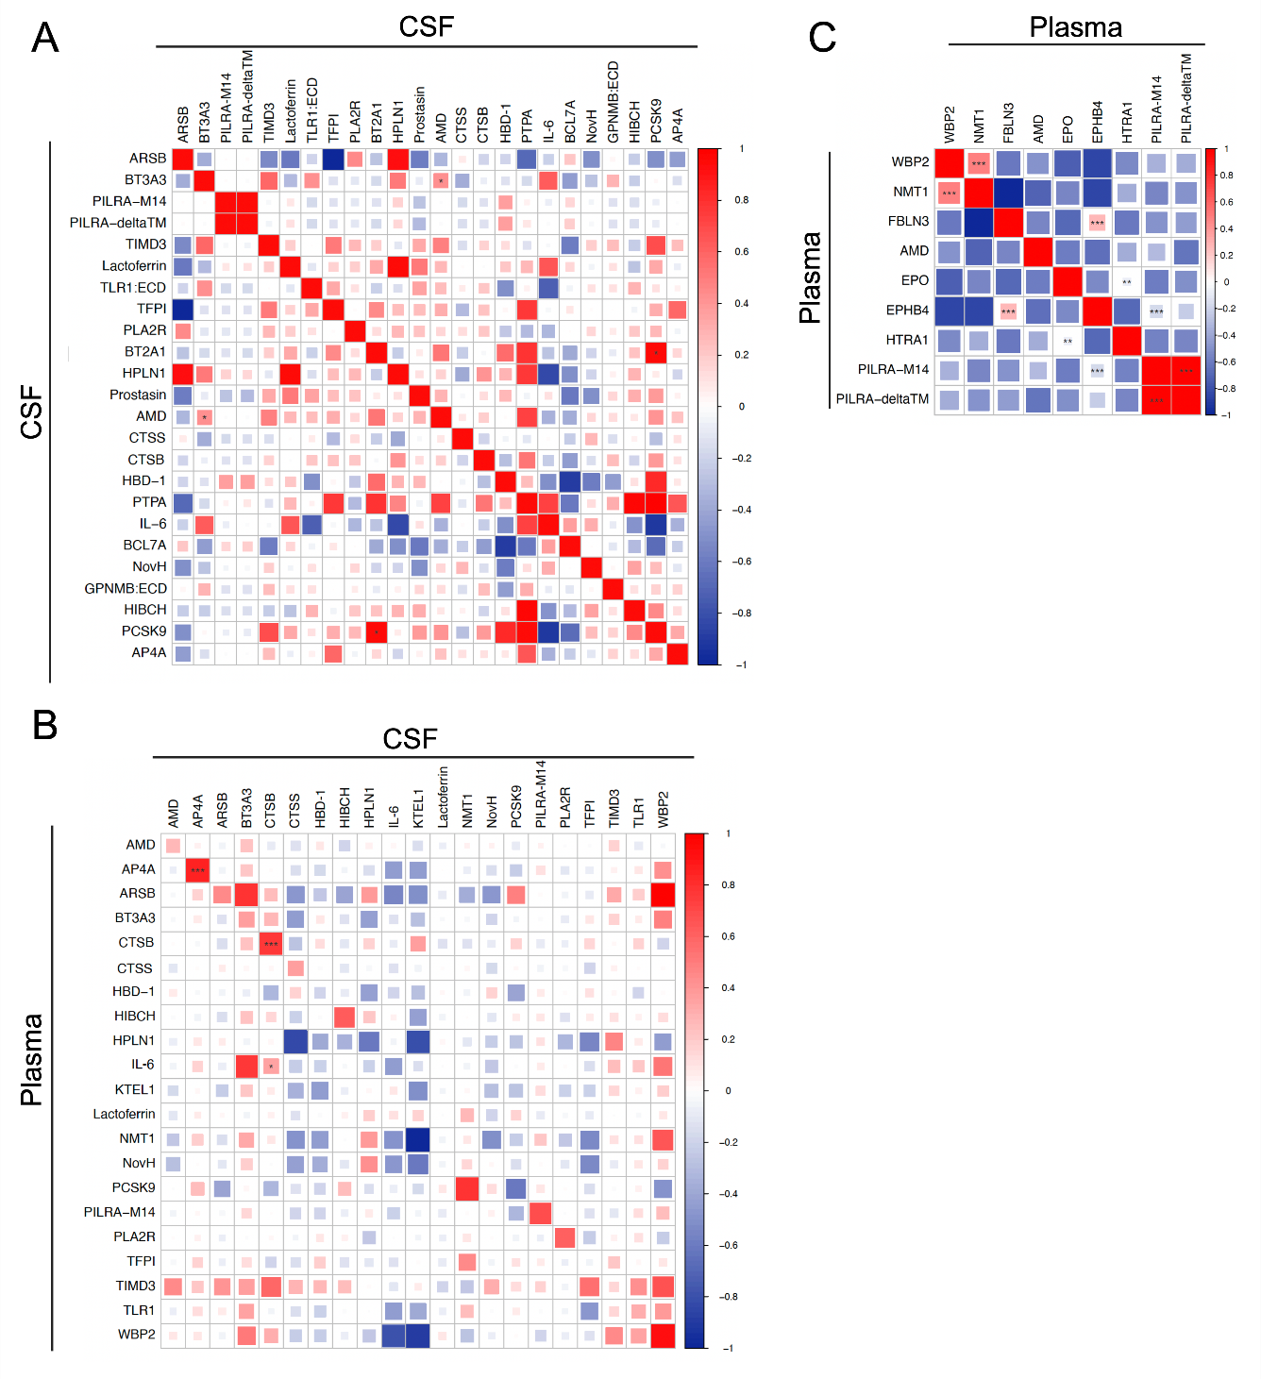

Extended data Fig.2 Genetic correlation between proteins associated with MRI-cSVD using protein quantitative trait loci. A. Genetic correlation across pQTLs for 24 CSF protein levels associated with MRI-cSVD. B.Genetic correlation across pQTLs for 21 CSF or plasma proteins significantly associated with MRI-cSVD and available in both plasma and CSF (x axis: pQTL for CSF protein levels; y axis: pQTL for plasma protein levels).. C. Genetic correlation across pQTLs for 9 plasma protein levels associated with MRI-cSVD * p<0.05, ** p<0.01, *** p<0.001. Only proteins with heritability greater than 20% could be used for genetic correlation analyses.

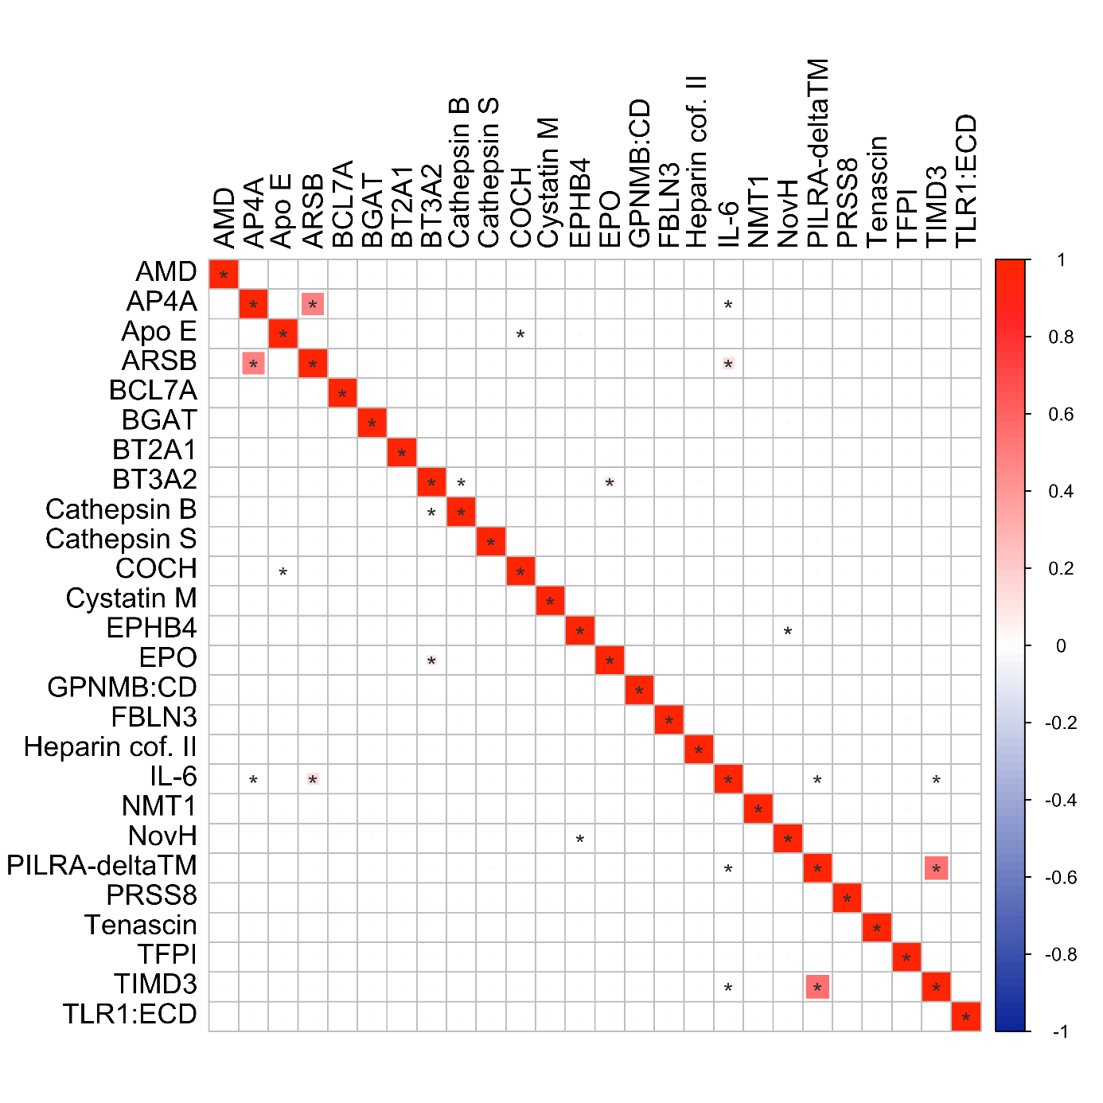
Extended data Fig. 3 Correlation of protein levels measured in the UKB across the 26 proteins measured. *p<7.7x10-3 (Bonferroni corrected threshold)

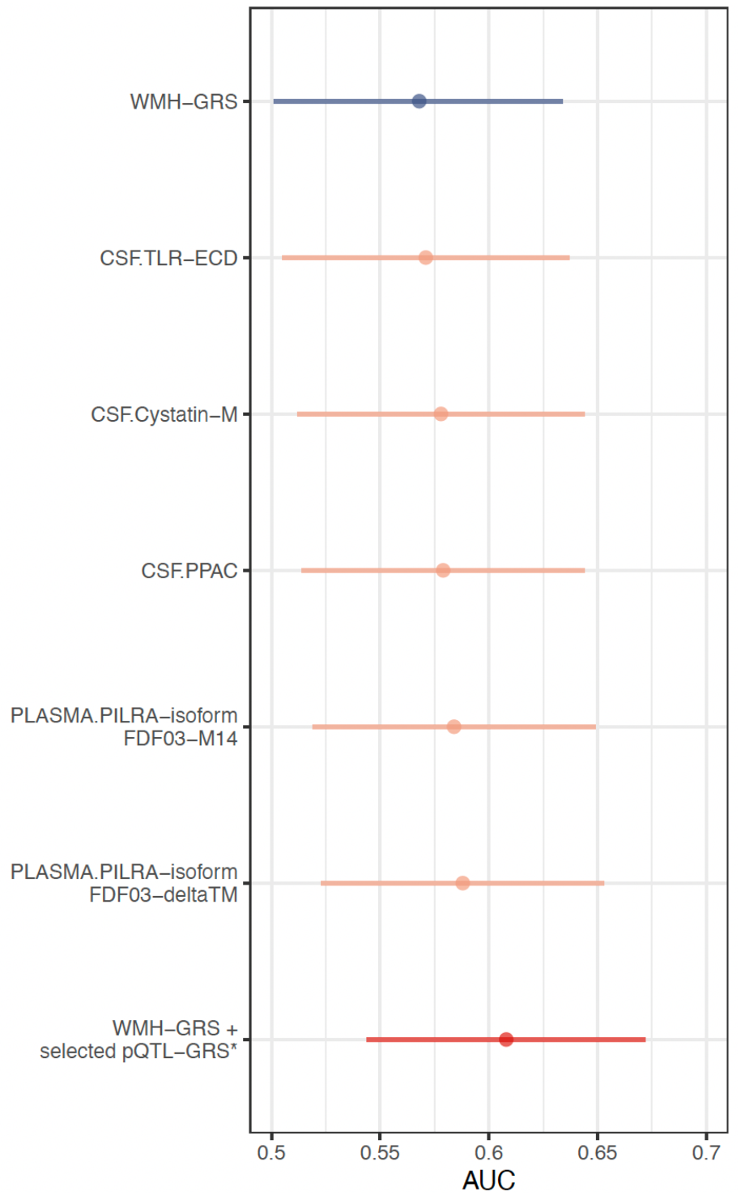

Extended data Fig.4 Prediction performance of pQTL and WMH genomic risk scores to predict extreme-cSVD. Prediction performance was assessed through internally validated AUC using the optimism bootstrap estimator (2,000 replications). All pQTL models include the WMH-GRS. *Selected pQTL-GRS: CSF.Cystatin-M, PLASMA.PILRA-isoform-FDF03-M14, CSF.PPAC, and CSF.TLR1-ECD. The blue line corresponds to the WMH GRS, the orange lines correspond to each cSVD-associated protein GRS added, and the red line corresponds to the final GRS with WMH and the GRS of all included cSVD-associated proteins (Methods) added. All models are adjusted for the first 5 principal components of population stratification. As PILRA isoforms were extremely correlated (r=0.99), we selected the isoform displaying the strongest association with extreme cSVD (PILRA-M14) for the combined model.

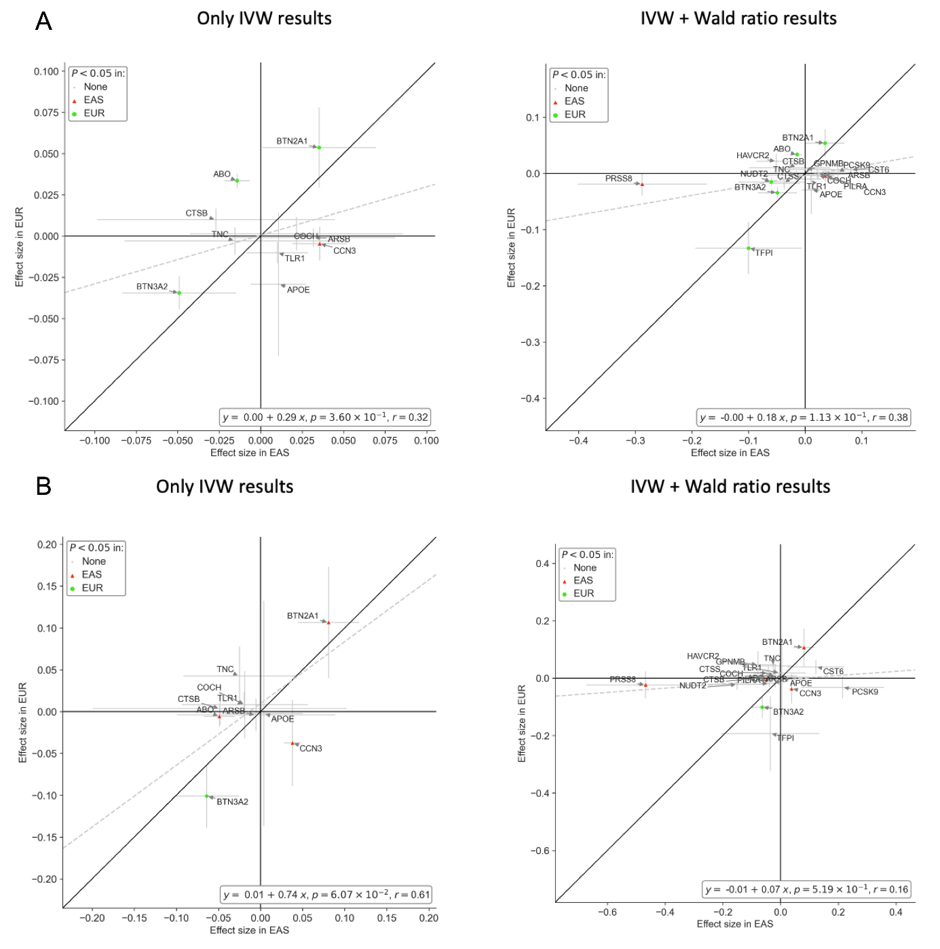Extended data Fig.5 Comparison of effect size estimates for MR associations of cSVD-associated proteins with ischemic stroke and small vessel stroke between Europeans (EUR) and East-Asians (EAS). A. Ischemic Stroke. B. Small vessel Stroke.

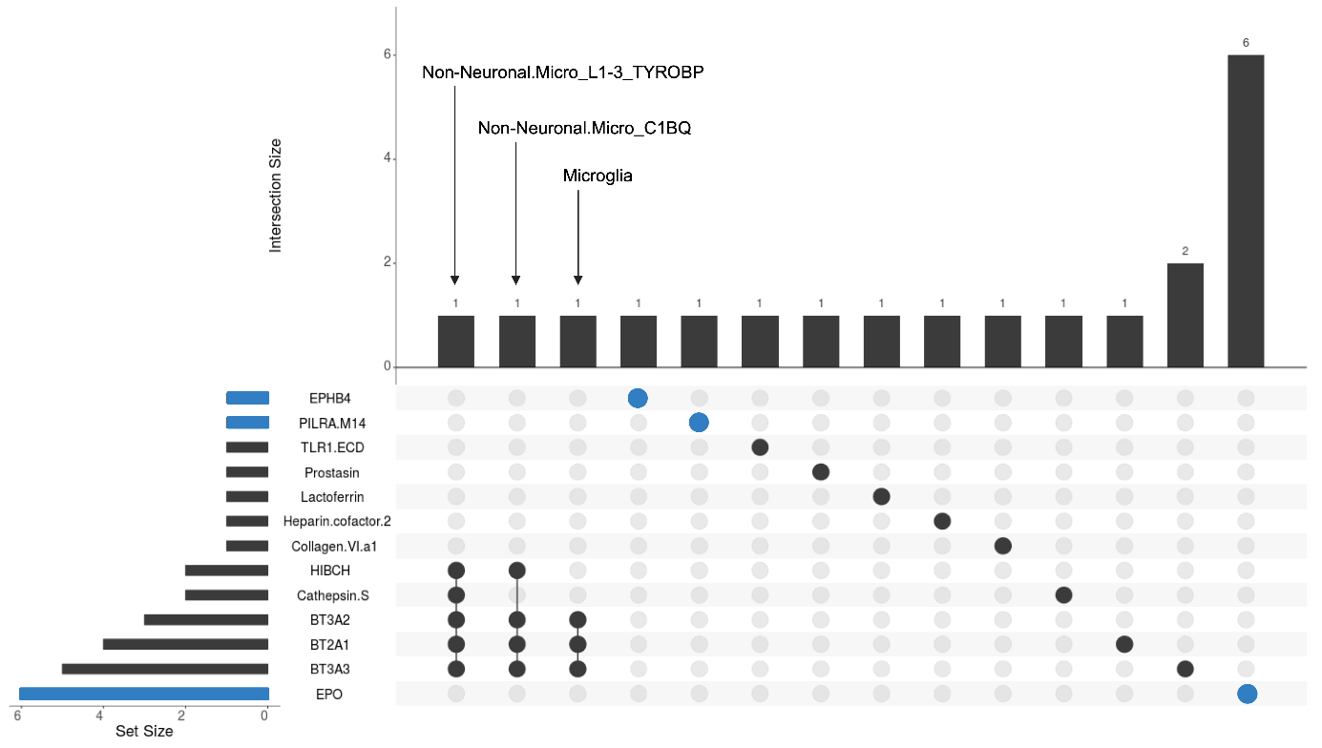
Extended data Fig.6 Cell-type enrichment in single cell RNA-seq databases using STEAP. Upset plot displays the number of significant enrichment results by protein (pQTL) horizontally and by cell-type vertically. CSF pQTLs are in black and plasma pQTLs are in blue. Details are displayed in Supplementary Table 25. Human and mouse single-cell databases are used in this analysis (Methods).

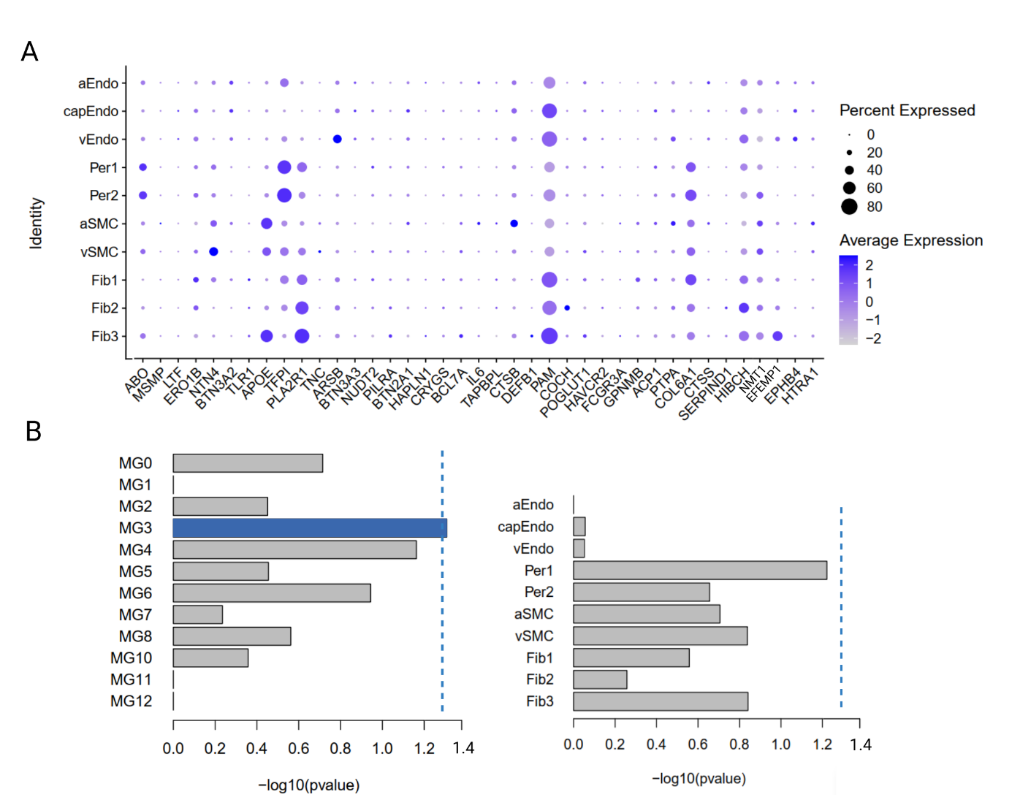
Extended data Fig.7 Single-nucleus gene expression/enrichment analyses. A. Single-nucleus cerebrovascular gene expression data of cSVD-associated protein coding genes in dorsolateral prefrontal cortex (ROS-MAP study). B. Enrichment analyses of cSVD-associated protein coding genes in microglial states and vascular cells. Dotted line corresponds to pval<0.05.

Supplementary methods

Three-City Dijon Study (3C-Dijon)
The 3C study is a research project conducted across three French cities (Bordeaux, Dijon, and Montpellier), involving a total of 9,294 participants. Its primary objective is to assess the risk of dementia and cognitive impairment associated with vascular factors. Eligibility criteria required participants to reside in the respective cities and be registered on the electoral rolls in 1999, be 65 years or older, and not be institutionalized. Approval for the study protocol was obtained from the Ethical Committee of the University Hospital of Kremlin-Bicêtre, and all participants provided informed consent. The data used in this project were collected as part of the 3C-Dijon study, which recruited 4,931 individuals between 1999 and 2001. Further details on the overall design of the 3C-Dijon study can be found elsewhere^{1,2}. Participants aged less than 80 years and enrolled between June 1999 and September 2000 (n=2,763) were invited to undergo brain MRI scans. A total of 2,285 subjects agreed to participate (82.7% response rate), and 1,924 MRI scans were performed, with 120 non-interpretable. Consequently, cerebral white matter lesion measures were available for 1,800 participants. MRI scans were conducted using a 1.5-Tesla Magnetom scanner (Siemens, Erlangen, Germany). The T1- and T2-weighted images of each subject were initially aligned using the AIR package, followed by analysis using an optimized Voxel-Based Morphometry (VBM) protocol with Statistical Parametric Mapping 99 (SPM99), which was adapted to accommodate the structural characteristics of the aged brain. Automated image processing software was utilized to detect, measure, and localize white matter hyperintensities (WMH).
Olink proteomic profiling, based on blood samples obtained at inclusion, was conducted in 1,056 participants with brain MRI measurements, without dementia at the time of the blood drawn, (Supplementary Table 22) selected based on availability of brain MRI and amounts of plasma tubes left. Protein measurements were conducted on the Olink Explore 3072 panel using PEA technology, following the manufacturer’s protocol³, at McGill Genome Center (Montreal, Canada).

Follow-up of significant protein-cSVD associations
Cross-platform follow-up
Data were transformed and normalized to Olink’s Normalized Protein eXpression (NPX) values, a relative protein quantification unit on a logarithmic base 2 scale. We generated PCA plots encompassing all proteins and samples, following which 3 samples were removed due to deviations greater than 5 standard deviations from the mean. Subsequently, separate PCAs were generated for each panel, leading to the exclusion of additional 9 samples with deviation greater than 5 SD from the mean. Additionally, we removed 3 proteins for which over 50% of NPX values were below the protein's limit of detection (LOD) value. For the remaining proteins, NPX values falling below the LOD threshold were kept for analyses.
PVS load prediction in the UK Biobank
We predicted the PVS load in the brain with the SHIVA-PVS algorithm⁴ (https://github.com/pboutinaud/SHIVA_PVS, T1.PVS/v1) applied on the T1-weigted (T1w) images from 5523 UKB subjects with both MRI with usable T1w images and proteomics data (there were 5826 subjects with both MRI and proteomics but T1w in 303 subjects were tagged as ‘unusable’ and excluded from the current analysis). We only quantified the PVS in T1w images acquired at the first time point for any subjects with repeated acquisitions.
A threshold of 0.5 (range [0 1]) has been applied to binarize the probability maps produced by the algorithm. The number of clusters, i.e. the number of PVSs in the deep white matter (DWM) and the basal ganglia (BG), was computed for each subject. Additionally, cluster size filter of 5 has been applied to the deep white matter (DWM), while no cluster size filter is applied to the basal ganglia (BG) quantification.
Protein genetic risk score (protein-GRS)
Genotype QC
Standard quality control was conducted on raw genotyped data in 3C-Dijon⁵. The raw genotyped data was imputed on the Haplotype Reference Consortium⁶. Post-imputation data were then harmonized to Phase 3 of the 1000 Genomes European subset, followed by post-imputation QC (MAF>0.01 and INFO>0.8)^{7,8}. In total, 4,188 3C-Dijon participants had viable genetic data, and 5,669,616 SNPs remained after post-imputation quality control.
QC of Summary Statistics
For GRS analysis we selected proteins associated with MRI-cSVD in MR analyses. pQTL summary statistics underwent similar QC, removing variants without an rsID, that were ambiguous or duplicated, or had a minor allele frequency (MAF) < 0.01. Genomic liftover was performed using the MungeSumstats R package to convert to hg19 if necessary⁹ and alleles were flipped to match the reference.
Association Analysis with Extreme cSVD.
We investigated the ability of protein-GRS to predict extremes of cSVD severity in the 3C-Dijon cohort². Briefly, after removing individuals with prevalent stroke, dementia, or brain tumor, we defined a binary phenotype for extreme cSVD by taking the 1st and 4th quartiles of log-transformed WMH volume residuals (extracted from linear regression adjusted for age, sex, and white matter mask volume) in 1,497 participants with MRI and genome-wide genotype data. As described in previous work¹⁰, participants with extensive cSVD (N=261) were participants with the highest WMH volume within the fourth quartile of WMH volume residuals, prioritizing participants with one or more lacunes (N=58); participants with minimal cSVD (N=253) were those in the bottom tail of the 1st quartile of the WMH volume residual distribution, who did not have any type of MRI-defined brain infarct.
Cross ancestry follow-up – Mendelian randomization pQTL (EAS) and subtypes of stroke.
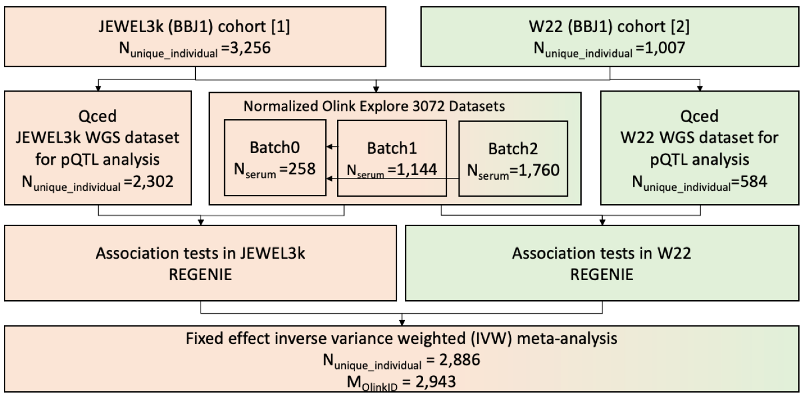

References

1. Godin, O. et al. White matter lesions as a predictor of depression in the elderly: the 3C-Dijon study. Biol. Psychiatry 63, 663–669 (2008).
2. 3C Study Group. Vascular factors and risk of dementia: design of the Three-City Study and baseline characteristics of the study population. Neuroepidemiology 22, 316–325 (2003).
3. Lind, L. et al. Use of a proximity extension assay proteomics chip to discover new biomarkers for human atherosclerosis. Atherosclerosis 242, 205–210 (2015).
4. Boutinaud, P. et al. 3D Segmentation of Perivascular Spaces on T1-Weighted 3 Tesla MR Images With a Convolutional Autoencoder and a U-Shaped Neural Network. Front. Neuroinformatics 15, 641600 (2021).
5. Anderson, C. A. et al. Data quality control in genetic case-control association studies. Nat. Protoc. 5, 1564–1573 (2010).
6. Das, S. et al. Next-generation genotype imputation service and methods. Nat. Genet. 48, 1284–1287 (2016).
7. Auton, A. et al. A global reference for human genetic variation. Nature 526, 68–74 (2015).
8. Pain, O. et al. Evaluation of polygenic prediction methodology within a reference-standardized framework. PLoS Genet. 17, e1009021 (2021).
9. Murphy, A. E., Schilder, B. M. & Skene, N. G. MungeSumstats: a Bioconductor package for the standardization and quality control of many GWAS summary statistics. Bioinformatics 37, 4593–4596 (2021).
10. Mishra, A. et al. Association of variants in HTRA1 and NOTCH3 with MRI-defined extremes of cerebral small vessel disease in older subjects. Brain J. Neurol. 142, 1009–1023 (2019).

