Neurologic Complications in Patients Receiving Aortic vs Subclavian vs Femoral Arterial Cannulation for Post-cardiotomy Extracorporeal Life Support: Results of the PELS Observational Multicenter Study

Appendix

Corresponding author:
Giovanni Chiarini, M.D.
Cardio-Thoracic Surgery Department
Maastricht University Medical Centre
P. Debyelaan, 25-6202AZ Maastricht-The Netherlands
Email: giovanni.chiarini88@gmail.com
Phone: 00393473926790

List of PELS Investigators
Giovanni Chiarini¹, Silvia Mariani^{1,2}, Bas C.T. van Bussel⁴, Samuel Heuts¹, Michele Di Mauro¹, Dominik Wiedemann⁵, Anne-Kristin Schaefer⁵, Luca Conci⁵, Diyar Saeed⁶, Jawad Khalil⁶, Sven Lehmann⁶, Matteo Pozzi⁷, Jean-Francois Obadia⁷, Antonio Loforte^{8,9}, Luca Botta⁸, Davide Pacini⁸, Udo Boeken¹⁰, Nikolaos Kalampokas¹⁰, Robertas Samalavicius¹¹, Agne Jankuviene¹¹, Karl Bounader¹², Erwan Flecher¹², Xiaotong Hou¹³, Jeroen J.H. Bunge^{14,15}, Dinis Dos Reis Miranda¹⁵, Hergen Buscher¹⁶, Kogulan Sriranjan¹⁶, Leonardo Salazar¹⁷, Bart Meyns¹⁸, Daniel Herr¹⁹, Michael A Mazzeffi¹⁹, Sacha Matteucc²⁰, Marco Di Eusanio²⁰, Sandro Sponga²¹, Igor Vendramin²¹, Graeme MacLaren²², Vitaly Sorokin²², Kollengode Ramanathan²², Claudio Russo²³, Alessandro Costetti²³, Francesco Formica^{2,24}, Pranya Sakiyalak²⁵, Antonio Fiore²⁶, Daniele Camboni²⁷, Chistof Schmid²⁷, Giuseppe Maria Raffa²⁸, Rodrigo Diaz²⁹, Roberto Castillo²⁹, I-wen Wang³⁰, Jae-Seung Jung³¹, Jan Belohlavek³², Tomas Grus³³, Vin Pellegrino³⁴, Giacomo Bianchi³⁵, Marco Solinas³⁵, Matteo Pettinari³⁶, Alessandro Barbone³⁷, José P. Garcia³⁸, Kiran Shekar³⁹, Glenn Whitman⁴⁰, Roberto Lorusso¹.

- Cardio-Thoracic Surgery Department, and Cardiovascular Research Institute Maastricht, Maastricht, The Netherlands.
- Cardiac Surgery Unit, San Gerardo Hospital, Monza, Italy
- Universidade de Pernambuco, Pernambuco, Brazil.
- Department of Intensive Care Medicine, and Cardiovascular Research Institute Maastricht, Maastricht, The Netherlands.
- Department of Cardiac Surgery, Medical University of Vienna, Vienna, Austria
- Department of Cardiac Surgery, Leipzig Heart Center, Leipzig, Germany
- Department of Cardiac Surgery, Louis Pradel Cardiologic Hospital, Lyon, France
- Division of Cardiac Surgery, IRCCS Azienda Ospedaliero-Universitaria di Bologna, Bologna, Italy.
- University of Turin, Turin, Italy
- Department of Cardiac Surgery, Medical Faculty, Heinrich Heine University, Duesseldorf, Germany.
- II Department of Anesthesiology, Centre of Anesthesia, Intensive Care and Pain management, Vilnius University Hospital Santariskiu Klinikos, Vilnius, Lithuania.
- Division of Cardiothoracic and Vascular Surgery. Pontchaillou University Hospital, Rennes, France.
- Center for Cardiac Intensive Care, Beijing Institute of Heart, Lung, and Blood Vessels Diseases, Beijing Anzhen Hospital, Capital Medical University, Beijing, China.
- Department of cardiology, Erasmus MC, Rotterdam, The Netherlands.
- Department of Intensive Care Adults, Erasmus MC, Rotterdam, The Netherlands.
- Department of Intensive Care Medicine, Center of Applied Medical Research, St Vincent's Hospital, Darlinghurst, NSW, Australia.
- Department of Cardiology, Fundación Cardiovascular de Colombia, Bucaramanga, Colombia.
- Department of Cardiac Surgery, University Hospitals Leuven and Department of Cardiovascular Sciences, University of Leuven, Leuven, Belgium.
- Departments of Medicine and Surgery, University of Maryland, Baltimore, USA.
- SOD Cardiochirurgia Ospedali Riuniti 'Umberto I - Lancisi - Salesi' Università Politecnica delle Marche, Ancona, Italy.
- Division of Cardiac Surgery, Cardiothoracic Department, University Hospital of Udine, Udine, Italy.
- Cardiothoracic Intensive Care Unit, National University Heart Centre, National University Hospital, Singapore, Singapore.
- Cardiac Surgery Unit, Cardiac Thoracic and Vascular Department, Niguarda Hospital, Milan, Italy.
- Department of Medicine and Surgery, University of Parma, Parma, Italy.
- Division of Cardiovascular and Thoracic Surgery, Department of Surgery, Faculty of Medicine Siriraj Hospital, Mahidol University, Bangkok, Thailand.
- Department of Cardio-Thoracic Surgery, University Hospital Henri-Mondor, Créteil, Paris, France.
- Department of Cardiothoracic Surgery, University Medical Center Regensburg, Regensburg, Germany.
- Department for the Treatment and Study of Cardiothoracic Diseases and Cardiothoracic Transplantation, IRCCS-ISMETT (Istituto Mediterraneo per i Trapianti e Terapie ad Alta Specializzazione), Palermo, Italy.
- ECMO Unit, Departamento de Anestesia, Clínica Las Condes, Las Condes, Santiago, Chile.
- Division of Cardiac Surgery, Memorial Healthcare System, Hollywood, FL 33021, USA.
- Department of Thoracic and Cardiovascular Surgery, Korea University Anam Hospital, Seoul, South Korea.
- 2nd Department of Internal Medicine, Cardiovascular Medicine General Teaching Hospital and 1st Faculty of Medicine, Charles University in Prague, Prague, Czech Republic.
- 2nd Department of Cardiovascular Surgery, First Faculty of Medicine, Charles University and General University Hospital in Prague, Prague, Czech Republic.
- Intensive Care Unit, The Alfred Hospital, Melbourne, VIC, Australia.
- Ospedale del Cuore Fondazione Toscana "G. Monasterio", Massa, Italy.
- Department of Cardiovascular Surgery, Ziekenhuis Oost-Limburg, Genk, Belgium.
- Cardiac Surgery Unit, IRCCS Humanitas Research Hospital – Rozzano (MI) – Italy.
- IU Health Advanced Heart & Lung Care, Indiana University Methodist Hospital, Indianapolis, IN, USA.
- Adult Intensive Care Services, The Prince Charles Hospital, Brisbane, Australia.
- Cardiac Intensive Care Unit, Johns Hopkins Hospital, Baltimore, Maryland, USA.

STROBE Statement—checklist of items that should be included in reports of observational studies

 | Item No | Recommendation | Page  No
Title and abstract | 1 | (a) Indicate the study’s design with a commonly used term in the title or the abstract | 1
Title and abstract | 1 | (b) Provide in the abstract an informative and balanced summary of what was done and what was found | 4
Introduction
Background/rationale | 2 | Explain the scientific background and rationale for the investigation being reported | 7
Objectives | 3 | State specific objectives, including any prespecified hypotheses | 7
Methods
Study design | 4 | Present key elements of study design early in the paper | 8
Setting | 5 | Describe the setting, locations, and relevant dates, including periods of recruitment, exposure, follow-up, and data collection | 8
Participants | 6 | (a) Cohort study—Give the eligibility criteria, and the sources and methods of selection of participants. Describe methods of follow-up  Case-control study—Give the eligibility criteria, and the sources and methods of case ascertainment and control selection. Give the rationale for the choice of cases and controls  Cross-sectional study—Give the eligibility criteria, and the sources and methods of selection of participants | 8
Participants | 6 | (b) Cohort study—For matched studies, give matching criteria and number of exposed and unexposed  Case-control study—For matched studies, give matching criteria and the number of controls per case
Variables | 7 | Clearly define all outcomes, exposures, predictors, potential confounders, and effect modifiers. Give diagnostic criteria, if applicable | 8 –  Supplementary methods
Data sources/ measurement | 8* | For each variable of interest, give sources of data and details of methods of assessment (measurement). Describe comparability of assessment methods if there is more than one group | 8 –  Supplementary methods
Bias | 9 | Describe any efforts to address potential sources of bias | 10
Study size | 10 | Explain how the study size was arrived at | n.a.
Quantitative variables | 11 | Explain how quantitative variables were handled in the analyses. If applicable, describe which groupings were chosen and why | 8
Statistical methods | 12 | (a) Describe all statistical methods, including those used to control for confounding | 9
Statistical methods | 12 | (b) Describe any methods used to examine subgroups and interactions | 9
Statistical methods | 12 | (c) Explain how missing data were addressed | 9
Statistical methods | 12 | (d) Cohort study—If applicable, explain how loss to follow-up was addressed  Case-control study—If applicable, explain how matching of cases and controls was addressed  Cross-sectional study—If applicable, describe analytical methods taking account of sampling strategy | n.a.
Statistical methods | 12 | (e) Describe any sensitivity analyses | 10
Continued on next page
Results
Participants | 13* | (a) Report numbers of individuals at each stage of study—eg numbers potentially eligible, examined for eligibility, confirmed eligible, included in the study, completing follow-up, and analysed | 10
Participants | 13* | (b) Give reasons for non-participation at each stage | 10
Participants | 13* | (c) Consider use of a flow diagram | Supplementary figure 1
Descriptive data | 14* | (a) Give characteristics of study participants (eg demographic, clinical, social) and information on exposures and potential confounders | 10
Descriptive data | 14* | (b) Indicate number of participants with missing data for each variable of interest | Supplementary table 2
Descriptive data | 14* | (c) Cohort study—Summarise follow-up time (eg, average and total amount) | 12
Outcome data | 15* | Cohort study—Report numbers of outcome events or summary measures over time | 11-12
Outcome data | 15* | Case-control study—Report numbers in each exposure category, or summary measures of exposure
Outcome data | 15* | Cross-sectional study—Report numbers of outcome events or summary measures
Main results | 16 | (a) Give unadjusted estimates and, if applicable, confounder-adjusted estimates and their precision (eg, 95% confidence interval). Make clear which confounders were adjusted for and why they were included | 11-12,  Table 6
Main results | 16 | (b) Report category boundaries when continuous variables were categorized
Main results | 16 | (c) If relevant, consider translating estimates of relative risk into absolute risk for a meaningful time period
Other analyses | 17 | Report other analyses done—eg analyses of subgroups and interactions, and sensitivity analyses | 12-13
Discussion
Key results | 18 | Summarise key results with reference to study objectives | 13-14
Limitations | 19 | Discuss limitations of the study, taking into account sources of potential bias or imprecision. Discuss both direction and magnitude of any potential bias | 16
Interpretation | 20 | Give a cautious overall interpretation of results considering objectives, limitations, multiplicity of analyses, results from similar studies, and other relevant evidence | 15
Generalisability | 21 | Discuss the generalisability (external validity) of the study results | 17
Other information
Funding | 22 | Give the source of funding and the role of the funders for the present study and, if applicable, for the original study on which the present article is based | 18

*Give information separately for cases and controls in case-control studies and, if applicable, for exposed and unexposed groups in cohort and cross-sectional studies.

Note: An Explanation and Elaboration article discusses each checklist item and gives methodological background and published examples of transparent reporting. The STROBE checklist is best used in conjunction with this article (freely available on the Web sites of PLoS Medicine at http://www.plosmedicine.org/, Annals of Internal Medicine at http://www.annals.org/, and Epidemiology at http://www.epidem.com/). Information on the STROBE Initiative is available at www.strobe-statement.org.

Supplementary Tables:
Supplementary Table 1 – Variable and Outcomes Definitions.
Variable and outcomes definitions.
Variable | Definition
Baseline Characteristics
Hypertension | Systolic blood pressure >140mmHg or diastolic blood pressure >90mmHg, or use of antihypertensive agents to maintain normal blood pressure
Smoking | Active (smoking during the past 30 days) and more than 100 cigarettes during lifetime
Copd | Diagnosis of chronic obstructive pulmonary disease, any GOLD classification
Peripheral Arterial Disease | Claudication, carotid occlusion or >50% stenosis, amputation for arterial disease or previous or planned intervention on the abdominal aorta, limb arteries or carotids
Pulmonary Hypertension | Systolic pulmonary artery pressure >50mmHg
Euroscore II | European System for Cardiac Operative Risk Evaluation II proposing a risk assessment of cardiac surgical procedures which incorporates patient age, sex, diabetic status, pulmonary disease, neurological function, renal function, presence of active endocarditis, pre-operative state, procedural urgency and procedure type
NYHA Class | Functional class of dyspnea according to the classification as proposed by the New York Heart Association
Preoperative Cardiogenic Shock | Preoperative state with life-threatening hypotension despite rapidly escalating inotropic support, critical organ hypoperfusion, with worsening acidosis and/or lactate levels
Preoperative Cardiac Arrest | Preoperative cardiopulmonary resuscitation in the 24 hours prior to surgery
Preoperative Right Ventricular Failure | Evidence of right-sided structural and/or functional abnormalities in combination with clinical symptoms and signs of RV failure
Emergency Surgery | Surgery before the beginning of the next working day after the decision to operate is made
Urgent Surgery | Patients not electively admitted for operation but requiring surgery during the current admission without a possibility to be discharged before undergoing the definite procedure
Aortic Vessel Disease | And disease of the ascending aorta, aortic arch or proximal descending aorta warranting surgical correction during the current procedure
Aortic Valve Disease | Any aortic valve disease, including (prosthetic) aortic valve stenosis, regurgitation and endocarditis
Mitral Valve Disease | Any mitral valve disease, including (prosthetic) mitral valve stenosis, regurgitation and endocarditis
Tricuspid Valve Disease | Any tricuspid valve disease, including (prosthetic) tricuspid valve stenosis, regurgitation and endocarditis
Pulmonary Valve Disease | Any pulmonary valve disease, including (prosthetic) pulmonary valve stenosis, regurgitation and endocarditis
Active Endocarditis | Patients still on antibiotic treatment for endocarditis at the time of surgery
Details On ECMO
Failure To Wean | Failure to wean from CPB despite preload optimization and completeness of surgery
Arrhythmia | Refractory ventricular arrhythmia with uncontrollable hemodynamic consequences
Cardiac Arrest | Abrupt loss of heart function despite acute and simple interventions such as pacing and defibrillation
Cardiogenic Shock | State of life-threatening hypotension despite rapidly escalating inotropic support, critical organ hypoperfusion, with worsening acidosis and/or lactate levels
Right Ventricular Failure | Evidence of right-sided structural and/or functional abnormalities in combination with clinical symptoms and signs of RV failure
Respiratory Failure | Reversible pulmonary disease which cannot anymore be managed by conventional mechanical ventilation, despite optimization of pharmacological interventions with or without prone positioning
Biventricular Failure | Biventricular dysfunction accompanied by both signs and symptoms of right-sided and left-sided heart failure
Chest Closed | Any cannulation condition in which the sternum is closed irrespective location of cannulas
Chest Open | Any cannulation condition in which the sternum is left open irrespective of skin closure
Postoperative Outcomes
Stroke | Neurological dysfunction caused by focal brain or retinal ischemia with clinical symptoms lasting less more than 24 hours, with or without permanent disability. Stroke severity as defined by Brott et al (1989) by modified ranking scale based on mRS score. Minor stroke = mRS <2. Major stroke = mRS > or equal to 2¹
Cerebral Hemorrhage | Neurological dysfunction caused by bleeding into the brain parenchyma²
Brain Edema | Swelling of the brain caused by numerous etiologies (vasogenic, osmotic, interstitial, cellular, etc)³
Seizures | Sudden bursts of electrical activity in the brain that can cause changes in levels of consciousness and/or movements⁴
Vasospasm | Prolonged vasoconstriction of the larger conducting intracranial arteries⁴
Arrhythmia | Any atrial or ventricular arrhythmia lasting more than 30 seconds
Leg Ischemia | Clinical signs of lower extremity ischemia requiring intervention (either by vascular surgery or cannula removal)
Bowel Ischemia | Intestinal ischemia with elevated lactate levels requiring abdominal surgical intervention
Acute Kidney Injury | Postoperative requirement for dialysis while not on dialysis before or duplication of preoperative creatinine levels (and absolute creatinine level >177μmol/L)
Pneumonia | Any (suspected) pulmonary infection treated with antibiotics
Septic Shock | Sepsis with vasopressor requirement to maintain MAP >65mmHg and serum lactate levels greater than 2mmol/L in the absence of hypovolemia⁵
ARDS, Acute Respiratory Distress Syndrome | Acute Respiratory Distress Syndrome. Acute diffuse inflammatory lung injury requiring invasive mechanical ventilation or extracorporeal membrane oxygenation⁶
Multi-Organ Failure | Hypometabolic state with involvement of more than one organ as established by biochemical and/or radiological analysis

Supplementary table 2. Missing Data in Overall Population
Variable | Missing Data  N (%)
Baseline conditions data
Age | 1 (0.1%)
Sex | 1 (0.1%)
Race | 433 (22.8%)
Body Surface Area | 12 (0.6%)
Hypertension | 62 (3.3%)
Dialysis | 61 (3.2%)
Previous Myocardial Infarction | 0 (0.0%)
Previous Endocarditis | 0 (0.0%)
Smoking | 288 (15.2%)
Previous Stroke | 0 (0.0%)
Atrial Fibrillation | 1 (0.1%)
Previous Acute Pulmonary Embolism | 172 (9.1%)
Diabetes Mellitus | 0 (0.0%)
Previous Transient Ischemic Attack | 207 (10.9%)
Chronic Obstructive Pulmonary Disease | 78 (4.1%)
Peripheral Artery Disease | 0 (0.0%)
Left Ventricle Ejection Fraction | 70 (3.7%)
Euroscore II | 519 (27.4%)
New York Heart Association | 78 (4.1%)
Preoperative Cardiogenic Shock | 28 (1.5%)
Preoperative Cardiac Arrest | 22 (1.2%)
Preoperative Right Ventricular Failure | 234 (12.3%)
Preoperative Biventricular Failure | 397 (20.9%)
Emergency Surgery | 22 (1.2%)
Procedural Characteristics Data
Coronary Artery Bypass Graft | 0 (0.0%)
Aortic Valve Surgery | 0 (0.0%)
Mitral Valve Surgery | 1 (0.1%)
Tricuspid Valve Surgery | 0 (0.0%)
Aortic Surgery | 0 (0.0%)
Aortic Surgery Type | 4 (1.1%)
Pulmonary Valve Surgery | 0 (0.0%)
Left Ventricular Assist Device | 0 (0.0%)
Right Ventricular Assist Device | 0 (0.0%)
Heart Transplantation | 0 (0.0%)
Off Pump Surgery | 24 (1.3%)
Conversion To Cardiopulmonary Bypass | 0 (0.0%)
Cardiopulmonary Bypass Time | 92 (5.0%)
Crossclamp Time | 103 (5.6%)
Intraoperative Transfusions | 1137 (59.9%)
Details On Extracorporeal Life Support
ECLS Indication | 32 (1.7%)
Cannulation Approach | 0 (0.0%)
Left Ventricle Unloading | 333 (17.6%)
ECLS Duration (Hours) | 18 (0.9%)
Post-Operative Outcomes
Intensive Care Unit Stay Duration (Days) | 58 (3.1%)
Hospital Stay Duration | 46 (2.4%)
Bleeding | 24 (1.3%)
Requiring Rethoracotomy | 118 (6.2%)
Cannulation Site Bleeding | 27 (1.4%)
Diffuse No-Surgical Related Bleeding | 170 (9.0%)
Brain Edema | 94 (5.0%)
Cerebral Hemorrhage | 97 (5.1%)
Seizure | 94 (5.0%)
Stroke | 12 (0.6%)
Vasospasm | 391 (20.6%)
Leg Ischemia | 607 (32.0%)*
Cardiac Arrest | 154 (8.1%)
Bowel Ischemia | 152 (8.0%)
Right Ventricle Failure | 190 (10.0%)
Acute Kidney Injury | 158 (8.3%)
Pneumonia | 190 (10.0%)
Septic Shock | 192 (10.1%)
Distributive Shock Syndrome | 193 (10.2%)
Acute Respiratory Distress Syndrome | 153 (8.1%)
Multiple Organ Failure | 26 (1.4%)
Vascular Surgery | 220 (11.6%)
In-Hospital Mortality | 0 (0.0%)
Neurological Monitoring
Near InfraRed Spectroscopy | 491 (25.9%)
TransCranial Doppler | 490 (25.8%)
ElectroEncephalogram | 490 (25.8%)
Brain Computed Tomography | 423 (22.3%)
Brain Biomarkers | 491 (25.9%)
Data are reported as n (% of total number of patients). ECLS: extracorporeal life support.*missing data n=65 (6.5%) in femoral patients

Supplementary Table 3. Post-Hoc Analyses for Significant Between-Group Differences
Comparisons of Column Proportions^{b}
 |  | Aortic | Subclavian/Axillary | Femoral
 |  | (A) | (B) | (C)
Age | (years) |  | A (0.002)  C (0.001)
Sex | Female |  | C (0.022)
Sex | Male |  |  | B (0.022)
Body Surface Area | (m²) |  | A (0.038)  C (0.005)
Left Ventricle Ejection Fraction | (%) | B (0.004) |  | B (0.000)
Euroscore II |  |  | A (0.000)  C (0.000)
Hypertension | No | B (0.017) |  | B (0.000)
Hypertension | Yes |  | A (0.017)  C (0.000)
Dialysis | No |  |  | B (0.037)
Dialysis | Yes |  | C (0.037)
Previous Myocardial Infarction | No |  |  | B (0.003)
Previous Myocardial Infarction | Yes |  | C (0.003)
Smoking | No | B (0.001) |  | B (0.001)
Smoking | Yes |  | A (0.001)  C (0.001)
Previous Stroke | No | B (0.013)  C (0.013)
Previous Stroke | Yes |  | A (0.013) | A (0.013)
Atrial Fibrillation | No |  |  | B (0.046)
Atrial Fibrillation | Yes |  | C (0.046)
Diabetes Mellitus | No |  |  | A (0.044)
Diabetes Mellitus | Yes | C (0.044)
Chronic Obstructive Pulmonary Disease | No | B (0.001)
Chronic Obstructive Pulmonary Disease | Yes |  | A (0.001)
Peripheral Artery Disease | No |  |  | A (0.000)  B (0.000)
Peripheral Artery Disease | Yes | C (0.000) | C (0.000)
Previous Cardiac Surgery | No | B (0.001)
Previous Cardiac Surgery | Yes |  | A (0.001)
Emergency Surgery | No |  |  | A (0.000)  B (0.000)
Emergency Surgery | Yes | C (0.000) | C (0.000)
Preoperative Cardiac Arrest | No |  |  | B (0.004)
Preoperative Cardiac Arrest | Yes |  | C (0.004)
Preoperative Biventricular Failure | No |  |  | B (0.017)
Preoperative Biventricular Failure | Yes |  | C (0.017)
Coronary Artery Disease | No |  |  | A (0.019)  B (0.003)
Coronary Artery Disease | Yes | C (0.019) | C (0.003)
Coronary Artery Bypass Graft | No |  |  | A (0.021)  B (0.001)
Coronary Artery Bypass Graft | Yes | C (0.021) | C (0.001)
Cardiopulmonary Bypass Time | (min) | C (0.034) | C (0.001)
Off-pump surgery | No |  | C( ,016)
Off-pump surgery | Yes |  |  | B( ,016)
Weight of surgery | Unknown |  | .a
Weight of surgery | Isolated CABG
Weight of surgery | Isolated non-CABG | B( ,000) |  | B( ,000)
Weight of surgery | 2 procedures |  | A( ,000)  C( ,000)
Weight of surgery | 3 or more procedures |  | A( ,000)  C( ,000)
Anticoagulation | None | B( ,008)
Anticoagulation | Heparin |  | A( ,003)
Anticoagulation | Bivalirudin |  | .a | .a
Anticoagulation | Argatroban |  | .a
Anticoagulation | Protamine
ECLS Indication | Failure to Wean |  | A (0.003)  C (0.000)
ECLS Indication | Acute Pulmonary Embolism | .ª | .ª
ECLS Indication | Arrhythmia
ECLS Indication | Cardiac Arrest | B (0.001) |  | B (0.000)
ECLS Indication | Cardiogenic Shock |  |  | B (0.001)
ECLS Indication | Pulmonary Hemorrhage
ECLS Indication | Right Ventricular Failure
ECLS Indication | Respiratory Failure |  | A (0.000)  C (0.001)
ECLS Indication | Biventricular Failure
ECLS Indication | Other
Left Ventricle Unloading | No |  | A (0.000)  C (0.000) | A (0.000)
Left Ventricle Unloading | Yes | B (0.000)  C (0.000) |  | B (0.000)
Postoperative Bleeding | No |  | A (0.000) | A (0.000)
Postoperative Bleeding | Yes | B (0.000)  C (0.000)
Leg Ischemia | No | C( ,001) | C( ,000)
Leg Ischemia | Yes |  |  | A( ,001)  B( ,000)
Postoperative Embolism | No | B( ,001) |  | B( ,000)
Postoperative Embolism | Yes |  | A( ,001)  C( ,000)
Neurological Composite End-Point | No |  |  | B (0.001)
Neurological Composite End-Point | Yes |  | C (0.001)
Cerebral Hemorrhage | No |  |  | B (0.003)
Cerebral Hemorrhage | Yes |  | C (0.003)
Seizures | No |  |  | B(0.032)
Seizures | Yes |  | C(0.032)
Stroke | No |  |  | B (0.000)
Stroke | Yes |  | C (0.000)
Arrhythmia | No | B (0.001) |  | B (0.000)
Arrhythmia | Yes |  | A (0.001)  C (0.000)
Right Ventricle Failure | No | B (0.000) |  | B (0.000)
Right Ventricle Failure | Yes |  | A (0.000)  C (0.000)
Acute Kidney Injury | No | B (0.000) |  | B (0.000)
Acute Kidney Injury | Yes |  | A (0.000)  C (0.000)
Pneumonia | No | B (0.002) |  | B (0.000)
Pneumonia | Yes |  | A (0.002)  C (0.000)
Acute Respiratory Distress Syndrome | No | B (0.009) |  | B (0.012)
Acute Respiratory Distress Syndrome | Yes |  | A (0.009)  C (0.012)
Multiple Organ Failure | No |  |  | A (0.007)
Multiple Organ Failure | Yes | C (0.007)
Vascular Surgery | No | C (0.001)
Vascular Surgery | Yes |  |  | A (0.001)
Monitoring: cerebral NIRS | No |  | A( ,000)  C( ,000)
Monitoring: cerebral NIRS | Yes | B( ,000) |  | B( ,000)
Monitoring: brain biomarkers | No |  | A( ,027)  C( ,003)
Monitoring: brain biomarkers | Yes | B( ,027) |  | B( ,003)
Monitoring: EEG | No | C( ,043) | .a
Monitoring: EEG | Yes |  | .a | A( ,043)
Monitoring: brain CT | No | B( ,004)  C( ,001)
Monitoring: brain CT | Yes |  | A( ,004) | A( ,001)
Monitoring: brain CT | Yes |  | A( ,000)  C( ,001)
Intensive Care Unit Stay | (days) |  | A (0.000)  C (0.000)
Hospital Stay | (days) |  | A (0.001)  C (0.004)
In-hospital mortality | No |  | A(0.000) | A(0.001)
In-hospital mortality | Yes | B(0.000)
Survival Group | Survivors |  | A (0.001) | A (0.002)
Survival Group | Deceased after Weaning
Survival Group | Deceased on ECLS | B (0.000)  C (0,014)
Results are based on two-sided tests. For each significant pair, the key of the category with the smaller column proportion appears in the category with the larger column proportion.
Significance level for upper case letters (A, B, C): .05
a. This category is not used in comparisons because its column proportion is equal to zero or one.
b. Tests are adjusted for all pairwise comparisons within a row of each innermost subtable using the Bonferroni correction.
ECLS: extracorporeal life support.

Sensitivity Analysis after Excluding Patients who Received a Post-Cardiotomy Extracorporeal Life Support Before 2010
Supplementary Table 4 - Baseline Characteristics of the Population 2010-2020.
 | Aortic  (n=397) |  | Subclavian/Axillary  (n=353) |  | Femoral  (n=803) |  | P-value
Age (years) | 65 | (55-72) | 68 | (57-74) | 64 | (55-71) | 0.003
Sex
Female | 151 | (38.0%) | 169 | (47.9%) | 283 | (35.3%) | <0.001
Male | 246 | (62.0%) | 184 | (52.1%) | 519 | (64.7%) | <0.001
BSA (m²) | 1.89 | (1.73-2.05) | 1.93 | (1.79-2.07) | 1.88 | (1.73-2.03) | 0.006
Comorbidities
Hypertension | 265 | (66.8%) | 269 | (76.2%) | 479 | (64.6%) | <0.001
Dialysis | 32 | (8.2%) | 43 | (12.8%) | 71 | (7.7%) | 0.017
Previous Myocardial Infarction | 109 | (27.5%) | 108 | (30.6%) | 195 | (24.3%) | 0.073
Previous Endocarditis | 32 | (8.1%) | 44 | (12.5%) | 58 | (7.2%) | 0.013
Smoking | 85 | (21.7%) | 92 | (34.6%) | 176 | (24.6%) | <0.001
Previous Stroke | 36 | (9.1%) | 51 | (14.4%) | 123 | (15.3%) | 0.010
Atrial Fibrillation | 104 | (26.2%) | 111 | (31.5%) | 199 | (24.8%) | 0.056
Previous Pulmonary Embolism | 8 | (2.0%) | 11 | (4.3%) | 6 | (0.8%) | 0.001
Diabetes Mellitus | 108 | (27.2%) | 104 | (29.5%) | 123 | (15.3%) | 0.055
Previous Transient Ischemic Attack | 8 | (2.0%) | 6 | (1.8%) | 19 | (2.6%) | 0.673
COPS | 28 | (7.1%) | 44 | (14.9%) | 74 | (9.2%) | 0.002
Peripheral Artery Disease | 71 | (17.9%) | 71 | (20.1%) | 79 | (9.8%) | <0.001
Left Ventricle Ejection Fraction (%) | 47 | (30-55) | 41 | (25-60) | 50 | (34-60) | 0.002
Euroscore II | 8.3 | (3.3-18.4) | 14.3 | (6.4-29.1) | 5.4 | (2.3-14.7) | <0.001
Preoperative Condition

NYHA Class
Class I | 26 | (7.0%) | 27 | (7.7%) | 65 | (8.4%) | <0.001
Class II | 77 | (20.8%) | 59 | (16.9%) | 196 | (25.4%) | <0.001
Class III | 151 | (40.7%) | 117 | (33.5%) | 325 | (42.0%) | <0.001
Class IV | 117 | (31.5%) | 146 | (41.8%) | 187 | (24.2%) | <0.001
Preoperative Cardiogenic Shock | 101 | (25.4%) | 87 | (25.9%) | 145 | (18.1%) | 0.002
Preoperative Cardiac Arrest | 36 | (9.1%) | 44 | (12.9%) | 40 | (5.0%) | <0.001
Preoperative Right Ventricular Failure | 43 | (11.1%) | 40 | (14.6%) | 54 | (7.5%) | 0.002
Preoperative Biventricular Failure | 28 | (7.4%) | 30 | (13.0%) | 44 | (6.3%) | 0.004
Emergency Surgery | 124 | (31.2%) | 104 | (31.2%) | 159 | (19.8%) | <0.001
Data are reported as n (% as valid percentage excluding missing values) or median (interquartile range). BSA: Body Surface Area; COPD: Chronic Obstructive Pulmonary Disease; NYHA: New York Heart Association.

Supplementary Table 5 - Procedural Characteristics of the Population 2010-2020
 | Aortic  (n=397) |  | Subclavian/Axillary  (n=353) |  | Femoral  (n=803) |  | P-value
Coronary Artery Bypass Graft | 181 | (45.6%) | 176 | (49.9%) | 335 | (31.7%) | 0.033
Aortic Valve Surgery | 140 | (35.3%) | 142 | (40.2%) | 280 | (34.9%) | 0.197
Aortic Valve Surgery Type
Aortic Valve Repair | 23 | (17.2%) | 41 | (35.7%) | 49 | (20.3%) | 0.006
Biological Prosthesis | 79 | (59.0%) | 55 | (47.8%) | 134 | (55.6%) | 0.006
Mechanical Prosthesis | 32 | (23.9%) | 19 | (16.5%) | 58 | (24.1%) | 0.006
Mitral Valve Surgery | 117 | (29.5%) | 130 | (36.8%) | 251 | (31.9%) | 0.091
Mitral Valve Surgery Type
Mitral Valve Repair | 44 | (38.6%) | 53 | (46.5%) | 95 | (41.7%) | 0.537
Biological Prosthesis | 42 | (36.8%) | 38 | (33.3%) | 71 | (31.1%) | 0.537
Mechanical Prosthesis | 28 | (24.6%) | 23 | (20.2%) | 62 | (13.0%) | 0.537
Tricuspid Valve Surgery | 51 | (12.8%) | 62 | (17.6%) | 104 | (13.0%) | 0.086
Aortic Surgery | 84 | (21.2%) | 78 | (22.1%) | 167 | (20.8%) | 0.833
Aortic Surgery Type
Aortic Root | 12 | (14.3%) | 13 | (17.1%) | 27 | (16.4%) | 0.245
Ascending Aorta And Root | 23 | (27.4%) | 20 | (26.3%) | 50 | (30.5%) | 0.245
Ascending Aorta | 24 | (28.6%) | 24 | (31.6%) | 34 | (20.6%) | 0.245
Ascending Aorta And Arch | 24 | (28.6%) | 16 | (21.1%) | 40 | (24.2%) | 0.245
Aortic Arch And Descending Aorta | 1 | (1.2%) | 3 | (3.9%) | 14 | (8.5%) | 0.245
Left Ventricular Assist Device | 5 | (1.3%) | 5 | (1.4%) | 10 | (1.2%) | 0.971
Right Ventricular Assist Device | 3 | (0.8%) | 1 | (0.3%) | 0 | (0.0%) | 0.052
Heart Transplantation | 26 | (6.5%) | 42 | (11.9%) | 59 | (7.3%) | 0.013
Off-Pump Surgery | 14 | (3.6%) | 7 | (2.0%) | 48 | (6.0%) | 0.006
Conversion To Cardiopulmonary Bypass | 6 | (42.9%) | 4 | (57.1%) | 11 | (21.6%) | 0.069
Cardiopulmonary Bypass Time (min) | 215 | (146-290) | 235 | (169-312) | 189 | (125-267) | <0.001
Crossclamp Time (min) | 108 | (69-155) | 108 | (72-159) | 99 | (64-148) | 0.045
Intraoperative Transfusions | 182 | (91.0%) | 50 | (100.0%) | 403 | (92.0%) | 0.096
Data are reported as n (% as valid percentage excluding missing values) or median (interquartile range).

Supplementary Table 6 - Details On Extracorporeal Life Support of the Population 2010-2020
 | Aortic  (n=397) |  | Subclavian/Axillary  (n=353) |  | Femoral  (n=803) |  | P-value
ECLS Indication
Failure to Wean | 146 | (37.2%) | 179 | (53.8%) | 242 | (30.3%) | <0.001
Acute Pulmonary Embolism | 0 | (0.0%) | 0 | (0.0%) | 2 | (0.3%) | <0.001
Arrhythmia | 8 | (2.0%) | 4 | (1.2%) | 21 | (2.6%) | <0.001
Cardiac Arrest | 39 | (9.9%) | 10 | (3.0%) | 81 | (10.2%) | <0.001
Cardiogenic Shock | 107 | (27.2%) | 57 | (17.1%) | 252 | (31.6%) | <0.001
Pulmonary Hemorrhage | 3 | (0.8%) | 1 | (0.3%) | 2 | (0.3%) | <0.001
Right Ventricular Failure | 51 | (13.0%) | 38 | (11.4%) | 98 | (12.3%) | <0.001
Respiratory Failure | 6 | (1.5%) | 20 | (6.0%) | 12 | (1.5%) | <0.001
Biventricular Failure | 28 | (7.1%) | 20 | (6.0%) | 72 | (9.0%) | <0.001
Other | 5 | (1.3%) | 4 | (1.2%) | 16 | (2.0%) | <0.001
Left Ventricle Unloading | 150 | (45.5%) | 34 | (13.1%) | 218 | (31.1%) | <0.001
ECLS Duration (hours) | 120 | (59-216) | 118 | (70-187) | 120 | (54-192) | 0.570
Anticoagulation Regimen
None | 48 | (12.3%) | 19 | (5.7%) | 65 | (8.3%) | 0.004
Heparin | 338 | (86.7%) | 316 | (94.0%) | 709 | (90.8%) | 0.004
Bivalirudin | 3 | (0.8%) | 0 | (0.0%) | 0 | (0.0%) | 0.004
Argatroban | 0 | (0.0%) | 0 | (0.0%) | 3 | (0.4%) | 0.004
Data are reported as n (% as valid percentage excluding missing values) or median (interquartile range). ECLS: Extracorporeal Life Support.

Supplementary Table 7 – Post-Operative Outcomes of the Population 2010-2020
 | Aortic  (n=397) |  | Subclavian/  Axillary  (n=353) |  | Femoral  (n=803) |  | P-value
Intensive Care Unit Stay (days) | 12 | (5-25) | 16 | (8-33) | 13 | (6-24) | <0.001
Hospital Stay (days) | 17 | (6-35) | 24 | (10-46) | 20 | (8-39) | <0.001
Postoperative Bleeding | 254 | (65.5%) | 186 | (53.0%) | 426 | (53.9%) | <0.001
Requiring Rethoracotomy | 166 | (43.0%) | 116 | (42.5%) | 282 | (35.6%) | 0.020
Cannulation Site Bleeding | 44 | (11.4%) | 51 | (14.7%) | 84 | (10.6%) | 0.143
Diffuse No-Surgical Related Bleeding | 113 | (29.2%) | 73 | (25.7%) | 145 | (19.8%) | 0.001
Composite End-Point Of Neurological Complications | 57 | (14.4%) | 68 | (19.3%) | 99 | (12.5%) | 0.011
Brain Edema | 12 | (3.0%) | 18 | (5.3%) | 25 | (3.4%) | 0.217
Cerebral Hemorrhage | 9 | (2.3%) | 20 | (6.0%) | 17 | (2.3%) | 0.003
Severity:
Minor | 4 | (44.4%) | 7 | (46.7%) | 4 | (27.3%) | 0.099
Disabling | 2 | (22.2%) | 7 | (46.7%) | 3 | (27.3%) | 0.099
Fatal | 3 | (33.3%) | 1 | (6.7%) | 6 | (54.5%) | 0.099
Seizure | 4 | (1.0%) | 12 | (3.5%) | 10 | (1.4%) | 0.018
Stroke | 34 | (10.9%) | 56 | (15.9%) | 73 | (9.2%) | 0.004
Severity:
Minor | 14 | (36.8%) | 27 | (61.4%) | 20 | (33.3%) | 0.041
Disabling | 15 | (39.5%) | 11 | (25.0%) | 21 | (35.0%) | 0.041
Fatal | 9 | (23.7%) | 6 | (13.6%) | 19 | (31.7%) | 0.041
Vasospasm | 0 | (0.0%) | 0 | (0.0%) | 3 | (0.4%) | 0.256
Leg Ischemia | 24 | (6.3%) | 16 | (4.6%) | 96 | (13.0%) | <0.001
Cardiac Arrest | 60 | (15.2%) | 48 | (16.7%) | 119 | (16.1%) | 0.864
Bowel Ischemia | 23 | (5.8%) | 22 | (7.6%) | 42 | (5.7%) | 0.491
Right Ventricular Failure | 80 | (20.3%) | 86 | (34.1%) | 118 | (16.0%) | <0.001
Acute Kidney Injury | 198 | (50.1%) | 203 | (71.2%) | 360 | (48.7%) | <0.001
Pneumonia | 84 | (21.3%) | 80 | (31.7%) | 153 | (20.7%) | 0.001
Septic Shock | 69 | (17.5%) | 42 | (16.7%) | 127 | (17.2%) | 0.968
Vasoplegic Syndrome | 45 | (11.4%) | 23 | (9.2%) | 91 | (12.3%) | 0.406
Acute Respiratory Distress Syndrome | 15 | (3.8%) | 20 | (6.9%) | 27 | (3.7%) | 0.057
Multiple Organ Failure | 159 | (40.3%) | 114 | (32.8%) | 256 | (32.0%) | 0.015
Vascular Surgery | 26 | (6.6%) | 23 | (9.3%) | 108 | (14.6%) | <0.001
In-Hospital Mortality | 274 | (69.0%) | 195 | (55.2%) | 477 | (59.4%) | <0.001
Main Cause of Death
Multiorgan Failure | 92 | (38.2%) | 72 | (39.1%) | 178 | (39.4%) | 0.289
Sepsis | 13 | (5.4%) | 17 | (9.2%) | 33 | (7.3%) | 0.289
Persistent Heart Failure | 90 | (37.3%) | 67 | (36.4%) | 152 | (33.6%) | 0.289
Vasoplegia | 7 | (2.9%) | 1 | (0.5%) | 9 | (2.0%) | 0.289
Bleeding | 18 | (7.5%) | 6 | (3.3%) | 25 | (5.5%) | 0.289
Neurological Injury | 8 | (3.3%) | 12 | (6.5%) | 24 | (5.3%) | 0.289
Bowel Ischemia | 7 | (2.9%) | 1 | (0.5%) | 10 | (2.2%) | 0.289
Other | 6 | (2.5%) | 8 | (4.3%) | 21 | (4.6%) | 0.289
Data are reported as n (% as valid percentage excluding missing values) or median (interquartile range).

Sensitivity Analysis after Excluding Patients who Suffered Previous Stroke, Previous Transient Ischemic Attack, Peripheral Vessel Disease or with Cardiac Arrest During Hospital Stay.
Supplementary Table 8 - Baseline Characteristic. Exclusion of Previous Stroke, Transient Ischemic Attack, Peripheral Vessel Disease or Cardiac Arrest
 | Aortic  (n=410) |  | Subclavian/Axillary  (n=315) |  | Femoral  (n=846) |  | P-value
Age (years) | 64 | (53-71) | 67 | (56-74) | 64 | (55-71) | 0.011
Sex
Female | 124 | (40.3%) | 102 | (48.3%) | 254 | (38.8%) | 0.049
Male | 184 | (59.7%) | 109 | (51.7%) | 400 | (61.2%) | 0.049
BSA (m²) | 1.87 | (1.71-2.03) | 1.94 | (1.80-2.07) | 1.87 | (1.72-2.03) | 0.002
Comorbidities
Hypertension | 173 | (56.2%) | 146 | (69.2%) | 384 | (58.8%) | 0.008
Dialysis | 17 | (5.2%) | 22 | (11.4%) | 48 | (7.4%) | 0.061
Previous Myocardial Infarction | 78 | (25.3%) | 72 | (34.1%) | 158 | (24.2%) | 0.015
Previous Endocarditis | 22 | (7.1%) | 23 | (10.9%) | 40 | (6.1%) | 0.066
Smoking | 65 | (21.7%) | 63 | (38.7%) | 144 | (24.4%) | <0.001
Atrial Fibrillation | 88 | (28.6%) | 63 | (30.0%) | 165 | (25.2%) | 0.303
Previous Pulmonary Embolism | 6 | (1.9%) | 8 | (5.0%) | 6 | (0.9%) | 0.002
Diabetes Mellitus | 67 | (21.8%) | 55 | (26.1%) | 138 | (21.1%) | 0.303
COPD | 22 | (7.1%) | 34 | (18.8%) | 62 | (9.6%) | <0.001
Left Ventricle Ejection Fraction (%) | 47 | (30-59) | 40 | (25-60) | 45 | (30-60) | 0.107
Euroscore II | 7.9 | (3.3-16.7) | 14.0 | (6.3-26.0) | 5.4 | (2.4-16.0) | <0.001
Preoperative Condition
NYHA Class
Class I | 18 | (6.3%) | 15 | (7.1%) | 46 | (7.3%) | <0.001
Class II | 64 | (22.2%) | 32 | (15.2%) | 138 | (21.9%) | <0.001
Class III | 110 | (38.2%) | 66 | (31.4%) | 273 | (43.4%) | <0.001
Class IV | 96 | (33.3%) | 97 | (46.2%) | 172 | (27.3%) | <0.001
Preoperative Cardiogenic Shock | 78 | (25.3%) | 46 | (23.1%) | 115 | (17.6%) | 0.015
Preoperative Right Ventricular Failure | 35 | (11.7%) | 23 | (13.6%) | 61 | (9.8%) | 0.307
Preoperative Biventricular Failure | 19 | (6.5%) | 18 | (12.9%) | 37 | (6.6%) | 0.031
Emergency Surgery | 92 | (29.9%) | 66 | (32.8%) | 125 | (19.1%) | <0.001
Data are reported as n (% as valid percentage excluding missing values) or median (interquartile range). BSA: Body Surface Area; COPD: Chronic Obstructive Pulmonary Disease; NYHA: New York Heart Association.

Supplementary Table 9 - Procedural Characteristics. Exclusion of Previous Stroke, Transient Ischemic Attack, Peripheral Vessel Disease or Cardiac Arrest
 | Aortic  (n=410) |  | Subclavian/Axillary  (n=315) |  | Femoral  (n=846) |  | P-value
Coronary Artery Bypass Graft | 117 | (38.0%) | 99 | (46.9%) | 261 | (39.9%) | 0.106
Aortic Valve Surgery | 103 | (33.4%) | 80 | (37.9%) | 204 | (31.2%) | 0.192
Aortic Valve Surgery Type
Aortic Valve Repair | 13 | (12.9%) | 21 | (31.3%) | 33 | (17.8%) | 0.038
Biological Prosthesis | 65 | (64.4%) | 33 | (49.3%) | 104 | (56.2%) | 0.038
Mechanical Prosthesis | 23 | (22.8%) | 13 | (19.4%) | 48 | (25.9%) | 0.038
Mitral Valve Surgery | 104 | (33.8%) | 74 | (35.1%) | 200 | (30.6%) | 0.391
Mitral Valve Surgery Type
Mitral Valve Repair | 39 | (38.6%) | 31 | (48.4%) | 72 | (37.7%) | 0.026
Biological Prosthesis | 40 | (39.6%) | 23 | (35.9%) | 55 | (28.8%) | 0.026
Mechanical Prosthesis | 22 | (21.8%) | 10 | (15.6%) | 64 | (33.5%) | 0.026
Tricuspid Valve Surgery | 47 | (15.3%) | 41 | (19.4%) | 98 | (15.0%) | 0.290
Aortic Surgery | 67 | (21.8%) | 43 | (20.4%) | 108 | (16.5%) | 0.114
Aortic Surgery Type
Aortic Root | 7 | (10.4%) | 8 | (19.0%) | 17 | (15.9%) | 0.386
Ascending Aorta And Root | 23 | (34.3%) | 12 | (28.6%) | 30 | (28.0%) | 0.386
Ascending Aorta | 19 | (28.4%) | 13 | (31.0%) | 26 | (24.3%) | 0.386
Ascending Aorta And Arch | 17 | (25.4%) | 9 | (21.4%) | 26 | (24.3%) | 0.386
Aortic Arch And Descending Aorta | 1 | (1.5%) | 0 | (0.0%) | 8 | (7.5%) | 0.386
LVAD | 5 | (1.6%) | 4 | (1.9%) | 6 | (0.9%) | 0.449
RVAD | 4 | (1.3%) | 1 | (0.5%) | 0 | (0.0%) | 0.015
Heart Transplantation | 28 | (9.1%) | 32 | (15.2%) | 76 | (11.6%) | 0.105
Off-Pump Surgery | 6 | (2.0%) | 4 | (1.9%) | 35 | (5.4%) | 0.010
Conversion to Cardiopulmonary Bypass | 3 | (50.0%) | 2 | (50.0%) | 7 | (18.9%) | 0.035
Cardiopulmonary Bypass Time (min) | 225 | (153-309) | 216 | (153-297) | 200 | (132-288) | 0.009
Crossclamp Time (min) | 112 | (63-165) | 102 | (67-168) | 99 | (64-153) | 0.073
Intraoperative Transfusions | 146 | (90.1%) | 38 | (100.0%) | 339 | (92.6%) | 0.114
Data are reported as n (% as valid percentage excluding missing values) or median (interquartile range). LVAD: Left Ventricular Assist Device; RVAD: Right Ventricular Assist Device.

Supplementary Table 10 - Details on ECLS. Exclusion of Previous Stroke, Transient Ischemic Attack, Peripheral Vessel Disease or Cardiac Arrest
 | Aortic  (n=410) |  | Subclavian/Axillary  (n=315) |  | Femoral  (n=846) |  | P-value
ECLS Indication
Failure to Wean | 132 | (42.9%) | 111 | (52.9%) | 235 | (35.9%) | <0.001
Acute Pulmonary Embolism | 0 | (0.0%) | 0 | (0.0%) | 1 | (0.2%) | <0.001
Arrhythmia | 5 | (1.6%) | 3 | (1.4%) | 20 | (3.1%) | <0.001
Cardiogenic Shock | 89 | (28.9%) | 38 | (18.1%) | 214 | (32.7%) | <0.001
Pulmonary Hemorrhage | 3 | (1.0%) | 1 | (0.5%) | 1 | (0.2%) | <0.001
Right Ventricular Failure | 43 | (14.0%) | 33 | (15.7%) | 87 | (13.3%) | <0.001
Respiratory Failure | 5 | (1.6%) | 13 | (6.2%) | 16 | (2.4%) | <0.001
Biventricular Failure | 26 | (8.4%) | 9 | (4.3%) | 66 | (10.1%) | <0.001
Other | 5 | (1.6%) | 2 | (1.0%) | 14 | (2.1%) | <0.001
ECLS Duration (hours) | 120 | (69-211) | 116 | (73-178) | 120 | (65-195) | 0.823
Anticoagulation Regimen
None | 34 | (11.30%) | 7 | (3.60%) | 50 | (7.80%) | 0.009
Heparin | 263 | (87.4%) | 187 | (95.9%) | 581 | (91.2%) | 0.009
Bivalirudin | 3 | (1.0%) | 0 | (0.0%) | 0 | (0.0%) | 0.009
Argatroban | 0 | (0.0%) | 0 | (0.0%) | 3 | (0.5%) | 0.009
Data are reported as n (% as valid percentage excluding missing values) or median (interquartile range). ECLS: Extracorporeal Life Support.

Supplementary Table 11 – Post-operative outcomes. Exclusion of Previous Stroke, Transient Ischemic Attack, Peripheral Vessel Disease or Cardiac Arrest
 | Aortic  (n=410) |  | Subclavian/Axillary  (n=315) |  | Femoral  (n=846) |  | P-value
Intensive Care Unit Stay (days) | 12 | (6-23) | 17 | (10-31) | 13 | (6-24) | <0.001
Hospital Stay (days) | 17 | (7-34) | 28 | (14-49) | 21 | (9-42) | <0.001
Postoperative Bleeding | 208 | (69,3%) | 101 | (48,1%) | 345 | (53.4%) | <0.001
Requiring Rethoracotomy | 145 | (48.5%) | 60 | (35.7%) | 237 | (37.1%) | 0.002
Cannulation Site Bleeding | 30 | (10.0%) | 27 | (13.0%) | 73 | (11.3%) | 0.587
Diffuse No-Surgical Related Bleeding | 92 | (30.8%) | 46 | (25.4%) | 128 | (20.1%) | 0.001
Composite End-Point Of Neurological Complications | 48 | (15.6%) | 38 | (18.0%) | 62 | (9.6%) | 0.001
Brain Edema | 11 | (3.6%) | 9 | (4.4%) | 14 | (2.2%) | 0.183
Cerebral Hemorrhage | 8 | (2.6%) | 12 | (5.9%) | 8 | (1.2%) | <0.001
Severity:
Minor | 4 | (50.0%) | 4 | (44.4%) | 0 | (0.0%) | 0.048
Disabling | 1 | (12.5%) | 4 | (44.4%) | 1 | (16.7%) | 0.048
Fatal | 3 | (37.5%) | 1 | (11.1%) | 5 | (83.3%) | 0.048
Seizure | 5 | (1.6%) | 3 | (1.5%) | 9 | (1.4%) | 0.959
Stroke | 35 | (11.4%) | 33 | (15.6%) | 46 | (7.1%) | <0.001
Severity:
Minor | 16 | (50.0%) | 15 | (62.5%) | 16 | (40.0%) | 0.491
Disabling | 9 | (28.1%) | 6 | (25.0%) | 13 | (32.5%) | 0.491
Fatal | 7 | (21.9%) | 3 | (12.5%) | 11 | (27.5%) | 0.491
Vasospasm | 0 | (0.0%) | 0 | (0.0%) | 1 | (0.2%) | 0.674
Leg Ischemia | 13 | (4.4%) | 7 | (3.4%) | 85 | (13.1%) | <0.001
Bowel Ischemia | 16 | (5.2%) | 16 | (9.2%) | 30 | (4.7%) | 0.064
Right Ventricular Failure | 55 | (17.9%) | 57 | (35.6%) | 114 | (17.7%) | <0.001
Acute Kidney Injury | 164 | (53.6%) | 110 | (64.7%) | 338 | (52.6%) | 0.017
Pneumonia | 70 | (22.8%) | 59 | (37.3%) | 123 | (19.1%) | <0.001
Septic Shock | 56 | (18.2%) | 35 | (22.2%) | 106 | (16.5%) | 0.241
Vasoplegic Syndrome | 32 | (10.4%) | 9 | (5.7%) | 81 | (12.6%) | 0.042
Acute Respiratory Distress Syndrome | 11 | (3.6%) | 13 | (7.5%) | 26 | (4.0%) | 0.010
Multiple Organ Failure | 130 | (42.3%) | 62 | (30.4%) | 200 | (31.1%) | 0.001
Vascular Surgery | 20 | (6.5%) | 13 | (9.0%) | 79 | (12.5%) | 0.017
In-Hospital Mortality | 215 | (69.8%) | 103 | (48.8%) | 370 | (56.6%) | <0.001
Main Cause Of Death
Multiorgan Failure | 76 | (40.0%) | 39 | (41.5%) | 138 | (39.3%) | 0.588
Sepsis | 15 | (7.9%) | 9 | (9.6%) | 28 | (8.0%) | 0.588
Persistent Heart Failure | 67 | (35.3%) | 34 | (36.2%) | 123 | (35.0%) | 0.588
Vasoplegia | 5 | (2.6%) | 0 | (0.0%) | 7 | (2.0%) | 0.588
Bleeding | 11 | (5.8%) | 3 | (3.2%) | 24 | (6.8%) | 0.588
Neurological Injury | 7 | (3.7%) | 8 | (8.5%) | 13 | (3.7%) | 0.588
Bowel Ischemia | 4 | (2.1%) | 1 | (1.1%) | 6 | (1.7%) | 0.588
Other | 5 | (2.6%) | 0 | (0.0%) | 12 | (3.4%) | 0.588
Data are reported as n (% as valid percentage excluding missing values) or median (interquartile range).

Supplementary Figures
Supplementary Figure 1: Data Flow from PELS Database to Current Analysis.
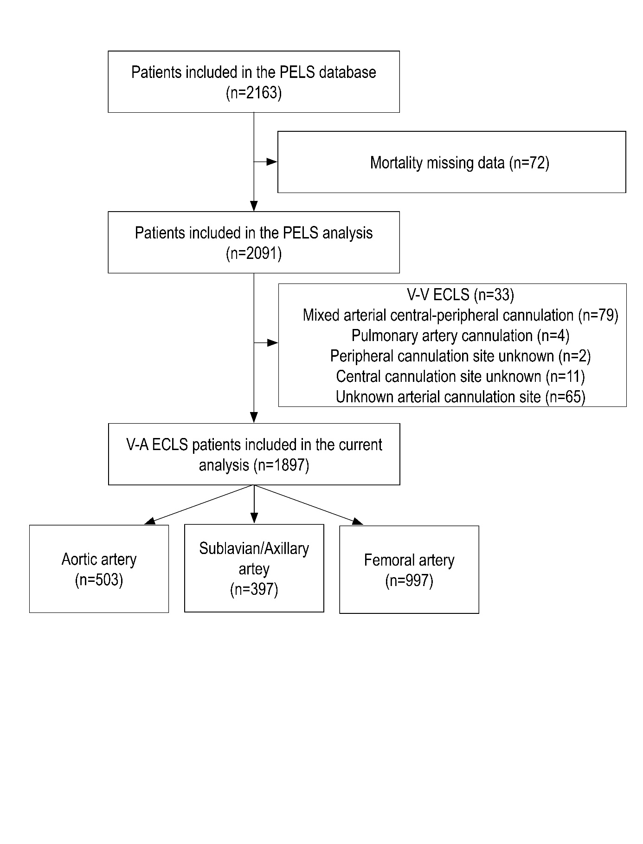

Supplementary Figure 2: Composite End-Point of Neurological Outcome in Sensitivity Analysis Including Patients From 2010 to 2020
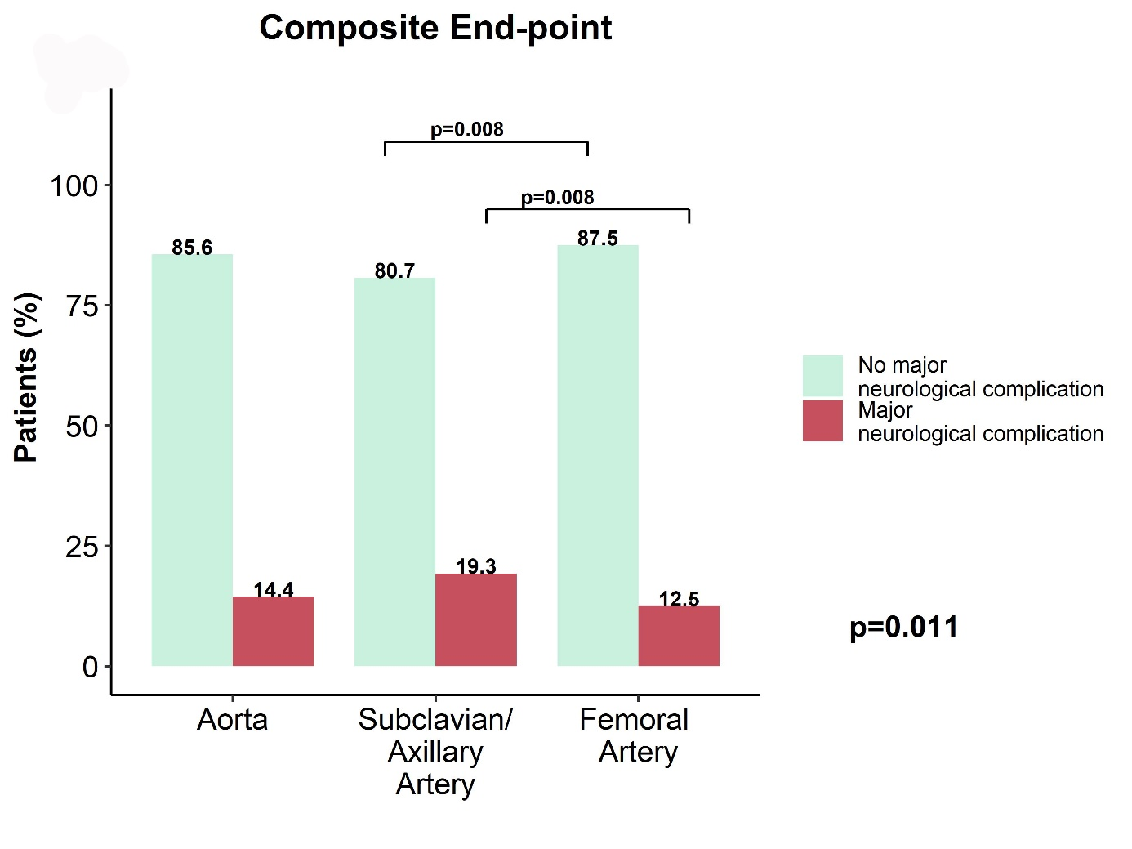

Supplementary Figure 3: Time of death in Sensitivity Analysis Including Patients From 2010 to 2020
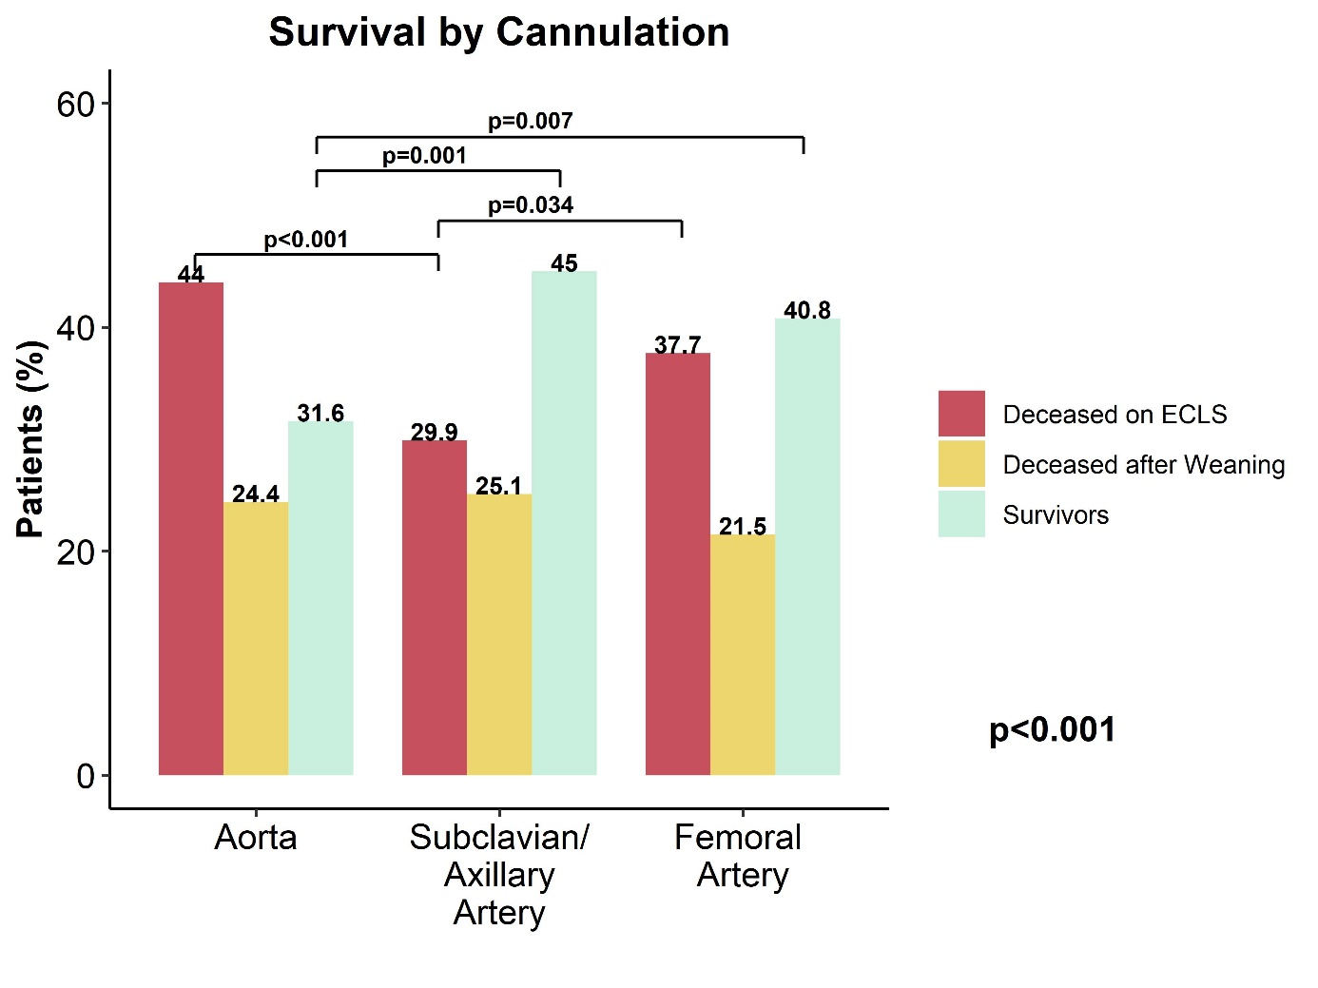

Supplementary Figure 4: Survival in Subclavian vs Femoral vs Aortic Cannulation including patients from 2010 to 2020
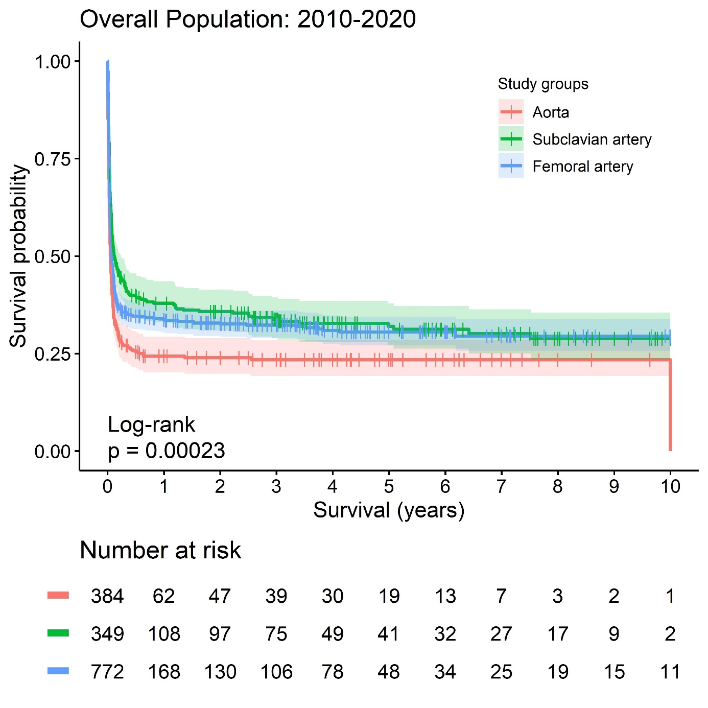

Supplementary Figure 5: Neurological Outcome Excluding Patients with Previous Stroke, Transient Ischemic Attack, Peripheral Vessel Disease or Cardiac Arrest
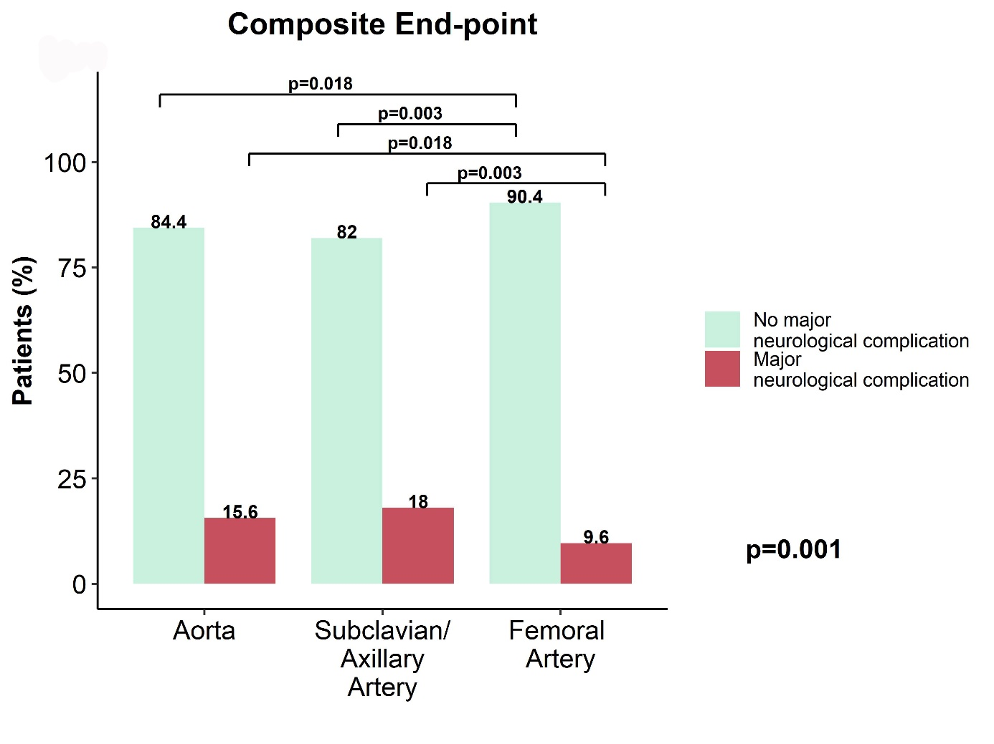

Supplementary Figure 6: Time of Death Excluding Previous Stroke, Transient Ischemic Attack, Peripheral Vessel Disease or Cardiac Arrest
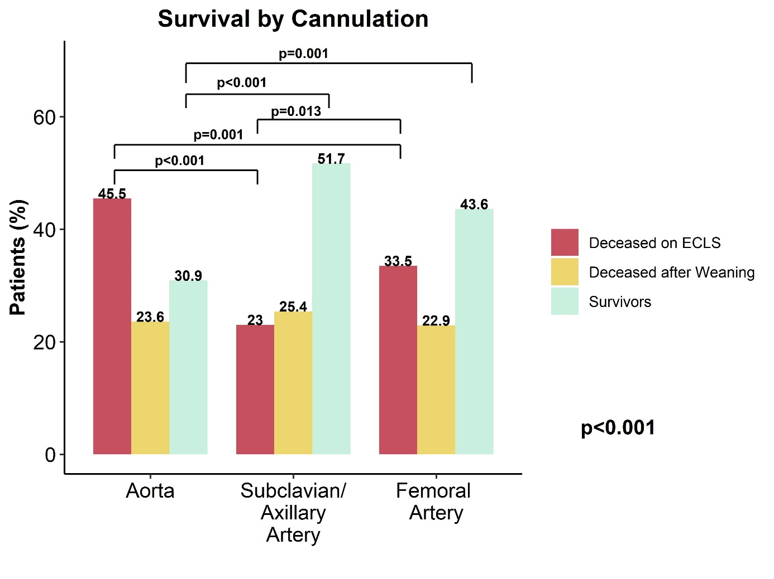

Supplementary Figure 7: Survival after Exclusion of Previous Stroke, Transient Ischemic Attack, Peripheral Vessel Disease or Cardiac Arrest.
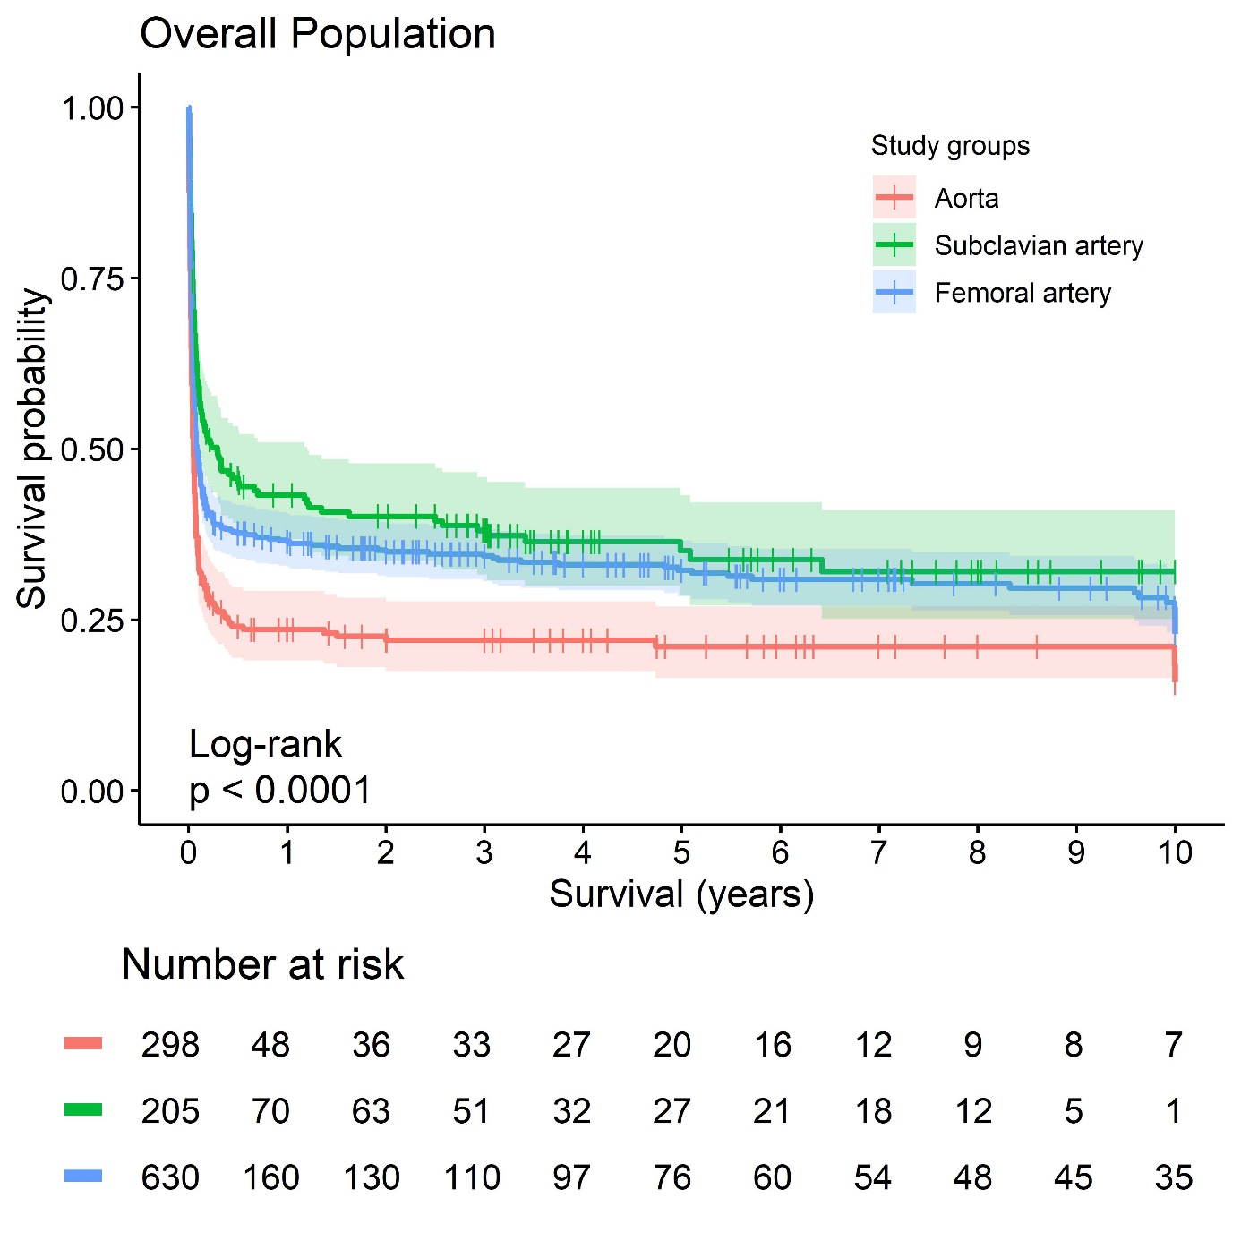

References
1. Lorusso R, Gelsomino S, Parise O, et al. Neurologic Injury in Adults Supported With Veno-Venous Extracorporeal Membrane Oxygenation for Respiratory Failure: Findings From the Extracorporeal Life Support Organization Database. Crit Care Med. Aug 2017;45(8):1389-1397. doi:10.1097/ccm.0000000000002502
2. Biancari F, Dalén M, Fiore A, et al. Multicenter study on postcardiotomy venoarterial extracorporeal membrane oxygenation. J Thorac Cardiovasc Surg. May 2020;159(5):1844-1854.e6. doi:10.1016/j.jtcvs.2019.06.039
3. Khanduja S, Kim J, Kang JK, et al. Hypoxic-Ischemic Brain Injury in ECMO: Pathophysiology, Neuromonitoring, and Therapeutic Opportunities. Cells. Jun 5 2023;12(11)doi:10.3390/cells12111546
4. Mateen FJ, Muralidharan R, Shinohara RT, Parisi JE, Schears GJ, Wijdicks EF. Neurological injury in adults treated with extracorporeal membrane oxygenation. Arch Neurol. Dec 2011;68(12):1543-9. doi:10.1001/archneurol.2011.209
5. Singer M, Deutschman CS, Seymour CW, et al. The Third International Consensus Definitions for Sepsis and Septic Shock (Sepsis-3). JAMA. Feb 23 2016;315(8):801-10. doi:10.1001/jama.2016.0287
6. Kowalewski M, Zieliński K, Brodie D, et al. Venoarterial Extracorporeal Membrane Oxygenation for Postcardiotomy Shock-Analysis of the Extracorporeal Life Support Organization Registry. Crit Care Med. Jul 1 2021;49(7):1107-1117. doi:10.1097/ccm.0000000000004922

