Supporting Information
Ideal carrier multiplication in monolayer MoSe₂

Joonsoo Kim^{1,†}, Hong-Guk Min^{2,†}, Sehwan Park^{1,†}, Jin Cheol Park¹, Junhyeok Bang^{3*}, Youngkuk Kim^{2,*}, and Ji-Hee Kim^{4,*}

Method
Sample characterization
The steady-states absorption spectrum is obtained using VIS spectrometer (Stellarnet, USA). The tapping mode AFM images are presented in Supplementary Fig. S1 and were measured using an XE-7 microscope (Park Systems, Korea). Raman spectroscopy was carried out using an NTEGRA SPECTRA (NT-MDT, Netherlands).
Transient absorption spectroscopy
A pulse laser was generated by a mode-locked Ti:Sapphire amplifier (COHERENT, USA) with sub-25-fs pulse duration and 1 kHz repetition rate. The central wavelength of the pulse was 800 nm, divided into ~3:1 by a beam splitter. The intense pulse was applied to an optical parameter amplifier (Light Conversion, Lithuania) with tuning from 250 to 15,000 nm, and was used as a pump beam. We used pump energies of 3.54, 3.35, 3.26, 3.18, 3.10, 3.06, 2.76, 2.48, 2.07 and 1.97 eV to generate photoexcited carriers below and above the 2E_{g} range. The absorbed photon density was controlled to within a range of 5 × 10¹¹ to 4 × 10¹² photons cm⁻². The weak pulse was focused on a nonlinear crystal to generate a white-light continuum (450~800 nm) that was used as a probe beam. The white light was divided by a beam splitter; one beam passed through the sample to detect the transient absorption signal (probe), and the other was used to reduce noise levels (reference). The signal and reference signals were collected by a spectrometer (Helios Fire, Ultrafast Systems, USA) with 2-nm spectral resolution. The delay stage controlled the probe beam path for time delay with the pump pulse.
The transient absorption signal was obtained by measuring the differential absorption, $∆A\left(E,t\right)$, with and without pump excitation for a given probe energy $E$ and time delay $t$, described as:
$∆A\left(E,t\right)=A_{pump-on}\left(E,t\right)-A_{pump-off}(E,0)$.
The carrier distribution in the spectral range could then be analyzed using the broadband probe and spectrometer. The relative time delay between the pump and probe was used to track carrier population dynamics, such as the recombination process. To this end, we obtained a three-dimensional spectrum and time-resolved dataset. In the spectral analysis, after the pump excited the carriers ($t>0)$, the carriers rapidly thermalized and occupied the conduction band edge. The filled band induced reduction of absorption$(∆A<0$) at bandgap energy due to Pauli blocking or band-filling effects, indicated as photobleaching. Excited carriers promoted increased absorption to an upper state$(∆A>0$), called photoinduced absorption.
Femtosecond spatiotemporal transient absorption microscopy (TAM) technique
A pump pulse was generated from the optical parameter amplifier system (Light Conversion, Lithuania). We used 600 nm excitation with ~1 x 10¹⁴ photons cm⁻². The single wavelength pump and the broadband probe pulse in the visible range passed through an objective lens (Nikon, TU Plan ELWD, ×50, 0.60 NA) and were focused on the sample with a 2-μm spot size at 600 nm. The probe light passing through the sample was collimated by another objective lens (Nikon, TU Plan ELWD, ×50, 0.60 NA) and detected by the spectrometer (Helios, Ultrafast system, USA).
Density functional theory (DFT) calculation
First-principles calculations based on DFT were performed using the Quantum Espresso package¹. We considered spin-orbit coupling using fully relativistic pseudopotentials, generated by the OPIUM code^{2, 3}. The Perdew-Burke-Ernzerhof generalized gradient approximation (PBE-GGA)⁴ was employed to approximate the exchange-correlation energies. The plane-waves basis was generated under the kinetic energy cutoff of 60 Ry. For atomic and electronic structure calculations, we used the Monkhorst-Pack sampling⁵ of $k$ points from the 12×12×1-grid and 12×12×4-grid of the monolayer and bulk MoSe₂ first Brillouin Zone (BZ), respectively. The atomic structure of monolayer MoSe₂ was obtained by minimizing the total energy with a fixed interlayer distance to 16.0 Å, sufficiently large enough to mimic the vacuum for the monolayer. These calculations led to the in-plane lattice constant a = 3.30 Å. The internal coordinates were fully relaxed for given lattice parameters, which led to the vertical distance between the nearest Mo and Se layers z ~ 1.67 Å, which agrees well with the literature⁶. For the bulk MoSe₂ structure, the atomic structure was fully relaxed until the Hellmann-Feynman forces were fully reduced below 10⁻⁶ Ry/Bohr, leading to the bulk lattice constants a ~ 3.30 Å and c ~ 12.91 Å in good agreement with previous studies^{7, 8}.
The Wannier Hamiltonian was generated using the Wannier90 package⁹. We used Mo d orbitals and Se p orbitals as initial projectors to describe the energy bands near the Fermi level E_{F}. The Wannier Hamiltonian reproduced the DFT bands in the frozen window of –4.99 eV < E – E_{F} < 3.51 eV and –3.95 eV < E – E_{F} < 3.55 eV for the monolayer and bulk MoSe₂, respectively. We employed the constant shift approach to model the experimental direct and indirect band gap of the monolayer and bulk MoSe₂, respectively. The monolayer conduction bands were shifted by 0.14 eV, while the bulk conduction bands were shifted by 0.33 eV. These shifts result in experimental band gaps of 1.19 eV and 1.54 eV for the bulk and monolayer, respectively.

Note 1. Evidence of carrier multiplication
When carrier multiplication (CM) occurs, the excess energy above bandgap excites additional electron-hole pairs. This process manifests through three distinctive fingerprints:
(1) Increase of the maximum ${|∆A\left(E\right)|}_{\text{max}}$
The number of excited carriers is linearly proportional to ${|∆A\left(E\right)|}_{\text{max}}$. As depicted in Figs. 1b and 1c, the two-fold increase in ${|∆A\left(E\right)|}_{\text{max}}$ above CM threshold energy (2.30E_{g}) indicates a corresponding two-fold increase of excited carriers.
(2) Transient Stark shift
CM occurring within a few picoseconds, leads to a transient local electric field enhancement, resulting in a transient Stark shift. This phenomenon causes linewidth broadening and redshift at early time delays as observed in Supplementary Fig. S5. The increased number of carriers arising from CM rapidly undergo Auger recombination, causing the spectral shift to disappear and return to the state without CM. The temporal evolution of the transient Stark shift is shown in Supplementary Fig. S6.
(3) Delayed build-up dynamics
Without CM, the excess energy rapidly thermalizes to band-edge states, leading to prompt build-up dynamics. However, when the photon energy exceeds the CM threshold energy, the build-up time is delayed owing to the additional energy relaxation process (red arrow in Fig. 1a). Notably, the threshold energy of CM in monolayer MoSe₂ is exactly twice the bandgap, such that the delayed build-up is observed at >2E_{g} excitation (Fig. 1b and Supplementary Fig. S7 for monolayer and Supplementary Fig. S8 for bulk).
These three distinct features serve as clear validation of CM.

Note 2. Evaluation of quantum yield
CM efficiency is evaluated through carrier generation rate per photon. Using transient absorption spectroscopy, we monitored the carrier population based on the spatio-temporally resolved ΔA signal. The absorbed photon density (APD) is calculated by pump fluence, absorption (Supplementary Fig. S2a for monolayer and Supplementary Fig. S9 for bulk MoSe₂), and beam area:
$APD=\frac{Power\left(J\right)×Absorption×e}{Area{(cm}^{2})×Energy (eV)}$,
where e is electric charge to convert Joules to electron volts. We used a 75-$μ$m pinhole to calculate the beam area from the post-to-pre-pinhole power ratio. Detailed APD calculations are shown in Tables S1 and S2. The MoSe₂ sample was excited with a sufficiently low photon density (10¹¹–10¹⁴ photons /cm²) that nonlinear effects, including many-body effects, were negligible (Fig. 1c, Supplementary Figs. S7 and S10). Based on the maximum $∆A$_{max} intensity for the A exciton as a function of absorbed photon density at various pump energies, we were able to obtain the linear slope by linear fitting (Fig. 1c for monolayer and Supplementary Fig. S4 for bulk). This linear slope implies the rate of carrier generation per photon. The slopes were identical at excitation < 2E_{g}, whereas the slopes became steeper at pump energies > 2E_{g}. Below 2E_{g}, CM does not occur, and the average slope corresponds to a quantum yield (QY) of 1, equivalent to one photon generating one electron-hole pair. Twice that slope is QY = 2, wherein one photon creates two electron-hole pairs. Each slope was normalized by the QY = 1, and the results are presented in Fig. 1d as a function of excitation energy normalized by the bandgap (E_{g}). The same evaluation method was applied to analyze the results for bulk MoSe2, as illustrated in Fig. 1d and Supplementary Fig. S4.

Note 3. Quantification of CM efficiency
We quantified CM efficiency based on the competition between relaxation and CM. This model is described in detail in Beard et al¹⁰. CM QY can be depicted as:
$$QY=\sum_{j=1}^{m}{j\frac{k_{cool}\prod_{i=0}^{j}{k_{CM}^{(i-1)}}}{\prod_{i=1}^{j}{(k_{cool}+k_{CM}^{\left(i\right)})}}} ,$$
where $k_{cool}$ is the cooling rate, $k_{CM}$ is the carrier multiplication rate, and m is rounding down to the nearest integral product of the photon energy over the bandgap. Thus, $m=\left[hv/E_{g}\right]$ and $k_{CM}^{0}=1$. The competition between $k_{cool}$ and $k_{CM}$ is expressed as:
$$k_{CM}=k_{cool}P{\left(\frac{hν-hν_{th}}{hν_{th}}\right)}^{s} ,$$
Where P is the competition factor between $k_{CM}$ and $k_{cool}$, and the exponent s is set to 2 due to Keldysh treatment^{10, 11}. Finally, CM efficiency ($η_{CM}$) can be defined as:
$$η_{CM}=\frac{P}{P+1} × 100\% .$$
Using QY, we calculate the ratio R_{CM} = (N_{CM} – N₀)/N₀ × 100%. N_{CM} (N₀) is the number of carriers generated in the energy range from 2E_{g} to 3E_{g} with (without) CM, respectively. As such, we get N_{CM} (N₀) by integrating QY for a corresponding $η_{CM}$ (for $η_{CM}$=0).

Note 4. Details regarding CM calculations
In this subsection, we explain the details of the CM calculations used in this study, as depicted in Supplementary Fig. S11. We describe the situation where an excited first electron in the initial $I_{1}$ state in the conduction band jumps to final state $F_{1}$ in the same or another conduction band while transferring its energy and momentum to a second electron in the initial $I_{2}$ state in the valence band, such that the second carrier jumps to final state $F_{2}$, satisfying energy-momentum conservation. We describe the CM probability $μ\left(ℏω,I_{1}\right)$ as:
$$μ\left(ℏω,I_{1}\right)=\sum_{m}^{occ}{\sum_{n_{F_{1}}}^{unocc}{∫dk_{F_{1}}δ(ℏω-E_{n_{I_{1}}}({k_{I}}_{1}}})+E_{m}({k_{I}}_{1})) ξ(I_{1},F_{1}) (1)$$
$$ξ\left(I_{1},F_{1}\right)= \sum_{{n_{F}}_{2}}^{unocc}{\sum_{{m_{I}}_{2}}^{occ}{∫dk_{I_{2}}}dk_{F_{2}}δ(E_{n_{F_{1}}}+E_{m_{I_{2}}}-E_{n_{I_{1}}}-E_{n_{F_{2}}})δ(k_{F_{1}}+k_{I_{2}}-k_{I_{1}}-}k_{F_{2}}). (2)$$
Here, $m$ is the band index for the occupied bands, $k_{α}$ ($n_{α}$ and $m_{α})$ is the lattice momentum (band indices) of the $α$ state ($α=I_{1}, I_{2},F_{1,}$ and $F_{2})$. The delta function $δ(ℏω-{E_{n}}_{I_{1}}\left(k_{I_{1}}\right)+E_{m}\left(k_{I_{1}}\right))$ in Eq. (1) imposes energy conservation during the optical excitation process for a given photon energy $ℏω$, while the two delta functions in Eq. (2) impose energy-momentum conservation during the CM transitions $I_{1}→F_{1}$ and $I_{2}→F_{2}$.
To model the experimental conditions, in which a pump laser with a finite full width at half maximum (FWHM) is used, $δ(ℏω-{E_{n}}_{I_{1}}\left(k_{I_{1}}\right)+E_{m}\left(k_{I_{1}}\right))$ was approximated by the Gaussian function. The FWHM of the Gaussian function was set at 79.49 and 50.61 meV for the monolayer and bulk cases, respectively, following the accuracy of the pump laser used for the corresponding CM experiments. Direct calculation of the triple integrations over the whole momentum space—one in Eq. (1) and two in Eq. (2)—is highly resource-intensive. We thus proposed an alternative approach, which generalizes the scheme introduced by Bang and Kang¹² into higher dimensions.

Computational Methods for the CM efficiency density N(I₁)
To efficiently evaluate the multiple integrals over momentum space, we extended Bang-Kang’s approach¹² as follows. First, for a given first carrier’s initial state ($I_{1})$, we searched for the final state ($F_{1})$ by sweeping over the entirety of the unoccupied bands (2nd and 3rd bands, in this specific example) on a momentum grid within the energy window $\left|E_{3_{F_{1}}}-E_{I_{1}}\right|> E_{g}$ or $\left|E_{2_{F_{1}}}-E_{I_{1}}\right|> E_{g}$, as depicted in Supplementary Fig. S12a. Here, $E_{I_{1}}$ is the energy of $I_{1}$state, $E_{2_{F_{1}}} and E_{3_{F_{1}}}$ are the respective energies of the $F_{1}$ states in the 2nd and 3rd bands, and $E_{g}$ is the global energy gap. We note that when $ℏω∼2E_{g}$, the energy difference between $I_{1}$ and $F_{1}$ should be comparable to $E_{g}$ $(\left|E_{3_{F_{1}}}-E_{I_{1}}\right|∼E_{g} or \left|E_{2_{F_{1}}}-E_{I_{1}}\right|∼E_{g}$ in our specific example) to fulfil the energy conservation imposed by the ${2E}_{g}$ optical excitation described by $δ(ℏω-E_{n_{I_{1}}}\left({k_{I}}_{1}\right)+E_{m}\left(k_{I_{1}}\right))$ (Supplementary Fig. S12a). Once we had obtained the list of $F_{1}$ states with energy and momentum differences $Δ_{E}(I_{1},F_{1})=E_{{3(2)}_{F_{1}}}-E_{I_{1}}, { Δ}_{k}(I_{1},F_{1})=k_{F_{1}}-k_{I_{1}}$, we shifted the valence bands by $-Δ_{E}(I_{1},F_{1})$ and $-Δ_{k}(I_{1},F_{1})$ in energy-momentum space (Supplementary Fig. S12b).$I_{2}$ and $F_{2}$ can be efficiently and simultaneously determined by counting the density of crossing states between the shifted valence and the conduction bands. This scheme is pivotal to avoid the double momentum integration, $∫∫dk_{I_{2}}dk_{F_{2}}$, thereby greatly reducing the computational cost. Note that counting the crossing points can be done much more efficiently by first subtracting the shifted valence band energy from the conduction band energy on the momentum grid and obtaining the density of states (DOS) from the subtracted energies. One can then figure out the existence of the crossing point by simply summing the DOS at the zero energy over the conduction bands on the momentum grid. These results require proper normalization by dividing by the square of the number of sampled $k$-points. Supplementary Fig. S12c shows example crossing points and corresponding excited carriers at $F_{1}$ and $F_{2}$. The crossings occur when the energy difference (indicated by the green double arrows) is zero for a given momentum, as marked by the red circles.

Details of CM calculations for monolayer MoSe₂
CM efficiency was calculated from the 20×20×1 uniform k-grid in the first Brillouin zone (BZ) of monolayer MoSe₂ (Supplementary Fig. S13d). We considered optical excitation by $ℏω= {2E}_{g}∼$ 3.08 eV. The FWHM of $79.5$ meV was incorporated into our calculations by introducing the Gaussian function. The color gradient in Supplementary Fig. S13b. highlights the band crossings obtained by summing the Gaussian functions from different valence bands. Due to energy conservation, it was safe to search for qualified $F_{1}$ states within the energy window $-1.3{ E}_{g}<E_{n_{F_{1}}}-E_{I_{1}}<-0.91 E_{g}$ for this monolayer case. To obtain the zero-energy DOS, which corresponds to the count of the band crossings, from a discretized $k$-point sampling, we used a Gaussian broadening of 100 meV for the energy difference between the pristine conduction and the shifted valence bands. The normalized CM efficiency was then linearly interpolated along the high-symmetry lines $Γ-M-K-Γ$. The CM efficiency is localized at the $K$ and $K’$ points. Thus, our calculations support that CM can occur near $K$ and $K’$.

Details of CM calculations for bulk MoSe₂
CM efficiency was calculated from the 20×20×4 uniform k-grid in the first BZ of bulk MoSe₂ (Supplementary Fig. S14d). Optical excitation by $ℏω= {2E}_{g}∼$ 2.38 eV was considered, and Gaussian functions with FWHM of $50.6$ meV were used. We used the lower FWHM in the bulk calculations due to the experimental conditions, in which the lower indirect band gap of bulk MoSe₂ requires a lower-frequency laser, accompanied by lower FWHM. The Gaussian functions at a given conduction band point were summed over the valence bands highlighted by the color gradient in Supplementary Fig. S14b. We searched qualified $F_{1}$ states within the energy window $-1.68E_{g}<E_{n_{F_{1}}}-E_{I_{1}}<-0.84E_{g}$ for this bulk case. To obtain the zero-energy DOS from a discretized $k$-point sampling, we used a Gaussian broadening of 100 meV for the energy difference between the conduction bands and the shifted valence bands. The normalized CM efficiency was then linearly interpolated along the high-symmetry lines $Γ-M-K-Γ-A-L-H-A$. These calculations yielded a CM efficiency that was nearly zero over the whole BZ. Thus, our calculations indicate that the CM efficiency of bulk MoSe₂ is negligible for the tested ${2E}_{g}$ optical excitation.

Note 5. Spatiotemporal carrier dynamics
We analyzed the spatial carrier distribution $∆A$(x, t) via multiple pump location measurements relative to the probe center. The pump-probe distance (d) was controlled by moving the pump position in one direction, across a range of -3 μm to 3 μm. The relative distance between the pump and probe was tracked by a CCD camera. The carrier distribution for the distance at a certain time was fitted by the Gaussian function as follows:
$ΔA \left(x, t\right)≈ N\left(x,t\right)=N(0,t)*exp⁡[-\frac{{(x-x_{0})}^{2}}{{2*σ}^{2}(t)}]$, (1)
where $N$ is the carrier population represented by $∆A$, x is the distance between the pump and probe, and $σ$ is the Gaussian broadening width. Spatial broadening over time can be described as a function of the relationship between the Gaussian width and the diffusion coefficient ($D$):
$D=\frac{Δσ^{2}(t)}{2Δt}=\frac{σ^{2}\left(t\right)-σ^{2}(0)}{2Δt}$. (2)
Owing to the linear relation between $D$ and $Δσ^{2}(t)$, D was obtained by linear fitting in Fig. 3d and Supplementary Fig. S15. The diffusion length ($L$) was calculated by
$L=\sqrt{Δσ^{2}\left(t\right)-σ^{2}(0)}$. (3)

Note 6. Carrier diffusion in MoSe₂
The initial fast carrier diffusion coefficients in monolayer and bulk MoSe₂ are 1.0 × 10⁴ and 0.3 × 10⁴ cm²/s, respectively (Fig. 3d). This rapid carrier diffusion contributes to fast hot carrier expansion. After photoexcitation, the carrier temperature reaches thousands of degrees Kelvin due to lower heat capacity of the electrons, and hot carriers expand rapidly with their excess energy converting to high kinetic energy. After this expansion, negative diffusion occurs from 1–10 ps because of the temperature mismatch between the diffusion of hot carriers and excitons, as seen in previous results^{13, 14} (Supplementary Fig. S15). During this contraction, carrier–phonon coupling induces thermalization of the hot carriers. They rapidly cool down to band-edge states, losing their kinetic energy and forming excitons. However, carrier–phonon coupling leads to lattice heating within 10 ps, resulting in the recovery of diffusion. The exciton diffusion coefficient is 10.4 cm²/s (Supplementary Fig. S15), almost identical to the reported diffusion coefficient (12 ± 3 cm²/s) for the MoSe₂ monolayer¹⁵. In contrast, the Gaussian width does not increase in bulk MoSe₂ after expansion. The many-body effects are negligible in our findings; hence, one possible explanation is that the defect states can restrict exciton diffusion, causing it to gradually reach a steady state over time. This is supported by the carrier dynamics of bulk MoSe₂, where recombination mainly occurs within 10 ps and residual or trap-captured excitons survive for up to 1 ns (Supplementary Fig. S8). A similar phenomenon has been observed in perovskite¹⁶ and bulk MoTe₂¹⁷.

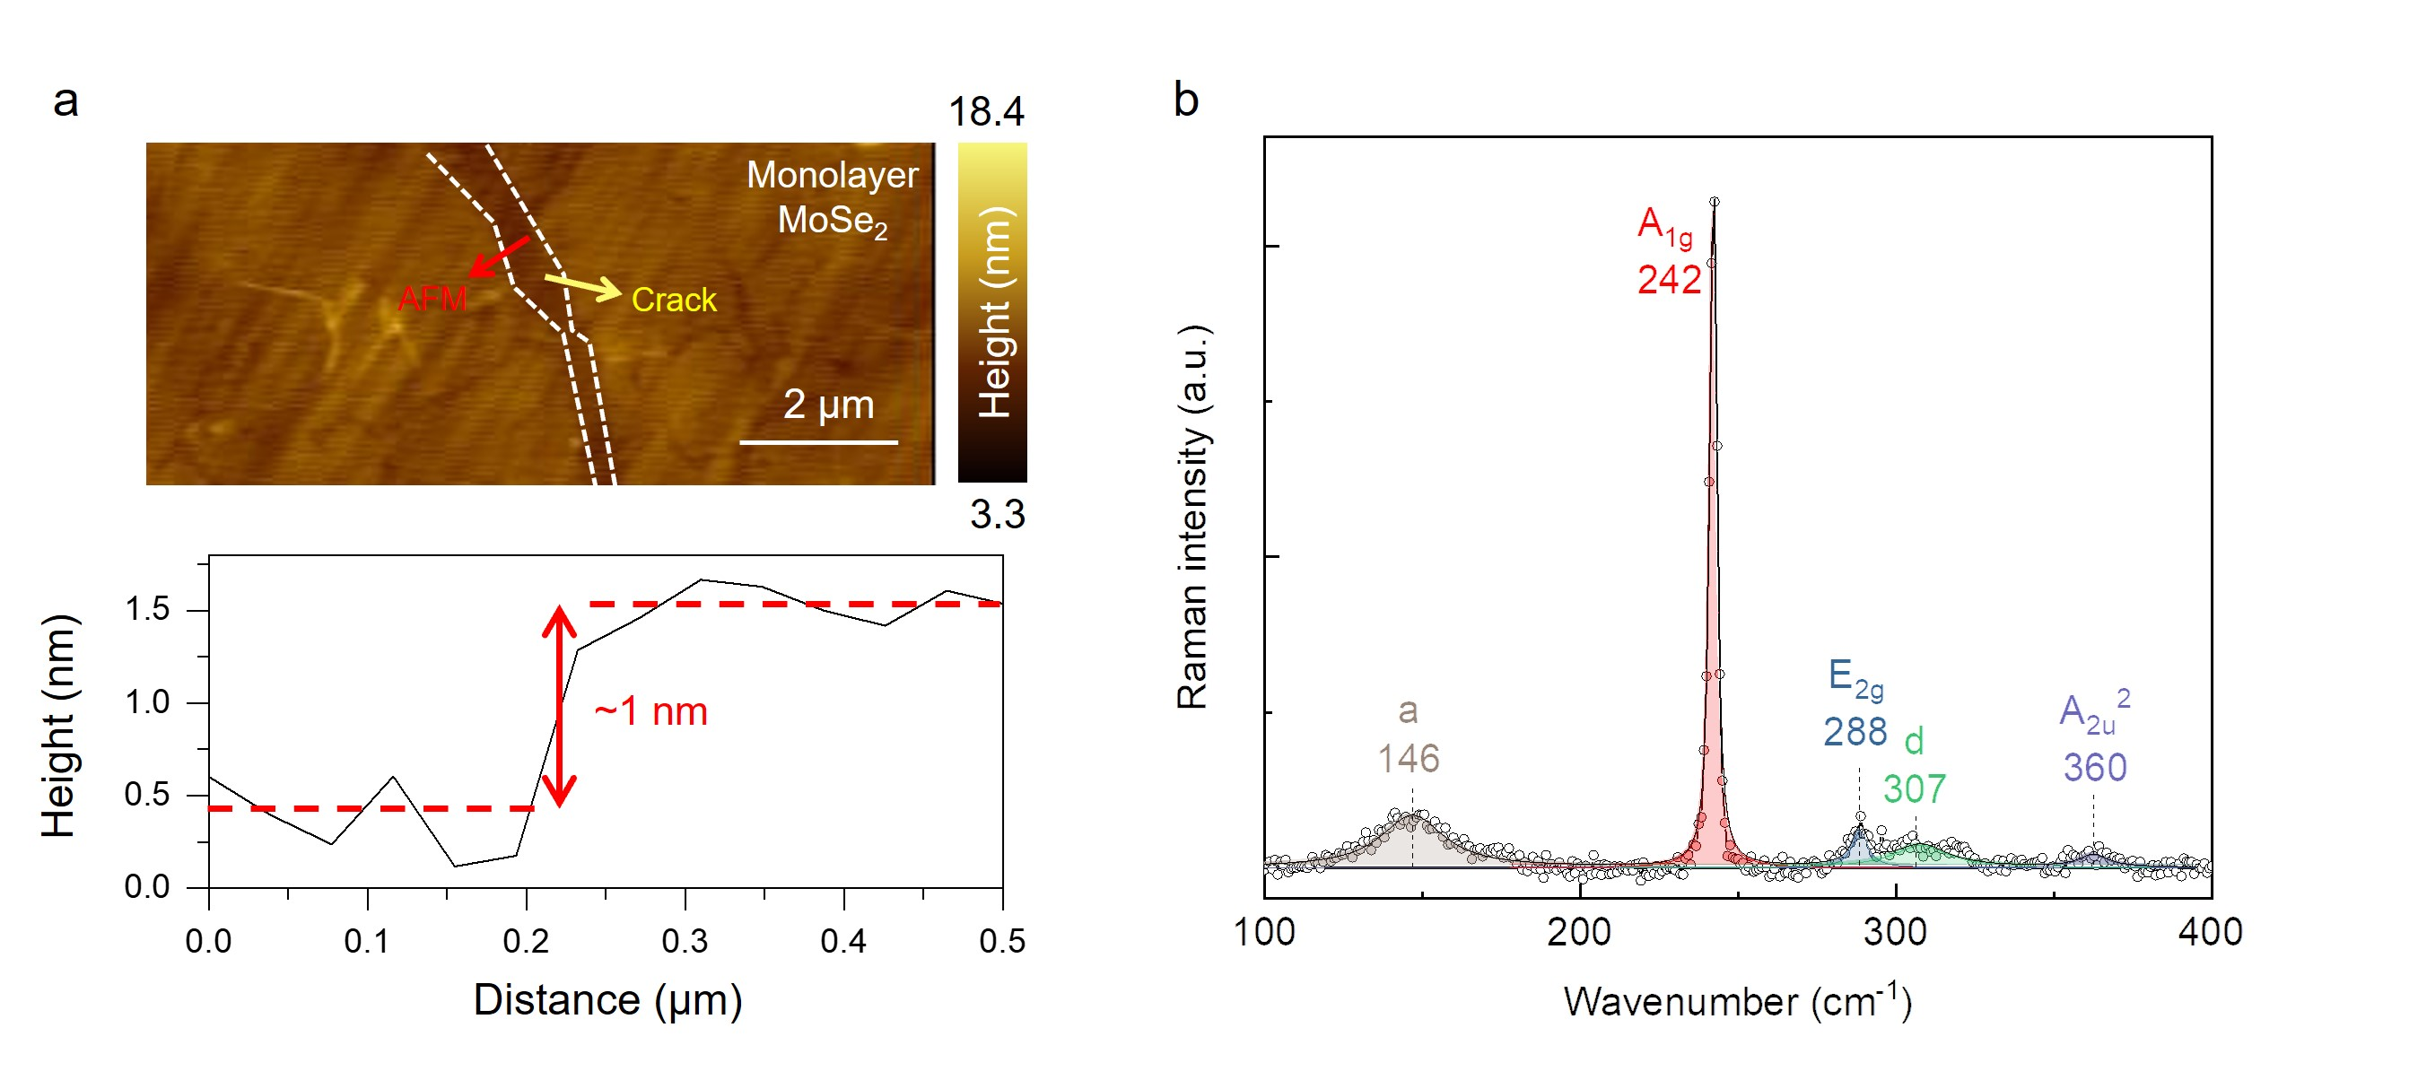 Supplementary Fig. S1. Sample characterization. (a) Atomic force microscopy (AFM) image (top) and height profile (bottom) of our MoSe₂ monolayer. We determined that the thickness of the MoSe₂ sample was 1 μm, which is close to typical thickness of a transition metal dichalcogenide (TMD) monolayer¹⁸. (b) Raman spectrum of the MoSe₂ monolayer. The spectrum was fitted using a Lorentzian function, showing peak position and vibration mode. The peak positions are identical to those of a MoSe₂ monolayer¹⁹.
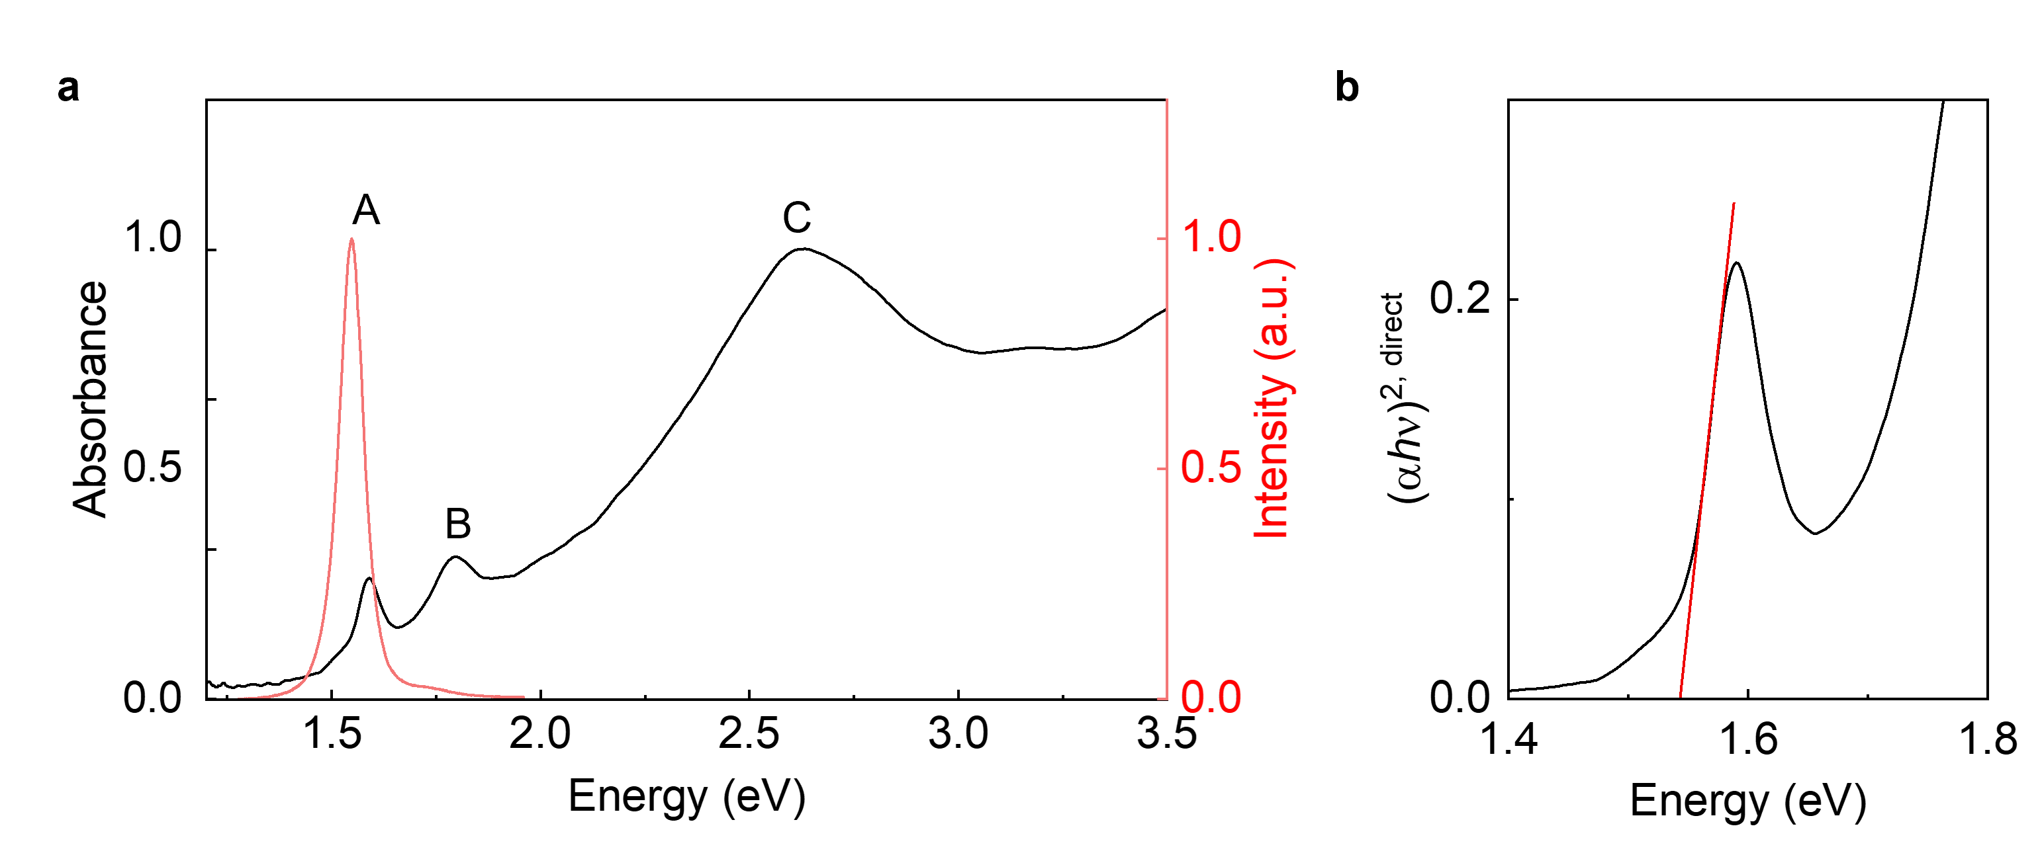
Supplementary Fig. S2. Absorption spectrum of monolayer MoSe₂ (a) The absorption spectrum of monolayer is depicted. Each exciton peak is denoted as A, B and C exciton. Red is photoluminescence data. (b) A Tauc plot of monolayer MoSe₂. We determined that the bandgap energy was 1.54 eV, which is equal to the photoluminescence peak energy.

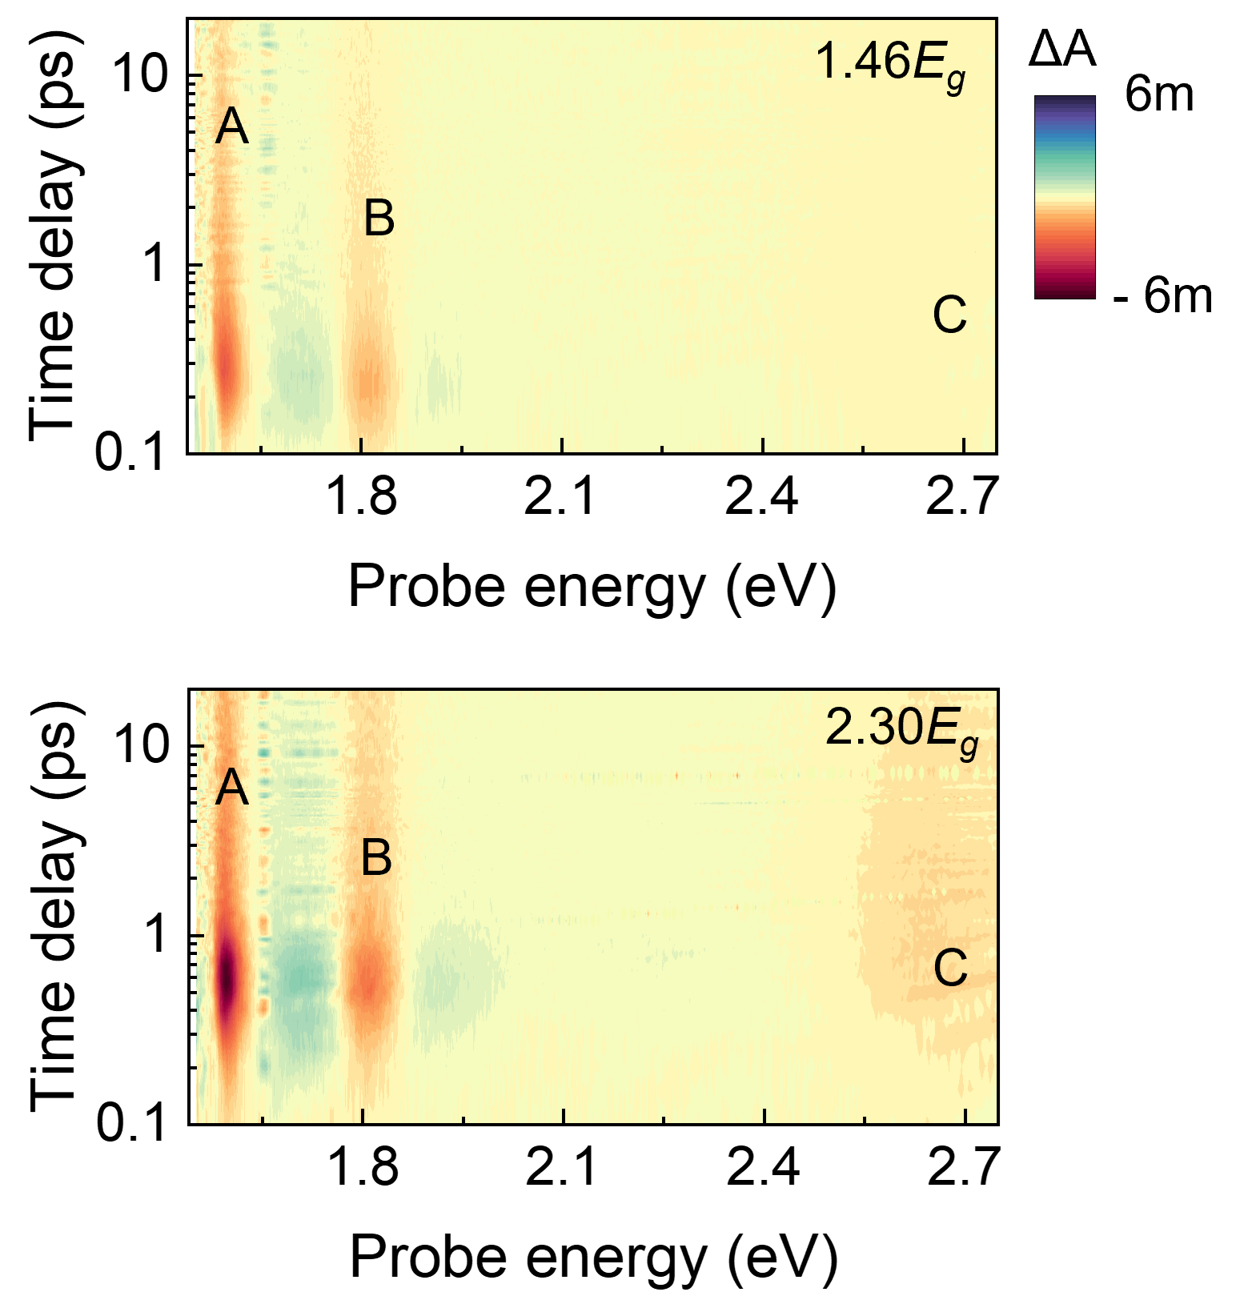
Supplementary Fig. S3. Transient absorption map of monolayer MoSe₂. Transient absorption spectroscopy using pump energies of a, 1.46$E_{g}$ (2.25 eV) and b, 2.30$E_{g}$ (3.54 eV) with the same photon density (1.5 × 10¹² cm⁻²). After excitation, the monolayer exhibits three photobleaching signals (i.e., the A, B, and C excitons), as observed at the absorption spectrum (Supplementary Fig. S2a). Despite experiencing the same photon density, the intensity of $∆A$ (i.e., the excited carrier density) is higher at 2.30$E_{g}$ than 1.46$E_{g}$ owing to carrier multiplication (CM).

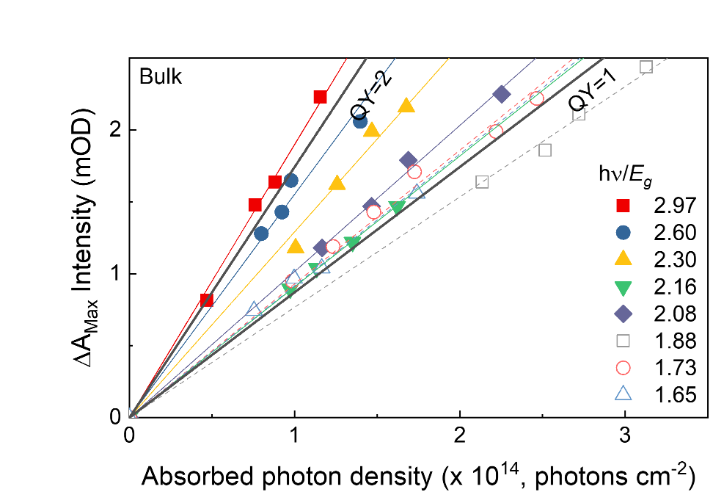
Supplementary Fig. S4. CM evaluation in bulk MoSe₂. The CM evaluation of bulk was performed in the same way as the monolayer in Fig. 1c.
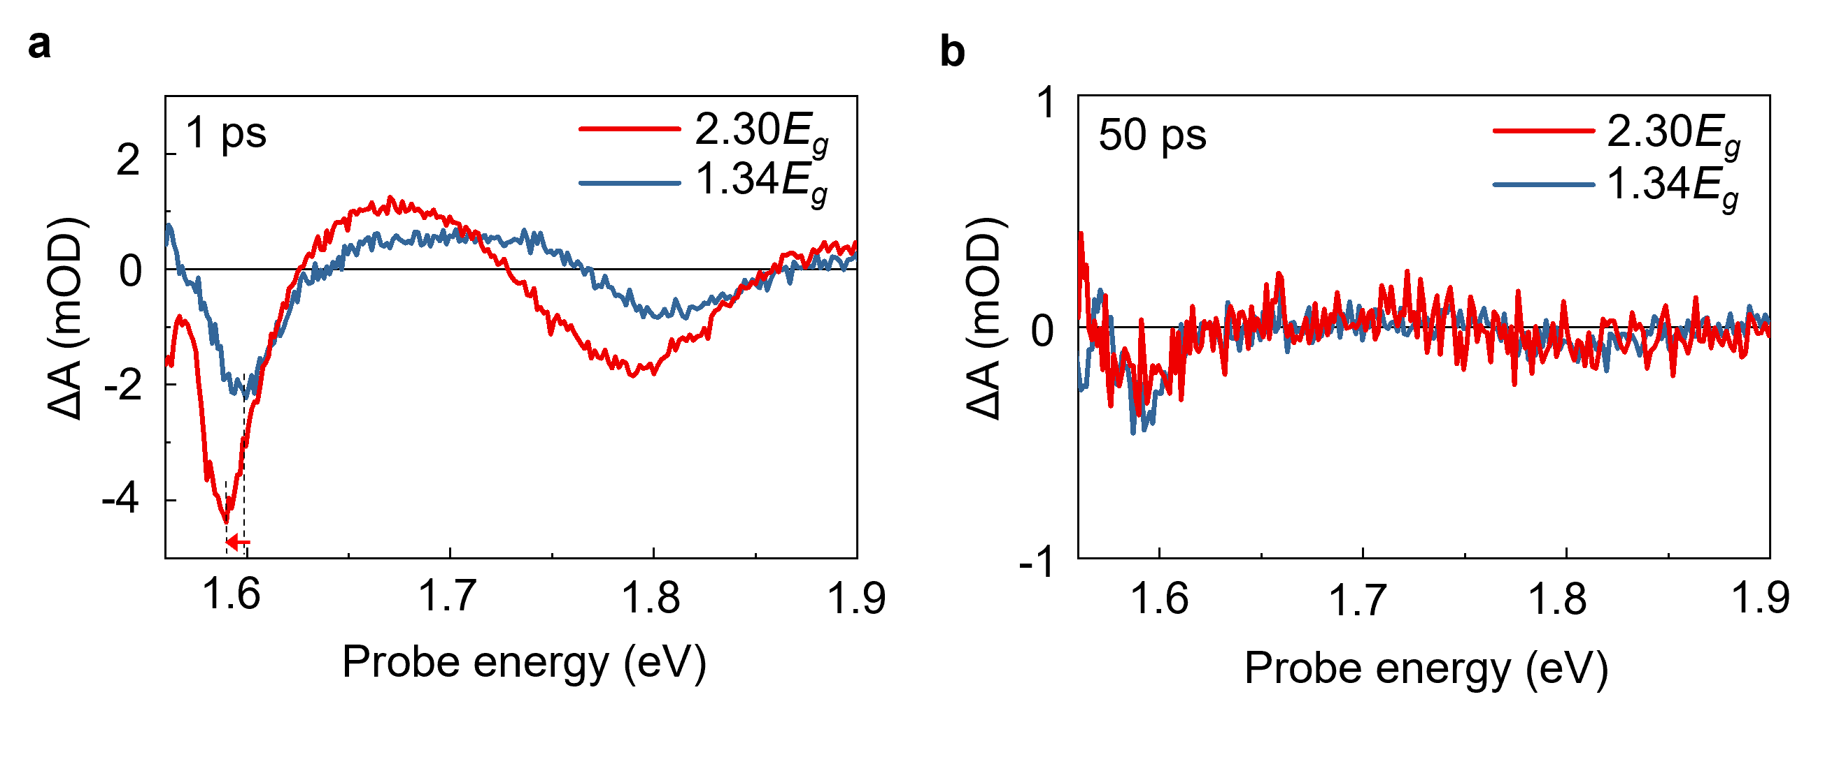
Supplementary Fig. S5. Transient absorption spectrum of monolayer MoSe₂. Transient absorption spectra were obtained by fixing the time delays to (a) 1 ps and (b) 50 ps with same photon density (1 × 10¹² cm⁻²). There are two obvious signatures of carrier multiplication. First, the carrier population at 2.30$E_{g}$ excitation is twice as high as that at 1.34$E_{g}$. Second, two PB peaks at 2.30$E_{g}$ are red-shifted at 1 ps (red arrows) due to Stark shift, compared to those at 1.34$E_{g}$. The validation of CM is explained in detail in Supplementary Note 1.

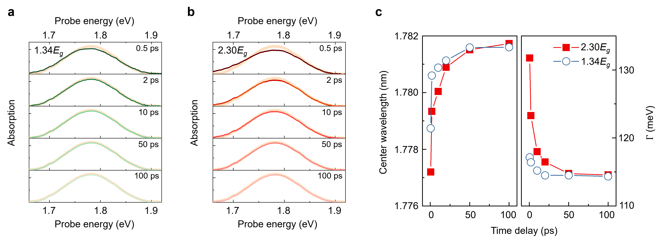 Supplementary Fig. S6. Transient absorption spectrum shift and broadening. We investigated transient spectra at 0.5, 2, 10, 50, and 100 ps with pump energies of 1.34$E_{g}$(a) and 2.30$E_{g}$(b). The time evolution of the spectra was fitted to a Gaussian function, and the center wavelengths and linewidth are plotted in (c). The temporally longer shift and broadening at 2.30$E_{g}$ were induced by local electric field enhancement owing to CM.

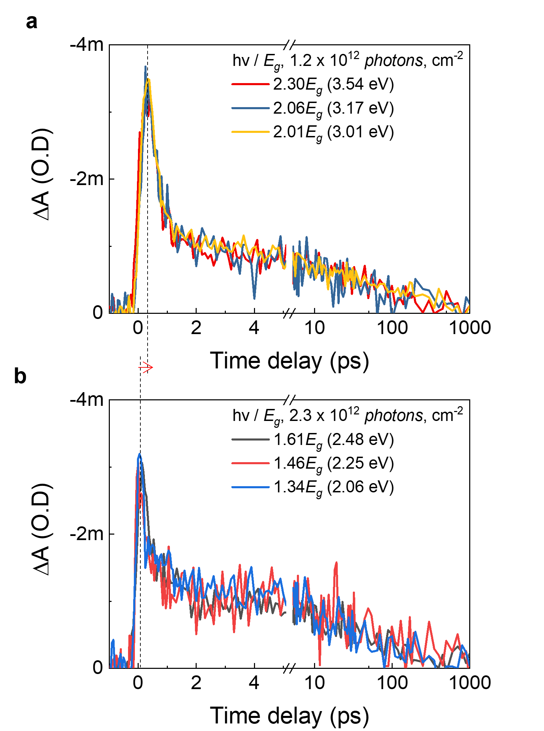
Supplementary Fig. S7. Carrier dynamics at the A exciton with different excitation energies. The carrier dynamics were investigated to evaluate CM with photon energies (a) above or (b) below 2$E_{g}$ at the A exciton state. Considering that $∆A$ represents photoexcited carrier density, $∆A$ intensities are equal under the same photon density conditions. However, above 2E_{g}, the intensity is observed to be twice that compared to below 2E_{g} owing to CM. Moreover, the rising dynamics above 2$E_{g}$ are slower (red arrow) than those observed at excitation < 2$E_{g}$, providing evidence of the CM.
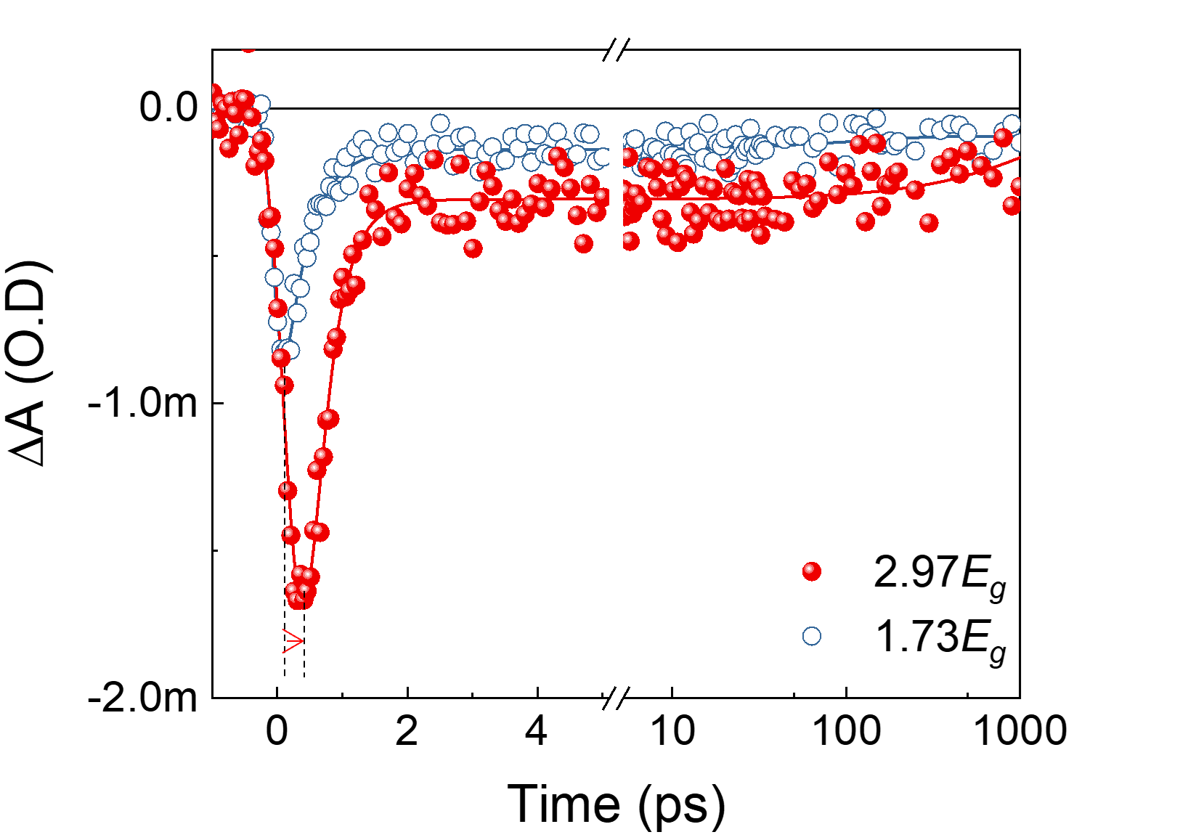
Supplementary Fig. S8. Transient absorption of bulk MoSe₂. Transient absorption kinetics with excitation at 2.97$E_{g}$ (red) and 1.73$E_{g}$ (blue). The absorbed photon density was fixed at 1 × 10¹⁴ photons/cm².

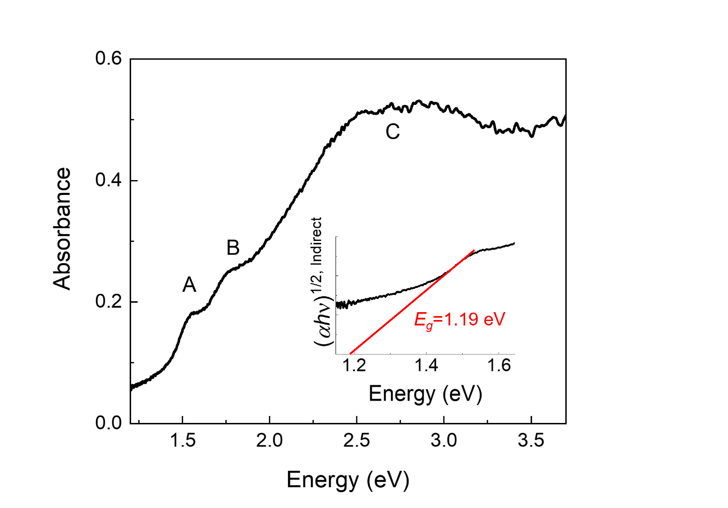
Supplementary Fig. S9. Optical characterization of bulk MoSe_{2.} Steady-state absorption of 30-nm bulk MoSe₂, including multiple peaks for the A, B, and C excitons. The inset shows a Tauc plot to determine the optical bandgap of bulk MoSe₂, revealing an indirect bandgap of 1.19 eV^{19, 20}.

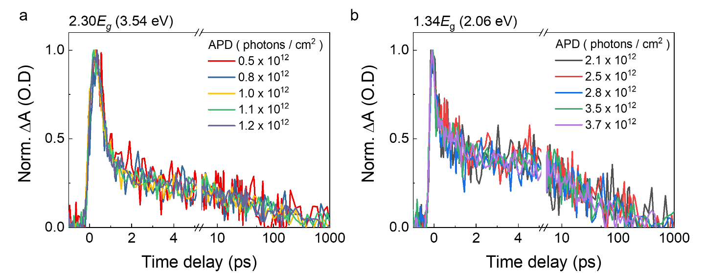
Supplementary Fig. S10. Normalized carrier dynamics at the A exciton. The $∆A$ dynamics were normalized with different photon density and pump energies at the A exciton state. The normalized $∆A$ dynamics were equal, even though the fluence increased. Moreover, the maximum $∆A$ intensity was linear as a function of photon density (Fig. 1c). This indicates that our investigation of CM was performed in a linear regime where non-linear effects are negligible.
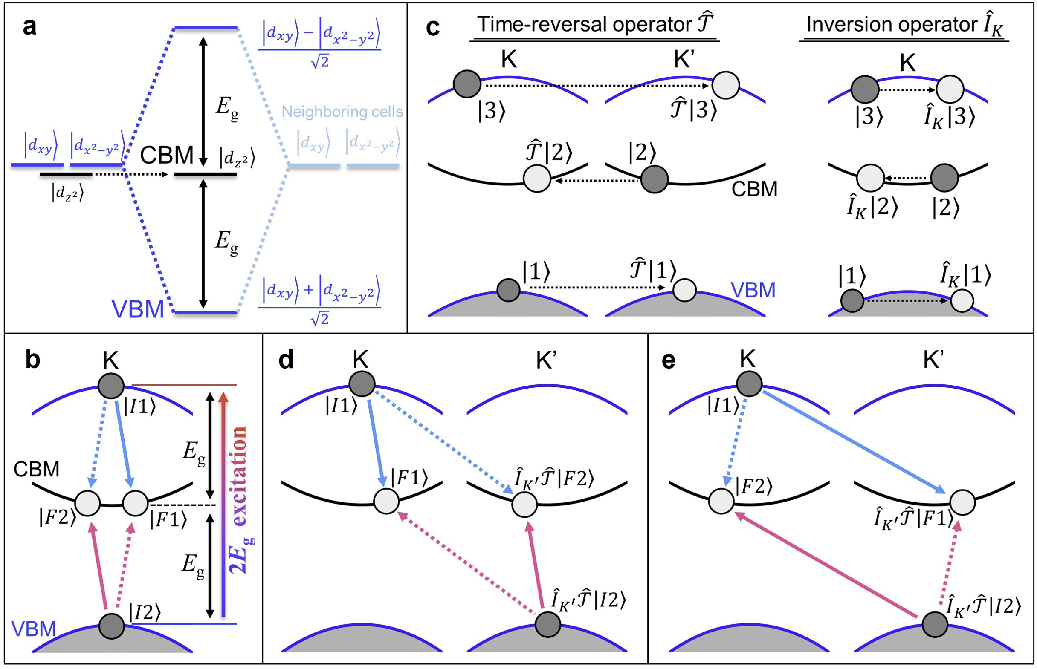
Supplementary Fig. S11. Inter-valley and intra-valley carrier multiplication process due to the valley symmetries. a, Schematic of orbital hybridization shown in the band structure of monolayer MoSe₂. For simplicity, we represent the three important orbitals $\left.\left|d_{z^{2}}\right.\right\rangle$, $\left.\left|d_{x^{2}-y^{2}}\right.\right\rangle$, and $\left.\left|d_{xy}\right.\right\rangle$ near the Fermi level in the vicinity of K and K’ points. $\left.\left|d_{x^{2}-y^{2}}\right.\right\rangle$ and $\left.\left|d_{xy}\right.\right\rangle$ (in blue) are hybridized through coupling with their counterparts in neighboring cells (in sky blue), forming the bonding and antibonding levels. This positions the $\left.\left|d_{z^{2}}\right.\right\rangle$ level near the middle of the bonding and antibonding levels. b, An example of the intra-valley CM channel. c, Schematic of the time-reversal operator $\hat{T}$ and the local inversions operator at K (or equivalently K') ${\hat{I}}_{K (K^{'})}$. The two blue and one black bands correspond respectively to the bonding, antibonding, and $\left.\left|d_{z^{2}}\right.\right\rangle$ levels in (a). d, e, Inter-valley CM channels. For the intra-valley CM channel comprising ($I_{1},I_{2},F_{1},F_{2})$ in (c), one inter-valley CM channel in (d) is generated by applying the $\hat{T}$ and ${\hat{I}}_{K}$ operators to $I_{2}$ and $F_{2}$. Another inter-valley CM channel in (e) is generated by applying these two operators to $I_{2}$ and $F_{1}$. Solid and dotted arrows represent direct and exchange processes, respectively.
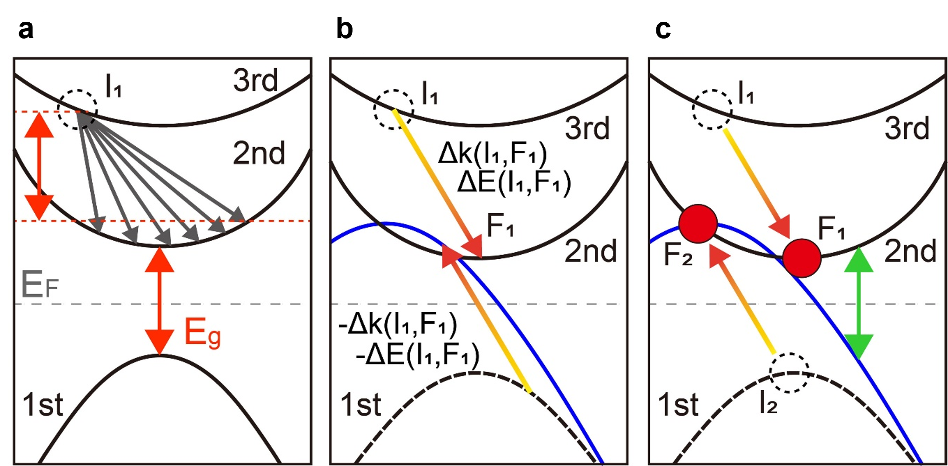
Supplementary Fig. S12. Schematic illustration of the generalized Bang-Kang approach. (a) Tested channels to transfer energy-momentum from the first carrier to the second. The gray arrows represent energy-momentum vectors with initial state $I_{1}$. The energy gap size is described by the red double arrows. We only tested energy-momentum vectors with energy larger than the energy gap, $E_{g}$. The dashed empty circle indicates the position of the resultant hole. (b) For a given energy-momentum vector, we shift the valence band in the opposite direction of the energy-momentum vector shown in a, as depicted by the blue band. (c) CM intensity can be efficiently evaluated by counting the density of the crossing states between the (blue) shifted valence and the (black) conduction bands. The green double arrow indicates the direct gap. Red solid circles indicate the positions of the multiplied electrons.

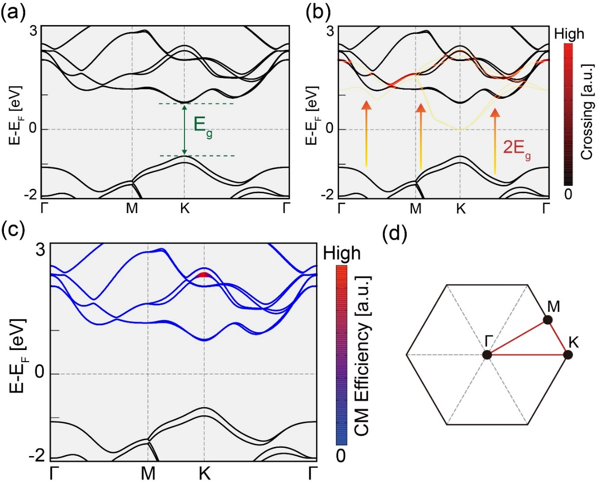
Supplementary Fig. S13. CM calculations for monolayer MoSe₂ at 2E_{g} excitation. (a) Band structure of monolayer MoSe₂ along the high-symmetry lines of the Brillouin zone (BZ) shown in (d). The direct band-gap $E_{g}$ at $K$is highlighted by a green double arrow. (b) Crossing points between the $2E_{g}$ shited valence bands (yellow) and the conduction bands. The intensity is contributed by function $δ(ℏω-E_{n_{I_{1}}}\left({k_{I}}_{1}\right)+E_{m}\left(k_{I_{1}}\right))$, which models a Gaussian function with a FWHM of 79.5 meV. The magnitude of $2E_{g}$ is shown by orange arrows. (c) Calculated CM efficiency for the monolayer bands. The thickness of the lines scales with the contribution of CM. (d) The BZ, with high-symmetry lines highlighted red.

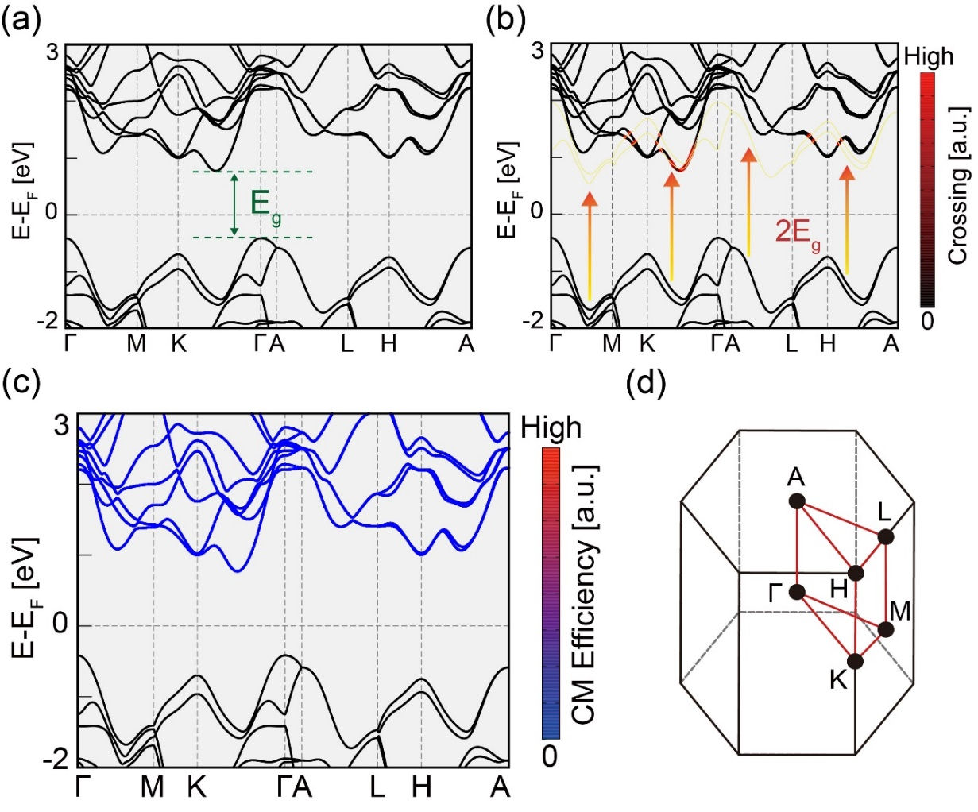
Supplementary Fig. S14. CM calculations for bulk MoSe₂ at 2E_{g} excitation. (a) Band structure of bulk MoSe₂ along the high-symmetry line of the hexagonal BZ shown in (d). The indirect band gap $E_{g}$ in the $K-Γ$line is indicated by a green double arrow. (b) Crossing points between the $2E_{g}$ shifted valence bands (yellow) and the conduction bands. The intensity is contributed from the function $δ(ℏω-E_{n_{I_{1}}}\left({k_{I}}_{1}\right)+E_{m}\left(k_{I_{1}}\right))$, which models a Gaussian function with the FWHM of 50.6 meV. The size of $2E_{g}$ is highlighted by orange arrows. (c) Calculated CM efficiency for the bluk bands along the high-symmetry lines. The thickness of lines scales with the contribution of CM. (d) BZ with the high-symmetry lines colored red.

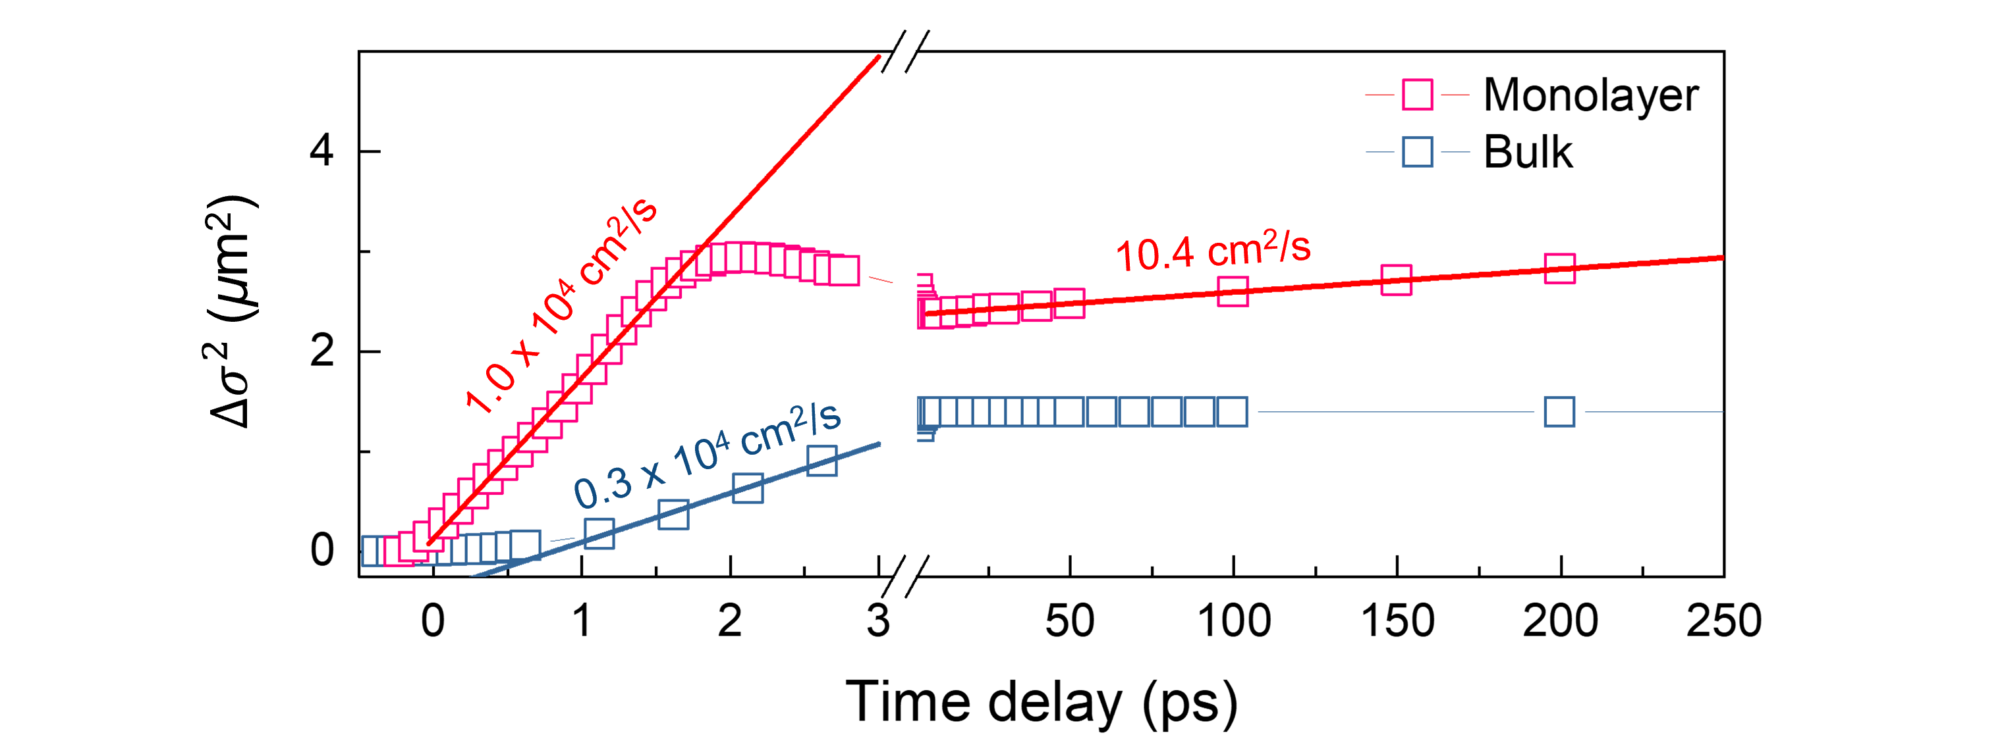
Supplementary Fig. S15. Diffusion coefficient comparison between monolayer and bulk MoSe_{2.} We monitored the temporal evolution of Δσ². The diffusion coefficients of the monolayer (red) and bulk (blue) were obtained by linear fit (solid line).

Table S1. Monolayer MoSe₂ absorbed photon density (APD) calculation
Energy  (eV) | Wavelength  (nm) | Before pinhole  (nJ) | After pinhole  (nJ) | Absorption | APD  (photons / cm² / nJ)
3.54 | 350 | 22.2 | 2.25 | 0.13 | 5.23×10¹¹
3.26 | 380 | 100 | 20.00 | 0.11 | 9.81×10¹¹
3.18 | 390 | 150 | 25.00 | 0.11 | 8.40×10¹¹
3.10 | 400 | 60 | 17.50 | 0.11 | 1.50×10¹²
3.18 | 410 | 27 | 2.50 | 0.11 | 4.65×10¹¹
2.48 | 500 | 36 | 20.00 | 0.12 | 3.91×10¹²
2.25 | 550 | 23 | 8.70 | 0.08 | 1.84×10¹²
2.07 | 600 | 128 | 18.00 | 0.05 | 4.93×10¹¹

Energy  (eV) | Wavelength  (nm) | Before pinhole  (nJ) | After pinhole  (nJ) | Absorption | APD  (photons / cm² / nJ)
3.54 | 350 | 100 | 15.00 | 0.49 | 2.92×10¹²
3.35 | 370 | 102 | 21.10 | 0.48 | 4.17×10¹²
3.06 | 405 | 100 | 25.00 | 0.52 | 5.96×10¹²
2.76 | 450 | 105 | 11.00 | 0.52 | 2.78×10¹²
2.64 | 470 | 103 | 10.45 | 0.51 | 2.78×10¹²
2.58 | 480 | 103 | 14.72 | 0.51 | 3.99×10¹²
2.53 | 490 | 102 | 22.00 | 0.51 | 6.17×10¹²
2.48 | 500 | 102 | 10.40 | 0.50 | 2.91×10¹²
2.43 | 510 | 104 | 9.60 | 0.49 | 2.61×10¹²
2.38 | 520 | 101 | 13.10 | 0.47 | 3.62×10¹²
2.25 | 550 | 100 | 9.50 | 0.42 | 2.48×10¹²
2.07 | 600 | 100 | 6.40 | 0.34 | 1.47×10¹²
1.97 | 630 | 100 | 7.40 | 0.30 | 1.57×10¹²
Table S2. Bulk MoSe₂ APD calculation

References
1. Giannozzi, P. et al. QUANTUM ESPRESSO: a modular and open-source software project for quantum simulations of materials. J. Phys.: Condens. Matter 21, 395502 (2009).
2. Ramer, N.J. & Rappe, A.M. Designed nonlocal pseudopotentials for enhanced transferability. Phys. Rev. B 59, 12471-12478 (1999).
3. Rappe, A.M., Rabe, K.M., Kaxiras, E. & Joannopoulos, J.D. Optimized Pseudopotentials. Phys. Rev. B 41, 1227-1230 (1990).
4. Perdew, J.P., Burke, K. & Ernzerhof, M. Generalized gradient approximation made simple. Phys. Rev. Lett. 77, 3865-3868 (1996).
5. Monkhorst, H.J. & Pack, J.D. Special points for Brillouin-zone integrations. Phys. Rev. B 13, 5188-5192 (1976).
6. Kumar, S. & Schwingenschlogl, U. Thermoelectric Response of Bulk and Mono layer MoSe₂ and WSe₂. Chem. Mater. 27, 1278-1284 (2015).
7. Coehoorn, R. et al. Electronic structure of MoSe₂, MoS₂, and WSe₂. I. Band-structure calculations and photoelectron spectroscopy. Phys. Rev. B 35, 6195-6202 (1987).
8. James, P.B. & Lavik, M.T. The crystal structure of MoSe₂. Aeta Cryst. 16, 1183-1183 (1963).
9. Mostofi, A.A. et al. An updated version of wannier90: A tool for obtaining maximally-localised Wannier functions. Comput. Phys. Commun. 185, 2309-2310 (2014).
10. Beard, M.C. et al. Comparing multiple exciton generation in quantum dots to impact ionization in bulk semiconductors: implications for enhancement of solar energy conversion. Nano Lett. 10, 3019-3027 (2010).
11. Zheng, W., Bonn, M. & Wang, H.I. Photoconductivity Multiplication in Semiconducting Few-Layer MoTe₂. Nano Lett. 20, 5807-5813 (2020).
12. Bang, J. & Kang, J. Subband-enhanced carrier multiplication in graphene nanoribbons. Phys. Rev. B 104, 035417 (2021).
13. Rosati, R., Perea-Causin, R., Brem, S. & Malic, E. Negative effective excitonic diffusion in monolayer transition metal dichalcogenides. Nanoscale 12, 356-363 (2020).
14. Liu, Q. et al. Visualizing Hot-Carrier Expansion and Cascaded Transport in WS₂ by Ultrafast Transient Absorption Microscopy. Adv. Sci. 9, e2105746 (2022).
15. Kumar, N. et al. Exciton diffusion in monolayer and bulk MoSe₂. Nanoscale 6, 4915-4919 (2014).
16. Seitz, M. et al. Exciton diffusion in two-dimensional metal-halide perovskites. Nat. Commun. 11, 2035 (2020).
17. Pan, S. et al. Understanding Spatiotemporal Photocarrier Dynamics in Monolayer and Bulk MoTe₂ for Optimized Optoelectronic Devices. ACS Appl. Nano Mater. 2, 459-464 (2018).
18. Quereda, J. et al. Symmetry regimes for circular photocurrents in monolayer MoSe₂. Nat. Commun. 9, 3346 (2018).
19. Nam, D., Lee, J.U. & Cheong, H. Excitation energy dependent Raman spectrum of MoSe₂. Sci. Rep. 5, 17113 (2015).
20. Tonndorf, P. et al. Photoluminescence emission and Raman response of monolayer MoS₂, MoSe₂, and WSe₂. Opt. Express 21, 4908-4916 (2013).

