Title: Real-World Clinical Outcomes Associated with Progression and Cirrhosis in Metabolic Dysfunction-Associated Steatohepatitis

Journal: Digestive Diseases and Sciences

Authors: Christina Qian¹, MSc; Jesse Fishman², PharmD, MSc; Shelagh M. Szabo¹, MSc; Yestle Kim², PharmD, MSc; Joe Medicis², PharmD, FASHP, FCP; Hannah Rochon¹, MSc; Rosie Sun¹, MSc; Michael Charlton³, MBBS, FRCP

Affiliations:
¹Broadstreet HEOR, Vancouver, BC, Canada; ²Madrigal Pharmaceuticals, Inc., West Conshohocken, PA, USA; ³University of Chicago Medicine, Chicago, IL, USA

Address for Correspondence:
Shelagh Szabo, MSc
201-343 Railway St, Vancouver, BC, Canada, V6A 1A4
sszabo@broadstreetheor.com

SDC, Table 1. Diagnostic and procedure codes for exclusion criteria
Exclusion criteria | Code type | Codes
Viral hepatitis | ICD-10-CM | K75.3, B16.0, B16.1, B16.2, B16.9, B17.0, B18.0, B18.1, B19.10, B19.11, Z22.51, B17.10, B17.11, B18.2, B19.20, B19.21, Z22.52, B00.81, B15.0, B15.9, B17.2, B17.8, B17.9, B18.8, B18.9, B19.0, B19.9, B25.1, B26.81, B94.2, O98.411, O98.412, O98.413, O98.419, O98.42, O98.43, Z22.50, Z22.59
 | HCPCS | G8459, G8461, G8463
Toxic liver disease | ICD-10-CM | K71.0, K71.10, K71.11, K71.2, K71.3, K71.4, K71.50, K71.51, K71.6, K71.7, K71.8, K71.9
Wilson’s disease | ICD-10-CM | E83.01
Gaucher’s disease | ICD-10-CM | E75.22
Lysosomal acid lipase deficiency | ICD-10-CM | E75.5, E75.6
Alcoholism/alcoholic liver disease | ICD-10-CM | E24.4, F10.10, F10.120, F10.121, F10.129, F10.14, F10.150, F10.151, F10.159, F10.180, F10.181, F10.182, F10.188, F10.19, F10.20, F10.21, F10.220, F10.221, F10.229, F10.230, F10.231, F10.232, F10.239, F10.24, F10.250, F10.251, F10.259, F10.26, F10.27, F10.280, F10.281, F10.282, F10.288, F10.29, F10.920, F10.921, F10.929, F10.94, F10.950, F10.951, F10.959, F10.96, F10.97, F10.980, F10.981, F10.982, F10.988, F10.99, G31.2, G62.1, G72.1, I42.6, K29.20, K29.21, K70.0, K70.10, K70.11, K70.2, K70.3, K70.30, K70.31, K70.40, K70.41  K70.9, K85.2, K86.0, O35.4XX0, O35.4XX1, O35.4XX2, O35.4XX3, O35.4XX4, O35.4XX5, O35.4XX9, O99.310, O99.311, O99.312, O99.313, O99.314, O99.315
Primary biliary/sclerosing cholangitis | ICD-10-CM | K74.3, K74.4, K74.5, K83.0
Hemochromatosis | ICD-10-CM | E83.118, E83.119
Autoimmune hepatitis | ICD-10-CM | K73.2, K75.4
Human immunodeficiency virus | ICD-10-CM | B20.X, B21.X, B22.X, B23.X, B24, R75, Z21
Exposure to heavy metals | ICD-10-CM | T56.X
Abbreviations: HCPCS, Healthcare Common Procedure Coding System; ICD-10-CM, International Classification of Diseases 10th revision Clinical Modification.

SDC, Table 2. Diagnosis and procedure codes used to identify cirrhosis and advanced cirrhosis-related events
Cirrhosis and advanced cirrhosis events | Code type | Codes
Cirrhosis | ICD-10-CM | K70.30, K74.60, K74.6, K74.4, K74.5, K74.69, I85.00, I85.10, I85.9, I98.2
Decompensated cirrhosis | CPT | 49083, 49082, 43460, 43244, 43243, 43205, 43227, 43204, 49427, 49425, 37182, 43400, 49084, 78291, 49080, 49081, 49426, 37183, 43401, 43255, 37145, 37160, 37140, 37181, 37180
Decompensated cirrhosis | HCPCS | C1040
Decompensated cirrhosis | ICD-10-CM Diagnosis | K72.01, K72.00, K76.2, K72.11, K72.10, K22.8, I85.0, I85.01, I86.4, I98.20, I98.3, K92.2, K92.0, K72.91, K72.90, K76.81, K76.82, K76.6, K76.7, R17, R18.8, K92.1, J90, I85.11, K65.2, G93.40, G93.41, G93.49, K70.31, K70.40, K70.41
Decompensated cirrhosis | ICD-10-CM Procedure | 0D9W00Z, 0D9W30Z, 0D9W40Z, 0D9W0ZZ, 0D9W0ZX, 0D9W3ZZ, 0D9W3ZX, 0D9W4ZZ, 0D9W4ZX, 0DL57DZ, 0DL58DZ
Decompensated cirrhosis | NDC | Treatment with lactulose
Other ascites | ICD-10-CM Diagnosis | R18.8, K70.10, K70.1, K70.30, K70.31, K71.50, K71.51
Hepatic encephalopathy | ICD-10-CM | K76.82
Unspecified encephalopathy | ICD-10-CM Diagnosis | G93.40, G93.41, G93.49
Liver transplantation | CPT | 47135, 47136
Liver transplantation | DRG | 005, 006, 405, 406, 407
Liver transplantation | HCPCS | S2053
Liver transplantation | ICD-10-CM Diagnosis | T86.40, T86.41, T86.42, T86.43, T86.49, Z48.23, Z94.4
Liver transplantation | ICD-10-CM Procedure | 0FY00Z0, 0FY00Z1, 0FY00Z2
Hepatic cell carcinoma | ICD-10-CM Diagnosis | C22.0, C22.1, C22.8, C24.0
Abbreviations: CPT, Current Procedural Terminology; DRG, Diagnosis-related group; HCPCS, Healthcare Common Procedure Coding System; ICD-10-CM, International Classification of Diseases 10th revision Clinical Modification; NDC, National Drug Code.
SDC, Table 3. Diagnosis and procedure codes used to identify comorbidities
Comorbidity | Setting of interest | Code type | Codes
Cardiovascular disease | Inpatient or outpatient | ICD-10-CM | I01-I01.9, I02.0, I05-I09.9, I20-I21.6, I21.9-I25.9, Z82.4-Z82.49, G45-G46.8, I60-I64, I64.1, I65-I69.998, Z82.3, G45-G46.8, I63-I63.9, I65-I66.9, I67.2-I67.848, I69.3-I69.4, I60-I62.9, I67.0-I67.1, I69.0- I69.298, I11-I11.2, I11.9, B33.2-B33.20, B33.22-B33.24, D86.85, I40-I41.8, I42-I43.8, I51.4-I51.6, B33.2-B33.20, B33.22-B33.24, D86.85, I40-I41.8, I51.4-I51.6, I42.6, I42.0-I42.5, I42.7-I43.8, I48-I48.92, I70.2-I70.92, I73-I73.9, B33.21, I33-I33.9, I38-I38.0, I39-I39.9, I30-I32.8, I34-I37.9, I51-I51.3, I51.7-I52.8, I72-I72.9, I77-I83.93, I86-I89.0, I89.9, I95.0-I95.1, I98, I98.8-I99.9, K75.1
Cardiovascular disease | Pharmacy dispensation | NDC (therapeutic classes/generic drug names) | Antihistamines & Comb, NEC (Belladonna)  Antihyperlipidemic Drugs, NEC  Cardiac Drugs, NEC  Cardiac Function, NEC  Cardiac, ACE Inhibitors  Cardiac, Alpha-Beta Blockers  Cardiac, Antiarrhythmic Agents  Cardiac, Beta Blockers  Cardiac, Calcium Channel  Cardiac, Cardiac Glycosides  Diuretic, Carb Anhydrase Inhib  Diuretics, Loop Diuretics  Diuretics, Misc.  Diuretics, Osmotic  Diuretics, Potassium-Sparing  Diuretics, Thiazides & Related  Kallikrein Inhibitor  Sympathomimetic Agents, NEC  Vasodilating Agents, NEC
Hypertension | Inpatient or outpatient | ICD-10-CM | I10, I11, I12, I13, I15
Hyperlipidemia | Inpatient or outpatient | ICD-10-CM | E78.0 to E78.5
Renal impairment | Inpatient or outpatient | ICD-10-CM | N18, N18.1 – N18.5, N17, N19, Z99.2, N49.2
Renal impairment | Inpatient or outpatient | Procedure codes beginning with | PBL, PBU, DR016, DR024
Renal impairment | Pharmacy dispensation | NDC (drug classes/ generic drug names) | Dialysis solutions, electrolyte depleters, electrolyte maintenance, erythropoiesis-stimulating agents, kidney stone agents, mineral replacement, multivitamin preparations
Type 1 diabetes mellitus | Inpatient or outpatient | ICD-10-CM | E10.x
Type 1 diabetes mellitus | Pharmacy dispensation | NDC (drug classes/generic drug names) | Insulin
Type 2 diabetes | Inpatient or outpatient | ICD-10-CM | E11.x
Obesity | Inpatient or outpatient | ICD-10-CM | Z68.3x, Z68.4x
Abbreviations: ICD-10-CM, International Classification of Diseases 10th revision Clinical Modification; NDC, National Drug Code; NEC, not elsewhere classified.

SDC, Table 4. Kaplan Meier probabilities for progression to clinical outcome by year for metabolic dysfunction-associated steatohepatitis patients without baseline cirrhosis
 | Number of events (probability of event, [95% CI])
 | Year 1 | Year 2 | Year 3 | Year 4 | Year 5
Composite clinical endpoint | 2,040 (10.5 [10.1-10.9]) | 3,139 (16.8 [16.2-17.3]) | 3,786 (22.0 [21.4-22.7]) | 4,165 (26.8 [26.0-27.5]) | 4,384 (31.4 [30.5-32.3])
Death | 209 (1.1 [0.9-1.2]) | 408 (2.2 [2.0-2.4]) | 581 (3.6 [3.3-3.9]) | 692 (5.0 [4.6-5.4]) | 771 (6.8 [6.2-7.3])
Significant hepatic event | 1,944 (10.0 [9.6-10.5]) | 2,981 (16.0 [15.5-16.5]) | 3,571 (20.8 [20.2-21.4]) | 3,921 (25.3 [24.5-26.0]) | 4,113 (29.4 [28.5-30.3])
Cirrhosis | 881 (4.6 [4.3-4.8]) | 1,263 (6.8 [6.4-7.1]) | 1,445 (8.3 [7.8-8.7]) | 1,559 (9.7 [9.3-10.2]) | 1,623 (11.2 [10.6-11.7])
Decompensated cirrhosis | 1,362 (7.0 [6.7-7.4]) | 2,293 (12.4 [11.9-12.9]) | 2,852 (17.0 [16.4-17.6]) | 3,177 (21.2 [20.4-21.9]) | 3,349 (24.9 [24.0-25.8])
Liver transplant | 11 (0.1 [0.02-0.1]) | 20 (0.1 [0.1-0.2]) | 28 (0.2 [0.1-0.2]) | 32 (0.2 [0.1-0.3]) | 37 (0.3 [0.2-0.4])
Hepatocellular carcinoma | 29 (0.1 [0.1-0.2]) | 48 (0.3 [0.2-0.3]) | 64 (0.4 [0.3-0.5]) | 73 (0.5 [0.4-0.6]) | 82 (0.7 [0.5-0.9])
Abbreviations: CI, confidence interval.

SDC, Table 5. Kaplan Meier probabilities for subsequent advanced liver events by year for metabolic dysfunction-associated steatohepatitis patients with baseline cirrhosis
 | Number of events (probability of event, [95% CI])
 | Year 1 | Year 2 | Year 3 | Year 4 | Year 5
Composite clinical endpoint | 7,548 (82.4 [81.6-83.2]) | 7,916 (86.9 [86.2-87.6]) | 8,048 (89.3 [88.6-89.9]) | 8,100 (90.7 [90.0-91.4]) | 8,122 (92.0 [91.1-92.7])
Death | 1,524 (16.6 [15.9-17.4]) | 2,188 (24.9 [24.0-25.8]) | 2,603 (32.4 [31.4-33.5]) | 2,795 (38.0 [36.7-39.2]) | 2,902 (43.5 [42.0-45.0])
Significant hepatic event | 7,345 (81.0 [80.2-81.8]) | 7,719 (85.7 [85.0-86.4]) | 7,849 (88.2 [87.4-88.9]) | 7,905 (89.9 [89.1-90.6]) | 7,926 (91.1 [90.2-91.9])
Cirrhosis | 6,662 (74.1 [73.2-75.0]) | 6,957 (78.0 [77.1-78.9]) | 7,052 (80.0 [79.1-80.8]) | 7,081 (81.0 [80.1-81.9]) | 7,095 (82.0 [81.0-83.0])
Decompensated cirrhosis | 5,503 (60.9 [59.9-61.9]) | 6,208 (69.8 [68.8-70.8]) | 6,488 (75.1 [74.1-76.1]) | 6,602 (78.6 [77.6-79.6]) | 6,653 (81.5 [80.3-82.7])
Liver transplant | 334 (3.9 [3.4-4.3]) | 407 (5.0 [4.5-5.5]) | 437 (5.8 [5.2-6.3]) | 443 (6.0 [5.5-6.6]) | 448 (6.5 [5.8-7.2])
Hepatocellular carcinoma | 515 (5.9 [5.4-6.4]) | 620 (7.5 [6.9-8.1]) | 670 (8.7 [8.0-9.4]) | 701 (10.0 [9.2-10.8]) | 719 (11.5 [10.4-12.5])
Abbreviations: CI, confidence interval.

SDC, Table 6. Kaplan Meier probabilities for risk of death by year for metabolic dysfunction-associated steatohepatitis patients with versus without cirrhosis
 | N events (probability of event [95% CI])
 | Year 1 | Year 2 | Year 3 | Year 4 | Year 5
With cirrhosis | 1,524  (16.6 [15.9-17.4]) | 2,188  (24.9 [24.0-25.8]) | 2,603  (32.4 [31.4-33.5]) | 2,795  (38.0 [36.7-39.2]) | 2,902  (43.5 [42.0-45.0])
Without cirrhosis | 209  (1.1 [0.9-1.2]) | 408  (2.2 [2.0-2.4]) | 581  (3.6 [3.3-3.9]) | 692  (5.0 [4.6-5.4]) | 771  (6.8 [6.2-7.3])
Abbreviations: CI, confidence interval.

SDC, Figure 1. Study diagram
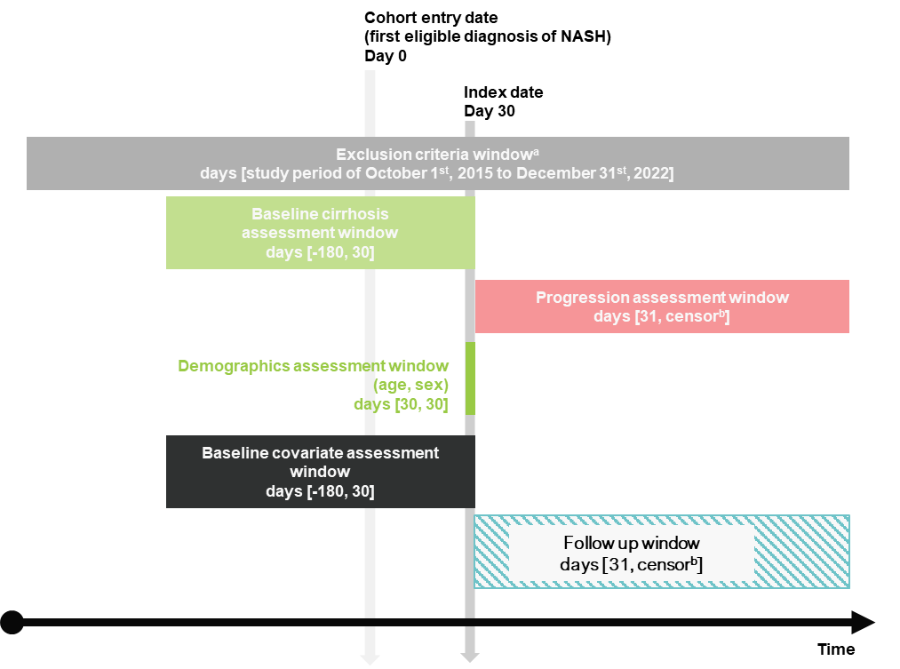
Abbreviation: NASH, nonalcoholic steatohepatitis.
ªExclusion criteria codes specified in Table S1.
^{b}All patients will be followed up until the end of enrollment or the beginning of a gap of >30 days in enrollment, death, or end of study period, whichever occurs first.

SDC, Figure 2. Days since NASH diagnosis to first cirrhosis event
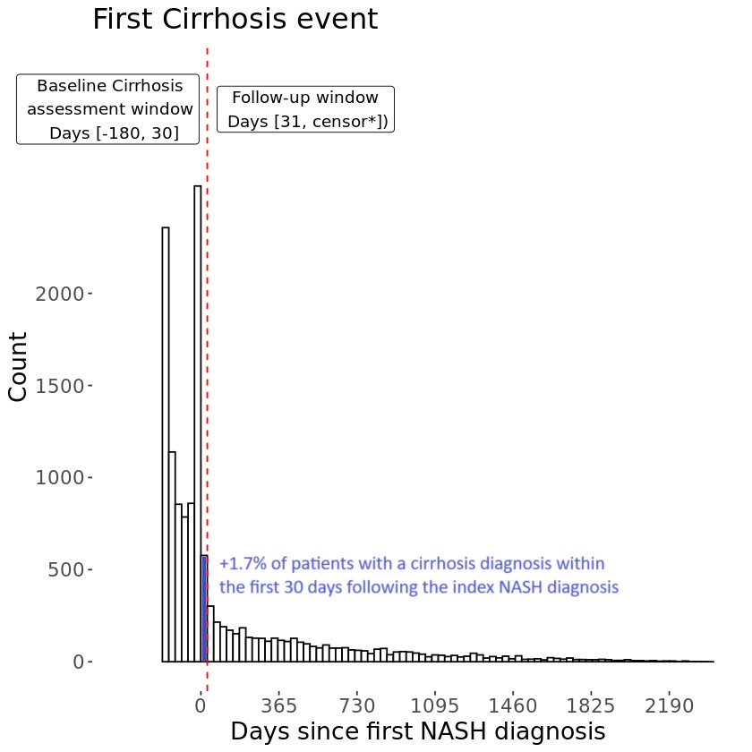
Abbreviation: NASH, nonalcoholic steatohepatitis.
SDC, Figure 3. Flow diagram of patients
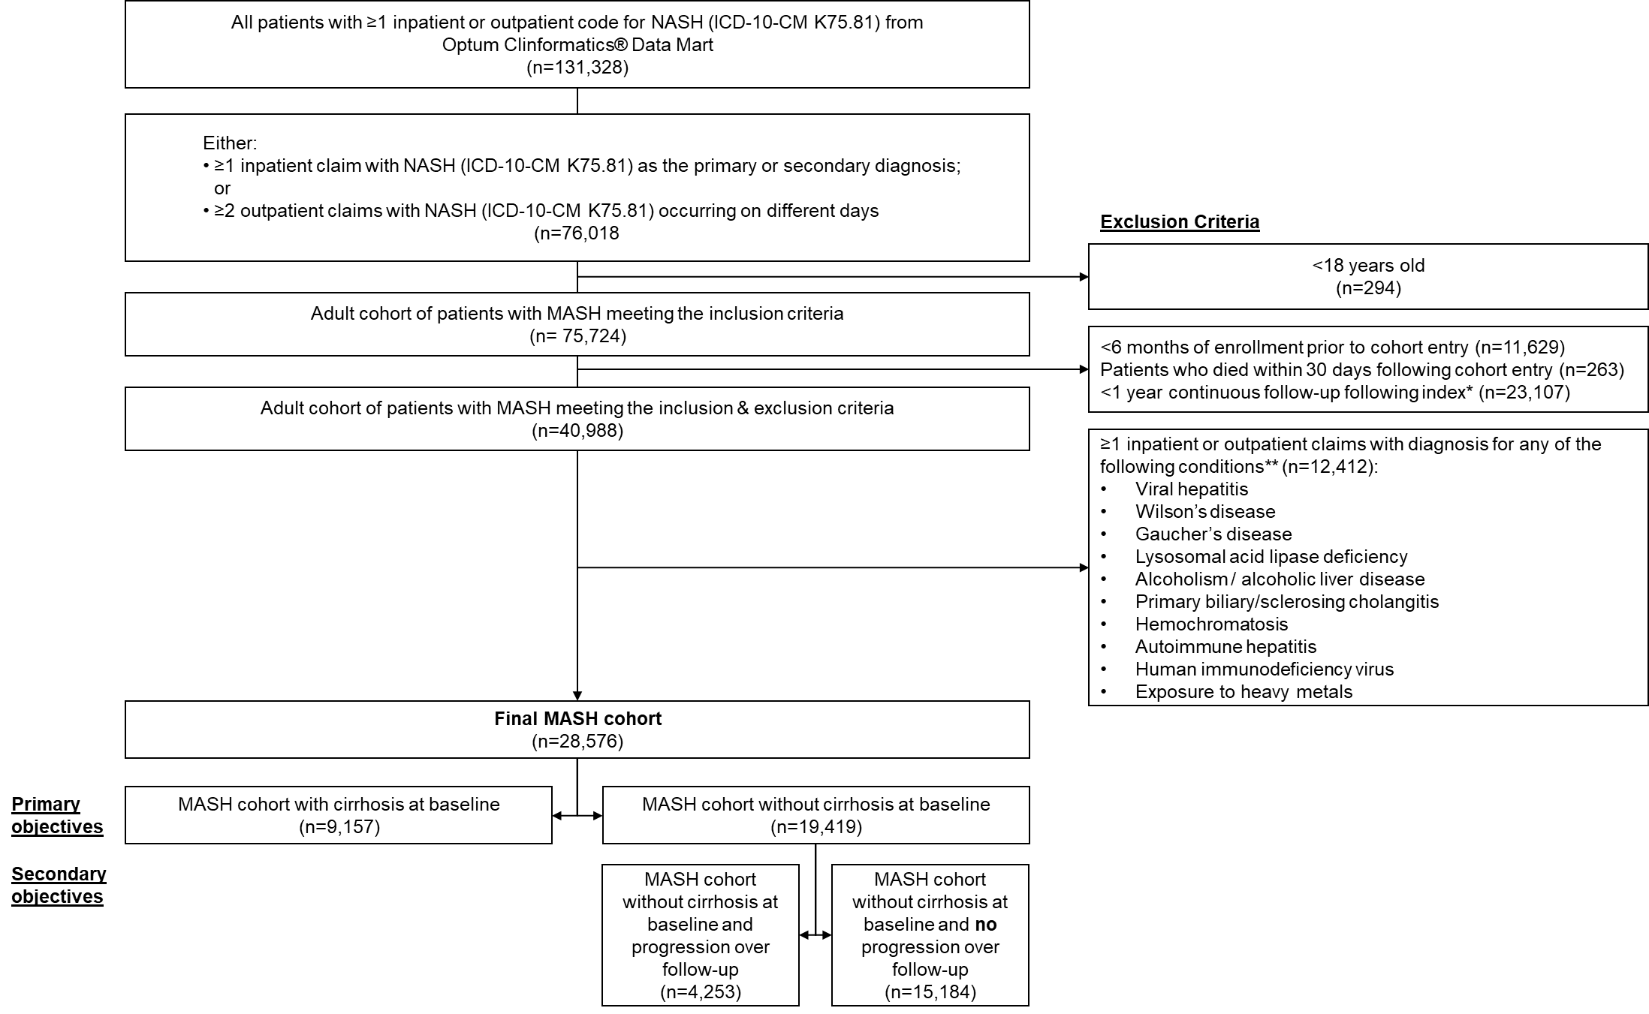
Abbreviation: ICD-10-CM, International classification of diseases 10th revision clinical modification; MASH, metabolic dysfunction-associated steatohepatitis; NASH, nonalcoholic steatohepatitis.
Note: Index was defined as 30 days following cohort entry (first eligible NASH diagnosis).
SDC, Figure 4. Kaplan-Meier curves for progression to individual events in MASH patients without cirrhosis
S3a. Kaplan-Meier curve for death
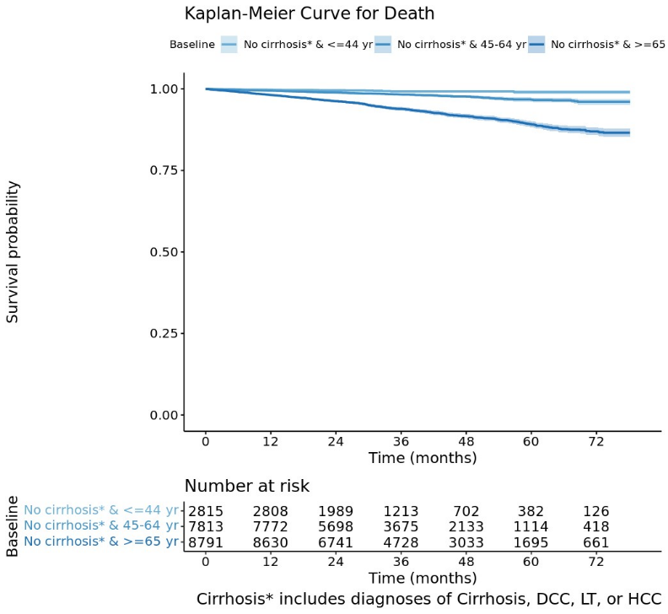
S3b. Kaplan-Meier curve for hepatic events including cirrhosis and DCC
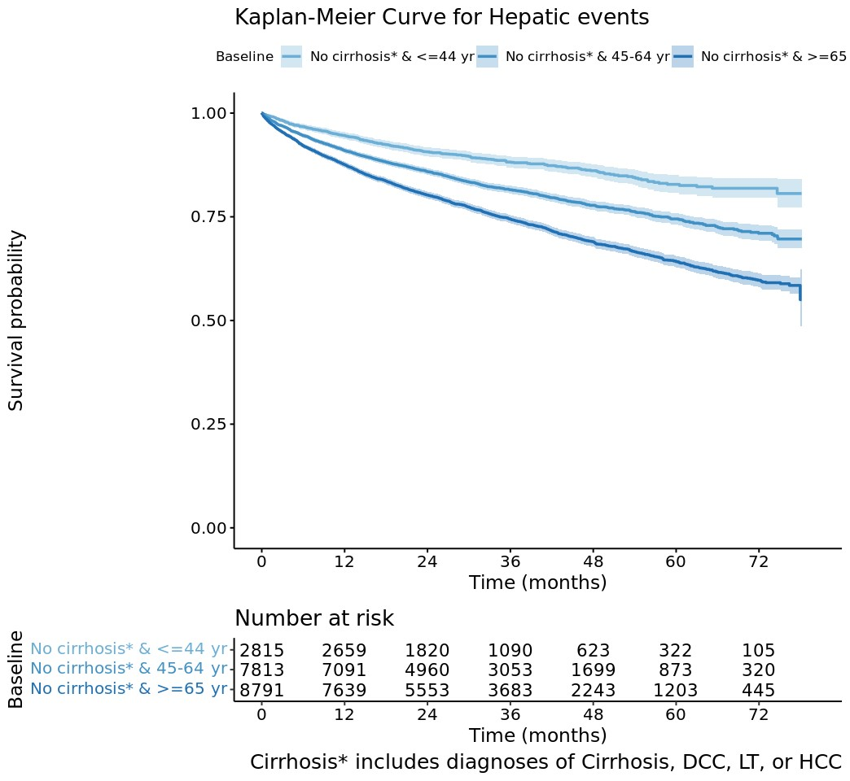
S3c. Kaplan-Meier curve for liver transplant
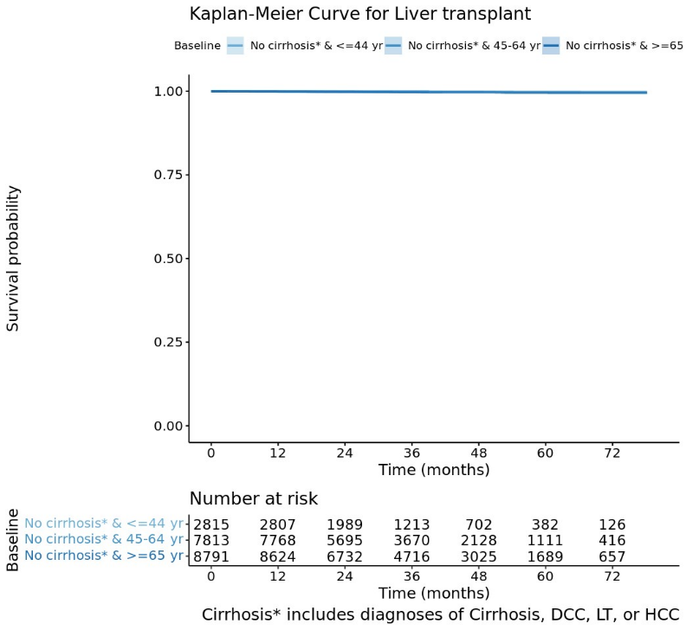
S3d. Kaplan-Meier curve for HCC
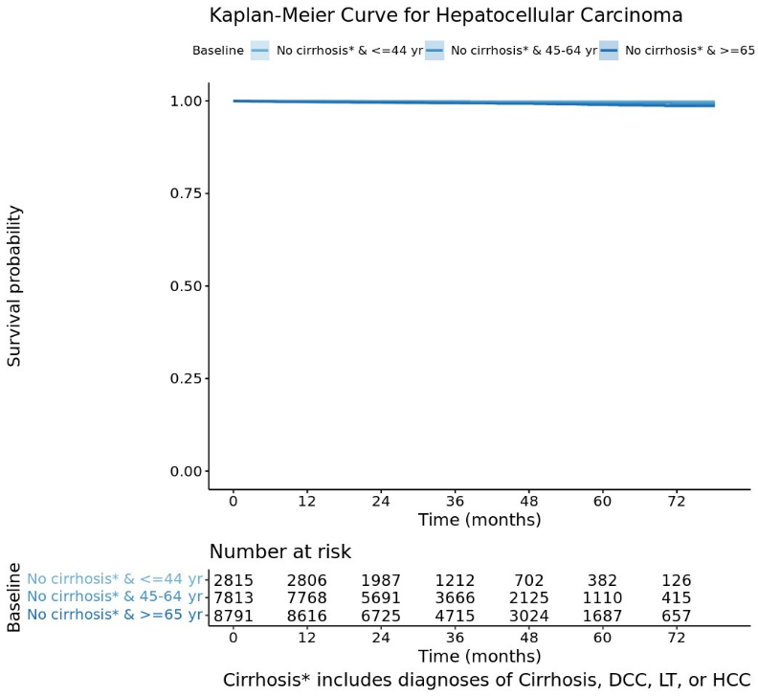
Abbreviations: DCC, decompensated cirrhosis; HCC, hepatocellular carcinoma; LT, liver transplantation; MASH, metabolic dysfunction-associated steatohepatitis.

SDC, Figure 5. Kaplan-Meier curves for subsequent individual events in MASH patients with baseline cirrhosis
S4a. Kaplan-Meier curve for death
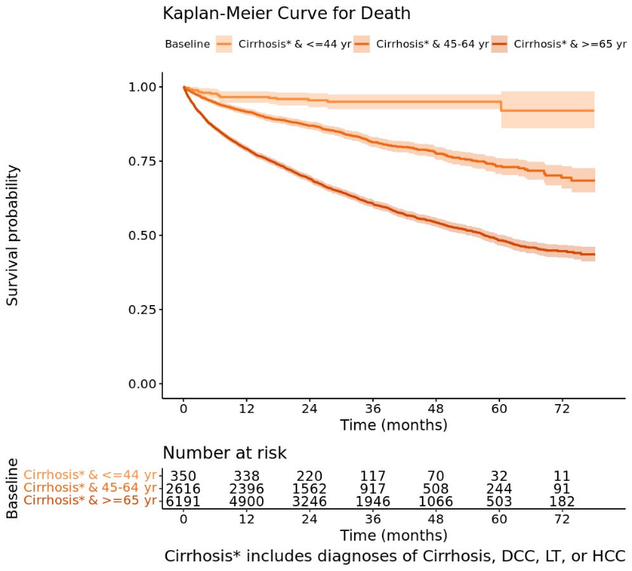
S4b. Kaplan-Meier curve for hepatic events
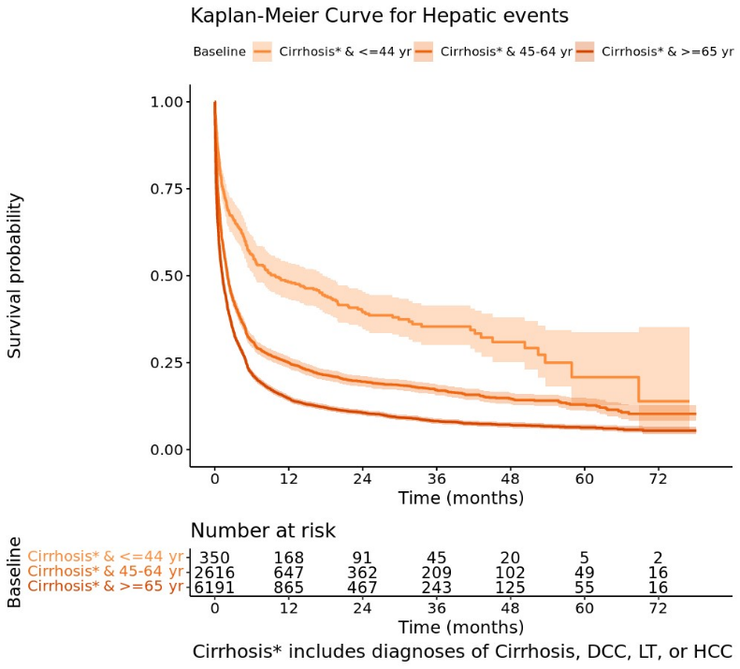
S4c. Kaplan-Meier curve for liver transplant
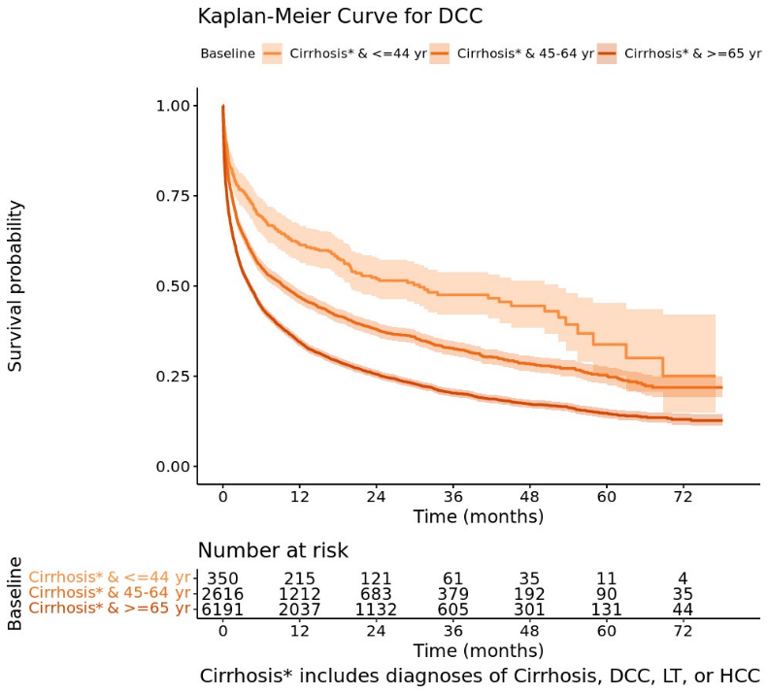
S4d. Kaplan-Meier curve for HCC
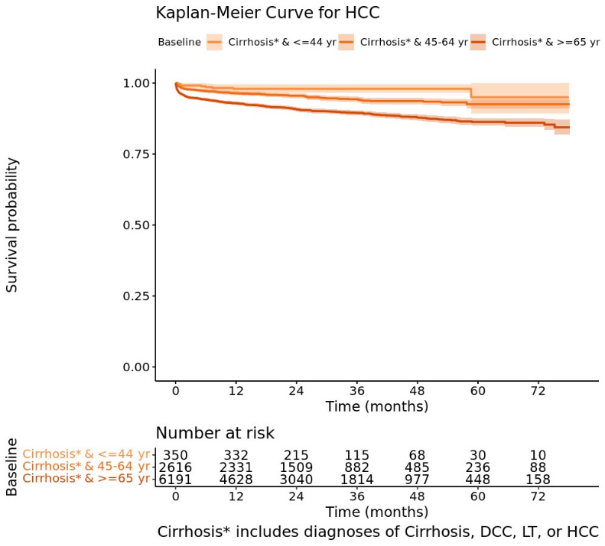
Abbreviations: DCC, decompensated cirrhosis; HCC, hepatocellular carcinoma; LT, liver transplantation; MASH, metabolic dysfunction-associated steatohepatitis.

