Text S1. The definition of each sleep trait
Sleep duration (Field ID 1160) was assessed by asking: “How many hours of sleep do you get in every 24 hours? (Please include naps)”. Answers could only contain integer values. Participants who answered “Do not know” and “Prefer not to answer”, as well as those who provided implausible sleep durations (<4 hours or >11 hours) were treated as missing. In regression analysis, three categories (short sleep duration, normal sleep duration, and long sleep duration) were derived, with “normal sleep duration” as reference. In genetic-association analysis and MR analysis, sleep duration was treated as a continuous variable.
Getting up in the morning (Field ID 1170) was assessed in the question “On an average day, how easy do you find it to get up in the morning?” with one of six possible answers: “Not at all easy”, “Not very easy”, “Fairly easy”, “Very easy”, “Do not know” or “Prefer not to answer”. “Do not know” and “Prefer not to answer” were coded as missing. In regression analysis, getting up in morning was treated as a categorical variable. In genetic-association analysis and MR analysis, we derived a four-level ordinal variable for getting up in morning where “Not at all easy”, “Not very easy”, “Fairly easy”, “Very easy” were coded as 1, 2, 3 and 4, respectively.
Chronotype (Field ID 1180) (morning or evening preference) was assessed in the question “Do you consider yourself to be?” with one of six possible answers: “Definitely a ‘morning’ person”, “More a ‘morning’ than ‘evening’ person”, “More an ‘evening’ than a ‘morning’ person”, “Definitely an ‘evening’ person”, “Do not know” or “Prefer not to answer”. Chronotype was derived as a four-level ordinal variable where “Definitely a ‘morning’ person”, “More a ‘morning’ than ‘evening’ person”, “More an ‘evening’ than a ‘morning’ person”, “Definitely an ‘evening’ person” were coded as 1, 2, 3 and 4, respectively. In regression analysis, chronotype was treated as a categorical variable.
Nap during the day (Field ID 1190) was assessed by asking: “Do you have a nap during the day?” with responses “Never/rarely”, “Sometimes”, “Usually” or “Prefer not to answer”. “Prefer not to answer” was coded as missing and others were coded from 1 to 3. In regression analysis, nap during day was treated as a categorical variable.
To assess insomnia symptoms (Field ID 1200), participants were asked: “Do you have trouble falling asleep at night or do you wake up in the middle of the night?” with responses “Never/rarely”, “Sometimes”, “Usually” or “Prefer not to answer”. Those who responded “Prefer not to answer” were set to missing. We derived a three-level ordinal variable for insomnia symptoms where “Never/rarely”, “Sometimes”, “Usually” were coded as 1, 2 and 3, respectively. In regression analysis, insomnia symptoms were treated as a categorical variable.
Daytime sleepiness (Field ID 1220) was ascertained by the question: “How likely are you to doze off or fall asleep during the daytime when you don't mean to? (e.g. while working, reading or driving)” with response options of “Never/rarely”, “Sometimes”, “Often”, “All of the time”, “Do not know” or “Prefer not to answer”. Those who responded “Do not know” and “Prefer not to answer” were set to missing. We derived a four-level ordinal variable for daytime sleepiness where “Never/rarely”, “Sometimes”, “Often”, “All of the time” were coded as 1, 2, 3 and 4, respectively. In regression analysis, daytime sleepiness was treated as a categorical variable.

Table S1. Baseline characteristics of participants in the UK Biobank (n = 407755)
Covariate |  |  | Sleep traits
Age | 56.91 ± 8.00 |  | Sleep duration
Gender |  |  | short sleep duration | 95869 (23.8)
Female | 220346 (54.0) |  | normal sleep duration | 277659 (68.9)
Male | 187409 (46.0) |  | long sleep duration | 29744 (7.4)
BMI | 27.41±4.76 |  | Getting up in morning
Townsend deprivation index | -1.56 ± 2.93 |  | Not at all easy | 14968 (3.7)
Qualifications |  |  | Not very easy | 54730 (13.4)
National exams at age 16 years | 209283 (51.4) |  | Fairly easy | 203440 (50.0)
Optional national exams at ages 17 to 18 years | 45584 (11.2) |  | Very easy | 133785 (32.9)
Vocational qualifications | 27400 (6.7) |  | Chronotype
College or University degree | 125116 (30.7) |  | Definitely morning | 96978 (26.6)
Physical Activityª |  |  | More morning | 132109 (36.3)
Low | 60892 (18.5) |  | More evening | 103790 (28.5)
Moderate | 166189 (50.4) |  | Definitely evening | 31292 (8.6)
High | 102914 (31.2) |  | Nap during the day
Smoking status |  |  | Never/rarely | 229869 (56.4)
Never | 221796 (54.6) |  | Sometimes | 156126 (38.3)
Previous | 143376 (35.3) |  | Usually | 21618 (5.3)
Current | 41158 (10.1) |  | Sleeplessness / Insomnia
Alcohol drinker status |  |  | Never/rarely | 96553 (23.7)
Never | 12776 (3.1) |  | Sometimes | 194384 (47.7)
Previous | 13948 (3.4) |  | Usually | 116542 (28.6)
Current | 380682 (93.4) |  | Daytime dozing Sleeping narcolepsy
 |  |  | Never/rarely | 312265 (76.8)
 |  |  | Sometimes | 83526 (20.6)
 |  |  | Often | 10594 (2.6)
 |  |  | All of the time | 26 (0.0)
Values are expressed as mean±standard deviation, or n (%).
ª Physical Activity was categorized into low(<10 excess metabolic equivalents (MET)-hours per week), moderate (10 ~ 49.9 excess MET-hours per week), and high (≥50 excess MET-hours per week).

Table S2. 65 single-nucleotide polymorphisms and effect sizes for continuous sleep duration identified in the UK Biobank.
SNP | Beta | SE | EA | OA | EA_freq | P-value | N
rs10262103 | 0.0169294 | 0.00235298 | C | A | 0.4225 | 6.26E-13 | 392573
rs10421649 | -0.0137483 | 0.00234091 | T | A | 0.441 | 4.28E-09 | 390792
rs10496379 | 0.01915 | 0.0034157 | T | A | 0.1316 | 2.07E-08 | 398149
rs10791507 | -0.0186285 | 0.00295723 | C | T | 0.185 | 2.99E-10 | 401943
rs1079727 | 0.0197153 | 0.00314661 | C | T | 0.1576 | 3.72E-10 | 402846
rs10973207 | 0.0196976 | 0.00317823 | T | G | 0.1554 | 5.74E-10 | 399457
rs10995307 | -0.0134281 | 0.00230266 | C | T | 0.4992 | 5.50E-09 | 399534
rs10998333 | -0.0131778 | 0.00235783 | A | G | 0.3883 | 2.29E-08 | 400783
rs116148468 | 0.0211404 | 0.00376466 | G | A | 0.1039 | 1.96E-08 | 401171
rs11621908 | -0.0258499 | 0.00427671 | T | C | 0.07923 | 1.50E-09 | 396437
rs11650677 | 0.0158478 | 0.00242431 | A | G | 0.338 | 6.28E-11 | 402848
rs11883686 | -0.0143189 | 0.00244351 | T | A | 0.3315 | 4.63E-09 | 401133
rs11887412 | 0.0181024 | 0.0026596 | C | G | 0.247 | 1.00E-11 | 401968
rs12336359 | 0.0142637 | 0.00236594 | C | G | 0.4053 | 1.65E-09 | 392592
rs12518468 | -0.0142452 | 0.00244916 | C | T | 0.3272 | 6.02E-09 | 399955
rs12567114 | 0.015633 | 0.00258672 | A | G | 0.2737 | 1.51E-09 | 398731
rs12791153 | 0.0269736 | 0.00433256 | T | A | 0.07728 | 4.80E-10 | 396455
rs12963463 | -0.0170296 | 0.00257299 | C | T | 0.2926 | 3.63E-11 | 385993
rs13107325 | -0.031379 | 0.00437468 | T | C | 0.07446 | 7.36E-13 | 403271
rs13247349 | 0.0147286 | 0.00267139 | G | T | 0.2488 | 3.52E-08 | 397319
rs180769 | 0.0129511 | 0.00233105 | T | C | 0.4235 | 2.76E-08 | 398880
rs1937443 | 0.0132115 | 0.00234285 | C | G | 0.4379 | 1.71E-08 | 393495
rs1983336 | 0.0129852 | 0.0023509 | A | G | 0.4035 | 3.33E-08 | 399008
rs2082374 | -0.0125766 | 0.00229611 | G | C | 0.4699 | 4.32E-08 | 402468
rs2192528 | 0.0135079 | 0.00229922 | A | G | 0.4798 | 4.23E-09 | 402130
rs2240332 | 0.0134942 | 0.00241126 | C | G | 0.3451 | 2.19E-08 | 402862
rs2325978 | 0.0143359 | 0.00238611 | G | A | 0.363 | 1.88E-09 | 401952
rs2683618 | -0.0175683 | 0.00231106 | A | G | 0.4451 | 2.93E-14 | 400995
rs2689001 | -0.0142778 | 0.00260977 | C | T | 0.2683 | 4.48E-08 | 397998
rs3095508 | -0.0166246 | 0.00233366 | A | C | 0.4066 | 1.05E-12 | 403271
rs330088 | -0.0160017 | 0.0023097 | T | C | 0.4516 | 4.27E-12 | 401063
rs35662245 | 0.0153149 | 0.0024262 | A | T | 0.3379 | 2.75E-10 | 402719
rs369648654 | -0.0145682 | 0.00230603 | T | G | 0.4874 | 2.66E-10 | 399170
rs37021 | -0.0145917 | 0.00232686 | G | A | 0.4425 | 3.59E-10 | 396797
rs3887290 | -0.0160673 | 0.00253899 | A | C | 0.2902 | 2.48E-10 | 399987
rs4076993 | 0.0127933 | 0.00233487 | T | C | 0.4215 | 4.27E-08 | 398157
rs4592416 | 0.0159034 | 0.00230059 | G | A | 0.4646 | 4.76E-12 | 402342
rs4938316 | -0.0171803 | 0.00309061 | T | C | 0.1676 | 2.72E-08 | 397035
rs55658675 | -0.0141931 | 0.0023987 | T | C | 0.356 | 3.28E-09 | 401290
rs55860148 | 0.0169458 | 0.00277992 | A | G | 0.2188 | 1.09E-09 | 400966
rs55974014 | -0.0160895 | 0.00278862 | A | C | 0.2187 | 7.95E-09 | 398142
rs56372231 | 0.0153789 | 0.00243208 | T | C | 0.3345 | 2.56E-10 | 402126
rs62060970 | -0.013646 | 0.00248703 | T | C | 0.3091 | 4.09E-08 | 400235
rs62120039 | -0.0297151 | 0.00471351 | A | C | 0.06373 | 2.90E-10 | 399684
rs62158206 | 0.039263 | 0.00278969 | C | T | 0.2177 | 5.60E-45 | 399323
rs6681755 | 0.0161734 | 0.00288956 | A | G | 0.1979 | 2.18E-08 | 401423
rs6685634 | 0.013443 | 0.00234622 | A | T | 0.3968 | 1.01E-08 | 401502
rs6687934 | -0.0129548 | 0.00230328 | C | T | 0.4583 | 1.86E-08 | 402698
rs6962471 | -0.0151045 | 0.00268242 | A | G | 0.2421 | 1.79E-08 | 399694
rs7115226 | 0.0271525 | 0.00444082 | A | C | 0.07225 | 9.71E-10 | 400760
rs77168259 | 0.0271356 | 0.00317365 | T | A | 0.1547 | 1.23E-17 | 401616
rs77334219 | 0.0141173 | 0.00246963 | T | C | 0.336 | 1.09E-08 | 389101
rs7764984 | -0.0160849 | 0.00244456 | G | A | 0.3266 | 4.71E-11 | 402499
rs7915425 | 0.0198516 | 0.00303853 | T | C | 0.1733 | 6.44E-11 | 401845
rs8038326 | -0.015801 | 0.00257705 | G | A | 0.2712 | 8.72E-10 | 402563
rs8050478 | 0.0156618 | 0.002295 | G | A | 0.4998 | 8.85E-12 | 401840
rs925872 | -0.0146562 | 0.00231456 | G | C | 0.4548 | 2.42E-10 | 398021
rs9382445 | -0.0154209 | 0.00236269 | C | T | 0.3778 | 6.73E-11 | 402741
rs9383349 | 0.0178434 | 0.00322273 | T | C | 0.1506 | 3.08E-08 | 398933
rs9451146 | -0.0156731 | 0.00274085 | T | C | 0.227 | 1.08E-08 | 400880
rs9563152 | -0.0131998 | 0.00240045 | T | C | 0.3696 | 3.82E-08 | 394986
rs979336 | 0.0183759 | 0.00253134 | T | G | 0.2868 | 3.90E-13 | 403109
rs9828888 | -0.0162343 | 0.00271284 | G | A | 0.2335 | 2.18E-09 | 402899
rs9843801 | 0.0157716 | 0.00242345 | C | T | 0.3416 | 7.63E-11 | 401240
rs9939973 | -0.0161978 | 0.00232059 | A | G | 0.4221 | 2.96E-12 | 403231
SNP, single-nucleotide polymorphisms; SE, standard error; EA, effect allele; OA, other allele; EA_freq, effect allele frequency.

Table S3. 65 single-nucleotide polymorphisms and effect sizes for getting up in morning identified in the UK Biobank.
SNP | Beta | SE | EA | OA | EA_freq | P-value | N
rs10102398 | -0.0131798 | 0.00216324 | A | G | 0.1811 | 1.11E-09 | 404693
rs10165674 | 0.0136097 | 0.00208321 | A | G | 0.1995 | 6.45E-11 | 405481
rs1017168 | -0.0104005 | 0.00175104 | A | C | 0.3545 | 2.86E-09 | 401664
rs10175975 | 0.0129784 | 0.00219486 | T | C | 0.1774 | 3.36E-09 | 399346
rs10239345 | 0.0106422 | 0.00180566 | C | A | 0.3106 | 3.78E-09 | 402935
rs10470887 | -0.00951995 | 0.00167588 | G | A | 0.4868 | 1.34E-08 | 403012
rs1067404 | -0.0133654 | 0.00194254 | T | G | 0.2419 | 5.98E-12 | 405502
rs10876005 | -0.011329 | 0.00166509 | G | C | 0.4898 | 1.02E-11 | 406711
rs11075924 | -0.0101695 | 0.00167053 | A | C | 0.4921 | 1.15E-09 | 403659
rs11172140 | 0.0118899 | 0.00193763 | C | A | 0.2452 | 8.45E-10 | 405757
rs11232172 | 0.0101029 | 0.00178551 | A | G | 0.3186 | 1.53E-08 | 406869
rs113240734 | 0.0199718 | 0.00225775 | A | G | 0.1614 | 9.12E-19 | 406883
rs113313477 | 0.0131258 | 0.00198734 | A | G | 0.2268 | 3.99E-11 | 406029
rs11757083 | 0.0117822 | 0.00196813 | T | C | 0.2323 | 2.15E-09 | 406202
rs12198513 | -0.0120302 | 0.00207625 | G | A | 0.2065 | 6.87E-09 | 397246
rs12604419 | -0.010637 | 0.00180908 | C | A | 0.3077 | 4.11E-09 | 403055
rs12621674 | -0.013534 | 0.00169564 | A | T | 0.4102 | 1.45E-15 | 404486
rs12736689 | 0.0493961 | 0.00488712 | C | T | 0.02993 | 5.16E-24 | 406132
rs12752290 | 0.0120923 | 0.00169255 | C | T | 0.4416 | 9.05E-13 | 399021
rs12804093 | -0.0124109 | 0.0017968 | C | T | 0.3125 | 4.95E-12 | 405175
rs12926225 | 0.0103407 | 0.0016846 | G | T | 0.4296 | 8.34E-10 | 405490
rs13155750 | -0.0114431 | 0.00196448 | G | A | 0.2343 | 5.71E-09 | 406059
rs142132869 | -0.00966638 | 0.00171784 | T | G | 0.4299 | 1.83E-08 | 389863
rs17766755 | -0.00982478 | 0.0017367 | A | G | 0.3592 | 1.54E-08 | 405272
rs2216614 | 0.00962113 | 0.00172653 | G | A | 0.3807 | 2.51E-08 | 401255
rs2339723 | -0.0102312 | 0.00180283 | A | G | 0.3074 | 1.39E-08 | 405975
rs2653355 | 0.0244383 | 0.00217346 | C | A | 0.1791 | 2.50E-29 | 406096
rs34327448 | -0.0113254 | 0.00177651 | T | A | 0.3291 | 1.83E-10 | 404559
rs35333999 | -0.0231328 | 0.00410597 | T | C | 0.04294 | 1.76E-08 | 406922
rs370727181 | -0.0178979 | 0.00300919 | C | A | 0.08632 | 2.72E-09 | 394391
rs3936093 | 0.0119642 | 0.00169204 | A | G | 0.4248 | 1.54E-12 | 401567
rs406952 | 0.00968815 | 0.00171946 | C | T | 0.377 | 1.76E-08 | 405646
rs4784655 | -0.0104269 | 0.00178767 | C | G | 0.3207 | 5.46E-09 | 404431
rs4884166 | -0.0137853 | 0.00208488 | A | G | 0.1981 | 3.80E-11 | 406303
rs4958317 | 0.0143287 | 0.00183481 | A | G | 0.2902 | 5.76E-15 | 405689
rs55938136 | 0.0125554 | 0.00198729 | G | A | 0.2259 | 2.66E-10 | 406857
rs59684759 | 0.010612 | 0.00187608 | G | A | 0.2715 | 1.55E-08 | 404947
rs61608856 | -0.00954521 | 0.00169198 | T | G | 0.4359 | 1.69E-08 | 398859
rs61773374 | 0.0166828 | 0.00209469 | G | A | 0.1964 | 1.67E-15 | 405923
rs620598 | 0.0114049 | 0.00199652 | G | A | 0.2246 | 1.11E-08 | 404936
rs62441740 | -0.0113978 | 0.00204807 | A | G | 0.2083 | 2.62E-08 | 406922
rs6510542 | -0.00997756 | 0.00175898 | C | T | 0.338 | 1.41E-08 | 406521
rs6745423 | 0.012345 | 0.00186441 | T | A | 0.277 | 3.56E-11 | 404390
rs67731969 | 0.0126819 | 0.00230388 | A | G | 0.1552 | 3.70E-08 | 402951
rs6907471 | 0.0097072 | 0.00169778 | T | C | 0.4395 | 1.08E-08 | 396654
rs6960360 | -0.00970775 | 0.00170364 | A | G | 0.3988 | 1.21E-08 | 405753
rs6970545 | -0.00999098 | 0.00167136 | C | T | 0.4907 | 2.26E-09 | 403339
rs71668693 | -0.0128157 | 0.00229693 | G | T | 0.1549 | 2.41E-08 | 406322
rs7234905 | 0.00926531 | 0.00167096 | T | C | 0.4546 | 2.94E-08 | 406456
rs72993056 | -0.0180408 | 0.00248219 | T | G | 0.1298 | 3.65E-13 | 404791
rs733007 | 0.0104319 | 0.00178386 | A | G | 0.3287 | 4.98E-09 | 400253
rs73643479 | -0.0266687 | 0.00452128 | A | G | 0.03668 | 3.67E-09 | 389454
rs74643199 | -0.0126817 | 0.00232393 | T | A | 0.1556 | 4.85E-08 | 396568
rs7520025 | -0.0099088 | 0.00173238 | C | T | 0.3615 | 1.07E-08 | 406138
rs75650221 | 0.0347959 | 0.0043719 | T | C | 0.03755 | 1.74E-15 | 406264
rs76048411 | 0.0112174 | 0.00166809 | T | C | 0.4823 | 1.76E-11 | 405763
rs77097132 | -0.015729 | 0.00279758 | T | C | 0.09833 | 1.89E-08 | 405823
rs77493532 | -0.021029 | 0.00372039 | A | G | 0.05297 | 1.58E-08 | 406414
rs77556405 | 0.0171517 | 0.00219159 | A | G | 0.1743 | 5.04E-15 | 406922
rs7833021 | -0.0114555 | 0.00200483 | C | T | 0.2249 | 1.10E-08 | 401404
rs7952746 | -0.0113857 | 0.00170045 | A | G | 0.4012 | 2.15E-11 | 405949
rs80261926 | 0.039458 | 0.00640823 | T | C | 0.01722 | 7.40E-10 | 404920
rs9399613 | -0.0105412 | 0.00186255 | T | C | 0.2857 | 1.52E-08 | 397436
rs9573972 | -0.0211697 | 0.00375037 | C | T | 0.05199 | 1.66E-08 | 406630
rs9937521 | 0.0103127 | 0.00169094 | T | C | 0.4201 | 1.07E-09 | 404068
SNP, single-nucleotide polymorphisms; SE, standard error; EA, effect allele; OA, other allele; EA_freq, effect allele frequency.

Table S4. 144 single-nucleotide polymorphisms and effect sizes for chronotype identified in the UK Biobank.
SNP | Beta | SE | EA | OA | EA_freq | P-value | N
rs10175975 | -0.0186516 | 0.00285028 | T | C | 0.1774 | 6.01E-11 | 357354
rs10236197 | 0.0149557 | 0.00224495 | C | T | 0.3694 | 2.71E-11 | 363300
rs10280205 | 0.0153164 | 0.0023444 | C | T | 0.3073 | 6.45E-11 | 363882
rs10495976 | -0.0135062 | 0.00224247 | T | A | 0.3894 | 1.71E-09 | 355408
rs10953799 | -0.0124261 | 0.00217496 | A | G | 0.4402 | 1.11E-08 | 364057
rs10995201 | -0.0184629 | 0.00313782 | G | A | 0.142 | 4.01E-09 | 355332
rs11032362 | -0.0263102 | 0.00376629 | A | G | 0.0904 | 2.84E-12 | 364169
rs11152350 | 0.0118372 | 0.00216485 | A | C | 0.4721 | 4.56E-08 | 363761
rs11174795 | 0.0181251 | 0.00319919 | T | C | 0.1319 | 1.47E-08 | 361981
rs11183272 | 0.0125951 | 0.00217706 | A | C | 0.4864 | 7.24E-09 | 360059
rs113337906 | -0.0270969 | 0.00398078 | A | T | 0.08132 | 9.99E-12 | 358702
rs113387037 | 0.0273684 | 0.00467978 | A | G | 0.05787 | 4.97E-09 | 358324
rs113851554 | 0.0285128 | 0.00498848 | T | G | 0.05086 | 1.09E-08 | 352940
rs1144566 | -0.0847552 | 0.00630272 | T | C | 0.03026 | 3.26E-41 | 364169
rs115774037 | -0.0385937 | 0.00670026 | C | T | 0.02635 | 8.42E-09 | 364169
rs115958380 | 0.0232812 | 0.00414357 | C | T | 0.0741 | 1.93E-08 | 360434
rs11642481 | -0.011924 | 0.00217755 | G | A | 0.4726 | 4.36E-08 | 359155
rs11698484 | 0.0245215 | 0.00411256 | T | C | 0.07549 | 2.48E-09 | 360265
rs11714441 | 0.0126839 | 0.00221005 | T | C | 0.399 | 9.52E-09 | 362432
rs11988576 | -0.017062 | 0.00302351 | G | C | 0.1504 | 1.67E-08 | 363386
rs12140153 | 0.0254452 | 0.00385709 | T | G | 0.08967 | 4.20E-11 | 351931
rs12476164 | -0.0237768 | 0.00359826 | A | G | 0.101 | 3.90E-11 | 362449
rs12497306 | -0.013751 | 0.00219794 | A | G | 0.4379 | 3.95E-10 | 357275
rs12555207 | 0.0159005 | 0.00221408 | T | C | 0.3935 | 6.91E-13 | 360575
rs12621674 | 0.018777 | 0.00220375 | A | T | 0.4102 | 1.60E-17 | 362002
rs1263143 | -0.0132778 | 0.00233522 | A | C | 0.3204 | 1.30E-08 | 358743
rs12632777 | 0.0129669 | 0.00230377 | C | A | 0.334 | 1.82E-08 | 359156
rs12691680 | 0.0164406 | 0.00224657 | T | C | 0.3714 | 2.52E-13 | 360548
rs12787765 | 0.0148835 | 0.00253032 | A | G | 0.2406 | 4.06E-09 | 363841
rs13011556 | -0.0171798 | 0.00254557 | G | C | 0.2382 | 1.49E-11 | 362271
rs13306731 | 0.0267665 | 0.00404537 | G | A | 0.07697 | 3.68E-11 | 364169
rs1386937 | 0.0216412 | 0.00261668 | C | T | 0.2191 | 1.34E-16 | 361407
rs1421085 | -0.0203974 | 0.00220381 | C | T | 0.4023 | 2.14E-20 | 364169
rs16881183 | -0.0142446 | 0.00223768 | T | C | 0.3763 | 1.95E-10 | 362086
rs171697 | -0.0141616 | 0.00230256 | G | C | 0.3284 | 7.74E-10 | 362693
rs17416732 | -0.0160716 | 0.00224373 | C | T | 0.3732 | 7.91E-13 | 361589
rs17575742 | 0.0156215 | 0.00273596 | A | C | 0.1928 | 1.13E-08 | 363695
rs17604349 | 0.021106 | 0.00284437 | A | G | 0.1767 | 1.17E-13 | 362359
rs17716502 | -0.0176813 | 0.00270841 | T | C | 0.2037 | 6.66E-11 | 356962
rs1820578 | 0.0151969 | 0.00256513 | G | A | 0.2305 | 3.14E-09 | 364125
rs183235241 | -0.0338426 | 0.00606894 | A | G | 0.03307 | 2.46E-08 | 360097
rs1871516 | 0.0126757 | 0.00229682 | C | T | 0.3309 | 3.42E-08 | 364169
rs1917955 | -0.015054 | 0.00219797 | C | T | 0.4124 | 7.45E-12 | 362286
rs197273 | -0.0119619 | 0.00217585 | A | G | 0.4711 | 3.85E-08 | 360403
rs202157 | -0.0184285 | 0.00237378 | C | T | 0.2979 | 8.29E-15 | 360511
rs2125109 | 0.0141195 | 0.0023409 | T | C | 0.3075 | 1.62E-09 | 364169
rs2232839 | 0.0198709 | 0.0026912 | T | C | 0.2131 | 1.54E-13 | 350625
rs2306061 | -0.0127131 | 0.0021722 | T | C | 0.4909 | 4.84E-09 | 360353
rs2550298 | 0.0179966 | 0.00223294 | T | C | 0.3768 | 7.68E-16 | 363698
rs2653349 | -0.0276235 | 0.00262724 | A | G | 0.216 | 7.49E-26 | 364169
rs2668733 | 0.0136359 | 0.00227751 | C | T | 0.3647 | 2.14E-09 | 354253
rs2699869 | -0.0120178 | 0.00217383 | A | C | 0.4542 | 3.23E-08 | 362286
rs2712056 | -0.0175254 | 0.00278832 | T | C | 0.184 | 3.28E-10 | 363412
rs2762088 | 0.0152183 | 0.00255231 | T | G | 0.2386 | 2.49E-09 | 360199
rs2916142 | -0.0139103 | 0.00221918 | T | C | 0.4574 | 3.66E-10 | 348906
rs2945870 | -0.0163595 | 0.00241984 | T | C | 0.2891 | 1.38E-11 | 352847
rs2971970 | -0.0169009 | 0.00262318 | T | G | 0.2175 | 1.17E-10 | 362786
rs3122391 | 0.0129399 | 0.00222203 | C | T | 0.3825 | 5.77E-09 | 363988
rs34070018 | -0.0205921 | 0.00358694 | G | A | 0.1008 | 9.43E-09 | 363107
rs34410 | -0.012753 | 0.00217558 | C | G | 0.4732 | 4.58E-09 | 359499
rs35935113 | 0.0124472 | 0.00217882 | C | T | 0.448 | 1.11E-08 | 361930
rs372379409 | -0.0444446 | 0.00676196 | C | G | 0.02646 | 4.95E-11 | 360446
rs3850174 | 0.0160309 | 0.00251641 | A | T | 0.2528 | 1.89E-10 | 355141
rs4008953 | -0.0138001 | 0.00239617 | G | A | 0.2874 | 8.46E-09 | 363035
rs41345049 | 0.0214129 | 0.00352569 | T | A | 0.1048 | 1.25E-09 | 364102
rs4245555 | -0.0169627 | 0.00222765 | C | T | 0.4135 | 2.65E-14 | 353127
rs4245601 | -0.0148676 | 0.00247873 | C | G | 0.2556 | 2.00E-09 | 363206
rs4246036 | -0.0172977 | 0.00238238 | C | T | 0.2929 | 3.86E-13 | 362595
rs4316403 | -0.0132127 | 0.00225456 | A | G | 0.3632 | 4.62E-09 | 362137
rs4328445 | -0.0119417 | 0.00218824 | A | C | 0.4285 | 4.84E-08 | 362096
rs4350910 | -0.020725 | 0.00338237 | G | A | 0.1161 | 8.94E-10 | 362035
rs4395148 | 0.0160316 | 0.00234998 | T | A | 0.3077 | 8.99E-12 | 360765
rs4506043 | 0.0163237 | 0.00278699 | C | T | 0.1861 | 4.71E-09 | 361698
rs4518438 | 0.0141095 | 0.00216453 | T | C | 0.4889 | 7.11E-11 | 363518
rs4527088 | 0.0162299 | 0.00221564 | G | A | 0.4103 | 2.39E-13 | 358659
rs4549082 | -0.0151175 | 0.00216695 | C | T | 0.4827 | 3.03E-12 | 362333
rs4672458 | 0.0128343 | 0.00216613 | T | C | 0.4733 | 3.13E-09 | 362493
rs4784233 | 0.0150244 | 0.00219997 | T | C | 0.4214 | 8.54E-12 | 360756
rs4800617 | 0.0122321 | 0.00221542 | A | G | 0.4003 | 3.37E-08 | 360045
rs4807212 | -0.0121325 | 0.00221862 | T | C | 0.4242 | 4.54E-08 | 353814
rs4912141 | -0.013891 | 0.00228959 | G | A | 0.3393 | 1.30E-09 | 361412
rs4916907 | 0.0171636 | 0.00249001 | G | T | 0.2529 | 5.47E-12 | 363084
rs4936290 | -0.012841 | 0.00227213 | C | A | 0.3512 | 1.59E-08 | 362151
rs500762 | -0.0190569 | 0.00260322 | C | T | 0.2238 | 2.48E-13 | 360889
rs56049037 | 0.0146456 | 0.00241106 | A | G | 0.285 | 1.25E-09 | 358528
rs58474235 | -0.0123243 | 0.00220713 | C | T | 0.426 | 2.35E-08 | 357448
rs58876439 | -0.023603 | 0.00423798 | A | G | 0.06993 | 2.56E-08 | 364152
rs59183559 | -0.0127333 | 0.00232383 | A | G | 0.3206 | 4.27E-08 | 361089
rs6001817 | -0.0170084 | 0.00220601 | G | T | 0.4012 | 1.26E-14 | 362858
rs606163 | 0.0122135 | 0.00218696 | G | A | 0.4318 | 2.34E-08 | 361362
rs6075647 | -0.0137737 | 0.00240499 | A | G | 0.2806 | 1.02E-08 | 364169
rs60984271 | -0.0166113 | 0.00278123 | T | A | 0.1851 | 2.34E-09 | 363989
rs61773390 | -0.025705 | 0.00271724 | T | G | 0.1969 | 3.10E-21 | 364169
rs62082402 | -0.0205816 | 0.0027548 | T | G | 0.1904 | 7.97E-14 | 363467
rs62135536 | -0.0389219 | 0.00610857 | T | C | 0.03238 | 1.87E-10 | 363569
rs62182115 | 0.0127808 | 0.00227816 | T | C | 0.3422 | 2.02E-08 | 362914
rs62553781 | 0.037579 | 0.00588528 | T | C | 0.03489 | 1.71E-10 | 363829
rs640245 | -0.0119848 | 0.00218193 | T | C | 0.4841 | 3.96E-08 | 356697
rs6477309 | 0.0135823 | 0.00231553 | C | T | 0.3335 | 4.48E-09 | 356059
rs6503090 | -0.0323813 | 0.00397639 | A | G | 0.08021 | 3.86E-16 | 363818
rs651001 | 0.0131676 | 0.00218697 | A | G | 0.4293 | 1.74E-09 | 363023
rs6575792 | -0.0127469 | 0.00220399 | G | A | 0.4175 | 7.32E-09 | 360181
rs6577620 | 0.01245 | 0.00219614 | T | C | 0.4525 | 1.44E-08 | 355384
rs6767145 | 0.0181351 | 0.00322423 | T | C | 0.1297 | 1.86E-08 | 361870
rs6778003 | -0.0167872 | 0.00238183 | T | G | 0.2922 | 1.82E-12 | 362144
rs698831 | 0.0183868 | 0.00237436 | G | A | 0.2985 | 9.67E-15 | 359200
rs6990077 | 0.0170107 | 0.00261506 | T | C | 0.22 | 7.78E-11 | 362134
rs71413625 | -0.0162076 | 0.00282276 | A | T | 0.1797 | 9.38E-09 | 361622
rs71452745 | 0.0246554 | 0.0043717 | T | C | 0.06562 | 1.70E-08 | 361992
rs71552589 | 0.0134707 | 0.00218795 | G | A | 0.4658 | 7.43E-10 | 356833
rs72647111 | -0.0199897 | 0.00299081 | A | G | 0.1551 | 2.33E-11 | 362110
rs72720396 | -0.0206181 | 0.00256093 | G | A | 0.2311 | 8.23E-16 | 364169
rs72829706 | 0.0309896 | 0.00563169 | G | A | 0.03833 | 3.74E-08 | 363330
rs72841627 | 0.0217801 | 0.00386385 | T | C | 0.08572 | 1.73E-08 | 363701
rs72867002 | -0.017718 | 0.00323276 | G | C | 0.1281 | 4.24E-08 | 364169
rs7304278 | 0.014606 | 0.00244586 | A | G | 0.272 | 2.35E-09 | 359185
rs7313852 | 0.0218428 | 0.00219121 | A | G | 0.4345 | 2.11E-23 | 361189
rs7334164 | 0.056588 | 0.00596131 | T | C | 0.03411 | 2.27E-21 | 364101
rs74181273 | -0.0145696 | 0.00227165 | T | C | 0.35 | 1.42E-10 | 361001
rs74357745 | 0.0197082 | 0.00331546 | G | A | 0.1214 | 2.78E-09 | 363536
rs7488974 | -0.0128709 | 0.00221509 | A | G | 0.3949 | 6.23E-09 | 361269
rs7547493 | -0.0269933 | 0.00281806 | G | A | 0.1784 | 9.88E-22 | 364169
rs7569743 | 0.0122405 | 0.00218179 | A | G | 0.4783 | 2.02E-08 | 357668
rs7701529 | 0.0147085 | 0.00257258 | A | T | 0.2348 | 1.08E-08 | 356988
rs77371258 | 0.0216469 | 0.00371175 | A | C | 0.09499 | 5.48E-09 | 359367
rs77655131 | 0.0205583 | 0.00331323 | T | C | 0.1232 | 5.48E-10 | 358533
rs7783012 | 0.0126537 | 0.00221304 | G | A | 0.407 | 1.08E-08 | 360581
rs79055896 | 0.0326481 | 0.00470634 | G | A | 0.05894 | 4.01E-12 | 347280
rs7917885 | 0.0124177 | 0.00217259 | T | G | 0.453 | 1.09E-08 | 364111
rs80271258 | 0.0409054 | 0.00383066 | T | C | 0.08748 | 1.30E-26 | 363466
rs8044054 | -0.0132382 | 0.00221487 | T | C | 0.3894 | 2.28E-09 | 364001
rs8072507 | -0.0135478 | 0.00239314 | C | T | 0.2857 | 1.51E-08 | 364169
rs848552 | 0.0122771 | 0.00216555 | C | G | 0.4712 | 1.44E-08 | 363172
rs928109 | 0.0132457 | 0.00216775 | T | C | 0.4801 | 9.95E-10 | 362599
rs931741 | -0.0134231 | 0.00236024 | C | G | 0.2998 | 1.29E-08 | 363282
rs9326002 | -0.0196926 | 0.00227558 | G | A | 0.3818 | 5.00E-18 | 346293
rs9347038 | -0.0122863 | 0.00216962 | G | A | 0.4509 | 1.49E-08 | 363904
rs9348050 | -0.0129015 | 0.00216855 | T | C | 0.4901 | 2.69E-09 | 360654
rs9357815 | -0.0232889 | 0.0036284 | T | C | 0.099 | 1.38E-10 | 362389
rs9381812 | -0.0167914 | 0.00237029 | G | A | 0.2962 | 1.40E-12 | 363666
rs9597250 | 0.0172677 | 0.00277701 | A | C | 0.1883 | 5.04E-10 | 359943
rs960783 | 0.0450821 | 0.0053261 | T | C | 0.04323 | 2.58E-17 | 362418
rs9956487 | -0.013178 | 0.00223705 | A | G | 0.4014 | 3.85E-09 | 351762
rs9964420 | 0.0213953 | 0.00236736 | A | C | 0.304 | 1.61E-19 | 359025
SNP, single-nucleotide polymorphisms; SE, standard error; EA, effect allele; OA, other allele; EA_freq, effect allele frequency.

Table S5. 92 single-nucleotide polymorphisms and effect sizes for nap during day identified in the UK Biobank.
SNP | Beta | SE | EA | OA | EA_freq | P-value | N
rs1001817 | -0.00785433 | 0.00129659 | T | C | 0.4914 | 1.38E-09 | 407612
rs10132779 | 0.011804 | 0.00166999 | G | A | 0.1846 | 1.57E-12 | 406027
rs10178509 | -0.0110489 | 0.00132083 | C | T | 0.4068 | 6.02E-17 | 405472
rs1026345 | -0.00831604 | 0.0014948 | C | T | 0.25 | 2.65E-08 | 407612
rs10772659 | 0.00735741 | 0.00131515 | A | T | 0.4433 | 2.22E-08 | 400218
rs10811445 | -0.00750956 | 0.00132723 | G | A | 0.3938 | 1.53E-08 | 405574
rs10868046 | -0.00759144 | 0.00134923 | G | A | 0.3932 | 1.84E-08 | 392889
rs10939973 | 0.00847077 | 0.00136066 | C | T | 0.3467 | 4.80E-10 | 406898
rs11125776 | -0.0126289 | 0.00184633 | G | T | 0.1445 | 7.93E-12 | 405069
rs112132098 | -0.0187765 | 0.00324859 | T | C | 0.04142 | 7.48E-09 | 407213
rs112520848 | 0.00770507 | 0.00134315 | C | G | 0.3836 | 9.67E-09 | 400130
rs11258652 | -0.0099935 | 0.00152546 | A | C | 0.2367 | 5.72E-11 | 405728
rs115685115 | -0.0185012 | 0.00337121 | G | A | 0.03833 | 4.07E-08 | 406306
rs11736115 | -0.00828333 | 0.00130837 | C | A | 0.4874 | 2.44E-10 | 398666
rs11761181 | 0.00913269 | 0.00154379 | C | T | 0.2282 | 3.31E-09 | 406485
rs117762617 | -0.0193212 | 0.00342748 | G | A | 0.03692 | 1.73E-08 | 407612
rs11974702 | -0.0135519 | 0.00231297 | G | A | 0.0859 | 4.66E-09 | 405880
rs12031519 | -0.0127874 | 0.00210199 | G | A | 0.108 | 1.18E-09 | 400224
rs12140153 | -0.0238466 | 0.0023039 | T | G | 0.08967 | 4.19E-25 | 393979
rs12193281 | -0.00974183 | 0.00137866 | C | T | 0.3307 | 1.60E-12 | 405482
rs12198196 | -0.014662 | 0.00256449 | C | T | 0.07079 | 1.08E-08 | 395916
rs12615434 | 0.0114288 | 0.00204454 | T | C | 0.1131 | 2.27E-08 | 406483
rs12939848 | -0.00728007 | 0.00132136 | T | C | 0.405 | 3.60E-08 | 406538
rs13033444 | 0.0100672 | 0.00144378 | G | A | 0.2823 | 3.11E-12 | 404151
rs13284688 | 0.0135497 | 0.00159886 | C | T | 0.2067 | 2.37E-17 | 407612
rs1415218 | 0.00818862 | 0.00144689 | T | C | 0.2802 | 1.52E-08 | 402889
rs1518327 | 0.00898128 | 0.00157736 | T | G | 0.2168 | 1.24E-08 | 402281
rs1535 | 0.00969158 | 0.00135822 | G | A | 0.3479 | 9.66E-13 | 407612
rs1592544 | -0.00910555 | 0.00130886 | T | C | 0.4956 | 3.49E-12 | 398069
rs1604079 | 0.0182426 | 0.00131968 | T | C | 0.4059 | 1.88E-43 | 406839
rs17158413 | 0.0100339 | 0.00153113 | A | G | 0.2355 | 5.64E-11 | 402814
rs171697 | 0.0130369 | 0.00137838 | G | C | 0.3284 | 3.15E-21 | 405965
rs17265513 | 0.00915577 | 0.00161775 | C | T | 0.2002 | 1.52E-08 | 407612
rs17502738 | -0.00918006 | 0.0016311 | C | T | 0.1963 | 1.82E-08 | 407612
rs17723754 | -0.01361 | 0.00131288 | T | C | 0.4269 | 3.54E-25 | 405459
rs17842157 | 0.0096137 | 0.00150772 | G | A | 0.2517 | 1.82E-10 | 398595
rs1837256 | 0.00937283 | 0.00138143 | G | A | 0.3293 | 1.16E-11 | 404985
rs1972024 | -0.0103211 | 0.00150363 | C | T | 0.2519 | 6.70E-12 | 400499
rs2081276 | -0.0117306 | 0.00154568 | A | G | 0.226 | 3.22E-14 | 407162
rs2202323 | 0.0075855 | 0.00134683 | G | C | 0.365 | 1.78E-08 | 404859
rs224029 | -0.00735026 | 0.00132014 | T | C | 0.3985 | 2.58E-08 | 407612
rs2250377 | 0.0143452 | 0.00136717 | A | G | 0.3386 | 9.41E-26 | 407612
rs2284015 | 0.0081564 | 0.00147886 | G | C | 0.2587 | 3.48E-08 | 406522
rs2326032 | 0.00880878 | 0.00145715 | A | C | 0.2712 | 1.49E-09 | 406986
rs2356274 | -0.00861583 | 0.00145632 | G | A | 0.2728 | 3.30E-09 | 404450
rs2370926 | -0.00815154 | 0.00135023 | C | T | 0.3665 | 1.57E-09 | 403440
rs2555582 | 0.00761225 | 0.00130528 | A | G | 0.4457 | 5.48E-09 | 405637
rs2653342 | 0.018094 | 0.00169572 | A | G | 0.1788 | 1.41E-26 | 404897
rs2730832 | 0.0113112 | 0.00202992 | T | C | 0.1147 | 2.52E-08 | 407612
rs2769916 | -0.00844373 | 0.00140084 | G | A | 0.3113 | 1.67E-09 | 404820
rs2836918 | 0.00880745 | 0.00144311 | C | T | 0.2839 | 1.04E-09 | 403100
rs285815 | 0.00836476 | 0.00130223 | T | A | 0.4561 | 1.33E-10 | 406055
rs34262487 | -0.0152089 | 0.00252537 | A | C | 0.07078 | 1.72E-09 | 405832
rs35011311 | -0.00894976 | 0.00147626 | T | G | 0.2654 | 1.34E-09 | 401347
rs35039375 | 0.0129618 | 0.00226867 | G | A | 0.08995 | 1.11E-08 | 404814
rs350785 | 0.0120221 | 0.00205404 | T | C | 0.1131 | 4.83E-09 | 402594
rs35559272 | -0.0086284 | 0.00133427 | T | C | 0.3846 | 1.00E-10 | 403764
rs378421 | 0.00774016 | 0.00132935 | A | G | 0.4172 | 5.80E-09 | 397185
rs3810484 | -0.00774129 | 0.00130399 | G | A | 0.4441 | 2.91E-09 | 406065
rs388016 | -0.00799569 | 0.00137392 | G | A | 0.3329 | 5.90E-09 | 407612
rs3935190 | -0.00847738 | 0.00131102 | G | A | 0.4645 | 1.01E-10 | 398660
rs4693686 | -0.00775239 | 0.00141789 | A | G | 0.2974 | 4.57E-08 | 405582
rs4700473 | -0.00745928 | 0.00133162 | T | A | 0.3978 | 2.12E-08 | 401353
rs4705772 | 0.00811185 | 0.00130154 | G | A | 0.4879 | 4.59E-10 | 402433
rs4793173 | 0.00802017 | 0.00134103 | A | C | 0.3701 | 2.23E-09 | 407041
rs4794752 | 0.0106912 | 0.00163332 | G | A | 0.1953 | 5.93E-11 | 406986
rs4983329 | -0.00791298 | 0.00130405 | C | A | 0.4434 | 1.30E-09 | 405917
rs554225 | -0.011132 | 0.00133265 | A | G | 0.3907 | 6.66E-17 | 403934
rs55660209 | -0.0209708 | 0.00155258 | G | A | 0.2248 | 1.45E-41 | 405443
rs55938136 | -0.020528 | 0.00154562 | G | A | 0.2259 | 3.03E-40 | 407547
rs60222088 | -0.0111126 | 0.00185233 | A | C | 0.1445 | 1.98E-09 | 402303
rs60874396 | -0.00830322 | 0.00144301 | C | T | 0.2825 | 8.72E-09 | 403301
rs60920123 | -0.00792428 | 0.00131092 | A | G | 0.4332 | 1.50E-09 | 404574
rs62189006 | -0.0122989 | 0.00225112 | G | A | 0.09149 | 4.67E-08 | 405002
rs625027 | -0.00746735 | 0.00129691 | C | T | 0.4814 | 8.53E-09 | 406682
rs6452787 | -0.00785481 | 0.00129924 | G | A | 0.4634 | 1.49E-09 | 406529
rs6589379 | -0.00733536 | 0.00134244 | G | T | 0.3668 | 4.65E-08 | 407133
rs66837824 | -0.00955972 | 0.00129912 | G | T | 0.4563 | 1.86E-13 | 406885
rs6694085 | -0.0116812 | 0.00172926 | G | T | 0.1683 | 1.43E-11 | 407612
rs72781017 | -0.00721895 | 0.00132119 | G | A | 0.4004 | 4.66E-08 | 407612
rs742787 | -0.0105313 | 0.00134081 | C | T | 0.3702 | 4.03E-15 | 406674
rs77154532 | -0.00807691 | 0.00136516 | G | A | 0.3556 | 3.29E-09 | 399193
rs785137 | 0.00782609 | 0.00130599 | C | T | 0.4318 | 2.07E-09 | 407612
rs7932966 | 0.00892242 | 0.0015224 | A | T | 0.2366 | 4.61E-09 | 407411
rs808934 | -0.00876782 | 0.00153465 | C | T | 0.2351 | 1.11E-08 | 401897
rs910187 | -0.00749668 | 0.00133815 | A | G | 0.3741 | 2.12E-08 | 407136
rs913264 | 0.00793997 | 0.00141084 | T | C | 0.302 | 1.83E-08 | 406710
rs9309116 | -0.00773108 | 0.00136395 | C | T | 0.345 | 1.44E-08 | 404263
rs9389556 | 0.0095241 | 0.00147649 | G | C | 0.2611 | 1.12E-10 | 405436
rs9468317 | -0.0095703 | 0.00163094 | C | T | 0.196 | 4.42E-09 | 407612
rs9476437 | -0.00718864 | 0.00129859 | T | C | 0.4942 | 3.10E-08 | 403694
rs971415 | -0.0114647 | 0.00197703 | G | A | 0.122 | 6.68E-09 | 407293
SNP, single-nucleotide polymorphisms; SE, standard error; EA, effect allele; OA, other allele; EA_freq, effect allele frequency.

Table S6. 45 single-nucleotide polymorphisms and effect sizes for sleeplessness / insomnia identified in the UK Biobank.
SNP | Beta | SE | EA | OA | EA_freq | P-value | N
rs10007721 | -0.0106952 | 0.00175111 | C | A | 0.2837 | 1.01E-09 | 404404
rs10815977 | -0.00932574 | 0.00159774 | G | A | 0.4936 | 5.32E-09 | 395660
rs10838708 | -0.00937717 | 0.00160052 | A | G | 0.4581 | 4.67E-09 | 396524
rs10865954 | 0.00964961 | 0.00166987 | T | C | 0.3349 | 7.54E-09 | 406837
rs11076319 | 0.008813 | 0.00159696 | T | C | 0.4288 | 3.42E-08 | 406342
rs111936821 | 0.010863 | 0.00195562 | A | G | 0.2086 | 2.78E-08 | 399050
rs113851554 | 0.0460752 | 0.00363873 | T | G | 0.05086 | 9.71E-37 | 394928
rs11790060 | -0.00981727 | 0.00167452 | C | T | 0.3318 | 4.56E-09 | 406881
rs11804386 | 0.00967968 | 0.00167037 | A | G | 0.3335 | 6.84E-09 | 406983
rs12049261 | 0.00991095 | 0.0017308 | C | G | 0.2935 | 1.03E-08 | 405856
rs12936466 | 0.0139855 | 0.00184033 | G | T | 0.2476 | 2.98E-14 | 400997
rs1348244 | -0.0112739 | 0.00205844 | C | T | 0.1793 | 4.33E-08 | 404296
rs1372507 | -0.00899429 | 0.00158908 | T | C | 0.438 | 1.51E-08 | 406757
rs139901931 | -0.0119891 | 0.00171467 | A | G | 0.3022 | 2.71E-12 | 406475
rs1476535 | -0.0104926 | 0.00160874 | C | T | 0.4363 | 6.93E-11 | 397562
rs1547630 | -0.00922983 | 0.00166559 | G | A | 0.347 | 3.00E-08 | 402161
rs1592757 | 0.0106928 | 0.00164503 | C | G | 0.3557 | 8.04E-11 | 406354
rs17151854 | 0.013078 | 0.00220646 | T | G | 0.1514 | 3.09E-09 | 403356
rs17522826 | 0.0146935 | 0.00205651 | A | G | 0.1844 | 9.02E-13 | 397216
rs17669584 | 0.0113592 | 0.0020602 | G | A | 0.1891 | 3.52E-08 | 389246
rs1784485 | -0.0110222 | 0.00201285 | G | C | 0.1915 | 4.36E-08 | 403045
rs197093 | -0.0113255 | 0.00205442 | T | C | 0.1839 | 3.54E-08 | 398982
rs254778 | 0.00960711 | 0.00171562 | G | A | 0.3087 | 2.15E-08 | 402211
rs2604572 | 0.00963132 | 0.00167281 | C | T | 0.3426 | 8.54E-09 | 399853
rs2956278 | 0.0123096 | 0.00192081 | G | A | 0.2144 | 1.47E-10 | 407097
rs314280 | -0.0094166 | 0.00158147 | A | G | 0.453 | 2.61E-09 | 407478
rs324017 | 0.0117873 | 0.00173079 | A | C | 0.2951 | 9.75E-12 | 406629
rs3824081 | 0.00922512 | 0.00158446 | T | C | 0.4737 | 5.81E-09 | 403456
rs4309038 | -0.0108111 | 0.00159265 | C | G | 0.4329 | 1.14E-11 | 405115
rs4886140 | -0.0101785 | 0.00170213 | A | G | 0.3299 | 2.24E-09 | 394269
rs4886860 | 0.0113789 | 0.00185655 | G | C | 0.2348 | 8.85E-10 | 407478
rs4930349 | -0.00905051 | 0.0016442 | A | G | 0.3624 | 3.70E-08 | 404423
rs56330606 | 0.00937158 | 0.00162276 | G | A | 0.3805 | 7.70E-09 | 406897
rs62158206 | -0.0129437 | 0.00191692 | C | T | 0.2177 | 1.46E-11 | 403489
rs6690017 | -0.0109151 | 0.00160547 | G | T | 0.4081 | 1.06E-11 | 405743
rs6724384 | 0.0117302 | 0.0016021 | T | C | 0.4257 | 2.45E-13 | 402726
rs6833329 | 0.00943921 | 0.00163155 | A | G | 0.3874 | 7.24E-09 | 401032
rs737226 | -0.0094782 | 0.00157631 | T | C | 0.4851 | 1.82E-09 | 407148
rs75709417 | 0.0133034 | 0.00243137 | T | C | 0.1198 | 4.46E-08 | 404193
rs7711696 | 0.0112783 | 0.00170979 | T | G | 0.3055 | 4.22E-11 | 406645
rs77602510 | -0.0166594 | 0.00296348 | A | G | 0.07624 | 1.89E-08 | 407212
rs7978201 | 0.0111833 | 0.0018276 | T | C | 0.2493 | 9.42E-10 | 404087
rs9563152 | 0.0123712 | 0.00164896 | T | C | 0.3696 | 6.28E-14 | 399106
rs9568926 | 0.0118286 | 0.00197024 | A | C | 0.2002 | 1.93E-09 | 407166
rs9815930 | -0.00982536 | 0.00159015 | A | T | 0.4806 | 6.46E-10 | 400443
SNP, single-nucleotide polymorphisms; SE, standard error; EA, effect allele; OA, other allele; EA_freq, effect allele frequency.

Table S7. 29 single-nucleotide polymorphisms and effect sizes for daytime dozing / sleeping (narcolepsy) identified in the UK Biobank.
SNP | Beta | SE | EA | OA | EA_freq | P-value | N
rs11242450 | 0.00665323 | 0.00109198 | C | T | 0.4755 | 1.11E-09 | 403727
rs12004849 | 0.00924139 | 0.00135303 | G | A | 0.2029 | 8.49E-12 | 405302
rs12140153 | -0.0174478 | 0.00193336 | T | G | 0.08967 | 1.81E-19 | 392816
rs1260326 | 0.00715417 | 0.00111242 | T | C | 0.3923 | 1.27E-10 | 406410
rs13010456 | -0.00869543 | 0.0011122 | G | A | 0.4045 | 5.37E-15 | 403112
rs1566362 | -0.00721661 | 0.00113215 | C | T | 0.3682 | 1.84E-10 | 402166
rs17131124 | 0.0111009 | 0.00197845 | G | C | 0.08383 | 2.01E-08 | 398955
rs17507216 | 0.00793241 | 0.00128361 | A | G | 0.233 | 6.43E-10 | 406410
rs1846644 | 0.0109262 | 0.00110618 | C | T | 0.4099 | 5.25E-23 | 406410
rs1896263 | 0.00812317 | 0.00145827 | T | C | 0.1688 | 2.54E-08 | 403403
rs1952366 | 0.00637471 | 0.00114381 | A | G | 0.3476 | 2.50E-08 | 404178
rs2371615 | 0.00609367 | 0.00111105 | T | G | 0.432 | 4.15E-08 | 396427
rs2393923 | -0.00723868 | 0.00116285 | C | T | 0.3213 | 4.82E-10 | 406375
rs264960 | 0.0073933 | 0.00111556 | T | A | 0.4061 | 3.42E-11 | 399431
rs2678207 | 0.0067553 | 0.00114994 | T | C | 0.3384 | 4.25E-09 | 405247
rs285793 | 0.00694345 | 0.00109635 | G | A | 0.4619 | 2.40E-10 | 402036
rs3122170 | 0.00960385 | 0.00130004 | C | A | 0.2299 | 1.50E-13 | 400397
rs34097347 | -0.00855791 | 0.00130798 | A | C | 0.2234 | 6.04E-11 | 403345
rs553314 | 0.00653801 | 0.00114667 | T | C | 0.3639 | 1.19E-08 | 394656
rs554225 | -0.00636269 | 0.00111931 | A | G | 0.3907 | 1.31E-08 | 402747
rs55938136 | -0.00811218 | 0.00129819 | G | A | 0.2259 | 4.14E-10 | 406345
rs56064318 | -0.00884696 | 0.00146104 | T | C | 0.1661 | 1.40E-09 | 405647
rs5758661 | -0.00606301 | 0.00109157 | A | C | 0.4573 | 2.79E-08 | 404575
rs6897863 | -0.00733702 | 0.00110639 | C | A | 0.4166 | 3.33E-11 | 403061
rs7097710 | -0.00672236 | 0.00115668 | C | G | 0.3346 | 6.19E-09 | 402143
rs74660763 | -0.00780541 | 0.00134282 | G | C | 0.2098 | 6.15E-09 | 401254
rs7598712 | -0.00608785 | 0.00110586 | T | G | 0.4439 | 3.69E-08 | 398361
rs843371 | 0.00832329 | 0.0012983 | A | G | 0.2291 | 1.45E-10 | 403985
rs960986 | -0.00682793 | 0.00112751 | T | C | 0.364 | 1.40E-09 | 406221
SNP, single-nucleotide polymorphisms; SE, standard error; EA, effect allele; OA, other allele; EA_freq, effect allele frequency.

Table S8. 130 single-nucleotide polymorphisms and effect sizes for telomere reported by Codd, V. et al.
SNP | Beta | SE | EA | OA | EA_freq | P-value | N
rs187540244 | 8.80E-02 | 1.50E-02 | A | G | 0.005 | 4.90E-09 | 455136
rs66731853 | 1.80E-02 | 2.00E-03 | A | G | 0.317 | 3.30E-16 | 463432
rs17185038 | 2.50E-02 | 4.10E-03 | G | C | 0.065 | 1.20E-09 | 464716
rs6669563 | -1.80E-02 | 2.30E-03 | A | G | 0.438 | 8.90E-19 | 464716
1:41236837_CT_C | -1.60E-02 | 2.60E-03 | C | CT | 0.225 | 1.80E-10 | 458273
rs41269079 | -1.50E-02 | 2.80E-03 | A | T | 0.189 | 3.60E-09 | 464215
rs139795227 | -6.10E-02 | 8.70E-03 | C | A | 0.014 | 4.90E-12 | 437231
rs4498805 | -1.50E-02 | 2.00E-03 | T | G | 0.453 | 1.00E-13 | 464158
rs3838300 | 3.30E-02 | 2.60E-03 | CA | C | 0.18 | 2.90E-35 | 463050
rs11579626 | -2.50E-02 | 3.60E-03 | C | A | 0.085 | 1.00E-11 | 464433
rs61818036 | 2.00E-02 | 2.80E-03 | A | G | 0.176 | 3.40E-12 | 461745
rs932002 | 3.90E-02 | 3.10E-03 | T | C | 0.151 | 2.40E-40 | 463856
rs9752694 | 1.50E-02 | 2.00E-03 | G | C | 0.429 | 2.40E-12 | 461608
rs56178008 | -1.40E-02 | 2.30E-03 | A | T | 0.437 | 3.80E-12 | 463319
rs202034370 | 1.10E-01 | 6.60E-03 | TA | T | 0.025 | 2.90E-57 | 456276
rs12613375 | -1.90E-02 | 3.10E-03 | T | C | 0.138 | 1.40E-10 | 461376
rs775145631 | 2.70E-02 | 2.00E-03 | T | TC | 0.409 | 4.20E-38 | 462415
rs35671754 | -1.20E-02 | 2.30E-03 | T | G | 0.296 | 5.90E-08 | 462765
rs869785 | 1.50E-02 | 2.00E-03 | C | T | 0.328 | 9.20E-12 | 463558
rs575032615 | -6.20E-02 | 8.70E-03 | G | A | 0.015 | 2.10E-12 | 416872
rs78491606 | 7.30E-02 | 7.40E-03 | C | A | 0.018 | 1.70E-22 | 464716
rs6776756 | 1.80E-02 | 2.00E-03 | A | G | 0.402 | 2.70E-17 | 463785
3:138398778_TA_T | -1.40E-02 | 2.30E-03 | T | TA | 0.441 | 6.60E-12 | 454254
rs41272947 | 1.60E-02 | 2.30E-03 | A | G | 0.458 | 1.90E-15 | 464361
rs2293607 | 9.50E-02 | 2.30E-03 | C | T | 0.242 | <1.0E-314 | 464283
rs753936006 | 2.40E-02 | 3.30E-03 | C | CAAAAA | 0.114 | 7.30E-12 | 461329
rs871134 | 1.80E-02 | 2.00E-03 | T | C | 0.431 | 2.20E-18 | 462176
rs13129697 | -1.70E-02 | 2.30E-03 | G | T | 0.279 | 5.20E-13 | 464716
rs35500378 | 1.40E-02 | 2.00E-03 | C | CACTT | 0.389 | 1.00E-10 | 463888
rs4435700 | -5.30E-02 | 2.60E-03 | A | C | 0.235 | 2.50E-102 | 459000
rs112951499 | -3.40E-02 | 4.60E-03 | AAACCCT | A | 0.063 | 1.30E-13 | 415296
rs7705526 | -7.90E-02 | 2.30E-03 | A | C | 0.327 | 9.10E-272 | 451006
rs61748181 | 5.90E-02 | 6.10E-03 | T | C | 0.029 | 1.40E-22 | 463851
5:78951569_GT_G | 2.40E-02 | 3.60E-03 | G | GT | 0.101 | 1.20E-11 | 463081
rs34255404 | -3.80E-02 | 4.60E-03 | A | G | 0.057 | 1.10E-16 | 463012
rs80324517 | -4.00E-02 | 4.80E-03 | A | G | 0.048 | 1.10E-16 | 464716
rs117247304 | 6.50E-02 | 8.20E-03 | A | G | 0.024 | 3.10E-16 | 372378
rs13230646 | 1.70E-02 | 2.30E-03 | C | T | 0.249 | 2.30E-12 | 458458
rs11769630 | 2.60E-02 | 4.10E-03 | A | T | 0.072 | 4.80E-11 | 455587
rs2538745 | 1.20E-02 | 2.00E-03 | C | T | 0.397 | 4.80E-09 | 459153
rs2056726 | 2.30E-02 | 2.30E-03 | A | G | 0.214 | 1.70E-19 | 464552
rs609953 | -1.30E-02 | 2.00E-03 | A | T | 0.382 | 5.50E-10 | 459026
rs7790856 | 4.30E-02 | 2.30E-03 | T | C | 0.289 | 1.80E-80 | 464345
rs4731541 | 2.00E-02 | 2.30E-03 | G | C | 0.375 | 1.60E-21 | 464268
rs1985369 | 3.10E-02 | 3.10E-03 | G | A | 0.132 | 2.40E-23 | 445833
rs2306646 | 2.10E-02 | 2.00E-03 | C | G | 0.441 | 4.20E-24 | 461926
rs762679 | -3.10E-02 | 3.10E-03 | A | T | 0.143 | 4.30E-26 | 464716
rs564224004 | 3.00E-02 | 3.30E-03 | CATATATTAT | C | 0.115 | 1.20E-19 | 457659
rs7012816 | -1.70E-02 | 3.10E-03 | A | G | 0.13 | 4.40E-08 | 464716
rs10112752 | 2.90E-02 | 2.00E-03 | A | G | 0.43 | 9.90E-44 | 462003
rs540491189 | -1.90E-01 | 2.40E-02 | T | G | 0.002 | 2.70E-15 | 385475
rs1023767 | 1.80E-02 | 2.30E-03 | A | G | 0.238 | 4.30E-14 | 464716
rs4742448 | -1.60E-02 | 2.00E-03 | G | C | 0.469 | 5.50E-14 | 443556
rs4743037 | -1.60E-02 | 2.60E-03 | T | C | 0.231 | 1.40E-10 | 462541
rs762222726 | 1.90E-02 | 2.00E-03 | C | CAAACAT | 0.399 | 7.30E-19 | 462547
rs12572897 | 3.40E-02 | 3.10E-03 | A | G | 0.13 | 4.00E-27 | 464716
10:101274251_CT_C | 2.30E-02 | 2.30E-03 | C | CT | 0.38 | 3.70E-28 | 463870
rs4919611 | 2.70E-02 | 3.30E-03 | A | C | 0.113 | 1.00E-16 | 464716
rs9419958 | 8.10E-02 | 3.10E-03 | C | T | 0.139 | 6.40E-155 | 463885
rs939916 | -2.40E-02 | 2.30E-03 | A | G | 0.33 | 6.30E-26 | 458773
rs10840270 | -1.50E-02 | 2.00E-03 | G | C | 0.344 | 1.40E-11 | 460657
rs611646 | 3.80E-02 | 2.30E-03 | A | T | 0.409 | 1.30E-71 | 464305
rs6590343 | -1.20E-02 | 2.00E-03 | G | A | 0.484 | 6.50E-09 | 463852
rs10845387 | 1.40E-02 | 2.30E-03 | A | G | 0.353 | 4.60E-11 | 464716
rs12369950 | 1.80E-02 | 3.10E-03 | C | T | 0.141 | 2.50E-09 | 462282
rs79977579 | -2.90E-02 | 3.60E-03 | A | C | 0.096 | 4.80E-17 | 457062
rs1907702 | -1.40E-02 | 2.60E-03 | A | G | 0.233 | 1.20E-08 | 462976
rs76666449 | -3.00E-02 | 3.60E-03 | C | T | 0.101 | 1.20E-18 | 461128
rs4758644 | 1.70E-02 | 2.60E-03 | C | A | 0.269 | 6.90E-13 | 464129
rs79228077 | 1.50E-02 | 2.30E-03 | T | G | 0.369 | 2.80E-10 | 394231
rs1332941 | -2.40E-02 | 2.80E-03 | G | A | 0.18 | 2.10E-17 | 460016
rs35017269 | -6.50E-02 | 8.40E-03 | A | G | 0.016 | 1.10E-14 | 447674
rs3093888 | 2.90E-02 | 4.80E-03 | A | G | 0.051 | 1.10E-09 | 463795
rs73581419 | -2.40E-02 | 3.30E-03 | T | C | 0.107 | 7.60E-13 | 462410
rs12884911 | 1.40E-02 | 2.00E-03 | T | C | 0.497 | 3.00E-11 | 463054
rs762810 | 2.00E-02 | 2.00E-03 | A | C | 0.352 | 3.90E-20 | 463076
rs137901416 | -4.50E-02 | 3.30E-03 | A | G | 0.1 | 1.50E-40 | 463864
14:91970514_GA_G | -1.80E-02 | 2.00E-03 | G | GA | 0.456 | 8.10E-19 | 463412
rs1957937 | -2.00E-02 | 2.80E-03 | T | A | 0.16 | 7.80E-13 | 463272
rs17677991 | -2.20E-02 | 2.00E-03 | G | C | 0.342 | 7.80E-24 | 464716
rs181647350 | 3.40E-02 | 2.60E-03 | C | T | 0.239 | 2.60E-44 | 455018
rs1980240 | -1.30E-02 | 2.00E-03 | C | A | 0.405 | 4.70E-10 | 462804
rs80116508 | 3.30E-02 | 4.30E-03 | A | G | 0.062 | 2.00E-14 | 458739
rs11646283 | -1.50E-02 | 2.00E-03 | C | T | 0.411 | 2.40E-12 | 461847
rs182059586 | 5.90E-02 | 6.90E-03 | C | T | 0.025 | 8.60E-18 | 408252
rs450962 | -1.40E-02 | 2.60E-03 | G | A | 0.284 | 2.90E-08 | 384323
rs8053839 | 1.50E-02 | 2.00E-03 | T | G | 0.458 | 5.90E-13 | 457145
rs12447324 | -1.50E-02 | 2.80E-03 | A | C | 0.197 | 1.10E-08 | 449188
rs76219171 | -3.60E-02 | 4.30E-03 | A | G | 0.058 | 4.70E-16 | 450771
rs139438549 | -2.80E-01 | 3.20E-02 | C | T | 0.001 | 5.70E-18 | 452323
rs142507451 | 1.50E-01 | 1.90E-02 | T | C | 0.003 | 8.00E-15 | 461205
rs528301822 | -2.30E-02 | 2.30E-03 | T | A | 0.289 | 2.40E-24 | 464229
rs62053340 | 2.10E-02 | 2.00E-03 | T | C | 0.383 | 1.50E-22 | 457598
rs34003787 | 2.40E-02 | 3.80E-03 | T | C | 0.088 | 1.80E-10 | 449493
rs11866592 | -3.40E-02 | 3.10E-03 | A | G | 0.142 | 3.70E-31 | 464397
rs2303262 | 4.70E-02 | 2.60E-03 | T | C | 0.223 | 1.80E-81 | 464716
rs62046862 | -2.40E-02 | 2.00E-03 | A | C | 0.479 | 3.60E-30 | 441263
rs9923119 | -1.80E-02 | 2.30E-03 | C | T | 0.25 | 1.90E-12 | 446260
rs7218033 | 2.30E-02 | 2.30E-03 | T | C | 0.253 | 5.10E-21 | 460449
rs4724 | 5.60E-02 | 3.10E-03 | A | G | 0.117 | 2.10E-64 | 464716
rs75664430 | 2.30E-02 | 2.60E-03 | G | C | 0.248 | 2.30E-22 | 462922
rs111527438 | -1.30E-02 | 2.00E-03 | C | T | 0.351 | 1.70E-09 | 462353
rs12941945 | 2.60E-02 | 2.80E-03 | G | A | 0.168 | 7.10E-21 | 458692
rs34405642 | -1.20E-02 | 2.30E-03 | GA | G | 0.415 | 2.40E-08 | 413522
rs2069536 | 1.50E-02 | 2.60E-03 | G | A | 0.25 | 2.20E-10 | 463298
rs144204502 | 1.00E-01 | 9.40E-03 | T | C | 0.013 | 3.40E-27 | 447012
rs3891167 | 4.40E-02 | 2.60E-03 | G | A | 0.253 | 3.70E-71 | 427300
rs78694226 | 6.60E-02 | 1.20E-02 | A | G | 0.008 | 1.60E-08 | 452168
rs8088824 | -2.50E-02 | 2.60E-03 | T | C | 0.237 | 5.60E-25 | 462570
rs2276182 | -2.40E-02 | 2.00E-03 | G | C | 0.403 | 2.60E-30 | 464368
rs6565924 | -1.20E-02 | 2.00E-03 | G | A | 0.361 | 4.10E-08 | 461318
rs1879100 | 1.90E-02 | 3.10E-03 | T | C | 0.138 | 9.30E-10 | 452390
rs80337039 | -8.50E-02 | 1.40E-02 | T | G | 0.006 | 6.90E-10 | 388380
rs35601737 | 1.40E-02 | 2.30E-03 | G | C | 0.296 | 1.80E-10 | 464716
rs8105767 | -3.30E-02 | 2.30E-03 | G | A | 0.295 | 1.90E-48 | 461895
rs4530278 | -1.30E-02 | 2.00E-03 | T | G | 0.402 | 9.60E-10 | 457460
rs11084431 | 1.20E-02 | 2.00E-03 | A | G | 0.396 | 2.60E-08 | 451567
rs8102497 | 1.50E-02 | 2.00E-03 | A | G | 0.432 | 8.00E-13 | 461793
rs1291143 | -4.90E-02 | 3.10E-03 | C | A | 0.151 | 1.20E-63 | 463481
rs544699357 | -1.70E-01 | 2.50E-02 | T | C | 0.002 | 8.10E-12 | 373245
rs577449057 | 1.50E-01 | 1.80E-02 | G | A | 0.005 | 2.80E-17 | 268900
rs187013287 | 2.80E-01 | 2.30E-02 | T | A | 0.003 | 2.10E-33 | 370530
rs35640778 | 2.10E-01 | 6.90E-03 | A | G | 0.021 | 7.00E-190 | 464716
20:62321690_GAGA_G | -1.20E-01 | 1.80E-02 | G | GAGA | 0.004 | 6.70E-12 | 349451
rs115610405 | 1.10E-01 | 7.40E-03 | A | C | 0.019 | 4.60E-51 | 464716
rs187577818 | -3.00E-01 | 2.20E-02 | C | A | 0.003 | 8.60E-44 | 373318
rs111527478 | -2.30E-02 | 3.60E-03 | A | G | 0.1 | 2.90E-10 | 457574
rs28502153 | 2.20E-02 | 2.30E-03 | A | C | 0.378 | 3.60E-24 | 464716
rs5845706 | -1.50E-02 | 2.30E-03 | CA | C | 0.356 | 1.70E-12 | 459636
rs131796 | 2.50E-02 | 2.60E-03 | GA | G | 0.236 | 5.20E-25 | 460083
SNP, single-nucleotide polymorphisms; SE, standard error; EA, effect allele; OA, other allele; EA_freq, effect allele frequency.

Table S9. 63 single-nucleotide polymorphisms and effect sizes for Circadian Rhythm identified in the UK Biobank.
SNP | Beta | SE | EA | OA | EA_freq | P-value | N
rs10236197 | 0.0110311 | 0.00166427 | C | T | 0.3694 | 3.40E-11 | 363224
rs10280205 | 0.00968238 | 0.00173804 | C | T | 0.3073 | 2.54E-08 | 363807
rs1065375 | 0.00961314 | 0.00165434 | T | C | 0.3768 | 6.22E-09 | 364093
rs10857793 | 0.0116522 | 0.00207687 | T | C | 0.181 | 2.02E-08 | 364032
rs10916892 | -0.00925891 | 0.00166551 | C | T | 0.373 | 2.71E-08 | 360489
rs11165580 | 0.00953812 | 0.00162464 | A | T | 0.4545 | 4.34E-09 | 357554
rs11174777 | 0.012749 | 0.00231436 | A | T | 0.1424 | 3.62E-08 | 356834
rs11205348 | 0.0106497 | 0.00180438 | A | G | 0.2831 | 3.59E-09 | 353606
rs115552537 | -0.0138697 | 0.00198499 | A | C | 0.2149 | 2.81E-12 | 351346
rs1158059 | -0.00966655 | 0.00160643 | C | T | 0.4967 | 1.77E-09 | 361767
rs116298301 | -0.0316662 | 0.00506778 | T | C | 0.02583 | 4.15E-10 | 360434
rs11692497 | -0.0103604 | 0.00162921 | T | C | 0.4143 | 2.03E-10 | 363278
rs11757278 | -0.0118551 | 0.0017416 | C | T | 0.3056 | 9.98E-12 | 363693
rs12305464 | -0.0127573 | 0.00231497 | A | C | 0.1413 | 3.57E-08 | 360136
rs12538820 | -0.0150569 | 0.00255379 | A | G | 0.1125 | 3.73E-09 | 358922
rs12589043 | 0.00966063 | 0.00160941 | A | C | 0.468 | 1.94E-09 | 362484
rs12614212 | 0.0103643 | 0.00167106 | A | G | 0.3695 | 5.57E-10 | 358638
rs12736689 | -0.0542576 | 0.00470616 | C | T | 0.02993 | 9.53E-31 | 363387
rs13069237 | -0.00886273 | 0.00162487 | C | T | 0.4287 | 4.92E-08 | 361361
rs13149900 | 0.0112904 | 0.00165761 | T | G | 0.3864 | 9.69E-12 | 358824
rs13222377 | 0.0123508 | 0.00210358 | A | G | 0.18 | 4.33E-09 | 357905
rs17374439 | -0.0185958 | 0.00201366 | T | C | 0.197 | 2.60E-20 | 363954
rs174560 | 0.0113784 | 0.00172542 | C | T | 0.3144 | 4.27E-11 | 363580
rs1983336 | 0.0147198 | 0.00164236 | A | G | 0.4035 | 3.19E-19 | 360252
rs202157 | -0.0107094 | 0.00175988 | C | T | 0.2979 | 1.16E-09 | 360435
rs224029 | -0.00891676 | 0.00163561 | T | C | 0.3985 | 4.99E-08 | 364093
rs2250377 | 0.0156562 | 0.00169295 | A | G | 0.3386 | 2.30E-20 | 364093
rs2306061 | -0.00922059 | 0.00161024 | T | C | 0.4909 | 1.03E-08 | 360278
rs2898659 | 0.011946 | 0.00202155 | A | G | 0.1956 | 3.44E-09 | 363802
rs3012075 | -0.0097928 | 0.00160106 | G | A | 0.49 | 9.58E-10 | 364093
rs35713433 | 0.0118644 | 0.00177663 | T | C | 0.2841 | 2.42E-11 | 363406
rs36177959 | 0.010057 | 0.00173266 | T | C | 0.3117 | 6.47E-09 | 361772
rs3827351 | 0.0110692 | 0.00181636 | C | A | 0.2646 | 1.10E-09 | 363694
rs3850174 | 0.0114365 | 0.00186604 | A | T | 0.2528 | 8.86E-10 | 355067
rs4239386 | 0.0133369 | 0.00170364 | A | T | 0.3343 | 4.95E-15 | 360982
rs4784233 | 0.0111859 | 0.00163073 | T | C | 0.4214 | 6.92E-12 | 360681
rs4792268 | -0.0189909 | 0.00295253 | G | A | 0.07997 | 1.26E-10 | 363550
rs494865 | -0.00972871 | 0.00160511 | A | G | 0.4958 | 1.35E-09 | 362643
rs4985446 | 0.0104495 | 0.0016528 | C | T | 0.3787 | 2.58E-10 | 364093
rs55938136 | -0.0189565 | 0.00191257 | G | A | 0.2259 | 3.74E-23 | 364038
rs56301633 | -0.0197399 | 0.00193615 | A | G | 0.2217 | 2.09E-24 | 360018
rs60579048 | -0.0151281 | 0.00214144 | G | T | 0.168 | 1.62E-12 | 364052
rs60874396 | -0.0122433 | 0.00178653 | C | T | 0.2825 | 7.24E-12 | 360251
rs62082401 | -0.0141186 | 0.00204222 | G | C | 0.1904 | 4.74E-12 | 363519
rs627395 | -0.0141221 | 0.00170755 | T | C | 0.3262 | 1.34E-16 | 363991
rs66843044 | 0.0171341 | 0.00259751 | G | A | 0.1064 | 4.22E-11 | 363429
rs67988891 | -0.00951475 | 0.00172482 | G | C | 0.319 | 3.46E-08 | 362408
rs71569325 | -0.0174627 | 0.00305622 | A | G | 0.07437 | 1.11E-08 | 363174
rs7187250 | -0.013138 | 0.00164125 | A | C | 0.3935 | 1.20E-15 | 363576
rs72983834 | 0.019729 | 0.00243982 | A | G | 0.1232 | 6.17E-16 | 363102
rs7323570 | 0.00960346 | 0.00172319 | T | C | 0.3204 | 2.50E-08 | 360387
rs7328841 | 0.0336041 | 0.00442929 | A | T | 0.03396 | 3.29E-14 | 364036
rs7423968 | -0.00957173 | 0.0016401 | G | A | 0.428 | 5.35E-09 | 355180
rs75117727 | -0.0117562 | 0.0016065 | G | A | 0.4824 | 2.52E-13 | 362993
rs7547493 | -0.0178397 | 0.00208911 | G | A | 0.1784 | 1.35E-17 | 364093
rs7795180 | 0.022998 | 0.00390236 | T | C | 0.04476 | 3.79E-09 | 358594
rs796007 | -0.0130902 | 0.00185129 | A | G | 0.2502 | 1.54E-12 | 363510
rs8071250 | 0.00945578 | 0.0016246 | C | T | 0.4186 | 5.88E-09 | 363739
rs8111359 | -0.0152725 | 0.00279009 | T | C | 0.0921 | 4.41E-08 | 358691
rs9476307 | -0.0108076 | 0.00163528 | G | A | 0.411 | 3.87E-11 | 361694
rs960783 | 0.0269827 | 0.00394847 | T | C | 0.04323 | 8.29E-12 | 362342
rs9956387 | 0.0143098 | 0.001611 | A | T | 0.497 | 6.56E-19 | 360711
rs9964420 | 0.0130546 | 0.00175513 | A | C | 0.304 | 1.02E-13 | 358950
SNP, single-nucleotide polymorphisms; SE, standard error; EA, effect allele; OA, other allele; EA_freq, effect allele frequency.

Table S10. MR estimate for Circadian Rhythm.
Method | Beta | SE | P-value
IVW | -0.13173985 | 0.02735468 | 1.464723e-06
MR-Egger | -0.15765829 | 0.08688170 | 0.07558186
Weighted mode | -0.08712008 | 0.09548390 | 0.3658481
Simple mode | -0.08712008 | 0.10255911 | 0.3995943
Weighted median method | -0.11125026 | 0.03888270 | 4.220722e-03

Figure S1. Scatter plots of MR analysis with LTL as exposure
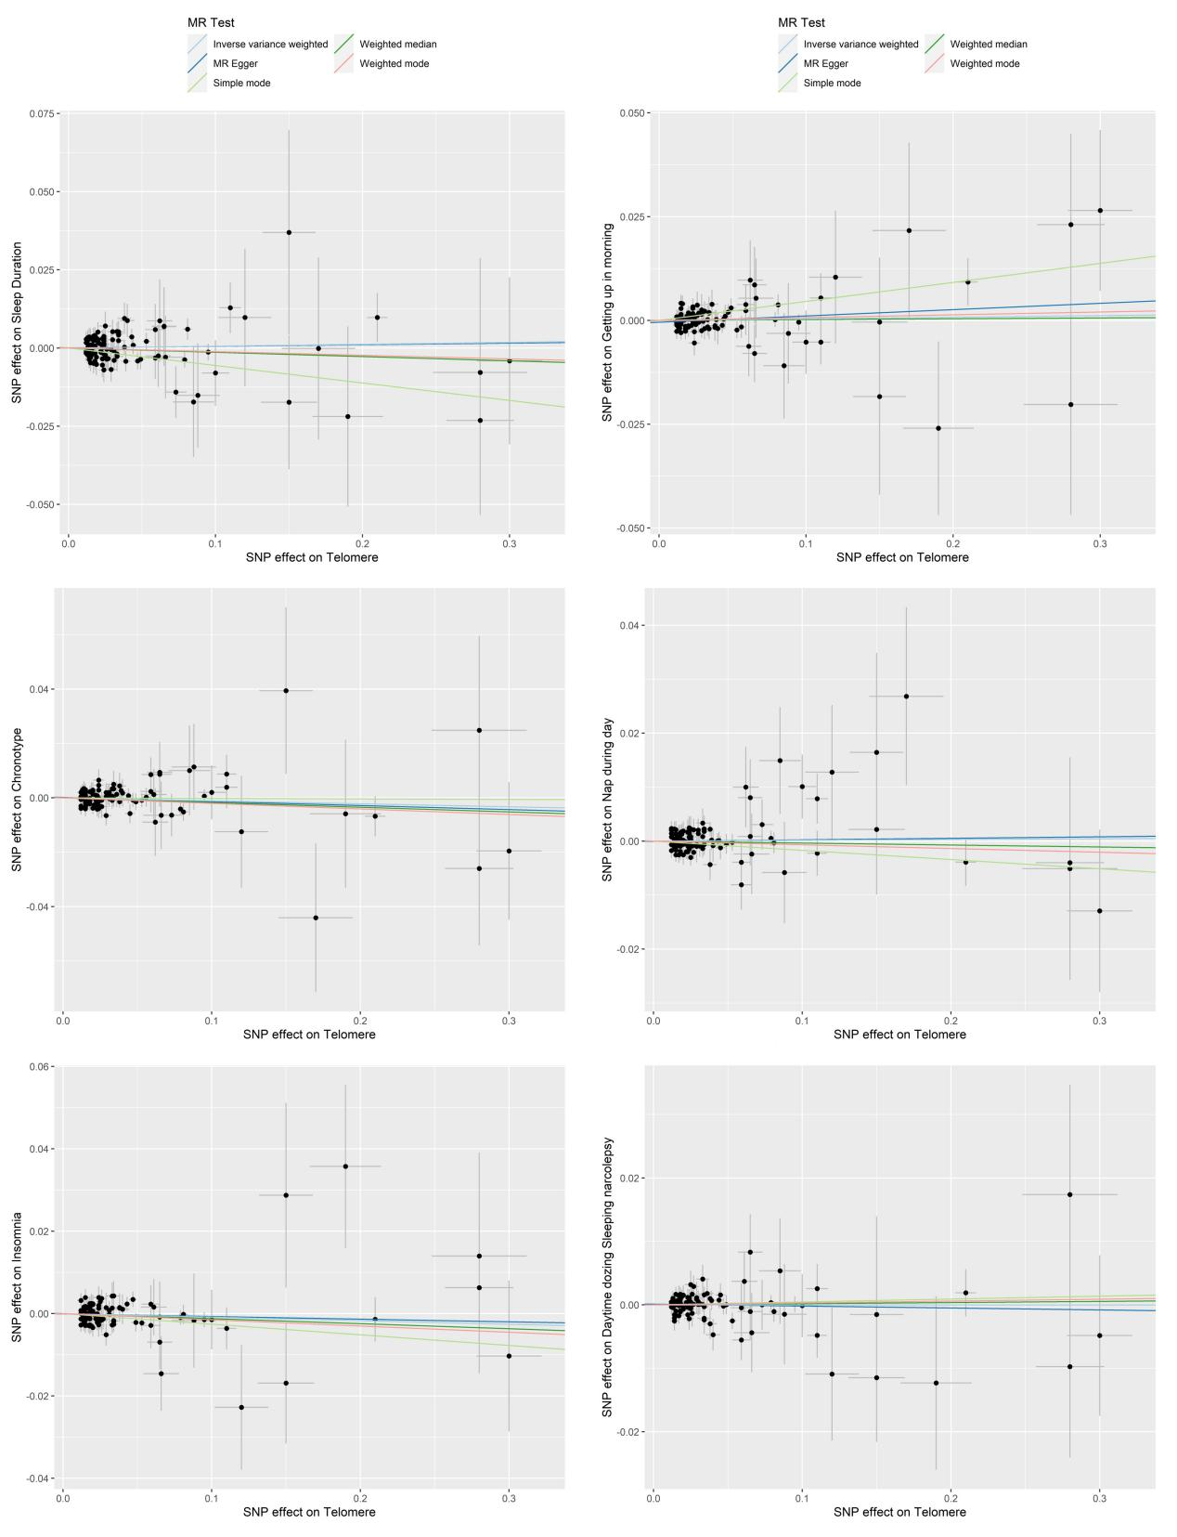

Figure S2. Scatter plots of MR analysis with LTL as outcome
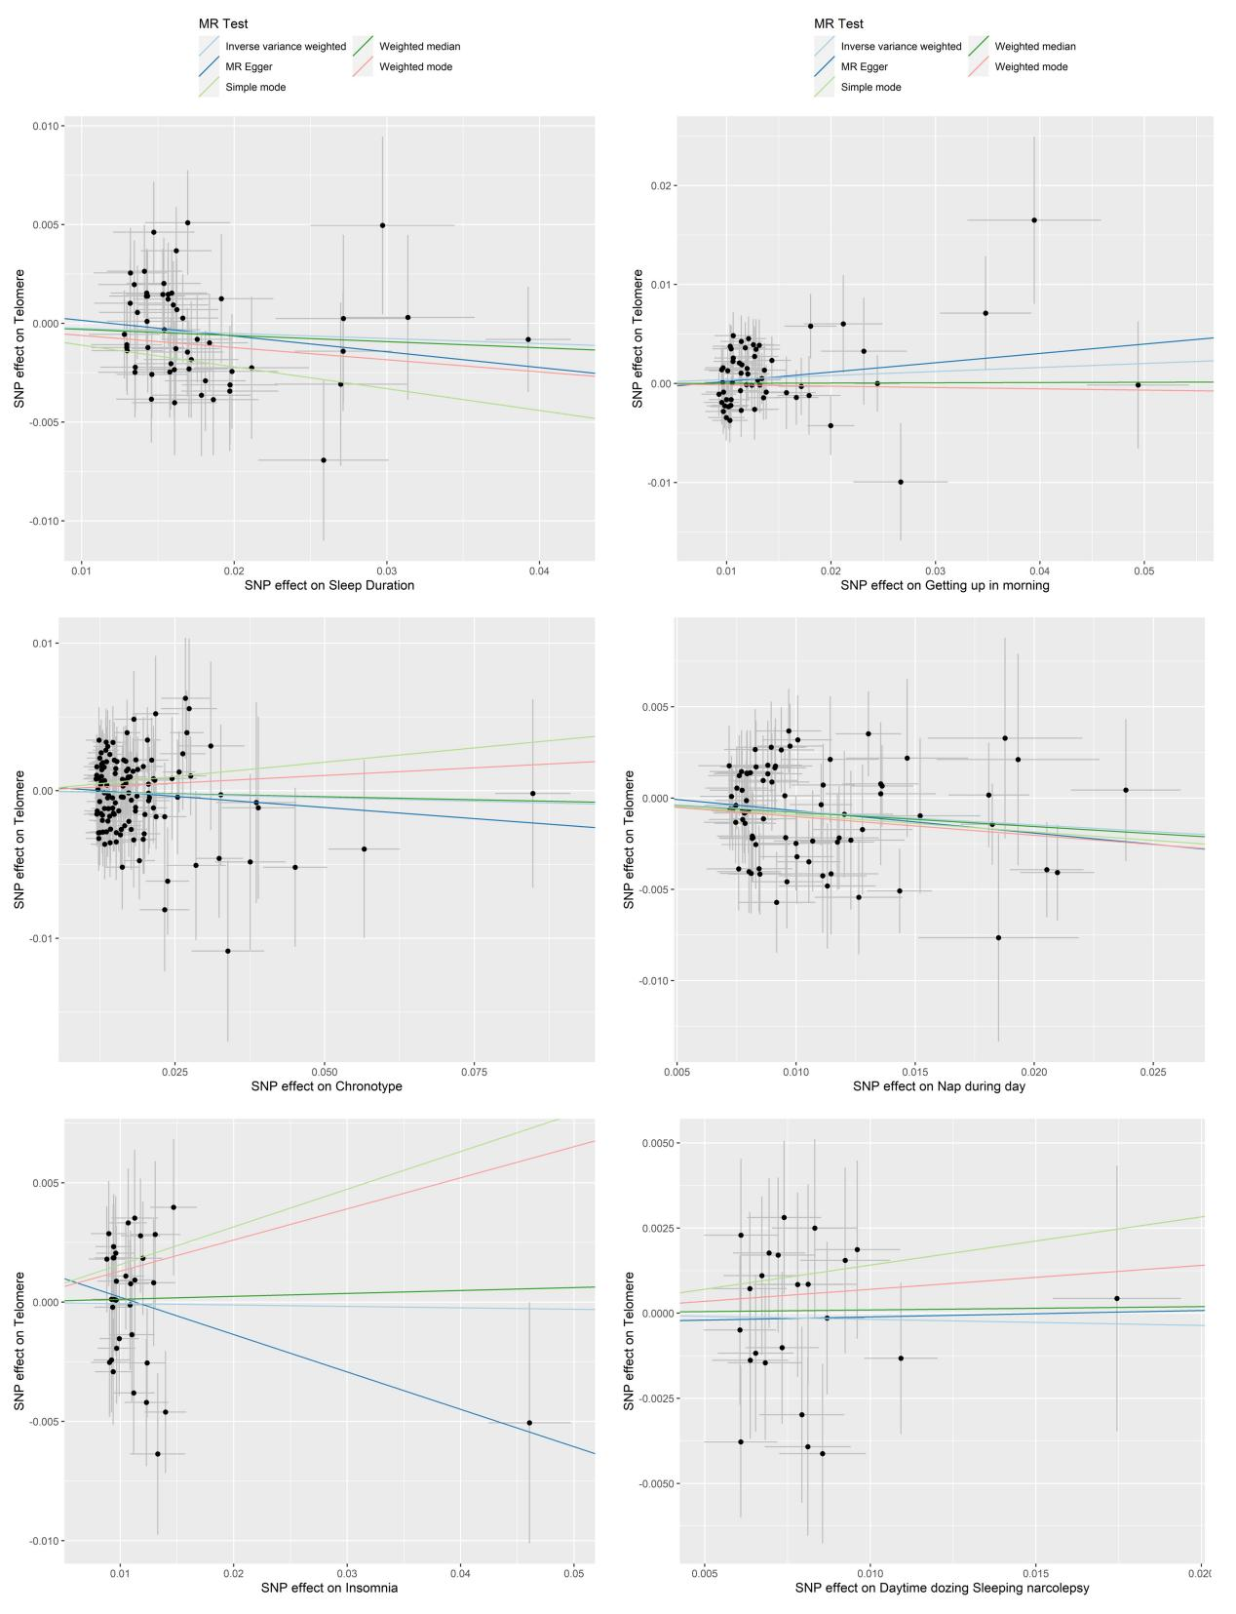
Figure S3. Forest plots of MR analysis with LTL as exposure
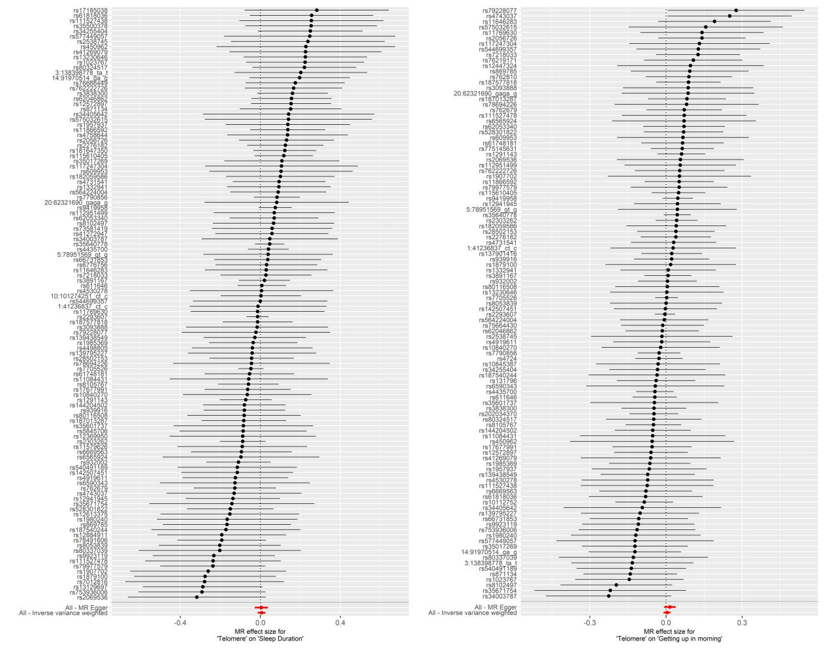
Figure S3. Forest plots of MR analysis with LTL as exposure (continue)
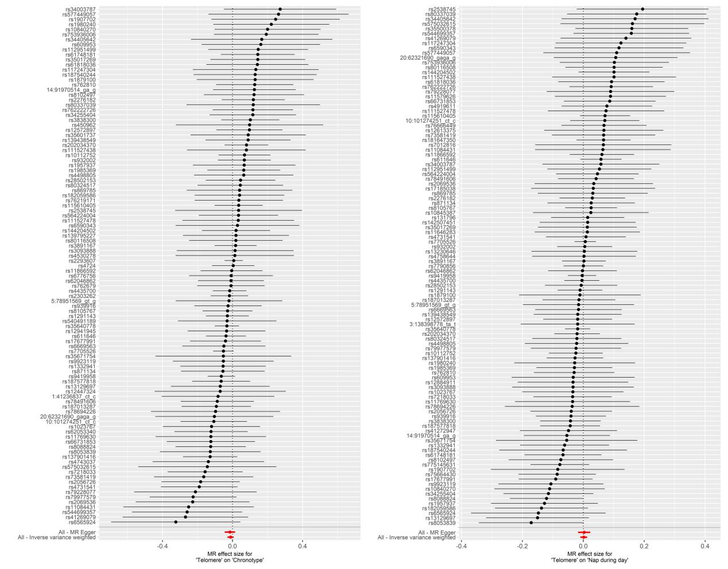

Figure S3. Forest plots of MR analysis with LTL as exposure (continue)
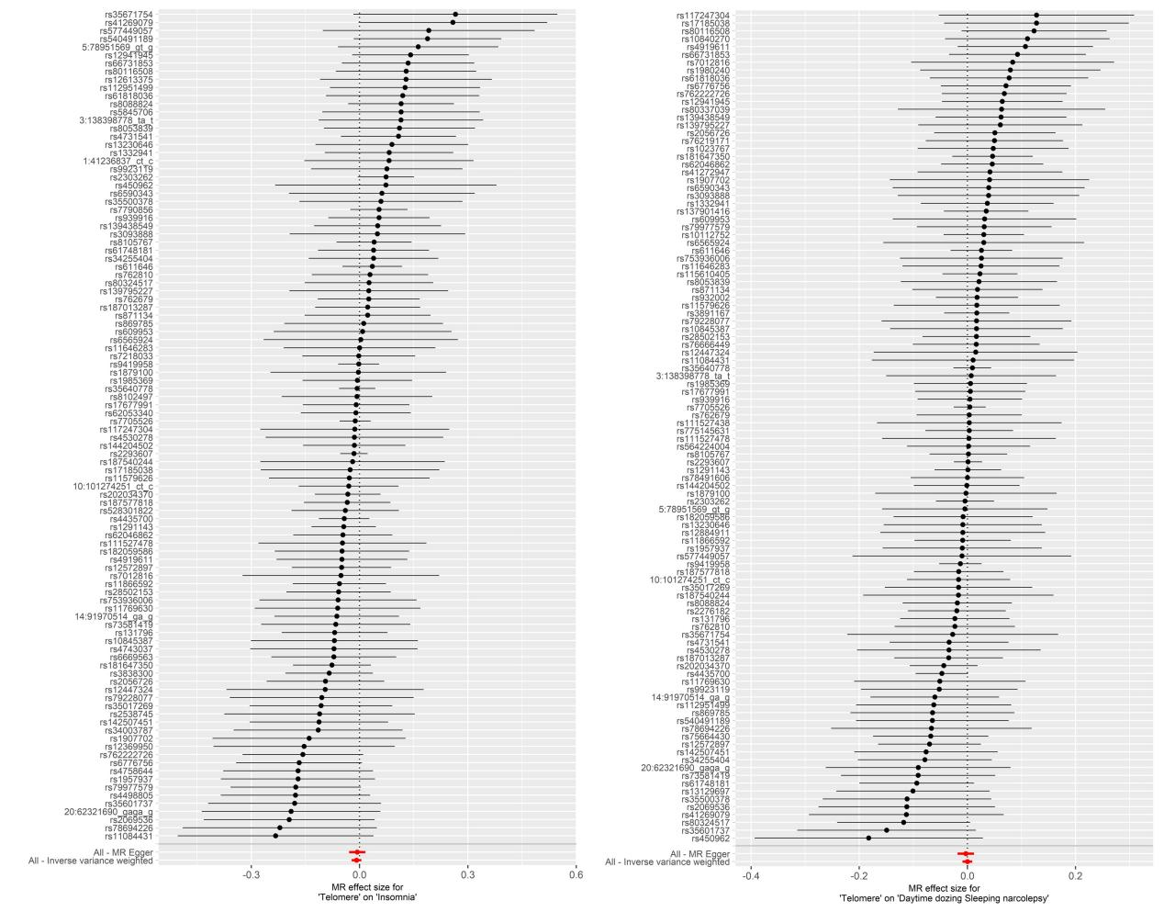

Figure S4. Forest plots of MR analysis with LTL as outcome
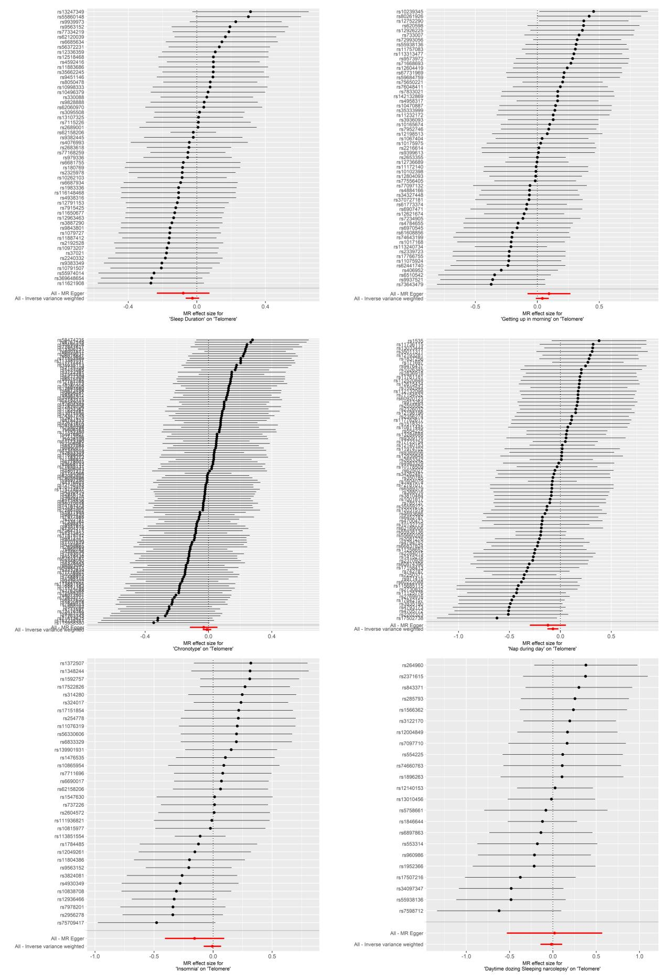

Figure S5. Funnel plots of MR analysis with LTL as exposure
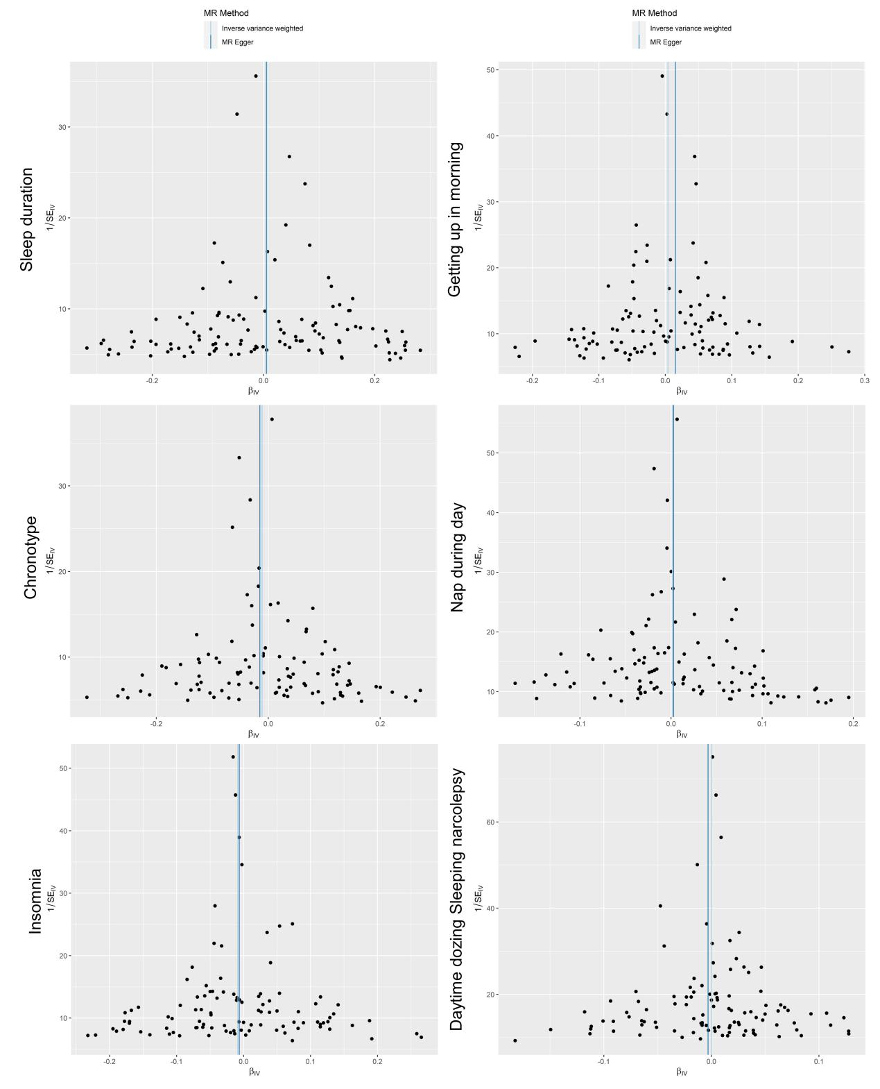

Figure S6. Funnel plots of MR analysis with LTL as outcome

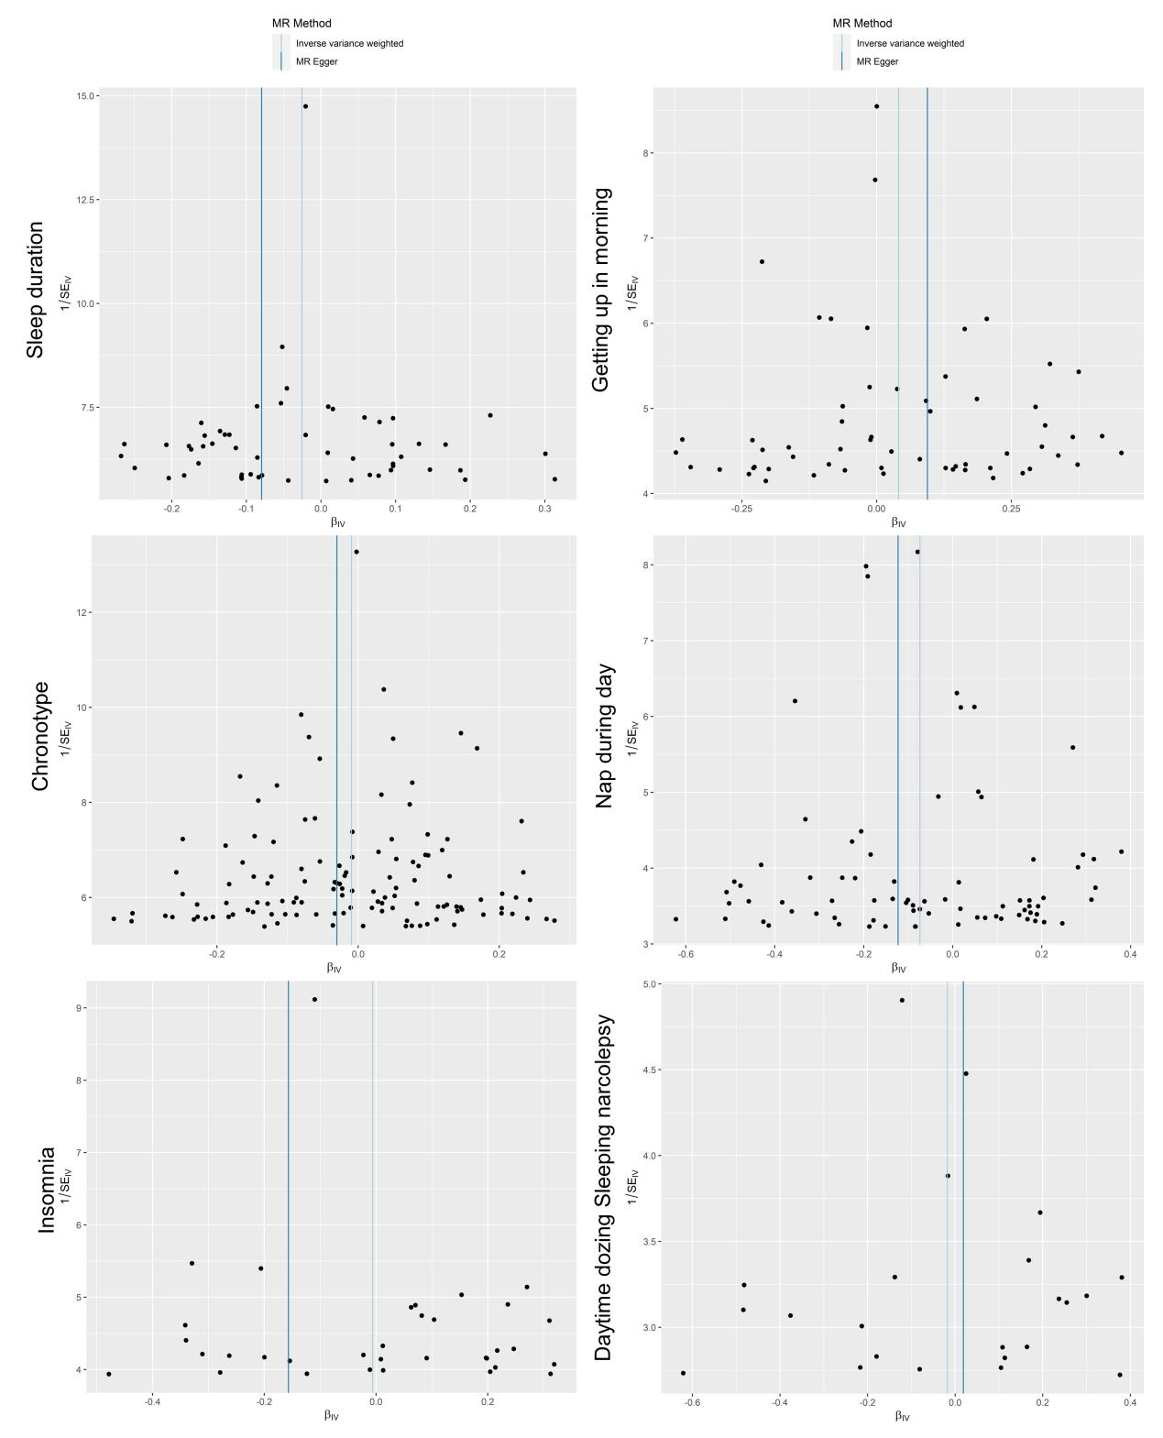

Figure S7. Non-linear MR results with piecewise linear method. a) using three strata of IV-free Exposure on the LTL. b) using five strata of IV-free Exposure. c) using ten strata of IV-free Exposure. Beta are SD changes in genetically predicted LTL for per SD increase in genetically predicted sleep duration.
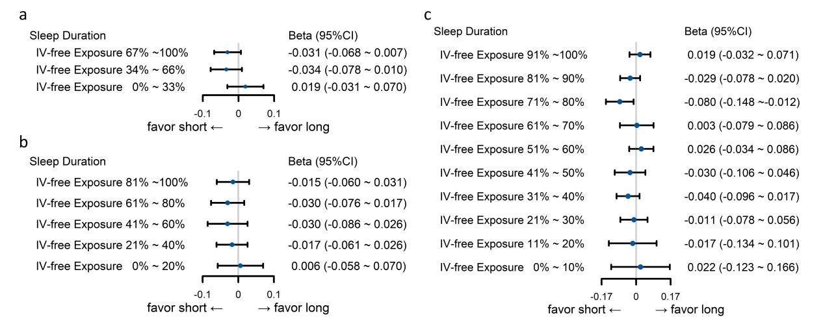

Table S11 P-value of Pleiotropy and Heterogeneity of Telomere on Sleep Characteristics in MR-Egger analysis

Sleep Characteristics (Outcome) | Pleiotropy | Heterogeneity
Sleep duration＊ | 0.471 | 0.457
Getting up in morning | 0.263 | 0.951
Chronotype | 0.979 | 0.934
Nap during the day | 0.332 | 0.517
Sleeplessness / insomnia | 0.394 | 0.629
Daytime dozing / sleeping (narcolepsy) | 0.884 | 0.966
＊continuous sleep duration

Table S12. P-value of Pleiotropy and Heterogeneity of Sleep Characteristics on Telomere in MR-Egger analysis
Sleep Characteristics (Exposure) | Pleiotropy | Heterogeneity
Sleep duration＊ | 0.720 | 0.285
Getting up in morning | 0.519 | 0.392
Chronotype | 0.413 | 0.941
Nap during the day | 0.205 | 0.722
Sleeplessness / insomnia | 0.192 | 0.423
Daytime dozing / sleeping (narcolepsy) | 0.485 | 0.173
＊continuous sleep duration

Table S13. MRlap estimates between sleep traits and leukocyte telomere length
Sleep Characteristics (Exposure) | Observed P | Corrected P | P for difference
Sleep duration＊ | 0.993 | 0.978 | 0.896
Getting up in morning | 0.163 | 0.186 | 0.191
Chronotype | 0.351 | 0.297 | 0.300
Nap during the day | 0.433 | 0.631 | 0.500
Sleeplessness / insomnia | 0.326 | 0.364 | 0.569
Daytime dozing / sleeping (narcolepsy) | 0.532 | 0.455 | 0.322
＊continuous sleep duration

