Appendix A. Supplementary data

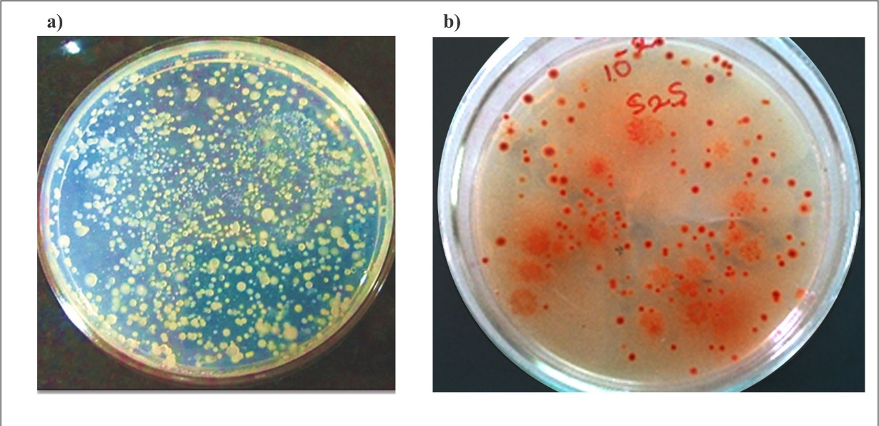
Figure 1 ZMA plate without Na₂SeO₃ a); ZMA plate with 2 mM Na₂SeO₃ b).

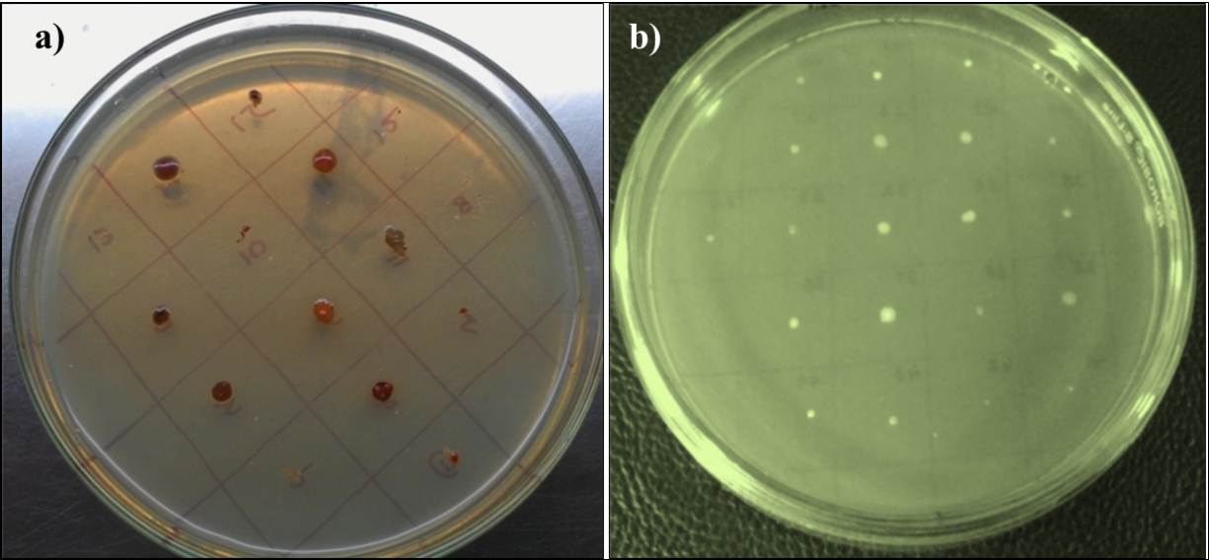
Figure 2 ZMA plate containing 6 mM Na₂SeO₃ showing brick red colouration due to reduction a); ZMA plate without Na₂SeO₃ showing no brick red colonies b).

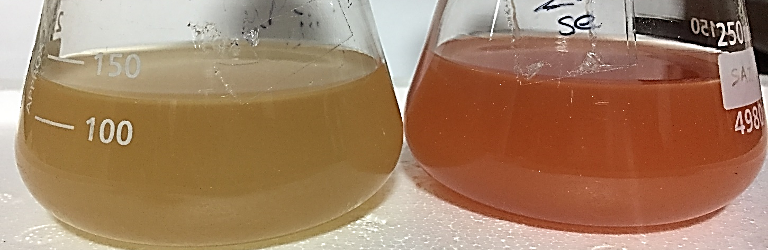
Figure 3 Growth of Halomonas venusta GUSDM4 in ZMB: without Na₂SeO₃ a); with 2 mM Na₂SeO₃ b).

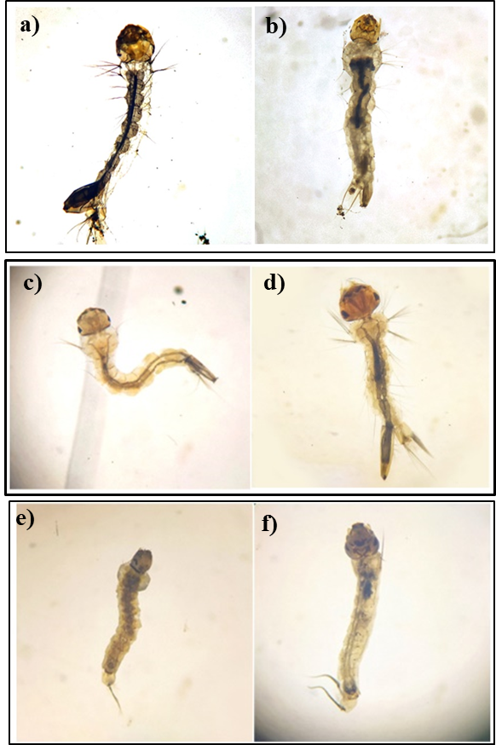
Figure 4 Larvae of: Aedes aegypti (control) a), Aedes aegypti (test) b); Culex quinquefasciatus (control) c), Culex quinquefasciatus (test) d); Anopheles stephensi (control) e), Anopheles stephensi (test) f).

