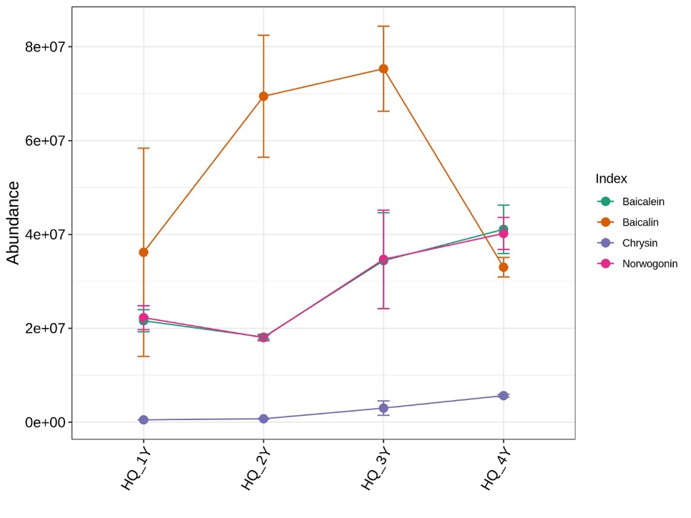
SFig. 1 The content variation trends of Chrysin, Baicalein, Norwogonin, and Baicalin in HuangQin across four years.

