Supporting Information
Preparation of D-NCCDs and its application in fluorescent/colorimetric dual-mode discrimination of glutamine enantiomers
Xuan Liao, Cancan Lu, Yaning Duan, Cuiling Ren*, Hongli Chen
State Key Laboratory of Applied Organic Chemistry, College of Chemistry and Chemical Engineering, Lanzhou University, Lanzhou 730000, P. R. China.

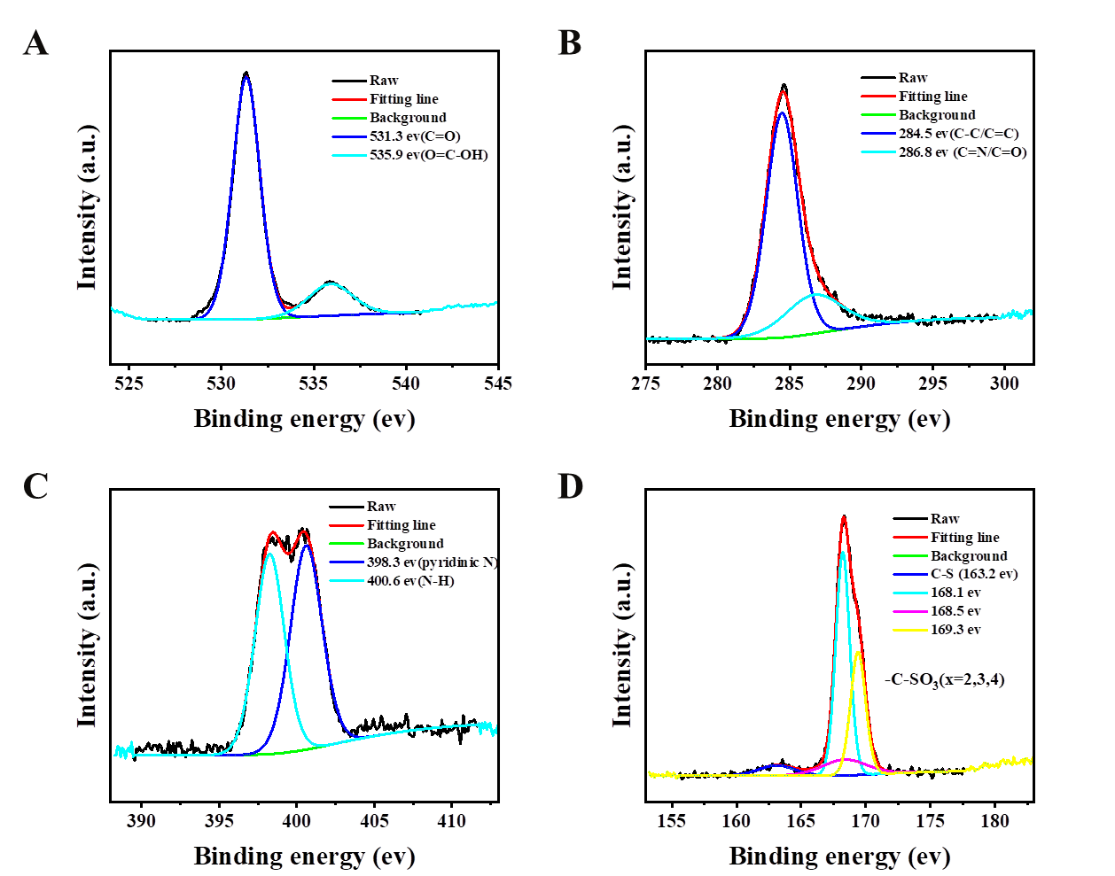
Figure S1. High resolution XPS spectra of (D) C 1s;(E) N 1s; (F) O 1s and (G) S 2p.
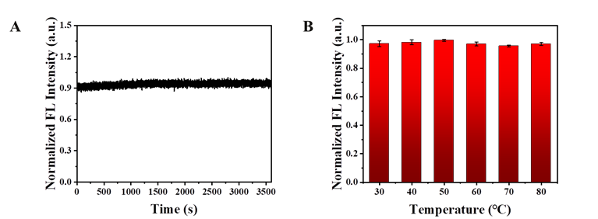
Figure S2. The effect of (A) light times and (B) temperature on the fluorescence signal of D-NCCDs.
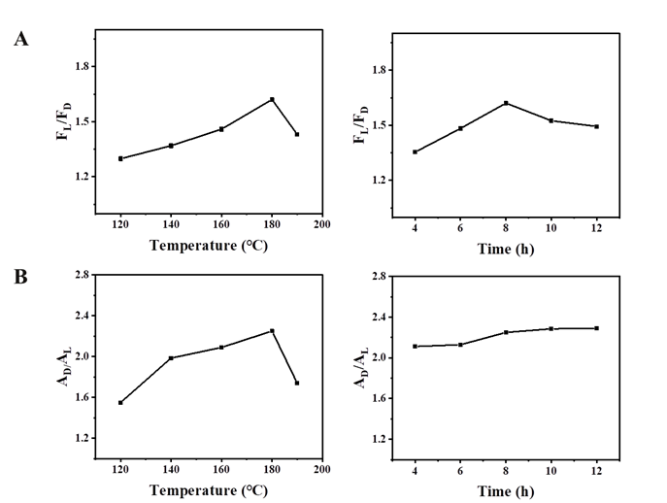
Figure S3. The influence of different reaction temperature and reaction time on the ability of D-NCCDs to recognize Gln enantiomers in (A) fluorescent and (B) colorimetric mode (The concentration of L-Gln and D-Gln is 10 mM).
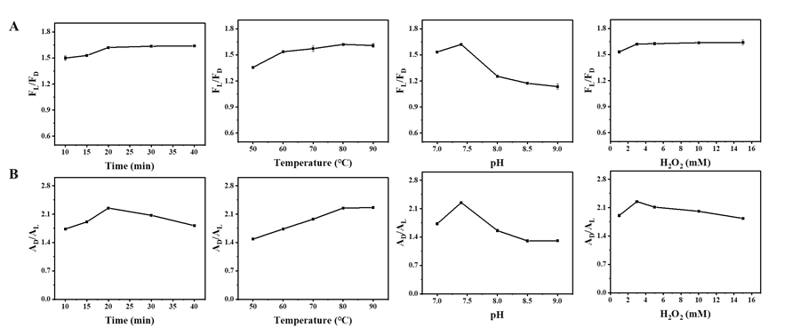
Figure S4. The influence of different temperature, incubation time, pH and concentration of H2O2 on the ability of D-NCCDs to recognize Gln enantiomers in (A) fluorescent and (B) colorimetric mode (The concentration of L-Gln and D-Gln is 10 mM).
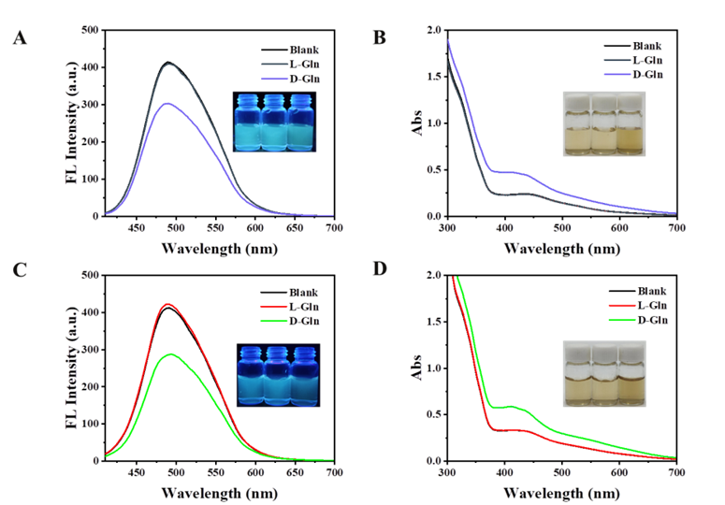
Figure S5. Effects of adding 10 mM L-Gln and D-Gln on (A) fluorescence signal and (B) absorbance of L-NCCDs, respectively; Effects of adding 10 mM L-Gln and D-Gln on (C) fluorescence signal and (D) absorbance of DL-NCCDs, respectively.

