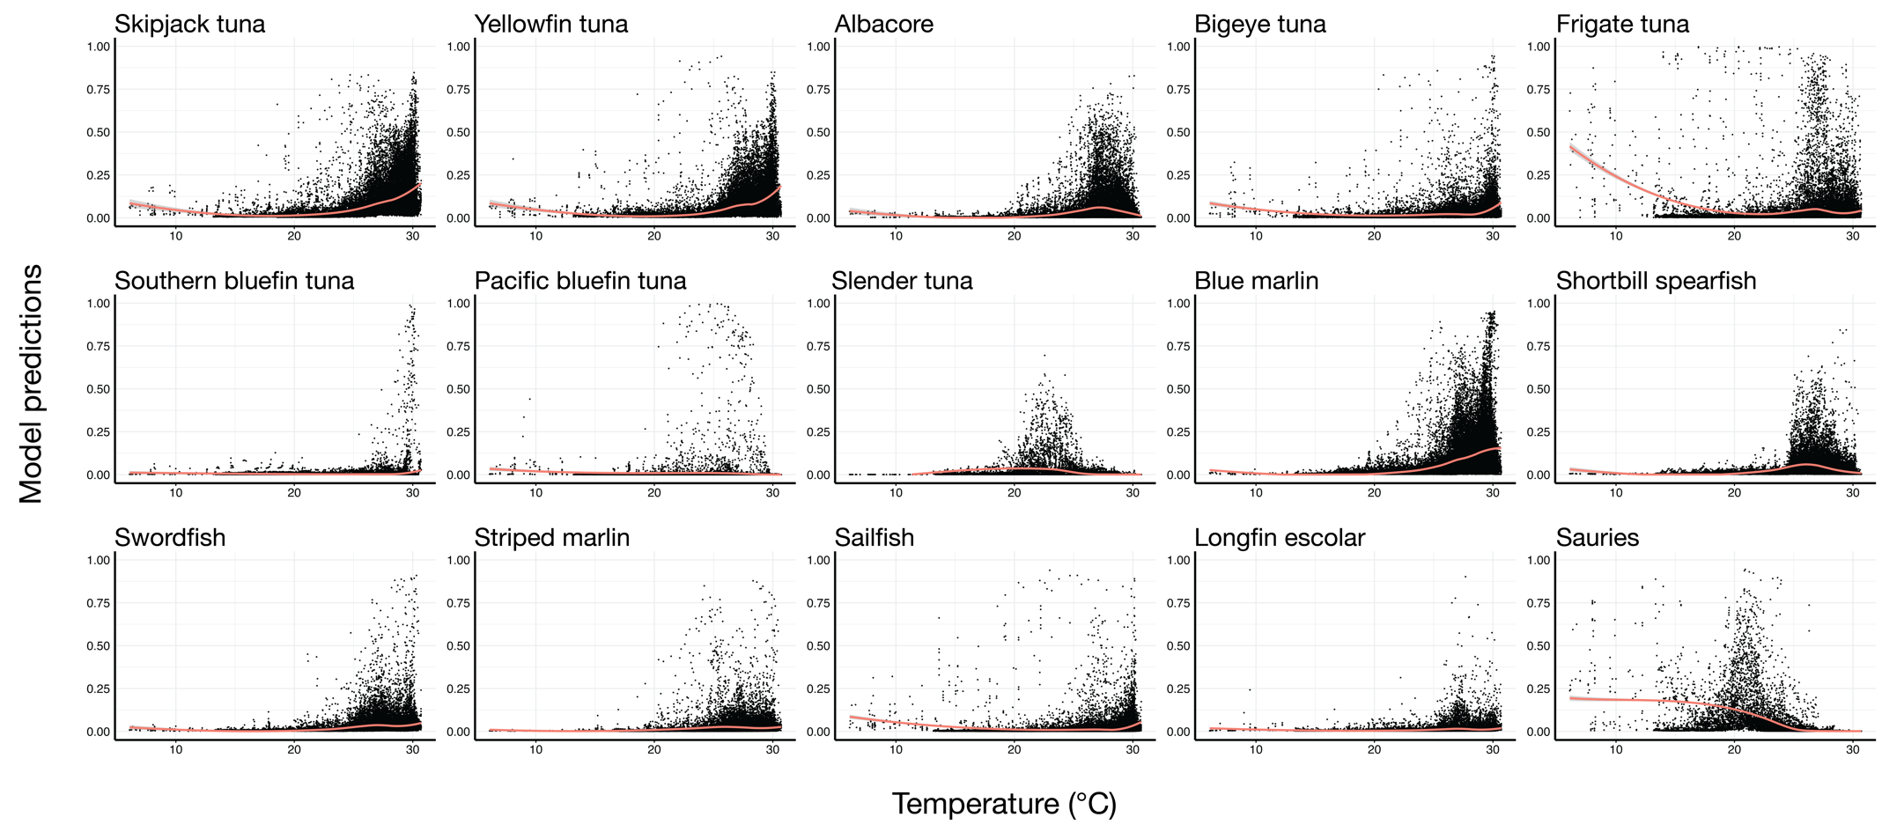
Fig. S1. Surface temperature (°C) preferences across taxa.

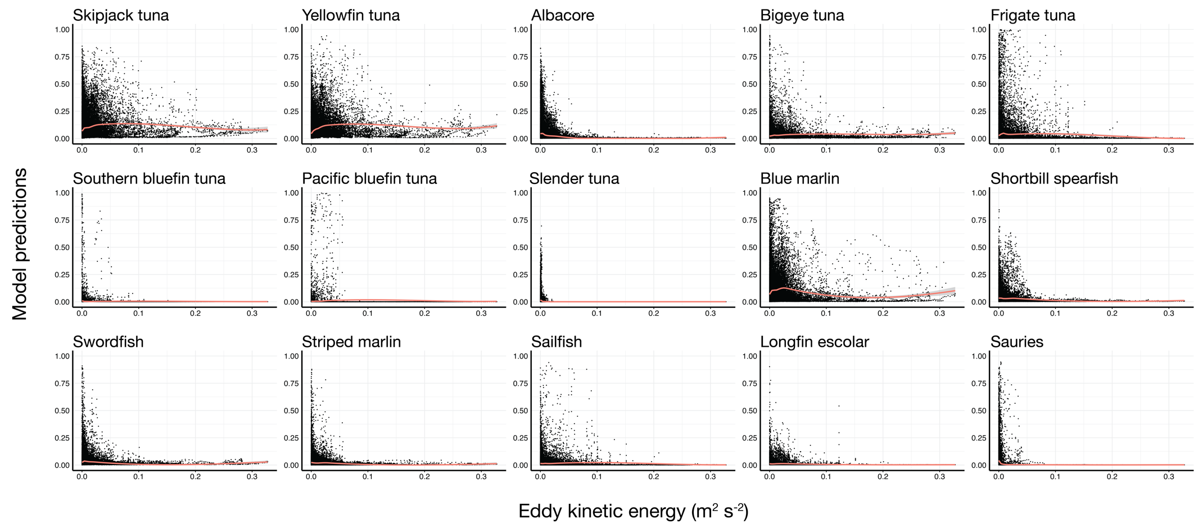
Fig. S2. Eddy kinetic energy (m² s⁻²) preferences across taxa.

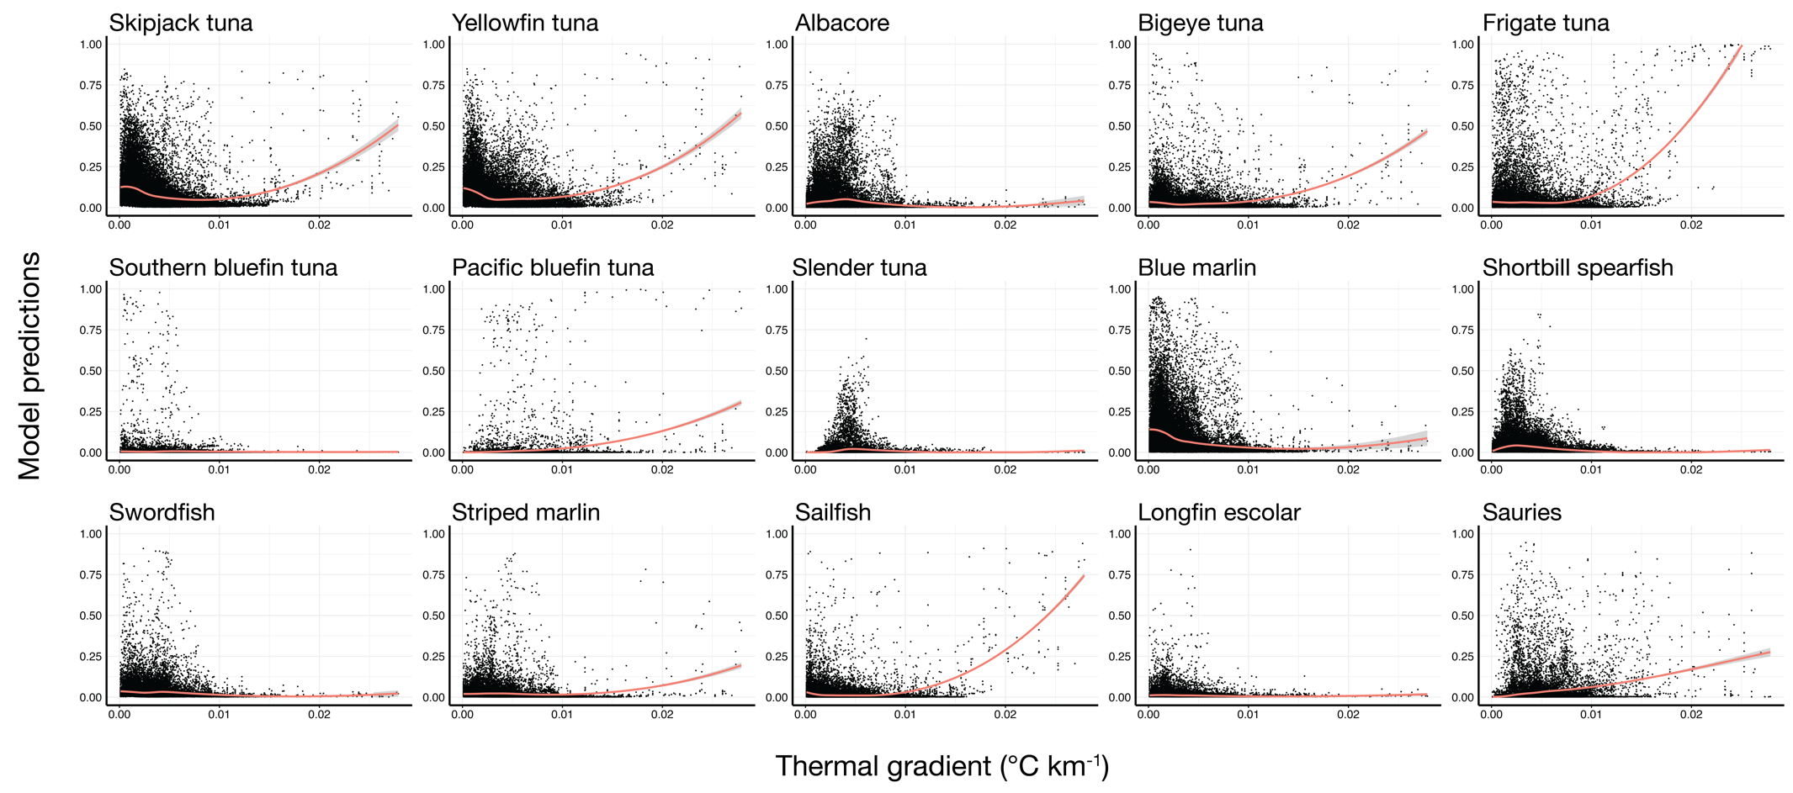
Fig. S3. Broad-scale thermal gradient (°C km⁻¹) preferences across taxa.

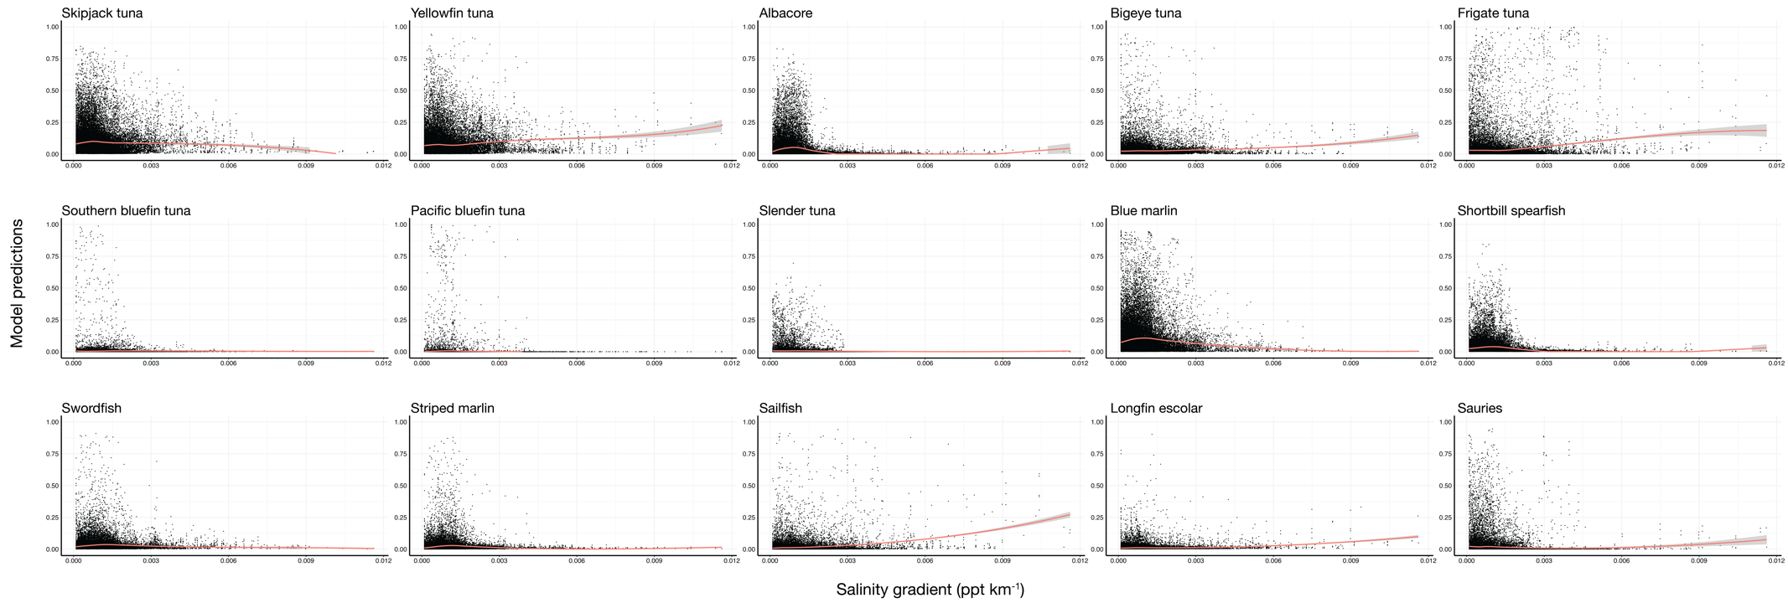
Fig. S4. Broad-scale salinity gradient (ppt km⁻¹) preferences across taxa.

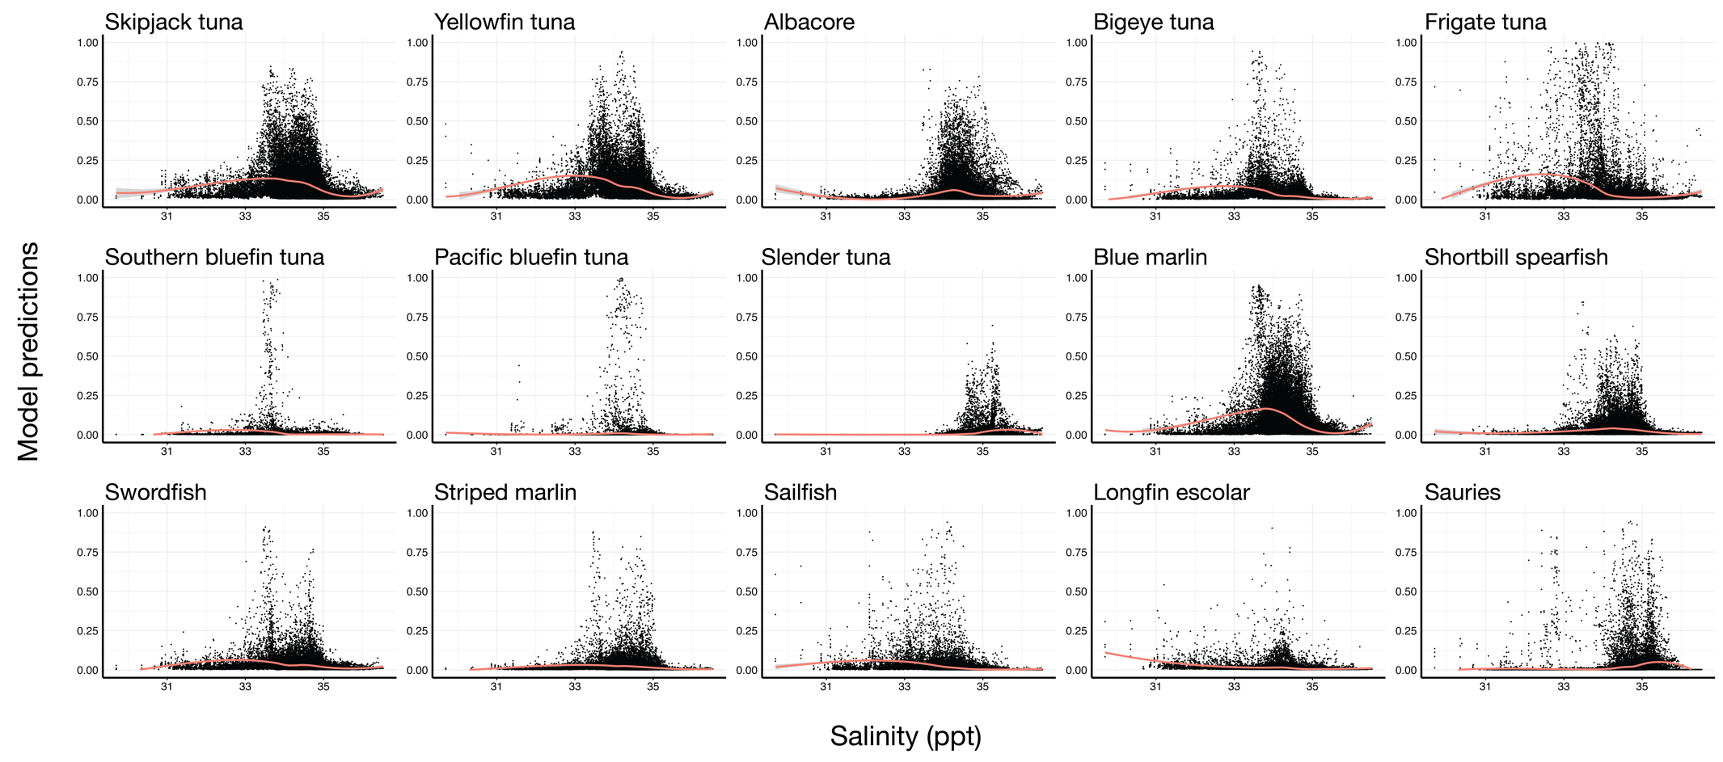
Fig. S5. Salinity (ppt) preferences across taxa.

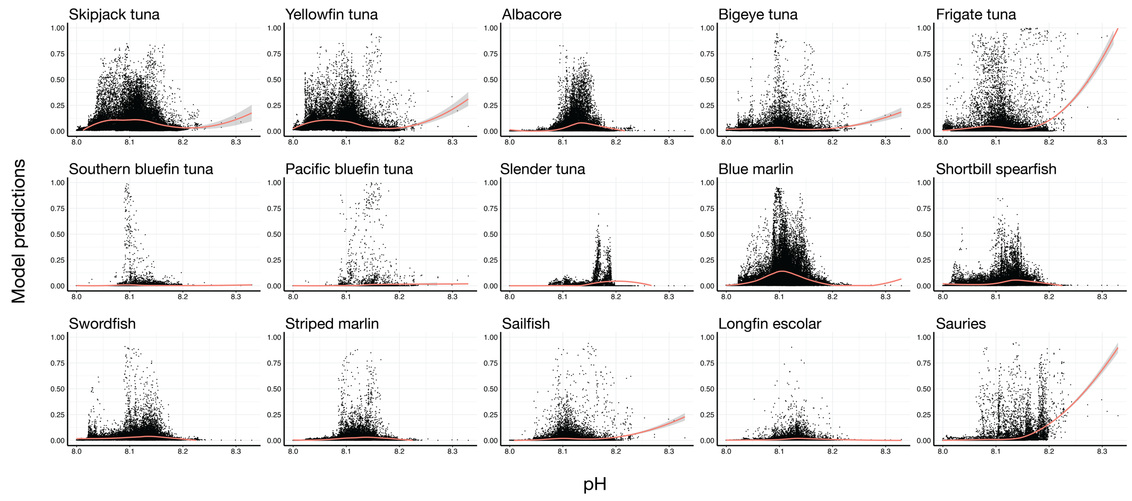
Fig. S6. pH preferences across taxa.

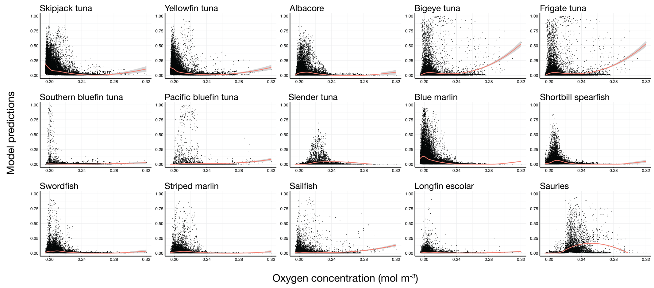
Fig. S7. Oxygen concentration (mol m⁻³) preferences across taxa.

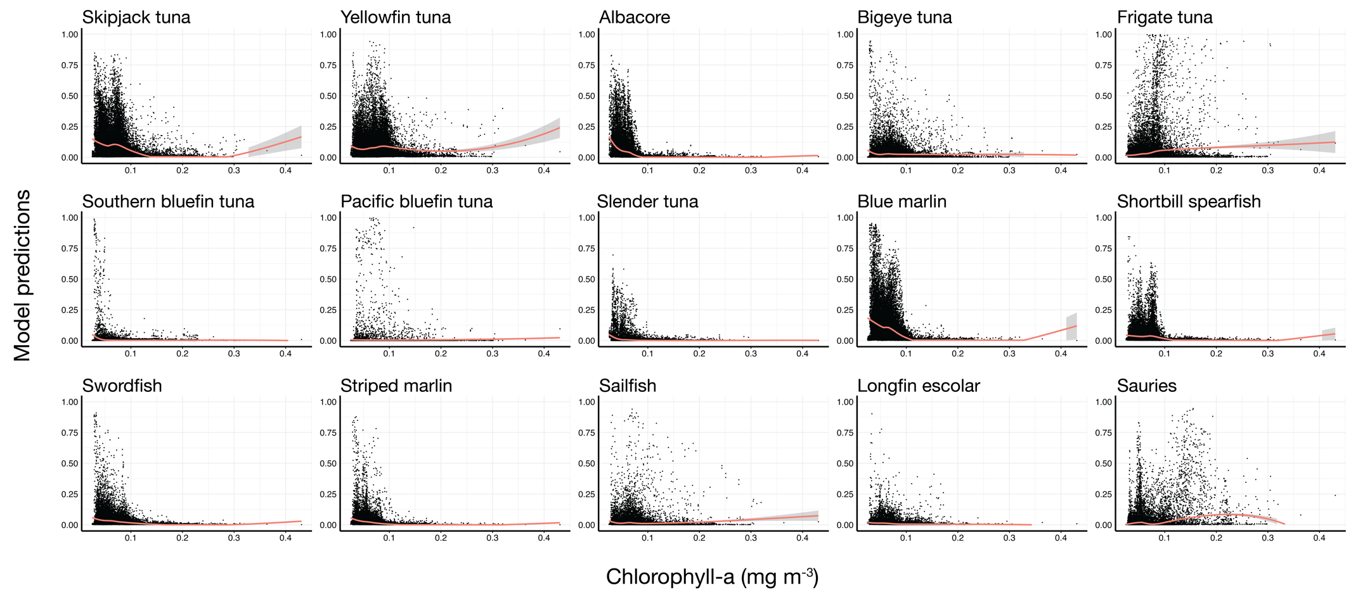
Fig. S8. Chlorophyll-a preferences across taxa.

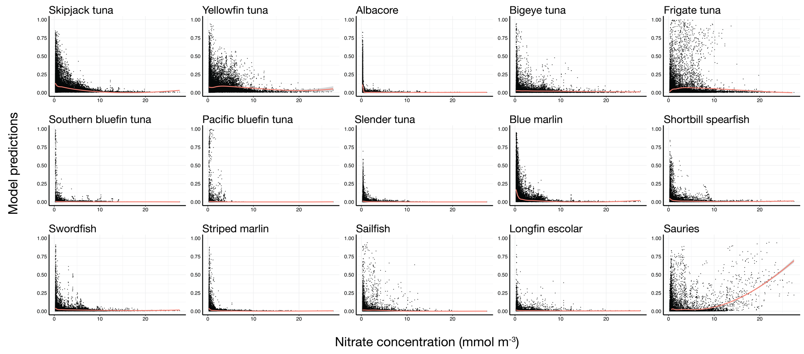
Fig. S9. Nitrate concentration (mmol m⁻³) preferences across taxa.

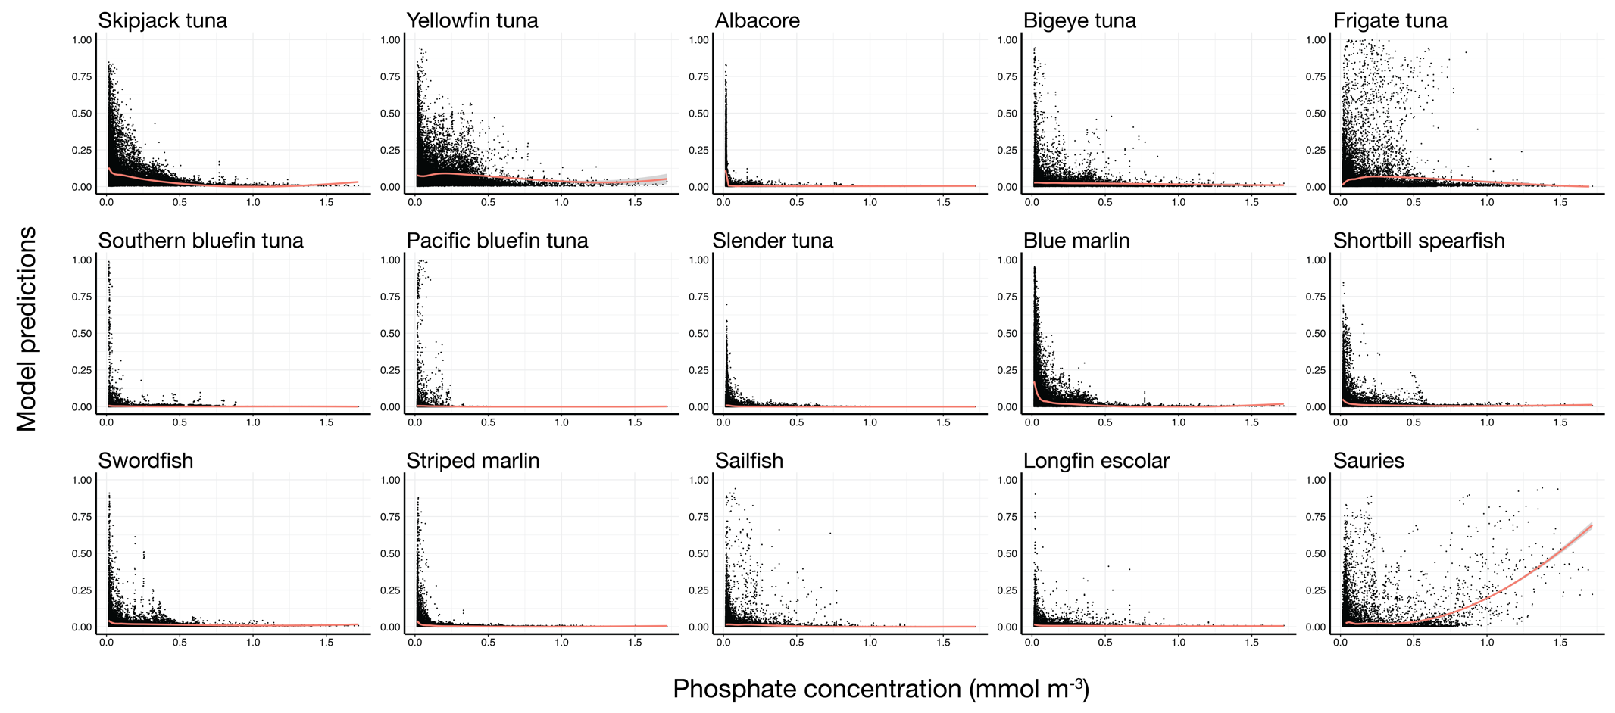
Fig. S10. Phosphate concentration (mmol m⁻³) preferences across taxa.

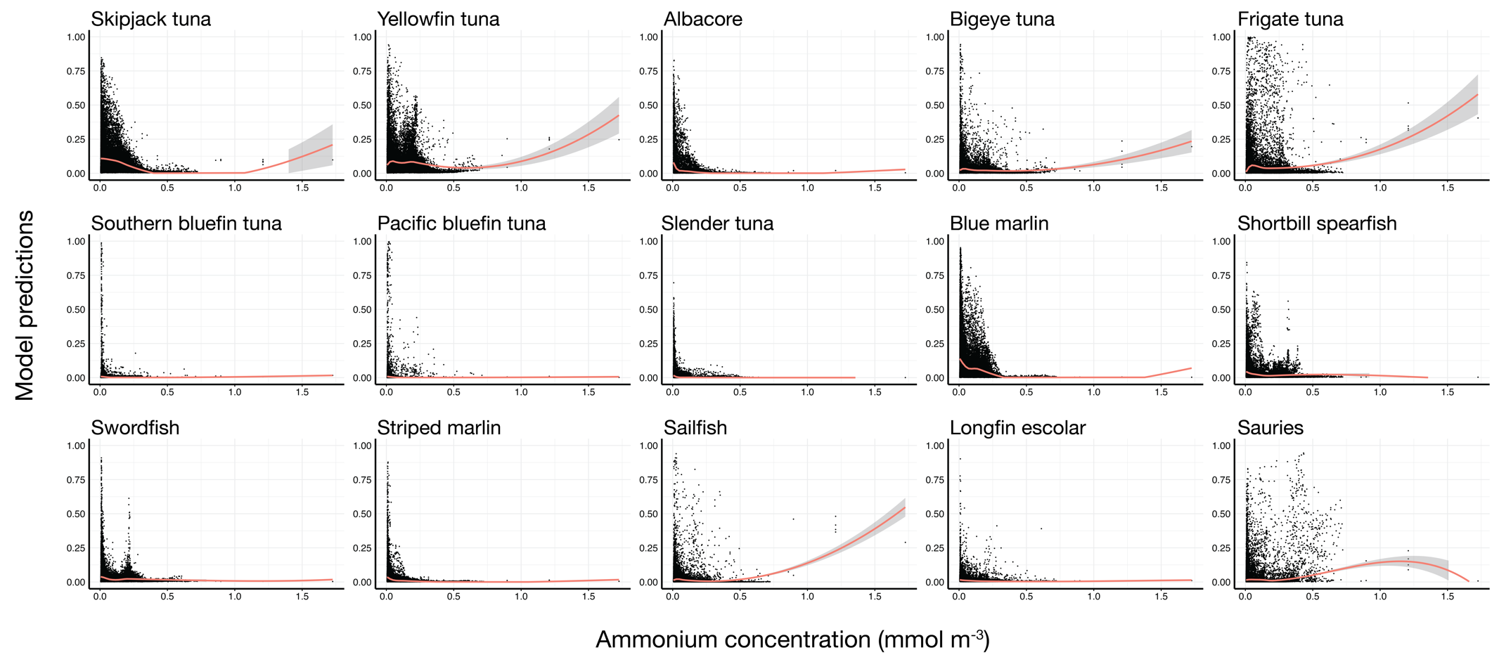
Fig. S11. Ammonium concentration (mmol m⁻³) preferences across taxa.

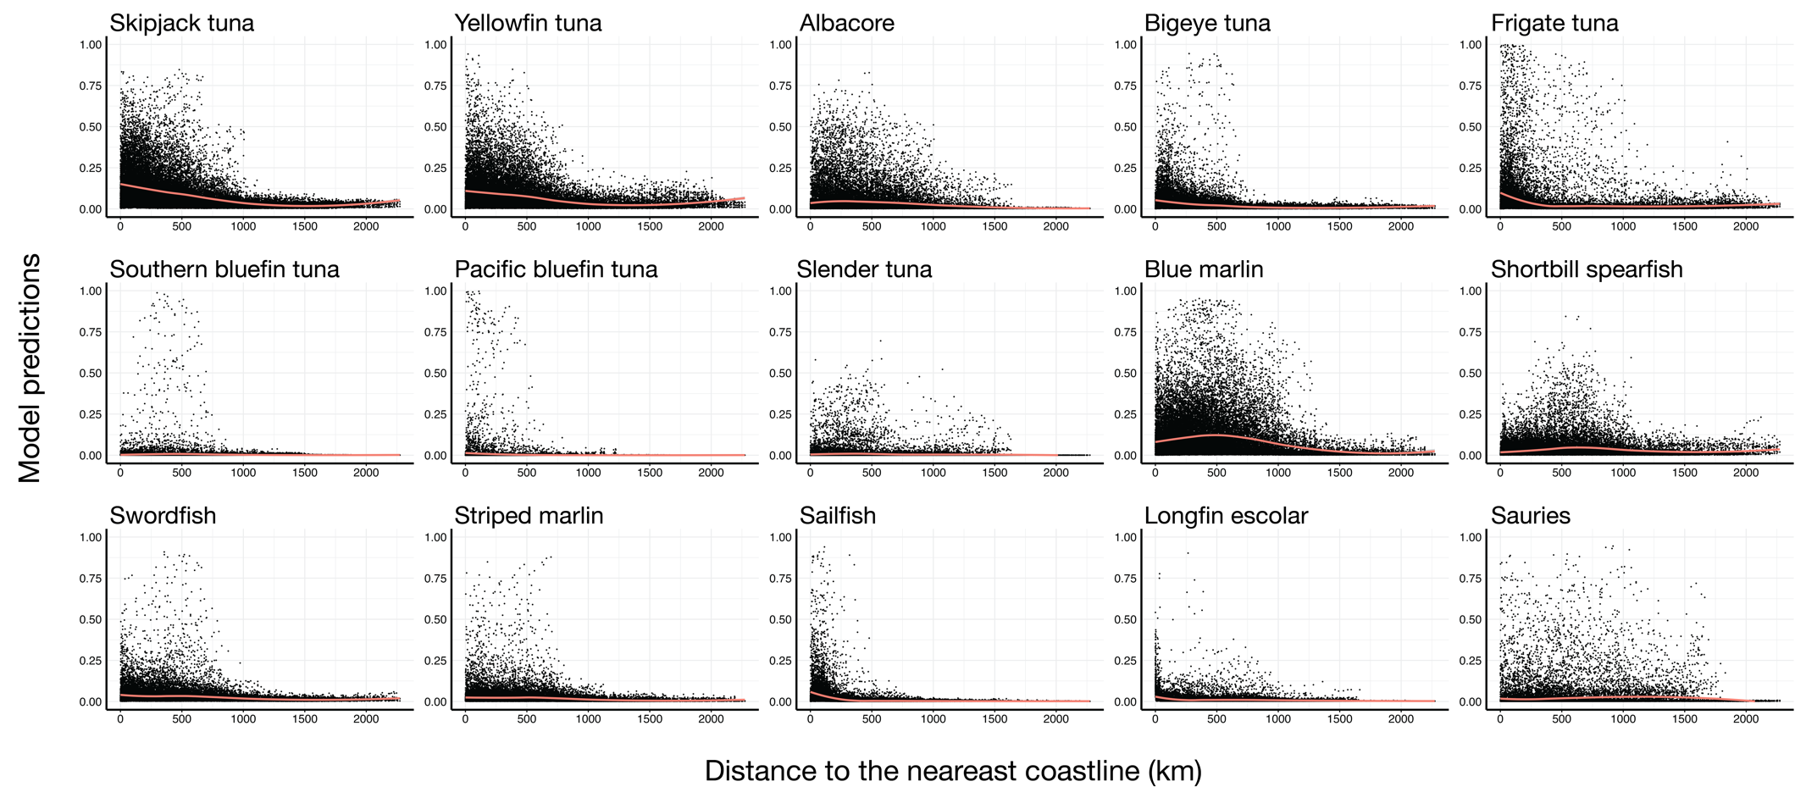
Fig. S12. Distance to the nearest coastline (km) preferences across taxa.

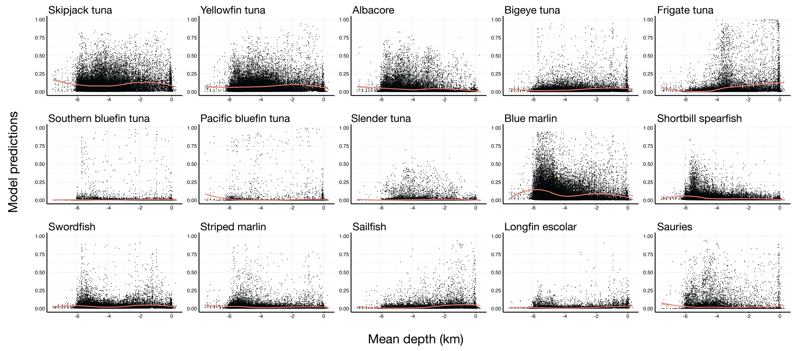
Fig. S13. Mean depth (km) preferences across taxa.

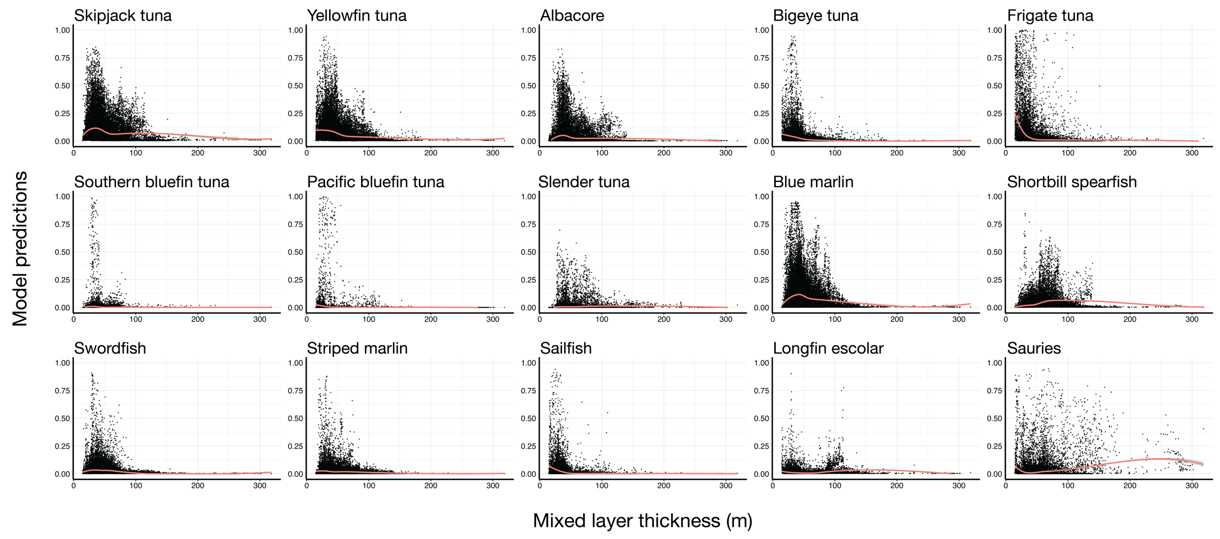
Fig. S14. Mixed layer thickness (m) preferences ascross taxa.

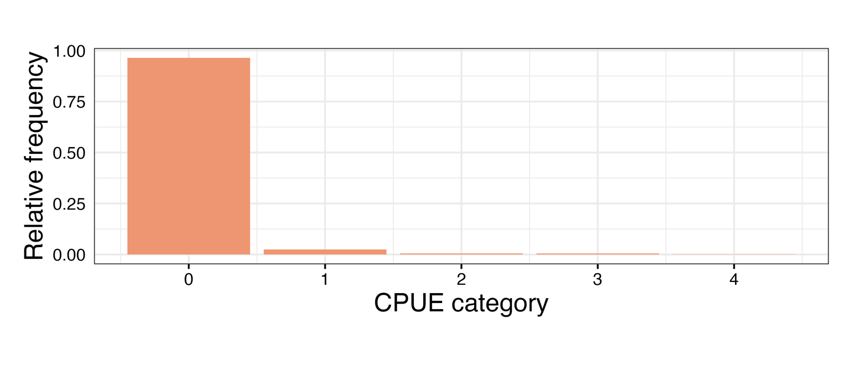
Fig. S15. Distribution of Catch Per Unit Effort (CPUE) categories across all taxa in the Nishikawa et al. (1985) data.

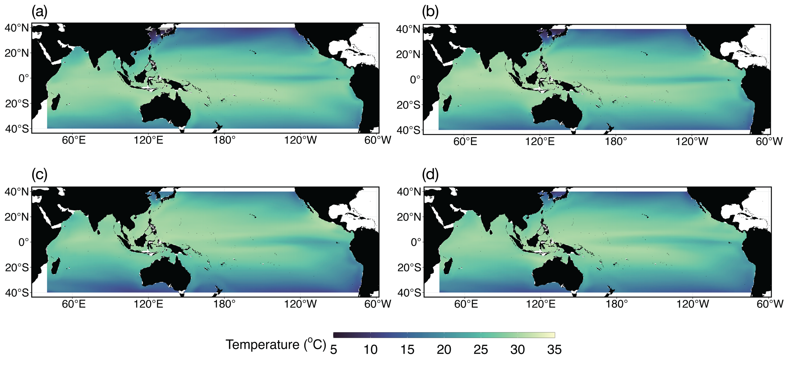
Fig. S16. Mean seasonal historical (1956-1981) surface temperature (ºC) across seasons: (a) January-March; (b) April-June; (c) July-September; and (d) October-December.
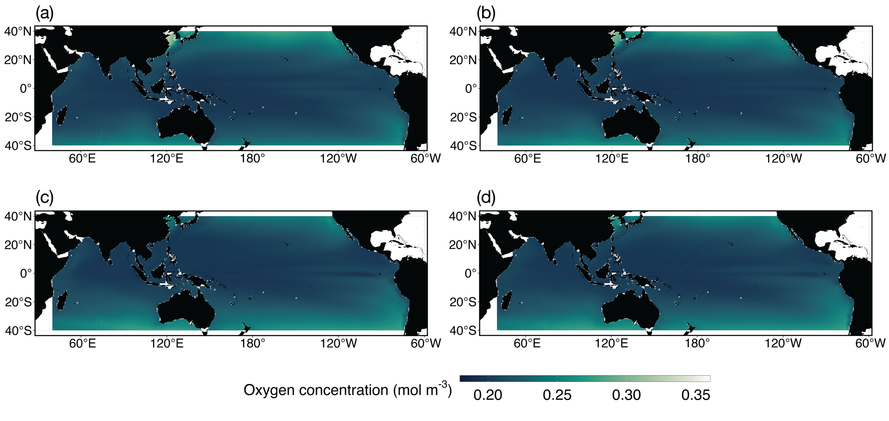
Fig. S17. Mean seasonal historical (1956-1981) surface oxygen concentration (mol m⁻³) across seasons: (a) January-March; (b) April-June; (c) July-September; and (d) October-December.
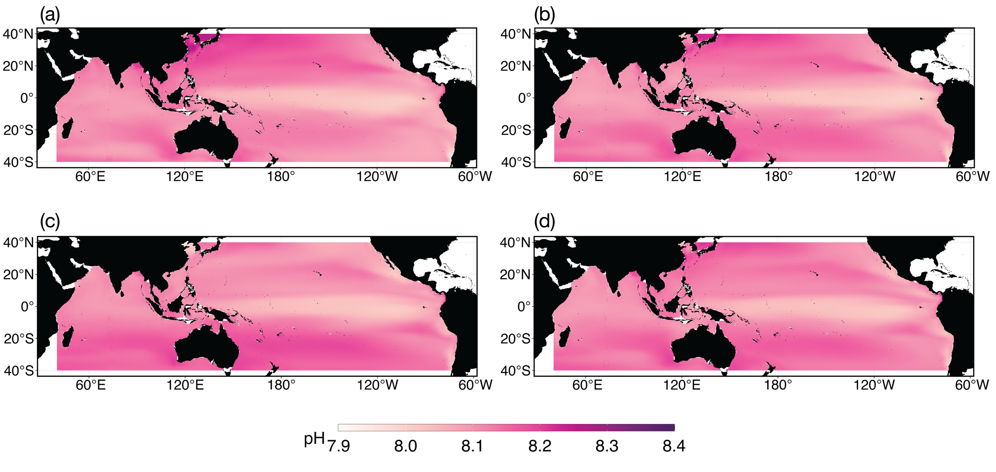
Fig. S18. Mean seasonal historical (1956-1981) surface pH across seasons: (a) January-March; (b) April-June; (c) July-September; and (d) October-December.
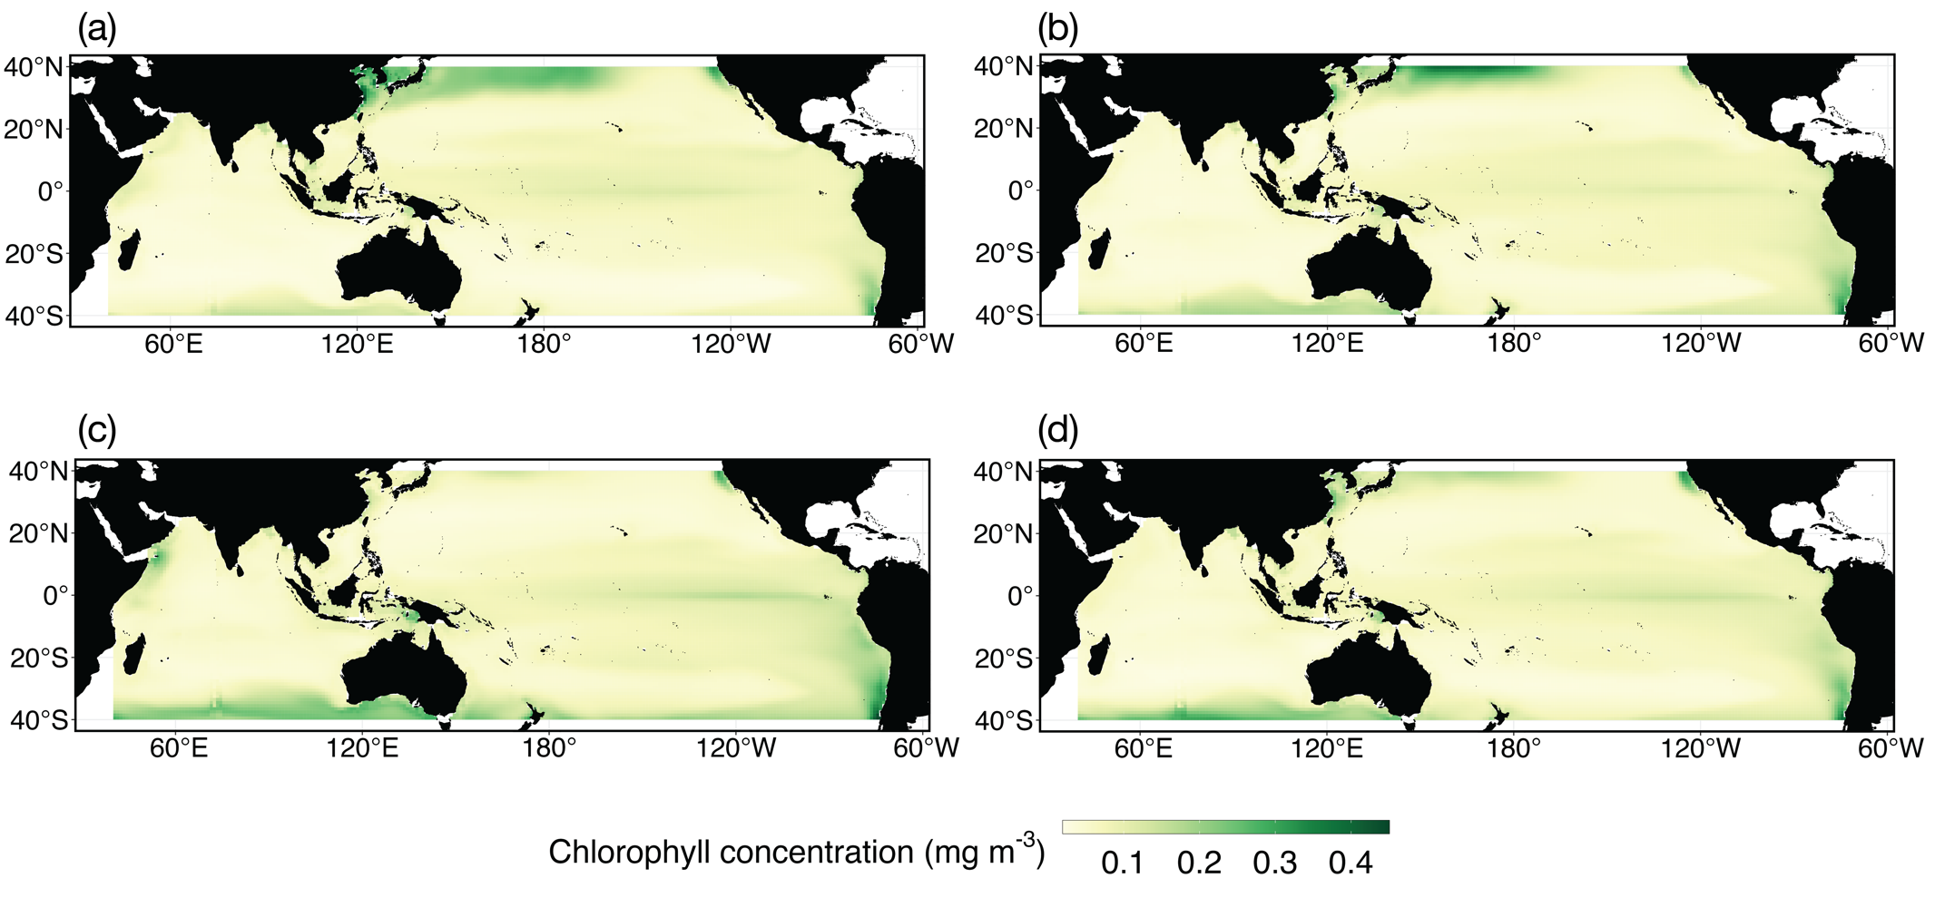
Fig. S19. Mean seasonal historical (1956-1981) surface chlorophyll concentration (mg m⁻³) across seasons: (a) January-March; (b) April-June; (c) July-September; and (d) October-December.
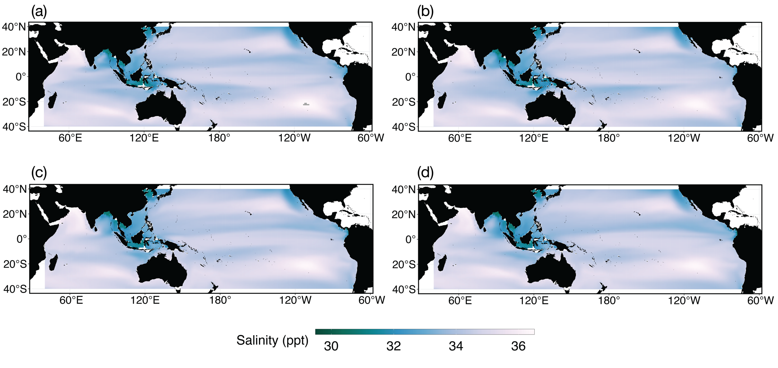
Fig. S20. Mean seasonal historical (1956-1981) surface salinity (ppt) across seasons: (a) January-March; (b) April-June; (c) July-September; and (d) October-December.
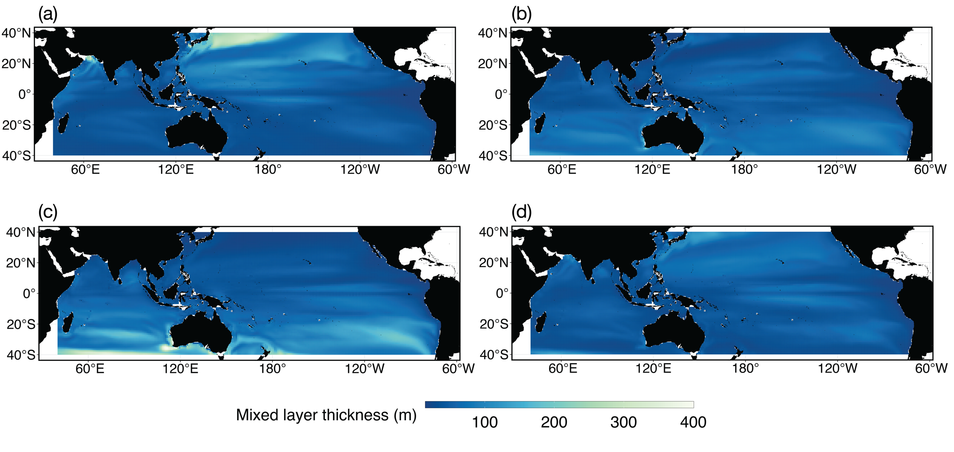
Fig. S21. Mean seasonal historical (1956-1981) mixed layer thickness (m) across seasons: (a) January-March; (b) April-June; (c) July-September; and (d) October-December.

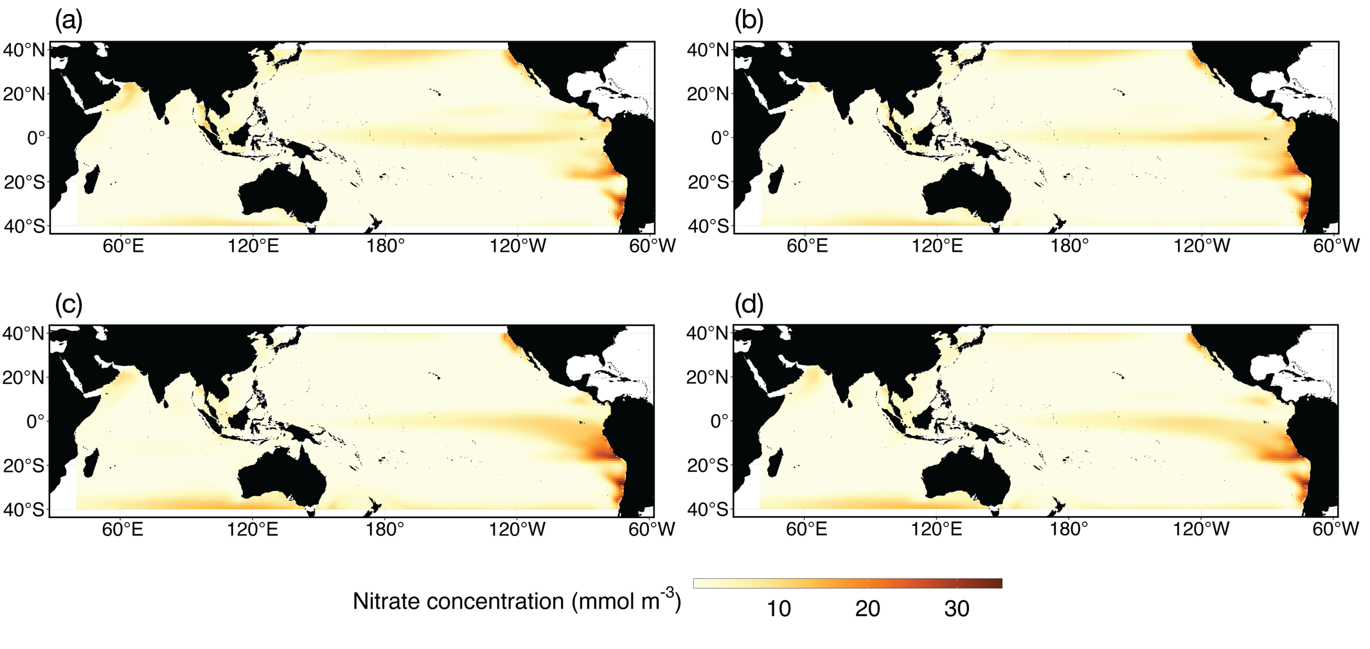
Fig. S22. Mean seasonal historical (1956-1981) surface nitrate concentration (mmol m⁻³) across seasons: (a) January-March; (b) April-June; (c) July-September; and (d) October-December.

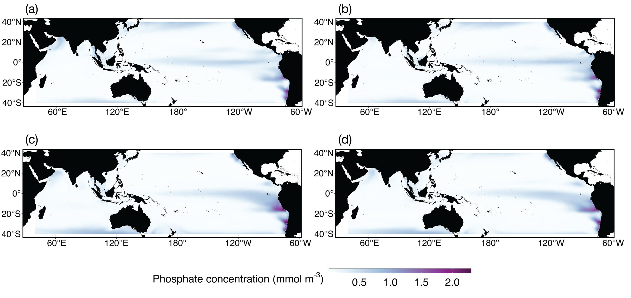
Fig. S23. Mean seasonal historical (1956-1981) surface phosphate concentration (mmol m⁻³) across seasons: (a) January-March; (b) April-June; (c) July-September; and (d) October-December.

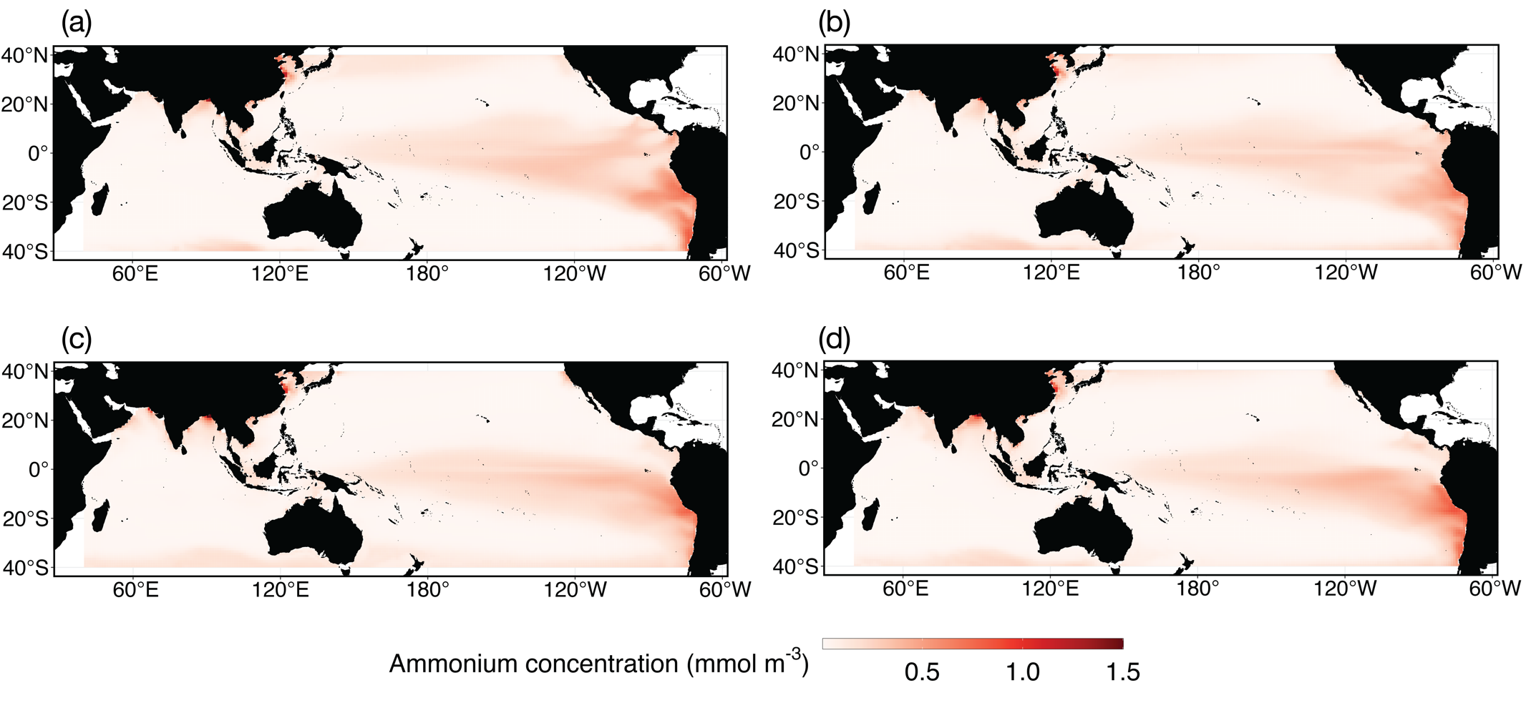
Fig. S24. Mean seasonal historical (1956-1981) surface ammonium concentration (mmol m⁻³) across seasons: (a) January-March; (b) April-June; (c) July-September; and (d) October-December.

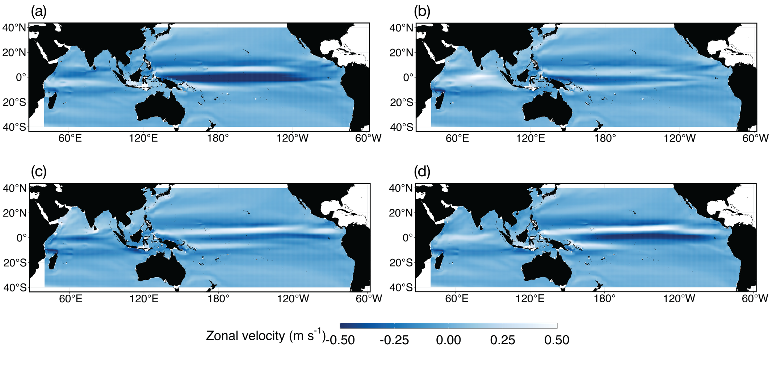
Fig. S25. Mean seasonal historical (1956-1981) surface zonal velocity (m s⁻¹) across seasons: (a) January-March; (b) April-June; (c) July-September; and (d) October-December.

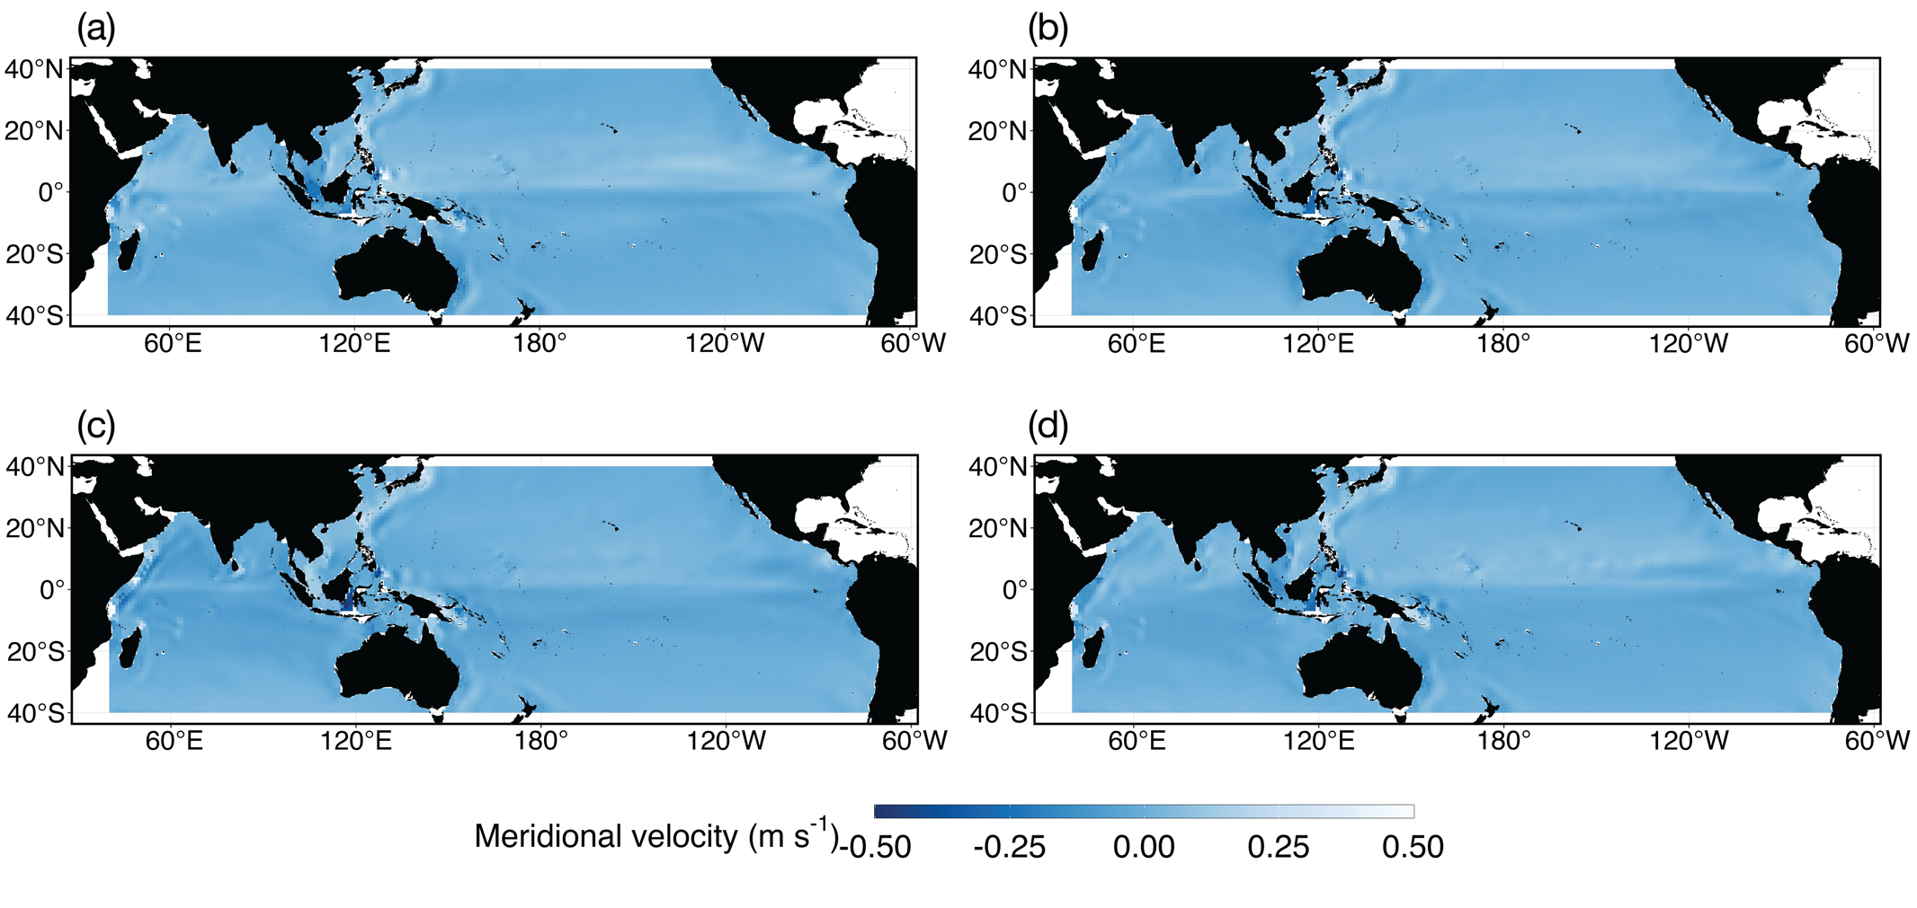
Fig. S26. Mean seasonal historical (1956-1981) surface velocity (m s⁻¹) across seasons: (a) January-March; (b) April-June; (c) July-September; and (d) October-December.

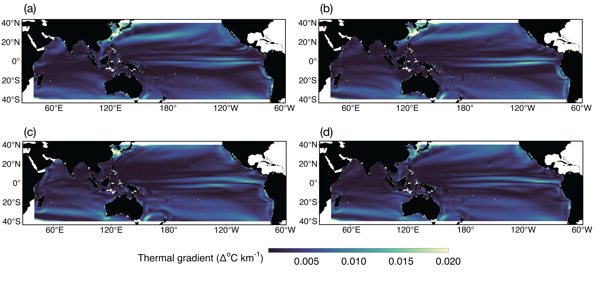
Fig. S27. Mean seasonal historical (1956-1981) broad-scale thermal gradients (∆°C km⁻¹) across seasons: (a) January-March; (b) April-June; (c) July-September; and (d) October-December.

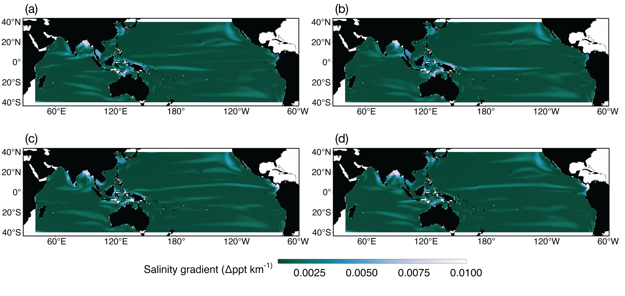
Fig. S28. Mean seasonal historical (1956-1981) broad-scale salinity gradients (∆°C km⁻¹) across seasons: (a) January-March; (b) April-June; (c) July-September; and (d) October-December.

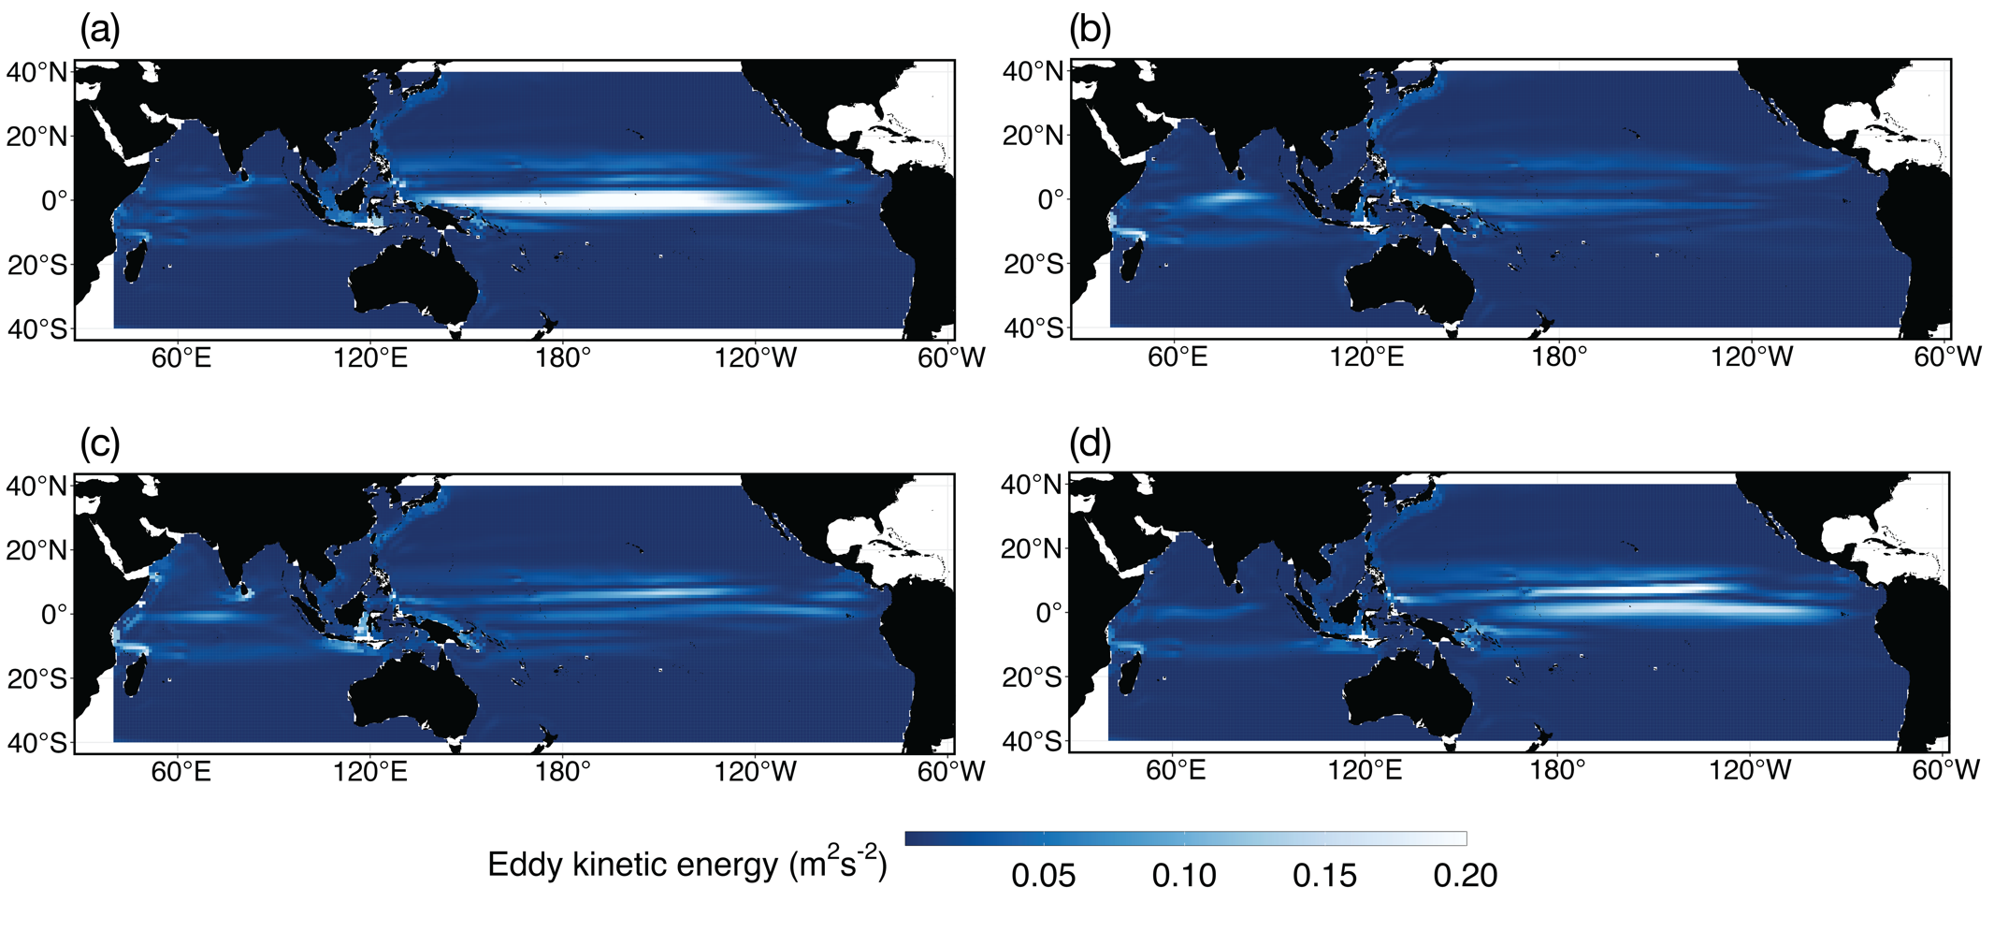
Fig. S29. Mean seasonal historical (1956-1981) eddy kinetic energy (EKE; m² s⁻²) across seasons: (a) January-March; (b) April-June; (c) July-September; and (d) October-December.
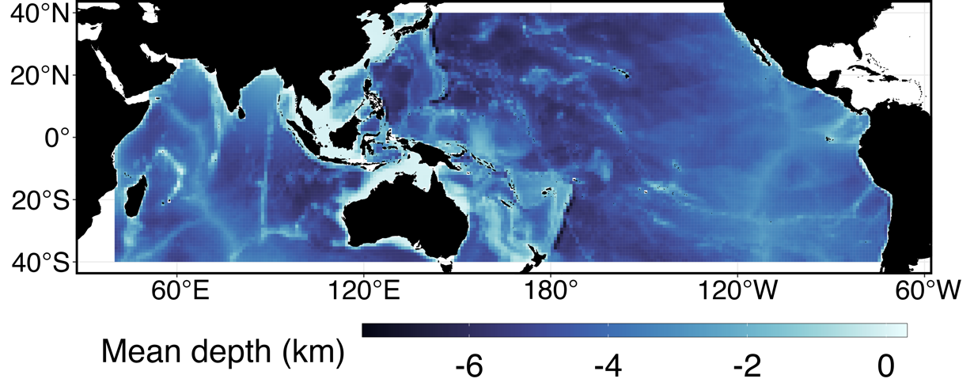
Fig. S30. Mean depth (km) in the sampling region.

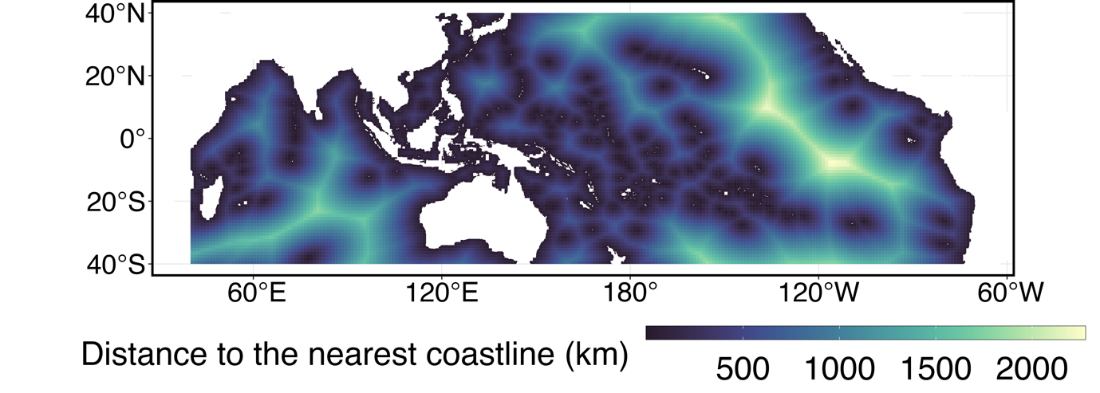
Fig. S31. Distance to the nearest coastline (km) in the sampling region.

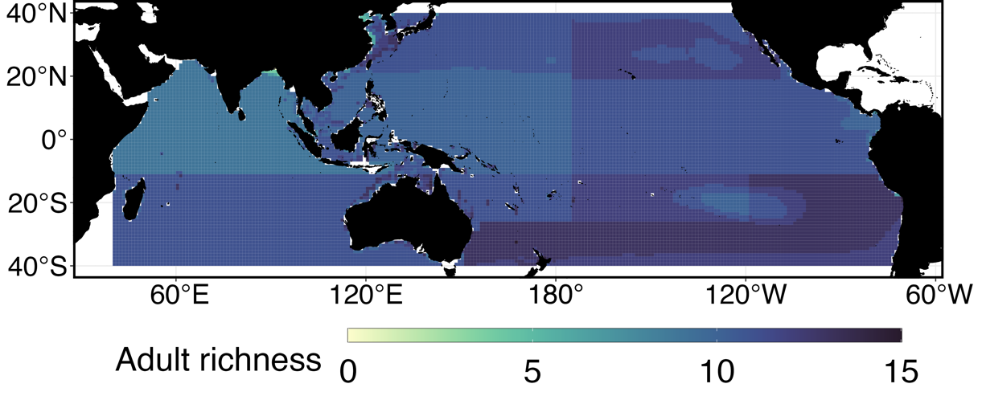
Fig. S32. Number of adult pelagic fish occurring for each grid cell using AquaMaps data.
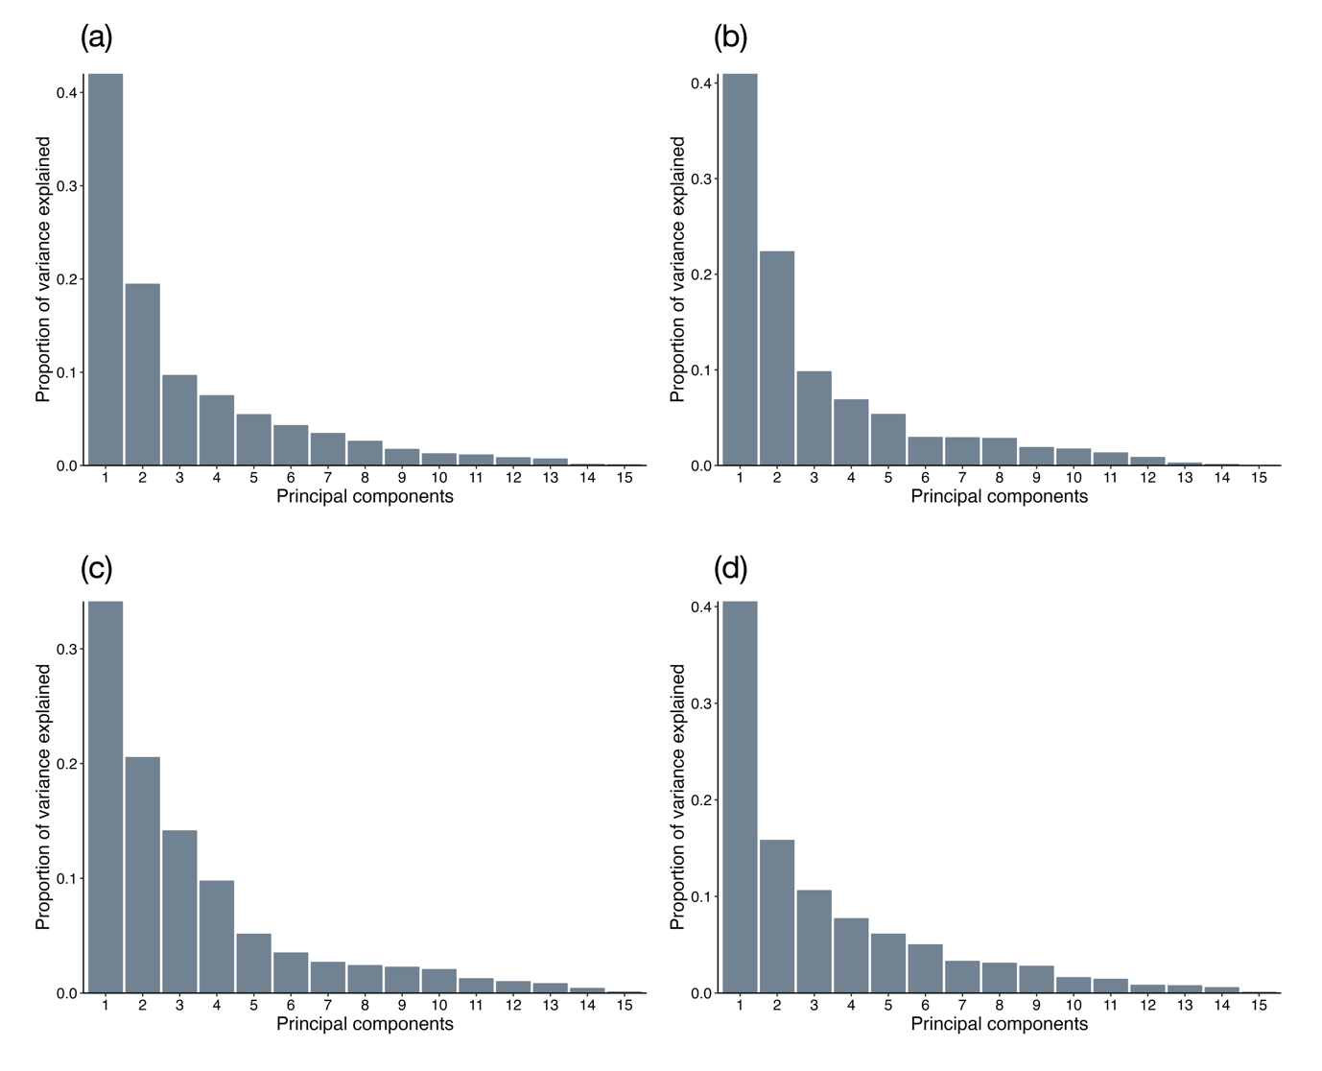
Fig. S33. Proportion of variance explained by principal components across seasons: (a) January-March; (b) April-June; (c) July-September; and (d) October-December.

Table S1. Boosted regression tree hyperparameters used to build most optimal models per taxon.
Taxa | Test AUC | Number of trees | Learning rate | Tree complexity | Bag fraction
Tunas
Skipjack tuna | 0.793 | 4150 | 0.01 | 2 | 0.75
Yellowfin tuna | 0.804 | 5900 | 0.008 | 2 | 0.75
Albacore | 0.888 | 7200 | 0.005 | 2 | 0.75
Bigeye tuna | 0.811 | 5050 | 0.007 | 2 | 0.75
Frigate tuna | 0.898 | 5650 | 0.009 | 2 | 0.5
Southern bluefin tuna | 0.996 | 1100 | 0.01 | 2 | 0.75
Pacific bluefin tuna | 0.994 | 3550 | 0.009 | 2 | 0.75
Slender tuna | 0.9852 | 1150 | 0.007 | 2 | 0.5
Billfish
Blue marlin | 0.845 | 8350 | 0.009 | 2 | 0.5
Striped marlin | 0.863 | 4550 | 0.007 | 2 | 0.5
Swordfish | 0.831 | 3450 | 0.009 | 2 | 0.75
Shortbill spearfish | 0.851 | 3300 | 0.009 | 2 | 0.75
Sailfish | 0.931 | 2550 | 0.01 | 2 | 0.75
Others
Longfin escolar | 0.859 | 2000 | 0.005 | 2 | 0.5
Sauries | 0.977 | 4100 | 0.005 | 2 | 0.5

Table S2. Ensembles of Coupled Model Intercomparison Project 6 (CMIP6) Earth System Models (ESMs) used to prepare historical seasonal predictors: i) surface temperature (tos); ii) surface oxygen (o2os); iii) surface pH (phos); iv) surface salinity (sos); v) surface chlorophyll-a (chlos); vi) mixed layer thickness (mlotst); vii) surface nitrate (no3os); viii) surface phosphate (po4os); ix) surface ammonium (nh4os); x) zonal velocity (uo); and xi) meridional velocity (vo).
Model | tos | o2os | phos | sos | chlos | mlotst | no3os | po4os | nh4os | uo | vo
ACCESS-ESM1-5 (1) | - | - | - | - | - | ü | ü | ü | - | ü | ü
BCC-CSM2-MR (2) | ü | - | - | ü | - | ü | - | - | - | ü | ü
CMCC-CM2-SR5 (3) | ü | - | - | ü | - | ü | - | - | - | ü | ü
CMCC-ESM2 (4) | ü | ü | ü | ü | ü | ü | ü | ü | - | ü | ü
FGOALS-f3-L (5) | ü | - | - | ü | - | ü | - | - | - | ü | ü
FGOALS-g3 (6) | ü | - | - | ü | - | ü | - | - | - | ü | ü
GFDL-CM4 (7) | ü | - | - | - | - | - | - | - | - | ü | ü
GFDL-ESM4 (8) | - | - | - | - | - | ü | ü | ü | ü | - | -
GISS-E2-1-G (9) | - | - | - | - | - | ü | - | - | ü | ü | ü
GISS-E2-1-H (10) | - | - | - | - | - | - | - | - | - | ü | ü
IPSL-CM5A2-INCA (11) | - | - | - | - | - | ü | - | - | - | ü | ü
MCM-UA-1-0 (12) | - | - | - | - | - | - | - | - | - | ü | ü
MIROC-ES2L (13) | ü | ü | ü | ü | ü | - | ü | ü | - | ü | ü
MIROC6 (14) | ü | - | - | ü | - | ü | - | - | - | ü | ü
MPI-ESM1-2-HR (15) | - | - | - | - | - | ü | ü | - | - | ü | ü
MRI-ESM2-0 (16) | ü | ü | ü | ü | ü | ü | ü | ü | - | ü | ü
NorESM2-LM (17) | ü | ü | ü | ü | ü | ü | ü | ü | - | ü | ü

References
1. T. Ziehn, M. Chamberlain, A. Lenton, R. Law, R. Bodman, M. Dix, Y. Wang, P. Dobrohotoff, J. Srbinovsky, L. Stevens, P. Vohralik, C. Mackallah, A. Sullivan, S. O’Farrell, K. Druken, CSIRO ACCESS-ESM1.5 model output prepared for CMIP6 CMIP historical (2019), , doi:10.22033/ESGF/CMIP6.4272.
2. T. Wu, M. Chu, M. Dong, Y. Fang, W. Jie, J. Li, W. Li, Q. Liu, X. Shi, X. Xin, J. Yan, F. Zhang, J. Zhang, L. Zhang, Y. Zhang, BCC BCC-CSM2MR model output prepared for CMIP6 CMIP historical (2018), , doi:10.22033/ESGF/CMIP6.2948.
3. T. Lovato, D. Peano, CMCC CMCC-CM2-SR5 model output prepared for CMIP6 CMIP historical (2020), , doi:10.22033/ESGF/CMIP6.3825.
4. T. Lovato, D. Peano, M. Butenschön, CMCC CMCC-ESM2 model output prepared for CMIP6 CMIP historical (2021), , doi:10.22033/ESGF/CMIP6.13195.
5. Y. Yu, CAS FGOALS-f3-L model output prepared for CMIP6 CMIP historical (2019), , doi:10.22033/ESGF/CMIP6.3355.
6. L. Li, CAS FGOALS-g3 model output prepared for CMIP6 CMIP historical (2019), , doi:10.22033/ESGF/CMIP6.3356.
7. H. Guo, J. G. John, C. Blanton, C. McHugh, S. Nikonov, A. Radhakrishnan, K. Rand, N. T. Zadeh, V. Balaji, J. Durachta, C. Dupuis, R. Menzel, T. Robinson, S. Underwood, H. Vahlenkamp, M. Bushuk, K. A. Dunne, R. Dussin, P. P. Gauthier, P. Ginoux, S. M. Griffies, R. Hallberg, M. Harrison, W. Hurlin, P. Lin, S. Malyshev, V. Naik, F. Paulot, D. J. Paynter, J. Ploshay, B. G. Reichl, D. M. Schwarzkopf, C. J. Seman, A. Shao, L. Silvers, B. Wyman, X. Yan, Y. Zeng, A. Adcroft, J. P. Dunne, I. M. Held, J. P. Krasting, L. W. Horowitz, P. C. D. Milly, E. Shevliakova, M. Winton, M. Zhao, R. Zhang, NOAA-GFDL GFDL-CM4 model output historical (2018), , doi:10.22033/ESGF/CMIP6.8594.
8. J. P. Krasting, J. G. John, C. Blanton, C. McHugh, S. Nikonov, A. Radhakrishnan, K. Rand, N. T. Zadeh, V. Balaji, J. Durachta, C. Dupuis, R. Menzel, T. Robinson, S. Underwood, H. Vahlenkamp, K. A. Dunne, P. P. Gauthier, P. Ginoux, S. M. Griffies, R. Hallberg, M. Harrison, W. Hurlin, S. Malyshev, V. Naik, F. Paulot, D. J. Paynter, J. Ploshay, B. G. Reichl, D. M. Schwarzkopf, C. J. Seman, L. Silvers, B. Wyman, Y. Zeng, A. Adcroft, J. P. Dunne, R. Dussin, H. Guo, J. He, I. M. Held, L. W. Horowitz, P. Lin, P. C. D. Milly, E. Shevliakova, C. Stock, M. Winton, A. T. Wittenberg, Y. Xie, M. Zhao, NOAA-GFDL GFDL-ESM4 model output prepared for CMIP6 CMIP historical (2018), , doi:10.22033/ESGF/CMIP6.8597.
9. N. G. I. for S. Studies (NASA/GISS), NASA-GISS GISS-E2.1G model output prepared for CMIP6 CMIP historical (2018), , doi:10.22033/ESGF/CMIP6.7127.
10. N. G. I. for S. Studies (NASA/GISS), NASA-GISS GISS-E2.1H model output prepared for CMIP6 CMIP historical (2019), , doi:10.22033/ESGF/CMIP6.7128.
11. O. Boucher, S. Denvil, G. Levavasseur, A. Cozic, A. Caubel, M.-A. Foujols, Y. Meurdesoif, Y. Balkanski, R. Checa-Garcia, D. Hauglustaine, S. Bekki, M. Marchand, IPSL IPSL-CM5A2-INCA model output prepared for CMIP6 CMIP historical (2020), , doi:10.22033/ESGF/CMIP6.13661.
12. R. Stouffer, UA MCM-UA-1-0 model output prepared for CMIP6 CMIP historical (2019), , doi:10.22033/ESGF/CMIP6.8888.
13. T. Hajima, M. Abe, O. Arakawa, T. Suzuki, Y. Komuro, T. Ogura, K. Ogochi, M. Watanabe, A. Yamamoto, H. Tatebe, M. A. Noguchi, R. Ohgaito, A. Ito, D. Yamazaki, A. Ito, K. Takata, S. Watanabe, M. Kawamiya, K. Tachiiri, MIROC MIROC-ES2L model output prepared for CMIP6 CMIP historical (2019), , doi:10.22033/ESGF/CMIP6.5602.
14. H. Tatebe, M. Watanabe, MIROC MIROC6 model output prepared for CMIP6 CMIP historical (2018), , doi:10.22033/ESGF/CMIP6.5603.
15. J. Jungclaus, M. Bittner, K.-H. Wieners, F. Wachsmann, M. Schupfner, S. Legutke, M. Giorgetta, C. Reick, V. Gayler, H. Haak, P. de Vrese, T. Raddatz, M. Esch, T. Mauritsen, J.-S. von Storch, J. Behrens, V. Brovkin, M. Claussen, T. Crueger, I. Fast, S. Fiedler, S. Hagemann, C. Hohenegger, T. Jahns, S. Kloster, S. Kinne, G. Lasslop, L. Kornblueh, J. Marotzke, D. Matei, K. Meraner, U. Mikolajewicz, K. Modali, W. Müller, J. Nabel, D. Notz, K. Peters-von Gehlen, R. Pincus, H. Pohlmann, J. Pongratz, S. Rast, H. Schmidt, R. Schnur, U. Schulzweida, K. Six, B. Stevens, A. Voigt, E. Roeckner, MPI-M MPI-ESM1.2-HR model output prepared for CMIP6 CMIP historical (2019), , doi:10.22033/ESGF/CMIP6.6594.
16. S. Yukimoto, T. Koshiro, H. Kawai, N. Oshima, K. Yoshida, S. Urakawa, H. Tsujino, M. Deushi, T. Tanaka, M. Hosaka, H. Yoshimura, E. Shindo, R. Mizuta, M. Ishii, A. Obata, Y. Adachi, MRI MRI-ESM2.0 model output prepared for CMIP6 CMIP historical (2019), , doi:10.22033/ESGF/CMIP6.6842.
17. Ø. Seland, M. Bentsen, D. J. L. Oliviè, T. Toniazzo, A. Gjermundsen, L. S. Graff, J. B. Debernard, A. K. Gupta, Y. He, A. Kirkevåg, J. Schwinger, J. Tjiputra, K. S. Aas, I. Bethke, Y. Fan, J. Griesfeller, A. Grini, C. Guo, M. Ilicak, I. H. H. Karset, O. A. Landgren, J. Liakka, K. O. Moseid, A. Nummelin, C. Spensberger, H. Tang, Z. Zhang, C. Heinze, T. Iversen, M. Schulz, NCC NorESM2-LM model output prepared for CMIP6 CMIP historical (2019), , doi:10.22033/ESGF/CMIP6.8036.

