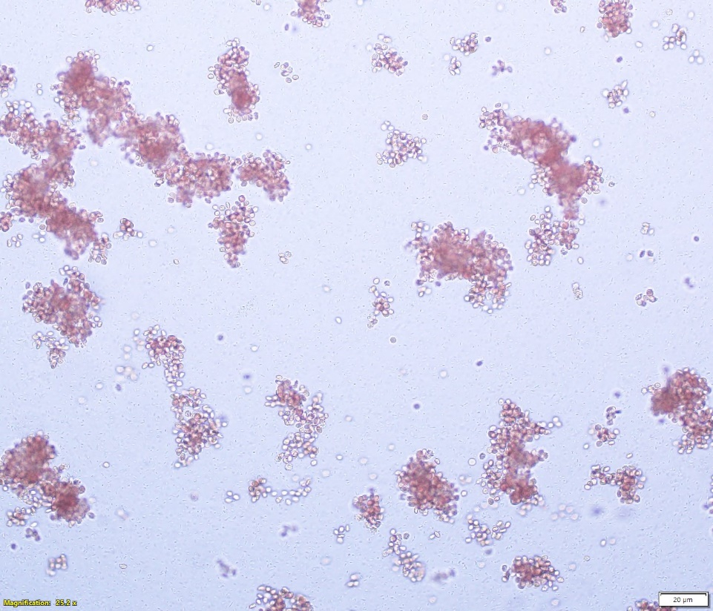

Supplementary information-2.
Hemagglutination of RBC by UPEC (200X).

