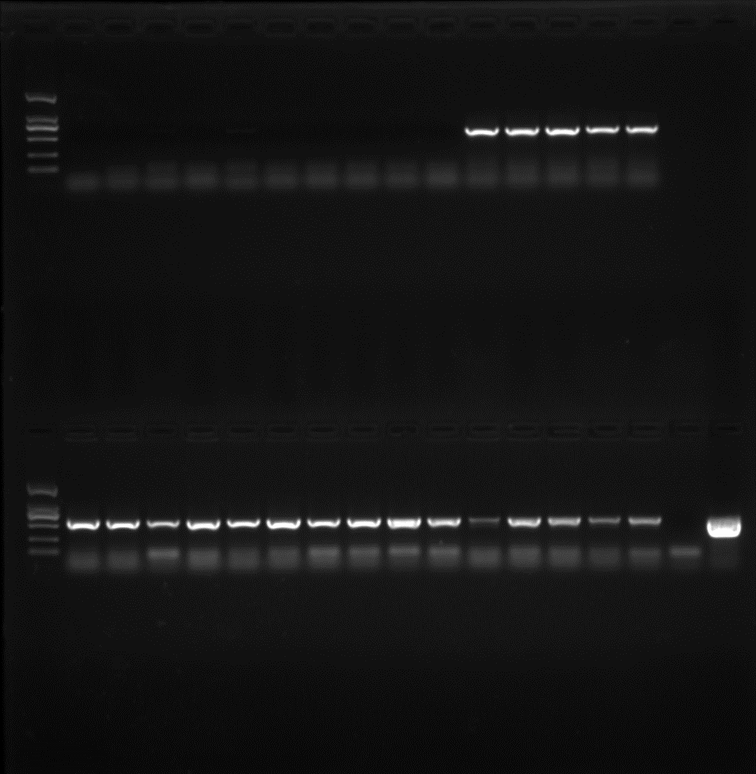
LsaYABBY7-OE
OE1 OE2 OE3 H₂O Vector
Image 1. The original gel picture of Figure 6A in the manuscript.
Verification of positive overexpression lines of LsaYABBY7-OE by PCR. The samples used ddH₂O and transformed vector as template were designated as negative and positive control, respective. Three LsaYABBY7 overexpression lines, OE1, OE2 and OE3, were selected and the gel image of the first three lanes were put together with the negative and positive controls. The lanes in the red rectangle, which could be edited and removed in word, were used in Figure 6A.

The three original images with different exposure levels and gray background were shown below:

