Supplementary Material

LsaYAB7, a homologous gene of FILAMENTOUS FLOWER, participating in the regulation of adaxial-abaxial polarity of leaves in lettuce

Supplementary Figures and Tables
Supplementary Figures Supplemental Figures
Figure S1. Phylogenetic relationships among the amino acid sequences of the nine lettuce YABBY genes. Numbers near the nodes represent bootstrap values. The scale bar represents 0.05 amino acid changes per site.

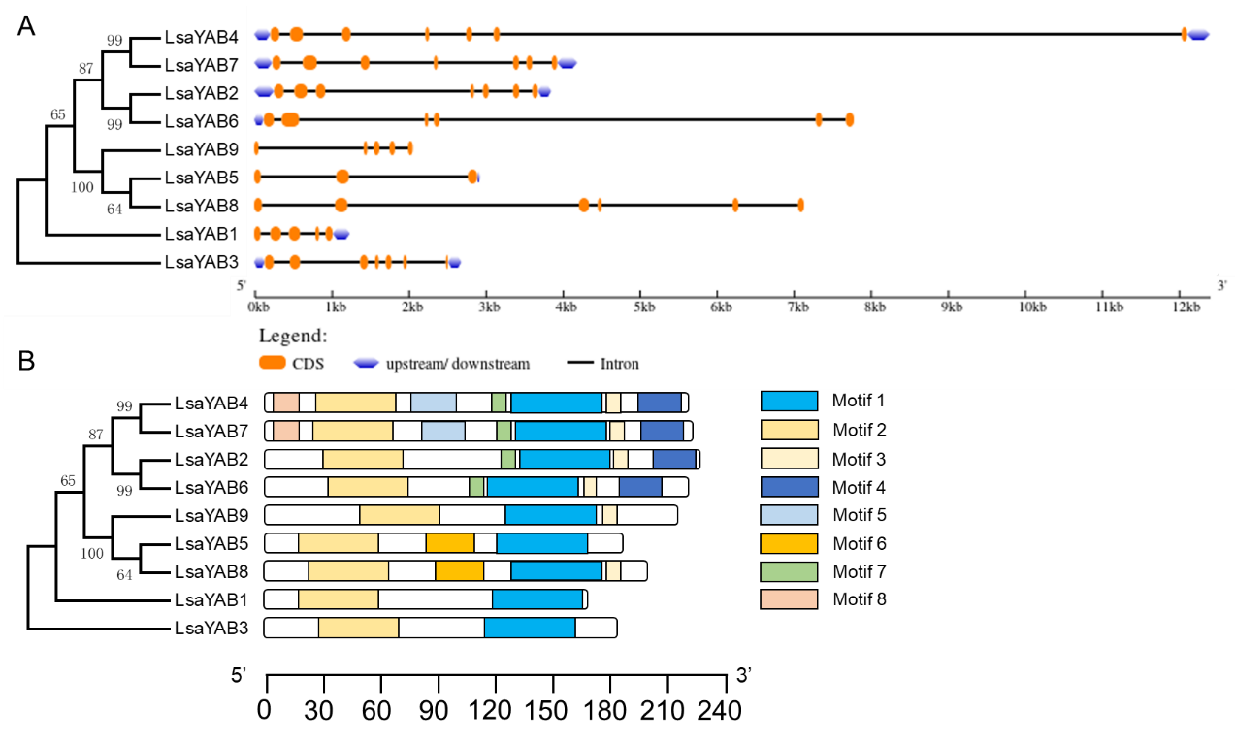
Figure S2. Gene structures and motif composition of LsaYABs.
A. The gene structures of LsaYABs.
B. The motif composition of LsaYAB proteins with MEME. Eight motifs are represented by different colored boxes. The same color rectangle in different proteins referred to the same motif. The sizes of motifs are proportional to their sequence lengths. The order of LsaYAB genes were based on the phylogenetic tree shown on the left of the figures. The size scales of gene and protein length were indicated at the bottom.

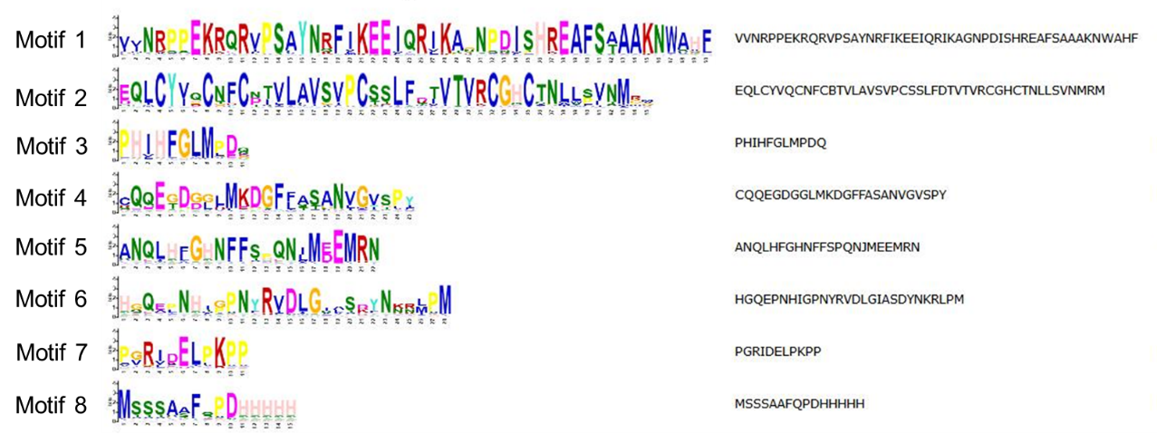
Figure S3. The probability diagram of amino acids in each motif.

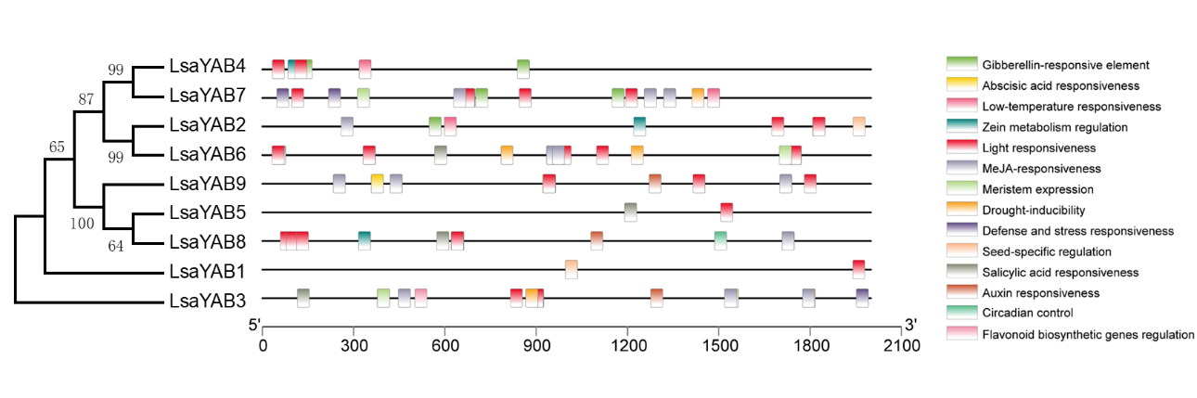
Figure S4. Cis-elements analysis of putative promoters of LsaYABs. The distribution of main cis-acting elements and their putative regulating factors were detected in the 2kb upstream promoter regions of LsaYAB genes. The different types of cis-elements are represented by different colors.
1.1 Supplementary Tables
The Supplementary Tables for this article can be found in the attached file with excel format.

