Rare pathogenic structural variants show potential to enhance prostate cancer germline testing for African men

Tingting Gong, Jue Jiang, M.S. Riana Bornman, Kazzem Gheybi, Phillip D. Stricker, Joachim Weischenfeldt, Shingai B. A. Mutambirwa, Weerachai Jaratlerdsiri and Vanessa M. Hayes

Supplementary Information
Supplementary Data

Supplementary Data 1: The detail of all dbVar studies (dbVar study name and ID) and reported allele frequencies of potentially pathogenic SVs identified in this study.

Supplementary Data 2: Rare cancer-related potentially pathogenic SV candidates identified in this study.

Supplementary Tables

Supplementary Table 1. Clinical and pathological characteristics of 170 prostate cancer patients included in this study
Variables |  |  | Prostate Cancer patients
Ethnic group |  |  | African | European
Number of patients |  |  | 113 | 57
Country of origin |  | South Africa | 113 | 4
 |  | Australia | 0 | 53
Mean age |  |  | 67 (45-99,  Std dev = 8.4)³ | 62 (46-72,  Std dev = 6.0)
Median preoperative PSA¹ |  |  | 244 (4.3 – 4847)⁴ | 9.4 (3.5 – 31.8)
PSA$>$20 ng/mL* |  |  | 65 | 40
PSA$≤$20 ng/mL |  |  | 36 | 17
ISUP GG² | 1 |  | 8 | 7
ISUP GG² | 2 |  | 10 | 0
ISUP GG² | 3 |  | 12 | 0
ISUP GG² | 4* |  | 42 | 9
ISUP GG² | 5* |  | 39 | 40
ISUP GG² | unknown |  | 2 | 1
¹PSA: Prostate Specific Antigen (ng/mL).
²ISUP GG: International Society of Urological Pathology Group Grading.
³One patient in African ancestry has no record of age.
⁴Twelve patients in African ancestry have no record of exact PSA.
*NCCN inclusion criteria for high-risk/very high-risk PCa defined by ISUP GG/PSA

Supplementary Table 2. The count of germline SVs discovered and genotyped in each ethnic group.
SV filtering criteria | Population | Total | DEL | DUP | INS | INV | TRA
High-quality SV calls | African | 38,668  (18,674) | 22,423  (10,846) | 2,155  (1,160) | 11,797  (5,350) | 1,189  (758) | 1,104  (560)
High-quality SV calls | European | 24,292  (4,298) | 14,377  (2,800) | 1,385  (390) | 7,169  (722) | 685  (254) | 676  (132)
High-quality SV calls | All | 42,966 | 25,223 | 2,545 | 12,519 | 1,443 | 1,236
High-quality genotype calls | African | 28,515  (19,114) | 16,903  (11,508) | 1,451  (1,246) | 8,350  (5,152) | 1,033  (720) | 778  (488)
High-quality genotype calls | European | 14,129  (4,728) | 8,519  (3,124) | 688  (483) | 3,961  (763) | 550  (237) | 411  (121)
High-quality genotype calls | All | 33,243 | 20,027 | 1,934 | 9,113 | 1,270 | 899
Gene-disruptive and MAF$≤$5% | African | 1,407  (1,314) | 747  (711) | 86  (84) | 74  (68) | 156  (151) | 344  (300)
Gene-disruptive and MAF$≤$5% | European | 543  (450) | 294  (258) | 50  (48) | 20  (14) | 44  (39) | 135  (91)
Gene-disruptive and MAF$≤$5% | All | 1,857 | 1,005 | 134 | 88 | 195 | 435
*Private SVs in bracket
Supplementary Table 3. The count of SVs with unknown classification in ClinVar or absent from dbVar scored by SV impact prediction tools.
Tool | Total SVs | DEL | DUP | INS | INV | TRA
StrVCTVRE | 409 | 353 | 56 | 0 | 0 | 0
CADD-SV | 1,180 | 976 | 124 | 80 | 0 | 0
POSTRE | 1,590 | 969 | 122 | 0 | 97 | 402
PhenoSV | 1,796 | 972 | 128 | 87 | 190 | 419
Scored by all three tools | 398 | 343 | 55 | 0 | 0 | 0
StrVCTVRE  Score $≥$0.37 | 136 | 114 | 22 | 0 | 0 | 0
CADD-SV  Score $≥$10 | 194 | 164 | 16 | 14 | 0 | 0
POSTRE  Score $≥$0.8 | 264 | 38 | 7 | 0 | 17 | 201
PhenoSV score $≥$0.5 | 640 | 179 | 30 | 2 | 82 | 347
PASS thresholds of any two tools* | 291 | 107 | 16 | 0 | 11 | 157
PASS thresholds of all four tools | 2 | 2 | 0 | 0 | 0 | 0
*Our study criteria to define pathogenic candidate SVs.

Supplementary Table 4. Criteria to predict and establish the potential pathogenicity of SVs
SV types | Criteria to define PP-SV candidates¹ |  |  |  | PP-SV candidate count
SV types | CADD-SV score $≥$10 | StrVCTVRE score $≥$0.37 | POSTRE  score $≥$0.8 | PhenoSV score $≥$0.5 | African-private | European-private | Shared
DEL | ✓ | ✓ | ✓ | ✓ | 67 | 39 | 1
DUP | ✓ | ✓ | ✓ | ✓ | 7 | 9 | 0
INS | ✕ | ✓ | ✕ | ✓ | 0 | 0 | 0
INV | ✕ | ✕ | ✓ | ✓ | 9 | 2 | 0
TRA | ✕ | ✕ | ✓ | ✓ | 107 | 38 | 12
¹Potential Pathogenic candidate DEL or DUP were required to meet two of the criteria.

Supplementary Table 5. Pathogenic scores computed by SV impact prediction tools for SVs in ClinVar.
chrom | start | end | SV type | ClinVar Significance | StrVCTVRE  score | CADD-SV score | POSTRE score | PhenoSV score
chr2 | 44281377 | 44281612 | DUP | Likely pathogenic | 0.54 | 10.68 | 0.75 | 0.99
chr15 | 28017719 | 28020677 | DEL | Likely pathogenic | 0.58 | 4.3 | 0.88 | 0.56
chr18 | 62152637 | 62157701 | DEL | Pathogenic | 0.62 | 7.5 | 0.67 | 0.94
chr1 | 231184145 | 231186249 | DEL | Benign | NA | 4.4 | 0.75 | 0.31
chr2 | 132488843 | 132490840 | DEL | Benign | NA | 4.8 | 0.15 | 0.03
chr3 | 130413180 | 130414060 | DEL | Benign | 0.48 | 7.0 | 0.75 | 0.39
chr5 | 177098012 | 177102222 | DEL | Benign | 0.07 | 12.8 | 0.63 | 0.02
chr9 | 6672237 | 6675374 | DEL | Benign | NA | 4.7 | 0.5 | 0.35
chr9 | 133252413 | 133258230 | DEL | Benign | 0.44 | 0.89 | 0.49 | 0.03
chr10 | 52766742 | 52769474 | DEL | Benign | 0.18 | 5.1 | 0 | 0.53
chr12 | 3461663 | 3463037 | DEL | Benign | NA | 3.5 | 0.33 | 0.52
chr15 | 33864126 | 33864212 | DUP | Uncertain significance | 0.55 | 9.6 | 0.33 | 0.97
chr17 | 73749723 | 73751769 | DEL | Benign | NA | 17.1 | 0.5 | 0.16
chr18 | 56089793 | 56090590 | DEL | Benign | NA | 4.3 | 0.63 | 0.20
*Scores in bold indicate meeting the criterion of individual SV impact prediction tool for pathogenicity as defined by our study.

Supplementary Table 6. Sequencing depth of coverage in identified potentially pathogenic DEL or DUP regions.
Gene name | chrom1 | pos1 | chrom2 | pos2 | SV type | Sample | Average depth in SV region (X) | Average depth in 10 kb upstream of SV region (X) | Average depth in 10 kb downstream of SV region (X)
SLC3A1 | chr2 | 44281377 | chr2 | 44281612 | DUP | N0001 | 57.8 | 39.0 | 38.5
 |  |  |  |  |  | SMU094 | 54.6 | 38.6 | 37.9
OCA2 | chr15 | 28017719 | chr15 | 28020677 | DEL | N0059 | 18.7 | 33.6 | 34.9
PIGN | chr18 | 62152637 | chr18 | 62157701 | DEL | SMU083 | 16.7 | 33.9 | 34.3
SLC7A2 | chr8 | 17418976 | chr8 | 17544122 | DEL | UP2035 | 22.4 | 43.6 | 43.2
 |  |  |  |  |  | KAL0054 | 16.0 | 32.3 | 30.9
DNAJC15 | chr13 | 43078470 | chr13 | 43079390 | DEL | 17135 | 20.8 | 41.2 | 39.5
BCL2L11 | chr2 | 111122626 | chr2 | 111125901 | DEL | KAL0101 | 21.9 | 43.8 | 35.6
BARD1 | chr2 | 214768022 | chr2 | 214772899 | DEL | N0073 | 16.1 | 30.9 | 31.5
COL4A2/ COL4A1 | chr13 | 110294204 | chr13 | 110633815 | DUP | UP2039 | 58.6 | 37.7 | 38.5
SLC2A5 | chr1 | 9045605 | chr1 | 9049441 | DUP | 11099 | 73.8 | 51.0 | 48.9
LTBP1/  BIRC6 | chr2 | 32403832 | chr2 | 33107415 | DUP | 5287 | 59.7 | 35.3 | 38.0

Supplementary Table 7. Literature review on tumour suppressor or oncogenic effect of genes disrupted by cancer-related PP-SV candidates.
Gene name | SV type | Potential impact in cancer | Cancer type | Reference
ATAD2 | DEL | Oncogenic effect | Multiple cancers | ¹
F5 | DEL | Oncogenic effect | Gastric cancer and PCa | ^{2, 3}
HDAC9 | DEL | Oncogenic effect | Multiple cancers | ^{4, 5}
FKBP9 | DEL | Oncogenic effect | PCa and glioblastoma | ^{6, 7}
ADAM2 | DEL | Oncogenic effect | Lung cancer | ⁸
GGA2 | DEL | Oncogenic effect | Lung cancer | ⁹
SELP | DEL | Oncogenic effect | glioblastoma | ¹⁰
OAS3 | DEL | Oncogenic effect | Multiple cancers | ¹¹
CYRZ | DEL | Unknown | DNA methylation-driven gene in PCa | ¹²
TULP2 | DEL | Unknown | Breast cancer associated gene in Genome-wide association studies | ¹³
BCKDHB | DEL | Unknown | Downregulation in breast cancer | ¹⁴
SLC7A2 | DEL | Tumour suppressor | Ovarian cancer and lung cancer | ^{15, 16}
DNAJC15 | DEL | Tumour suppressor | Breast cancer | ¹⁷
BCL2L11 | DEL | Tumour suppressor | Gastric cancer | ¹⁸
BARD1 | DEL | DNA damage repair gene | Multiple cancers | ¹⁹
COL4A2 | DUP | Oncogenic effect | Gastric cancer and breast cancer | ^{20, 21}
BIRC6 | DUP | Oncogenic effect | PCa, lung cancer and breast cancer | ^{22, 23, 24, 25}
LTBP1 | DUP | Oncogenic effect | Lymphoma, PCa, Esophageal squamous cell carcinoma, breast cancer | ^{26, 27, 28, 29, 30}
LTBP1 | DUP | Tumour suppressor | Cervical caner | ³⁰
SLC2A5 | DUP | Oncogenic effect | Multiple cancers | ³¹
MLH1 | INV | DNA mismatch repair gene | PCa and Lynch syndrome | ^{32, 33}
RB1 | INV | Tumour suppressor | PCa | ³⁴
WASF1 | INV | Tumour suppressor | PCa | ³⁵
FOXP1 | INV | Tumour suppressor | PCa | ^{36, 37}
NSD3 | INV | Oncogenic effect | Multiple cancers | ^{38, 39}
GRM8 | TRA | Oncogenic effect | PCa | ⁴⁰
WDR43 | TRA | Oncogenic effect | Colorectal cancer and lung cancer | ^{41, 42, 43}
NPM1 | TRA | Oncogenic effect | PCa and lung cancer | ^{44, 45, 46}
NUSAP1 | TRA | Oncogenic effect | PCa | ⁴⁷
MECOM | TRA | Oncogenic effect | Multiple cancers | ^{48, 49}
PKHD1 | TRA | Oncogenic effect | Colon cancer | ⁵⁰
PKHD1 | TRA | Tumour suppressor | Colorectal cancer | ⁵¹
CTNNA1 | TRA | Tumour suppressor | Multiple cancers | ⁵²
PHC3 | TRA | Tumour suppressor | PCa | ⁵³
PRKACA | TRA | Oncogenic effect | Adrenocortical cancer | ⁵⁴
KCTD3 | TRA | Unknown | Mutation associated with neurogenetic and neurodevelopmental disorders | ⁵⁵
DST | TRA | Tumour suppressor | Breast cancer | ⁵⁶
AK8 | TRA | Tumour suppressor | Uterine Carcinosarcoma | ⁵⁷

Supplementary Figures
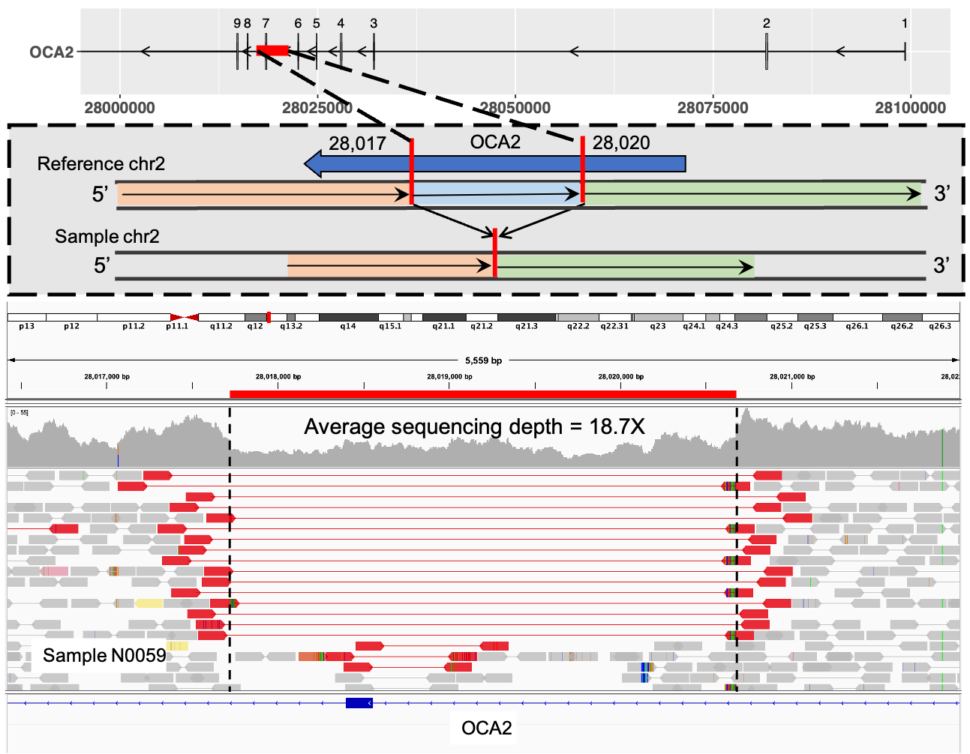
Supplementary Figure 1. OCA2 pLoF deletion reported as “likely pathogenic” in ClinVar. Top row shows transcript structure of OCA2 and deletion region highlighted in red. Middle row shows the DEL schematic diagram. Bottom row shows the sequencing read depth and alignments in DEL region using Integrative Genomic Viewer. Both the discordantly aligned read-pairs (red) and split-reads (soft-clipped bases in rainbow colour) support the existence of the DEL and its breakpoints. DEL breakpoints are shown in dashed black vertical lines.

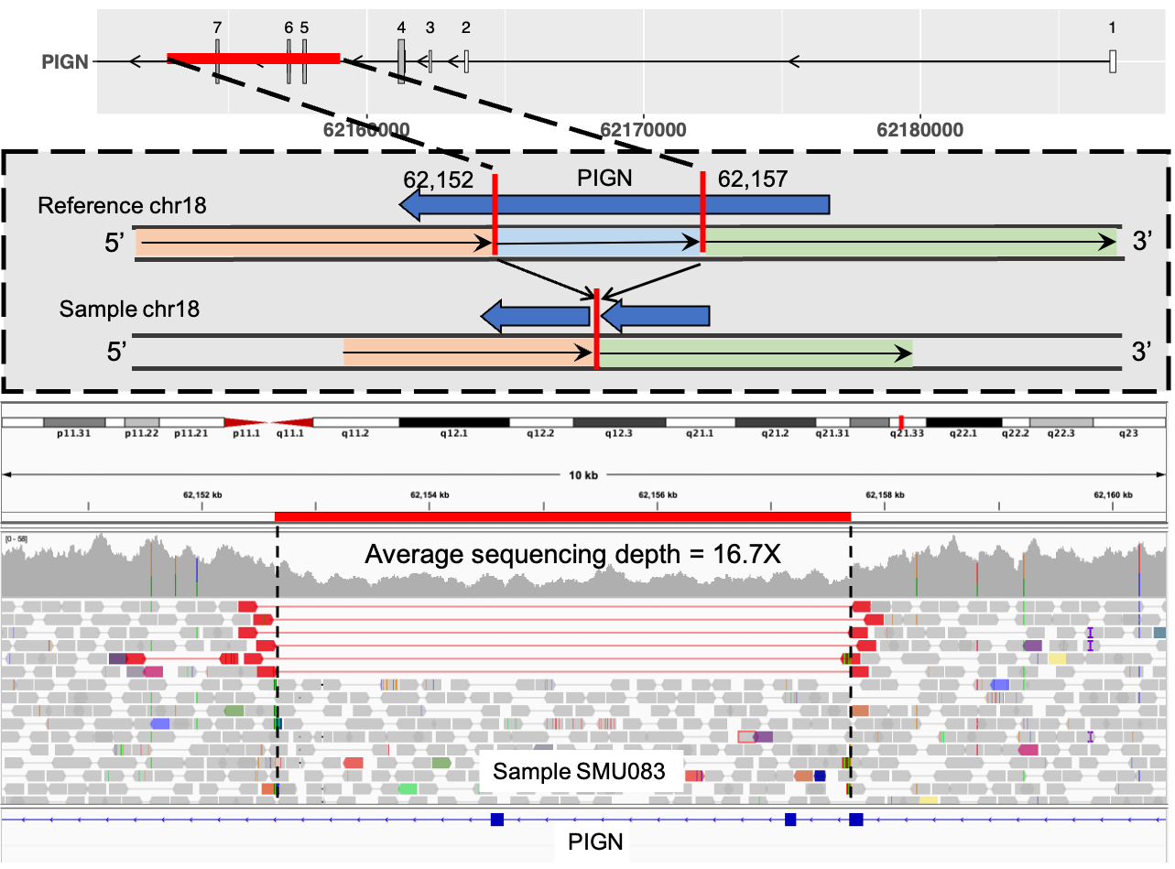
Supplementary Figure 2. PIGN pLoF deletion reported as “pathogenic” in ClinVar. Top row shows transcript structure of PIGN and deletion region highlighted in red. Middle row shows the DEL schematic diagram. Bottom row shows the sequencing read depth and alignments in DEL region using Integrative Genomic Viewer. Both the discordantly aligned read-pairs (red) and split-reads (soft-clipped bases in rainbow colour) support the existence of the DEL and its breakpoints. DEL breakpoints are shown in dashed black vertical lines.

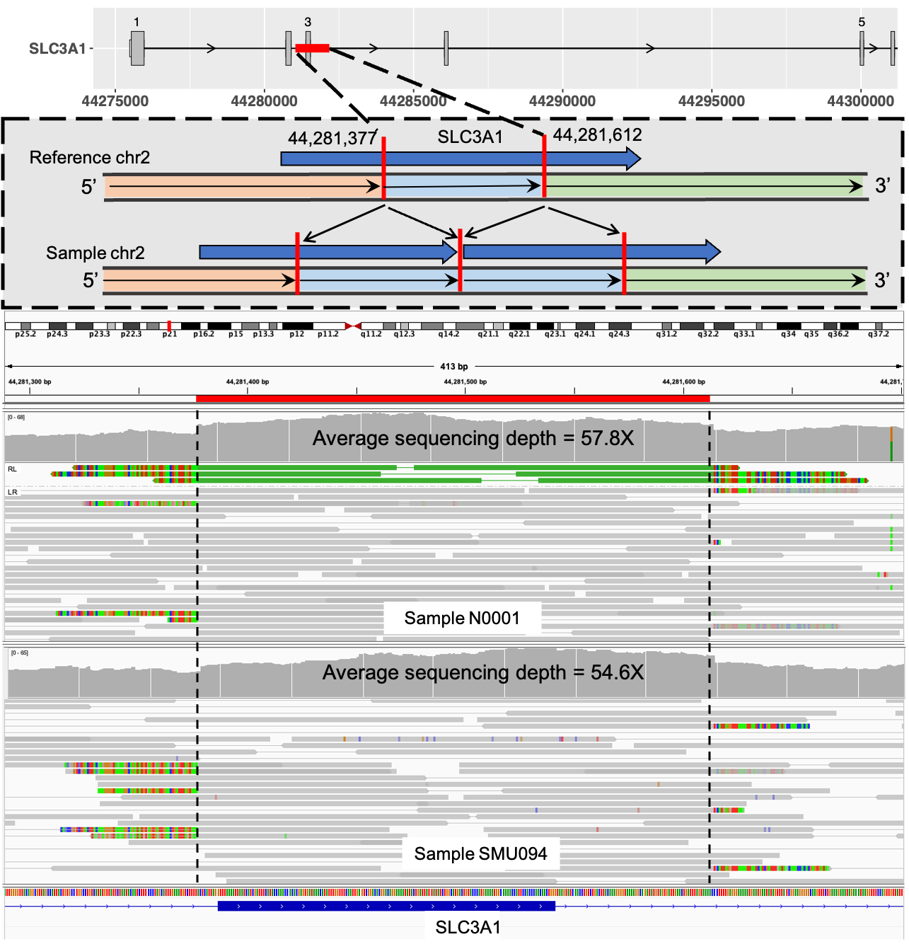
Supplementary Figure 3. SLC3A1 intragenic exon duplication reported as “likely pathogenic” in ClinVar. Top row shows transcript structure of SLC3A1 and DUP region highlighted in blue. Bottom row shows DUP supporting read-pairs (green) by visual inspection of aligned sequencing data using Integrative Genomic Viewer. DUP supporting read-pairs were not observed for sample SMU094, while higher coverage in the DUP region was observed.

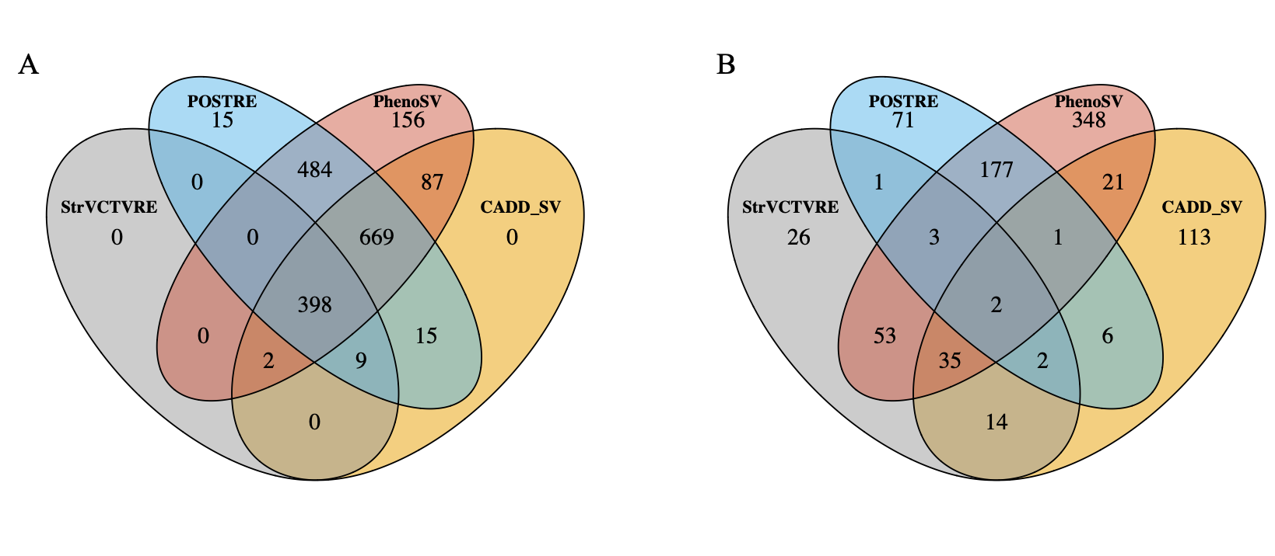
Supplementary Figure 4. Low-frequency gene-disruptive SVs with unknown classification in ClinVar or absent from dbVar scored by SV impact prediction tools. (A) Count of all scored SVs. (B) Count of SVs with CADD-SV score $≥$ 10, StrVCTVRE score $≥$0.37, POSTRE score $≥$0.8 or PhenoSV score $≥$0.5.

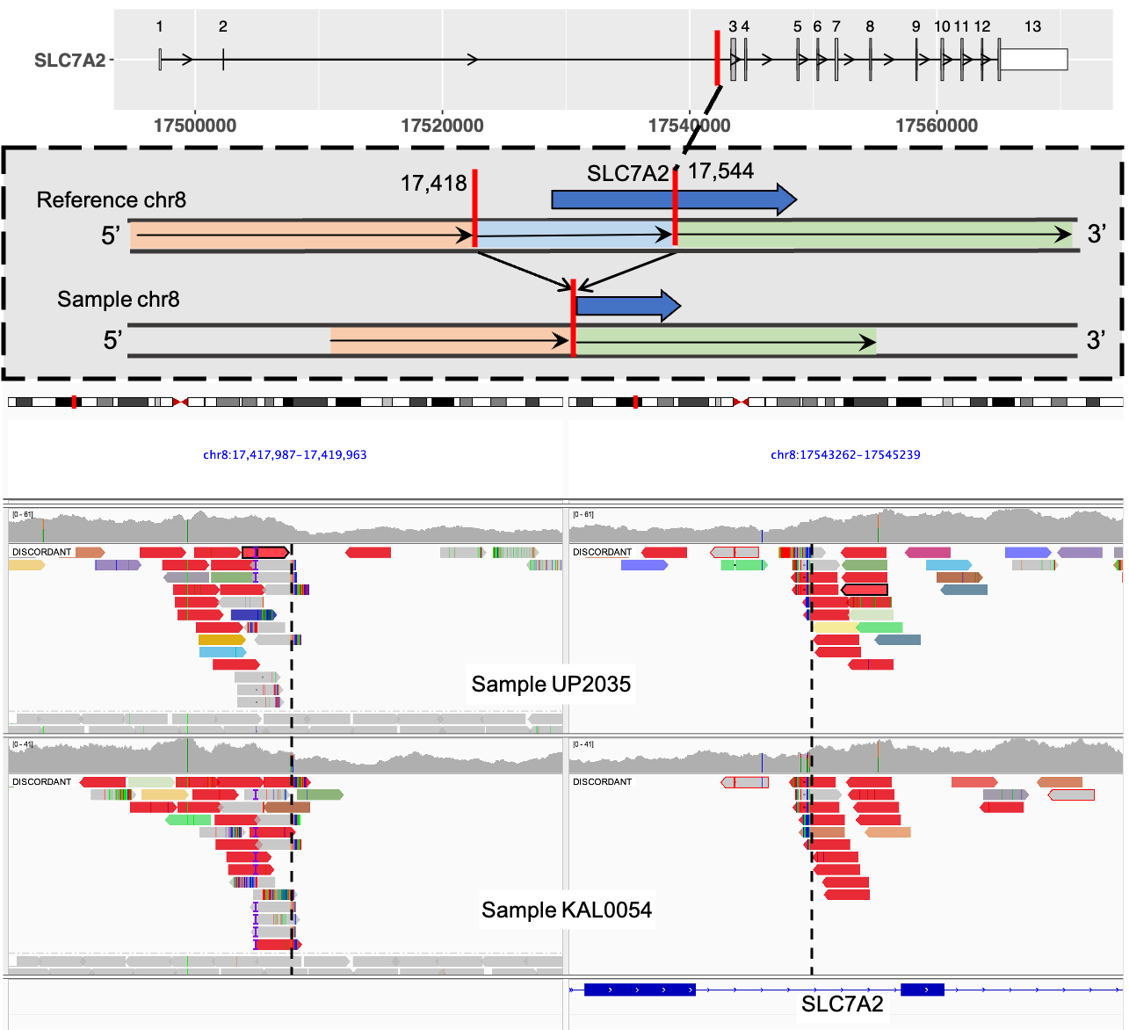
Supplementary Figure 5. SLC7A2 pLoF deletion identified as potentially pathogenic SV. Top row shows transcript structure of SLC7A2 and DEL breakpoint in red. Middle row shows the DEL schematic diagram. Bottom row shows the sequencing read depth and alignments around DEL breakpoints using Integrative Genomic Viewer. Both the discordantly aligned read-pairs (red) and split-reads (soft-clipped bases in rainbow colour) support the existence of the DEL and its breakpoints. DEL breakpoints are shown in dashed black vertical lines.

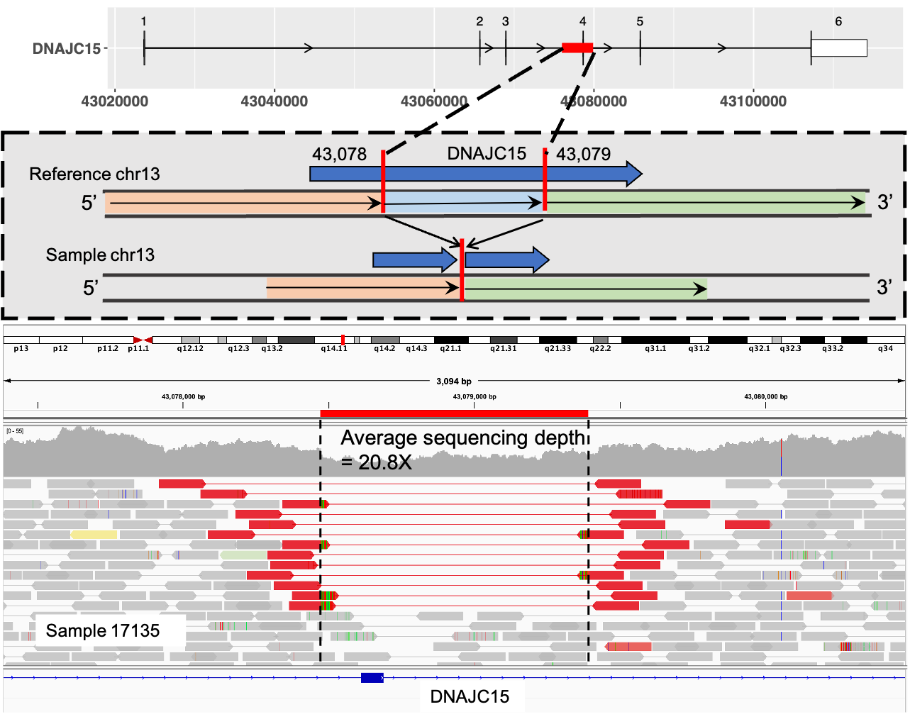
Supplementary Figure 6. DNAJC15 pLoF deletion identified as potentially pathogenic SV. Top row shows transcript structure of DNAJC15 with DEL region highlighted in read. Middle row shows the DEL schematic diagram. Bottom row shows the sequencing read depth and alignments in DEL region using Integrative Genomic Viewer. Both the discordantly aligned read-pairs (red) and split-reads (soft-clipped bases in rainbow colour) support the existence of the DEL and its breakpoints. DEL breakpoints are shown in dashed black vertical lines.
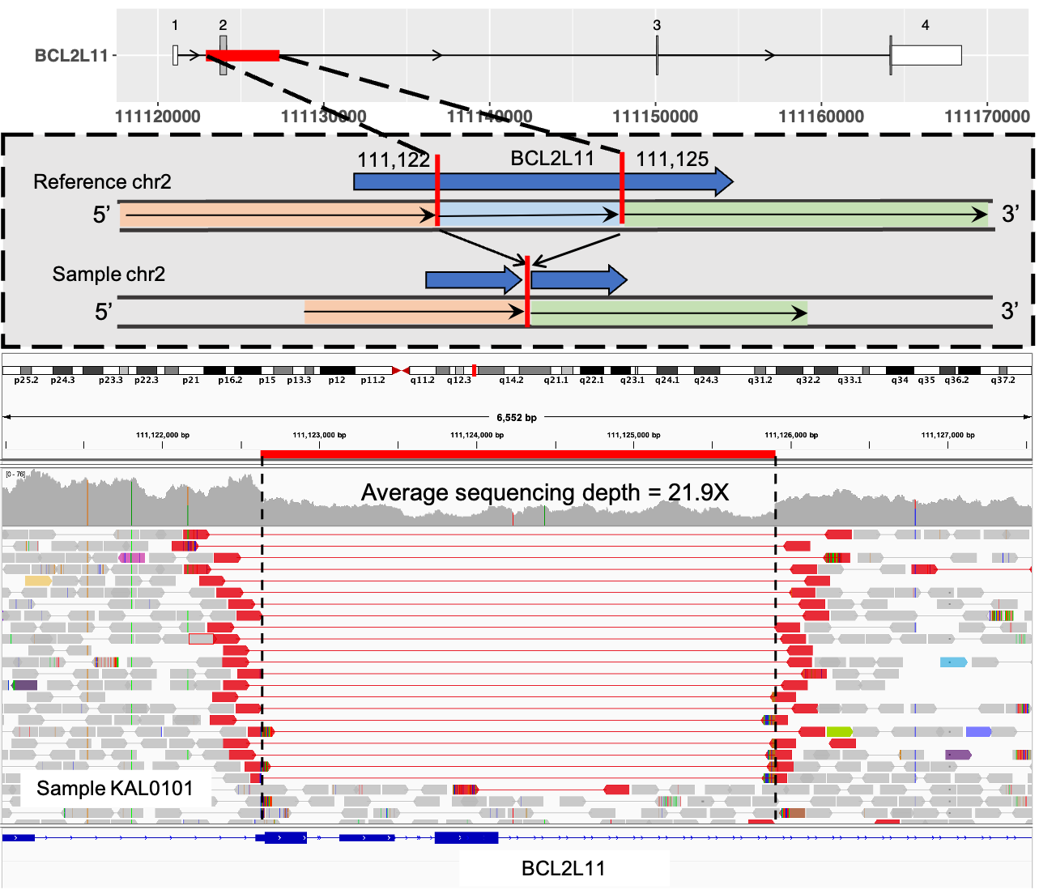
Supplementary Figure 7. BCL2L11 pLoF deletion identified as potentially pathogenic SV. Top row shows transcript structure of BCL2L11 with DEL region highlighted in read. Middle row shows the DEL schematic diagram. Bottom row shows the sequencing read depth and alignments in DEL region using Integrative Genomic Viewer. Both the discordantly aligned read-pairs (red) and split-reads (soft-clipped bases in rainbow colour) support the existence of the DEL and its breakpoints. DEL breakpoints are shown in dashed black vertical lines.

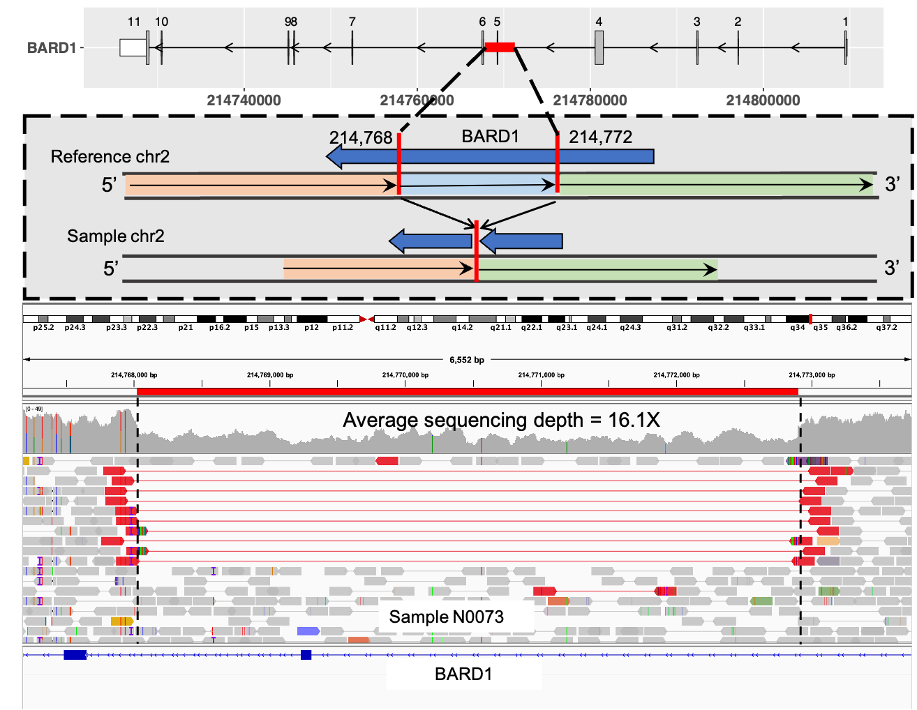
Supplementary Figure 8. BARD1 pLoF deletion identified as potentially pathogenic SV. Top row shows transcript structure of BARD1 with DEL region highlighted in read. Middle row shows the DEL schematic diagram. Bottom row shows the sequencing read depth and alignments in DEL region using Integrative Genomic Viewer. Both the discordantly aligned read-pairs (red) and split-reads (soft-clipped bases in rainbow colour) support the existence of the DEL and its breakpoints. DEL breakpoints are shown in dashed black vertical lines.

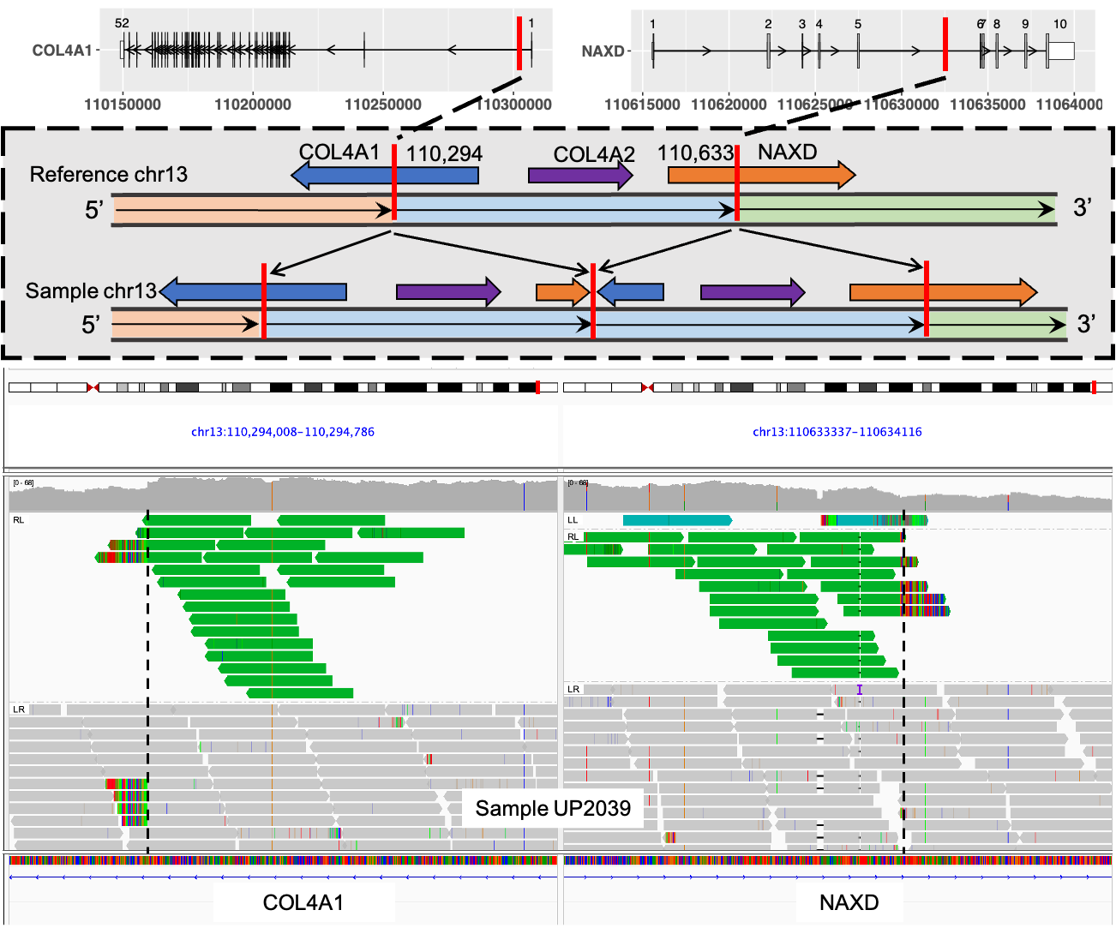
Supplementary Figure 9. COL4A2 whole-gene DUP identified as potentially pathogenic SV. This dbVar reported 339,611 base DUP with breakpoints disrupting COL4A1 and NAXD. Top row shows transcript structure of COL4A1 and NAXD, and DUP breakpoints in red. Middle row shows the DUP schematic diagram. Bottom row shows the sequencing read depth and alignments around DUP breakpoints using Integrative Genomic Viewer. Both the discordantly aligned read-pairs (green) and split-reads (soft-clipped bases in rainbow colour) support the existence of the DUP and its breakpoints. DUP breakpoints are shown in dashed black vertical lines.
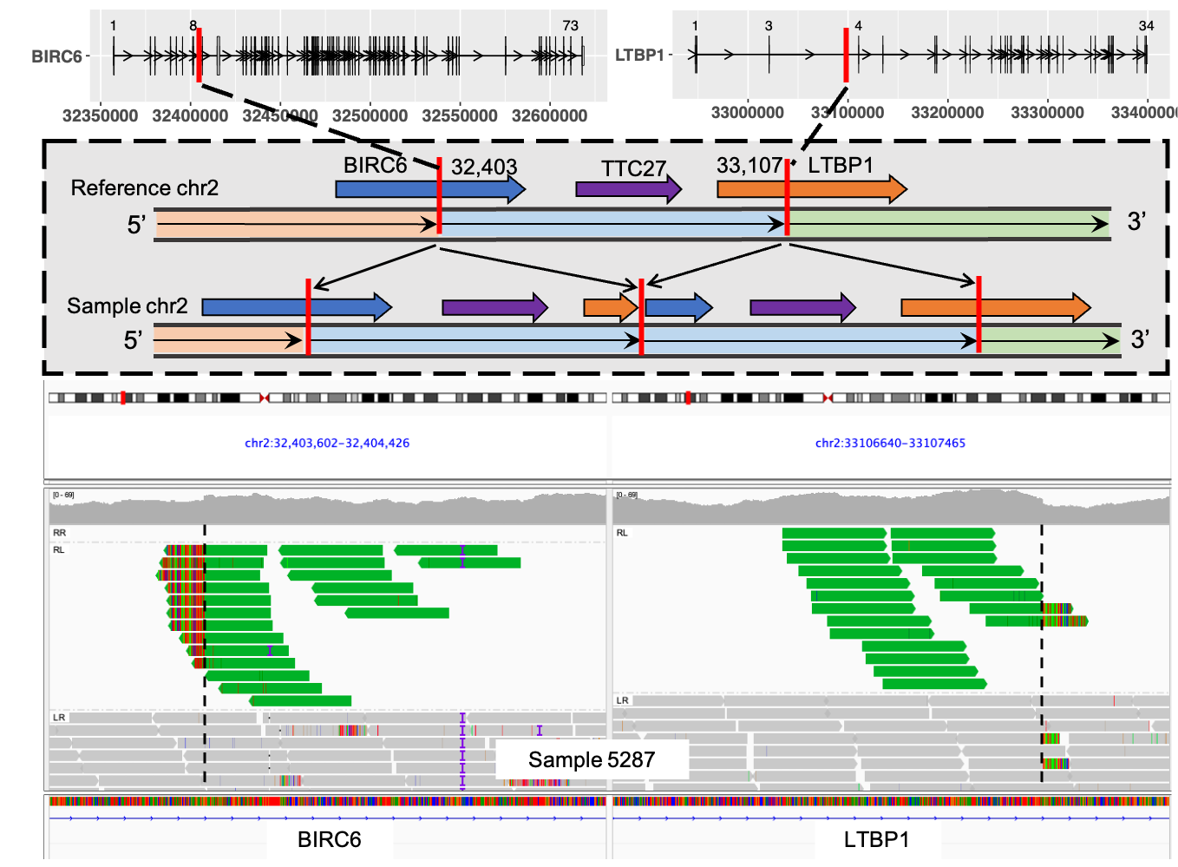
Supplementary Figure 10. Whole-gene DUP identified as “cautionary” potentially pathogenic SV. This dbVar reported 703,583 base DUP with breakpoints disrupting LTBP1 and BIRC6. Top row shows transcript structure of LTBP1 and BIRC6, and DUP breakpoints in red. Middle row shows the DUP schematic diagram. Bottom row shows the sequencing read depth and alignments around DUP breakpoints using Integrative Genomic Viewer. Both the discordantly aligned read-pairs (green) and split-reads (soft-clipped bases in rainbow colour) support the existence of the DUP and its breakpoints. DUP breakpoints are shown in dashed black vertical lines.

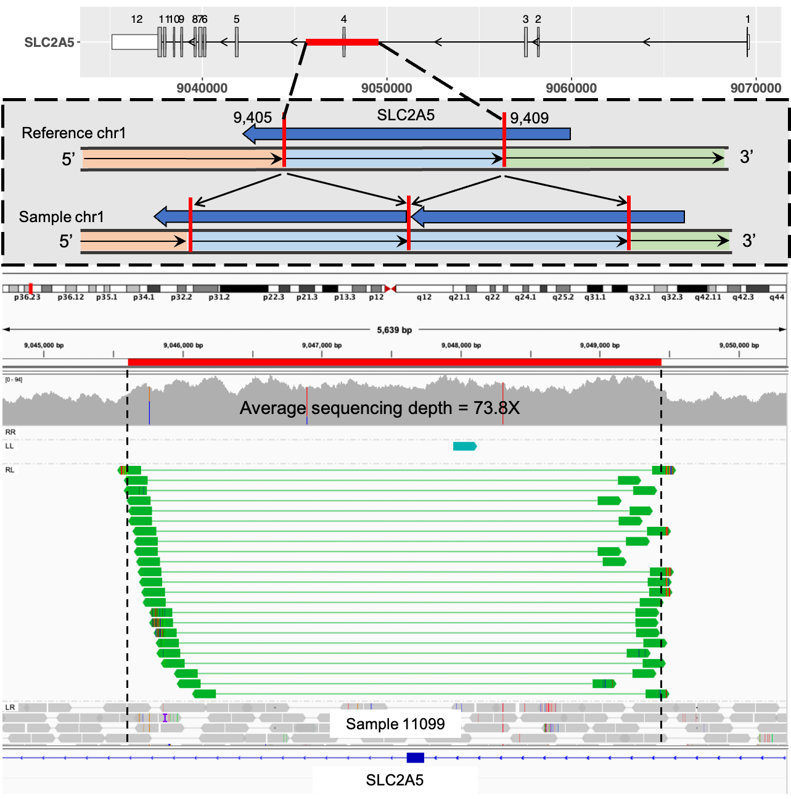
Supplementary Figure 11. SLC2A5 intragenic exon DUP identified as potentially pathogenic SV. Top row shows transcript structure of SLC2A5, with DUP region in red. Middle row shows the DUP schematic diagram. Bottom row shows the sequencing read depth and alignments in DUP region using Integrative Genomic Viewer. Both the discordantly aligned read-pairs (green) and split-reads (soft-clipped bases in rainbow colour) support the existence of the DUP and its breakpoints. DUP breakpoints are shown in dashed black vertical lines.

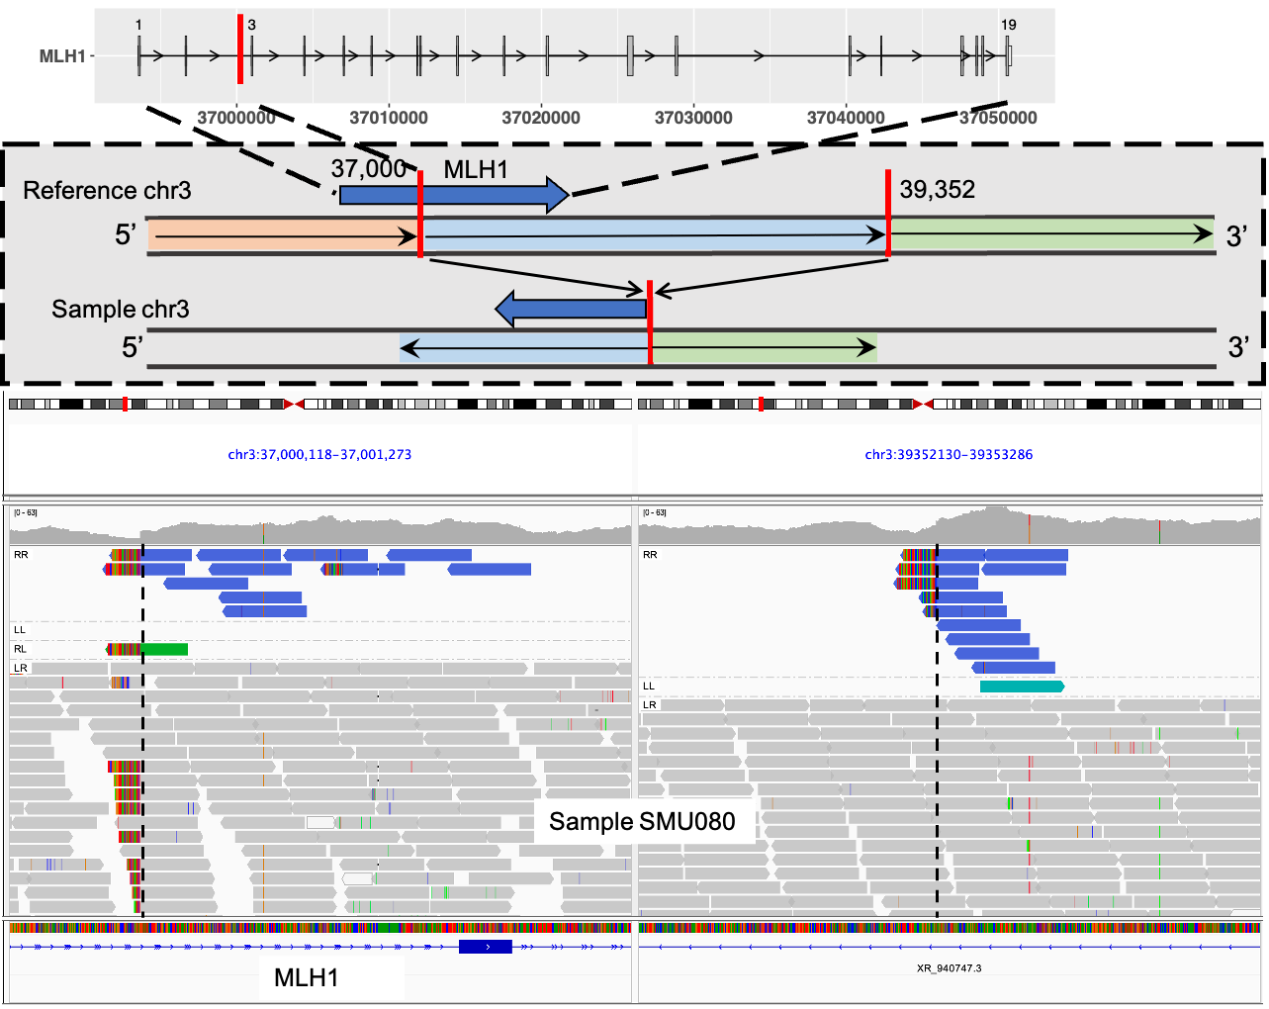
Supplementary Figure 12. MLH1 pLoF inversion identified as potentially pathogenic SV. Top row shows transcript structure of MLH1 and INV breakpoint in red. Middle row shows the INV schematic diagram. Bottom row shows the sequencing read depth and alignments around INV breakpoints using Integrative Genomic Viewer. Both the discordantly aligned read-pairs (blue) and split-reads (soft-clipped bases in rainbow colour) show the existence of the INV and its breakpoints. INV breakpoints are shown in dashed black vertical lines.

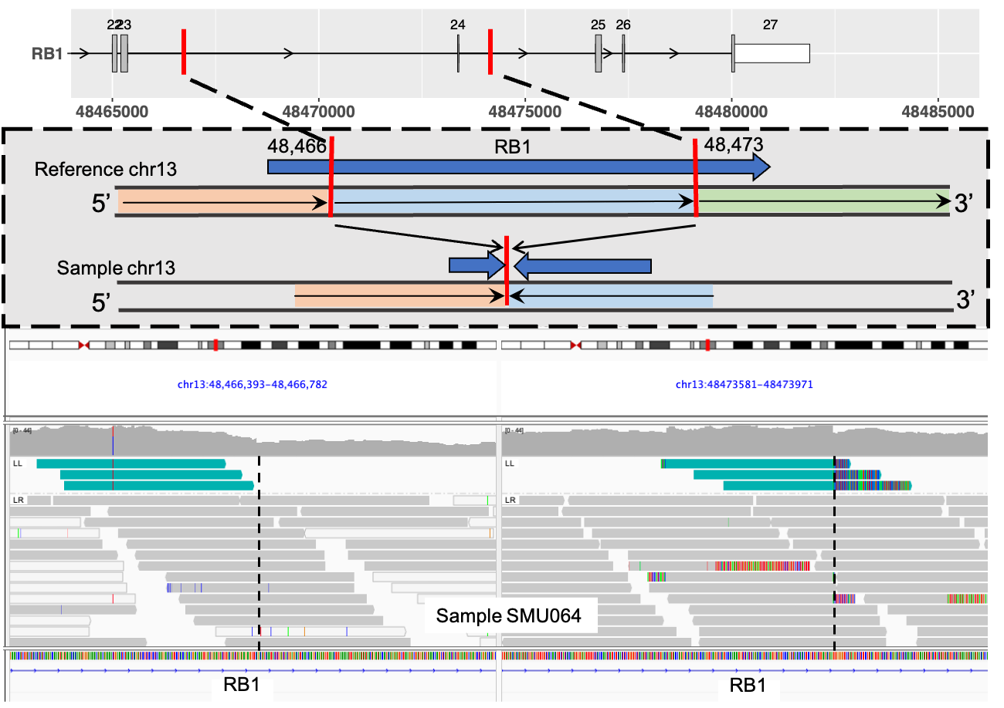
Supplementary Figure 13. RB1 pLoF inversion identified as potentially pathogenic SV. Top row shows transcript structure of RB1 and INV breakpoint in red. Middle row shows the INV schematic diagram. Bottom row shows the sequencing read depth and alignments around INV breakpoints using Integrative Genomic Viewer. Both the discordantly aligned read-pairs (cyan) and split-reads (soft-clipped bases in rainbow colour) show the existence of the INV and its breakpoints. INV breakpoints are shown in dashed black vertical lines.

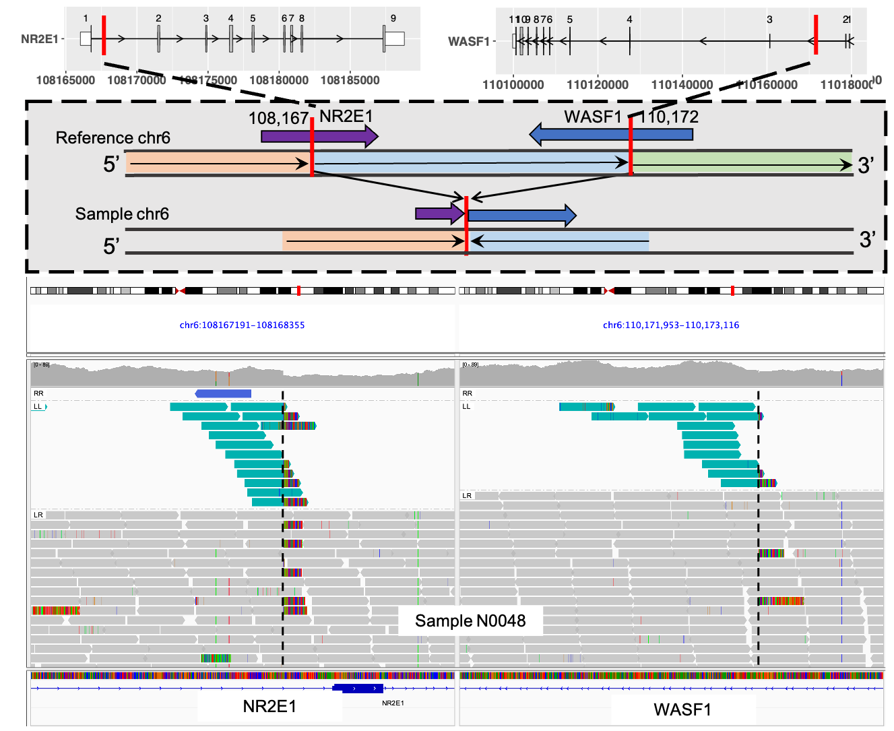
Supplementary Figure 14. WASF1 pLoF inversion identified as potentially pathogenic SV. Top row shows transcript structure of WASF1 and NR2E1 and INV breakpoint in red. Middle row shows the INV schematic diagram. Bottom row shows the sequencing read depth and alignments around INV breakpoints using Integrative Genomic Viewer. Both the discordantly aligned read-pairs (cyan) and split-reads (soft-clipped bases in rainbow colour) show the existence of the INV and its breakpoints. INV breakpoints are shown in dashed black vertical lines.

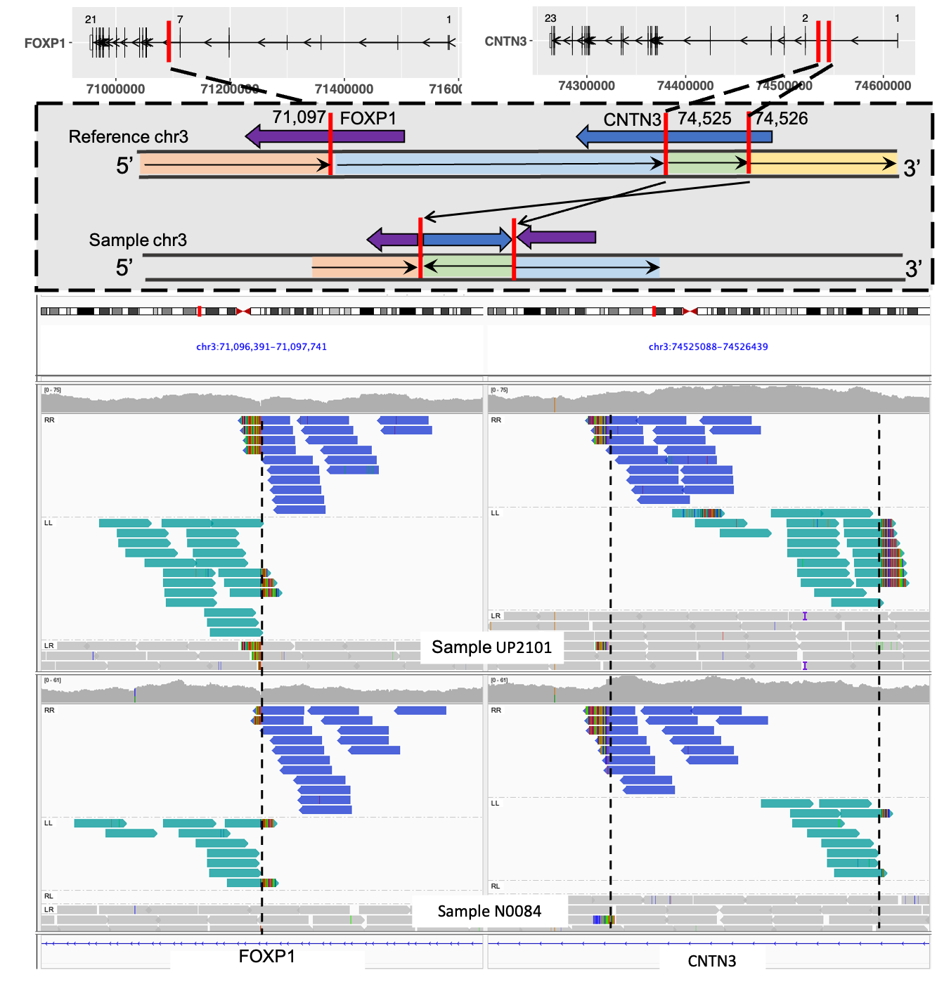
Supplementary Figure 15. FOXP1 pLoF inversion identified as potentially pathogenic SV. Top row shows transcript structure of FOXP1 and CNTN3 and INV breakpoint in red. Middle row shows the INV schematic diagram. Bottom row shows the sequencing read depth and alignments around INV breakpoints using Integrative Genomic Viewer. Both the discordantly aligned read-pairs (blue and cyan) and split-reads (soft-clipped bases in rainbow colour) support the existence of the INV and its breakpoints. INV breakpoints are shown in dashed black vertical lines.

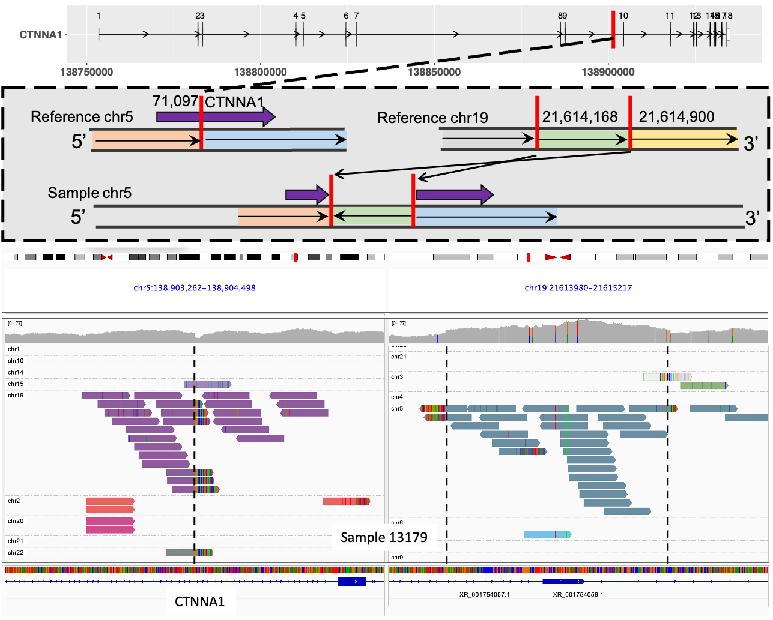
Supplementary Figure 16. CTNNA1 translocation identified as potentially pathogenic SV. Top row shows transcript structure of CTNNA1 and TRA breakpoint in red. Middle row shows the TRA schematic diagram. Bottom row shows the sequencing read depth and read alignments around TRA breakpoints using Integrative Genomic Viewer. Both the discordantly aligned read-pairs (purple and grey) and split-reads (soft-clipped bases in rainbow colour) support the existence of the TRA and its breakpoints. Sequencing reads with mate aligned to chr19 are in purple and reads with mate aligned to chr5 are in grey. TRA breakpoints are shown in dashed black vertical lines.

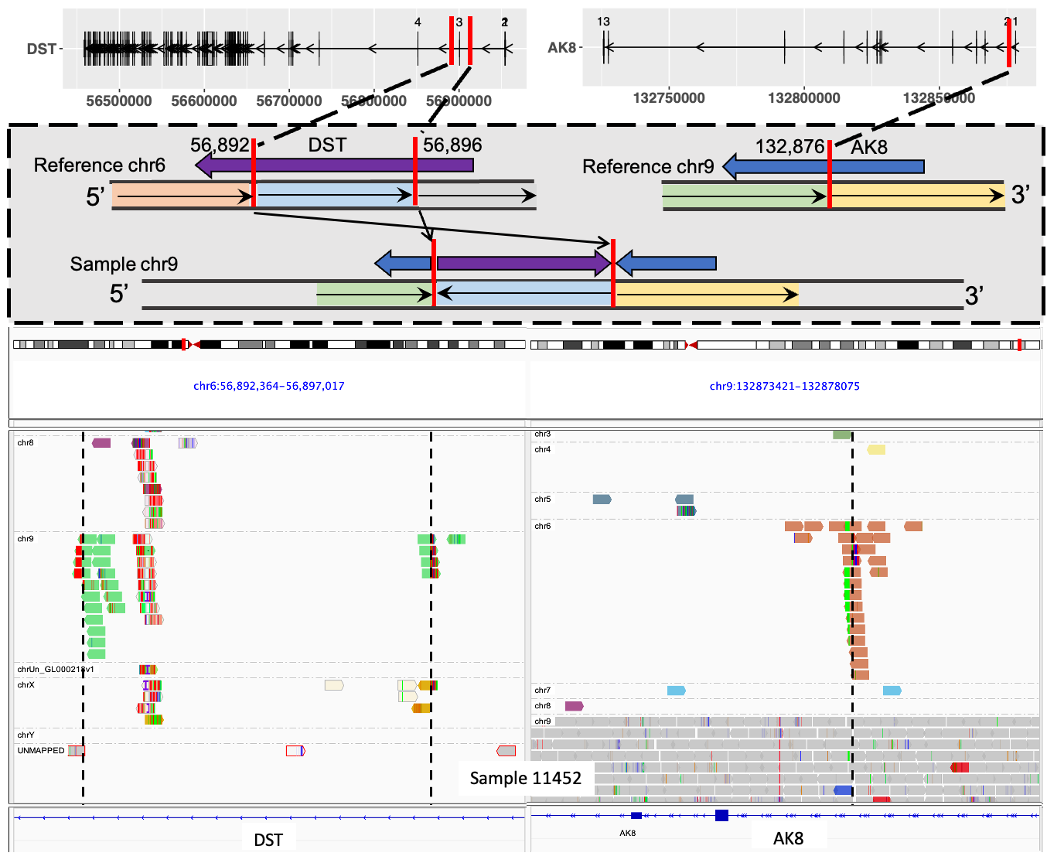
Supplementary Figure 17. AK8-DST Translocation identified as potentially pathogenic SV. Top row shows transcript structure of DST and AK8 with TRA breakpoint in red. Middle row shows the TRA schematic diagram. Bottom row shows the sequencing read depth and read alignments around TRA breakpoints using Integrative Genomic Viewer. Both the discordantly aligned read-pairs (green and orange) and split-reads (soft-clipped bases in rainbow colour) support the existence of the TRA and its breakpoints. Sequencing reads with mate aligned to chr9 are in green and reads with mate aligned to chr6 are in orange. TRA breakpoints are shown in dashed black vertical lines.

REFERENCES

1. Liu H, et al. Tumor-Promoting ATAD2 and Its Preclinical Challenges. Biomolecules 12, (2022).

2. Liu Y, Liao XW, Qin YZ, Mo XW, Luo SS. Identification of F5 as a Prognostic Biomarker in Patients with Gastric Cancer. Biomed Res Int 2020, 9280841 (2020).

3. Klee EW, et al. Candidate serum biomarkers for prostate adenocarcinoma identified by mRNA differences in prostate tissue and verified with protein measurements in tissue and blood. Clin Chem 58, 599-609 (2012).

4. Patra R, Chakraborty J, Das NC, Mukherjee S. An integrated omics study on the role of HDAC9 gene in the oncogenic events of human gastrointestinal-tract associated cancers. Human Gene 37, 201189 (2023).

5. Kim B, Sohn HM, Hyun H, Lim W. Effect of HDAC9 inhibition on epithelial-mesenchymal transition in CD133+ prostate cancer cell lines. J Chemother 34, 45-54 (2022).

6. Jiang FN, et al. Increasing of FKBP9 can predict poor prognosis in patients with prostate cancer. Pathol Res Pract 216, 152732 (2020).

7. Xu H, et al. FKBP9 promotes the malignant behavior of glioblastoma cells and confers resistance to endoplasmic reticulum stress inducers. Journal of Experimental & Clinical Cancer Research 39, 44 (2020).

8. Dervovic D, et al. In vivo CRISPR screens reveal Serpinb9 and Adam2 as regulators of immune therapy response in lung cancer. Nature Communications 14, 3150 (2023).

9. O'Farrell H, et al. Integrative Genomic Analyses Identifies GGA2 as a Cooperative Driver of EGFR-Mediated Lung Tumorigenesis. J Thorac Oncol 14, 656-671 (2019).

10. Yeini E, et al. P-selectin axis plays a key role in microglia immunophenotype and glioblastoma progression. Nature Communications 12, 1912 (2021).

11. Li XY, et al. OAS3 is a Co-Immune Biomarker Associated With Tumour Microenvironment, Disease Staging, Prognosis, and Treatment Response in Multiple Cancer Types. Front Cell Dev Biol 10, 815480 (2022).

12. Xu N, et al. Identification of key DNA methylation-driven genes in prostate adenocarcinoma: an integrative analysis of TCGA methylation data. J Transl Med 17, 311 (2019).

13. Rose AM. Cancer and the junkyard chromosome: how repeat DNA sequence on chromosome 19 influences risk of malignant disease. Oncotarget 9, 31942-31944 (2018).

14. Biswas D, et al. Inhibiting BCKDK in triple negative breast cancer suppresses protein translation, impairs mitochondrial function, and potentiates doxorubicin cytotoxicity. Cell Death Discovery 7, 241 (2021).

15. Sun T, Bi F, Liu Z, Yang Q. SLC7A2 serves as a potential biomarker and therapeutic target for ovarian cancer. Aging (Albany NY) 12, 13281-13296 (2020).

16. Jiang S, et al. Lower SLC7A2 expression is associated with enhanced multidrug resistance, less immune infiltrates and worse prognosis of NSCLC. Cell Communication and Signaling 21, 9 (2023).

17. Alessandrini F, Pezzè L, Menendez D, Resnick MA, Ciribilli Y. ETV7-Mediated DNAJC15 Repression Leads to Doxorubicin Resistance in Breast Cancer Cells. Neoplasia 20, 857-870 (2018).

18. Zhang H, et al. Onco-miR-24 regulates cell growth and apoptosis by targeting BCL2L11 in gastric cancer. Protein Cell 7, 141-151 (2016).

19. Tarsounas M, Sung P. The antitumorigenic roles of BRCA1–BARD1 in DNA repair and replication. Nature Reviews Molecular Cell Biology 21, 284-299 (2020).

20. Feng Z, et al. Could CTSK and COL4A2 be specific biomarkers of poor prognosis for patients with gastric cancer in Asia?—a microarray analysis based on regional population. Journal of Gastrointestinal Oncology 11, 386-401 (2020).

21. JingSong H, et al. siRNA-mediated suppression of collagen type iv alpha 2 (COL4A2) mRNA inhibits triple-negative breast cancer cell proliferation and migration. Oncotarget 8, 2585-2593 (2017).

22. Zhuang W, Zhang C, Hao F, Sun X. Baculoviral IAP Repeat Containing 6 (BIRC6) Is a Predictor of Prognosis in Prostate Cancer. Med Sci Monit 24, 839-845 (2018).

23. Hao T, Wang Z, Yang J, Zhang Y, Shang Y, Sun J. MALAT1 knockdown inhibits prostate cancer progression by regulating miR-140/BIRC6 axis. Biomed Pharmacother 123, 109666 (2020).

24. Dong X, et al. Elevated expression of BIRC6 protein in non-small-cell lung cancers is associated with cancer recurrence and chemoresistance. J Thorac Oncol 8, 161-170 (2013).

25. Gómez Bergna SM, et al. Exploring the Role of the Inhibitor of Apoptosis BIRC6 in Breast Cancer: A Database Analysis. JCO Clinical Cancer Informatics, e2200093 (2022).

26. Lin R, et al. Suppression of latent transforming growth factor-β (TGF-β)-binding protein 1 (LTBP1) inhibits natural killer/ T cell lymphoma progression by inactivating the TGF-β/Smad and p38MAPK pathways. Experimental Cell Research 407, 112790 (2021).

27. Saraon P, et al. Proteomic Profiling of Androgen-independent Prostate Cancer Cell Lines Reveals a Role for Protein S during the Development of High Grade and Castration-resistant Prostate Cancer. Journal of Biological Chemistry 287, 34019-34031 (2012).

28. Cai R, et al. LTBP1 promotes esophageal squamous cell carcinoma progression through epithelial-mesenchymal transition and cancer-associated fibroblasts transformation. Journal of Translational Medicine 18, 139 (2020).

29. Zhang J, Deng H, Wang J. LTBP1 promotes the progression of triple negative breast cancer via activating the RhoA/ROCK signaling pathway. Cancer Insight 3, (2023).

30. Gu H, et al. Immune suppressive signaling regulated by latent transforming growth factor beta binding protein 1 promotes metastasis in cervical cancer. Braz J Med Biol Res 55, e12206 (2023).

31. Groenendyk J, et al. Loss of the fructose transporter SLC2A5 inhibits cancer cell migration. Front Cell Dev Biol 10, 896297 (2022).

32. Nourmohammadi Abadchi S, et al. MLH1 Loss in Primary Prostate Cancer. JCO Precis Oncol 7, e2200611 (2023).

33. Bonadona V, et al. Cancer Risks Associated With Germline Mutations in MLH1, MSH2, and MSH6 Genes in Lynch Syndrome. JAMA 305, 2304-2310 (2011).

34. Abida W, et al. Genomic correlates of clinical outcome in advanced prostate cancer. Proceedings of the National Academy of Sciences 116, 11428-11436 (2019).

35. Sowalsky AG, et al. Loss of Wave1 gene defines a subtype of lethal prostate cancer. Oncotarget; Vol 6, No 14, (2015).

36. Cai H, et al. In Vivo Application of CRISPR/Cas9 Revealed Implication of Foxa1 and Foxp1 in Prostate Cancer Proliferation and Epithelial Plasticity (2022).

37. Takayama K, et al. Integrative analysis of FOXP1 function reveals a tumor-suppressive effect in prostate cancer. Mol Endocrinol 28, 2012-2024 (2014).

38. Yuan G, et al. Elevated NSD3 histone methylation activity drives squamous cell lung cancer. Nature 590, 504-508 (2021).

39. Nuñez Y, Vera S, Baeza V, Gonzalez-Pecchi V. NSD3 in Cancer: Unraveling Methyltransferase-Dependent and Isoform-Specific Functions. Int J Mol Sci 25, (2024).

40. Bakht MK, et al. Identification of alternative protein targets of glutamate-ureido-lysine associated with PSMA tracer uptake in prostate cancer cells. Proceedings of the National Academy of Sciences 119, e2025710119 (2022).

41. Di Y, et al. The c-MYC-WDR43 signalling axis promotes chemoresistance and tumour growth in colorectal cancer by inhibiting p53 activity. Drug Resistance Updates 66, 100909 (2023).

42. Sun H, et al. WD repeat domain 43 promotes malignant progression of non-small cell lung cancer by regulating CDK2. The International Journal of Biochemistry & Cell Biology 151, 106293 (2022).

43. Li Z, et al. WD40 repeat 43 mediates cell survival, proliferation, migration and invasion via vimentin in colorectal cancer. Cancer Cell International 21, 418 (2021).

44. Ruan Y, Xu H, Ji X. High expression of NPM1 via the Wnt/β-catenin signalling pathway might predict poor prognosis for patients with prostate adenocarcinoma. Clin Exp Pharmacol Physiol 49, 525-535 (2022).

45. Loubeau G, et al. NPM1 silencing reduces tumour growth and MAPK signalling in prostate cancer cells. PLoS One 9, e96293 (2014).

46. Liu XS, et al. NPM1 Is a Prognostic Biomarker Involved in Immune Infiltration of Lung Adenocarcinoma and Associated With m6A Modification and Glycolysis. Front Immunol 12, 724741 (2021).

47. Gordon CA, Gong X, Ganesh D, Brooks JD. NUSAP1 promotes invasion and metastasis of prostate cancer. Oncotarget 8, 29935-29950 (2017).

48. Liang B, Wang J. EVI1 in Leukemia and Solid Tumors. Cancers (Basel) 12, (2020).

49. Ma Y, et al. CRISPR-mediated <em>MECOM</em> depletion retards tumor growth by reducing cancer stem cell properties in lung squamous cell carcinoma. Molecular Therapy 30, 3341-3357 (2022).

50. Han L, et al. Comprehensive characterization of PKHD1 mutation in human colon cancer. Cancer Med 13, (2024).

51. Ward CJ, et al. Germline PKHD1 mutations are protective against colorectal cancer. Human Genetics 129, 345-349 (2011).

52. Huang J, et al. The Role of CTNNA1 in Malignancies: An Updated Review. J Cancer 14, 219-230 (2023).

53. Josson S, Chung LW, Gururajan M. microRNAs and Prostate Cancer. Adv Exp Med Biol 889, 105-118 (2015).

54. Berthon AS, Szarek E, Stratakis CA. PRKACA: the catalytic subunit of protein kinase A and adrenocortical tumors. Front Cell Dev Biol 3, 26 (2015).

55. Angrisani A, Di Fiore A, De Smaele E, Moretti M. The emerging role of the KCTD proteins in cancer. Cell Communication and Signaling 19, 56 (2021).

56. Qiu X, et al. Identification of m6A-Associated Gene DST as a Prognostic and Immune-Associated Biomarker in Breast Cancer Patients. Int J Gen Med 15, 523-534 (2022).

57. Huang R, et al. Co-expression Analysis of Genes and Tumor-Infiltrating Immune Cells in Metastatic Uterine Carcinosarcoma. Reproductive Sciences 28, 2685-2698 (2021).

