The supplementary data for

Gγ-protein GS3 function in tight genetic relation with OsmiR396/GS2 to regulate grain size in rice

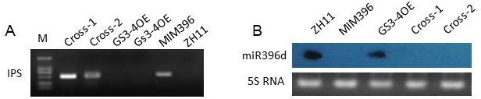
Figure S1 Molecular detection and phenotype of the cross between MIM396 and GS3-4OE plants
A, Genomic detection the IPS gene in ZH11, MIM396, GS3-4OE, and the cross plants.
B, miRNA Northern blotting of the miR396d in ZH11, MIM396, GS3-4OE, and the cross plants.

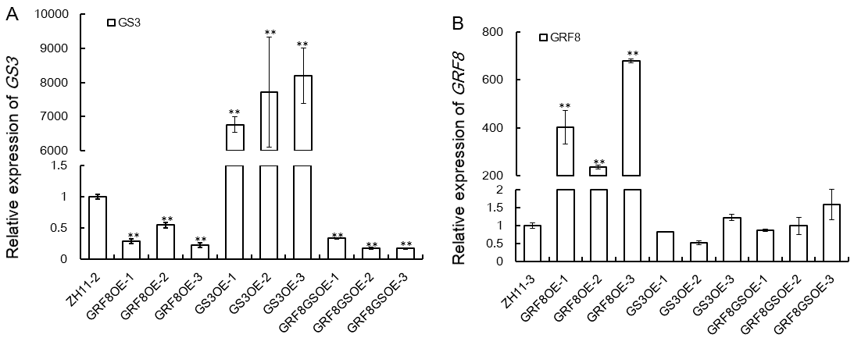
Figure S2 qRT-PCR assay to check the expression of GS3 and OsGRF8 gene in the putative cross plants of GRF8OE and GS3-4OE.
A, Expression of GS3 gene in the putative cross plants of GRF8OE and GS3-4OE.
B, Expression of OsGRF8 gene in the putative cross plants of GRF8OE and GS3-4OE.

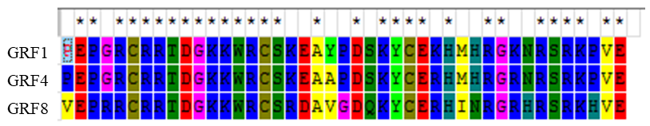
Figure S3 Alignment of the WRC domain of the OsGRF1, OsGRF4 and OsGRF8 proteins

