- Supplementary Figures
Significant Winter Atlantic Niño effect on ENSO and its future projection

Jae-Heung Park^{1*}, Young-Min Yang², Yoo-Geun Ham³, Hyun-Su Jo³, Hyo-Jin Park⁴,
So-Eun Park⁴, Chao Liu⁴, Gagan Mandal⁴, Soon-Il An⁴, and Jong-Seong Kug¹*,

¹School of Earth and Environmental Sciences, Seoul National University, Seoul, South Korea
²Key Laboratory of Meteorological Disaster, Ministry of Education (KLME)/Joint International Research Laboratory of Climate and Environment Change (ILCEC)/Collaborative Innovation Center on Forecast and Evaluation of Meteorological Disasters (CIC-FEMD), Nanjing University of Information Science and Technology, Nanjing 210044, China.
³Environmental Planning Institute, Seoul National University, Seoul, South Korea
⁴Department of Atmospheric Sciences/Irreversible Climate Change Research Center, Yonsei University, Seoul, South Korea

Submitted to Nature Communications

Corresponding authors:
Dr. Jae-Heung Park (e-mail: jhp11010@gmail.com), School of Earth and Environmental Sciences, Seoul National University, Seoul, South Korea
Prof. Jong-Seong Kug (e-mail: jskug1@gmail.com), School of Earth and Environmental Sciences, Seoul National University, Seoul, South Korea
Supplementary Table 1 | Correlation coefficients between primary climate mode in Atlantic Ocean and ENSO during 1950-2021. Summer Atlantic Niño in JJA[1], Northern Tropical Atlantic in MAM[1], Winter Atlantic Niño in D[0]JF[1], and Atlantic Warm Pool (a.k.a., Western Hemisphere Warm Pool) in JAS[0] are correlated with ENSO in D[1]JF[2].

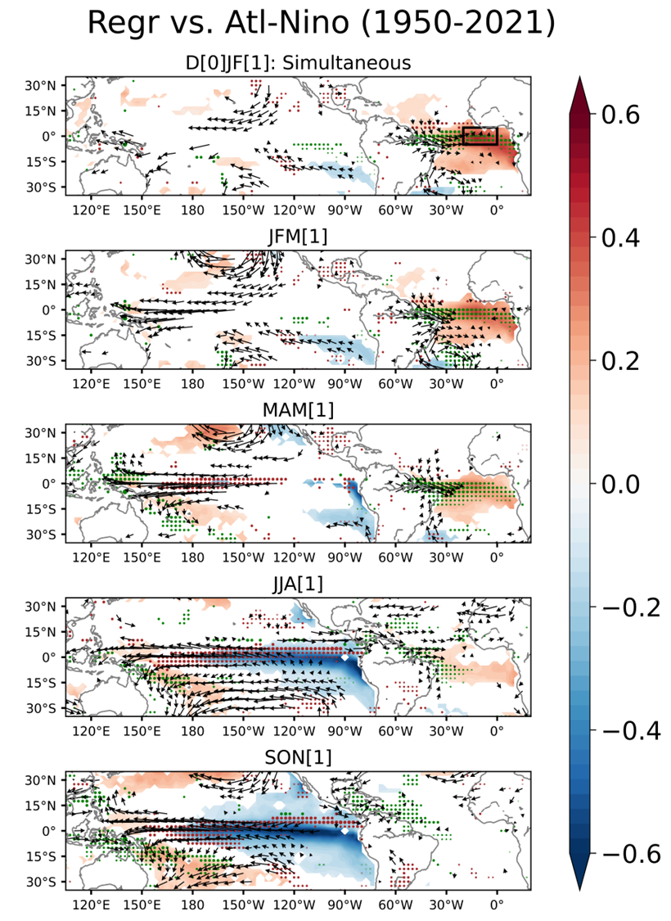
Supplementary Figure 1 | Spatiotemporal evolution patterns of oceanic and atmospheric states regarding Winter Atlantic Niño in ERA5. Regressed SSTAs (°C, shading bar at right), low-level wind anomalies (vector, at 850hPa), and precipitation anomalies (dots, green and brown for positive and negative) from D[0]JF[1] (top) to SON[1] (bottom) against the winter Atlantic Niño index (D[0]JF[1]) during 1950–2021. The SSTA, winds, and precipitation reflect a 95% confidence level by Student’s t-test (df = N-2).
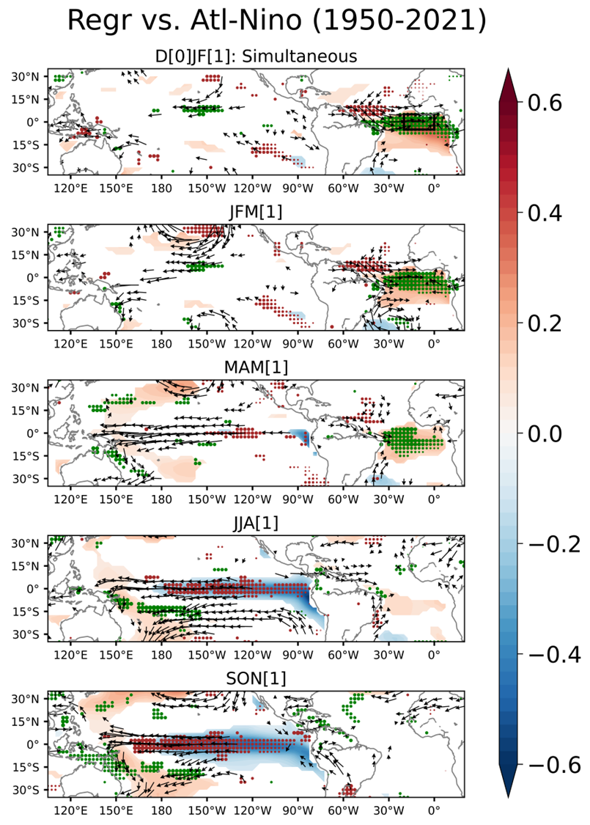
Supplementary Figure 2 | Spatiotemporal evolution patterns of oceanic and atmospheric states regarding Winter Atlantic Niño in ERSSTv5 and NCEP-R1. Regressed SSTAs (°C, shading bar at right), low-level wind anomalies (vector, at 850hPa), and precipitation anomalies (dots, green and brown for positive and negative) from D[0]JF[1] (top) to SON[1] (bottom) against the winter Atlantic Niño index (D[0]JF[1]) during 1950–2021. The SSTA, winds, and precipitation reflect a 95% confidence level by Student’s t-test (df = N-2).
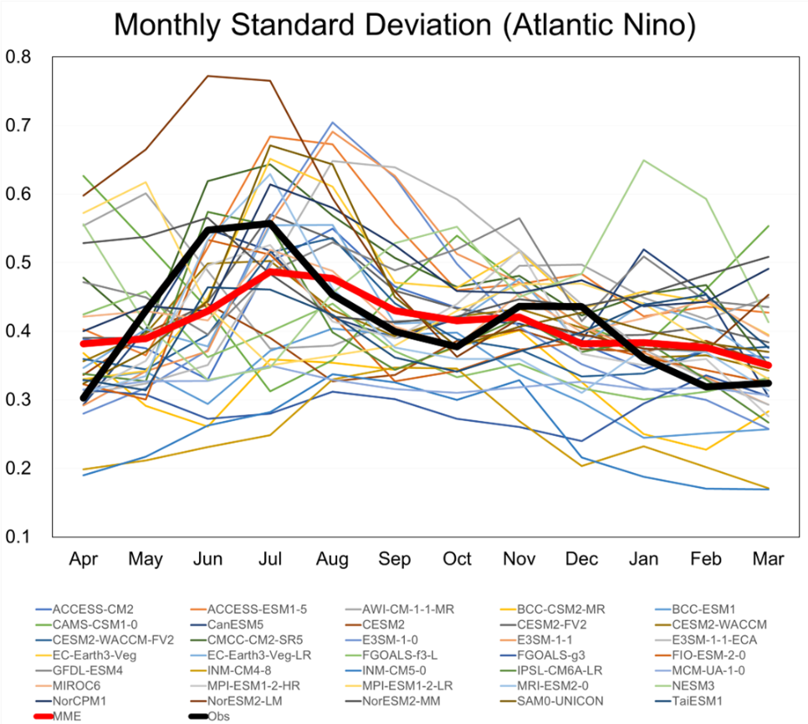
Supplementary Figure 3 | Monthly Standard deviation of Atlantic Niño. Monthly standard deviation of Atlantic Niño index in CMIP6 models. MME is indicated by a thick red line. The thick black line indicates the observed monthly standard deviation of Atlantic Niño.

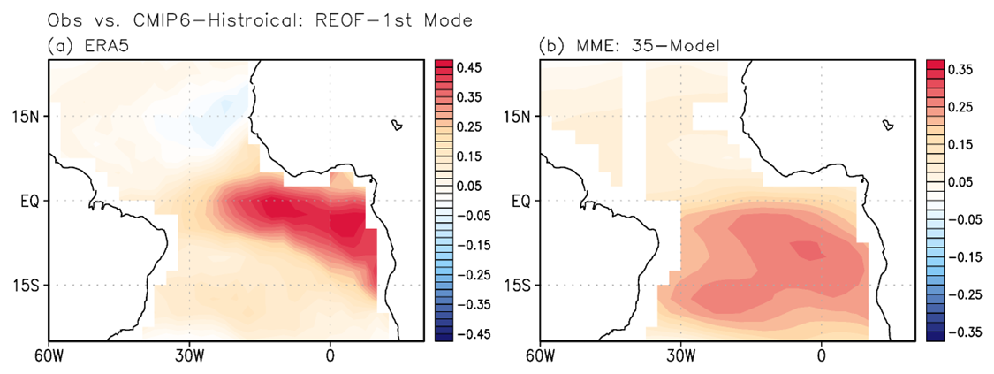
Supplementary Figure 4 | 1st Rotating-EOF mode of SST in tropical Atlantic Ocean in boreal winter in observation and CMIP6. (a) The 1st R-EOF mode of SSTA over the equatorial Atlantic in ERA5. (b) The MME of the 1st R-EOF modes of SSTA over the equatorial Atlantic in Historical simulations of climate models in CMIP6.
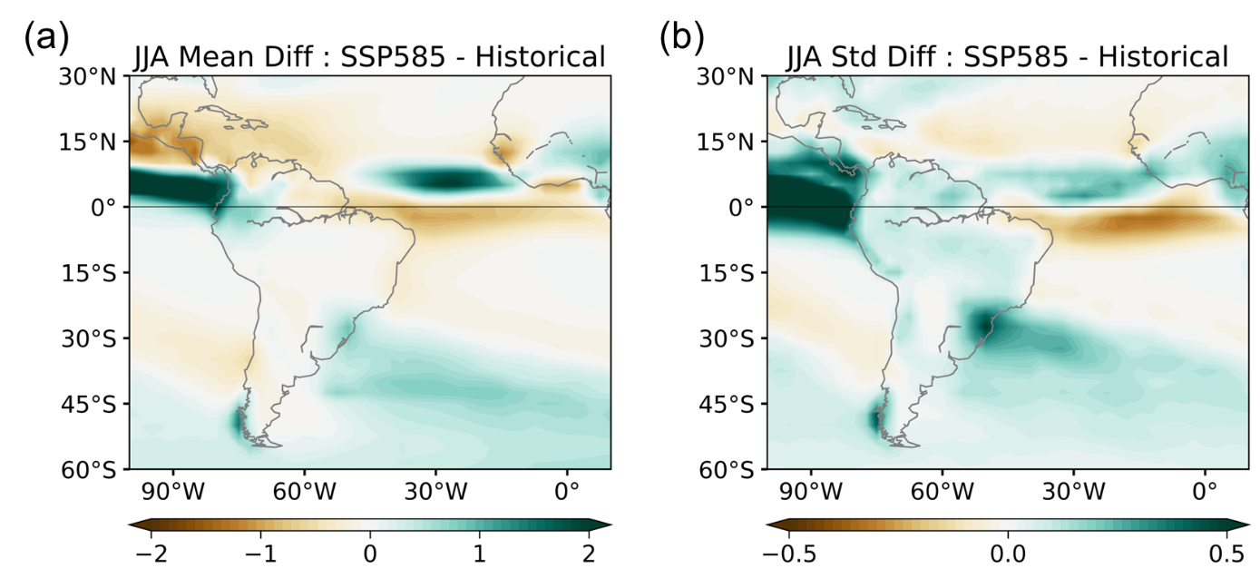
Supplementary Figure 5 | Mean state difference between historical and SSP585 simulations. (a) Differences in climatological mean precipitation in the JJA season between SSP585 (2015-2100) and historical (1850-2014) simulations. (b) Differences in standard deviation of precipitation (shading) in the JJA season between SSP585 and historical simulations.

