Sl. No | Name of the Compound | Molecular  Formula | Molecular Weight | Peak Area (%) | Structure
 | Glutaric acid | C₂₈H₅₄O₄ | 454 | 23.9 | 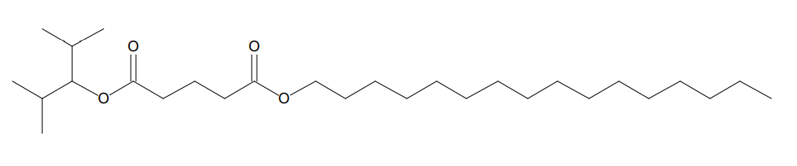
 | Sebacic acid | C₂₇H₅₂O₅ | 456 | 13.0 | 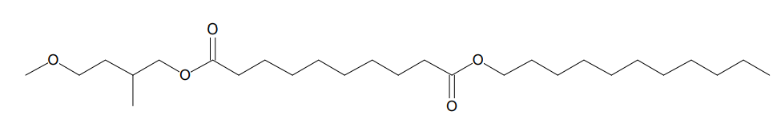
 | 3-methyl but-2-yl undecyl ester | C₂₆H₅₀O₄ | 426.3 | 9.72 | 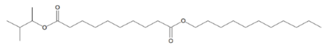
 | 2-methylpent-3-yl undecyl ester | C₂₇H₅₂O₄ | 440.3 | 7.25 | 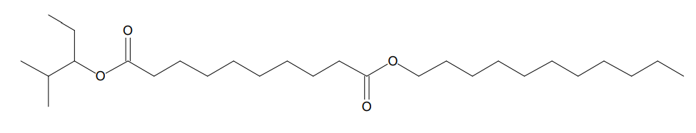
 | 4-methylhept-3-yl undecyl ester | C₂₉H₅₆O₄ | 468.4 | 4.97 | 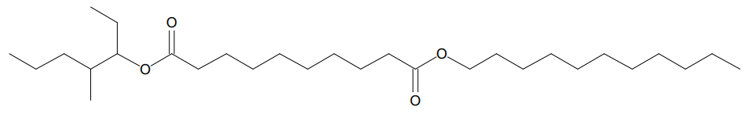
 | 3-hexyl undecyl ester | C₂₇H₅₂O₄ | 440.3 | 3.41 | 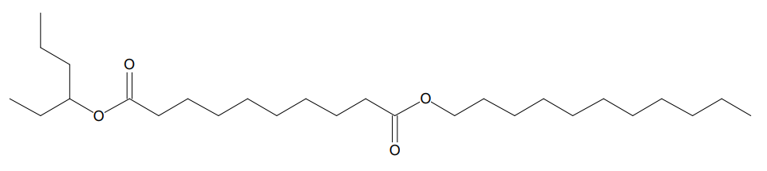
 | 4-methylpent-2-yl undecyl ester | C₂₇H₅₂O₄ | 440.3 | 3.14 | 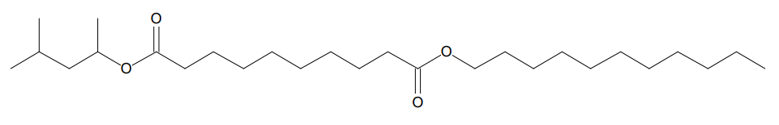
 | 3,3-dimethylbut-2-yl undecyl ester | C₂₇H₅₂O₄ | 440.3 | 2.90 | 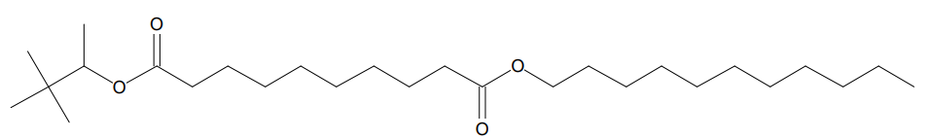
 | Adipic acid | C₂₇H₅₂O₄ | 440.3 | 2.79 | 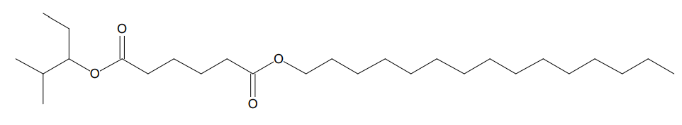
 | 3-heptyl undecyl ester | C₂₈H₅₄O₄ | 454.4 | 2.57 | 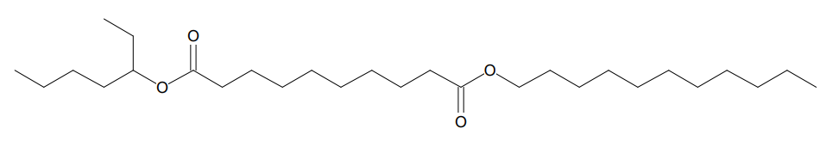
 | Glutaric acid | C₁₉H₂₇BrO₅ | 414.1 | 22.0 | 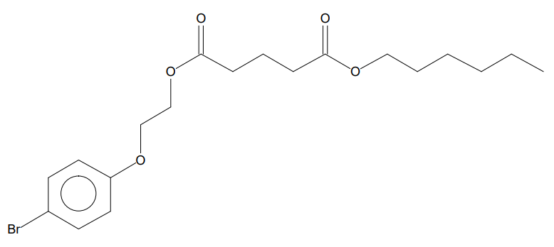
 | Spiro  [4H-1,3-benzodioxin2,1'- [2,5] cyclohexadiene]-2' carboxylic acid | C₁₇H₁₂Cl₂O₈ | 413.9 | 22.0 | 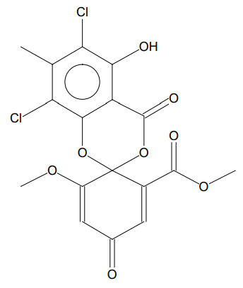
 | Phthalic acid | C₂₂H₁₆C_{l2}O₄ | 414.0 | 15.1 | 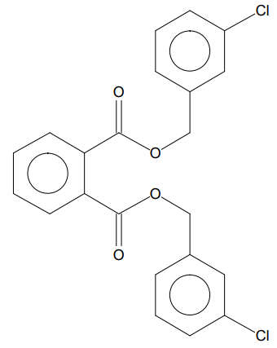
 | 4-Bromobenzoic acid | C₁₃H₅BrCl₄O₂ | 411.8 | 15.1 | 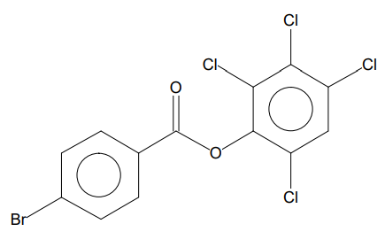
 | Propan-1-one, 3-(4-chlorophenyl)-3-(4-chlorophenylthio)-1-(3,4-dimethylphenyl)- | C₂₃H₂₀Cl₂O_{S} | 414.1 | 6.88 | 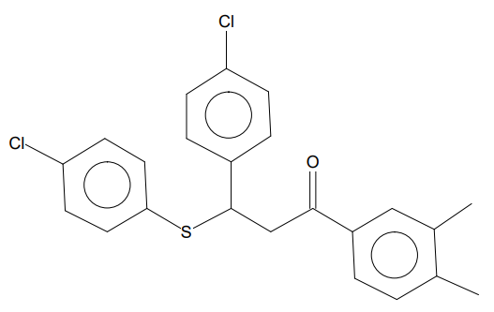
 | α-Mono-n-butylaminomethyl-2,6-di[p-chlorophenyl]-4-pyridinemethanol | C₂₃H₂₄Cl₂N₂O | 414.1 | 5.54 | 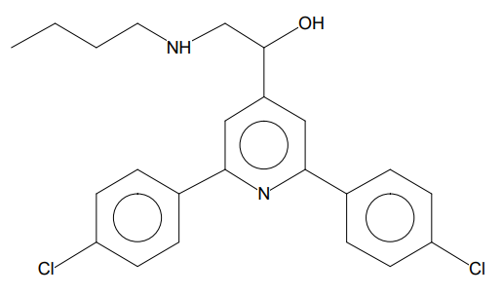
 | Trans-1-Benzyl-2,4-diphenyl-5-benzoyl-2-imidazoline | C₂₉H₂₄N₂O | 416.18 | 5.11 | 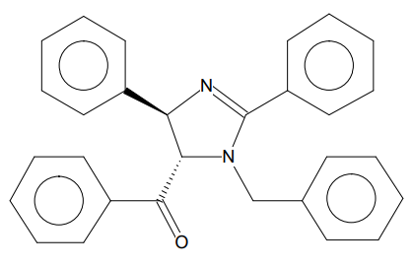
 | Benzoic acid,  silver (1+) salt | C₇H₅AgO₂ | 227.9 | 2.48 | 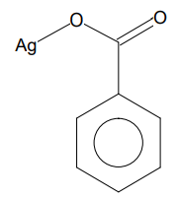
 | Thiophosphoric acid | C₁₅H₂₁Cl₂O₃PS₂ | 414 | 1.20 | 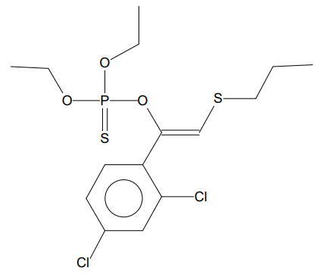
 | 3-Bromobenzoic acid | C₁₃H₅BrCl₄O₂ | 411.8 | 1.06 | 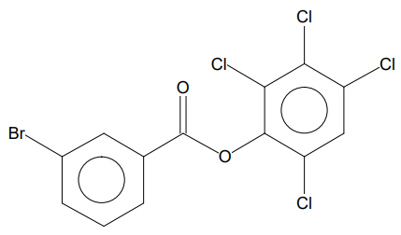
 | Isopentedrone | C₁₂H₁₇NO | 191 | 33.5 | 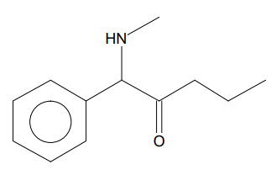
 | 7,8-Diazabicyclo[4.2.2]deca-2,4,7-trien-7-oxide | C₈H₁₀N₂O | 150 | 3.36 | 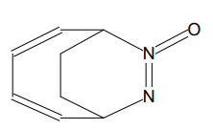
 | 2H-[1,2,4]Triazole-3-sulfonic acid benzyl-methyl-amide | C₁₀H₁₂N₄O₂S | 252 | 3.52 | 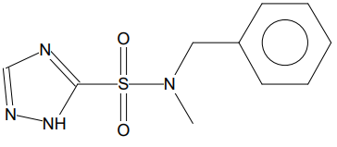
 | 2-Aminohydratropic acid | C₉H₁₁NO₂ | 165 | 3.12 | 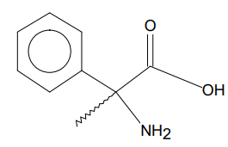
 | 1-Propanol, 3-(ethylthio) | C₅H₁₂OS | 120 | 2.88 | 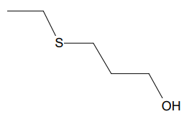
 | 2-[3-(4-Methoxyphenyl)-1,2,4-oxadiazol-5-yl] aniline | C₁₅H₁₃N₃O₂ | 267 | 2.52 | 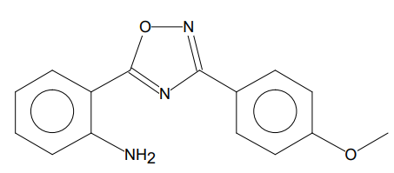
 | Benzenemethanamine, N, α-dimethyl | C₉H₁₃N | 135 | 2.34 | 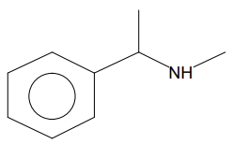
 | 3-Amino-1-chloro-4-phenyl-2-butanone | C₁₀H₁₂ClNO | 197 | 2.16 | 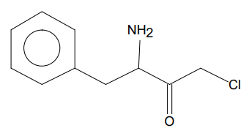
 | N-(2-Phenylpropan-2-yl) acetamide | C₁₁H₁₅NO | 177 | 2.08 | 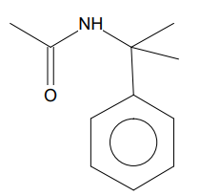
 | Propane, 1-[(1-methyl ethyl)thio] | C₆H₁₄S | 118 | 1.84 | 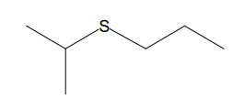
 | Benzamidine | C₇H₈N₂ | 120 | 12.2 | 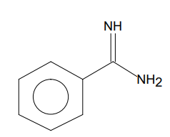
 | Hydrazine carboxamide, 2-(phenyl methylene)- | C₈H₉N₃O | 163 | 6.64 | 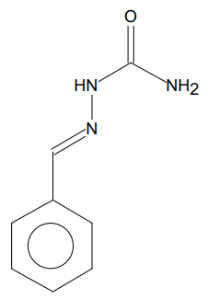
 | 3-Pyridinecarbonitrile, 1,4-dihydro-1-methyl | C₇H₈N₂ | 120 | 6.13 | 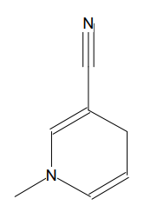
 | 2-Aminohydratropic acid | C₉H₁₁NO₂ | 165 | 5.14 | 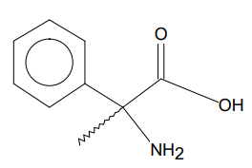
 | p-Toluic acid, 2-phenylethyl ester | C₁₆H₁₆O₂ | 240 | 4.78 | 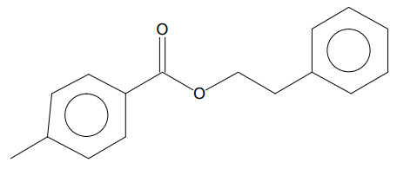
 | Hydrazine carboxamide, 2-(phenylmethylene)- | C₈H₉N₃O | 163 | 6.64 | 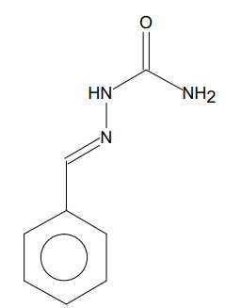
 | 1,2-Naphthalenediol, 1,2,3,4-tetrahydro | C₁₀H₁₂O₂ | 164 | 4.60 | 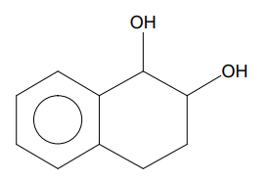
 | Pyridine, 5-ethenyl-2-methyl | C₈H₉N | 119 | 3.88 | 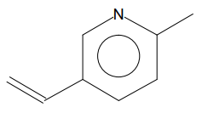
 | m-Toluic acid, 2-phenylethyl ester | C₁₆H₁₆O₂ | 240 | 3.58 | 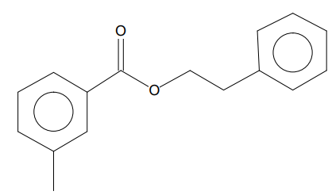
 | o-Toluic acid, 2-phenylethyl ester | C₁₆H₁₆O₂ | 240 | 2.88 | 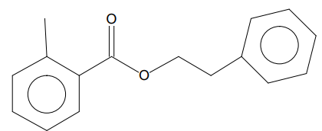
Table 04: Bioactive derivative of Benincasa hispida in GC-MS analysis

Sl. No | Compound Name | Compound  Cid | MF | MW | RB | LE. Sa | LE. Ln | DC | LogP | RMSD | Iupac_Inchikey
 | 1-[2-[2-hydroxy-3-(propylamino) propoxy] phenyl]-3-phenyl-propan-1-one | 4932 | C₂₁H₂₇NO₃ | 341.4 | 12 | -0.574 | -1.163 | -4.905 | -1.376 | 15.513 | JWHAUXFOSRPERK-UHFFFAOYSA-N
 | 2-phenyl ethyl 2-phenylacetate | 7601 | C₁₆H₁₆O₂ | 240.3 | 6 | -0.526 | -0.928 | -3.609 | -1.386 | 16.592 | ZOZIRNMDEZKZHM-UHFFFAOYSA-N
 | trimethyl (2-phenyl sulfanyl ethyl) silane | 12938686 | C₁₁H₁₈SSi | 210.41 | 4 | -0.619 | -0.96 | -3.423 | -0.865 | 13.38 | ICBYMDJSRHCOPY-UHFFFAOYSA-N
 | (3R)-1,3-dibenzyl-5-phenyl-3H-1,4-benzodiazepin-2-one | 53322654 | C₂₉H₂₄N₂O | 416.5 | 5 | -0.33 | -0.746 | -3.33 | -1.249 | 17.32 | IUTLMDNQFCPFLT-AREMUKBSSA-N
 | 2,6-dimethyl-5-oxo-hept-1-enyl]-4'-(hydroxymethyl)-4,7'-dimethyl | 71579367 | C₂₅H₃₄O₅ | 414.5 | 7 | -0.31 | -0.679 | -2.99 | -1.169 | 19.958 | ADVQUGFWSPNWGG-MMHRJDEDSA-N
 | 1'-isopropyl-5-phenyl-spiro[3H-1,3,4-thiadiazole-2,3'-indoline]-2'-one | 24753026 | C₁₈H₁₇N₃OS | 323.4 | 2 | -0.368 | -0.72 | -2.977 | -0.122 | 17.229 | UELBYBHAJLYAIE-UHFFFAOYSA-N
 | bis(2-chloro-5-methyl-phenyl) benzene-1,3-dicarboxylate | 91740299 | C₂₂H₁₆C_{l2}O₄ | 415.3 | 6 | -0.31 | -0.661 | -2.862 | -0.7 | 19.912 | TWTRJLJIQDYMBM-UHFFFAOYSA-N
 | bis[[dimethylsilyloxy(dimethyl)silyl] oxy]-dimethyl-silane | 553663 | C₁₀H₃₂O₄Si₅ | 356.78 | 8 | -0.398 | -0.719 | -2.837 | -0.709 | 17.472 | OMABSGMMFGVCDF-UHFFFAOYSA-N
 | m-tolyl N-methylcarbamate | 14322 | C₉H₁₁NO₂ | 165.19 | 3 | -0.512 | -0.771 | -2.686 | -0.075 | 14.301 | VOEYXMAFNDNNED-UHFFFAOYSA-N
 | 2-(1-propoxyethoxy) ethylbenzene | 61403 | C₁₃H₂₀O₂ | 208.3 | 7 | -0.43 | -0.705 | -2.615 | -1.251 | 16.213 | FMYCPRQGKSONCP-UHFFFAOYSA-N
 | (2,3,4,6-tetrachlorophenyl) 4-bromobenzoate | 91728234 | C₁₃H₅BrC_{l4}O₂ | 414.9 | 3 | -0.293 | -0.541 | -2.161 | -0.307 | 16.629 | XVVROJFYSIDWLV-UHFFFAOYSA-N
 | 1-(2,3-dichlorophenyl)-4-[3-(2-naphthyloxy) propyl] piperazine | 1.46E+08 | C₂₃H₂₄C_{l2}N₂O | 415.4 | 6 | -0.234 | -0.498 | -2.158 | -0.134 | 17.81 | QAKAHVIIXGWTQO-UHFFFAOYSA-N
 | hexadecyl 2-hydroxypropanoate | 37098 | C₁₉H₃₈O₃ | 314.5 | 18 | -0.264 | -0.507 | -2.074 | -1.166 | 18.683 | WUKXMJCZWYUIRZ-UHFFFAOYSA-N
 | [2-hydroxy-1-(hydroxymethyl) ethyl] (Z)-tetracos-15-enoate | 53480973 | C₂₇H₅₂O₄ | 440.7 | 27 | -0.165 | -0.368 | -1.633 | -0.58 | 19.056 | HXZFYDGMORCWCA-KTKRTIGZSA-N
 | (3-dodecanoyloxy-2-hydroxy-propyl) do decanoate | 101758 | C₂₇H₅₂O₅ | 456.7 | 27 | -0.157 | -0.354 | -1.581 | -1.006 | 20.811 | KUVAEMGNHJQSMH-UHFFFAOYSA-N
 | bis(2-ethylhexyl) dienedioate | 29401 | C₂₈H₅₄O₄ | 454.7 | 25 | -0.07 | -0.159 | -0.71 | -0.378 | 19.622 | MTPSFISGWJGUGN-UHFFFAOYSA-N
 | tetradecyl carbochlorination | 92493 | C₁₅H₂₉ClO₂ | 276.84 | 14 | 0.134 | 0.237 | 0.921 | -1.366 | 18.41 | KQHBSKZGPQPRIT-UHFFFAOYSA-N
 | 2-hydroxyundecanoic acid | 5282899 | C₁₁H₂₂O₃ | 202.29 | 10 | 0.18 | 0.287 | 1.045 | -0.495 | 15.654 | MNRBGFKCVTVNBA-UHFFFAOYSA-N
 | (3R)-3-hydroxydodecanoic acid | 5312804 | C₁₂H₂₄O₃ | 216.32 | 11 | 0.199 | 0.327 | 1.212 | -0.289 | 17.375 | MUCMKTPAZLSKTL-LLVKDONJSA-N
 | 2-hydroxypropyl dodecanoate | 14870 | C₁₅H₃₀O₃ | 258.4 | 14 | 0.228 | 0.403 | 1.568 | -0.879 | 19.343 | BHIZVZJETFVJMJ-UHFFFAOYSA-N
 | 1-[2-[2-hydroxy-3-(propylamino) propoxy] phenyl]-3-phenyl-propan-1-one | 4932 | C₂₁H₂₇NO₃ | 341.4 | 12 | -0.574 | -1.163 | -4.905 | -1.376 | 15.513 | JWHAUXFOSRPERK-UHFFFAOYSA-N
 | 2-hydroxy-3-[2-(4-hydroxyphenyl) acetyl] azo-1H-indole-5-carboxylic acid | 136068627 | C₁₇H₁₃N₃O₅ | 339.3 | 7 | -0.698 | -1.415 | -5.969 | -1.484 | 16.371 | DXMNZMFMHRNRIL-UHFFFAOYSA-N
 | 2,2-dibromo-1-(3,4-dihydro-2H-1,4-benzoxazin-6-yl) ethanone | 166107885 | C₁₀H₉Br₂NO₂ | 334.99 | 2 | -0.928 | -1.522 | -5.644 | -1.445 | 15.943 | FAFPNGFYWAOZHF-UHFFFAOYSA-N
 | (2R)-2-(9H-fluoren-9-ylmethoxycarbonylamino)-3-(2-naphthyl)propanoic acid | 7130590 | C₂₈H₂₃NO₄ | 437.5 | 8 | -0.504 | -1.153 | -5.183 | -2.495 | 18.214 | JYUTZJVERLGMQZ-AREMUKBSSA-N
 | (2R)-2-(9H-fluoren-9-ylmethoxycarbonylamino)-3-(2-naphthyl)propanoic acid | 7130590 | C₂₈H₂₇N₃O₂ | 437.5 | 8 | -0.504 | -1.153 | -5.183 | -2.495 | 18.214 | JYUTZJVERLGMQZ-AREMUKBSSA-N
 | 2-[(7-oxo-5-phenyl-1H-pyrazolo[1,5-a]pyrimidine-3-carbonyl)amino]acetic acid | 137635296 | C₁₅H₁₂N₄O₄ | 312.28 | 5 | -0.634 | -1.24 | -5.128 | -1.287 | 14.844 | YWRBFQXZTWMBLH-UHFFFAOYSA-N
 | (Z)-N-(1,3-dioxolan-2-ylmethoxy) Benz imidoyl cyanide | 9576081 | C₁₂H₁₂N₂O₃ | 232.23 | 4 | -0.77 | -1.327 | -5.088 | -1.396 | 17.846 | WFVUIONFJOAYPK-SDNWHVSQSA-N
 | N-[2-[(4-bromophenyl) methoxy]-4-nitro-phenyl] methanesulfonamide | 16125315 | C₁₄H₁₃BrN₂O₅S | 401.23 | 6 | -0.607 | -1.187 | -4.909 | -1.39 | 19.596 | ZJHDHIFNJKSKJN-UHFFFAOYSA-N
 | 4-benzyl-3-(4-ethoxyphenyl)-1H-1,2,4-triazole-5-thione | 919877 | C₁₇H₁₇N₃OS | 311.4 | 5 | -0.585 | -1.122 | -4.59 | -1.777 | 22.489 | GBHZFUVNXPAEKT-UHFFFAOYSA-N
 | (2S,3S,4S,5R)-2,3,4,5-tetrahydroxy-6-oxo-hexanamide | 94281 | C₆H₁₁NO₆ | 193.15 | 9 | -0.813 | -1.261 | -4.496 | -0.681 | 15.483 | JRIOKBXQMHEJOZ-QTBDOELSSA-N
 | 1-(4-methoxyphenyl)-4-phenyl-butan-1-one | 44589436 | C₁₇H₁₈O₂ | 254.32 | 6 | -0.618 | -1.115 | -4.399 | -1.678 | 19.385 | XBNJLAPERJEQAO-UHFFFAOYSA-N
 | 4-[6-(3,4,5-trimethoxyanilino) pyrazin-2-yl] benzamide | 11696578 | C₂₀H₂₀N₄O₄ | 380.4 | 7 | -0.47 | -1.001 | -4.338 | -1.973 | 19.79 | LZLKDDDQYGMZTB-UHFFFAOYSA-N
 | 4-morpholino-N-(p-tolyl)-6-[2,2,2-trifluoro-1-(trifluoromethyl) ethoxy]-1,3,5-triazin-2-amine | 1068748 | C₁₇H₁₇F₆N₅O₂ | 437.34 | 7 | -0.441 | -0.967 | -4.254 | -1.557 | 20.951 | FVFOZCBFMTVJII-UHFFFAOYSA-N
 | 3-methyl-1,3-benzothiazol-2-one hydrazone | 5782694 | C₈H₉N₃S | 179.24 | 1 | -0.81 | -1.218 | -4.246 | -1.287 | 21.194 | PHOLIFLKGONSGY-NTMALXAHSA-N
 | 2-(2,3-dihydrobenzofuran-5-yl)-5-[(4-methoxyphenyl) methylsulfanyl]-1,3,4-oxadiazole | 44590238 | C₁₈H₁₆N₂O₃S | 340.4 | 5 | -0.502 | -0.999 | -4.174 | -1.476 | 20.57 | KDBVFKKUBSCXLU-UHFFFAOYSA-N
 | undecyl 1-(2,6-difluoro-3-methyl-benzoyl) piperidine-4-carboxylate | 91722360 | C₂₅H₃₇F₂NO₃ | 437.6 | 14 | -0.388 | -0.865 | -3.833 | -2.664 | 17.88 | QDAVBCMMOWIPJV-UHFFFAOYSA-N
 | (2,4-dichloro-1-naphthyl) 2,4,5-trifluoro-3-methoxy-benzoate | 91730377 | C₁₈H₉C_{l2}F₃O₃ | 401.2 | 4 | -0.403 | -0.831 | -3.537 | -2.054 | 22.096 | ROSUSCOOUSFPSY-UHFFFAOYSA-N
 | ethyl 4-(1-methyl-5-nitro-benzimidazol-2-yl) butanoate | 13086946 | C₁₄H₁₇N₃O₄ | 291.3 | 7 | -0.454 | -0.854 | -3.453 | -1.073 | 16.593 | VJVBGSJZBDBEIF-UHFFFAOYSA-N
 | 4-(imidazole-1-ylmethyl)-2-[2-(4-phenyl phenyl) ethoxy]benzonitrile | 20691443 | C₂₅H₂₁N₃O | 379.5 | 7 | -0.359 | -0.776 | -3.39 | -1.381 | 19.457 | ZMHFYICSWNADEI-UHFFFAOYSA-N
 | N-(2,6-difluoro-3-methyl-benzoyl)-2,6-difluoro-3-methyl-N-octyl-benzamide | 91722198 | C₂₄H₂₇F₄NO₂ | 437.5 | 11 | -0.338 | -0.752 | -3.335 | -2.537 | 22.146 | FSQGTRSCOAJXSS-UHFFFAOYSA-N
Table 04: Pharmacokinetic profile of Pro-apoptosis BAX protein on Benincasa hispida ligands

Sl. No | Compound Name | Compound  Cid | MF | MW | RB | LE. Sa | LE. Ln | DC | Logp | RMSD | Iupac_Inchikey
 | 10-tetramethoxy-6,8,13,13a-tetrahydro-5H-isoquinolino[2,1-b]isoquinoline | 72301 | C₂₁H₂₅NO₄ | 355.4 | 4 | -1.173 | -2.418 | -10.297 | -4.226 | 55.034 | AEQDJSLRWYMAQI-KRWDZBQOSA-N
 | 4-[bis(4-chlorophenyl) methylsulfanyl]-4-phenyl-butane-2-one | 69696062 | C₂₃H₂₀C_{l2}OS | 415.4 | 7 | -1.019 | -2.134 | -9.169 | -5.211 | 55.537 | RQIOFLHJEOGHOT-UHFFFAOYSA-N
 | 1'-isopropyl-5-phenyl-spiro[3H-1,3,4-thiadiazole-2,3'-indoline]-2'-one | 24753026 | C₁₈H₁₇N₃OS | 323.4 | 2 | -1.123 | -2.196 | -9.08 | -3.097 | 51.934 | UELBYBHAJLYAIE-UHFFFAOYSA-N
 | (3R)-1,3-dibenzyl-5-phenyl-3H-1,4-benzodiazepin-2-one | 53322654 | C₂₉H₂₄N₂O | 416.5 | 5 | -0.89 | -2.01 | -8.975 | -5.176 | 54.112 | IUTLMDNQFCPFLT-AREMUKBSSA-N
 | 1-(2,3-chlorophenyl)-4-[3-(2-naphthyl oxy) propyl]piperazine | 145991385 | C₂₃H₂₄C_{l2}N₂O | 415.4 | 6 | -0.966 | -2.055 | -8.903 | -5.421 | 53.791 | QAKAHVIIXGWTQO-UHFFFAOYSA-N
 | 2,6-dimethyl-5-oxo-hept-1-enyl]-4'-(hydroxymethyl)-4,7'-dimethyl-spiro[2,3-dihydropyran-6,2'-5,8a-dihydro-4aH-chromene]-6'-one | 71579367 | C₂₅H₃₄O₅ | 414.5 | 6 | -0.902 | -1.98 | -8.712 | -4.235 | 53.145 | ADVQUGFWSPNWGG-MMHRJDEDSA-N
 | 1-[2-[2-hydroxy-3-(propylamino) propoxy] phenyl]-3-phenyl-propane-1-one | 4932 | C₂₁H₂₇NO₃ | 341.4 | 11 | -0.977 | -1.979 | -8.349 | -3.285 | 51.737 | JWHAUXFOSRPERK-UHFFFAOYSA-N
 | (2,3,4,6-tetra chlorophenyl) 4-bromobenzoate | 91728234 | C₁₃H₅BrC_{l4}O2 | 414.9 | 3 | -0.971 | -1.791 | -7.157 | -3.441 | 54.034 | XVVROJFYSIDWLV-UHFFFAOYSA-N
 | bis(2-chloro-5-methyl-phenyl) benzene-1,3-dicarboxylate | 91740299 | C₂₂H₁₆C_{l2}O₄ | 415.3 | 6 | -0.775 | -1.65 | -7.15 | -3.483 | 54.021 | TWTRJLJIQDYMBM-UHFFFAOYSA-N
 | [2-hydroxy-1-(hydroxymethyl) ethyl] (Z)-tetracos-15-enoate | 53480973 | C₂₇H₅₂O₄ | 440.7 | 25 | -0.717 | -1.596 | -7.075 | -4.461 | 55.868 | HXZFYDGMORCWCA-KTKRTIGZSA-N
 | [(Z)-1-(2,4-dichlorophenyl)-2-propylsulfanyl-vinyloxy]-diethoxy-thioxo-lambda5-phosphane | 5377090 | C₁₅H₂₁C_{l2}O₃PS₂ | 415.3 | 10 | -0.861 | -1.683 | -6.961 | -3.814 | 55.788 | PLPOWLPHKUUFMH-PTNGSMBKSA-N
 | 2-phenyl ethyl 2-phenylacetate | 7601 | C₁₆H₁₆O₂ | 240.3 | 6 | -0.983 | -1.736 | -6.753 | -2.799 | 53.002 | ZOZIRNMDEZKZHM-UHFFFAOYSA-N
 | 2-aminobenzamide | 6942 | C₇H₈N₂O | 136.15 | 1 | -1.453 | -2.041 | -6.742 | -1.336 | 54.834 | PXBFMLJZNCDSMP-UHFFFAOYSA-N
 | trimethyl (2-phenyl sulfanyl ethyl) silane | 12938686 | C₁₁H₁₈SSi | 210.41 | 4 | -1.193 | -1.85 | -6.596 | -2.901 | 53.068 | ICBYMDJSRHCOPY-UHFFFAOYSA-N
 | 1-(methoxymethyl)benzotriazole | 542390 | C₈H₉N₃O | 163.18 | 2 | -1.18 | -1.775 | -6.186 | -1.187 | 52.589 | QEIXBXXKTUNWDK-UHFFFAOYSA-N
 | hexadecyl 2-hydroxy-propanoate | 37098 | C₁₉H₃₈O₃ | 314.5 | 17 | -0.771 | -1.479 | -6.051 | -3.789 | 53.984 | WUKXMJCZWYUIRZ-UHFFFAOYSA-N
 | 5-tetrahydroxy-6-oxo-hexamine | 94281 | C₆H₁₁NO₆ | 193.15 | 5 | -1.079 | -1.673 | -5.965 | -0.847 | 54.701 | JRIOKBXQMHEJOZ-QTBDOELSSA-N
 | 2-isopropenyl pyrazine | 62897 | C₇H₈N₂ | 120.15 | 1 | -1.333 | -1.804 | -5.769 | -1.601 | 54.033 | JMKUTMOIKCXELD-UHFFFAOYSA-N
 | bis(2-ethylhexyl) dodecanedioate | 29401 | C₂₈H₅₄O₄ | 454.7 | 25 | -0.558 | -1.26 | -5.627 | -3.626 | 56.05 | MTPSFISGWJGUGN-UHFFFAOYSA-N
 | 2-(1-propoxyethoxy) ethylbenzene | 61403 | C₁₃H₂₀O₂ | 208.3 | 7 | -0.894 | -1.467 | -5.44 | -2.675 | 53.862 | FMYCPRQGKSONCP-UHFFFAOYSA-N
 | 1'-isopropyl-5-phenyl-spiro[3H-1,3,4-thiadiazole-2,3'-indoline]-2'-one | 72301 | C₂₁H₂₅NO₄ | 355.4 | 4 | -1.173 | -2.418 | -10.297 | -4.226 | 55.034 | AEQDJSLRWYMAQI-KRWDZBQOSA-N
 | 1-(4-methoxyphenyl)-3-phenyl-propan-1-one | 245554 | C₁₆H₁₆O₂ | 240.3 | 5 | -1.223 | -2.158 | -7.21 | -3.313 | 52.969 | WMPHLIJZKDSFFR-UHFFFAOYSA-N
 | 2-[4-oxo-1-(2-trimethylsilylethoxymethyl) cinnolin-3-yl] acetic acid | 146836711 | C₁₆H₂₂N₂O₄Si | 334.44 | 7 | -0.932 | -1.822 | -7.076 | -2.123 | 52.804 | SFGGNVFJRNOASB-UHFFFAOYSA-N
 | 1-(3-chlorophenyl)-N-(1H-imidazol-2-ylmethyl) pyrrolidin-3-amine | 71975805 | C₁₄H₁₇ClN₄ | 276.76 | 4 | -1.013 | -1.828 | -7.021 | -3.085 | 56.133 | LHBSTKCUYDUXLA-UHFFFAOYSA-N
 | 1-chloro-3-(4-nitrophenoxy) benzene | 16815 | C₁₂H₈ClNO₃ | 249.65 | 3 | -1.07 | -1.846 | -7.015 | -2.841 | 56.249 | XEUAYIJJIQXNOO-UHFFFAOYSA-N
 | 3-[(3,5-dimethyl isoxazole-4-yl)methylsulfanyl]-6-methyl-4H-1,2,4-triazin-5-one | 135413071 | C₁₀H₁₂N₄O₂S | 252.3 | 3 | -1.062 | -1.832 | -6.901 | -2.004 | 53.049 | MAOUMAOCNWVKAU-UHFFFAOYSA-N
 | N-(trimethylsilyl methyl) octadecan-1-amine | 71348606 | C₂₂H₄₉NSi | 355.7 | 19 | -0.843 | -1.679 | -6.889 | -3.752 | 51.895 | ALYHWJDDYKHBBR-UHFFFAOYSA-N
 | 1-(4-morpholino phenyl) ethenone | 38362 | C₁₂H₁₅NO₂ | 205.25 | 2 | -1.135 | -1.861 | -6.631 | -1.924 | 53.924 | AKQWEDMTPCAESO-UHFFFAOYSA-N
 | 5-(4-methoxyphenyl)-N-phenyl-1,3,4-oxadiazol-2-amine | 13901969 | C₁₅H₁₃N₃O₂ | 267.28 | 4 | -0.935 | -1.724 | -6.586 | -2.995 | 52.654 | TWSJIBKNSNSSOE-UHFFFAOYSA-N
 | 1-(3,6-dimethylhydrazine-2-yl) ethenone | 104722 | C₈H₁₀N₂O | 150.18 | 1 | -1.341 | -1.952 | -6.567 | -1.699 | 53.836 | JFUVDGXTDCVGHA-UHFFFAOYSA-N
 | 5-(1,3-benzodioxol-5-yl)-1,3,4-oxadiazol-2-amine | 3067251 | C₉H₇N₃O₃ | 205.17 | 1 | -1.083 | -1.776 | -6.514 | -1.343 | 51.876 | RDYBBDXAHGPAOB-UHFFFAOYSA-N
 | (2S)-2-amino-3-phenyl-propanoic acid | 6140 | C₉H₁₁NO₂ | 165.19 | 3 | -1.253 | -1.884 | -6.465 | -1.667 | 54.783 | COLNVLDHVKWLRT-QMMMGPOBSA-N
 | hexadecyl 1-(2,2-dimethyl propanol) pyrrolidine-2-carboxylate | 91721437 | C₂₆H₄₉NO₃ | 423.7 | 19 | -0.675 | -1.48 | -6.311 | -4.21 | 52.621 | FQKHCORZSILBBK-UHFFFAOYSA-N
 | (6-chloro-3-phenyl-pyridazine-4-yl) octyl sulfanyl formate | 41463 | C₁₉H₂₃ClN₂O₂S | 378.9 | 11 | -0.756 | -1.532 | -6.294 | -3.581 | 51.343 | JTZCTMAVMHRNTR-UHFFFAOYSA-N
 | N, N-diethyl benzamide | 15542 | C₁₁H₁₅NO | 177.24 | 4 | -1.142 | -1.77 | -6.288 | -1.565 | 51.195 | JLNGEXDJAQASHD-UHFFFAOYSA-N
 | 6-methoxy-4-methyl-1H-quinoline-2-thione | 935963 | C₁₁H₁₁NOS | 205.28 | 1 | -1.084 | -1.73 | -6.268 | -2.007 | 53.637 | VHEWCRNTYVTZPW-UHFFFAOYSA-N
 | 2-chloro-N-(2-phenyl ethyl) acetamide | 94921 | C₁₀H₁₂ClNO | 197.66 | 5 | -1.137 | -1.764 | -6.265 | -2.092 | 54.212 | LNWWGHNQLOXRTF-UHFFFAOYSA-N
 | 4-methyl-2-phenyl-1,3-dioxolane | 595928 | C₁₀H₁₂O₂ | 164.2 | 1 | -1.196 | -1.799 | -6.125 | -1.529 | 54.564 | CDIKGISJRLTLRA-UHFFFAOYSA-N
 | 11a-hexamethyl-9-trimethylsilyl oxy-3b-hexadecahydrocyclopenta[a]chrysen-1-yl] ethanone | 91753086 | C₃₂H₅₆O₂Si | 500.9 | 3 | -0.459 | -1.077 | -7.21 | -2.536 | 52.474 | CWQUWBSFGPDZNL-LVEKUKLESA-N
 | 3-ethylsulfanylpropan-1-ol | 87762 | C₅H₁₂OS | 120.22 | 5 | -0.949 | -1.178 | -7.076 | -1.387 | 55.15 | KRUJXSIEMOWXOF-UHFFFAOYSA-N
Table 05: Pharmacokinetic profile of Acetylcholine protein on Benincasa hispida ligands

