Table 1 Chemical structure (with IUPAC name) of 35 target pesticides
Sl. no | Name of the pesticides (with IUPAC) | Chemical structure
1. | Acephate  (O,S-Dimethyl acetylphosphoramidothioate2) | 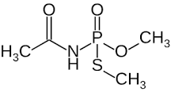
2. | Acetamiprid  ((E)-N1-[(6-chloro-3-pyridyl)methyl]-N2-cyano-N1-methylacetamidine) | 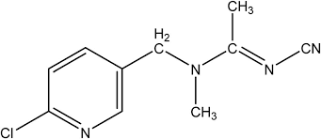
3. | Azoxystrobin  (methyl (E)-2-{2-[6-(2-cyanophenoxy) pyrimidin-4-yloxy]phenyl}-3-methoxyacrylate) | 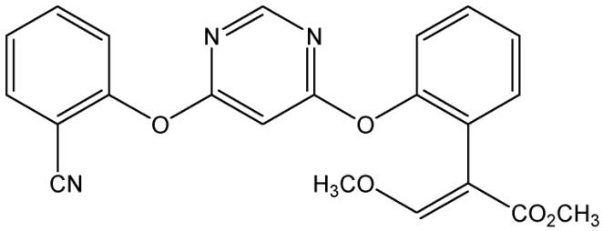
4. | Buprofezin  ((Z)-2-tert-butylimino-3-isopropyl-5-phenyl-1,3,5-thiadiazinan-4-one) | 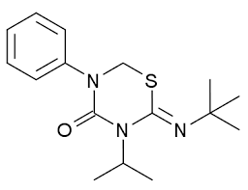
5. | Carbendazim  (methyl benzimidazol-2-ylcarbamate) | 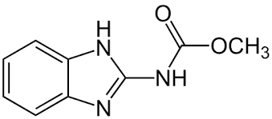
6. | Carbofuran  (2,2-Dimethyl-2,3-dihydro-1-benzofuran-7-yl methylcarbamate) | 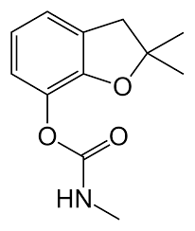
7. | Carbofuran-3-Hydroxy  (2,3-dihydro-3-hydroxy-2,2-dimethyl-7-benzofuranyl carbamic acid methyl ester) | 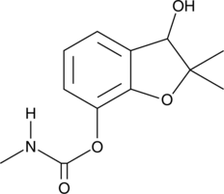
8. | Chlorantraniliprole  (3-bromo-4'-chloro-1-(3-chloro-2-pyridyl)-2'-methyl-6'-(methylcarbamoyl)pyrazole-5-carboxanilide) | 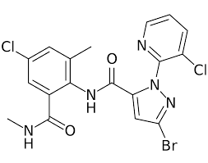
9. | Chlorpyrifos  (O,O-diethyl O-(3,5,6-trichloropyridin-2-yl) thiophosphate) | 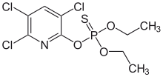
10. | Cyantraniliprole  (3-bromo-1-(3-chloro-2-pyridyl)-4'-cyano-2'-methyl-6'-(methylcarbamoyl)pyrazole-5-carboxanilide) | 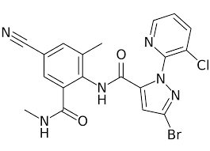
11. | Dimethoate  (2-dimethoxyphosphinothioylsulfanyl-N-methylacetamide) | 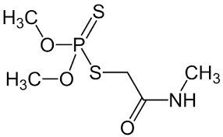
12. | Emmamectin Benzoate  ((4''R)-5-O-Demethyl-4''-deoxy-4''-(methylamino)avermectin A1a benzoate) | 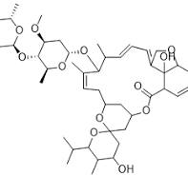
13. | Flonicamid  (N-cyanomethyl-4-(trifluoromethyl)nicotinamide) | 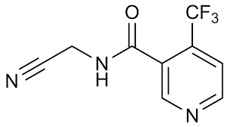
14. | Fluopyram  (N-[2-[3-chloro-5-(trifluoromethyl)-2-pyridyl]ethyl]-α,α,α-trifluoro-ortho-toluamide) | 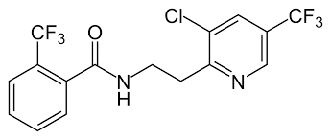
15. | Hexaconazole  ((RS)-2-(2,4-dichlorophenyl)-1-(1H-1,2,4-triazol-1-yl)hexan-2-ol) | 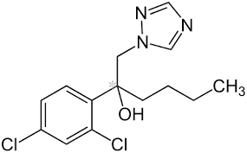
16. | Imidacloprid  (1-(6-chloro-3- pyridylmethyl)-N-nitroimidazolidin-2-ylideneamine) | 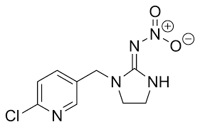
17. | Indoxacarb  (methyl (S)-N-[7-chloro-2,3,4a,5-tetrahydro-4a-(methoxycarbonyl)indeno[1,2-e][1,3,4]oxadiazin-2-ylcarbonyl]-4'-(trifluoromethoxy)carbanilate) | 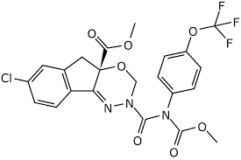
18. | Malaoxon  (diethyl 2-(dimethoxyphosphorylsulfanyl)butanedioate) | 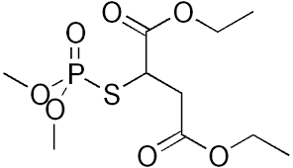
19. | Malathion  ([(dimethoxyphosphorothioyl)sulfanyl]butanedioate, Diethyl) | 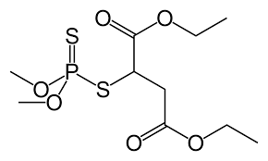
20. | Metalaxyl  (methyl N-(methoxyacetyl)-N-(2,6-xylyl)-DL-alaninate) | 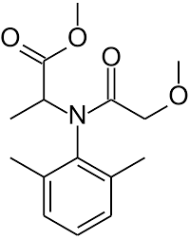
21. | Metalaxyl-M (Mefenoxam)  (methyl N-(methoxyacetyl)-N-(2,6-xylyl)-D-alaninate)
22. | Methamidophos  ((RS)-(O,S-dimethyl phosphoramidothioate)) | 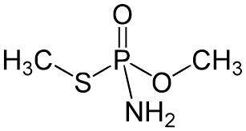
23. | Monocrotophos  (Dimethyl (2E)-4-(methylamino)-4-oxobut-2-en-2-yl phosphate) | 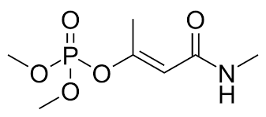
24. | Propiconazole  (1-[ [2-(2,4-dichlorophenyl)-4-propyl-1,3-dioxolan-2-yl]methyl]-1,2,4-triazole) | 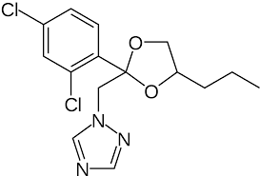
25. | Spinetoram J  ( (2R,5R,9R,10S,14R,15S,19S)-15-[(2R,5S,6R)-5-(dimethylamino)-6-methyloxan-2-yl]oxy-7-[(2R,3R,4R,5S,6S)-4-ethoxy-3,5-dimethoxy-6-methyloxan-2-yl]oxy-19-ethyl-14-methyl-20-oxatetracyclo[10.10.0.02,10.05,9]docos-11-ene-13,21-dione) | 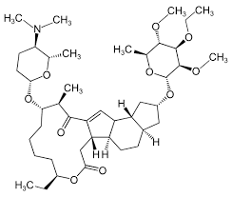
26. | Spinosyn A  ((2R,3aS,5aR,5bS,9S,13S,14R,16aS,16bR)-13-{[(2R,5S,6R)-5-(dimethylamino)tetrahydro-6-methyl-2H-pyran-2-yl]oxy}-9-ethyl-14-methyl-2,3,3a,5a,5b,6,9,10,11,12,13,14,16a,16b-tetradecahydro-1H-as-indaceno[3,2-d]oxacyclododecin-7-one.) | 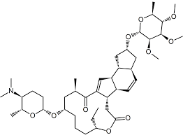
27. | Spinosyan D  ((2R,3aS,5aR,5bS,9S,13S,14R,16aS,16bR)-13-[(2R,5S,6R)-5-(dimethylamino)tetrahydro-6-methyl-2H-pyran-2-yl]-9-ethyl-14,16-dihydroxy-3a,5b,9-trimethyl-7-oxo-7,9-methano-1H,5H,11H,13H-benzo[α]pyrano[4',3':6,7]indolizino[1,2-b]quinoline-2,5-dipropanoic acid) | 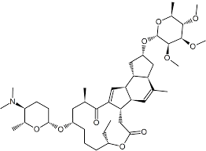
28. | Spiromesifen  (3-mesityl-2-oxo-1-oxaspiro[4.4]non-3-en-4-yl 3,3-dimethylbutyrate) | 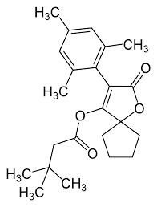
29. | Spirotetramat  (cis-4-(ethoxycarbonyloxy)-8-methoxy-3-(2,5-xylyl)-1-azaspiro[4.5]dec-3-en-2-one) | 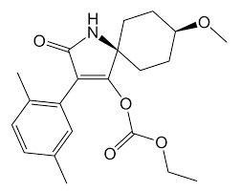
30. | Tebuconazole  (1-(4-chlorophenyl)-4,4-dimethyl-3-(1,2,4-triazol-1-ylmethyl)pentan-3-ol) | 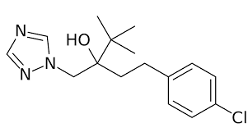
31. | Thiamethoxam  ((NZ)-N-[3-[(2-chloro-1,3-thiazol-5-yl)methyl]-5-methyl-1,3,5-oxadiazinan-4-ylidene]nitramide) | 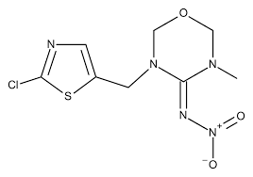
32. | Trifloxystrobin  (methyl (E)-methoxyimino-{(E)-α-[1-(α,α,α-trifluoro-m-tolyl)ethylideneaminooxy]-o-tolyl}acetate) | 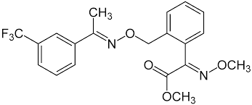
33. | Fipronil  (5-amino-1-(2,6-dichloro-4-(trifluoromethyl)phenyl)-4-((trifluoromethyl)sulfinyl)-1H-pyrazole-3-carbonitrile) | 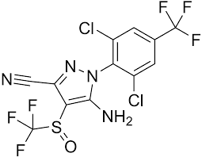
34. | Fipronil-sulfone  (5-Amino-1-[2,6-dichloro-4-(trifluoromethyl)phenyl]-4-[(trifluoromethyl)sulfinyl]-1H-pyrazole-3-carbonitrile) | 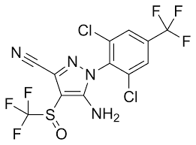
35. | Flubendiamide  (N¹-[4-(1,1,1,2,3,3,3-Heptafluoropropan-2-yl)-2-methylphenyl]-3-iodo-N²-[1-(methanesulfonyl)-2-methylpropan-2-yl]benzene-1,2-dicarboxamide) | 