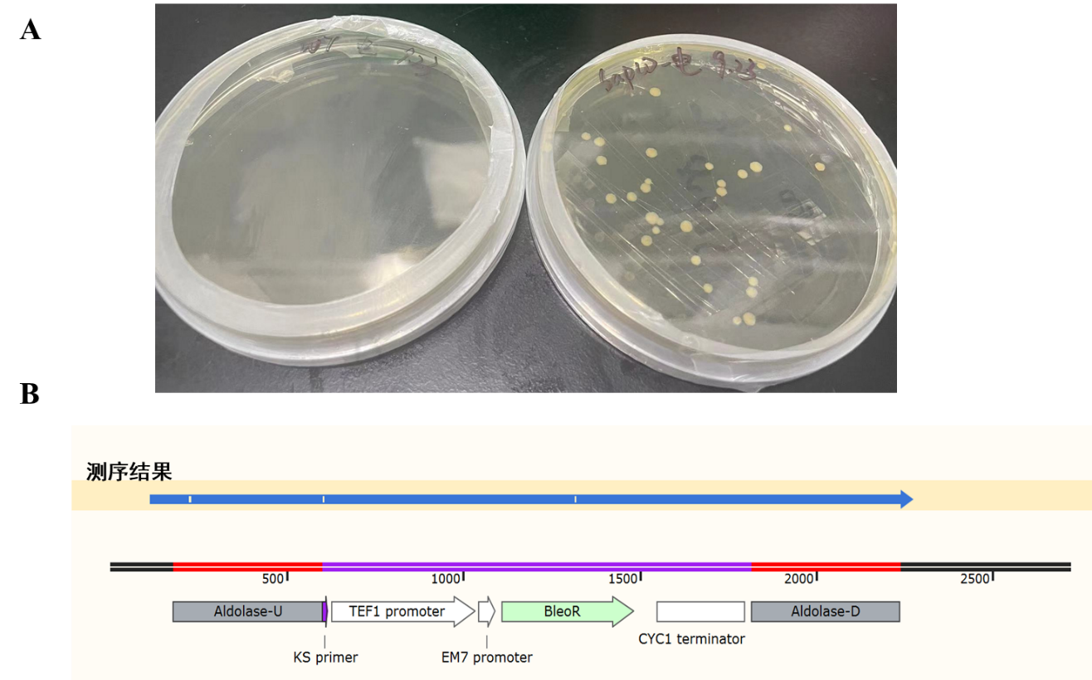
（b）
（a）

Fig. S1 Screening ALDOA knockout positive strains (a) and sequence alignment (b)

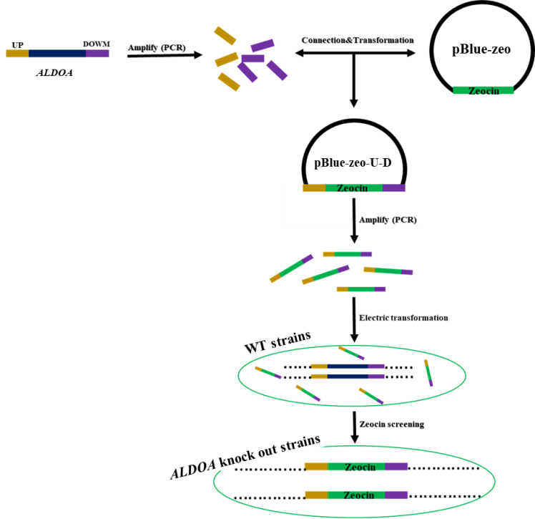
DOWN
Fig. S2 Schematic diagram of ALDOA knockout strain construction

Table S1 Primers for construction and validation
引物 | Sequence（5’→3’）
ALDOA-U-F | AGGGGGCCCGTGCTCCGCTGCGGTA
ALDOA-U-R | CCGCTCGAGTTTGCTGCAAGTTCAATCCAA
ALDOA-D-F | CGCGGATCCTATGTCCAAAAGATCTCT
ALDOA-D-R | TGCTCTAGATTGCAGTCTCTTCAG
ALDOA-F | GCGCACTCTTTCTTTATCTTTCT
ALDOA-R | ATGCTTCGCACCACAGG
BLM-F | AATACGACAAGGTGAGGAACTAAAC
BLM-R | GCCGTCGGACGTGTCAGT
PAP-RT-F | CAAATCCAGCAACAACCAAAACAAC
PAP-RT-R | GCAGTAGGGTCCTCAGAATAATGAA
PDAT-RT-F | CAAGCGAATAGGTGCCTCCA
PDAT-RT-R | CCAGCTTCGTCTCCGCATAA
PDCT-RT-F | TACGCAACGAGGAGGAATGG
PDCT-RT-R | ACGCAGACGTATCCACCAAG
FAS-RT-F | TGAGGCGTTTGCCAACTACA
FAS-RT-R | GCTCCTTGACAATGACCATG
DGAT- RT-F | AGGAATCGGTAGTCCGAAGCGGC
DGAT-RT-R | AGAAAGGGTTTGGCAAAGCTCGC
LPCAT- RT-F | GAGGTGCATATACCGACGCA
LPCAT-RT-R | GCGGAAGAGTTCCCATGACA
G6PDH- RT-F | ATGAAGGCAGGAAAGGC
G6PDH-RT-R | CGTAGCGGTCGTGGTAG
CLF-RT-F | TCCGTTCTGCCTAAGGAA
CLF-RT-R | GAGAGCCGTCTTGATGAG
ACC-RT-F | CTCCTTGTTGATGCAGGATCCTT
ACC-RT-R | GTGTCGCGTACCATCATGGTGAA

