Impairment of Theta Oscillation in Hippocampus CA1 mediates age-dependent movements’ alternations in 5xFAD Mouse Model of Alzheimer's Disease
Hong Ni^{1,4#}, Zhongzhao Guo^{1,5,6#}, Jie Wang^{3#}, Zilu Zhu¹, Guohui Zhang^{4*}, Deheng Wang^{1,2*}

1. School of Integrative Medicine, Shanghai University of Traditional Chinese Medicine, 201203, Shanghai, China.

2. Engineering Research Center of Traditional Chinese Medicine Intelligent Rehabilitation, Shanghai University of Traditional Chinese Medicine, 201203, Shanghai, China

3. Department of Endocrinology, Shanghai Municipal Hospital of Traditional Chinese Medicine, Shanghai University of Traditional Chinese Medicine, 200071, Shanghai, China.

4. Rehabilitation department, Yueyang Hospital of Integrated Traditional Chinese and Western Medicine, 200437, Shanghai, China.

5. Department of Rehabilitation Medicine, Tong Ren Hospital, Shanghai Jiao Tong University School of Medicine, Shanghai 200336, China;

6. Institute of Rehabilitation, Shanghai Jiao Tong University School of Medicine, 200025, Shanghai, China;

#These authors contributed equally to this work.

*To whom correspondence should be addressed.
E-mail: Dr. Wang: wangdeheng@shutcm.edu.cn;

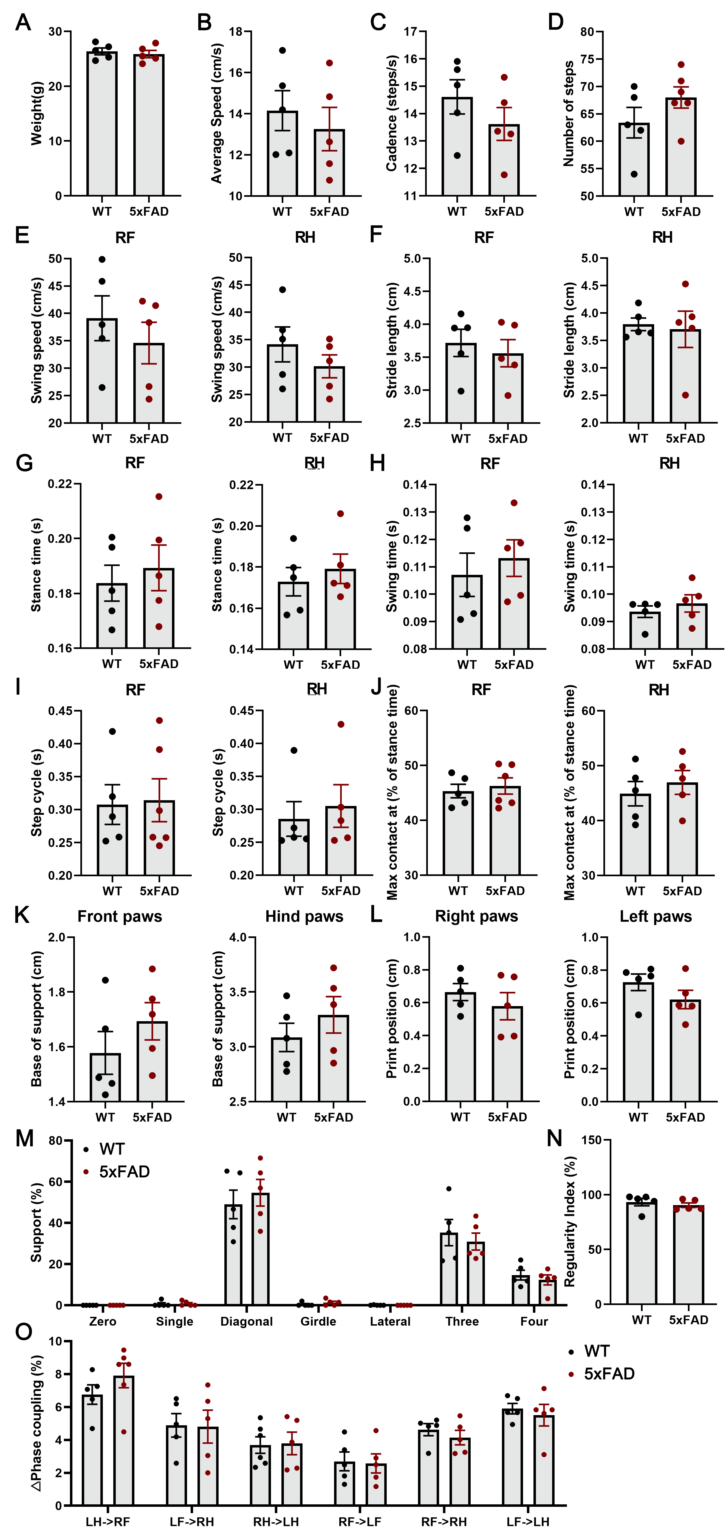
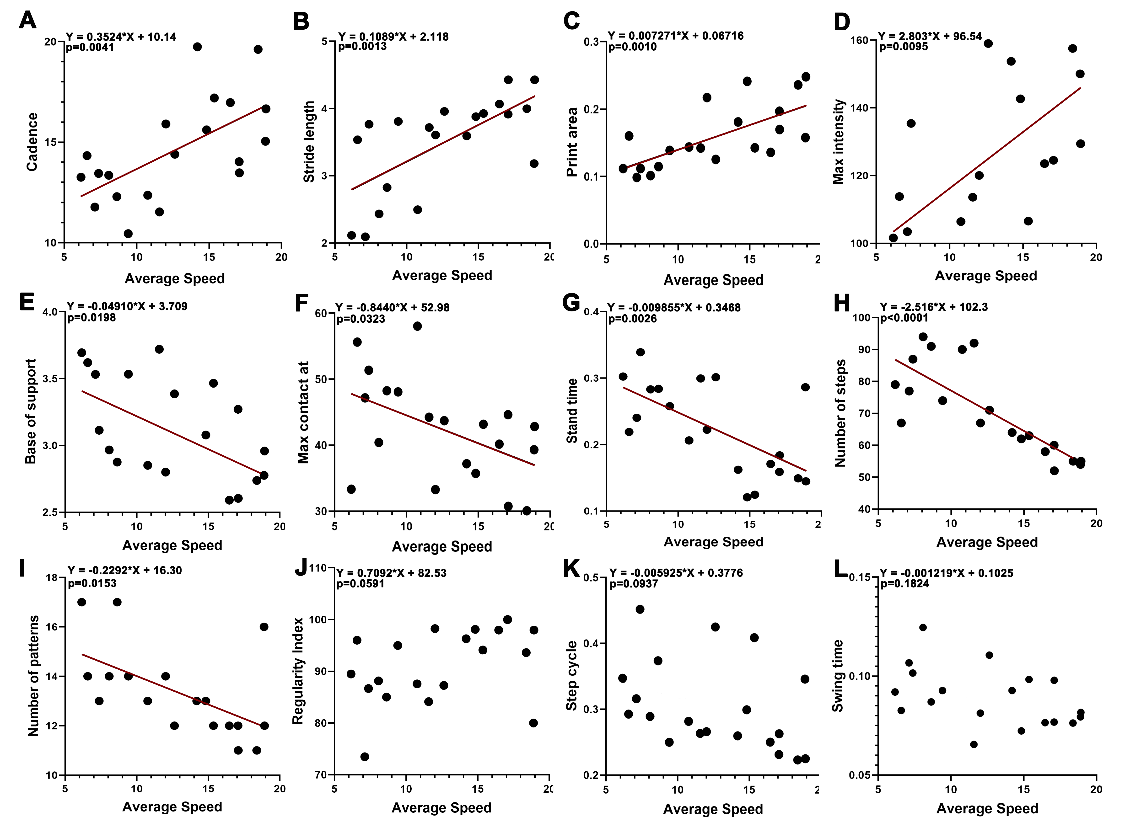Figure S1. The speed-related gait parameters of 9-month-old WT and 5xFAD mice at same speed. (A) Weight. (B) Average speed. (C) Cadence. (D) Number of steps. (E) Swing speed of right forelimb and hindlimb. (F) Stride length of right forelimb and hindlimb. (G) Stance time of right forelimb and hindlimb. (H) Swing time of right forelimb and hindlimb. (I) Step cycle time of right forelimb and hindlimb. (J) Maximum contact at (% of stance time). (K) Base of support of front and hind paws. (L) Print position of right and left paws. (M) Support ways. (N) Regularity index. (O) Δ Phase coupling. n = 5 per group; No statistical difference was found (Unpaired t test).
Figure S2. Correlation between average speed and gait parameters of 9-month-old 5xFAD mice. (A-D) The gait parameters (cadence, stride length, print area and max intensity) which are positively correlated with speed. (E-I) The gait parameters (base of support, max contact at, stand time, and number of steps) which are negative correlated with speed. (J-L) The gait parameters (regularity index, step cycle and swing time) which are not correlated with speed. The average of four paws values was calculated for each parameters and used to plot against corresponding average speed, and it was considered correlated if p < 0.05 with linear regression F-test. Significant linear correlations are marked with a red best fit line; n = 20.
Figure S3. The change of speed cells proportion in hippocampus CA1. (A) Spike Sorting for different neurons. (B) An example of speed correlated cell in WT mouse. (C) Same as (B) but the mouse is 5xFAD.
(D) The speed correlations for all cells in hippocampus CA1 of WT mouse in one session of OFT and cell was considered correlated if p<0.05 (linear regression F-test). Significant linear correlations are marked with a red best fit line. (E) Same as (D) but the mouse is 5xFAD. (F, H) Mean r² values for all cells, speed cells, and non-speed cells in hippocampus CA1 of WT and 5xFAD mice. (G, I) Diagram showing the proportions of speed cells and non-speed cells in hippocampus CA1 of WT and 5xFAD mice. (A speed cell was defined by the correlation between firing rates and running speed [p < 0.05; linear regression F-test]. Significant linear correlations are marked with a red best fit line. The bars indicate the means ± SEM; n = 5 per group; *p < 0.05 (Unpaired t test).

