Supplementary Information

Reducing exposure to COVID-19 by improving access to fever clinics: An empirical research of the Shenzhen area of China

Data source: Publicly available at the Shenzhen Municipal Health Commission(http://wjw.sz.gov.cn/)

Supplementary Fig.S1. Daily changes in confirmed cases of "COVID-9" in Shenzhen as of February 29,2020

Supplementary Fig.S2. The number of ECs, confirmed cases and available beds in Shenzhen as of February 7, 2020.
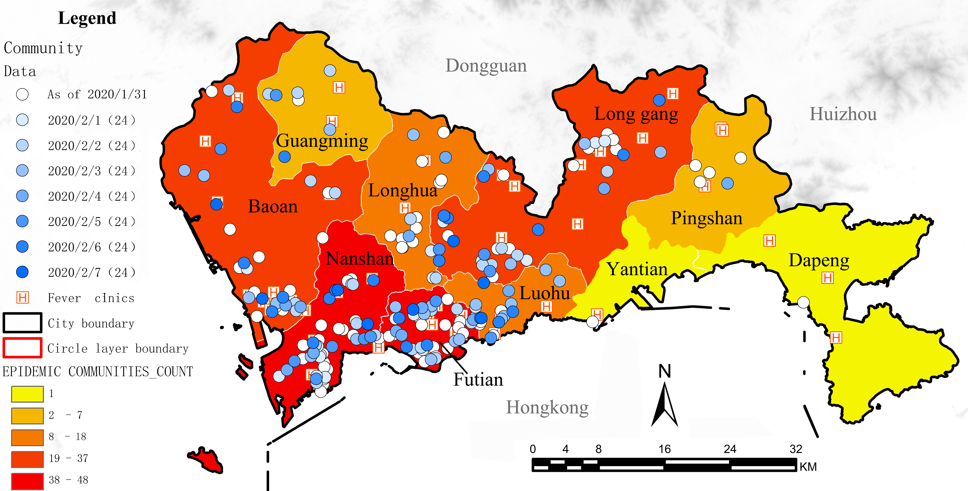
Supplementary Fig.S3. The spatial distribution of ECs and FCs as of February 7, 2020.

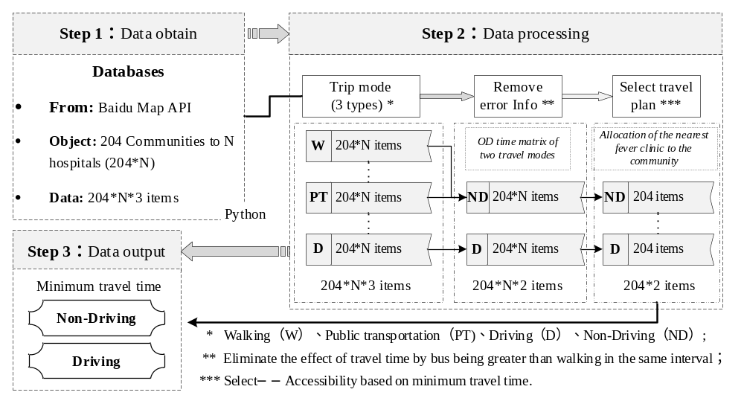
Supplementary Fig.S4. Baidu navigation data acquisition and process flow chart

