Supplemental Methods

Definition of Acute Decompensated Heart Failure
If patients received intravenous diuretics (furosemide or bumetanide) they were marked as having hypervolemia as a surrogate for ADHF diagnosis. If this criterion was met, and patients had a NT pro-brain natriuretic peptide measured within 24 hours with a value ≥ 125 pg/mL(1) or did not have a NT pro-brain natriuretic peptide resulted within 24 hours, the patient was assumed to have ADHF and was monitored by the model. The patients needed to be administered a second dose of intravenous diuretics within the subsequent 48 hours for continued monitoring, and if no second dose was administered, it was assumed the patient does not have ADHF and stopped monitoring.

Variables
We consider two types of patient data: static data, which we assume does not change over time, and dynamic data, which does. No static variables were missing for any patients. However, some dynamic variables were never measured for some patients.
Static variables included age, sex, body mass index (weight/height in kg/m²), and documented history of hypertension, chronic renal disease, diabetes mellitus, coronary artery disease, atrial fibrillation, chronic obstructive pulmonary disease, and cardiomyopathy at admission.
The dynamic variables included three categories: vital signs recorded by the nursing staff, laboratory tests and prescribed medications. Consistent with clinical practice, these variables are recorded at different frequencies in individual patients depending on clinical need. The dynamic variables could be used to evaluate trends, for example a rising respiratory rate over time.
Systolic and diastolic blood pressure and calculated mean arterial pressure, heart rate, respiratory rate, oxygen saturation, respiratory support (nasal cannula oxygen, face mask or non-rebreather mask oxygen, high-flow nasal cannula, non-invasive positive pressure ventilation, mechanical ventilation), temperature, urine output and daily weights were documented in the EHR by nursing staff as per hospital policy. Laboratory data included were hemoglobin (g/dL), white blood cell count (K/cu mm), platelets (K/cu mm), renal function (blood urea nitrogen – mg/dL, creatinine – mg/dL), hepatic function panel (aspartate transaminase – U/L, alanine transaminase – U/L, albumin – g/dL, total bilirubin – mg/dL), sodium (mmol/L), potassium (mmol/L), glucose (mg/dL), bicarbonate (mmol/L), lactate (mmol/L), troponin (ng/mL), pro-NT brain natriuretic peptide (pg/mL), thyroid stimulating hormone (IU/mL), arterial and venous pH, paO₂ (mmHg), paCO₂ (mmHg). Medication administration was recorded for each of the following, with only drugs on institutional formulary included in the algorithm: hydralazine, nitrates (isosorbide mononitrate, isosorbide dinitrate), thiazide diuretics (metolazone, hydrochlorothiazide, chlorothiazide), beta-blockers (metoprolol, propranolol, atenolol, carvedilol, bisoprolol, nadolol, labetalol), angiotensin converting enzyme inhibitors/angiotensin receptor blockers (lisinopril, captopril, enalapril, losartan, valsartan), calcium channel blockers (nifedipine, amlodipine, nicardipine, diltiazem, verapamil), amiodarone, vasopressor/inotropic drugs (norepinephrine, epinephrine, dobutamine, dopamine, milrinone, phenylephrine, vasopressin). Medication dosages were not included. Trends over the previous 3 days were used for laboratory data, vital signs data, and urine output. We also examined the interaction terms of sodium and BUN, systolic blood pressure and BUN, urine output and BUN, hemoglobin and serum creatinine without finding any improvement in prediction.
To reduce erroneous results recorded by nursing staff certain cut-offs were utilized for particular features. Extreme limits were used to avoid removal of any true values. Systolic blood pressure had to be < 400 mmHg, and > 20 mmHg, diastolic blood pressure had to be > 0 mmHg, mean arterial blood pressure > 0 mmHg, heart rate had to be > 10 and < 300 beats per minute, respiratory rate had to be > 0 and < 100 breaths per minute, oxygen saturation > 20%, temperature > 80◦F, urine output ≤ 1000ml/hr, and weight > 60 pounds.
Discharge diagnosis ICD-10 codes was used to double-check that diagnosis of ADHF and CS were not missed by our model. Discharge disposition was used to identify patients that were discharged to hospice with end-stage cardiomyopathy only. Both discharge diagnosis and disposition were not used for CS risk prediction.

Model Development
To overcome significant class imbalance, patients with ADHF who did not develop any form of shock were randomly downsampled when data was extracted from 23,458 to 9,000. This brought the total number of cases in the dataset to 10,003 (9000 Heart failure no shock, 265 cardiogenic shock and 738 other shock). The dataset was randomly partitioned into training and testing sets, with 75% of the data being used for training and 25% used for evaluation after the completion of model development. The partitioning was performed stratified on the outcome. During the final evaluation the classes were reweighted in order for the positive prevalence in the testing dataset to be reflective of that in the original population. In particular, (23,458 – 9,000) * 0.25 = 3614 heart failure, no shock or other shock cases were added back since neither were downsampled originally. This made the positive prevalence in the testing dataset to be equal to in the original total population for the purposes of reporting performance in this work.
For each model we evaluated, hyperparameter tuning was performed by means of a five-fold cross-validation. Cross-validation refers to the random partitioning of the training dataset during model development and is a commonly used best practice for reporting model performance and developing models particularly when there are a moderate number of cases. Each round of crossvalidation partitions the data into complementary subsets, and then separately performing analysis on each partition. Subsequently the results are averaged.

Model Evaluation
Each true positive case was reviewed from time of alert by the model to time of diagnosis of CS by the clinical team based on EHR documentation and was categorized into one of three groups:
- Patients that may have received treatment that was potentially harmful or contributed to deterioration (Group A), including:
  - Uptitration of negative inotropes such as beta-blockers or non-dihydropyridine calcium channel blockers for sinus tachycardia, intravenous fluid bolus, and target net positive fluid balance by clinical team.
- Patients for whom either more tailored non-invasive or invasive therapies may be available (Group B), such as:
  - Cessation of negative inotropic agents, continuation of diuresis despite creatinine rise, uptitration of diuretic doses if poor diuretic response, or invasive therapy which included pulmonary artery catheter insertion to evaluate cardiac performance and filling pressures, and/or transfer to a higher level of care for closer monitoring and possible earlier initiation of inotropic therapy.
- Patients who are already known by the team to be critically ill and at high-risk of CS, based on clinician documentation, where an alert does not provide any new information (Group C).

Supplemental Figure 1. After patient admission the model follows the patient to see if they received IV diuretics +/- got pro-NT BNP testing within 24 hours. Once criteria are met then the patient enters the monitoring as acute decompensated heart failure until patient develops cardiogenic shock (outcome of interest), develops other type of shock, goes to surgery or is discharged. If the patient does not develop one of these outcomes within 48 hours of the first dose of diuretic then a second dose of intravenous diuretic is required to remain in the monitoring zone, if this second dose is not received then monitoring is stopped and the model follows the patient to see if diuretic is started again later in the hospitalization. If a patient never receives diuretics or receives diuretics after one of the four outcomes, then they are never in the monitoring zone. IV = intravenous; Pro-NT BNP = pro-NT brain natriuretic peptide.

Supplemental Figure 2. Precision-recall curve. AUC = area under the curve;
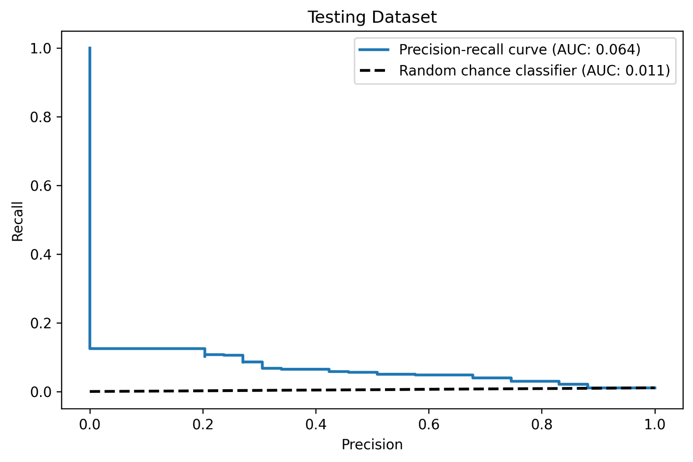
Example case of Group A
Case 1:
History: 68-year-old with coronary artery disease post coronary artery bypass surgery, hypertension, chronic renal disease who was admitted with poorly controlled hyperglycemia and dyspnea concerning for acute decompensated heart failure to medicine service.
On day 2 after admission, blood urea nitrogen and creatinine was rising and diuretics were stopped and patient was given intravenous fluid bolus and on day 4 required emergent transfer to higher level of care, and initiation of inotropes, higher respiratory support and higher dose diuretics.
Model alert: On day 2
Possible therapeutic changes from the time of alert to time of cardiogenic shock diagnosis: continued diuresis with increase in diuretic regimen, avoid intravenous fluid administration, stop carvedilol 12.5mg twice daily, cardiology consult. If failure to improve consider early inotropic support.
Outcome: Discharged after 11 days in the hospital
See Supplemental Figure 3

Supplemental Figure 3
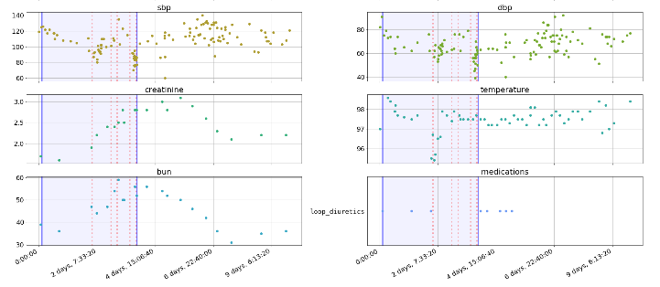

Feature characteristics of case example 1. First solid purple vertical line indicates time patient entered model as acute decompensated heart failure, and second purple line indicates time of cardiogenic shock diagnosis. Dashed line indicates points where model crossed high-risk threshold. At the time of trigger, intravenous diuretics had been stopped and are not restarted until the diagnosis of cardiogenic shock is made.

Supplemental Figure 4. Comparison of location of alert by prediction model and location of eventual cardiogenic shock diagnosis. CCU = coronary care unit;

Supplemental Table 1. Performance of different machine learning classification algorithms.
Model | AUC
Logistic regression | 0.82
Random forest | 0.74
Decision tree | 0.74
Support Vector Machine | 0.78
Linear Discriminant Analysis | 0.76
K-nearest neighbor | 0.81
AUC = receiver operatic characteristic curve area under the curve

Supplemental Table 2. Variables in predictive model.
Variables | Coefficient | P-value
Systolic blood pressure | -0.0569 (-0.070 to -0.044) | < 0.001*
Heart rate | 0.0184 (0.008 to 0.028) | < 0.001*
Temperature | -0.4071 (-0.588 to -0.233) | < 0.001*
Blood urea nitrogen | 0.0315 (0.023 to 0.040) | < 0.001*
Sodium | -0.0775 (-0.112 to -0.043) | < 0.001*
SpO₂ | 0.0781 (0.021 to 0.135) | < 0.001*
Hydralazine | 0.8260 (0.367 to 1.285) | < 0.001*
Respiratory rate trend | 0.3405 (0.104 to 0.577) | 0.005*
Venous pH | 3.6526 (1.040 to 6.266) | 0.006*
Hemoglobin | 0.1075 (0.027 to 0.188) | 0.009*
White blood cell | -0.0511 (-0.096 to -0.006) | 0.025*
Age | -0.0149 (-0.028 to -0.002) | 0.028*
SBP Trend | 0.0309 (0.000 to 0.062) | 0.049*
Platelets | 0.0016 (-0.000 to 0.003) | 0.070
Arterial pH trend | -15.5393 (-34.164 to 3.085) | 0.102
BNP trend | < 0.001 (-0.000 to < 0.001) | 0.113
Arterial pH | 2.1205 (-0.507 to 4.748) | 0.114
ALT | 0.0010 (-0.000 to 0.002) | 0.149
Albumin | 0.2249 (-0.099 to 0.548) | 0.173
Glucose | 0.0017 (-0.001 to 0.004) | 0.198
Gender | 0.2209 (-0.134 to 0.576) | 0.222
PaCO₂ trend | -0.0863 (-0.227 to 0.054) | 0.229
AST | -0.0013 (-0.003 to 0.001) | 0.251
Troponins | -0.0356 (-0.097 to 0.026) | 0.254
Respiratory rate | 0.0196 (0.014 to 0.053) | 0.256
Isosorbide nitrates | 0.2842 (-0.238 to 0.806) | 0.286
BUN trend | 0.1947 (-0.163 to 0.553) | 0.286
Bicarbonate | 0.0187 (-0.016 to 0.054) | 0.295
Potassium | -0.1543 (-0.453 to 0.145) | 0.312
Oxygen therapy | 0.8532 (-0.811 to 2.517) | 0.315
Weights trend | -0.0046 (-0.014 to 0.004) | 0.321
ACEI/ARB | -0.2063 (-0.628 to 0.215) | 0.337
DBP Trend | -0.0204 (-0.062 to 0.022) | 0.341
Creatinine trend | 2.2858 (-2.584 to 7.156) | 0.358
Urine output trend | 0.0008 (-0.001 to 0.003) | 0.441
Lactate trend | 0.5941 (-1.002 to 2.190) | 0.466
Diastolic blood pressure | 0.0067 (-0.012 to 0.025) | 0.474
Admissions in past 1-year | 0.0376 -0.076 to 0.151) | 0.518
Urine output | -0.0005 (-0.002 to 0.001) | 0.523
ALT trend | 0.0154 (-0.037 to 0.067) | 0.561
Lactate | 0.0598 (-0.162 to 0.281) | 0.597
Comorbidities | 0.0283 (-0.079 to 0.135) | 0.605
Heart rate trend | -0.0091 (-0.044 to 0.026) | 0.606
Temperature trend | -0.3397 (-1.967 to 1.288) | 0.682
Bicarbonate trend | -0.1345 (-0.809 to 0.539) | 0.696
Platelet trend | -0.0181 (-0.114 to 0.078) | 0.711
Creatinine | -0.0303 (-0.195 to 0.135) | 0.719
Albumin trend | -0.7759 (-5.811 to 4.259) | 0.763
Total bilirubin | -0.0110 (-0.085 to 0.063) | 0.770
Troponins trend | -0.0964 (-0.905 to 0.712) | 0.815
PaCO₂ | -0.0032 (-0.031 to 0.025) | 0.823
Thyroid stimulating hormone | 0.0008 (-0.010 to 0.012) | 0.886
Sodium trend | 0.0224 (-0.331 to 0.376) | 0.901
White blood cell trend | -0.0335 (-1.239 1.172) | 0.957
SpO₂ trend | 0.0006 (-0.027 to 0.028) | 0.969
Venous pH trend | -0.4485 (-29.451 to 28.554) | 0.976
Abbreviations: SBP = systolic blood pressure; DBP = diastolic blood pressure; BNP = B-type natriuretic peptide; BUN = blood urea nitrogen; AST = aspartate transaminase; ALT = alanine transaminase; ACEI/ARB = angiotensin converting enzyme inhibitor/angiotensin receptor bloc

References

1. McMurray JJ, Adamopoulos S, Anker SD et al. ESC Guidelines for the diagnosis and treatment of acute and chronic heart failure 2012: The Task Force for the Diagnosis and Treatment of Acute and Chronic Heart Failure 2012 of the European Society of Cardiology. Developed in collaboration with the Heart Failure Association (HFA) of the ESC. Eur Heart J 2012;33:1787-847.

