Supporting Information
Pore Space Partition in Rigid Metal-Organic Frameworks Containing Organic Vertices for Trace Benzene Adsorption
Yingying Zhang,¹ Chaozhuang Xue,² Zhi Fang,³ Yexin Huang,¹ Hui Li,¹ Yuqing Qi,¹ Kai Zhu,¹ Fang Peng,¹ Lei Gan,¹ Hongliang Huang,³* and Huajun Yang¹*
¹ Jiangsu Key Laboratory of Biomedical Materials, School of Chemistry and Materials Science, Nanjing Normal University, Nanjing 210023, China.
² School of Chemistry and Chemical Engineering, Liaocheng University, Liaocheng 252059, China.
³ State Key Laboratory of Separation Membranes and Membrane Processes, School of Chemical Engineering and Technology, Tiangong University, Tianjin 300387, China.
Contents
Section 1. Materials in NNMs synthesis S3
Section 2. Measurements S3
Section 3. PSP strategy on rigid acs S6
Section 4. Structural analysis S7
Section 5. Pore size and BET analysis S19
Section 6. Additional benzene adsorption and PXRD data S28
Section 7. Additional IGM analysis S31
Section 8. Tables S32
Section 9 Topology analysis S45
Section 10. Reference S47

Section 1. Materials in NNMs synthesis
FeCl₃·6H₂O (99%), Cr(NO₃)·9H₂O (99%), 4,4',4'',4''',4'''',4'''''-(9,10-Dihydro-9,10-[1,2]benzenoan-thracene-2,3,6,7,14,15-hexayl)hexabenzoic acid (L1, 98%), 4',4''',4''''',4''''''',4''''''''', 4'''''''''''-(9,10-Dihydro-9,10-[1,2]benzenoanthracene-2,3,6,7,14,15-hexayl)hexakis([1,1'-biphenyl]-4-carboxylic acid) (L2, 98%), 5′,5′′′-Bis(4-carboxyphenyl)-5′′-(4,4′′-dicarboxy[1,1′:3′,1′′-terphenyl]-5′-yl)-2′′,4′′,6′′-trimethyl[1,1′:3′,1′′:3′′,1′′′:3′′′,1′′′′-quinquephenyl]-4,4′′′′-dicarboxylic acid (L3, >95%), 2,5,8-tri-(4-pyridyl)-1,3,4,6,7,9-hexaazaphenalene (P1), 4,4'-(5'-(4-(Pyridin-4-yl)phenyl)-[1,1':3',1''-terphenyl]-4,4''-diyl)dipyridine (P2, 98%), 2,4,6-Tris(4-(pyridin-4-yl)phenyl)-1,3,5-triazine (P3, >95%), N,N-dimethylformamide (DMF, >99.8%), pyridine (Py, >99.5%), Trifluoroacetic acid (TFA, 99%), hydrofluoric acid (HF, 40%), anhydrous dichloromethane (>99.9%), deionized water (DI H₂O). All reagents, except ligand P1 and DI H₂O, were obtained from commercial sources and used without further purification. The ligand P1 was synthesized according to the previous report.

Section 2. Measurements
Structure characterizations: Single-crystal X-ray diffraction (SCXRD) data of NNMs was collected at low temperature using a Bruker D8 VENTURE CCD diffractometer operating at 50 kV and 30 mA using Cu-Kα radiation (λ= 1.5406 Å). Data were integrated using SAINT and scaled with multi-scan absorption correction using SADABS. The structure was solved by direct methods and refined by full-matrix least squares on F² using the APEX3 programs. Powder X-ray Diffraction (PXRD) measurements on as-synthesized NNM sample by using a Rigaku SmartLab X-ray powder diffractometer with Cu-Kα radiation. The data collection for NNMs-Fe was performed at room temperature in the range from 3º to 40º with a step size of ~0.01º, speed duration time of 10, IS of 1/2 deg, RS1 of 20 mm, while high-resolution diffraction data of NNMs (Cr) was performed in the range from 4º to 110º with speed duration time of 1, IS of 1/4 deg, RS1 of 5 mm. The simulated structures of NNMs-Cr were obtained through Rietveld refinement using high-resolution X-ray diffraction data on TOPAS 64 V6. The simulated powder patterns of NNMs-Fe were obtained from the single crystal data. Thermogravimetric (TGA) analysis was carried out on a Netzch STA449F3 analyzer heated from ambient temperature to 800 ºC under a nitrogen gas atmosphere with a heating rate of 25 ºC/min. Fourier transform infrared spectroscopy (FTIR) was recorded on a Brucker Tensor 27 in the range of 4000-400 cm⁻¹ using the KBr pellets.
Rietveld refinement details: The crystal structure of Cr based NNMs were verified and refined through Reitveld method using Fullprof Suit software. The background of the XRDs pattern were simulated using the linear interpolation between a set background points with refinable heights. The peak profile was modeled by “pseudo-voigt function” in the Fullprof Suit software. No restraints or constraints were adopted when performing structure refinement. The zero-error was considered because the structures X-ray diffractometer has not been corrected using standard sample regularly. In addition, the anisotropic atomic displacement parameters were used in the refinement process.
Scanning electron microscope (SEM) measurement: SEM measurements for Cr samples were carried out by using a FEI NNS450 field emission scanning electron microscope equipped with 50 mm² X-Max50 SDD energy dispersive spectroscopy (EDS) detector. Data acquisition was performed with an accelerating voltage of 15 kV and 20 s accumulation time.
Gas Sorption Measurement: N₂ sorption measurements were carried out on Automatic High Performance Surface Area and Aperture Analyzer (BSD-660 A3M). Prior to the measurement, the as-synthesized sample was purified with DMF and then soaked in DMF for 24 h. Then the samples were washed with dichloromethane for 3 times and soaked in dichloromethane for three days. During each day, the solution was refreshed. After solvent exchange, the upper solvent was decanted. The sample was first dried under N₂ flow gently and was subsequently transferred into the test tube. The degas program was set as heating to 100 ºC, then keeping 100 ºC for 6 h in situ degassing.
Benzene-vapor sorption measurements: Benzene vapor sorption isotherms were measured by a volumetric method using a MICRATRAC BELSORP MAX Ⅱ gas sorption analyzer. The degas process was performed under 100 ℃ for around 10 hours and all analyses were performed using a water bath held at constant temperature with a recirculating chiller. The benzene vapor sorption cycling experiments were used the same method. After the first benzene adsorption test, the sample was reactivated at 100 ℃ for around 10 hours and the mass of sample was measured to ensure complete removal of guest benzene. The relative pressure (P/P₀) are from 0 to 0.95.
DFT Calculation method
The spin-polarized density functional theory (DFT) calculations^{1,2} were carried out in the CP2K code.³ All calculations employed a mixed Gaussian and planewave basis sets. Core electrons were represented with norm-conserving Goedecker-Teter-Hutter pseudopotentials,⁴⁻⁶ and the valence electron wavefunction was expanded in a double-zeta basis set with polarization functions⁷ along with an auxiliary plane wave basis set with an energy cutoff of 450 eV. The generalized gradient approximation exchange-correlation functional of Perdew, Burke, and Enzerhof (PBE)⁸ was used. Periodic structure of MOF was used in the DFT calculation and each configuration was optimized with the Broyden-Fletcher-Goldfarb-Shanno (BGFS) algorithm with SCF convergence criteria of 1.0×10⁻⁶ au. The van der Waals correction of Grimme’s DFT-D3 model was also adopted.⁹
The adsorption energy between the benzene molecule and the MOFs was calculated using the following equation:
ΔE= $E_{benzene@MOF}$ - $E_{MOF}$ - $E_{benzene}$ (S1)
In Eq. (S1), $E_{benzene@MOF}$ and $E_{MOF}$ represent the total energies of the MOF with and without the adsorption of benzene molecule, respectively. $E_{benzene}$ is the total energy of the benzene molecule. According to this equation, a negative adsorption energy corresponds to a stable adsorption structure.
Independent gradient model (IGM) analyses were adopted to visually understand the noncovalent interactions for the host-guest interaction.¹⁰ In this work, IGM analyses were based on the DFT calculated benzene adsorption configurations in MOFs, in which the MOF framework fragment and benzene molecule was intercepted for clearly showing various interactions. The IGM analyses were achieved by Multiwfn software package 3.8,¹¹ while the VMD 1.9.3 program¹² was used to render the IGM visualized isosurfaces of weak interaction for the host-guest interaction.

Section 3. PSP strategy on rigid acs

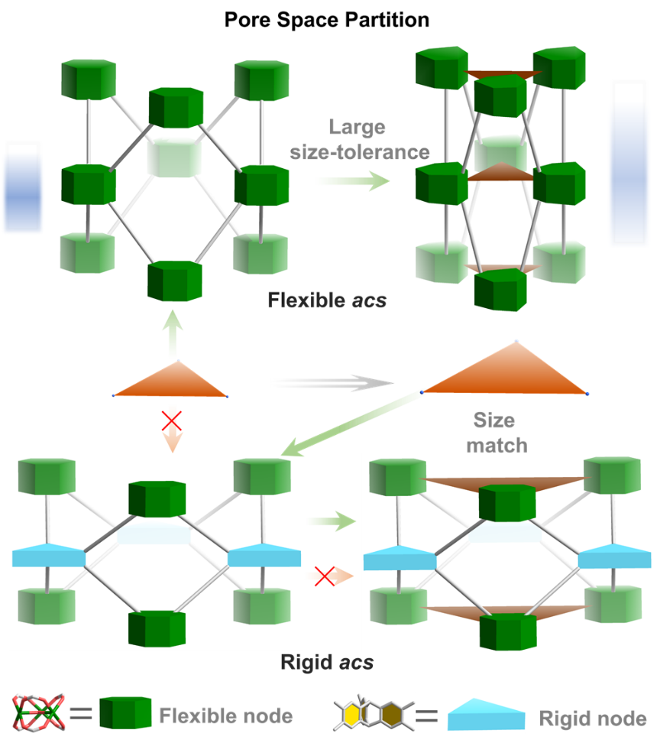
Fig. S1 Illustration for the difference between flexible acs network and rigid acs network in pore space partitioning.

Fig. S2 The size relationship between trigonal primatic ligand (d_{L}) and partitioning ligand (d_{P}) in NNM structures.

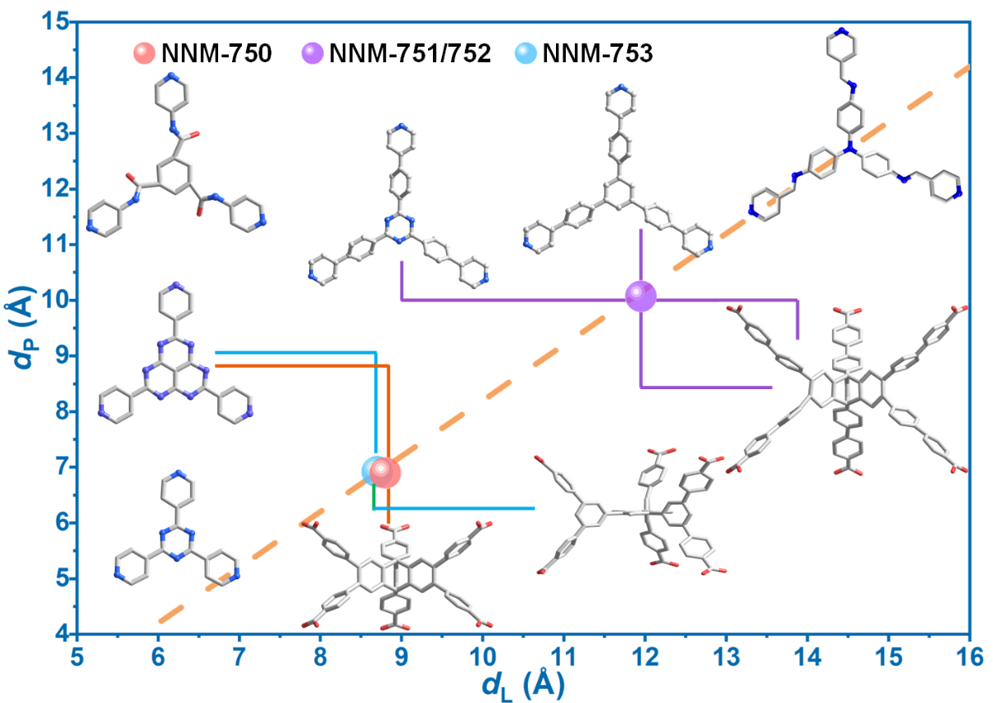
Fig. S3 Linear size relation of L and P ligands. (Inset shows the ligands we tried in this work)

Section 4. Structural analysis
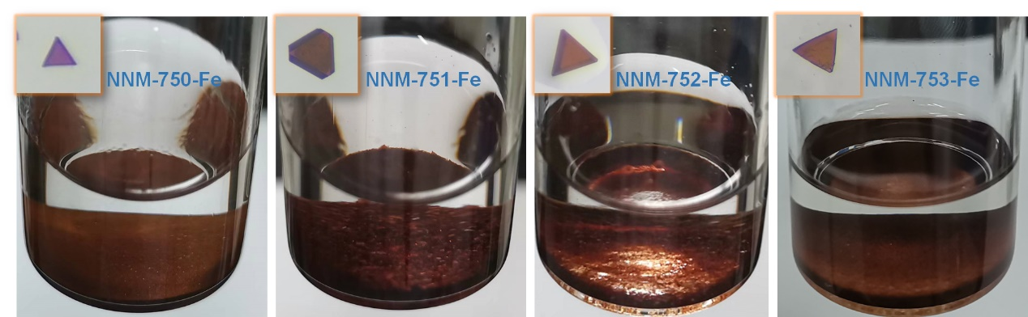
Fig. S4 Optical pictures for Fe-based NNMs.

Fig. S5 Experimental and Simulated PXRD patterns for NNM-750-Fe (a), NNM-751-Fe (b), NNM-752-Fe (c), NNM-753-Fe (d).

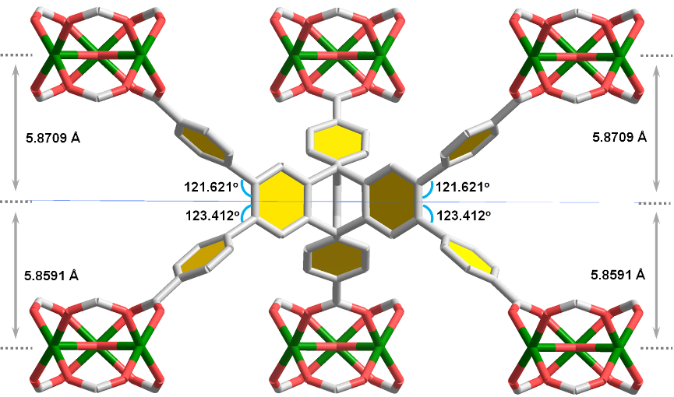
Fig. S6 Asymmetric extension of 6-c ligand in NNM-750-Fe.

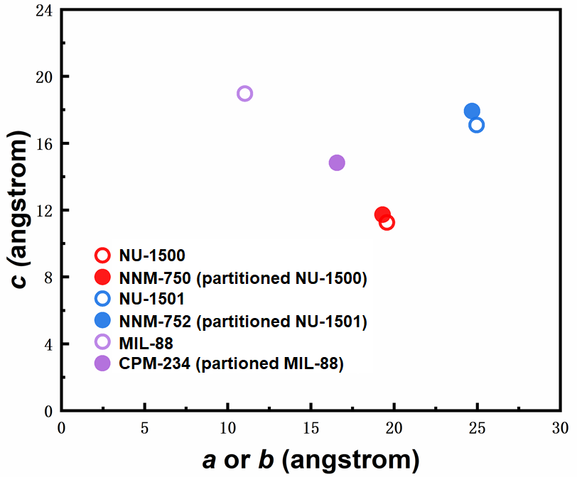
Fig. S7 Comparison of unit cell axis variation between flexible acs and rigid acs before after PSP. Large size tolerance for partitioning ligand can be achieved in flexible acs, while only size matched partition ligand can be incorporated in rigid acs.

Fig. S8 6-c ligands of L1 and L2 in NNM-750, -751, and -752.

Fig. S9 6-c L3 ligand in NNM-753. (a) side view, (b) top view.

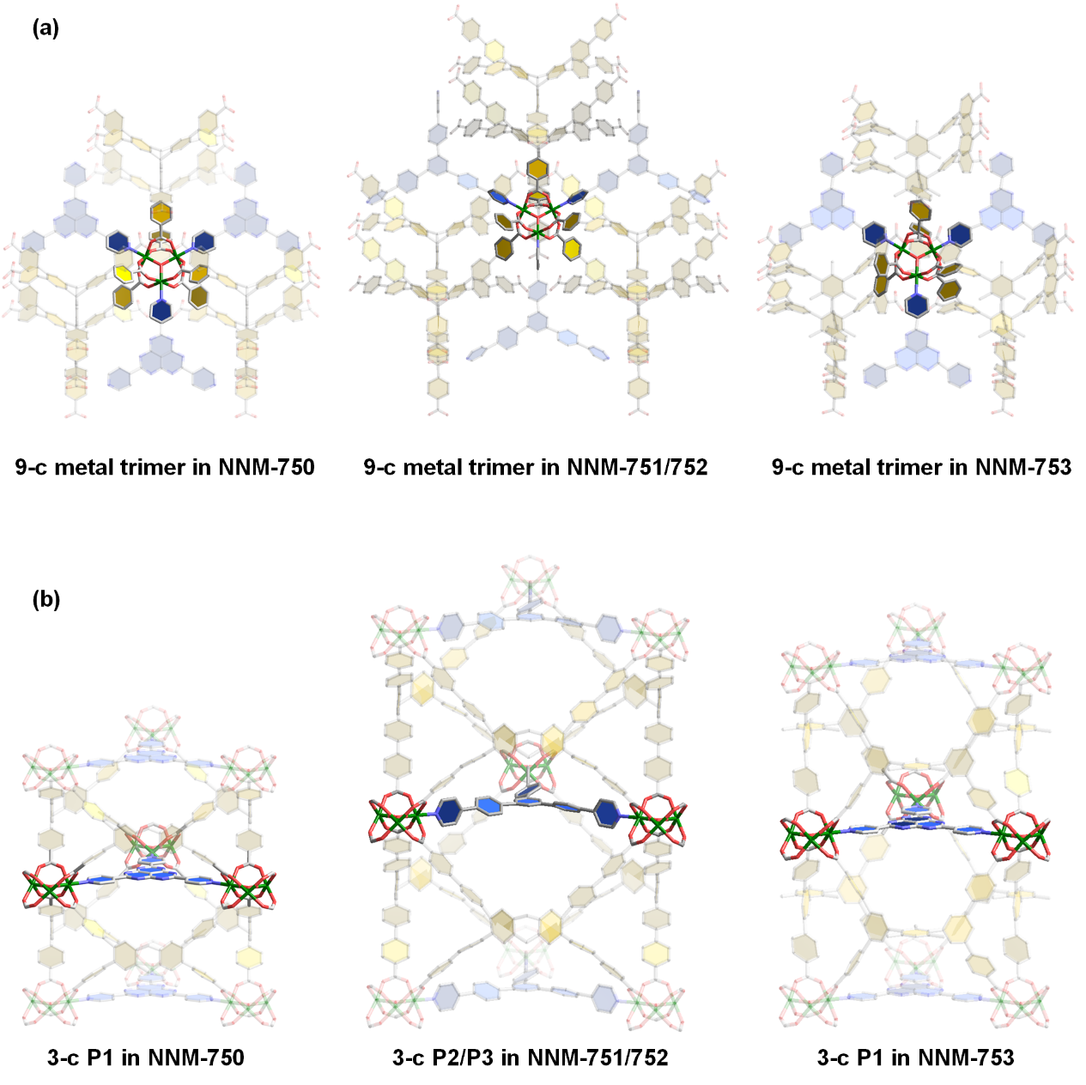
Fig. S10 9-c metal trimer (a) and 3-c partitioning ligands in NNMs.

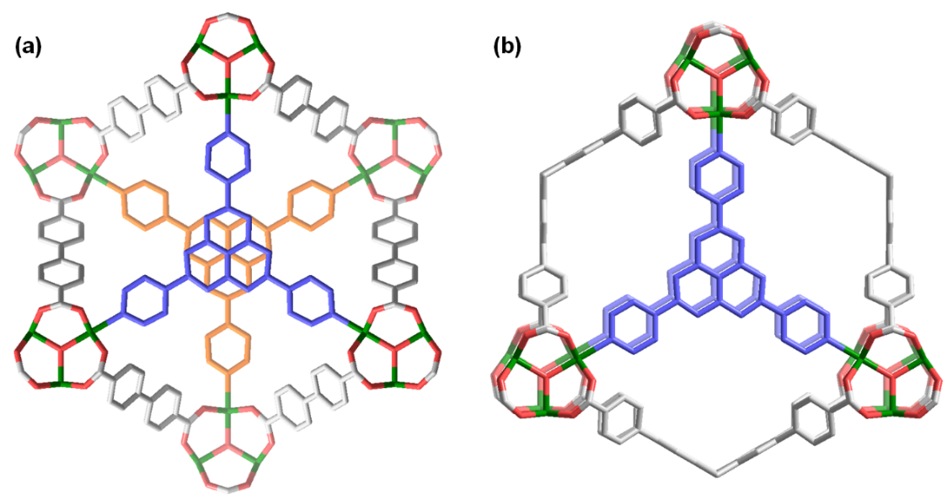
Fig. S11 The stacking mode comparison of partitioning ligand between pacs structures built from ditopic carboxylate and hexatopic carboxylate.

Fig. S12 SEM image for NNM-750-Cr.

Fig. S13 SEM image for NNM-751-Cr.

Fig. S14 SEM image for NNM-752-Cr.

Fig. S15 SEM image for NNM-753-Cr.

Fig. S16 PXRD patterns of experimental Cr phases in comparison with the simulated ones: (a) NNM-750-Cr; (b) NNM-751-Cr; (c) NNM-752-Cr; (d) NNM-753-Cr. Black, simulated; red, experimental.

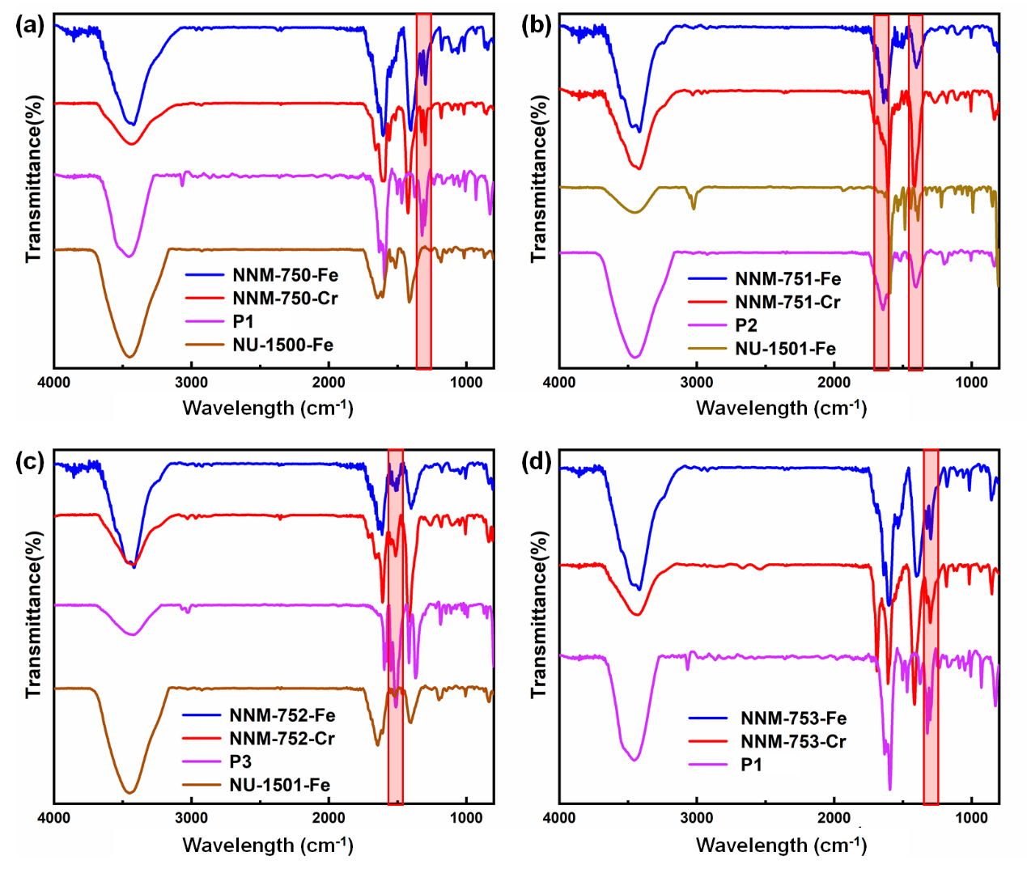
Fig. S17 FTIR spectra for four pairs of NNMs (the highlighted zone indicated the characteristic absorption of P ligands, which is absent in non-partitioned structures).

Fig. S18 PXRD patterns comparison between partitioned structures of NNM-X-Cr/Fe (X = 750, 751, 752) and non-partitioned counterparts (the diffraction peaks in highlighted zone belong to the (001) lattice plane).

Fig. S19 Rietveld refinement results for Cr based NNMs: (a) for NNM-750-Cr; (b) for NNM-751-Cr; (c) for NNM-752-Cr; (d) for NNM-753-Cr. Pink: observed; blue: Rietveld-refined; black: calculated; orange: difference plot between observed and Rietveld-refined; light-blue: Bragg positions. Insets show SEM spectra.

Section 5. Pore size and BET analysis
Fig. S20 Pore-size distribution of NNMs based on DFT model.

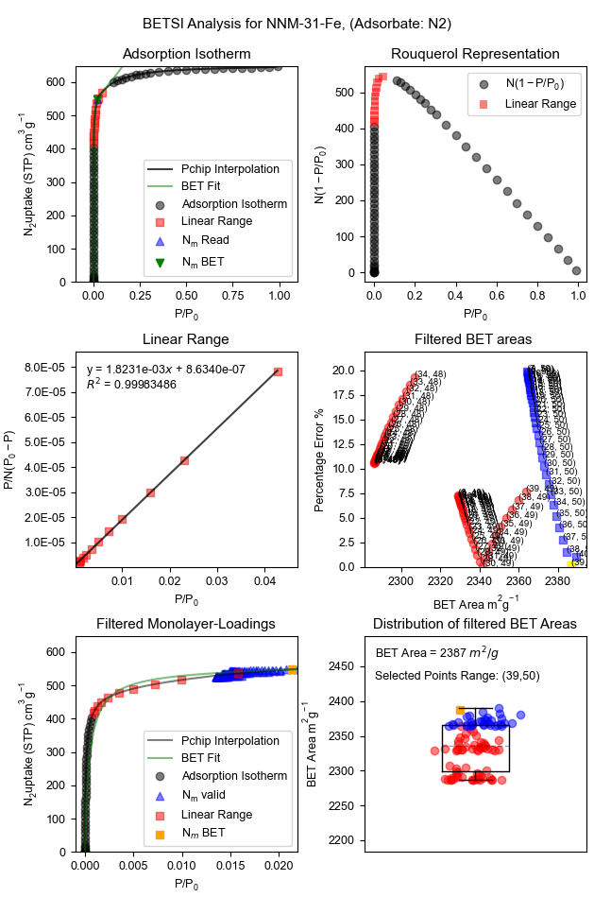
Fig. S21 BETSI analysis for NNM-750-Fe. (Adsorbate: N₂)

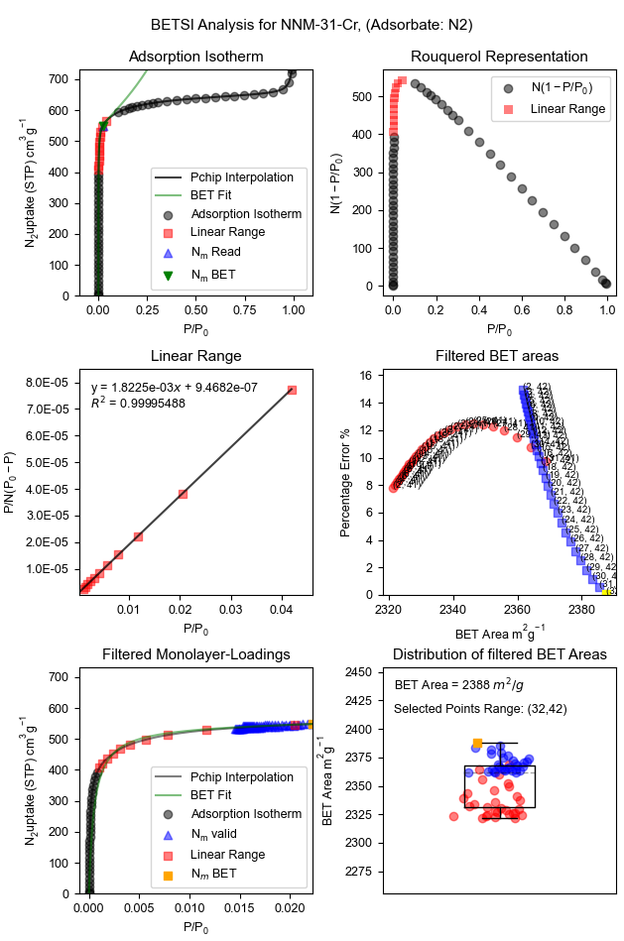
Fig. S22 BETSI analysis for NNM-750-Cr. (Adsorbate: N₂)

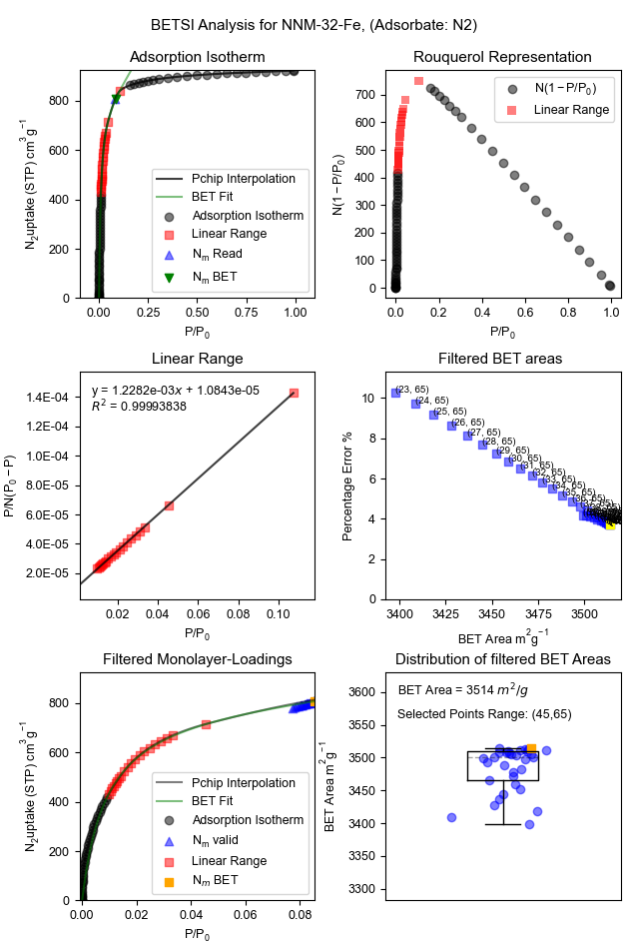
Fig. S23 BETSI analysis for NNM-751-Fe. (Adsorbate: N₂)

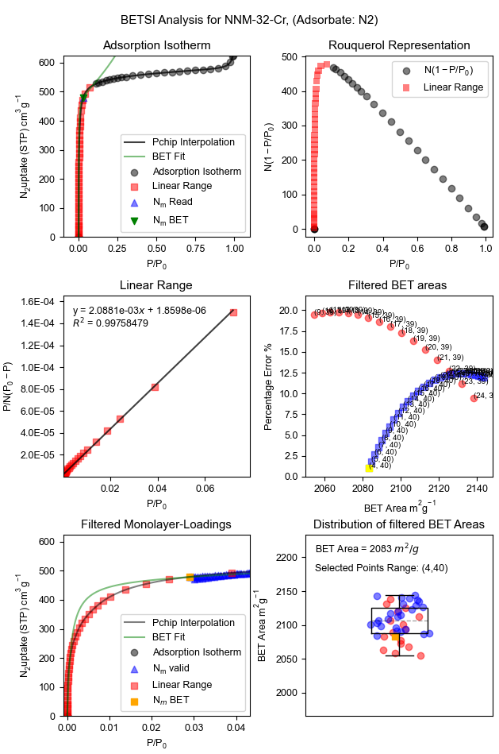
Fig. S24 BETSI analysis for NNM-751-Cr. (Adsorbate: N₂)

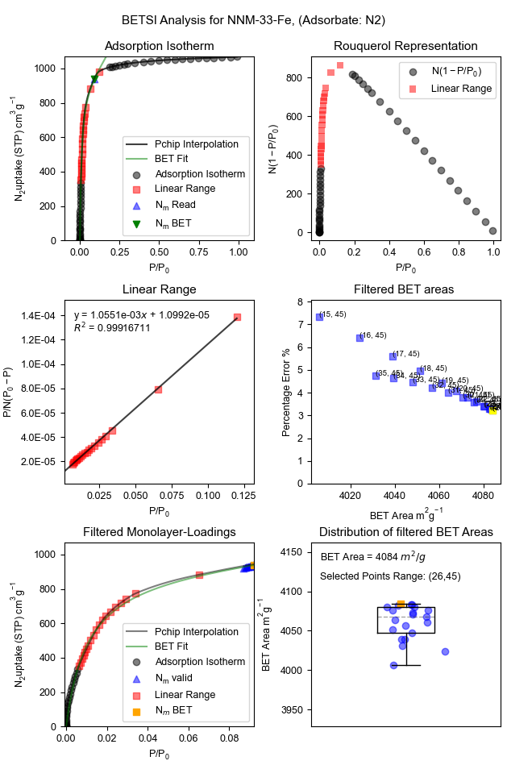
Fig. S25 BETSI analysis for NNM-752-Fe. (Adsorbate: N₂)

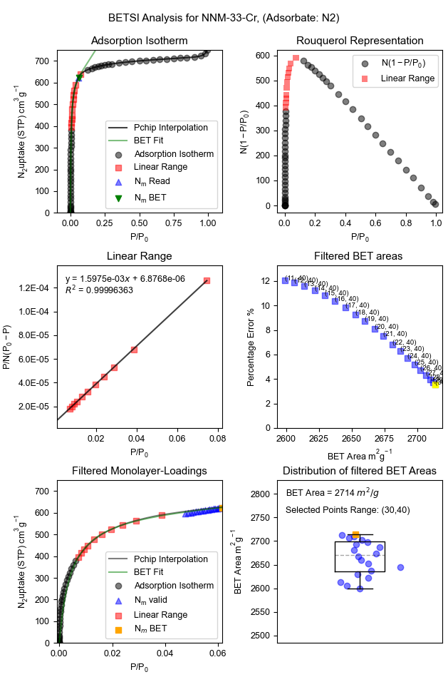
Fig. S26 BETSI analysis for NNM-752-Cr. (Adsorbate: N₂)

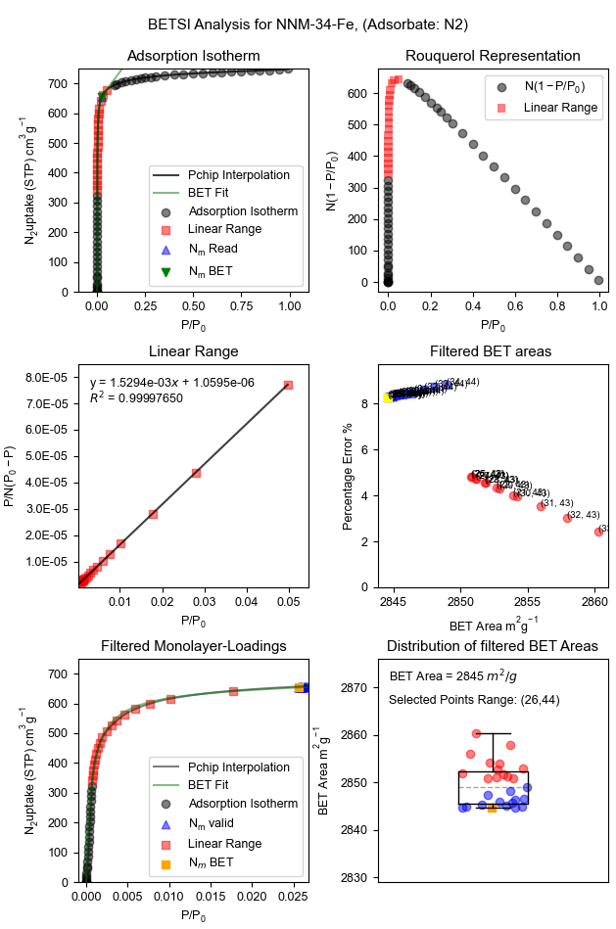
Fig. S27 BETSI analysis for NNM-753-Fe. (Adsorbate: N₂)

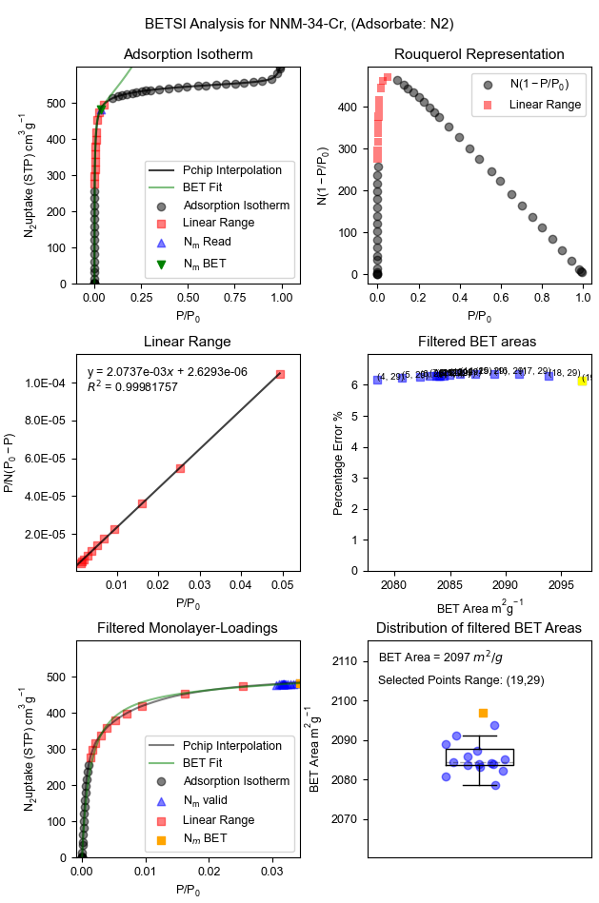
Fig. S28 BETSI analysis for NNM-753-Cr. (Adsorbate: N₂)

Section 6. Additional benzene adsorption and PXRD data
Fig. S29 Benzene adsorption isotherms of NU-1500-Fe and NU-1501-Fe at 298 K.

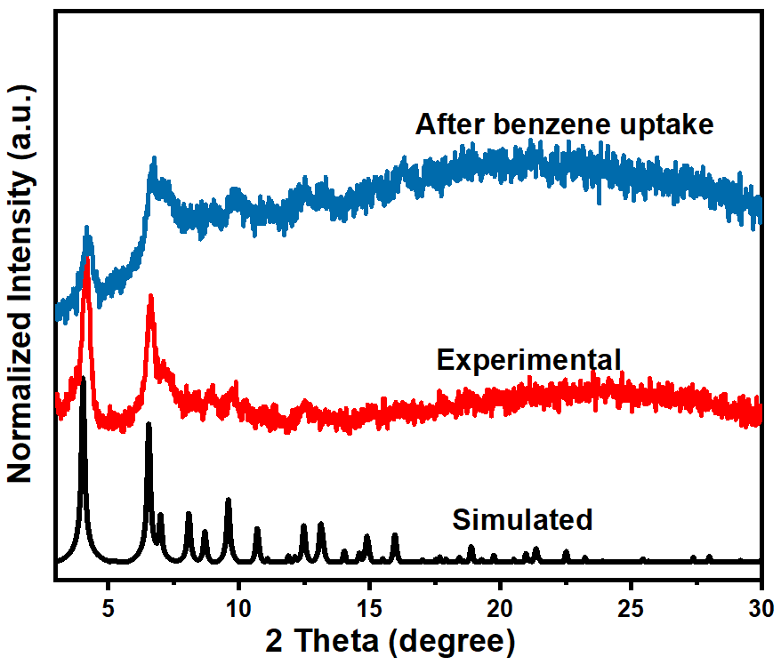
Fig. S30 Comparison of PXRD patterns for NU-1501-Fe before and after one cycle of benzene absorption.

Fig. S31 Benzene adsorption isotherm of MIL-88-Fe at 298 K.

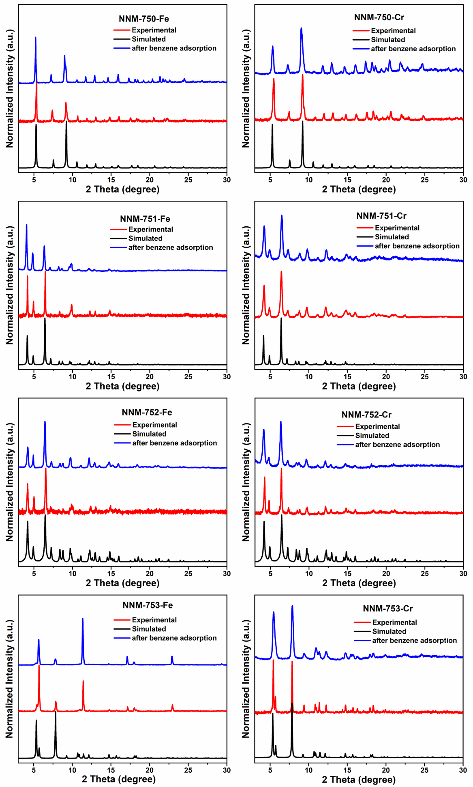
Fig. S32 PXRD patterns of NNMs before and after benzene adsorption.

Section 7. Additional IGM analysis

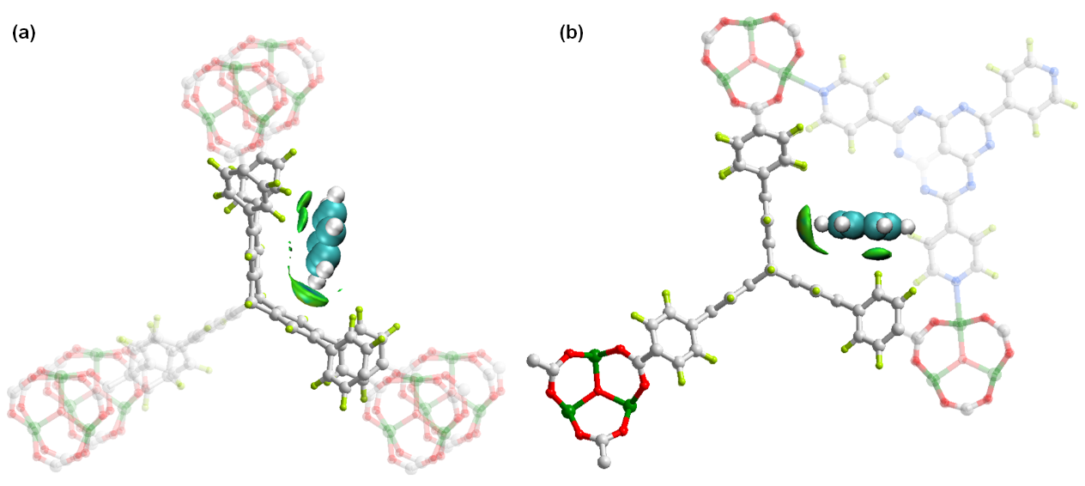
Fig. S33 The IGM isosurfaces for benzene at the iptycene site (site A) in NU-1500 (a) and at in NNM-750 (b).

Section 8. Tables
Table S1. Crystal data and structure refinement for NNM-750-Fe.
Identification code NNM-750-Fe
Empirical formula C84 H44 Fe3 N9 O13
Formula weight 1554.83
Temperature 193(2) K
Wavelength 1.54178 Å
Crystal system Trigonal
Space group P3
Unit cell dimensions a = 19.308(4) Å α = 90.00
b = 19.308(4) Å β = 90.00
c = 11.730(2) Å γ = 120.00
Volume 3787.3(17) Å³
Z 1
Density (calculated) 0.682 Mg/m³
Absorption coefficient 2.564 mm⁻¹
F(000) 793
Theta range for data collection 2.642 to 69.217°
Index ranges -22<=h<=23, -22<=k<=23, -14<=l<=13
Reflections collected 28103
Independent reflections 8380 [R(int) = 0.0680]
Completeness to theta = 67.679° 98.8 %
Refinement method Full-matrix least-squares on F²
Data / restraints / parameters 8380 / 97 / 317
Goodness-of-fit on F² 0.995
Final R indices [I>2sigma(I)] R1 = 0.0843, wR2 = 0.2382
R indices (all data) R1 = 0.1103, wR2 = 0.2664
Largest diff. peak and hole 0.882 and -0.498 e. Å⁻³

Table S2. Crystal data and structure refinement for NNM-751-Fe.
Identification code NNM-751-Fe
Empirical formula C137 H83 Fe3 N3 O13
Formula weight 2146.61
Temperature 193(2) K
Wavelength 1.54178 Å
Crystal system Hexagonal
Space group P-6
Unit cell dimensions a = 24.686(5) Å α = 90°
b = 24.686(5) Å β = 90°
c = 17.927(7) Å γ = 120°
Volume 9461(5) Å³
Z 1
Density (calculated) 0.377 Mg/m³
Absorption coefficient 1.066 mm⁻¹
F(000) 1108
Theta range for data collection 2.465 to 63.786°
Index ranges -28<=h<=28, -28<=k<=23, -20<=l<=20
Reflections collected 81484
Independent reflections 10742 [R(int) = 0.1974]
Completeness to theta = 63.786° 99.8 %
Refinement method Full-matrix least-squares on F²
Data / restraints / parameters 10742 / 289 / 267
Goodness-of-fit on F² 1.039
Final R indices [I>2sigma(I)] R1 = 0.0460, wR2 = 0.0927
R indices (all data) R1 = 0.1101, wR2 = 0.1104
Largest diff. peak and hole 0.141 and -0.123 e.Å⁻³

Table S3. Crystal data and structure refinement for NNM-752-Fe.

Identification code NNM-752-Fe
Empirical formula C134 H80 Fe3 N6 O13
Formula weight 2149.59
Temperature 150(2) K
Wavelength 1.54178 Å
Crystal system Hexagonal
Space group P-6
Unit cell dimensions a = 24.388(2) Å α = 90°
b = 24.388(2) Å β = 90°
c = 17.938(3) Å γ = 120°
Volume 9240(2) Å3
Z 1
Density (calculated) 0.386 Mg/m³
Absorption coefficient 1.094 mm⁻¹
F(000) 1108
Theta range for data collection 2.092 to 44.643°
Index ranges -21<=h<=22, -22<=k<=19, -16<=l<=16
Reflections collected 15295
Independent reflections 5084 [R(int) = 0.1407]
Completeness to theta = 44.643° 99.8 %
Refinement method Full-matrix least-squares on F²
Data / restraints / parameters 5084 / 491 / 267
Goodness-of-fit on F² 1.072
Final R indices [I>2sigma(I)] R1 = 0.1395, wR2 = 0.3272
R indices (all data) R1 = 0.2493, wR2 = 0.3840
Absolute structure parameter 0.72(4)
Largest diff. peak and hole 0.409 and -0.471 e.Å⁻³

Table S4. Crystal data and structure refinement for NNM-753-Fe.
Identification code NNM-753-Fe
Empirical formula C91 H54 Fe3 N9 O13
Formula weight 1648.98
Temperature 193(2) K
Wavelength 1.54178 Å
Crystal system Hexagonal
Space group P-6
Unit cell dimensions a = 19.0827(4) Å α= 90º
b = 19.0827(4) Å β= 90º
c = 15.4406(5) Å γ = 120º
Volume 4869.4(3) Å3
Z 1
Density (calculated) 0.562 Mg/m³
Absorption coefficient 2.007 mm-1
F(000) 845
Theta range for data collection 2.674 to 66.782º
Index ranges -22<=h<=22, -18<=k<=21, -16<=l<=18
Reflections collected 27683
Independent reflections 5930 [R(int) = 0.0678]
Completeness to theta = 66.782º 99.8 %
Refinement method Full-matrix least-squares on F²
Data / restraints / parameters 5930 / 0 / 191
Goodness-of-fit on F² 0.993
Final R indices [I>2sigma(I)] R1 = 0.0421, wR2 = 0.1042
R indices (all data) R1 = 0.0479, wR2 = 0.1089
Largest diff. peak and hole 0.194 and -0.257 e.Å⁻³

Table S5. Crystallographic information of NNM-750-Cr by Rietveld refinement.
MOF | NNM-750-Cr
Formula | C84 H44 Cr3 N9 O13
Formula weight | 1575.28
Crystal system | Trigonal
Space group | P3
a (Å) | 18.9838
b (Å) | 18.9838
c (Å) | 12.0440
V (Å³) | 3758.93
α, β | 90º
γ | 120º
Z | 1
Crystal density (g cm⁻³) | 0.682
Rp (%) | 5.05
Rwp (%) | 8.81

Table S6. Crystallographic information of NNM-751-Cr by Rietveld refinement.
MOF | NNM-751-Cr
Formula | C137 H83 Cr3 N3 O13
Formula weight | 2141.11
Crystal system | Hexagonal
Space group | P-6
a (Å) | 24.24520
b (Å) | 24.24520
c (Å) | 18.03860
V (Å³) | 9183.009
α, β | 90º
γ | 120º
Z | 1
Crystal density (g cm⁻³) | 0.387
Rp (%) | 3.05
Rwp (%) | 4.89

Table S7. Crystallographic information of NNM-752-Cr by Rietveld refinement.
MOF | NNM-752-Cr
Formula | C134 H80 Cr3 N6 O13
Formula weight | 2138.04
Crystal system | Hexagonal
Space group | P-6
a (Å) | 24.19940
b (Å) | 24.19940
c (Å) | 18.11680
V (Å³) | 9188.007
α, β | 90º
γ | 120º
Z | 1
Crystal density (g cm⁻³) | 0.386
Rp (%) | 3.38
Rwp (%) | 4.83

Table S8. Crystallographic information of NNM-753-Cr by Rietveld refinement.
MOF | NNM-753-Cr
Formula | C91 H54 Cr3 N9 O13
Formula weight | 545.31
Crystal system | Hexagonal
Space group | P-6
a (Å) | 18.79050
b (Å) | 18.79050
c (Å) | 15.64730
V (Å³) | 4784.612
α, β | 90º
γ | 120º
Z | 3
Crystal density (g cm⁻³) | 0.568
Rp (%) | 1.69
Rwp (%) | 4.00

Table S9. A comparison of metal density between FIN series and select prototypical MOFs with low metal density.
Materials | d_{G}  [mmol g⁻¹] | d_{V}  [mmol cm⁻³] | Metal mass fraction (%) | Crystal Density | Metal | Ref.
NNM-750-Fe | 1.93 | 1.31 | 10.78 | 0.682 | Fe | This work
NNM-750-Cr | 1.94 | 1.33 | 10.11 | 0.682 | Cr | This work
NNM-751-Fe | 1.39 | 0.53 | 7.78 | 0.378 | Fe | This work
NNM-751-Cr | 1.40 | 0.54 | 7.29 | 0.387 | Cr | This work
NNM-752-Fe | 1.40 | 0.54 | 7.79 | 0.386 | Fe | This work
NNM-752-Cr | 1.40 | 0.54 | 7.30 | 0.386 | Cr | This work
NNM-753-Fe | 1.82 | 1.02 | 10.2 | 0.562 | Fe | This work
NNM-753-Cr | 1.83 | 1.04 | 9.5 | 0.568 | Cr | This work
NU-1501-Al | 1.91 | 0.54 | 5.15 | 0.283 | Al | ¹³
NU-1500-Cr | 2.52 | 1.36 | 13.1 | 0.539 | Al | ¹⁴
DUT-6 | 3.73 | 1.08 | 24.4 | 0.386 | Zn | ¹⁵
IRMOF-74-XI | 1.30 | 0.26 | 3.16 | 0.200 | Mg | ¹⁶
BIF-9-Li | 2.92 | 2.19 | 2.03 | 0.750 | Li | ¹⁷
MIL-100(Cr) | 2.19 | 3.50 | 11.38 | 1.60 | Cr | ¹⁸

Table S10. A summary of porosity and pH stability of benchmark MOFs. ª (Note: We use the value under the most harsh conditions; some references have contradictory results which could probably due to the test hours and we use the best result with test hours for at least 24.)
MOF | Porosity | ∆pH of stability  (PXRD/GS)^{b} | Acid Stability  (PXRD/GS) | Basic Stability  (PXRD/GS) | Reference
NNM-750-Cr | 66.0 % | 15.1/15.1 | UL / UL | pH=14 (PD) / pH=14 (PD) | This work
NNM-752-Cr | 77.1 % | 15.1/15.1 | UL / UL | pH=14 (PD) / pH=14 (PD) | This work
CPM-243 | 57.1 % | 16.1/15.8 | UL / UL | 10 M NaOH / 5M NaOH | ¹⁹
UIO-66 | 53.2 % | 12.0/11.5 | pH=0 / pH=1.5 | pH=12 / pH=12 | ^{20,21}
ZIF-8 | 50.4 % | 10.9/NA | pH=4 / pH=4 | 8M NaOH* / NA | ²⁰⁻²²
MIL-101-Cr | 75.5 % | 12/12 | pH=0 / pH=0 | pH=12 / pH=12 | ²⁰
MOF-808 | 41.3 % | 11.1/NA | Concentrated acid | 10 / NA | ²³
PCN-601 | 50.4 % | 11.3/11.3 | pH=4 / pH=4 | UL* /UL* | ²⁴
PCN-426-Cr | 76.3 % | 12.6/NA | 4M HCl / NA | pH=12 / NA | ²⁵
PCN-333-Cr | 86.3 % | 11/11 | pH=0 / pH=0 | pH=11 / pH=11 | ²⁶
PCN-224 | 77.8 % | 11/11 | pH=0 / pH=0 | pH=11 / pH=11 | ²⁷
NU-1000 | 79.4 % | 10/10 | pH=1 / pH=1 | pH=11 / pH=11 | ²⁸
BUT-8(Cr) | 67.0 % | 12.1/NA | UL / NA | pH=11 / NA | ²⁹
Ni(BTP)₂ | 64.4 % | 11/11 | pH=3* / pH=3* | pH=14 / pH=14 | ³⁰
ZrPP-1 | 51.5 % | 14.3(PD)/NA | pH=1 (PD) / NA | UL (PD) / NA | ³¹
Cr-SXU-1 | 80.9 % | 11.5/11.5(PD) | 3M HCl / 3M HCl (PD) | pH=11 / pH=11 | ³²
Cr-MIL-142A | 57.2 | 12.5/12.5(PD) | 3M HCl (PD) / NA | pH=12 (PD) / NA | ³²
JUC-1000 | 51.4 % | 11/11 | pH=1.5 / pH=1.5 | pH=12.5 / pH=12.5 | ²¹
PFC-8 | 44.6 % | 13.1/13.1 | UL / UL | pH=12 / pH=12 | ³³
ª UL: unlimited. It indicates that the materials could be stable under concentrated acids or under saturated NaOH solutions; *: the condition is under high temperature (100 ºC). GS: gas adsorption; NA: data not available; PD: partially decomposed at the condition due to significant broadening of PXRD peaks or significant decrease of surface area.
^{b} The pH range of stability is defined as the gap of pH values that the materials can withstand, which is calculated as the highest pH value the material can withstand minus the lowest pH value the material can withstand.

Table S11. Benzene adsorption by reported adsorbents at 298 K and P/P₀ = 0.01.
Adsorbents | Q_{0.01}(mmol/g) | Crystal density | Q_{0.01}(mmol/cm³) | Reference
NNM-750-Fe | 8.97 | 0.682 | 6.12 | This work
NNM-750-Cr | 8.43 | 0.69 | 5.82 | This work
NNM-753-Fe | 8.41 | 0.562 | 4.73 | This work
NNM-753-Cr | 5.46 | 0.568 | 3.10 | This work
NU-1500-Fe | 8.98 | 0.536 | 4.81 | This work
Mn-MOF-74 | 6.30 | 1.091 | 6.87 | ³⁴
ZJU-520(Al) | 5.98 | 0.677 | 4.05 | ³⁵
BUT-53(Co) | 2.49 | 1.085 | 2.70 | ³⁶
BUT-54(Co) | 4.31 | 0.90 | 3.88 | ³⁶
BUT-55(Co) | 3.51 | 1.069 | 3.75 | ³⁶
BUT-56(Co) | 3.42 | 1.096 | 3.75 | ³⁶
BUT-57(Co) | 3.44 | 0.833 | 2.87 | ³⁶
BUT-58(Zn) | 3.41 | 1.139 | 3.88 | ³⁶
ZJU-620(Al) | 3.8 | 0.892 | 3.39 | ³⁷
[Li₂Zn₂(1-H-bdc)₃(bpy)] | 2.44 | 1.305 | 3.18 | ³⁸
[Li₂Zn₂(1-NH₂-bdc)₃(bpy)] | 2.05 | 1.341 | 2.75 | ³⁸
[Li₂Zn₂(1-NO₂-bdc)₃(bpy)] | 1.22 | 1.401 | 1.71 | ³⁸
MIL-101(Cr) | 1.09 | 0.44 | 0.48 | ³⁹
Carboxen1000 | 2.81 | 0.47 | 1.32 | ³⁹
ZIF-8(Zn) | 0.01 | 0.924 | 0.01 | ³⁹
MCM-41 | 0.42 | 0.34 | 0.14 | ³⁹
PAF-1 | 3.66 | 0.315 | 1.15 | ³⁹
BUT-66(Zr) | 2.72 | 1.062 | 2.89 | ³⁹
BUT-67(Zr) | 1.95 | 0.933 | 1.82 | ³⁹
MOF-177(Zn) | 1.60 | 1.011 | 1.62 | ⁴⁰
MFM-300(Sc) | 3.02 | 1.073 | 3.24 | ⁴¹
MFM-300(Fe) | 2.63 | 1.207 | 3.17 | ⁴¹
MFM-300(Al) | 2.99 | 1.187 | 3.55 | ⁴¹
MFM-300(In) | 2.82 | 1.388 | 3.91 | ⁴¹
MFM-300(Cr) | 2.71 | 1.169 | 3.17 | ⁴¹
MFM-300(V) | 2.28 | 1.13 | 2.58 | ⁴¹
UiO-66-(CuII) | 3.92 | 1.245 | 4.88 | ⁴¹
UiO-66-(CuI) | 2.74 | 1.244 | 3.41 | ⁴¹
UiO-66-defect | 2.55 | 1.194 | 3.04 | ⁴¹
UiO-66 | 1.78 | 1.177 | 2.10 | ⁴¹
HZSM-5 | 1.35 | 0.952 | 1.29 | ⁴²
HKUST-1 | 0.91 | 0.961 | 0.87 | ⁴³

Section 9 Topology analysis
Topology analysis for NNM-750~753.
C: partitioned ligand; O: metal-trimer cluster; X: 6-c ligand
Topology for C
--------------------
Atom C links by bridge ligands and has
Common vertex with R(A-A)
O 1 1.0000 1.0000 0.0631 ( 1 1 0) 11.148A 1
O 1 1.0000 0.0000 0.0631 ( 1 0 0) 11.148A 1
O 1 0.0000 0.0000 0.0631 ( 0 0 0) 11.148A 1
Topology for O
--------------------
Atom O links by bridge ligands and has
Common vertex with R(A-A)
C 1 0.6667 0.3333 0.0670 ( 0 0 0) 11.148A 1
C 1 -0.3333 0.3333 0.0670 (-1 0 0) 11.148A 1
C 1 -0.3333 -0.6667 0.0670 (-1-1 0) 11.148A 1
X 1 0.3333 -0.3333 -0.4346 ( 0-1-1) 12.584A 1
X 1 -0.6667 -0.3333 -0.4346 (-1-1-1) 12.584A 1
X 1 0.3333 0.6667 -0.4346 ( 0 0-1) 12.584A 1
X 1 0.3333 0.6667 0.5654 ( 0 0 0) 12.609A 1
X 1 0.3333 -0.3333 0.5654 ( 0-1 0) 12.609A 1
X 1 -0.6667 -0.3333 0.5654 (-1-1 0) 12.609A 1
Topology for X
--------------------
Atom X links by bridge ligands and has
Common vertex with R(A-A)
O 1 1.0000 1.0000 1.0631 ( 1 1 1) 12.584A 1
O 1 0.0000 1.0000 1.0631 ( 0 1 1) 12.584A 1
O 1 0.0000 0.0000 1.0631 ( 0 0 1) 12.584A 1
O 1 1.0000 1.0000 0.0631 ( 1 1 0) 12.609A 1
O 1 0.0000 1.0000 0.0631 ( 0 1 0) 12.609A 1
O 1 0.0000 0.0000 0.0631 ( 0 0 0) 12.609A 1
-------------------------
Structural group analysis
-------------------------
-------------------------
Structural group No 1
-------------------------
Structure consists of 3D framework with XOC
Coordination sequences
----------------------
C: 1 2 3 4 5 6 7 8 9 10
Num 3 18 33 110 99 272 201 506 339 812
Cum 4 22 55 165 264 536 737 1243 1582 2394
----------------------
O: 1 2 3 4 5 6 7 8 9 10
Num 9 20 75 74 213 164 423 290 705 452
Cum 10 30 105 179 392 556 979 1269 1974 2426
----------------------
X: 1 2 3 4 5 6 7 8 9 10
Num 6 32 42 134 114 308 222 554 366 872
Cum 7 39 81 215 329 637 859 1413 1779 2651
----------------------
TD10=2490
Vertex symbols for selected sublattice
--------------------------------------
C Point symbol:{4^3}
Extended point symbol:[4(2).4(2).4(2)]
--------------------------------------
O Point symbol:{4^21.6^15}
Extended point symbol:[4.4.4.4.4.4.4.4.4.4.4.4.4.4.4.4.4.4.4(2).4(2).4(2).6(2).6(2).6(2).6(2).6(2).6(2).6(3).6(3).6(3).6(9).6(9).6(9).6(9).6(9).6(9)]
--------------------------------------
X Point symbol:{4^9.6^6}
Extended point symbol:[4(2).4(2).4(2).4(2).4(2).4(2).4(2).4(2).4(2).6(14).6(14).6(14).6(14).6(14).6(14)]
--------------------------------------
Point symbol for net: {4^21.6^15}{4^3}{4^9.6^6}
3,6,9-c net with stoichiometry (3-c)(6-c)(9-c); 3-nodal net

New topology, please, contact the authors (16813 types in 3 databases)

Section 10. Reference
1. Hohenberg, P. & Kohn, W. Inhomogeneous Electron Gas. Phys. Rev. 136, B864-B871, (1964).
2. Kohn, W. & Sham, L. J. Self-Consistent Equations Including Exchange and Correlation Effects. Phys. Rev. 140, A1133-A1138, (1965).
3. VandeVondele, J. et al. Quickstep: Fast and accurate density functional calculations using a mixed Gaussian and plane waves approach. Comput. Phys. Commun. 167, 103-128, (2005).
4. Goedecker, S., Teter, M. & Hutter, J. Separable dual-space Gaussian pseudopotentials. Phys. Rev. B 54, 1703-1710, (1996).
5. Hartwigsen, C., Goedecker, S. & Hutter, J. Relativistic separable dual-space Gaussian pseudopotentials from H to Rn. Phys. Rev. B 58, 3641-3662, (1998).
6. Krack, M. & Parrinello, M. All-electron ab-initio molecular dynamics. PCCP 2, 2105-2112, (2000).
7. VandeVondele, J. & Hutter, J. Gaussian basis sets for accurate calculations on molecular systems in gas and condensed phases. J. Chem. Phys. 127, (2007).
8. Perdew, J. P., Burke, K. & Ernzerhof, M. Generalized Gradient Approximation Made Simple. Phys. Rev. Lett. 77, 3865-3868, (1996).
9. Grimme, S., Antony, J., Ehrlich, S. & Krieg, H. A consistent and accurate ab initio parametrization of density functional dispersion correction (DFT-D) for the 94 elements H-Pu. J. Chem. Phys. 132, (2010).
10. Lefebvre, C. et al. Accurately extracting the signature of intermolecular interactions present in the NCI plot of the reduced density gradient versus electron density. PCCP 19, 17928-17936, (2017).
11. Lu, T. & Chen, F. Multiwfn: A multifunctional wavefunction analyzer. J. Comput. Chem. 33, 580-592, (2012).
12. Humphrey, W., Dalke, A. & Schulten, K. VMD: Visual molecular dynamics. J. Mol. Graphics 14, 33-38, (1996).
13. Chen, Z. et al. Balancing volumetric and gravimetric uptake in highly porous materials for clean energy. Science 368, 297-303, (2020).
14. Chen, Z. et al. Reticular Access to Highly Porous acs-MOFs with Rigid Trigonal Prismatic Linkers for Water Sorption. J. Am. Chem. Soc. 141, 2900-2905, (2019).
15. Klein, N. et al. A Mesoporous Metal–Organic Framework. Angew. Chem. Int. Ed. 48, 9954-9957, (2009).
16. Deng, H. et al. Large-Pore Apertures in a Series of Metal-Organic Frameworks. Science 336, 1018-1023, (2012).
17. Wu, T. et al. Zeolite RHO-Type Net with the Lightest Elements. J. Am. Chem. Soc. 131, 6111-6113, (2009).
18. Férey, G. et al. A Hybrid Solid with Giant Pores Prepared by a Combination of Targeted Chemistry, Simulation, and Powder Diffraction. Angew. Chem. Int. Ed. 43, 6296-6301, (2004).
19. Yang, H. et al. Ultrastable High-Connected Chromium Metal–Organic Frameworks. J. Am. Chem. Soc. 143, 14470-14474, (2021).
20. Leus, K. et al. Systematic study of the chemical and hydrothermal stability of selected “stable” Metal Organic Frameworks. Microporous Mesoporous Mater. 226, 110-116, (2016).
21. He, H. et al. A Stable Metal–Organic Framework Featuring a Local Buffer Environment for Carbon Dioxide Fixation. Angew. Chem. Int. Ed. 57, 4657-4662, (2018).
22. Park, K. S. et al. Exceptional chemical and thermal stability of zeolitic imidazolate frameworks. Proc. Natl. Acad. Sci. 103, 10186-10191, (2006).
23. Liang, W. et al. Tuning pore size in a zirconium–tricarboxylate metal–organic framework. CrystEngComm 16, 6530-6533, (2014).
24. Wang, K. et al. Pyrazolate-Based Porphyrinic Metal–Organic Framework with Extraordinary Base-Resistance. J. Am. Chem. Soc. 138, 914-919, (2016).
25. Liu, T.-F. et al. Stepwise Synthesis of Robust Metal–Organic Frameworks via Postsynthetic Metathesis and Oxidation of Metal Nodes in a Single-Crystal to Single-Crystal Transformation. J. Am. Chem. Soc. 136, 7813-7816, (2014).
26. Lian, X. et al. The preparation of an ultrastable mesoporous Cr(iii)-MOF via reductive labilization. Chem. Sci. 6, 7044-7048, (2015).
27. Feng, D. et al. Construction of Ultrastable Porphyrin Zr Metal–Organic Frameworks through Linker Elimination. J. Am. Chem. Soc. 135, 17105-17110, (2013).
28. Howarth, A. J. et al. Chemical, thermal and mechanical stabilities of metal–organic frameworks. Nat. Rev. Mater. 1, 15018, (2016).
29. Yang, F. et al. A flexible metal–organic framework with a high density of sulfonic acid sites for proton conduction. Nat. Energy 2, 877-883, (2017).
30. Colombo, V. et al. High thermal and chemical stability in pyrazolate-bridged metal–organic frameworks with exposed metal sites. Chem. Sci. 2, 1311-1319, (2011).
31. Chen, E.-X. et al. Acid and Base Resistant Zirconium Polyphenolate-Metalloporphyrin Scaffolds for Efficient CO2 Photoreduction. Adv. Mater. 30, 1704388, (2018).
32. Wang, J.-H. et al. Solvent-Assisted Metal Metathesis: A Highly Efficient and Versatile Route towards Synthetically Demanding Chromium Metal–Organic Frameworks. Angew. Chem. Int. Ed. 56, 6478-6482, (2017).
33. Huang, G. et al. A Comparison of Two Isoreticular Metal–Organic Frameworks with Cationic and Neutral Skeletons: Stability, Mechanism, and Catalytic Activity. Angew. Chem. Int. Ed. 59, 4385-4390, (2020).
34. Mukherjee, S. et al. Harnessing Lewis acidic open metal sites of metal–organic frameworks: the foremost route to achieve highly selective benzene sorption over cyclohexane. Chem. Commun. 52, 8215-8218, (2016).
35. Hu, L. et al. Double-walled Al-based MOF with large microporous specific surface area for trace benzene adsorption. Nat. Commun. 15, 3204, (2024).
36. He, T. et al. Trace removal of benzene vapour using double-walled metal–dipyrazolate frameworks. Nat. Mater. 21, 689-695, (2022).
37. Hu, L. et al. A Novel Aluminum-Based Metal-Organic Framework with Uniform Micropores for Trace BTEX Adsorption. Angew. Chem. Int. Ed. 62, e202215296, (2023).
38. Sapianik, A. A. et al. Exceptionally effective benzene/cyclohexane separation using a nitro-decorated metal–organic framework. Chem. Commun. 56, 8241-8244, (2020).
39. Xie, L.-H., Liu, X.-M., He, T. & Li, J.-R. Metal-Organic Frameworks for the Capture of Trace Aromatic Volatile Organic Compounds. Chem 4, 1911-1927, (2018).
40. Yang, K., Xue, F., Sun, Q., Yue, R. & Lin, D. Adsorption of volatile organic compounds by metal-organic frameworks MOF-177. J. Environ. Chem. Eng. 1, 713-718, (2013).
41. Han, Y. et al. Control of the pore chemistry in metal-organic frameworks for efficient adsorption of benzene and separation of benzene/cyclohexane. Chem 9, 739-754, (2023).
42. Jhung, S. H. et al. Microwave Synthesis of Chromium Terephthalate MIL-101 and Its Benzene Sorption Ability. Adv. Mater. 19, 121-124, (2007).
43. Zhao, Z. et al. Competitive adsorption and selectivity of benzene and water vapor on the microporous metal organic frameworks (HKUST-1). Chem. Eng. J. 259, 79-89, (2015).

