Supporting Figures and Tables

Construction of Scalable Multi-channel DNA Nanoplatform for the Combined Detection of Multi-component Biomarkers of Cancer

Yiwei Songª, Xiuyan Jinª, Yiou zhaoª, Shuwen Chengª, Sai Xu^{b}, Shengjun Buª, Liming Liuª, Chunyang Zhou^{a,*}, Chunying Pang^{a,*}

ªCollege of Life Science and Technology, Joint Laboratory of Medical Instrument Innovation, Changchun University of Science and Technology, Changchun, 130000, China
^{b}School of Science, Dalian Maritime University, Dalian 116026, China

*Corresponding author: Dr. Chunyang Zhou
College of Life Science and Technology, Joint Laboratory of Medical Instrument Innovation, Changchun University of Science and Technology, Changchun, 130000, China
E-mail: cyzhoucust@126.com.
Dr. Chunying Pang
College of Life Science and Technology, Joint Laboratory of Medical Instrument Innovation, Changchun University of Science and Technology, Changchun, 130000, China
E-mail: 1281957328@qq.com.

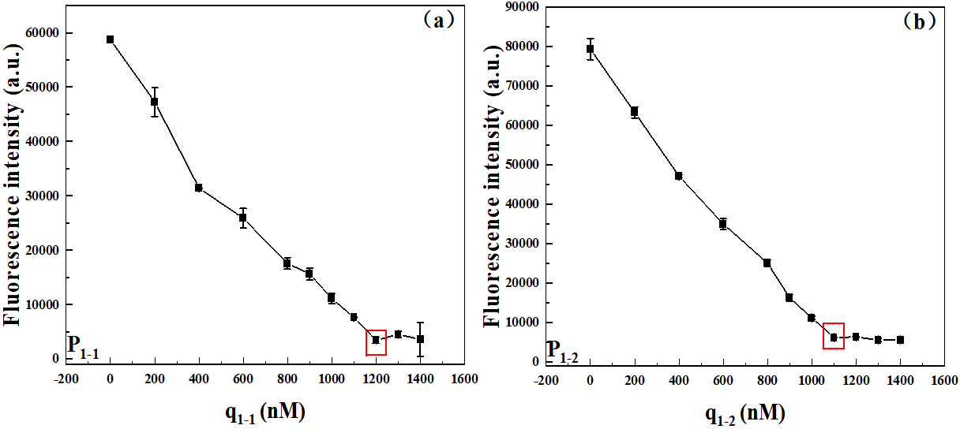
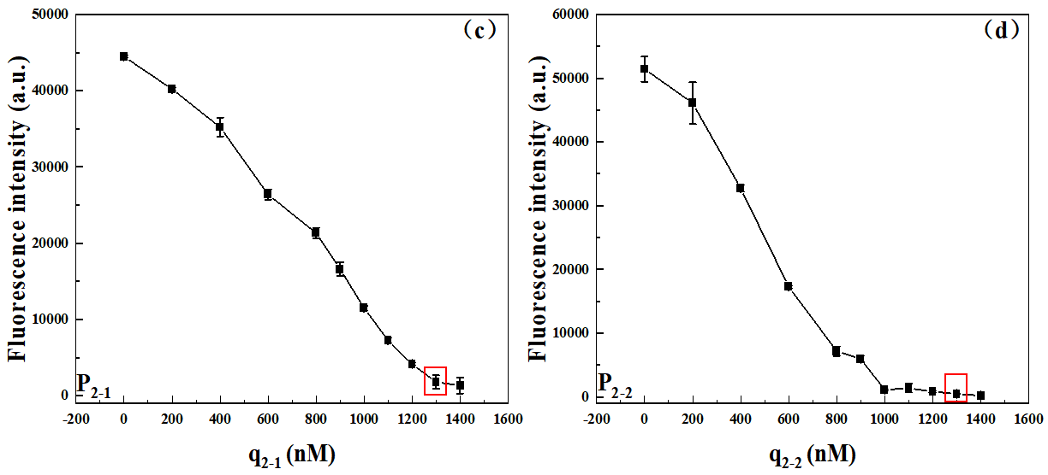
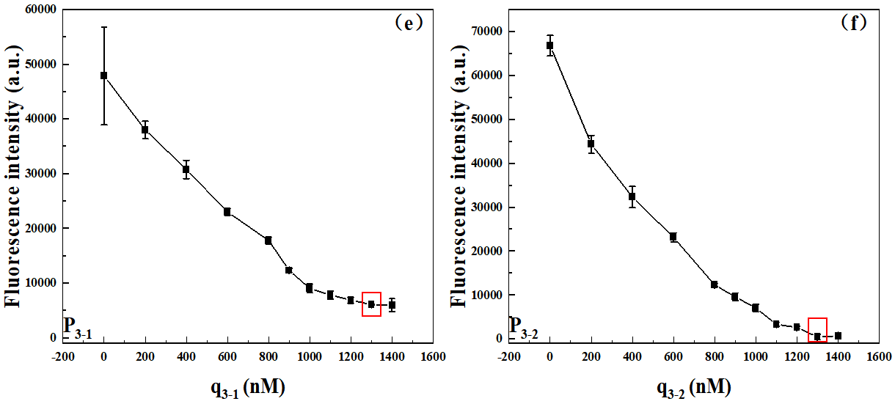
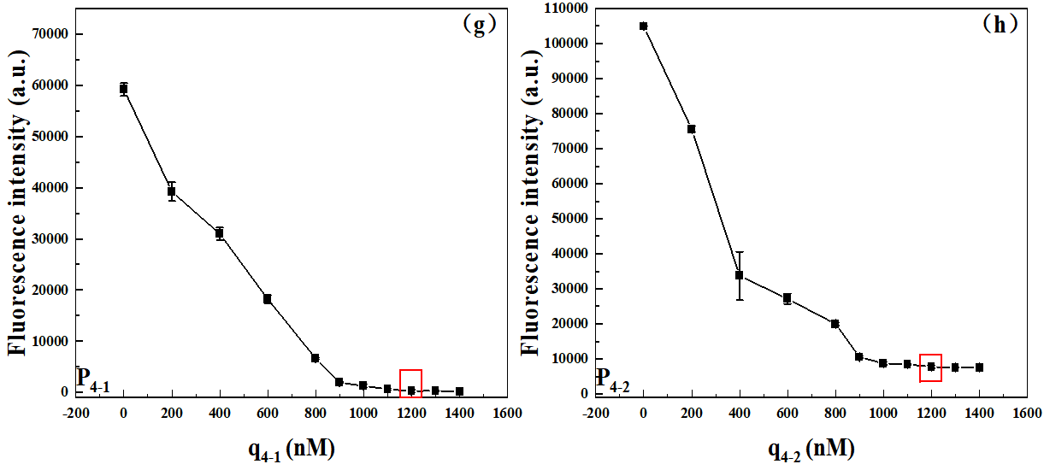
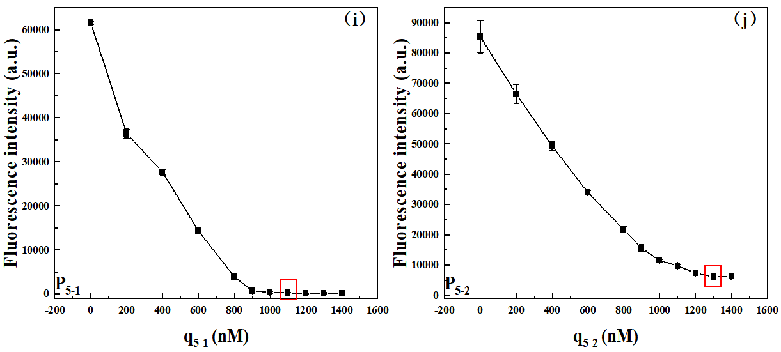
Fig. S1 Concentration optimization diagram of q_{n-1}. In order to improve the sensitivity of the sensor and reduce the background signal of the reaction substrate, it is necessary to optimize the concentration of each DNA sequence involved in the construction of the fluorescent switch monomer. First, we choose to fix the concentrations of both p_{n-1} and f_{n-1} at 1 µM and remain constant, and then add q_{n-1}. With the increase of q_{n-1} concentration, the fluorescence intensity in the figure showed a decreasing trend. However, when the fluorescence intensity decreases near a certain value range, it appears to stop decreasing while maintaining a steady low fluorescence intensity, even if the concentration of q_{n-1} increases. Therefore, such value that changes the trend of fluorescence intensity is the optimal concentration of the q_{n-1}. In the figure, the optimum concentration of q_{n-1} for each platform monomer has been circled in red

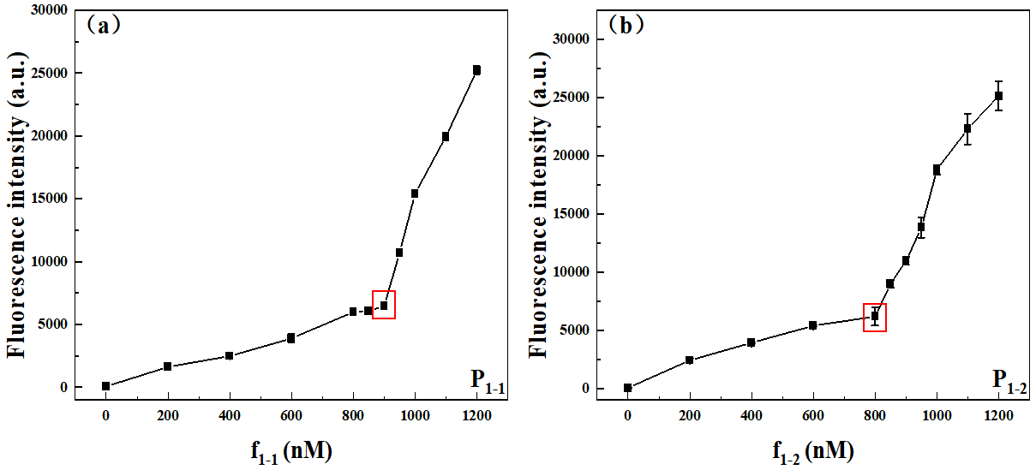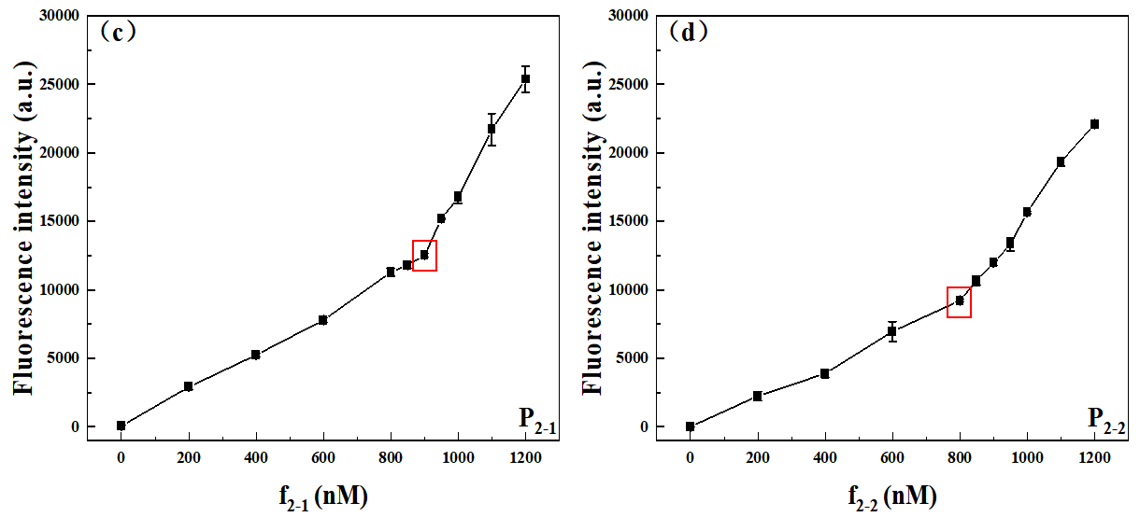
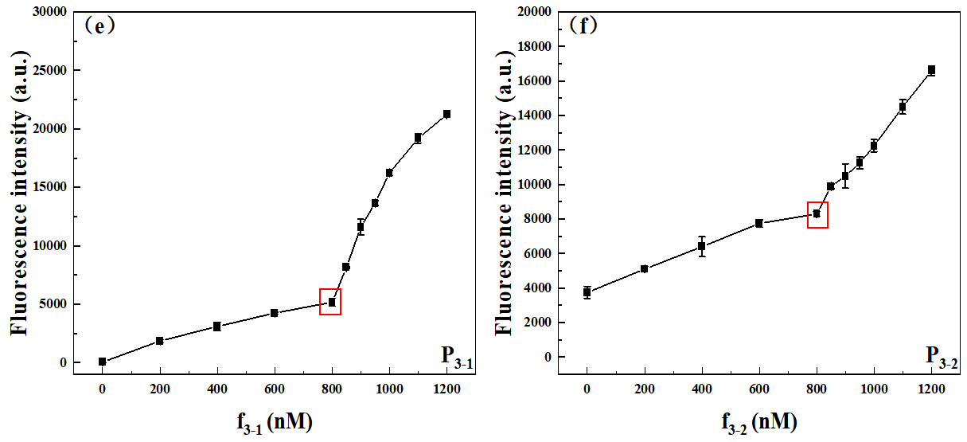
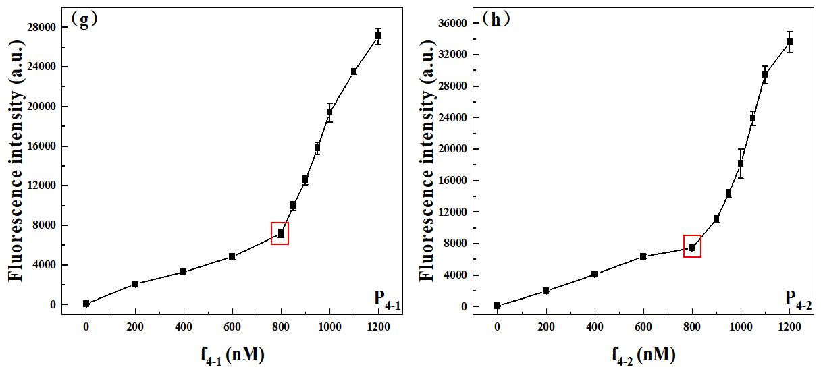
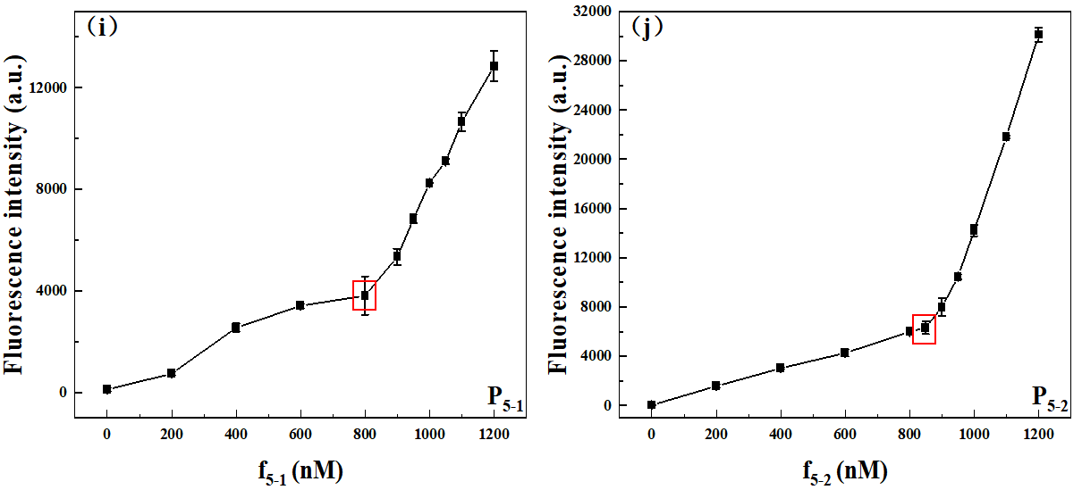
Fig. S2 Concentration optimization diagram of f_{n-1}. After the optimization of q_{n-1}, the concentration of f_{n-1} need to be further optimized. First, the concentration of p_{n-1} was selected as 1 µM and remains constant, and the concentration of q_{n-1} was selected as the optimized value marked in the red box in Figure S1. With the increase of f_{n-1} concentration, the change of fluorescence intensity in the figure was gradually increased. However, when the fluorescence intensity slowly raised to a certain value, it showed a sharp increase. This is because f_{n-1} had been fully hybridized with p_{n-1}, and the rest of the increased f_{n-1} existed freely in the solution without being quenched by q_{n-1}, and therefore showed a sharply enhanced fluorescence signal. Therefore, such value that changes the trend of fluorescence intensity is the optimal concentration of the f_{n-1}. In the figure, the optimum concentration of f_{n-1} for each platform monomer has been circled in red

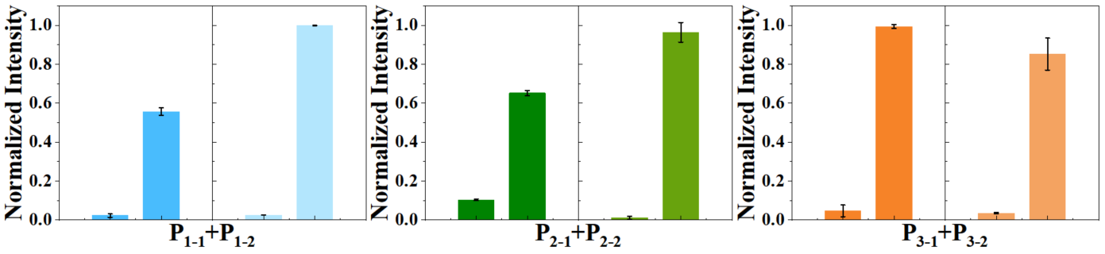
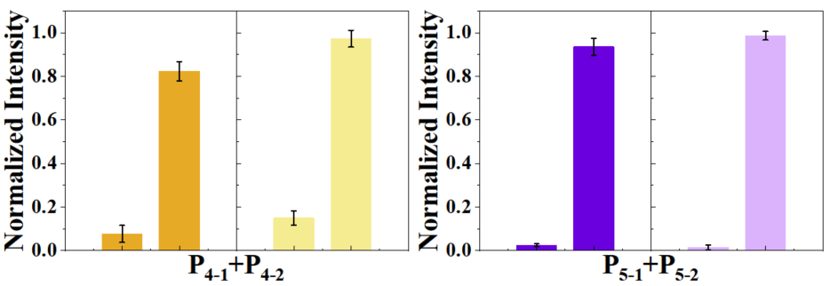
Fig. S3 Changes in fluorescence intensity of ten monomers, which divided into five subsets, before and after adding the target. Each subset can still maintain an ideal fluorescence switching effect and a low background signal

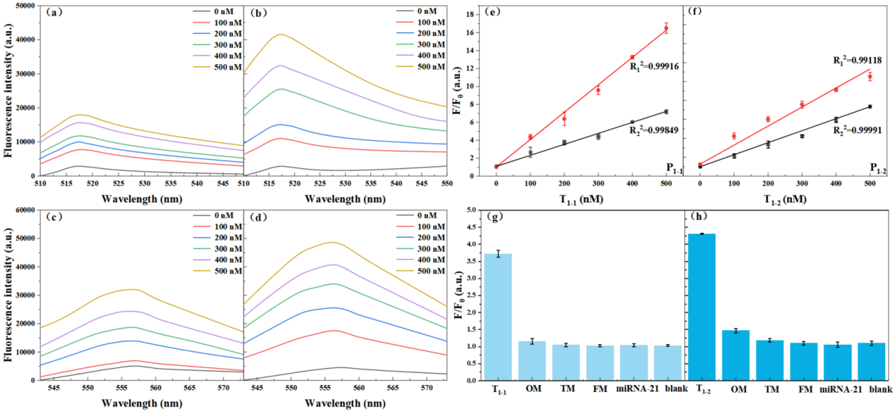
Fig. S4 Performance evaluations of biosensor based on CHA. Fluorescence profile corresponding to different concentrations of (a-b) T₁₋₁ gene and (c-d) T₁₋₂ gene (from top to bottom: 500 nM, 400 nM, 300 nM, 200 nM, 100 nM, 0 nM). (e-f) Calibration curves of response of different concentrations (0-500 nM) to target genes. Linear range was from 0 to 500 nM. (g-h) Specificity against different kinds of (g) Target₁₋₁ and (h) Target₁₋₂ gene at concentration of 500 nM: complementary target, single base mutation target, three-base mutation target, five base mutation target, miRNA-21, blank control. The error bars were obtained via three independent experiments and denote standard deviation (S.D.)

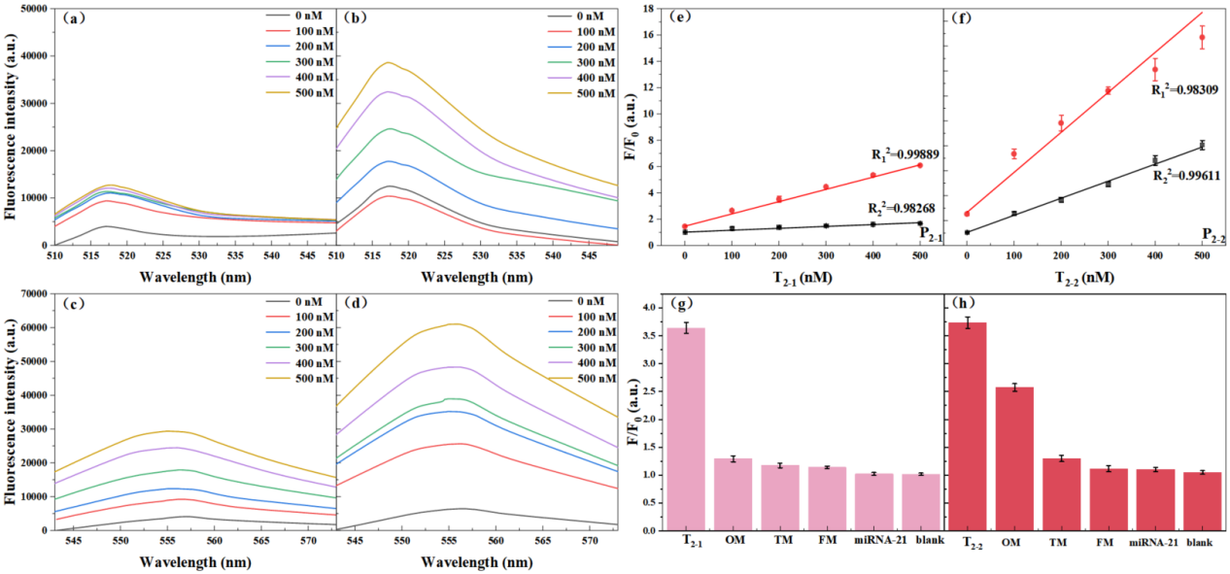Fig. S5 Performance evaluations of biosensor based on CHA. Fluorescence profile corresponding to different concentrations of (a-b) T₂₋₁ gene and (c-d) T₂₋₂ gene (from top to bottom: 500 nM, 400 nM, 300 nM, 200 nM, 100 nM, 0 nM). (e-f) Calibration curves of response of different concentrations (0-500 nM) to target genes. Linear range was from 0 to 500 nM. (g-h) Specificity against different kinds of (g) Target₂₋₁ and (h) Target₂₋₂ gene at concentration of 500 nM: complementary target, single base mutation Target, three-base mutation target, five base mutation target, miRNA-21, blank control. The error bars were obtained via three independent experiments and denote standard deviation (S.D.)

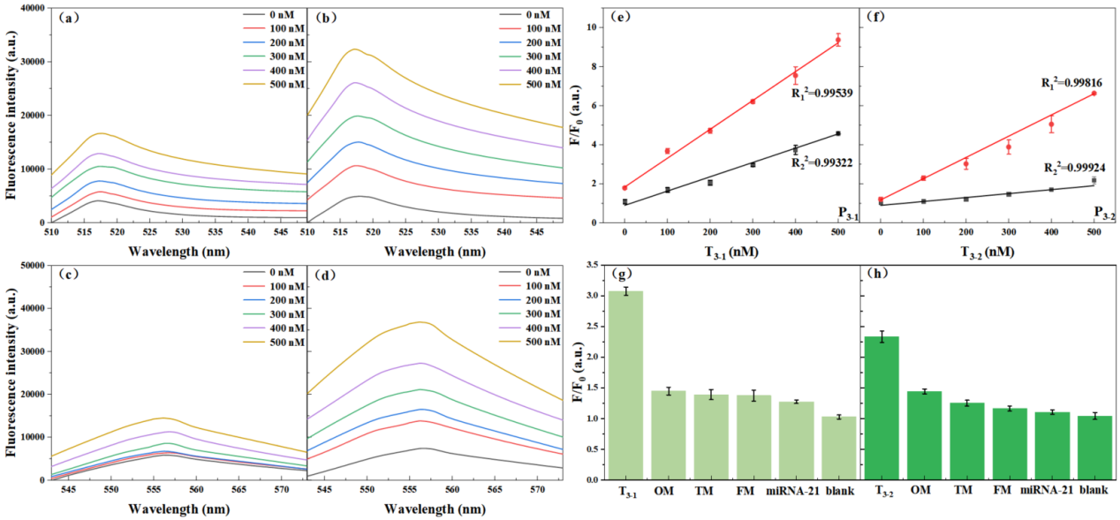
Fig. S6 Performance evaluations of biosensor based on CHA. Fluorescence profile corresponding to different concentrations of (a-b) T₃₋₁ gene and (c-d) T₃₋₂ gene (from top to bottom: 500 nM, 400 nM, 300 nM, 200 nM, 100 nM, 0 nM). (e-f) Calibration curves of response of different concentrations (0-500 nM) to target genes. Linear range was from 0 to 500 nM. (g-h) Specificity against different kinds of (g) Target₃₋₁ and (h) Target₃₋₂ gene at concentration of 500 nM: complementary target, single base mutation target, three-base mutation target, five base mutation target, miRNA-21, blank control. The error bars were obtained via three independent experiments and denote standard deviation (S.D.)

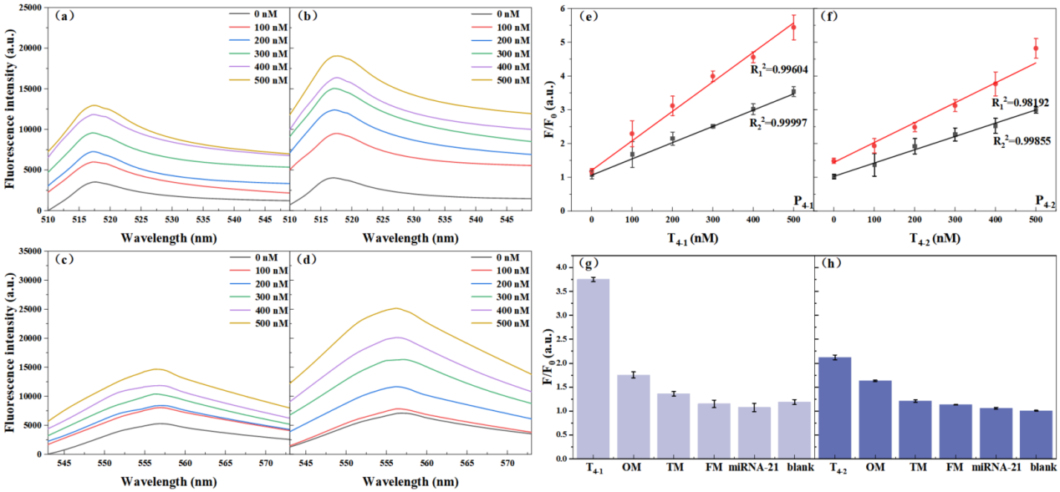
Fig. S7 Performance evaluations of biosensor based on CHA. Fluorescence profile corresponding to different concentrations of (a-b) T₄₋₁ gene and (c-d) T₄₋₂ gene (from top to bottom: 500 nM, 400 nM, 300 nM, 200 nM, 100 nM, 0 nM). (e-f) Calibration curves of response of different concentrations (0-500 nM) to target genes. Linear range was from 0 to 500 nM. (g-h) Specificity against different kinds of (g) Target₄₋₁ and (h) Target₄₋₂ gene at concentration of 500 nM: complementary target, single base mutation target, three-base mutation target, five base mutation target, miRNA-21, blank control. The error bars were obtained via three independent experiments and denote standard deviation (S.D.)

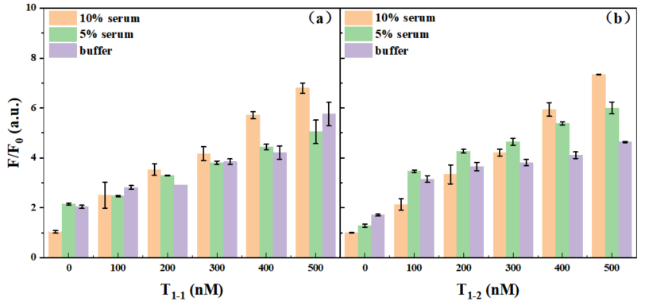
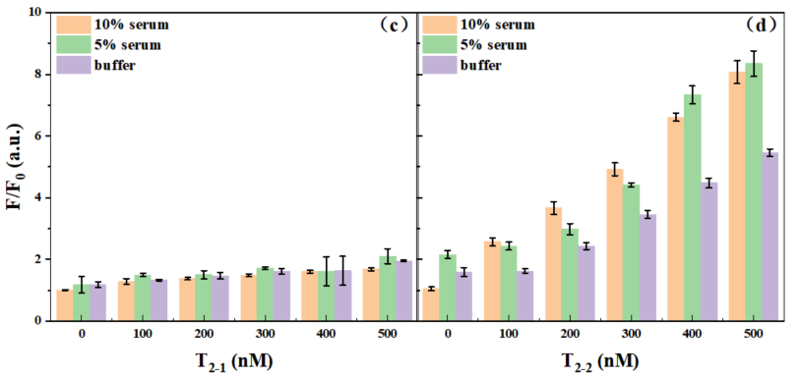
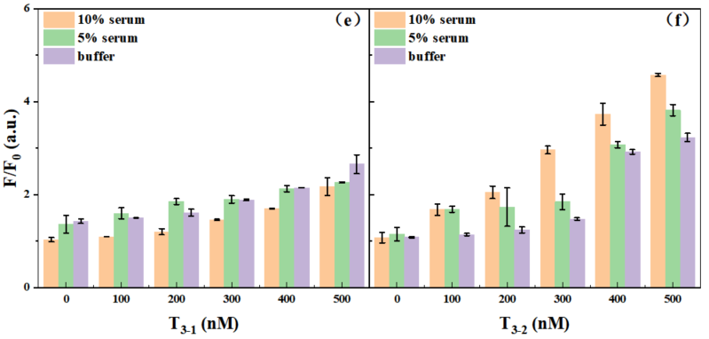
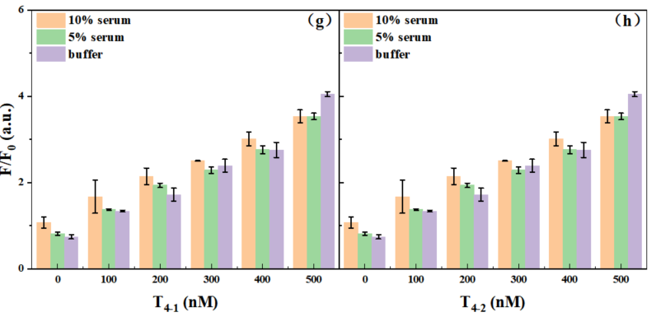
Fig. S8 Fluorescence assay results of the detection of (a) Target₁₋₁, (b) Target₁₋₂, (c) Target₂₋₁, (d) Target₂₋₂, (e) Target₃₋₁, (f) Target₃₋₂, (g) Target₄₋₁, (h) Target₄₋₂ in real human serum solutions at 10% (orange), 5% (green) concentrations, and in PBS buffer (purple), respectively

Table S1 Single-stranded DNA used for the construction of reaction platform
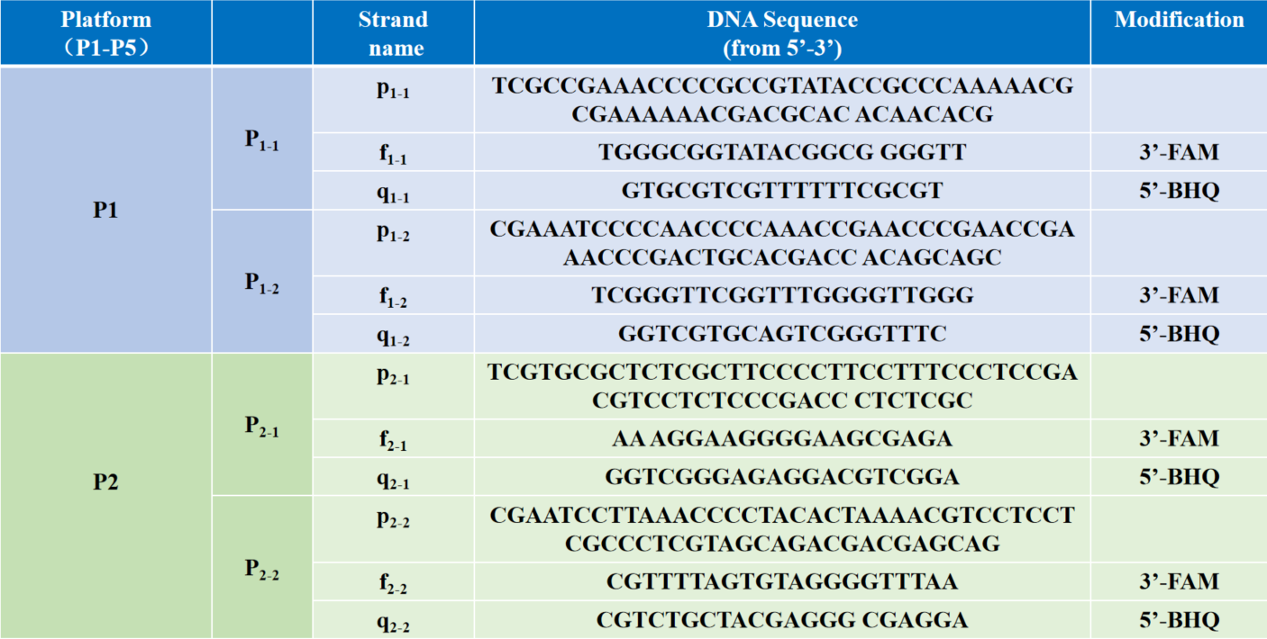
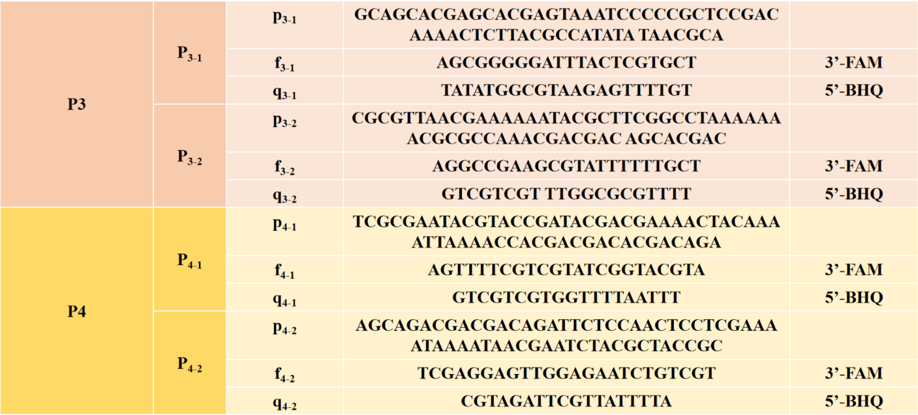
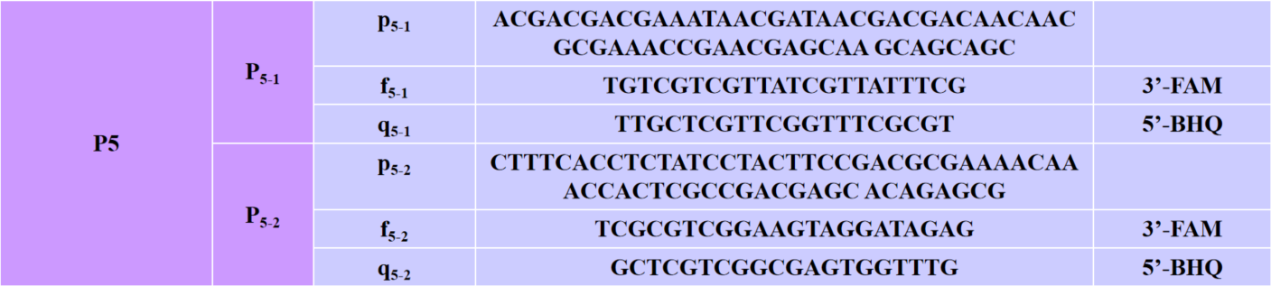

Table S2 Display of Hairpin-structure DNA sequences involved in CHA
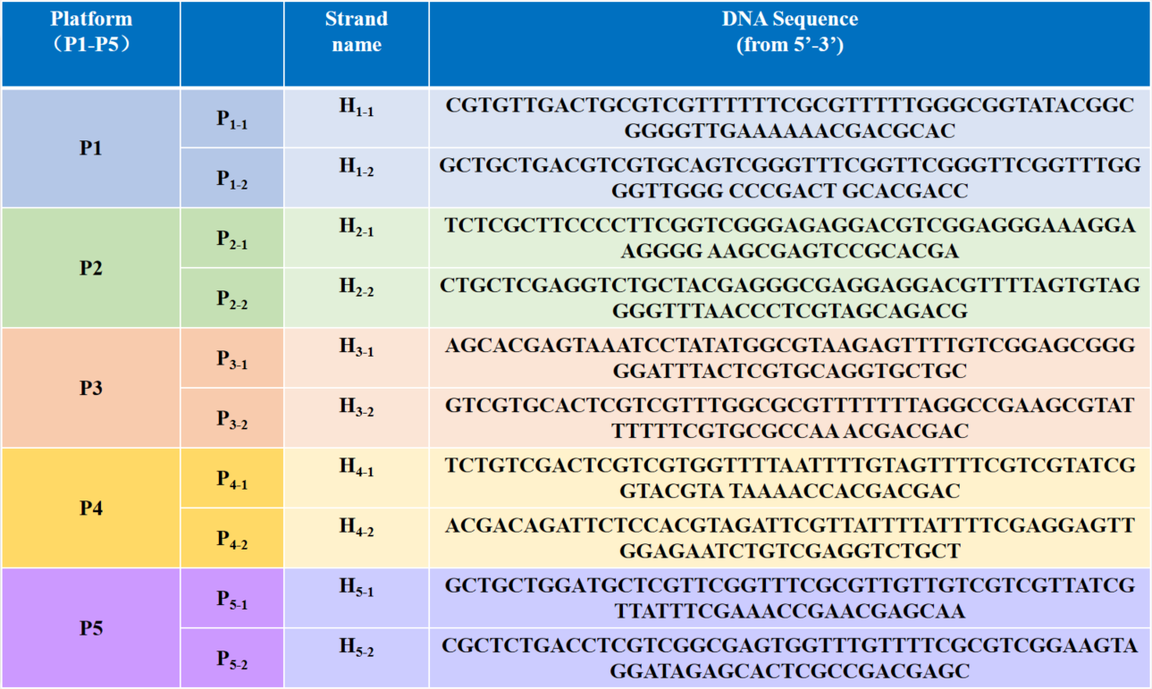

Table S3 The presentation of DNA sequences used to demonstrate the specificity of the biosensor constructed in this work
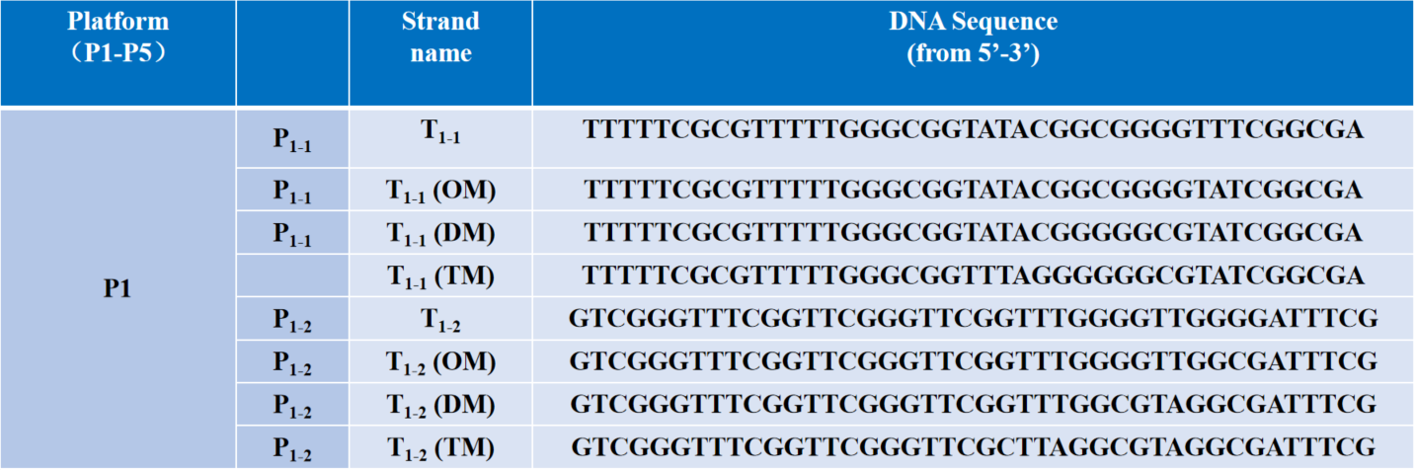
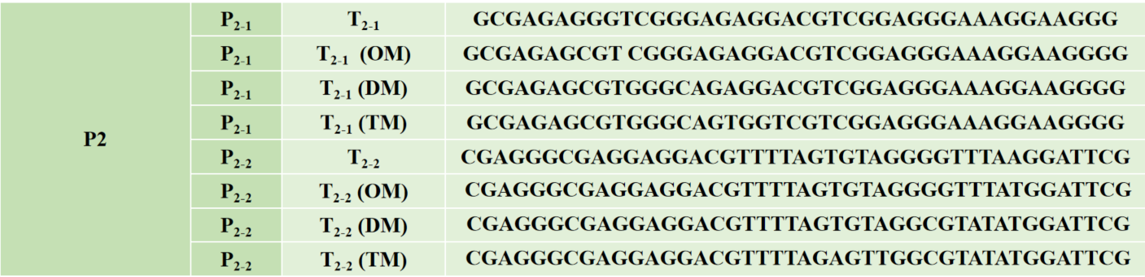
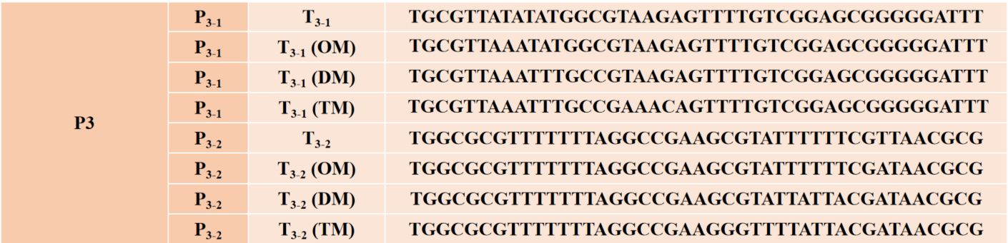
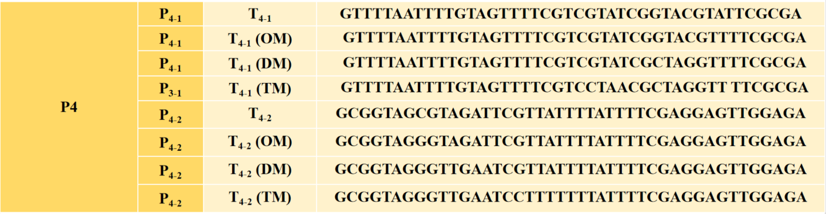
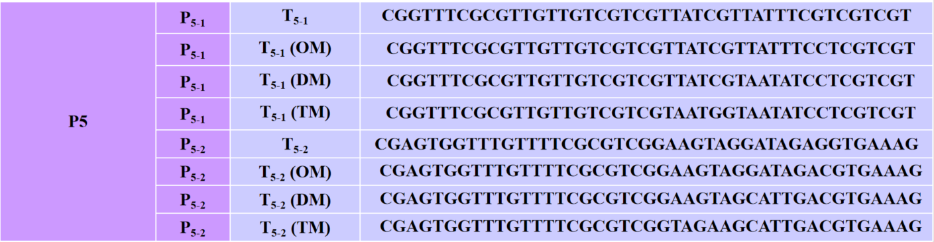

Table S4 Real sample assays in human serum for T₁₋₁ and T₁₋₂ gene detection (n=3)
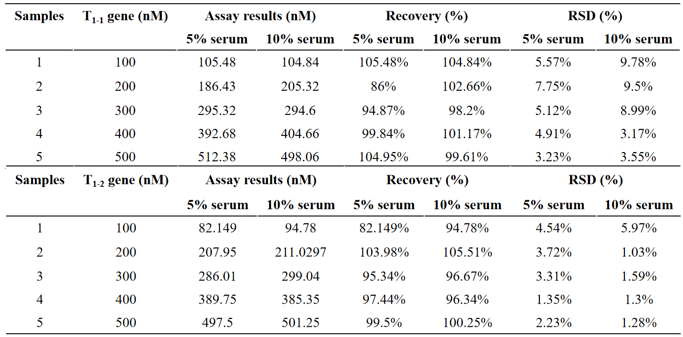

Table S5 Real sample assays in human serum for T₂₋₁ and T₂₋₂ gene detection (n=3)
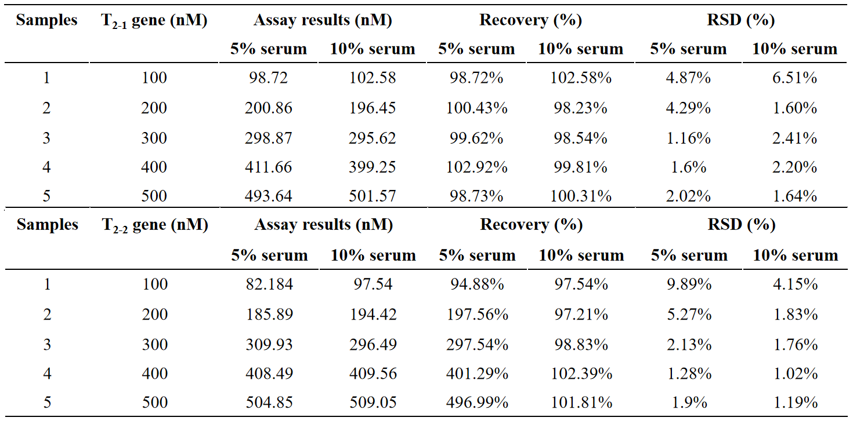

Table S6 Real sample assays in human serum for T₃₋₁ and T₃₋₂ gene detection (n=3)
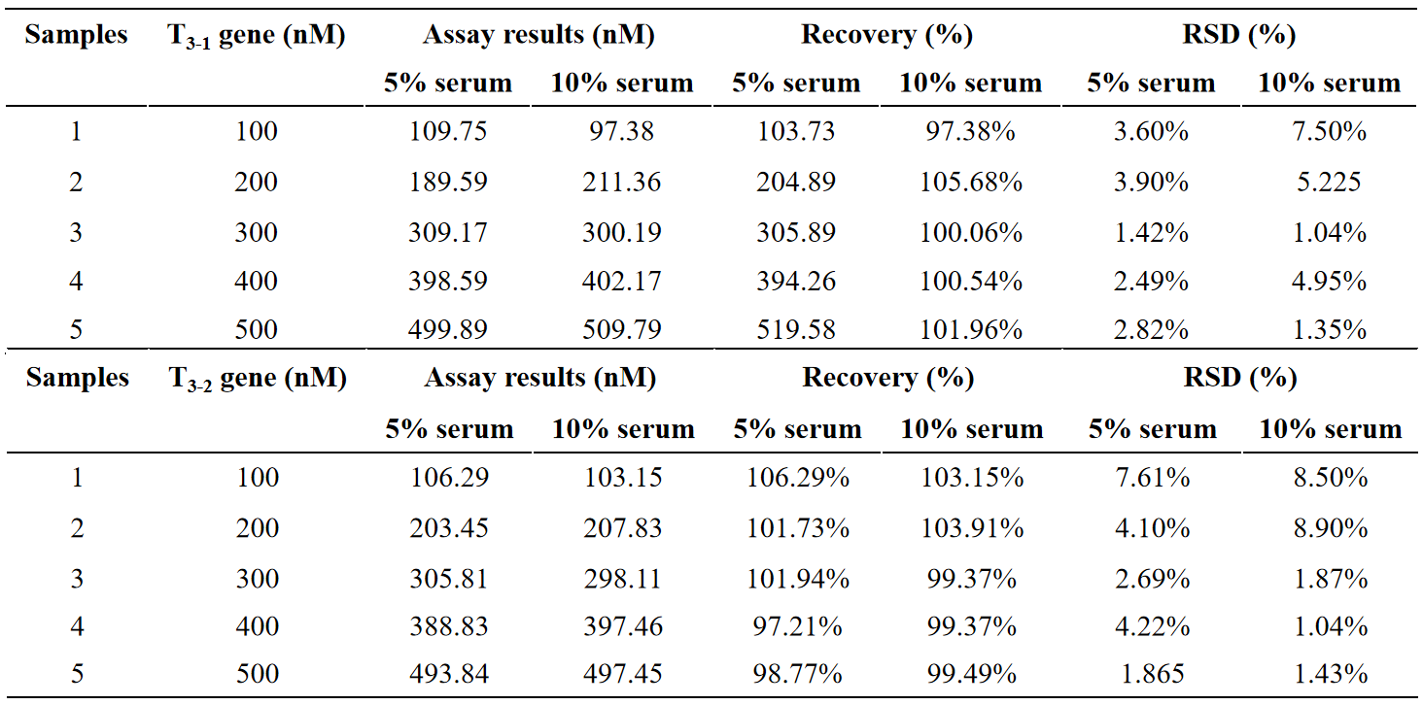

Table S7 Real sample assays in human serum for T₄₋₁ and T₄₋₂ gene detection (n=3)
