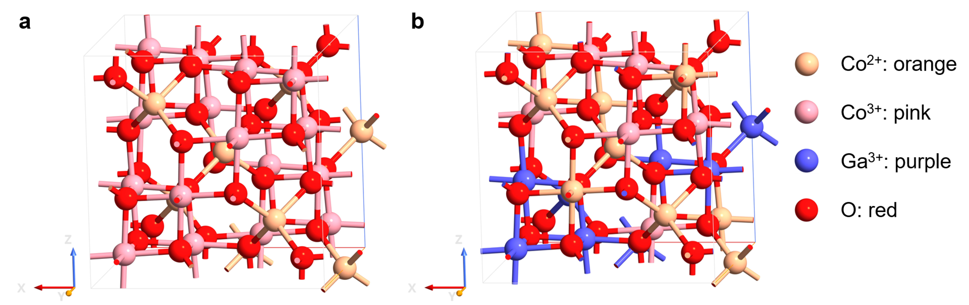
Scheme 1: Normal and inverse spinel structure. a, Structure of Co₃O₄ normal spinel. b, Transformation of Co²⁺ from tetrahedral to octahedral environment by foreign cations replacement. Orange: Co²⁺, pink: Co³⁺, purple: Ga³⁺, red: O.

