Supporting Information

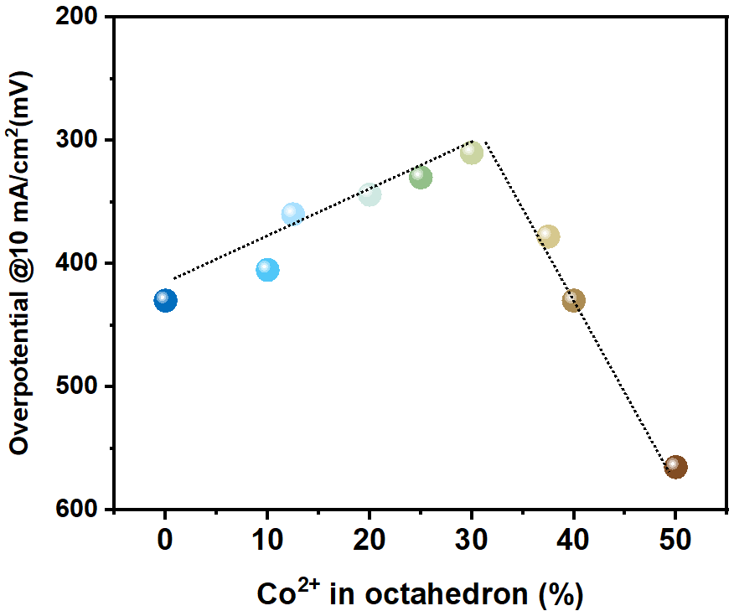

Supplementary Fig. 1: OER overpotential at 10 mA/cm² of Co₃O₄ into which we introduced increasing concentrations of octahedral Co²⁺.

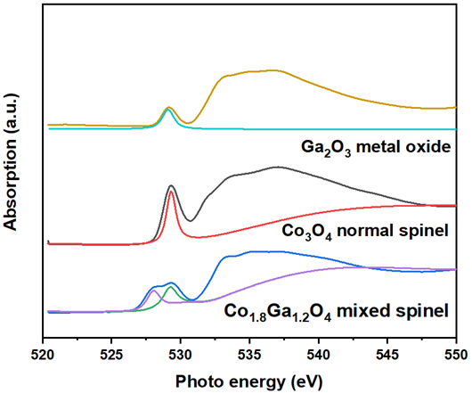
Supplementary Fig. 2: O K-edge sXAS spectra for Co_{1.8}Ga_{1.2}O₄ inverse spinel, Co₃O₄ normal spinel, and Ga₂O₃ metal oxide. We find out that in both Co₃O₄ and Ga₂O₃ only one prominent peak can be located around 529 eV, while a new peak at 528 eV can be found in Co_{1.8}Ga_{1.2}O₄ mixed spinel. This new peak can be ascribed to the transition of electrons in t_{2g} orbitals filling the e_{g} orbitals, giving rise to the partially unoccupied t_{2g} states and higher spine state of cobalt ions.

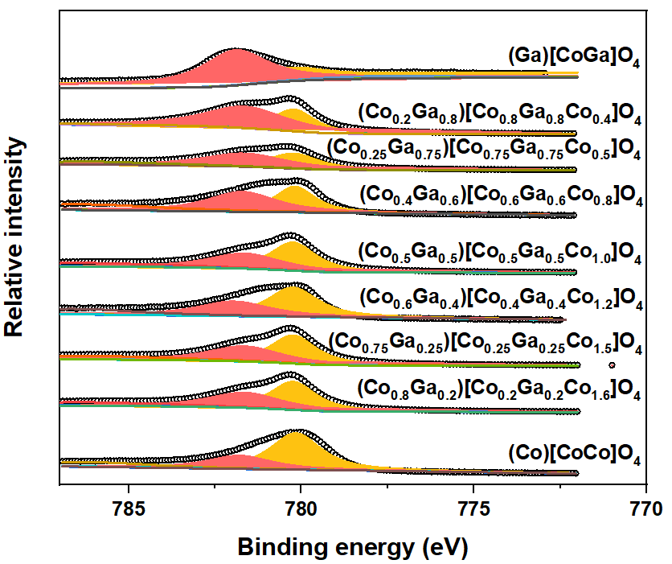
Supplementary Fig. 3: XPS spectra pf Co_{x}Ga_{(3-x)}O₄ with different concentration of Ga³⁺.

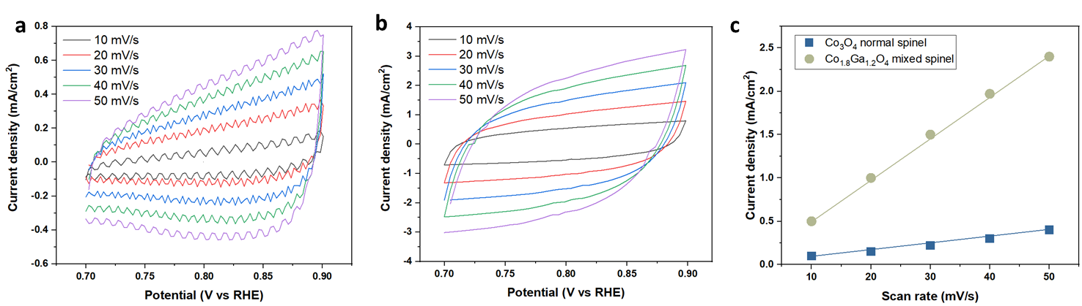
Supplementary Fig. 4: Electrochemical double layer capacitance of a, Co₃O₄ normal spinel and b, Co_{1.8}Ga_{1.2}O₄ mixed spinel. c, the Electrochemical surface area (ECSA) comparison. Co₃O₄ normal spinel has an ECSA of 0.25 mF/cm², while Co_{1.8}Ga_{1.2}O₄ mixed spinel has an ECSA of 1.31 mF/cm².

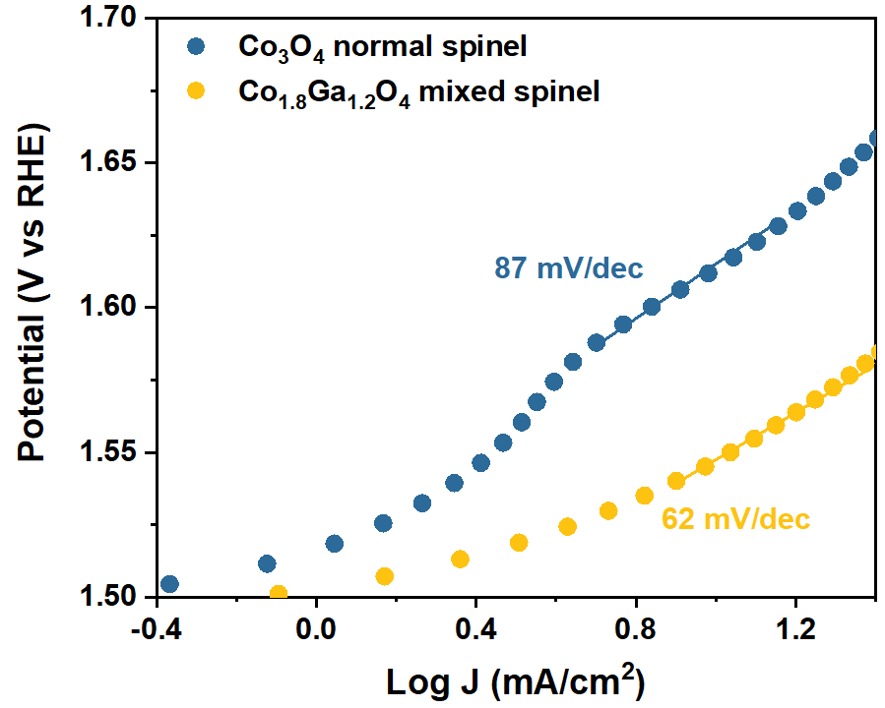
Supplementary Fig. 5: Tafel slopes comparison between Co₃O₄ normal spinel and Co_{1.8}Ga_{1.2}O₄ mixed spinel.

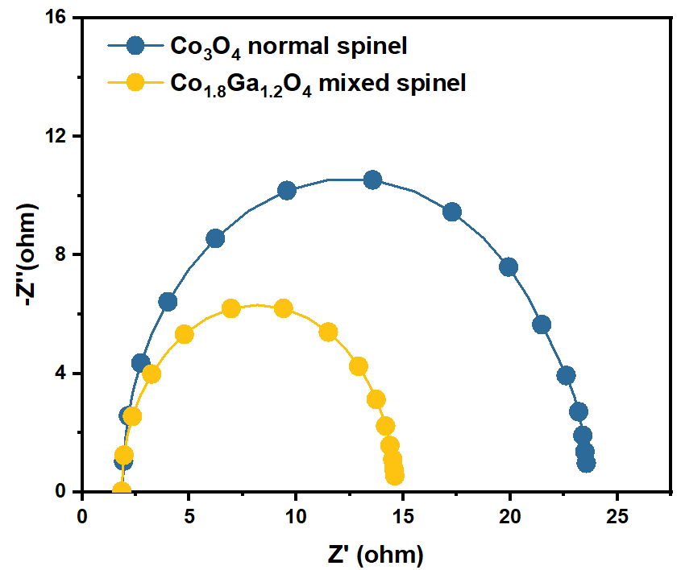
Supplementary Fig. 6: Nyquist plots comparison between Co₃O₄ normal spinel and Co_{1.8}Ga_{1.2}O₄ mixed spinel.

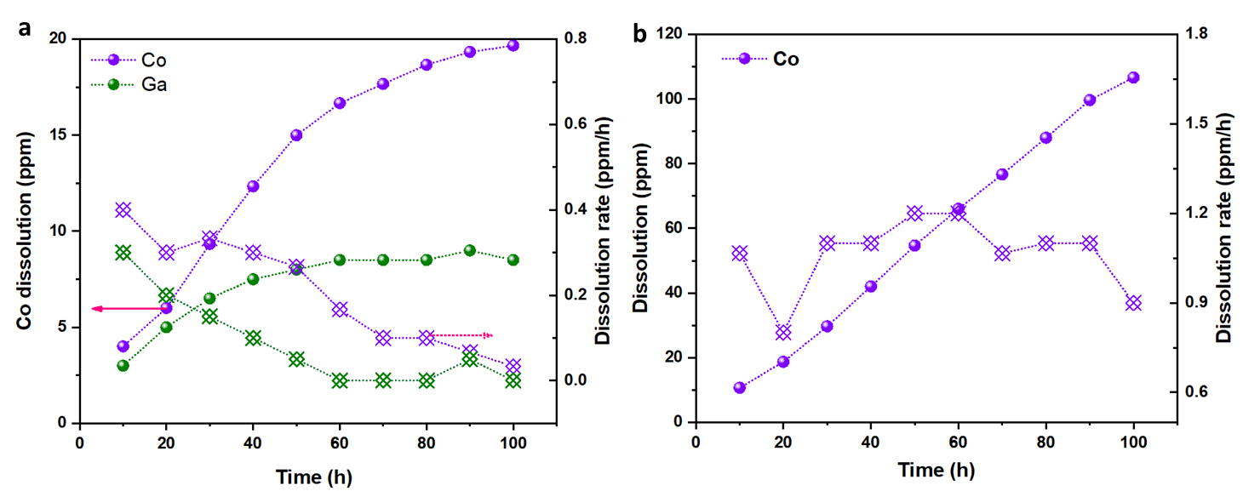
Supplementary Fig. 7: ICP-AES results of a, Co_{1.8}Ga_{1.2}O₄ and b, Co₃O₄ working at 10 mA/cm² in 0.5 M H₂SO₄, showing 5/6 of Co in Co_{1.8}Ga_{1.2}O₄ inverse spinel can be protected against dissolution during 100 hours test.

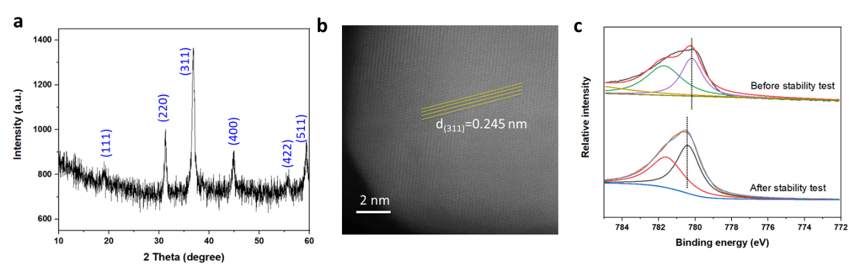
Supplementary Fig. 8: a, XRD pattern of Co_{x}Ga_{(3-x)}O₄ after stability test. b, TEM image of Co_{1.8}Ga_{1.2}O₄ after stability test. c, XPS spectra of Co in Co_{1.8}Ga_{1.2}O₄ after stability test.

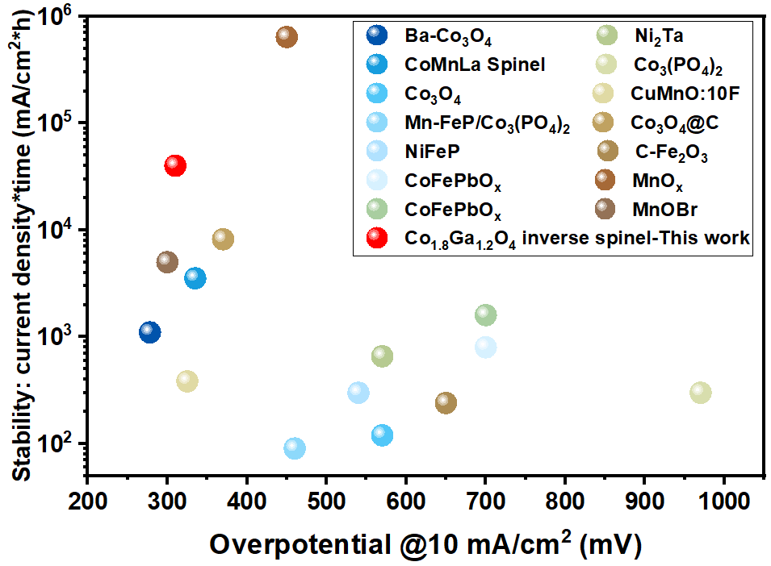
Supplementary Fig. 9: OER activity and stability for recently reported earth abundant electrocatalysts^{6,20-31}

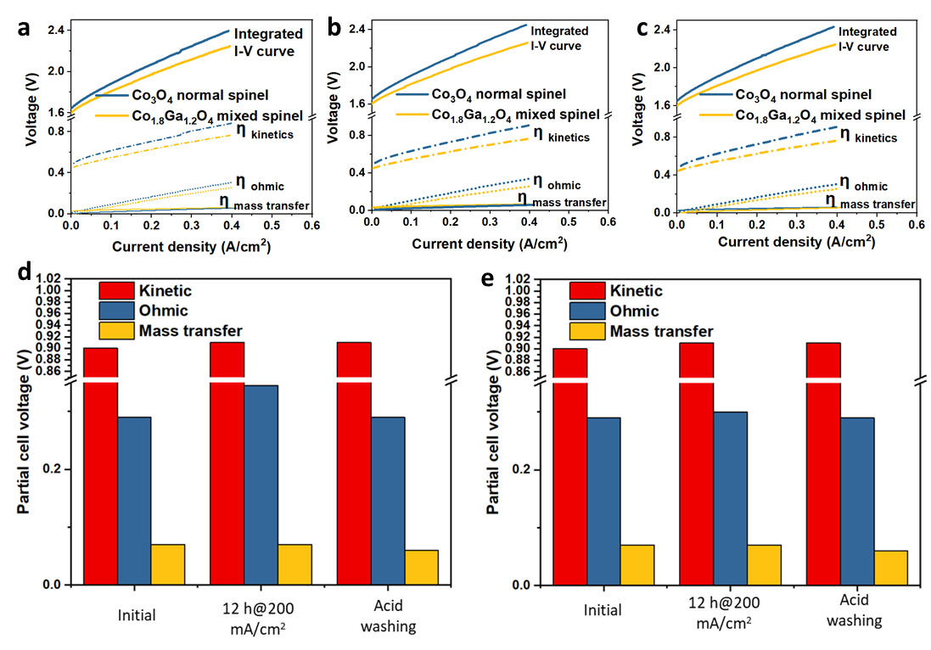
Supplementary Fig. 10: I-V curves of Co₃O₄ normal spinel and Co_{1.8}Ga_{1.2}O₄ mixed spinel in PEMWE, categorized by kinetic overpotential (η_{kinetics}), ohmic overpotential (η_{ohmic}), and mass transfer overpotential (η_{mass transfer}). PEMWE performance of Co₃O₄ normal spinel and Co_{1.8}Ga_{1.2}O₄ mixed spinel at a, Initial stage, b, after working at 200 mA/cm² for 12h, c, in a membrane electrode assembly washed using acid, then subjected to PEMWE evaluation. Comparison of cell voltage contributed by η_{kinetics}, η_{ohmic}, and η_{mass transfer} using d, Co₃O₄ normal spinel and e, Co_{1.8}Ga_{1.2}O₄ mixed spinel as the anode.

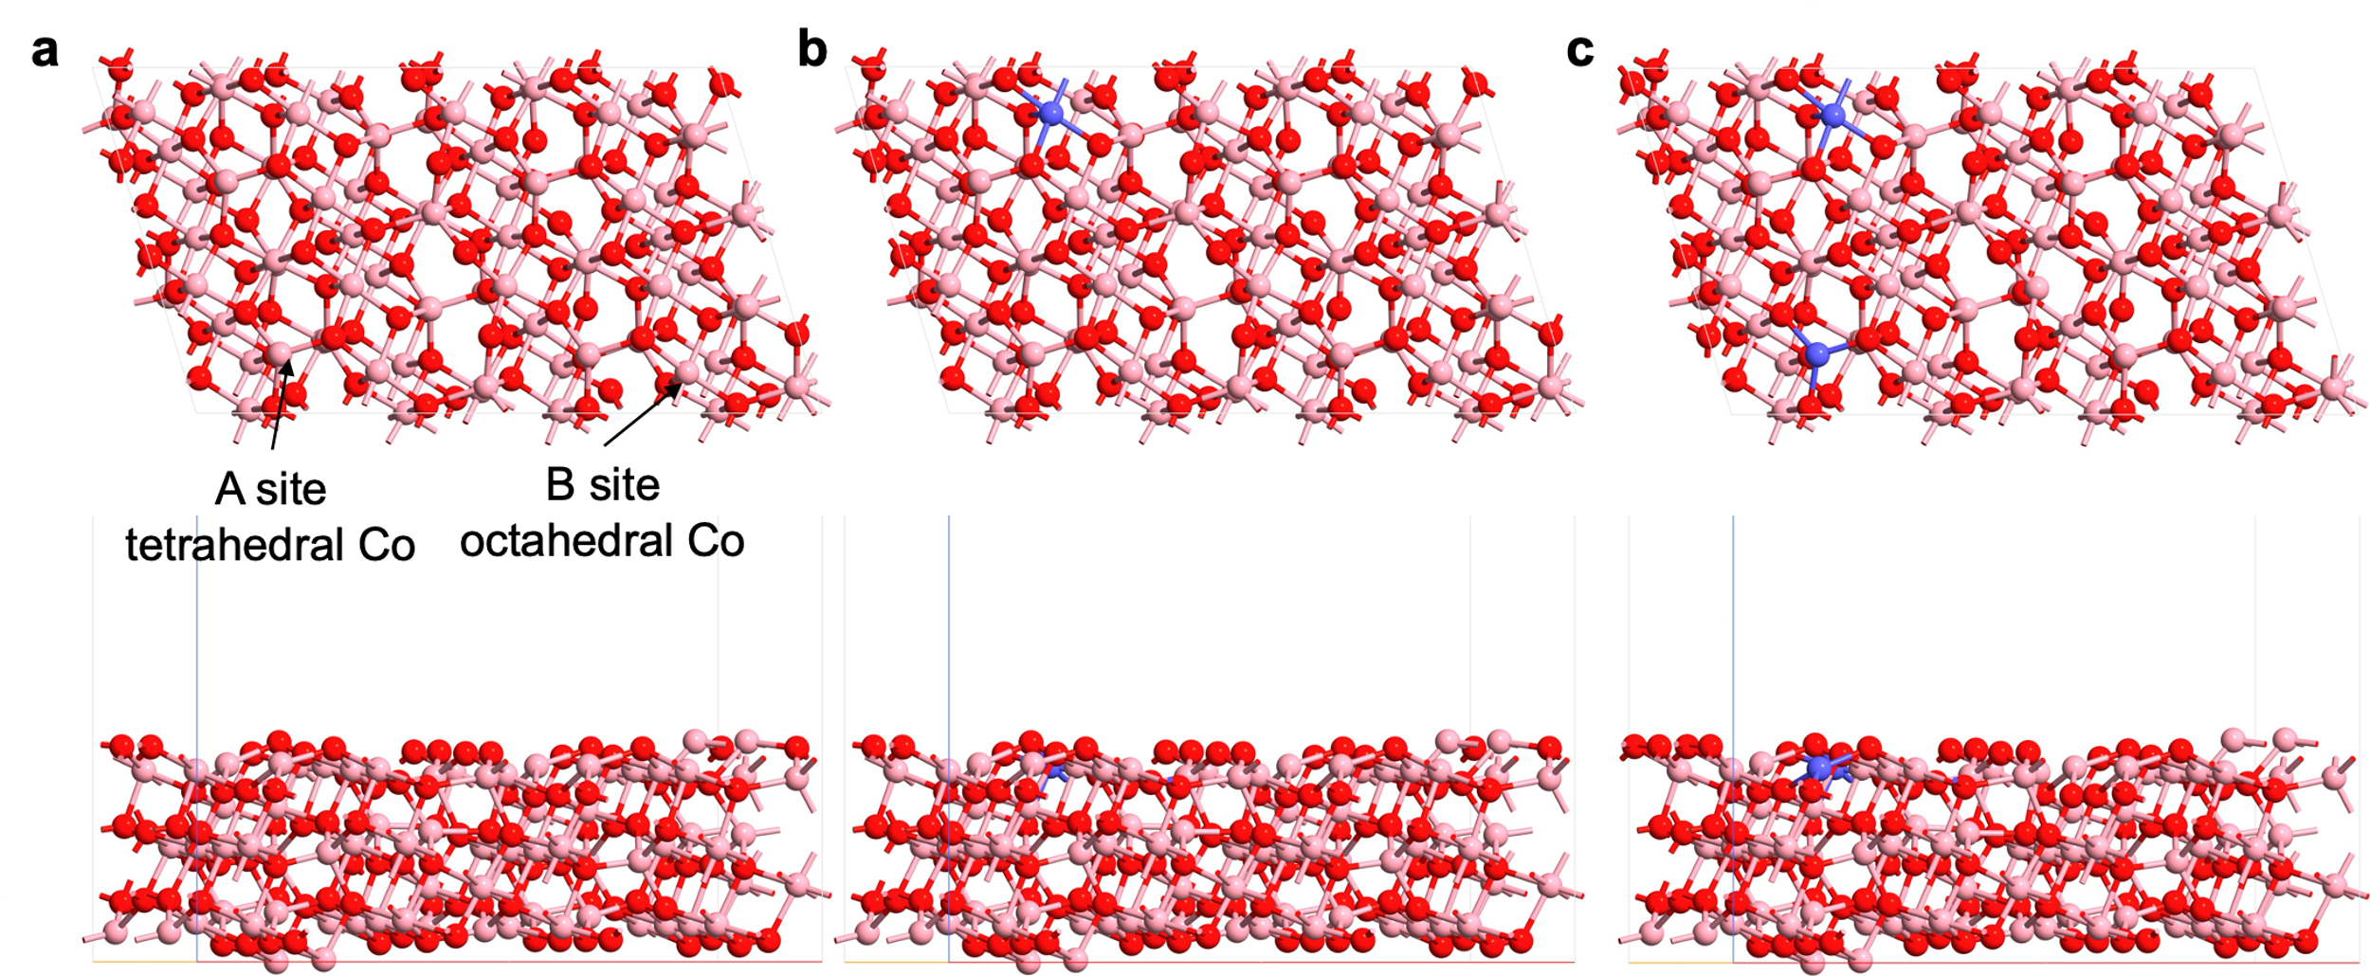
Supplementary Fig. 11: Surface structures of Co₃O₄ and Co_{1.8}Ga_{1.2}O₄. (311) surface structures of Co₃O₄ (a), Co₃O₄ with one Co atom substituted by Ga atom (b), and Co₃O₄ with two Co atoms substituted by Ga atoms (c). The pink, purple, and red atoms refer to Co, Ga, and O, respectively. A and B sites labelled by black arrows represent the tetrahedral and octahedral site in the normal and inverse spinel structure. The location of substituted Ga atoms was determined by systematically consider the inequivalent site and used the most thermodynamic stable configuration as the final structure, and the structure in c was used to represent the Co_{1.8}Ga_{1.2}O₄ in the present study.
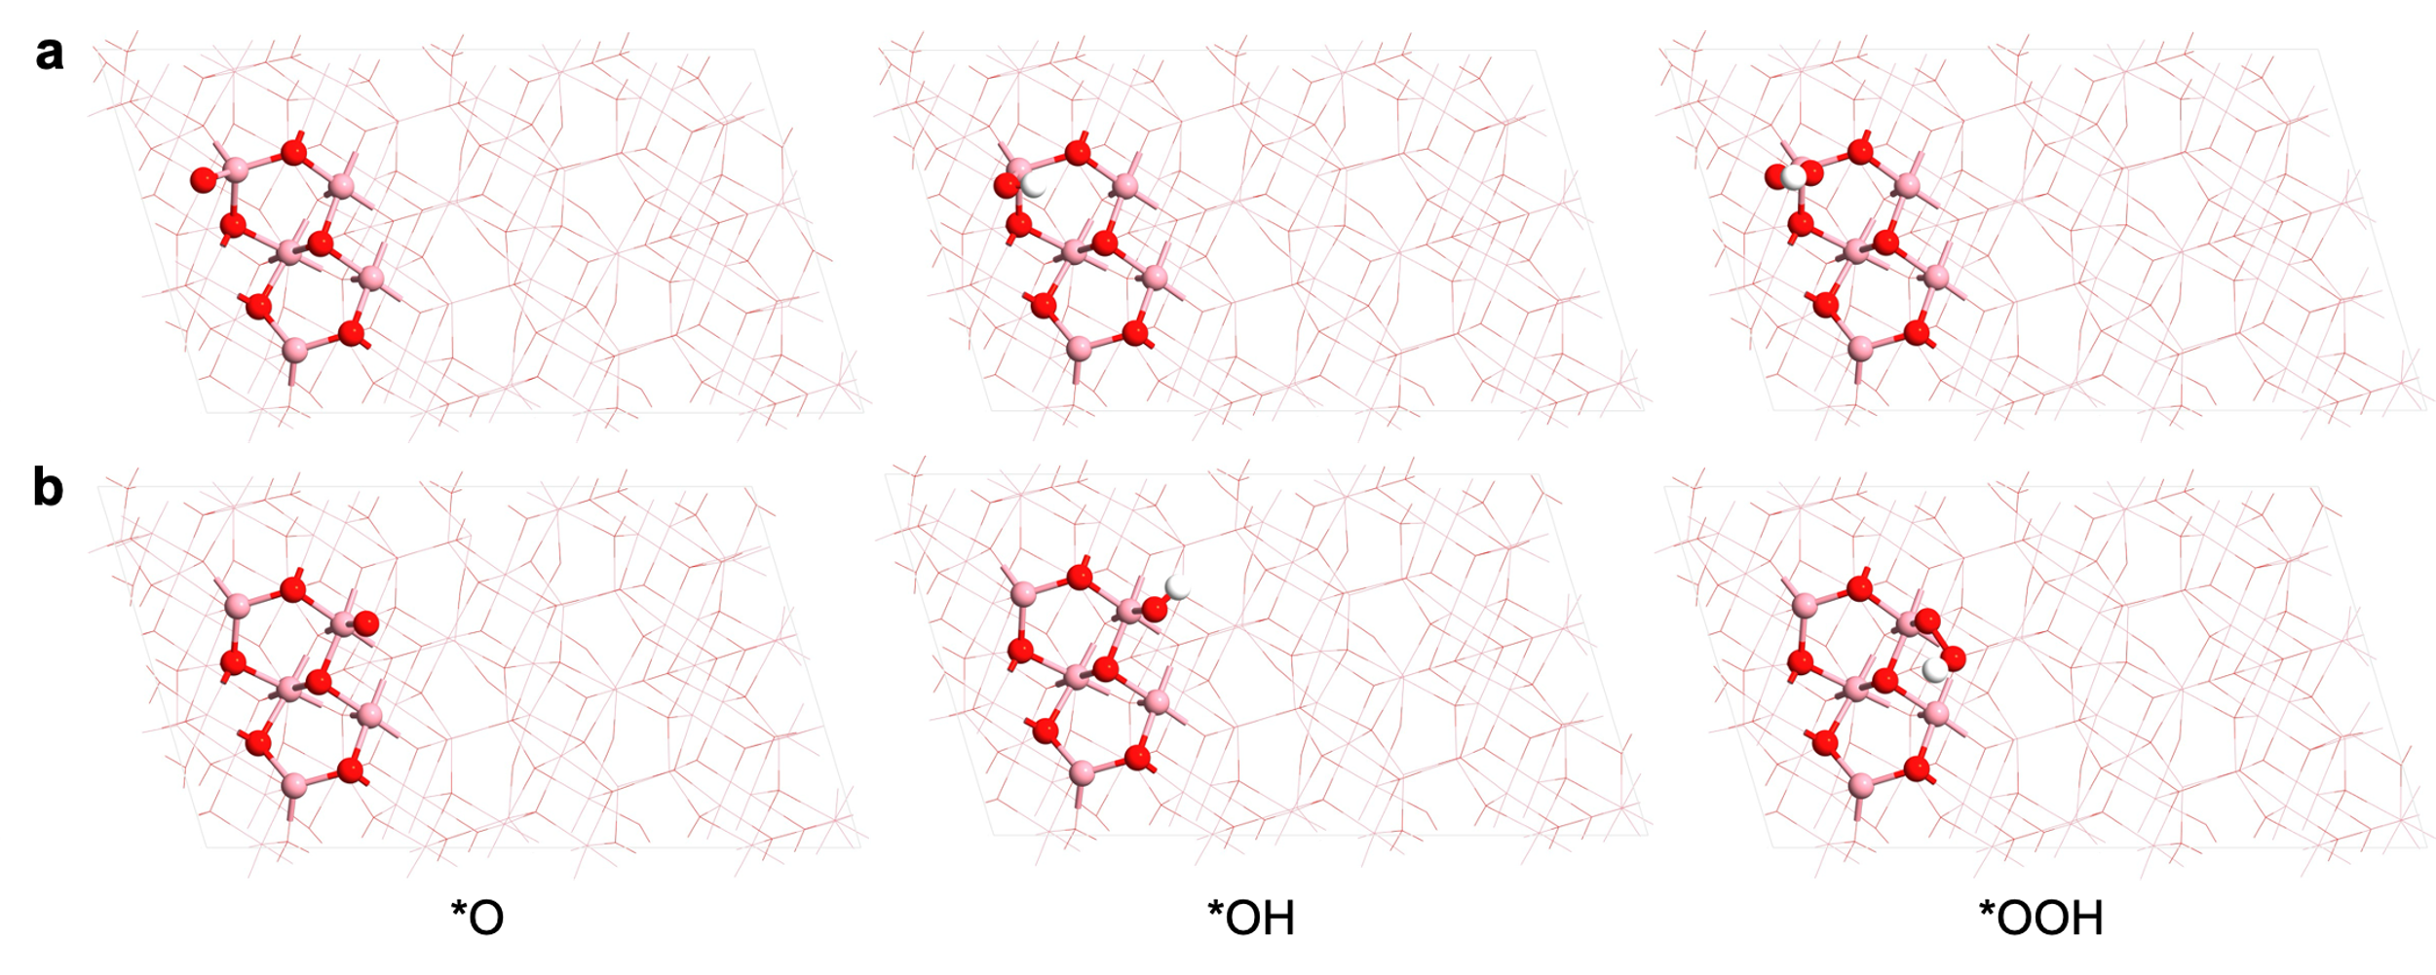
Supplementary Fig. 12: OER intermediates in AEM on Co₃O₄. OER intermediates in AEM, *O, *OH, *OOH, adsorbed on A site (a) and B site (b), respectively. The pink and red atoms refer to Co and O, respectively.

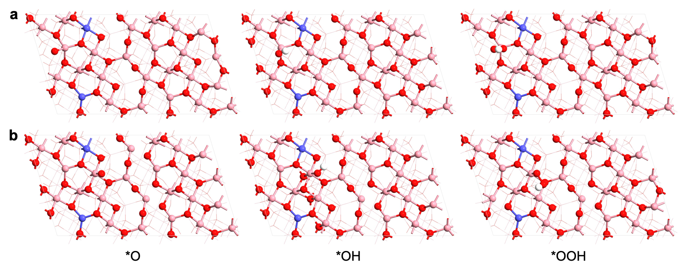
Supplementary Fig. 13: OER intermediates in AEM on Co_{1.8}Ga_{1.2}O₄. OER intermediates in AEM, *O, *OH, *OOH, adsorbed on A site (a) and B site (b), respectively. The pink, purple, and red atoms refer to Co, Ga, and O, respectively.

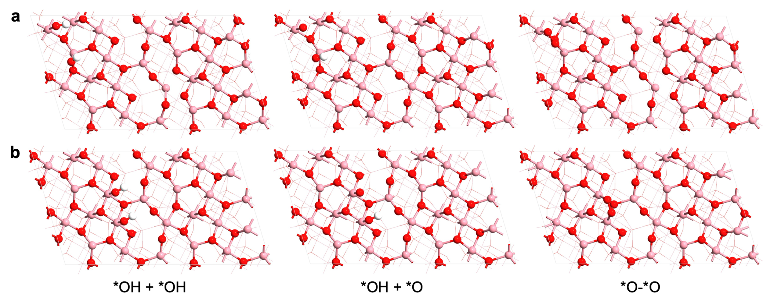
Supplementary Fig. 14: OER intermediates in OPM on Co₃O₄. OER intermediates in OPM, *OH-*O, *OH-*OH, *O-*O, adsorbed on combined A-B sites (a) and B-B sites (b), respectively. The pink and red atoms refer to Co and O, respectively.

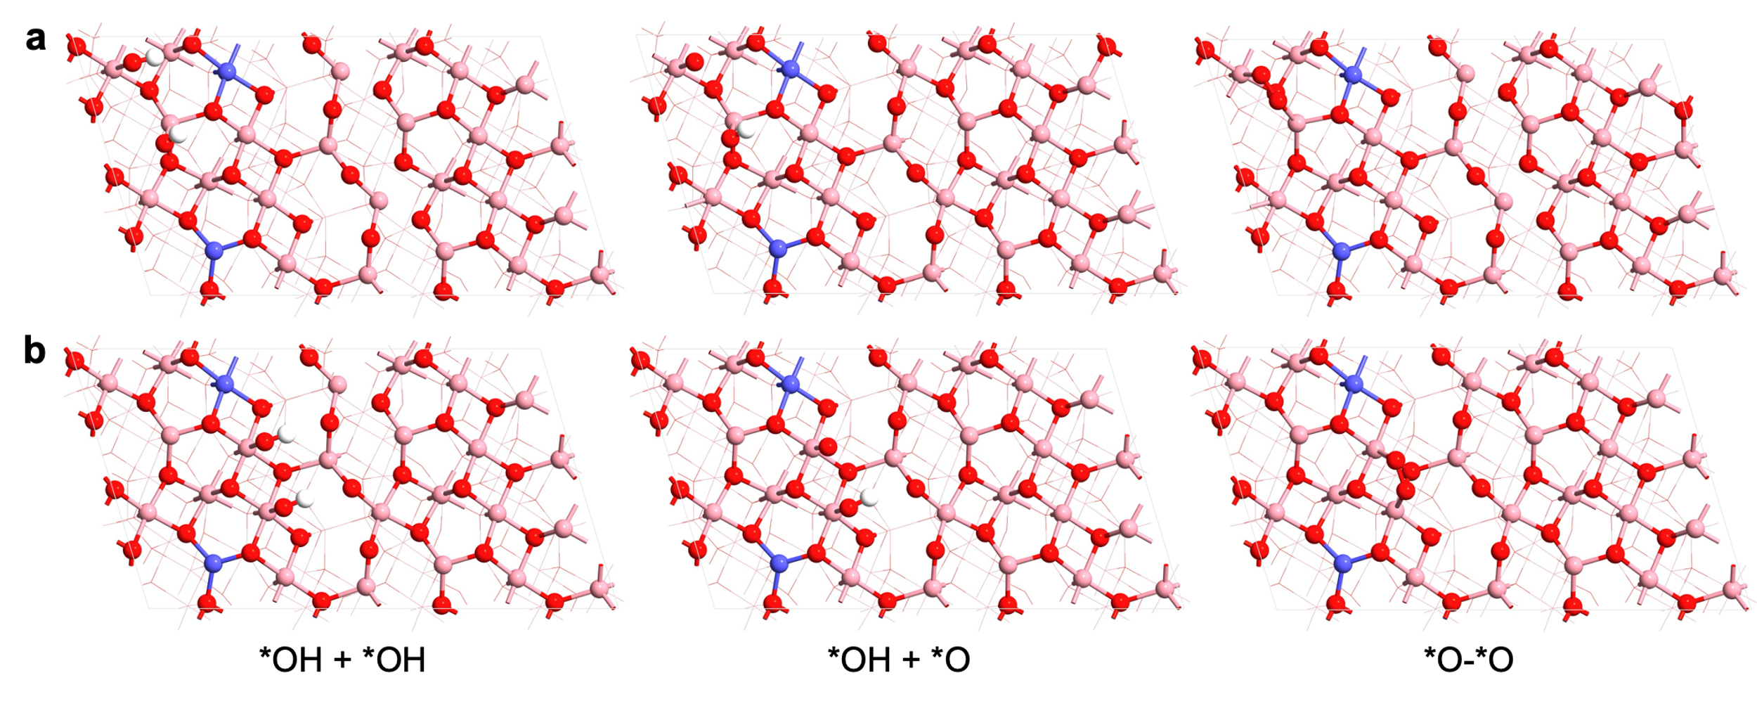
Supplementary Fig. 15: OER intermediates in OPM on Co_{1.8}Ga_{1.2}O₄. OER intermediates in OPM, *OH-*O, *OH-*OH, *O-*O, adsorbed on combined A-B sites (a) and B-B sites (b), respectively. The pink and red atoms refer to Co and O, respectively.

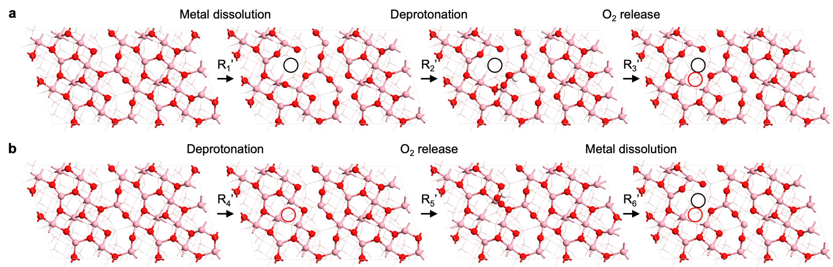

Supplementary Fig. 16: Co₃O₄ surfaces in dissolution pathways. Optimized geometry of Co₃O₄ surfaces in M and O pathways as depicted in Fig. 4c, respectively. R₁’–R₃’ is the M pathway which prioritizes metal dissolution. R₄’–R₆’ is the O pathway which prioritizes oxygen 6 dissolution. The pink, purple, and red atoms refer to Co, Ga, and O, respectively.

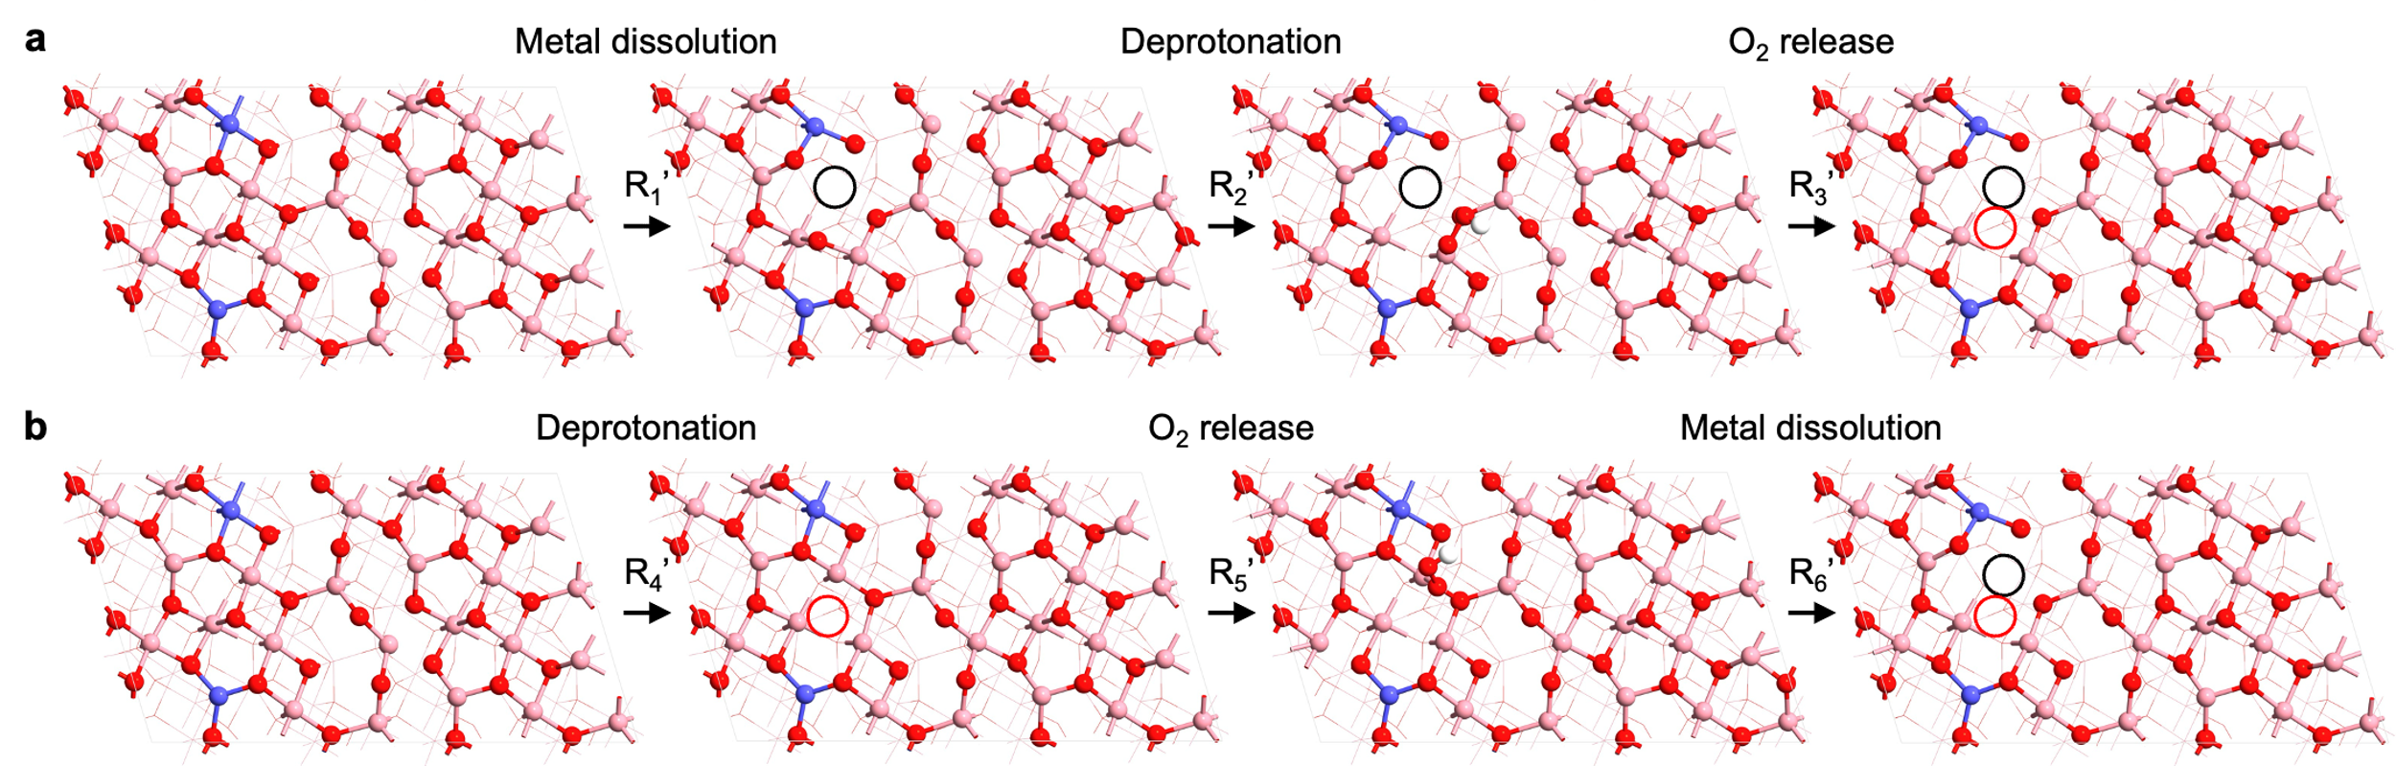
Supplementary Fig. 17: Co_{1.8}Ga_{1.2}O₄ surfaces in dissolution pathways. Optimized geometry of Co_{1.8}Ga_{1.2}O₄ surfaces in M and O pathways as depicted in Fig. 4c, respectively. R₁’–R₃’ is the M pathway which prioritizes metal dissolution. R₄’–R₆’ is the O pathway which prioritizes oxygen 6 dissolution. The pink, purple, and red atoms refer to Co, Ga, and O, respectively.

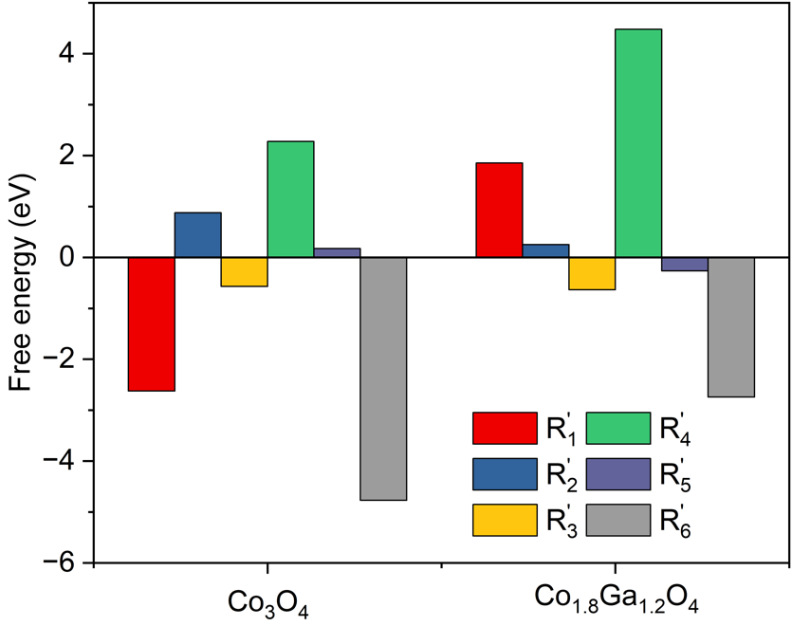
Supplementary Fig. 18: Energetics of dissolution on Co₃O₄ and Co_{1.8}Ga_{1.2}O₄ surfaces. OER intermediates in AEM, *O, *OH, *OOH, adsorbed on A site (a) and B site (b), respectively. The pink, purple, and red atoms refer to Co, Ga, and O, respectively.

Supplementary Table 1: OER performance comparison between Co_{1.8}Ga_{1.2}O₄ inverse spinel with other PGM-free acidic OER electrocatalysts.

Catalyst | Overpotential @10 mA/cm² (mV) | Stability (time @ current density) | Reference in main text
CoMnLaO_{x} | 300 | 350 h @ 10 mA/cm² | 6
Co₂MnO₄ | 395 | 320 h @ 100 mA/cm²; 60 h @ 200 mA/cm² | 11
Ba-Co₃O₄ | 278 | 110 h @ 10 mA/cm² | 20
NiFeP | 540 | 30 h @ 10 mA/cm² | 21
CoFePbO_{x} | 700 | 8 h @100 mA/cm² | 22
Ni₂Ta | 570 | 66 h @ 10 mA/cm² | 23
Mn-doped FeP/Co₃(PO₄)₂ | 390 | 8.3 h@5 mA/cm² | 24
Co₃O₄ | 360 | 40 h @ 10 mA/cm² | 25
Mn_{7.5}O₁₀Br₃ | 290 | 500 h @ 10 mA/cm² | 26
ONPPGC/OCC | 470 | 10 h@ 10 mA/cm² | 27
Co₃O₄@C | 370 | 82 h @100 mA/cm² | 28
C-Fe₃O₄ | 650 | 24 h @ 10 mA/cm² | 29
CuMnO:F | 325 | 24 h @ 16 mA/cm² | 30
MnO_{x} | 420 | 3200 h@200 mA/cm² | 31
Co_{1.8}Ga_{1.2}O₄ | 270 | 200 h @ 200 mA/cm² | This work

