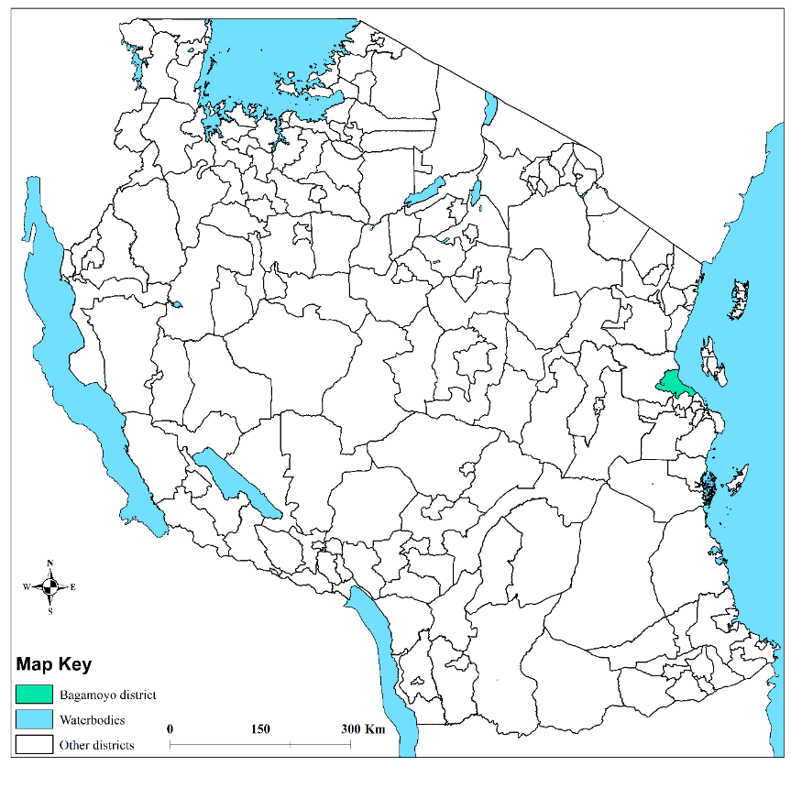
Map generated by Yeromin P Mlacha (IHI)

