Local extinction of an isolated dugong population near Okinawa Island, Japan

Hajime Kayanne, Takeshi Hara, Nobuaki Arai, Hiroya Yamano, Hiroyuki Matsuda

Supplementary Information

This document contains:
Extended Data Figures 1 to 7.
Supplementary Tables 1 and 2.

As separate Excel file:
Supplementary Data 1. Identification of dugong individuals along Okinawa Island coast.

a b
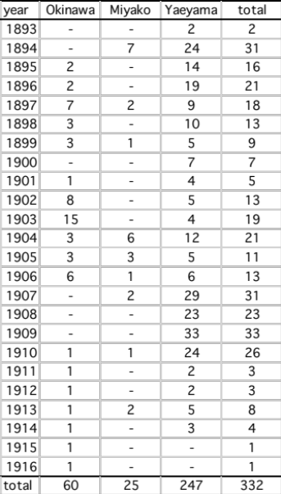

Extended Data Fig. 1: Change in dugong population sizes between 1893 and 1916. a, Estimates of the numbers of dugongs near Ryukyu Islands (C_{t}), based on harvest records. b, Table of harvest records reconstructed from fishery statistics^{10,11}.
a b c
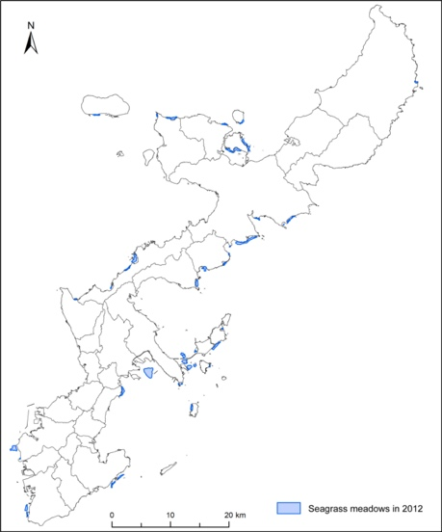
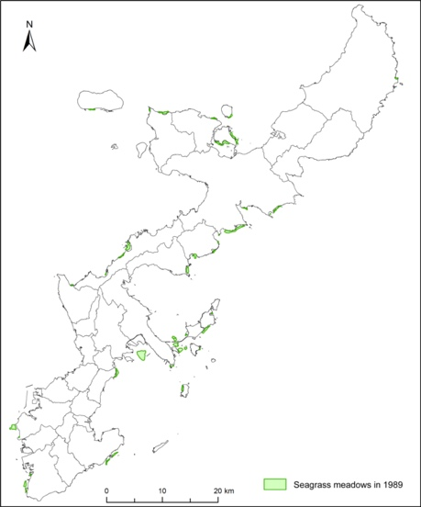
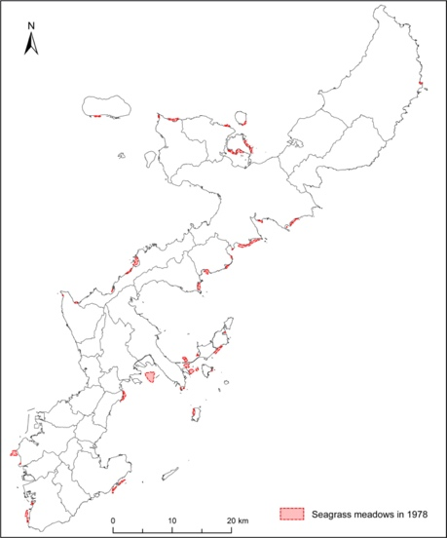

Extended Data Fig. 2: Change in areas of seagrass meadows. area in 1978 (a); in 1989 (b); and in 2012 (c).

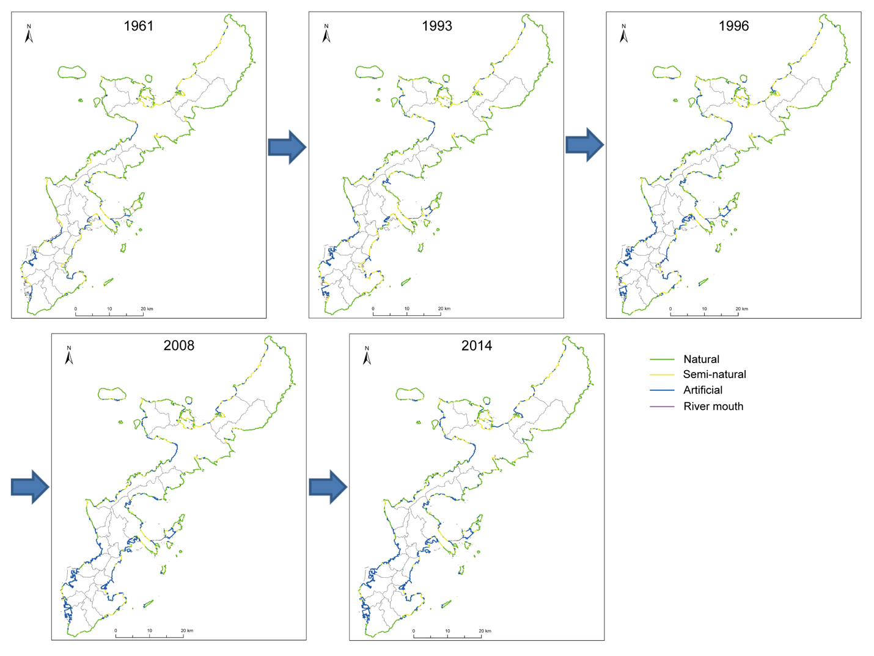

Extended Data Fig. 3: Change in the coastline around Okinawa Island. Natural (green), semi-natural (yellow)，artificial (blue), and river mouth (purple). Data source: for 1961 and 2008 (ref. ²⁴); for 1993 (ref. ²⁵); for 1996 (ref. ²⁶). The figure for 2014 was prepared based on topographic maps and aerial photographs of the Geospatial Information Authority of Japan.
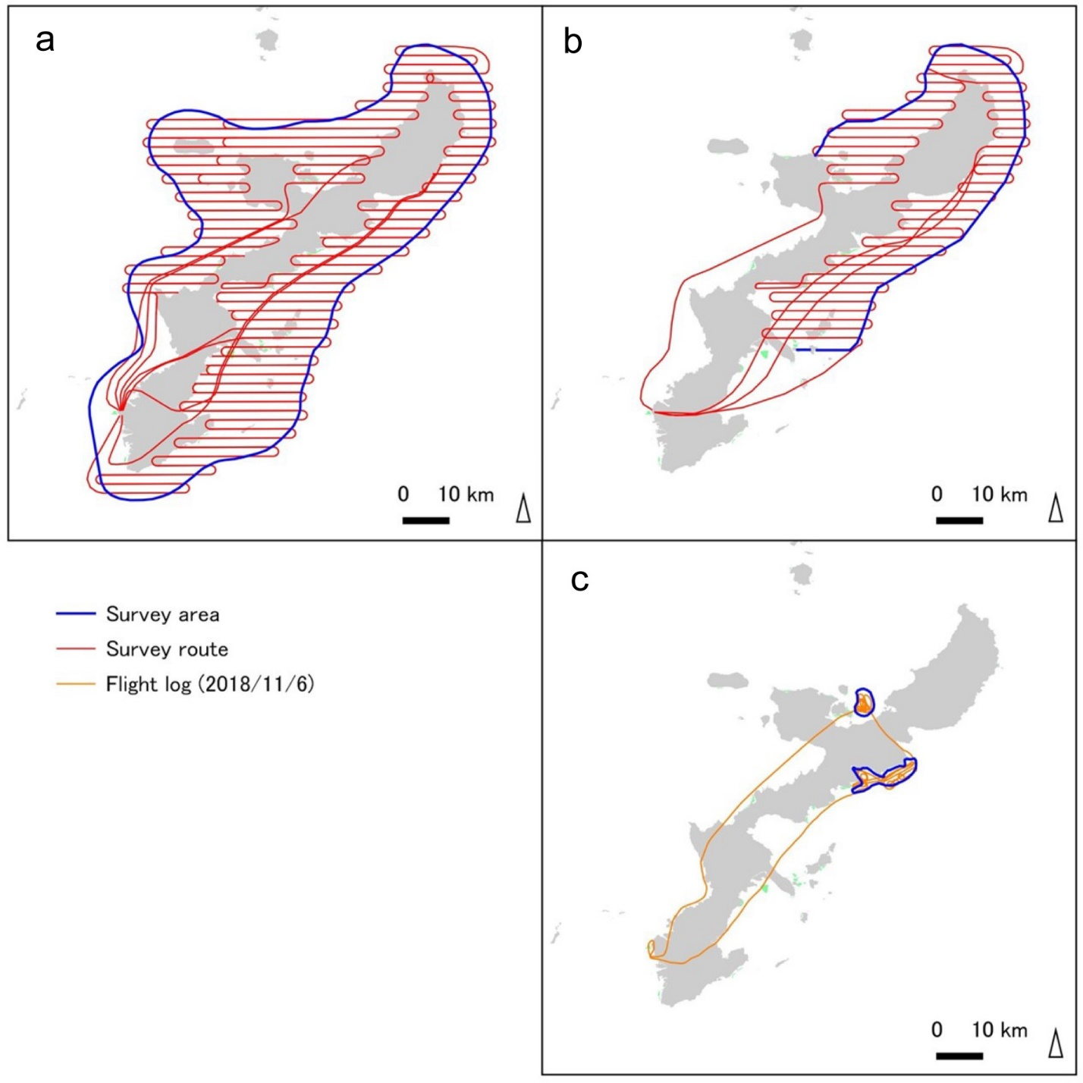

Extended Data Fig. 4: Representative survey tracks of the aircraft. a, Once a month from 2007 to June 2009. b, Four times a year since 2009. c, Once a week by helicopter since 2014.
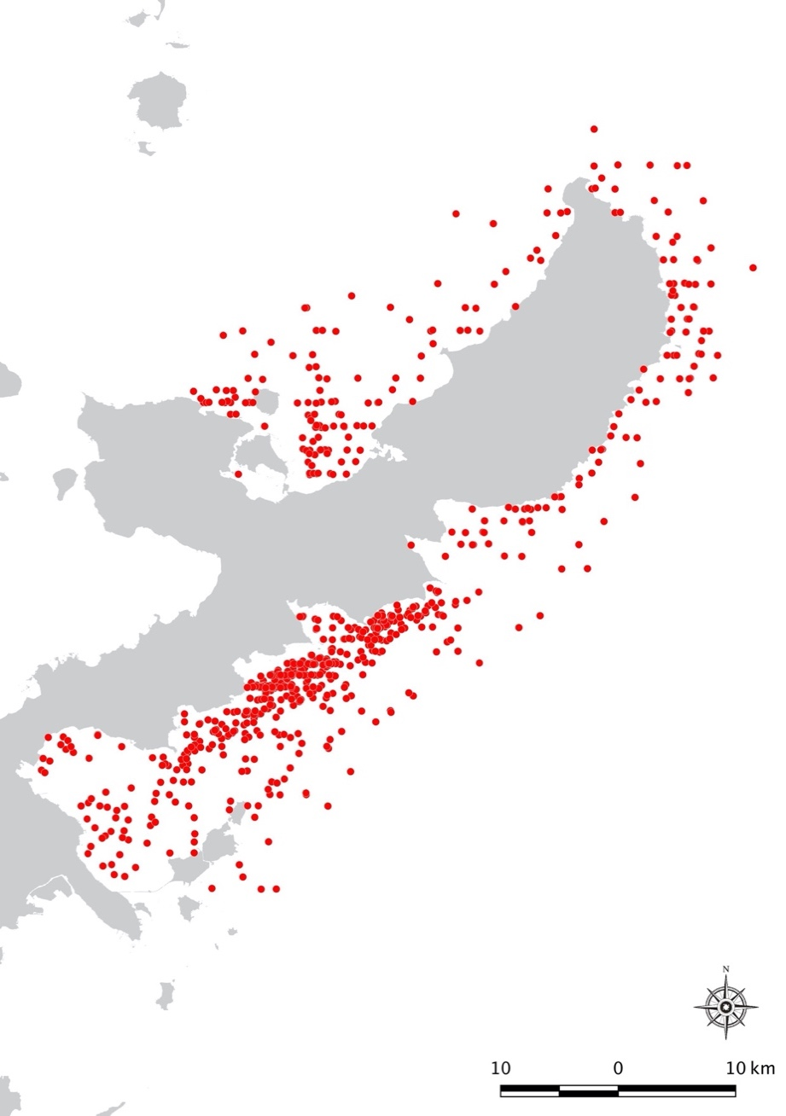

Extended Data Fig. 5: Records of sea turtle observations. From May 2009 to September 2018, which were identified during the dugong surveys by aircraft and helicopter.
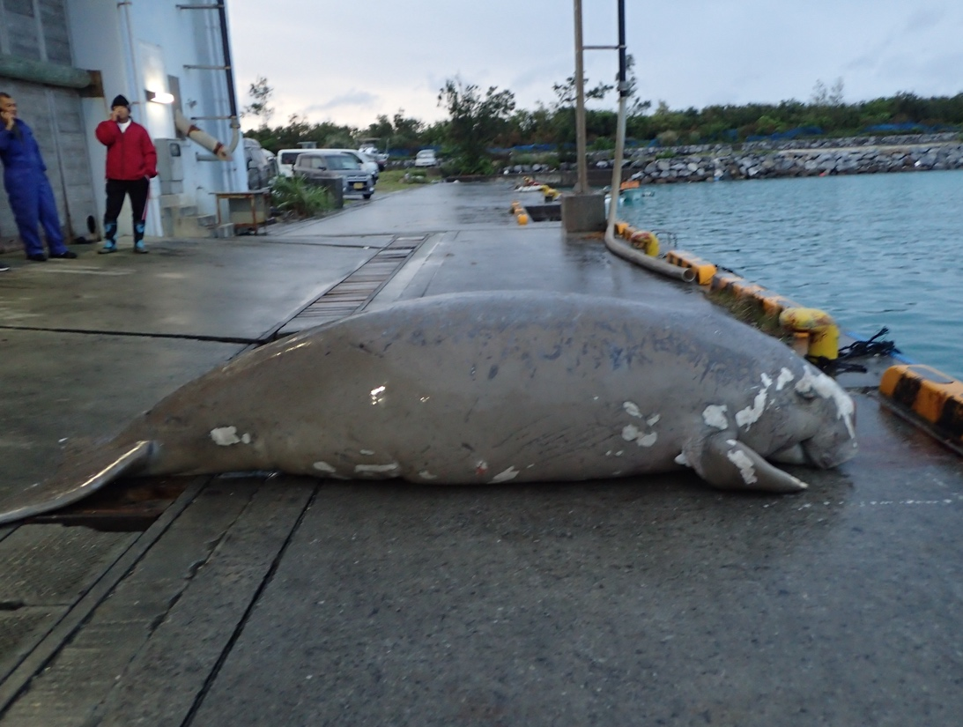

Extended Data Fig. 6: Dead body of individual B. Found on 18 March 2019 at Unten Port, east coast of Okinawa.

Extended Data Fig. 7: The probability that N₁₉₉₇≤ 11 against the range of 10 < N₁₉₇₉ < 25 under different fecundity, survival, and growth rates.

Supplementary Table 1. Record of caught or drifted dugong individuals.
Based on (ref. ²²), with addition and revision from the source of newspaper accounts and the recent one of N23.
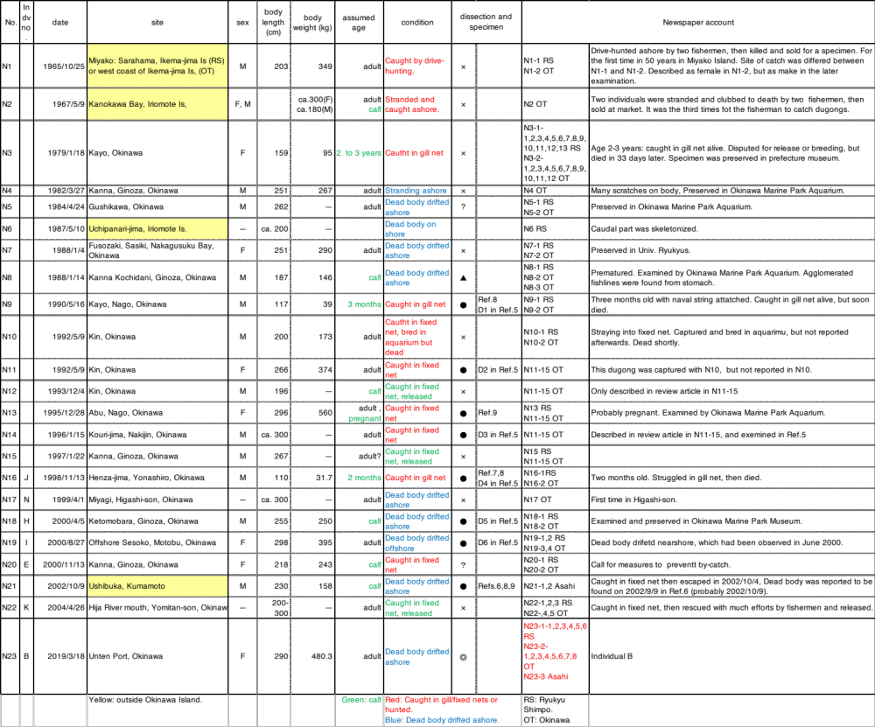

Supplementary Table 2. Records of caught or drifted dugong individuals.
An example of population change based on a probability model estimated from the number of drifted bodies with different r. "-" indicates extinction.

t | Ct | r=5% | r =4% | r=2% | r=1% | r=0.1%
1979 | 1 | 12 | 13 | 18 | 21 | 24
1980 | 0 | 13 | 14 | 18 | 20 | 23
1981 | 0 | 13 | 14 | 18 | 20 | 23
1982 | 1 | 14 | 14 | 18 | 20 | 23
1983 | 0 | 15 | 13 | 17 | 19 | 22
1984 | 1 | 16 | 13 | 17 | 20 | 22
1985 | 0 | 15 | 12 | 16 | 19 | 21
1986 | 0 | 15 | 12 | 16 | 19 | 21
1987 | 0 | 16 | 12 | 16 | 19 | 21
1988 | 2 | 18 | 12 | 16 | 19 | 21
1989 | 0 | 17 | 10 | 14 | 17 | 19
1990 | 1 | 17 | 11 | 14 | 17 | 19
1991 | 0 | 19 | 10 | 14 | 16 | 18
1992 | 2 | 20 | 11 | 15 | 16 | 18
1993 | 1 | 18 | 9 | 13 | 15 | 16
1994 | 0 | 18 | 10 | 12 | 14 | 15
1995 | 1 | 19 | 11 | 12 | 14 | 15
1996 | 1 | 20 | 11 | 11 | 13 | 14
1997 | 1 | 19 | 11 | 10 | 12 | 13
1998 | 1 | 21 | 11 | 9 | 11 | 12
1999 | 1 | 21 | 11 | 8 | 10 | 11
2000 | 3 | 21 | 10 | 7 | 10 | 10
2001 | 0 | 19 | 7 | 4 | 7 | 7
2002 | 1 | 20 | 7 | 4 | 7 | 7
2003 | 0 | 20 | 6 | 3 | 6 | 6
2004 | 0 | 21 | 6 | 3 | 6 | 6
Frequency |  | 54% | 42% | 51% | 50% | 31%

