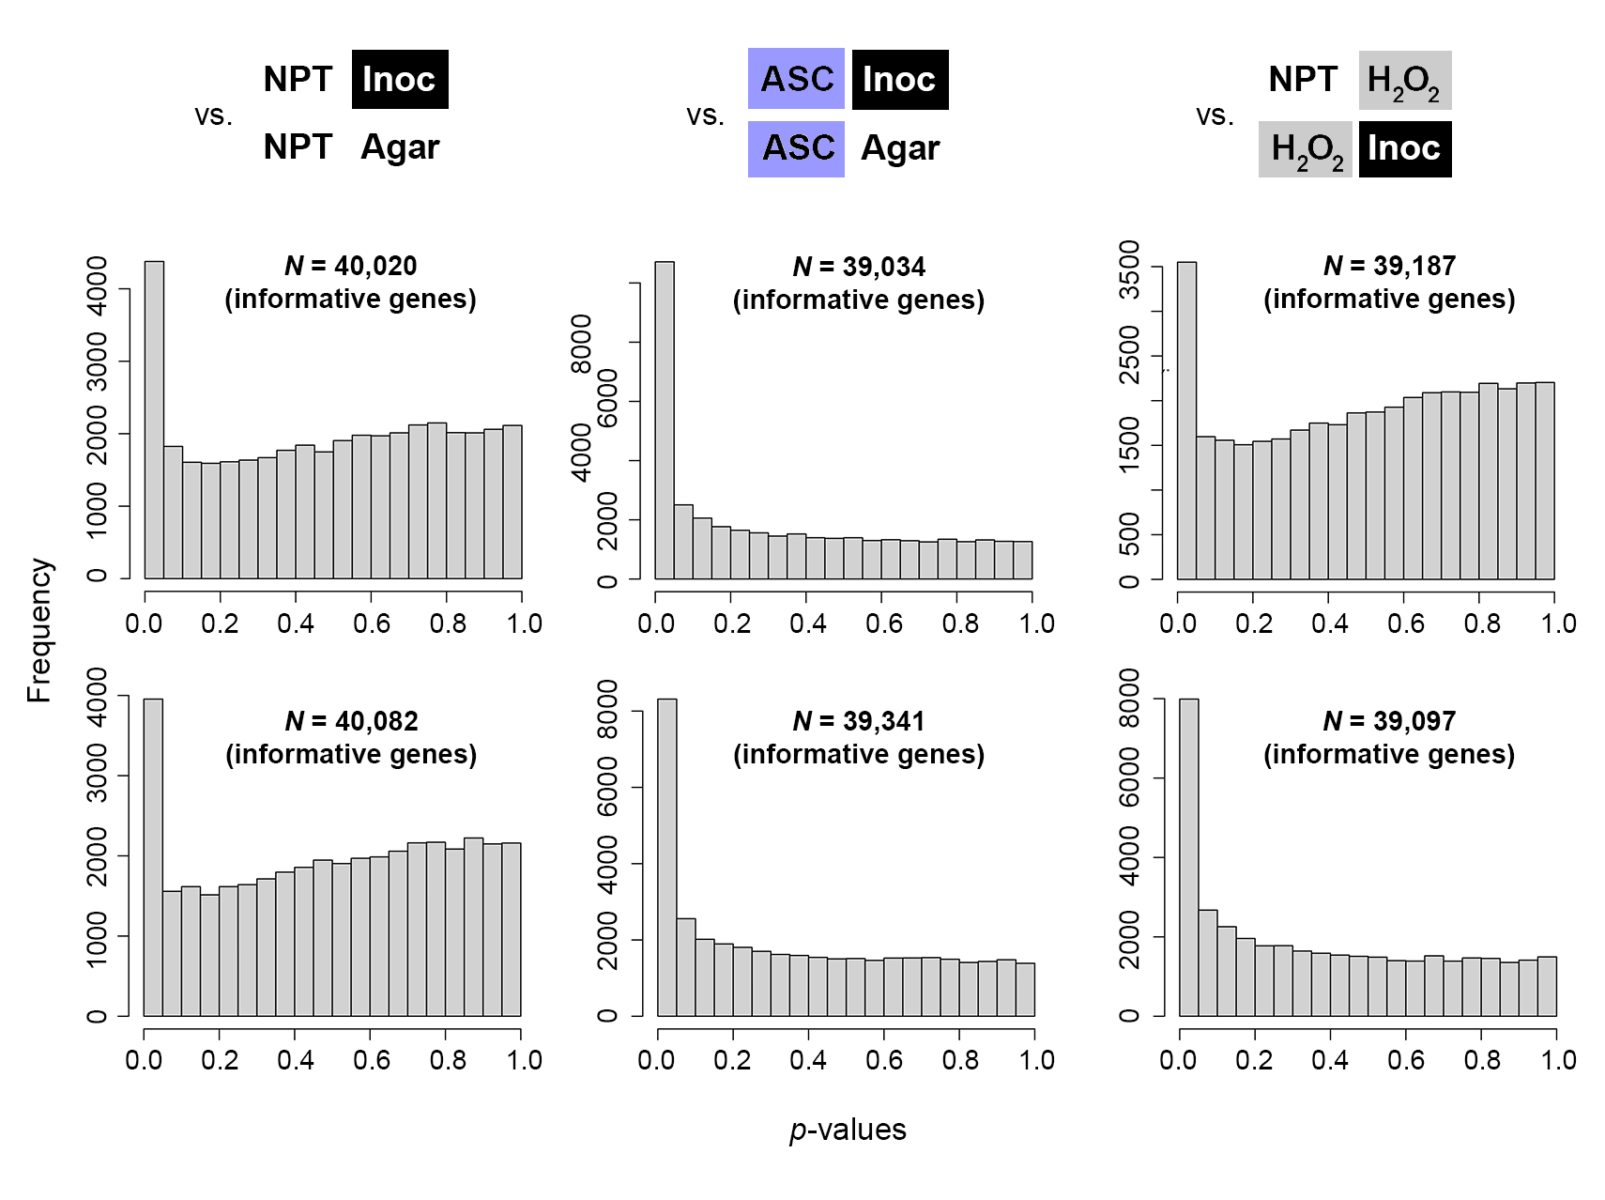
B
F
E
D
C
A
Fig. S1 P value histograms of the informative genes of normalized read counts for the treatment comparisons of the resistant genotype [R-G] DT97-4290: (Panels A-C) for the non-pre-treated [NPT] mock-inoculated [Agar] vs. M. phaseolina-inoculated [Inoc] (A), ascorbic acid [ASC] pre-treated inoculated [Inoc] vs. mock-inoculated [Agar] (B), non-pre-treated H₂O₂ vs. H₂O₂ pre-treated M. phaseolina -inoculated treatment (C). In the susceptible genotype [S-G] Pharaoh: (Panels D-F) for the non-pre-treated mock-inoculated [Agar] vs. inoculated [Inoc] (D), ascorbic acid pre-treated [ASC] inoculated [Inoc] vs. mock-inoculated [Agar] (E), and non-pre-treated [NPT] H₂O₂ vs. H₂O₂ pre-treated inoculated [Inoc] treatment (F).

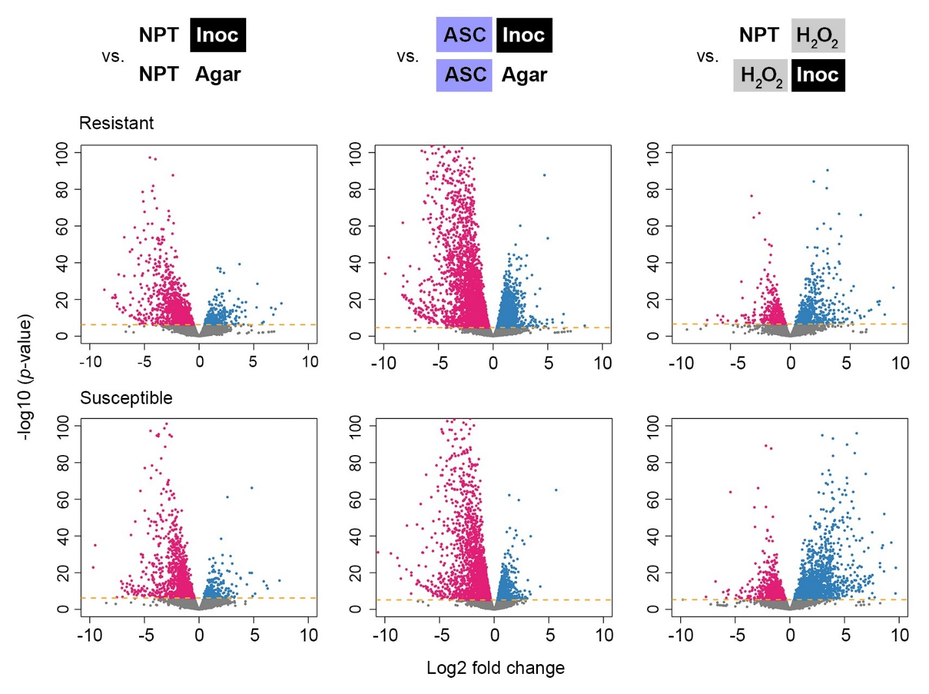

Fig. S2 Volcano plots displaying differential gene expression of log2 fold changes versus negative log10 p-values for pairwise comparisons within the resistant genotype DT97-290 for M. phaseolina-inoculated [Inoc] vs. mock-inoculated [Agar]; ascorbic acid pre-treated [ASC] inoculated [Inoc] vs. mock-inoculated [Agar]; and non-pre-treated [NPT] and H₂O₂-treated vs. H₂O₂ pre-treated and inoculated [Inoc]; in the susceptible genotype pharaoh for inoculated [Inoc] vs. mock inoculated [Agar]; ascorbic acid pre-treated and inoculated [Inoc] vs. mock-inoculated [C]; and non-pre-treated [NPT] and H₂O₂-treated vs. H₂O₂ pre-treated and inoculated [Inoc].

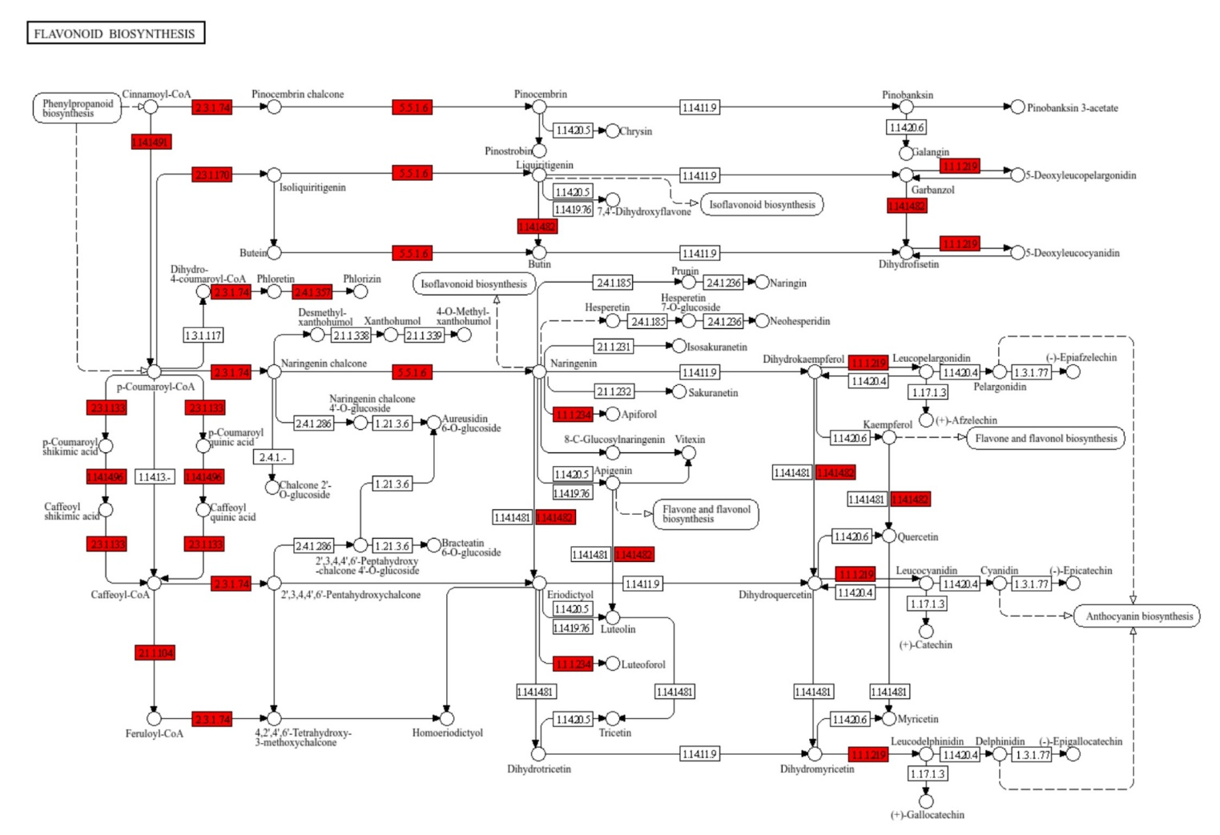
Fig. S3 Flavonoid biosynthesis pathway associated genes (highlighted) induced in the resistant genotype when comparing non-pre-treated M. phaseolina-inoculated vs. non-pre-treated mock-inoculated control

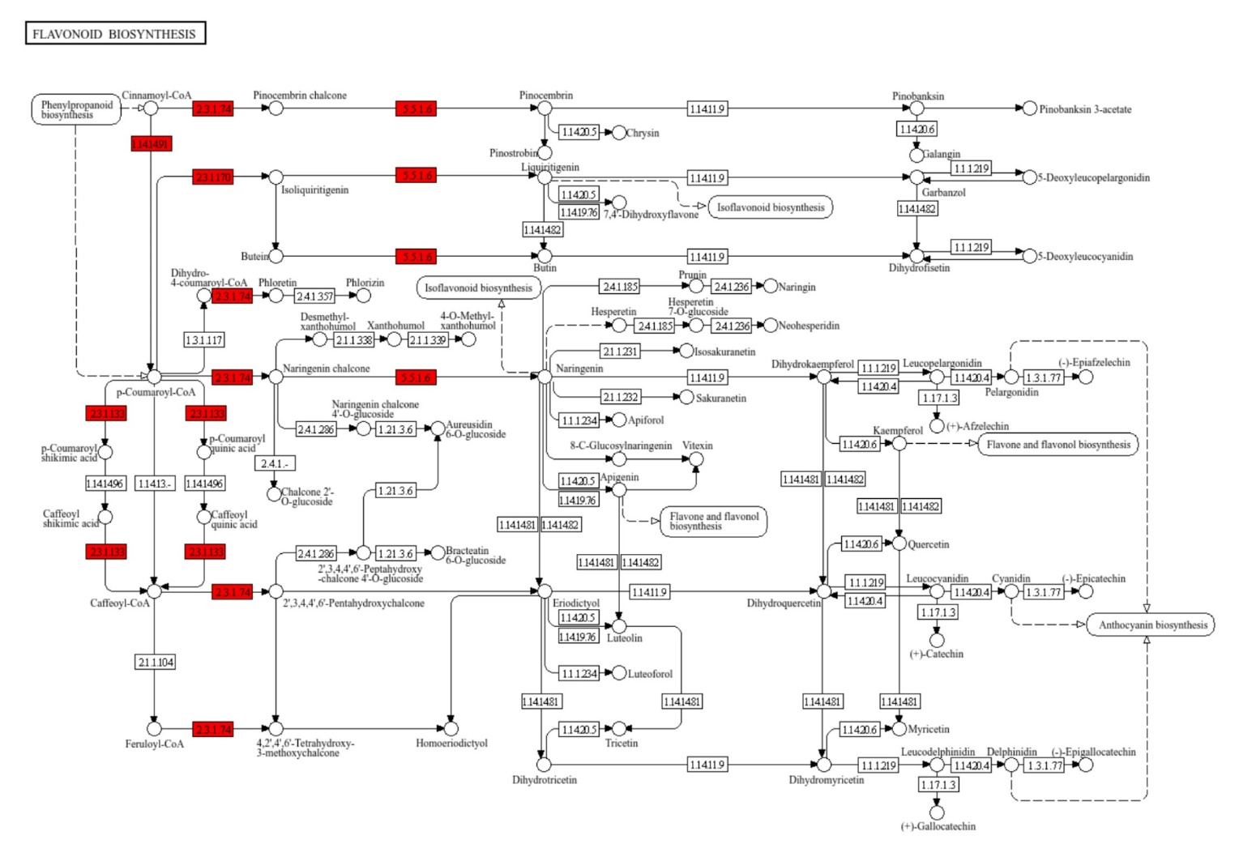
Fig. S4 Flavonoid biosynthesis pathway associated genes (highlighted) induced in the susceptible genotype when comparing non-pre-treated M. phaseolina-inoculated versus the non-pre-treated mock-inoculated control.

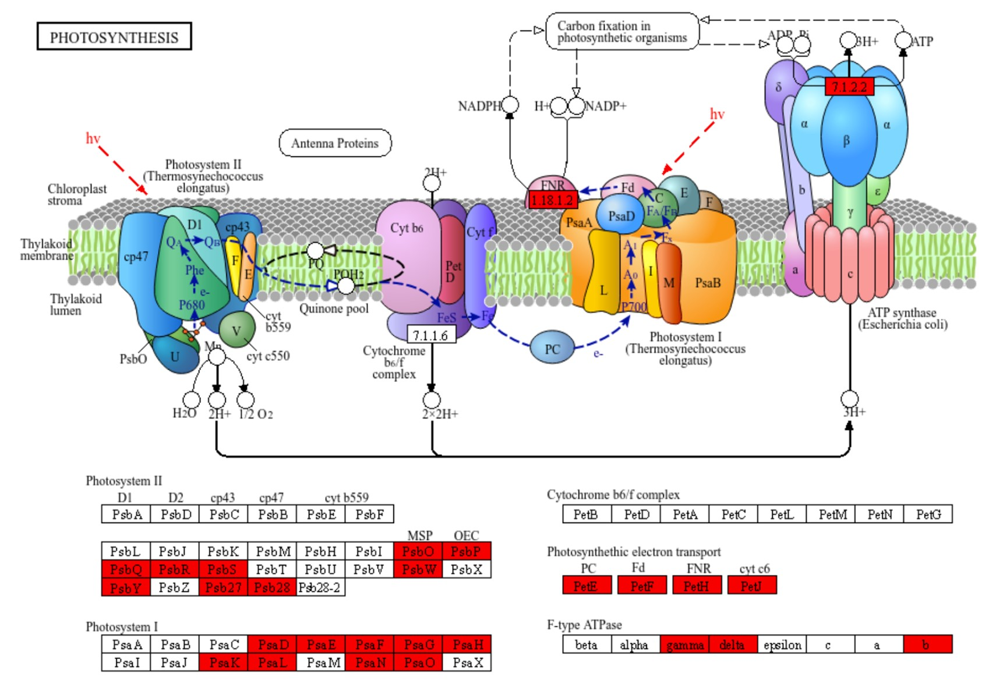
Fig. S5 Photosynthesis pathway associated genes (highlighted) induced in the resistant genotype when comparing ascorbic acid pre-treated and M. phaseolina-inoculated versus the ascorbic acid pre-treated mock-inoculated control.

