Ising Dynamics for Reprogrammable Threshold Sensing in Wireless Devices
Nicolas Casilli¹, Seunghwi Kim², Hussein M.E. Hussein¹, Ryan Tetro¹, Luca Colombo¹, Matteo Rinaldi¹, Philip X.-L. Feng³, Andrea Alù^{2,4}, and Cristian Cassella^{1, †}
¹Institute for Nano Systems Innovation (NanoSI), Department of Electrical and Computer Engineering, Northeastern University, Boston, Massachusetts 02115, USA
²Photonics Initiative, Advanced Science Research Center, City University of New York, New York City, New York 10031, USA
³Department of Electrical and Computer Engineering, University of Florida, Gainesville, Florida 32611, USA
⁴Physics Program, Graduate Center, City University of New York, New York City, New York 10016, USA
†Corresponding author: c.cassella@northeastern.edu
Supplementary Table S1: Table of Acronyms
Acronym | Definition
RF | Radio Frequency
SPIN | Sensing Parametric Ising Node
PO | Parametric Oscillator
AI | Artificial Intelligence
IoT | Internet of Things
PoI | Parameter of Interest
MEMS | Microelectromechanical Systems
$$f_{p}$$ | Pump frequency driving the POs
$$P_{in}$$ | Input power of the interrogation signal interrogating SPINs
$$f_{p}/2$$ | Subharmonic oscillation frequency passively generated by the POs
$∆ϕ$ | Phase difference between the POs in SPINs
$$P_{out}$$ | Output power radiated by SPINs’ output antenna
$$P_{th}$$ | Pump power required to excite the subharmonic generation in the POs of SPINs
LiNbO₃ | Lithium Niobate
$$Z_{C}$$ | Generic impedance used to couple the POs in SPINs
$$Z_{L}$$ | Load impedance terminating the output of the power combiner, equal to 50 Ω
$$Z_{eq}$$ | Complex impedance loading even or odd equivalent circuits of the SPIN
$$Z_{W,E}$$ | Complex input impedance of the even mode decomposition of the power combiner
$$Z_{res}$$ | Complex impedance of the resonant sensor
$$Z_{W,O}$$ | Complex input impedance of the even mode decomposition of the power combiner
$$P_{th,E}$$ | Pump power required to excite the subharmonic generation in the even equivalent circuit of the SPIN
$$P_{th,O}$$ | Pump power required to excite the subharmonic generation in the odd equivalent circuit of the SPIN
BVD | Butterworth Van-Dyke
$$f_{h}$$ | Frequency that marks a transition between coupling states
$$f_{res}$$ | Resonance frequency of resonant sensor embedded in the coupling of the SPINs’ POs
$$f_{l}$$ | Frequency that marks another transition between coupling states arising from the power combiner used in the built SPIN
$$T_{a}$$ | Ambient temperature
$${ΔT}_{a}$$ | Change in ambient temperature
TCF | Temperature Coefficient of Frequency
$$T_{th}$$ | Temperature Threshold
PCB | Printed Circuit Board
Q | Quality factor
$$k_{t}^{2}$$ | Electromechanical coupling coefficient of piezoelectric film
$$P_{R}$$ | Wirelessly received power backscattered from SPINs
$$f_{x}$$ | A selected value of $f_{p}$ that induces a change in SPINs’ preferred coupling state within ${ΔT}_{a}$
PO₁, PO₂, PO₃, PO₄ | Identifiers of the POs used in the proposed 4-PO multiparameter SPIN
$R_{12}$, $R_{23}$, $R_{34}$, $R_{13}$ | Resistances used to couple the POs in the proposed 4-PO multiparameter SPIN
$$R_{ij}$$ | Generic resistance coupling POs in the proposed 4-PO multiparameter SPIN
$$Z_{TL}$$ | Characteristic impedance of transmission lines making up the Wilkinson power combiner
$$R_{iso}$$ | Isolation resistance of Wilkinson power combiner
TX | Transmitter
RX | Receiver
${ΔR}_{12}$, $ΔR_{23}$, and ${ΔR}_{34}$ | Percentage change in $R_{12}$, $R_{23}$, or $R_{34}$ arising from sensed PoIs
$Z_{1}$, $Z_{2}$, $Z_{3}$ | Circuital branches comprising POs
HB | Harmonic Balance
pAG | Power auxiliary generator
$$χ^{(2)}$$ | Type of nonlinearity
$a$, $b$ | Intracavity resonant modes
$κ_{a}$, $κ_{a,b}$ | Loss rate describing the intracavity modes
$Δ_{a}$, $Δ_{ab}$ | Detuning of the resonant modes with respect to $f_{p}/2$
$f_{a}$, $f_{a,b}$ | Resonant frequency of the resonant modes minimizing the power required to excite their subharmonic waveforms
$$r_{1}$$ | Gain saturation coefficient for resonant modes
$$r_{2}$$ | Small-signal gain parameter for resonant modes
$A$, $B$ | Amplitudes of the resonant modes’ waveforms
$θ$, $θ_{a}$, $θ_{b}$ | Phase of the resonant modes’ waveforms
$$A_{th}$$ | Amplitude threshold solutions
$$c$$ | Mechanical mode in the LiNbO₃ MEMS resonator
$$Γ_{c}$$ | Mechanical loss rate
$$Δ_{c}$$ | Detuning of LiNbO₃ MEMS resonator with respect to $f_{p}/2$
$$g$$ | Nonlinear coupling rate
$$G$$ | Effective coupling
$$\overline{κ}$$ | Effective loss rate
$$\overline{Δ}$$ | Effective detuning
$$A_{th,E}$$ | Amplitude solution corresponding to a ferromagnetic coupling state
$$A_{th,O}$$ | Amplitude solution corresponding to an anti-ferromagnetic coupling state
$r_{2,E}$, $r_{2,O}$ | Small-signal gain parameters triggering the $A_{th,E}$ and $A_{th,O}$ solutions, respectively
$${r_{2,E}}^{cr}$$ | Minimum small-gain parameter needed to activate the $A_{th,E}$ solution
$${r_{2,O}}^{cr}$$ | Minimum small-gain parameter needed to activate the $A_{th,O}$ solution
$$C_{0}$$ | Static capacitance of the interdigitated structure of LVRs
LVR | Laterally Vibrating Resonator
$$R_{m}$$ | Motional resistance of the resonator when fitted to the BVD model
$$L_{m}$$ | Motional inductance of the resonator when fitted to the BVD model
$$C_{m}$$ | Motional capacitance of the resonator when fitted to the BVD model
CW | Continuous wave
EIRP | Effective isotropic radiated power

Design and Analytical Modelling of SPINs
We followed the process delineated in [1] to design the POs, aiming primarily at minimizing $P_{th}$ and confine the input signal and the output signal in two separate meshes [Fig. S1(a)]. Addressing these goals requires a proper synthesis of the branch impedances ($Z_{1}$, $Z_{2}$, and $Z_{3}$) forming each PO in SPINs’ circuit [see Fig. S1(b)]. $Z_{1}$, $Z_{2}$, and $Z_{3}$ were synthesized to satisfy four resonant conditions [1] [see Fig. S1(b)]:
1. The mesh including the series of $Z_{1}$ and $Z_{3}$ should series resonate at $f_{p}$.
2. $Z_{2}$ should act as a notch filter for $f_{p}$.
3. The mesh including the series of $Z_{2}$ and $Z_{3}$ should series resonate at $f_{p}/2$.
4. $Z_{1}$ should act as a notch filter for $f_{p}/2$.
The satisfaction of these four resonant conditions permits to maximize the voltage modulation at $f_{p}$ across the varactor hosted in $Z_{3}$ while ensuring that the PO’s generated subharmonic output signals are directed towards its output port (i.e., one of the power-combiner’s input ports). Each PO’s optimum circuit components can be found for any desired $f_{p}$ value by using Harmonic Balance (HB) [2] and a simulation technique known as the “power auxiliary generator (pAG) technique” [3], as demonstrated in [1], [4], [5] . The pAG technique is also useful to identify $P_{th}$, whose analytical expression is available in [1] for the generalized single-varactor T-network architecture used by PO₁ and PO₂. It is worth mentioning that we have used the analytical expression of $P_{th}$ available in [1] to compute the $P_{th,E}$ and $P_{th,O}$ trends reported in the main manuscript. The optimization process for the design of SPINs’ POs was conducted in conjunction with electromagnetic simulations capturing the behavior of SPINs’ printed circuit board (PCB). This allowed us to account for any parasitic reactance arising from PCB traces and connectors. An $f_{p}$ value equal to 876 MHz was targeted during the design of the reported SPIN’s POs, which is about twice the resonant frequency of the LiNbO₃ resonant sensor. The selected components and component values are listed in Table S2.
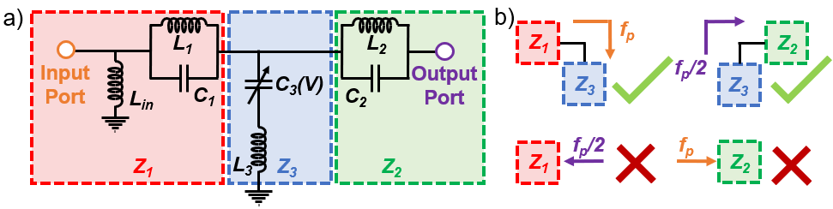
Figure S1 a) Circuit schematic of a single PO delineating which components are part of the $Z_{1}$, $Z_{2}$, and $Z_{3}$ branches. b) Illustrative demonstration of the 4 resonance conditions that allow to minimize the input power level required to start the subharmonic oscillation. Note that the $P_{th,E}$ and $P_{th,O}$ trends shown in the main manuscript were conducted by embedding the respective $Z_{eq}$ into the output port of the $Z_{2}$ branch.

Supplementary Table S2: Components list of the fabricated SPIN:
Component | Nominal Value | Model Number
$$L_{1}$$ | 8.2 nH | 0402HP-8N2
$$L_{2}$$ | 47 nH | 0402HP-47N
$$L_{3}$$ | 16 nH | 0402HP-16N
$$L_{in}$$ | 2 nH | 0402HP-2N0
$$C_{1}$$ | 5.3 pF | GRM1555C1H5R3WA01
$$C_{2}$$ | 2.0 pF | GRM1555C1E2R0CA01
$$C_{3}$$ | 1.2 pF | SMV1430

Analytical Studies of Systems via Coupled Mode Theory

Phase Bistability of a Single PO
In this section, we thoroughly investigate highly nonlinear systems discussed in the main text through full analytical studies. The model of a single PO consists of two modes mediated by the second-order parametric process, analogous to the $χ^{(2)}$ processes in nonlinear optics, and it can be effectively described by a single mode [6]:
$$\begin{aligned}\dot{a}= -\left[\frac{κ_{a}}{2}+iΔ_{a}+r_{1}{\left|a\right|}^{2}\right]a-ir_{2}a^{*}. \#\left(S.1\right)\end{aligned}$$
In this regard, we represent $a$ as the amplitude of the resonant mode in a single PO with a loss rate described by $κ_{a}$ and a detuning $Δ_{a}=2π\left(f_{a}- \frac{f_{p}}{2}\right)$. In this analysis, $f_{a}$ represents the optimal frequency of operation for the resonant mode, equivalent to the value of $f_{p}$/2 minimizing the $P_{th}$ of the SPINs’ POs. $r_{1}$ and $r_{2}$ map to the gain saturation coefficient and the small-signal gain parameter, respectively. We can then apply a rotational frame of $a\underset{→}{} a^{-i\frac{π}{4}}$ to rewrite Eq. (S.1) as the following:
$$\begin{aligned}\dot{a} = -\left[\frac{κ_{a}}{2}+iΔ_{a}+r_{1}{\left|a\right|}^{2}\right]a+r_{2}a^{*}. \#\left(S.2\right)\end{aligned}$$
Then, we can set $a= {Ae}^{-iθ}$ and express Eq. (S.2) when constraining $θ$ to $0$ or $π$ (to enforce the criteria required for phase bistability [4]) as the following:
$$\begin{aligned}0 = -\left[\frac{κ_{a}}{2}+iΔ_{a}+r_{1}A^{2}- r_{2}\right]A. \#\left(S.3\right)\end{aligned}$$
We can obtain the solution of Eq. (S.3) , i.e., $A_{th}= \sqrt{\frac{r_{2}-\frac{κ}{2}-iΔ_{a}}{r_{1}}}$, which is indeed the threshold for phase bistability, when $r_{2}≥\frac{κ_{a}}{2}+iΔ_{a}$. Such solution indicates that phase bistability is achieved when driving the PO with a sufficiently large $r_{2}$ due to the emergence of a period-doubling regime through a nonlinear bifurcation [7], [8], [9].

Even and Odd Mode Thresholds for Coupled POs
We present a model describing the behavior of the circuit introduced in the main text. Fig. S2 illustrates the schematic of the system under investigation, consisting of two parametric oscillators mediated by the $χ^{\left(2\right)}$ nonlinearity and coupled with a mechanical resonant cavity. Given the effective Hamiltonian of the system, $H_{int}= ℏg \left(a^{*}c+b^{*}c+h.c\right)$, its equations of motion can be described by temporal coupled-mode theory via the Heisenberg picture:
$$\begin{aligned}\dot{a}= -\left[\frac{κ_{a,b}}{2}+iΔ_{a,b}+r_{1}{\left|a\right|}^{2}\right]a-ir_{2}a^{*}-igc,\#(S.4)\end{aligned}$$
$$\begin{aligned}\dot{b}= -\left[\frac{κ_{a,b}}{2}+iΔ_{a,b}+r_{1}{\left|b\right|}^{2}\right]b-ir_{2}b^{*}-igc, \#\left(S.5\right)\end{aligned}$$
$$\begin{aligned}\dot{c}= -\left[\frac{Γ_{c}}{2}+iΔ_{c}\right]c-ig\left(a+b\right). \#\left(S.6\right)\end{aligned}$$
Here, $a$ and $b$ represent the amplitudes of the intracavity fields of the two modes representing the POs in the SPIN circuit while $κ_{ab}$ represents the total loss rates for both modes. In this analysis, we treat these modes as identical. Similarly, $c$ represents the mechanical mode in the LiNbO₃ resonator and $Γ_{c}$ maps its mechanical loss rate. The detuning term, $Δ_{a,b}$ corresponds to the difference between the frequency of the modes ($f_{a,b}$) and the subharmonic frequency, given as $f_{p}/2$ in the main text, and takes the form: $Δ_{a,b}= 2π\left(f_{a,b}- \frac{f_{p}}{2}\right)$. $Δ_{c}$ maps to the detuning of $f_{res}$ with respect to $f_{p}/2$ and is given as $2π\left(f_{res}- \frac{f_{p}}{2}\right)$. Additionally, $r_{1} ≈ \frac{2{|g|}^{2}}{κ}$ is the gain saturation coefficient, $r_{2}$ is the small-signal gain parameter, and $g ≈ 4Γ_{c}$ is the nonlinear coupling rate, indicating that the modes are strongly coupled [6].
When considering the system to operate in its steady state, we can rewrite Eq. (S.4) and Eq. (S.5) as the following:
$$\begin{aligned}0= -\left[\frac{κ_{a,b}}{2}+iΔ_{a,b}+r_{1}{\left|a\right|}^{2}\right]a-ir_{2}a^{*}-\frac{{g }^{2}b}{\frac{Γ_{c}}{2}+iΔ_{c}},\#(S.7)\end{aligned}$$
$$\begin{aligned}0= -\left[\frac{κ_{a,b}}{2}+iΔ_{a,b}+r_{1}{\left|b\right|}^{2}\right]b-ir_{2}b^{*}-\frac{{g }^{2}a}{\frac{Γ_{c}}{2}+iΔ_{c}}.\#\left(S.8\right)\end{aligned}$$
Now, by defining the effective coupling as $G= \frac{{g }^{2}}{\frac{Γ_{c}}{2}+iΔ_{c}}$, the effective loss rate as $\overline{κ}= κ_{a,b}+ \frac{{g }^{2}Γ_{c}}{{\left(\frac{Γ_{c}}{2}\right)}^{2 }+ {Δ_{c}}^{2}}$, and the effective detuning as $\overline{Δ}= Δ_{a,b}+ \frac{{g }^{2}Δ_{c}}{{\left(\frac{Γ_{c}}{2}\right)}^{2 }+ {Δ_{c}}^{2}}$, we can further rewrite Eq. (S.7) and Eq. (S.8) into the following form:
$$\begin{aligned}0= -\left[\frac{\overline{κ}}{2}+i\overline{Δ}+r_{1}A^{2}\right]A+r_{2}Ae^{i2θ_{a}}-GBe^{i∆ϕ},\#(S.9)\end{aligned}$$
$$\begin{aligned}0= -\left[\frac{\overline{κ}}{2}+i\overline{Δ}+r_{1}B^{2}\right]B+r_{2}Be^{i2θ_{a}}-GAe^{-i∆ϕ},\#\left(S.10\right)\end{aligned}$$
where $a=Ae^{iθ_{a}}$ and $b=Be^{iθ_{b}}$. In Eq. (S.9) and Eq. (S.10), it is useful to recall from the previous subsection that $θ_{a}$ and $θ_{b}$ are constrained to $0$ or $π$, meaning that the relative phase difference $∆ϕ≡ θ_{a}-θ_{b}$ is also constrained to these values. When enforcing these conditions and then subtracting Eq. (S.10) from Eq. (S.9), we can model the system with a single equation, and when setting equal mode amplitudes ($A=B$) it takes the form:
$$\begin{aligned}0= -\left(\frac{\overline{κ}}{2}+i\overline{Δ}\right)-r_{1}\left(3A^{2}\right)+r_{2} ∓G.\#\left(S.11\right)\end{aligned}$$
From Eq. (S.11), we then have two possible amplitude solutions ($A_{th,E}$ and $A_{th,O}$), corresponding to whether $∆ϕ$ equals $0$ or $π$, respectively, as given below:
$$\begin{aligned}A_{th,E}= \sqrt{\frac{r_{2}- \frac{κ_{a,b}}{2}-i∆_{a,b}-2G}{3r_{1}}},\#\left(S.12\right)\end{aligned}$$
$$\begin{aligned}A_{th,O}= \sqrt{\frac{r_{2}- \frac{κ_{a,b}}{2}-i∆_{a,b}}{3r_{1}}}.\#\left(S.13\right)\end{aligned}$$
Here, the nonzero solutions of Eq. (S.12) and Eq. (S.13) are obtained when the gain parameter is larger than its critical value, e.g., $r_{2,E}≥ {r_{2,E}}^{cr}= \frac{κ_{a,b}}{2}+i∆_{a,b}+2G$ or $r_{2,O}≥ {r_{2,O}}^{cr}=\frac{κ_{a,b}}{2}+i∆_{a,b}$. In this case, $r_{2,E}$ and $r_{2,O}$ refer to the small-signal gain parameters corresponding to each solution while ${r_{2,E}}^{cr}$ and ${r_{2,O}}^{cr}$ denote the minimum value of $r_{2,E}$ and $r_{2,O}$ required to excite the in-phase or out-of-phase solutions, respectively. Clearly, ${r_{2,E}}^{cr}$ and ${r_{2,O}}^{cr}$ exhibit differing values based on the effective coupling $G$ and the manifested solution (in-phase or out-of-phase) arises depending on which small-signal gain parameter requires the least amount of power to sustain. It is important to note that this analytical treatment most accurately models the region of $f_{p}/2$ near $f_{ab}$ and $f_{res}$, as the impact of the static capacitance ($C_{0}$) of the LiNbO₃ MEMS device is not embedded in the analysis.
To characterize the mode competition, we plot the difference between $|{r_{2,E}}^{cr}|$ and $|{r_{2,O}}^{cr}|$ across a range of $f_{p}/2$ values in Fig. S3(a). Unsurprisingly, we see that in the immediate region near $f_{res}$, the value of $|{r_{2,O}}^{cr}|$ is less than the value of $|{r_{2,E}}^{cr}|$, indicating a preference for an out-of-phase solution. In such a scenario, the coupling can be assumed as dissipative since $Γ_{c} ≫ ∆_{c}$. Nonetheless, we can clearly observe a value of $f_{h}$ near $f_{res}$ where $|{r_{2,E}}^{cr}|$ becomes less than ${|r_{2,O}}^{cr}|$ and the system prefers an in-phase solution. To validate this modelling, we numerically solve Eq. (S.4), Eq. (S.5), and Eq. (S.6) for $f_{p}/2$ values above and below $f_{h}$ and plot the steady-state oscillations of the $a$ and $b$ modes in Fig. S3(b-e). For the selected $f_{p}/2$ values below $f_{h}$ (437.5 MHz and 440 MHz, shown in Fig. S3(b) and Fig. S3(c)), the system preferred an in-phase solution while the opposite (an out-of-phase solution) was obtained when selecting $f_{p}/2$ above $f_{h}$(441 MHz and 442.5 MHz, shown in Fig. S3(d) and Fig. S3(e)). Even more, to validate the relationship between $f_{h}$ and $T_{a}$, we embedded the measured TCF of the fabricated LiNbO₃ MEMS resonator into the model of the mechanical mode and then plotted $|{r_{2,E}}^{cr}|$ - $|{r_{2,O}}^{cr}|$ with respect to $f_{p}/2$ for various $T_{a}$ values, equal to 25 ˚C , 50 ˚C, and 75 ˚C [see Fig. S3(f)]. As can be observed, the temperature-driven changes in $f_{res}$ cause sufficient shifts in $Δ_{c}$ (and therefore $G$ and $|{r_{2,E}}^{cr}|$) to alter the respective position of $f_{h}$, ultimately changing the system’s preference between even and odd modes for certain values of $f_{p}/2$.

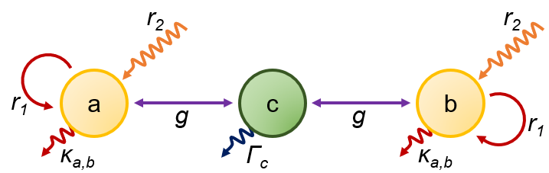
Figure S2 a) Schematic of the system of interest: $a$ and $b$ are both coupled to $c$. Intracavity modes $a$ and $b$ are described with a gain saturation coefficient $r_{1}$, a small-signal gain parameter $r_{2}$, and total loss rate $κ_{a,b}$. These modes are coupled via $g$ to $c$, a mechanical mode with a mechanical loss rate represented by $Γ_{c}$.
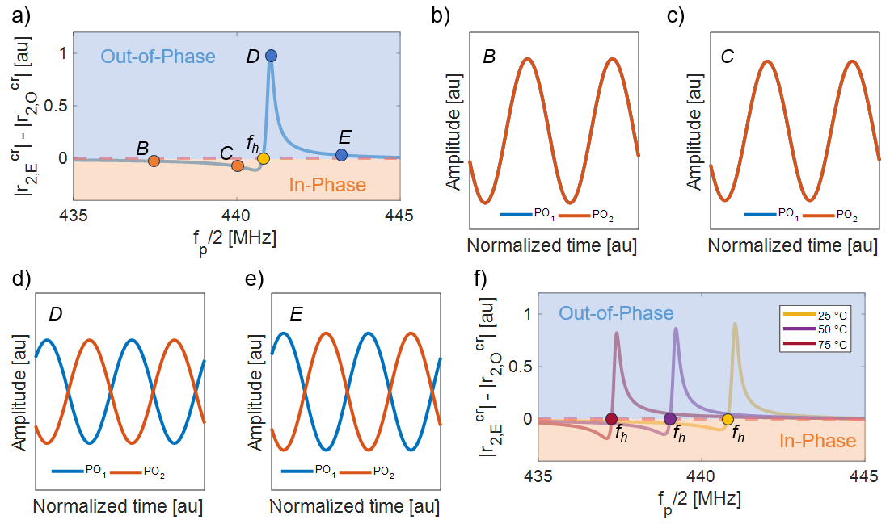
Figure S3 a) Numerically extracted trend of $|{r_{2,E}}^{cr}|$ - $|{r_{2,O}}^{cr}|$ for $f_{p}/2$ near $f_{res}$. As can be noted, there exists a transition point $f_{h}$ where the preferred solution changes between ferromagnetic and anti-ferromagnetic coupling states. b-e) Simulated waveforms of the coupled POs extracted by solving Eq. (S.4-S.6) taken when $f_{p}/2$ = 437.5 MHz, 440 MHz, 441 MHz, and 442 MHz, corresponding to points B-E in a). f) Numerically extracted trend of $|{r_{2,E}}^{cr}|$ - $|{r_{2,O}}^{cr}|$ for $f_{p}/2$ near $f_{res}$ for $T_{a}$ = 25 ˚C, 50 ˚C, and 75 ˚C, clearly demonstrating a temperature-dependent change in the position of $f_{h}$.

Even and Odd Mode Behavior

Modelling of the Power Combiner
The ideal Wilkinson power combiner consists of two quarter-wave transmission lines with a characteristic impedance $Z_{TL}$ equal to $Z_{L}\sqrt{2}$, where $Z_{L}$ represents the termination impedance equal to 50 Ω. These transmission lines are connected using a shunt isolation resistor, $R_{iso}$, equal to ${2Z}_{L}$ [Fig. S4(a)] [10], [11]. Both the even and odd mode equivalent circuits of the ideal Wilkinson power combiner exhibit an equivalent resistance equal to $Z_{L}$ at the optimal design frequency [10], [11]. In Fig. S4(b), the quarter-wave transmission line transforms the 2$Z_{L}$ termination impedance to only $Z_{L}$ while in Fig. S4(c), the short circuit termination is transformed into an open circuit, making the equivalent termination resistance equal to $R_{iso}/2$, or $Z_{L}$. Therefore, an ideal Wilkinson power combiner operating at its targeted frequency does not impact SPINs’ mode competition [1], [11]. However, as we operate at frequencies detuned from the nominal one, the transmission lines stop having an electrical length equal to a quarter wavelength. Consequently, Wilkinson power combiners typically exhibit dispersive properties innate to their physical realizations.
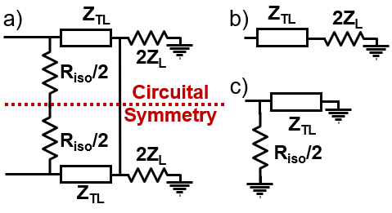
Figure S4 a) Circuit schematic of an ideal Wilkinson power combiner circuit specifically illustrating its axis of symmetry. b)-c) Even and odd mode equivalent circuits of the Wilkinson power combiner shown in (a). Both circuits exhibit an equivalent impedance matched to $Z_{L}$ when operating at one targeted design frequency. These circuits also have input impedances equal to $Z_{W,E}$ and $Z_{W,O}$, respectively.

SPIN Dynamics Excluding the Power Combiner
To better understand the dynamics of our assembled SPIN prototype without the power combiner, it is informative to look at the different behaviors that two electrical POs, terminated to separate 50 Ω loads, exhibit [see Fig. S5(a)] when coupled by different types of impedance while being driven at the specific frequency that minimizes $P_{th}$. We can still refer to the coupling impedance between the two electrical POs as $Z_{C}$, as we have done for SPINs’ coupling impedance. In this case study, it is straightforward to realize that $P_{th,E}$ is independent of $Z_{C}$. This is not surprising since the voltage difference across $Z_{C}$ must be zero when the POs are in a ferromagnetic coupling state (i.e., the two POs’ output signals have the same magnitude and the same phase). $P_{th,O}$, on the other hand, can vary substantially, reaching the lowest value when $Z_{C}$ behaves as a short circuit at $f_{p}/2$. Yet, $P_{th,O}$ can also be higher than $P_{th,E}$ when the reactance of $Z_{C}$ significantly detunes both POs’ output meshes. The effect of this detuning on $P_{th,O}$ is analogous to changing the resonance frequency of a Mathieu resonator without changing its pump frequency [4], [12].
We numerically studied the trends of $P_{th,E}$ and $P_{th,O}$ for a system of two POs formed by the same lumped components used in the demonstrated SPIN prototype. Initially, we considered the two POs terminated to separate 50 Ω loads and operating at a fixed $f_{p}$ value [876 MHz, corresponding to $f_{p}/2$ = 438 MHz, see Fig. S5(a)]. These trends were extracted when considering that the POs were coupled using: i) a resistor with resistance changing between 2 Ω and 2 kΩ [see Fig. S5(b)], ii) an inductor with reactance changing from 2 Ω to 2 kΩ [see Fig. S5(c)], iii) a capacitor with reactance changing from -2 kΩ to -2 Ω [see Fig. S5(d)]. As shown in Fig. S5(b) and Fig. S5(c), when coupling the POs with either a resistor or an inductor, $P_{th,O}$ yields a smaller value than $P_{th,E}$ for all the investigated cases. This indicates that the anti-ferromagnetic coupling state is always preferred. On the other hand, when sweeping the reactance of a purely capacitive $Z_{C}$ value we found that a transition in the preferred coupling state can occur. Specifically, for large capacitance values (i.e., for low reactance values) $P_{th,O}$ is lower than $P_{th,E}$, making the anti-ferromagnetic coupling state preferred. However, a change in the preferred coupling state occurs for low capacitance values (i.e., for large reactance values). In this scenario, the detuning of the POs originating from the capacitive coupler causes an increase of $P_{th,O}$ that ultimately makes the ferromagnetic coupling state the one that is preferred.
Then, we repeated the case study conducted in Fig. 3(c-d). However, this time we considered each PO terminated to a 50 Ω load rather than to an input port of the power combiner, like what is delineated in Fig. S5(a). As seen in Fig. S6(a-b), we found that removing the power combiner did not significantly change $f_{h}$ with respect to Fig. 3(f); however, we did not find the second transition at $f_{l}$. To validate this, we experimentally measured the output waveforms of each PO in the assembled SPIN prototype using an oscilloscope with 50 Ω terminations, as done in Fig. 4(e). During this experiment, we considered $T_{a}$ fixed to room temperature and used a wired connection to a signal generator to pump the POs with $P_{in}$ = 0 dBm for $f_{p}/2$ ranging from 420 MHz to 450 MHz. We then calculated $∆ϕ$ from the measured waveforms of the POs for each explored $f_{p}/2$ value and found, indeed, that $f_{l}$ does not exist without the power combiner [Fig. S6(c)].

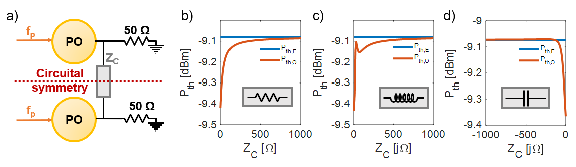Figure S5 a) Symbolic schematic of a network of two POs terminated to 50 Ω loads, coupled by using an arbitrary impedance $Z_{C}$. Like in Fig. 2(b), $Z_{C}$ is represented as the series of two identical impedances equal to$Z_{C}/2$. Numerically extracted trends at a fixed $f_{p}/2$ value (438 MHz) for $P_{th,E}$ and $P_{th,O}$ when considering b) $Z_{C}$ to be purely resistive with a resistance ranging from 2 Ω to 2 kΩ; c) $Z_{C}$ to be a purely inductive element with a reactance ranging from 2 Ω to 2 kΩ; d) $Z_{C}$ to be a purely capacitive element with a reactance ranging from -2 kΩ to -2 Ω.

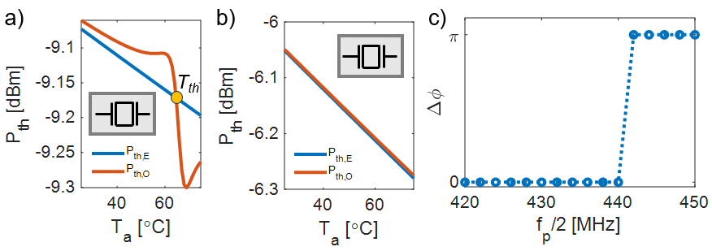
Figure S6 Analytically extracted trends of $P_{th,E}$ and $P_{th,O}$ when considering different $T_{a}$ for a fixed $f_{p}/2$ of a) 438 MHz and b) 432 MHz. c) Experiment at room temperature demonstrating that $f_{l}$ does not exist in the SPIN prototype when the power combiner is removed from the coupling network.

Fabrication and Characterization of LiNbO₃ Resonator

Fabrication Process
With regards to the X-Cut YZ30° lithium niobate (LiNbO₃) resonator used in the assembled SPIN prototype, it was designed as a Laterally Vibrating Resonator (LVR) operating in the S₀ mode with a resonance frequency of approximately 438.46 MHz in laboratory conditions [13]. Such a resonator was fabricated using the following process. Firstly, a bulk lithium niobate wafer was bonded onto a high-resistivity silicon wafer through surface activation bonding by NGK, Ltd. Then, using chemical mechanical polishing and ion trimming, the layer of LiNbO3 was thinned to a desired thickness of 1 µm [Fig. S7 (a)]. After this, a 200 nm layer of aluminum-silicon-copper (AlSiCu) was sputtered and patterned using chlorine-based reactive ion etching to form the resonator’s interdigitated electrodes [Fig. S7 (b)]. Then, the resonator plate was patterned using an anisotropic ion milling physical etch with a 72˚ substrate angle [Fig. S7 (c)]. Finally, the device was released from the silicon substrate using 18 cycles of xenon difluoride (XeF₂) isotropic etching [Fig. S7 (d)]. The cross-sectional and top view stress mode shape at resonance of such a device, simulated using COMSOL® Multiphysics can be seen in Fig. S7 (e).
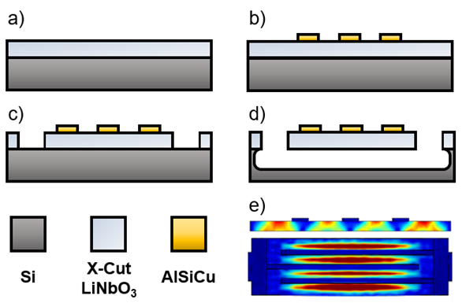
Figure S7 a) 1 µm thin film of LiNbO₃ bonded onto a 4-inch Si wafer by implementing surface activation bonding, chemical mechanical polishing, and ion trimming. b) Sputtering and patterning of 200 nm AlSiCu electrodes to form the interdigitated structure of the microacoustic device. c) 72˚ substrate angle ion mill etching of the LiNbO₃. d) Release of interdigitated structure using 18 cycles of XeF₂. e) Stress mode shape in the propagation direction of the fabricated $S_{0}$ mode LVR taken from a cross-sectional view cutting through all electrodes (top) and a top-down view (bottom).

Temperature Coefficient of Frequency (TCF)
The S-parameters of the fabricated resonator were characterized in laboratory conditions via direct wafer probing with GSG probes. Its admittance was extracted analytically, and the device’s electrical performance was fitted to the Butterworth Van-Dyke (BVD) model. When measured, the device exhibited a resonant frequency ($f_{res}$) of 438.46 MHz, an electromechanical coupling ($k_{t}^{2}$) of 16.9%, and a quality factor at resonance (Q_{s}) of 2214. These parameters yielded an equivalent motional resistance ($R_{m}$), motional inductance ($L_{m}$), and motional capacitance ($C_{m}$) of 75.69 Ω, 44.55 µH, and 2.96 fF respectively when modeled in the electrical domain. The static capacitance ($C_{0}$), indicating the intrinsic capacitance of the interdigitated structure at rest, was fitted as 19.47 fF [see Fig. S8(a)]. After these measurements, the device was wire-bonded onto the SPIN’s PCB. The device’s admittance was re-extracted from the two output ports of the assembled SPIN prototype, showing a ~3 MHz shift in $f_{res}$ due to electrical loading caused by the traces of the PCB and by the wirebonds. Then, we extracted the TCF of the LiNbO₃ device [13], [14]. This was done by raising $T_{a}$ from room temperature (25˚C) to 75 ˚C in steps of 10 ˚C while measuring the resultant $f_{res}$ of the device [see Fig. S8(b)]. Subsequently, the device’s TCF was determined by mathematically fitting a value for TCF to a first-order expression relating $f_{res}$, $T_{a}$, and TCF with respect to a baseline room temperature, as derived from [13]. This device’s TCF was measured as -165 ppm/˚C [see Fig. S8(c)] [15], [16]. When modeling the assembled SPIN prototype in the circuital simulations, the extracted TCF was embedded within the BVD model to implement the measured shifts in $f_{res}$ as a function of $T_{a}$ [see Fig. S8(d)].
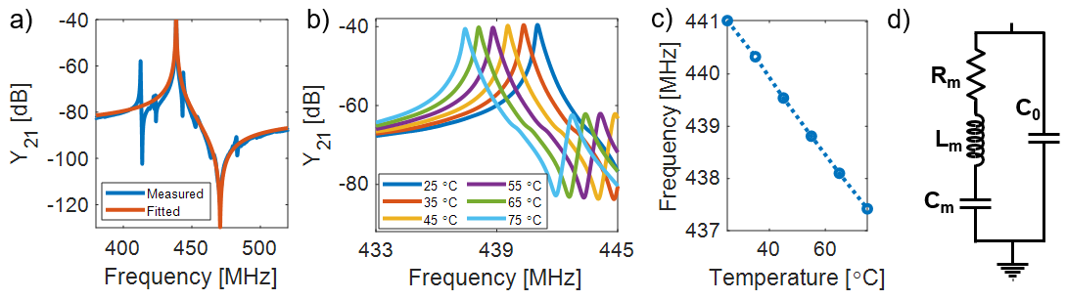
Figure S8 a) Measured and fitted admittance of the fabricated LiNbO₃ resonator extracted by directly probing the device. b) Measured admittance zoom-in around $f_{res}$ for various $T_{a}$ of the fabricated LiNbO₃ resonator when wirebonded onto the PCB hosting the SPIN. c) Measured trend of $f_{res}$ with respect to $T_{a}$ used to extract the first order approximation of the SPIN’s TCF. d) Schematic of the BVD model used in the circuit simulations mapping the SPIN’s behavior.

Even and Odd Mode Modelling of SPINs
To further characterize the behavior of SPINs and their even and odd mode equivalent circuits [Fig. 2(a),(c-d)], we conducted additional simulations leveraging the pAG technique [1], [3], [4]. These simulations were performed for a series of $f_{p}$ (corresponding to $f_{p}/2$ values of 428 MHz, 431 MHz, 435 MHz, 438 MHz, and 442 MHz) at both $T_{a}$ = 25 ˚C and 75 ˚C. Firstly, we performed separate HB simulations on SPINs’ even and odd mode equivalent circuits, as shown in Fig. 2(c-d). We swept $P_{in}$ from 100 µW to 1000 µW and continuously monitored $P_{out}$ at the output of each equivalent circuit for each combination of $f_{p}$ and $T_{a}$. In Fig. S9(a-j), we show the extracted trends of the even and odd mode equivalent circuits’ output power at $f_{p}/2$ vs. $P_{in}$. Because these simulations were performed on the even and odd mode equivalent circuits of the SPIN, we can determine $P_{th,E}$ and $P_{th,O}$ directly from each circuit’s extracted $P_{out}$. Unsurprisingly, these simulations confirm that the even and odd equivalent circuits exhibit different $P_{th}$ values due to differences in their loading terminations ($Z_{eq}$). Even more, the difference between the $P_{th,E}$ and $P_{th,O}$ values extracted using HB simulations aligned with those found analytically [Fig. 3(f-h)]. After this characterization of $P_{th,E}$ and $P_{th,O}$, we conducted time-domain simulations for the entire SPIN circuit [Fig. 2(a)]. In these simulations [plotted in Fig. S10], we swept $P_{in}$ from 100 µW to 1000 µW for the same combinations of $f_{p}$ and $T_{a}$. After reaching $P_{in}$ = 1000 µW, we measured the voltage waveforms of each PO immediately before entering the power combiner’s inputs. The waveforms depicted in Fig. S10(a-e) correspond to when $T_{a}$ = 25 ˚C, while those shown in Fig. S5(f-j) correspond to $T_{a}$ = 75 ˚C. Upon inspection, the only investigated $f_{p}/2$ values producing a ferromagnetic coupling state at 25 ˚C are 435 MHz and 438 MHz, in accordance with our measurements [Fig. 4(b)] and analytical modelling [Fig. 3(f)]. At 75 ˚C, a ferromagnetic coupling state is preferred only when $f_{p}/2$ equals 431 MHz or 435 MHz, affirming that ${∆T}_{a}$-driven shifts of both $f_{l}$ and $f_{h}$ lead to changes in the $∆ϕ$ across the investigated range of $f_{p}/2$. A final set of HB simulations considering the aforementioned $f_{p}/2$ and $T_{a}$ conditions was performed to extract the power of the full SPIN circuit at its output ($P_{out}$). In these simulations, we again swept $P_{in}$ from 100 µW to 1000 µW and continuously probed the output termination of the SPIN circuit for $P_{out}$. Fig. S11(a-e) depict $P_{out}$ for both investigated $T_{a}$ values and for the same set of $f_{p}/2$. The simulations shown in Fig. S11 illustrate that anti-ferromagnetic coupling states (when the voltage waveforms are out-of-phase with each other) result in a complete annihilation of $P_{out}$ while ferromagnetic coupling states (when the voltage waveforms are in-phase with each other) lead to strong values of $P_{out}$. Since the preferred coupling state of the SPINs’ POs maps directly to which equivalent circuit requires the least amount of energy to activate its subharmonic oscillations, we can link the emergence of a strong or weak $P_{out}$ directly to the mode competition between the even and odd equivalent circuits.
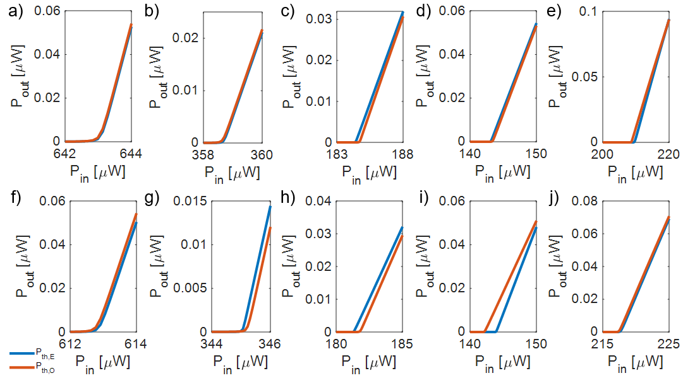Figure S9 Simulated $P_{th,E}$ (blue) and $P_{th,O}$ (orange) at $T_{a}$ = 25 ˚C and for $f_{p}/2$ = a) 428 MHz, b) 431 MHz, c) 435 MHz, d) 438 MHz, and e) 442 MHz. Simulated $P_{th,E}$ (blue) and $P_{th,O}$ (orange) at $T_{a}$ = 75 ˚C for $f_{p}/2$ = f) 428 MHz, g) 431 MHz, h) 435 MHz, i) 438 MHz, and j) 442 MHz. All plots are zoomed-in to the neighborhood of $P_{in}$ near $P_{th,E}$ and $P_{th,O}$.

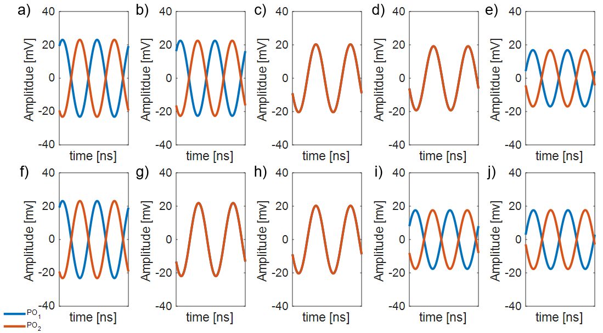
Figure S10 Numerically extracted voltage waveforms (PO₁ – blue and PO₂ – orange) at $T_{a}$ = 25 ˚C for $f_{p}/2$ = a) 428 MHz, b) 431 MHz, c) 435 MHz, d) 438 MHz, and e) 442 MHz. Numerically extracted output waveforms (PO₁ – blue and PO₂ – orange) at $T_{a}$ = 75 ˚C for $f_{p}/2$ = f) 428 MHz, g) 431 MHz, h) 435 MHz, i) 438 MHz, and j) 442 MHz.
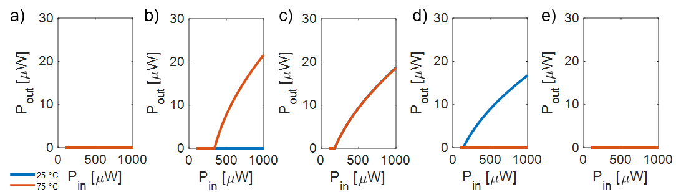
Figure S11 Numerically extracted $P_{out}$ for $f_{p}/2$ = a) 428 MHz, b) 431 MHz, c) 435 MHz, d) 438 MHz, and e) 442 MHz at $T_{a}$ = 25 ˚C (blue) and $T_{a}$ = 75 ˚C (orange).

Experimental Setups
The experimental setup used to characterize the performance of the assembled SPIN prototype is shown in Fig. S12. The input port of the assembled SPIN prototype was fed with a continuous-wave (CW) signal generated from a signal generator transmitting swept values of $f_{p}$ at various input power levels, $P_{in}$. The output of the SPIN prototype was connected to a spectrum analyzer to monitor $P_{out}$. $P_{in}$was manually swept to determine the device’s $P_{th}$ across a range of different $f_{p}$ values. Finally, we also conducted a wired experiment in which we removed the power combiner from the SPIN prototype’s circuit and connected its output ports to the 50 Ω ports of an oscilloscope to measure the time domain waveforms of the generated subharmonic oscillations. For these experiments, $f_{p}$ and $P_{in}$ were swept to determine $f_{l}$ [which is non-existent without the combiner, see Fig. S3(c)] and $f_{h}$, as well as to demonstrate the resiliency of the POs’ synchronization to fluctuations in $P_{in}$.
The SPIN prototype was also wirelessly characterized by performing wireless testing as shown in Fig. S13. The experiment intended to emulate a transceiver sending an interrogating signal to excite the SPIN prototype and reading its response over a range of $f_{p}$ and $T_{a}$ values. To accomplish this, the CW interrogating signal was transmitted through a wideband log-periodic antenna (model no: Aaronia HyperLOG 4025, with a gain of +4 dBi) after amplifying it with a power amplifier (model no: ZHL-1000-3W+, with a power gain of +45 dB) to achieve an EIRP of + 30 dBm [17]. The SPIN prototype’s backscattered signal was received through an isotropic dipole antenna (model no: 712-ANT-433-CW-QW, with a gain of +3.3 dBi) connected to a spectrum analyzer to characterize $P_{R}$. The SPIN prototype was placed onto a temperature-controlled heating element positioned one meter away from the emulated transceiver’s antennas and it was terminated at its input and output ports with two isotropic dipole antennas operating near $f_{p}$ (model no: AEACAC054010-S915, with a gain of +2 dBi) and $f_{p}/2$ (model no: 712-ANT-433-CW-QW, with a gain of +3.3 dBi), respectively. For each combination of $f_{p}$ and $T_{a}$, the EIRP was swept from 0 dBm (representing a $P_{in}$ incident to the SPIN which is much lower than $P_{th}$) up to 30 dBm and then $P_{R}$ was recorded.
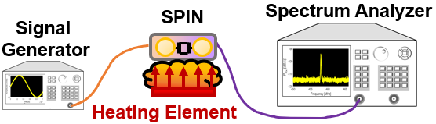
Figure S12 Schematic of the experimental setup used for the wired experiment characterizing $P_{out}$ with respect to $f_{p}$, $T_{a}$, and $P_{in}$. A signal generator is connected directly to the input of the SPIN, and the output signal is connected to a spectrum analyzer where $P_{out}$ is measured. Another wired experiment was conducted in which the power combiner was removed from the SPIN and its POs’ outputs were terminated to the ports of an oscilloscope. In this experiment, the time domain waveforms of the subharmonic oscillations were measured to extract $∆ϕ$ for varying $f_{p}$ and $P_{in}$ values.

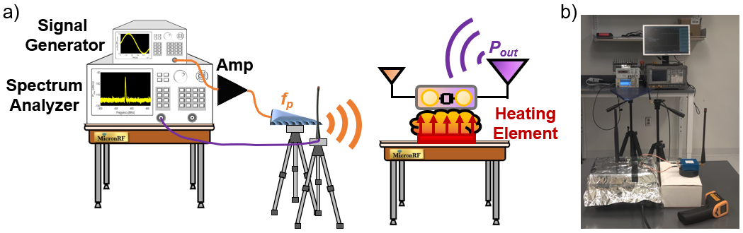
Figure S13 a) Schematic of the experimental setup used for the wireless experiment. A signal generator connected to a power amplifier and a directive antenna interrogates the SPIN placed onto a heating element. The backscattered signal is captured via an antenna through a spectrum analyzer and $P_{R}$ is recorded for each value of $f_{p}$ and $T_{a}$. b) Photo of our experimental setup.

References
[1] H. M. E. Hussein, M. A. A. Ibrahim, G. Michetti, M. Rinaldi, M. Onabajo, and C. Cassella, “Systematic Synthesis and Design of Ultralow Threshold 2:1 Parametric Frequency Dividers,” IEEE Trans. Microw. Theory Tech., vol. 68, no. 8, pp. 3497–3509, Aug. 2020, doi: 10.1109/TMTT.2020.2999790.
[2] A. Suarez, Analysis and Design of Autonomous Microwave Circuits. John Wiley & Sons, 2009.
[3] C. Cassella and G. Piazza, “Low phase-noise autonomous parametric oscillator based on a 226.7 MHz AlN contour-mode resonator,” IEEE Trans. Ultrason. Ferroelectr. Freq. Control, vol. 62, no. 4, pp. 617–624, Apr. 2015, doi: 10.1109/TUFFC.2014.006753.
[4] N. Casilli, T. Kaisar, L. Colombo, S. Ghosh, P. X.-L. Feng, and C. Cassella, “Parametric Frequency Divider Based Ising Machines,” Phys. Rev. Lett., vol. 132, no. 14, p. 147301, Apr. 2024, doi: 10.1103/PhysRevLett.132.147301.
[5] H. Hussein and C. Cassella, “Frequency Domain Acoustic-Based Subharmonic Tags for Far-Field Identification,” preprint, Aug. 2022. doi: 10.36227/techrxiv.20505711.v1.
[6] H. M. E. Hussein, S. Kim, M. Rinaldi, A. Alù, and C. Cassella, “Passive frequency comb generation at radiofrequency for ranging applications,” Nat. Commun., vol. 15, no. 1, p. 2844, Apr. 2024, doi: 10.1038/s41467-024-46940-2.
[7] S. Strogatz, Nonlinear dynamics and chaos: with applications to physics, biology, chemistry, and engineering, Repr. in Studies in nonlinearity. Cambridge, Mass: Westview Press, 2007.
[8] J. Woo and R. Landauer, “Fluctuations in a parametrically excited subharmonic oscillator,” IEEE J. Quantum Electron., vol. 7, no. 9, pp. 435–440, Sep. 1971, doi: 10.1109/JQE.1971.1076831.
[9] S. Kim, S. H. Park, and C. S. Ryu, “Noise-Enhanced Multistability in Coupled Oscillator Systems,” Phys. Rev. Lett., vol. 78, no. 9, pp. 1616–1619, Mar. 1997, doi: 10.1103/PhysRevLett.78.1616.
[10] M. Roberg and C. Campbell, “A Novel Even & Odd-Mode Symmetric Circuit Decomposition Method,” in 2013 IEEE Compound Semiconductor Integrated Circuit Symposium (CSICS), Monterey, CA, USA: IEEE, Oct. 2013, pp. 1–4. doi: 10.1109/CSICS.2013.6659204.
[11] D. M. Pozar, Microwave engineering, 4th ed. Hoboken, NJ: Wiley, 2012.
[12] T. L. Heugel, O. Zilberberg, C. Marty, R. Chitra, and A. Eichler, “Ising machines with strong bilinear coupling,” Phys. Rev. Res., vol. 4, no. 1, p. 013149, Feb. 2022, doi: 10.1103/PhysRevResearch.4.013149.
[13] L. Colombo, A. Kochhar, G. Vidal-Alvarez, P. Simeoni, U. Soysal, and G. Piazza, “Sub-GHz X-Cut Lithium Niobate S ₀ Mode MEMS Resonators,” J. Microelectromechanical Syst., vol. 31, no. 6, pp. 888–900, Dec. 2022, doi: 10.1109/JMEMS.2022.3204449.
[14] L. Colombo, A. Kochhar, G. Vidal-Alvarez, and G. Piazza, “High-Figure-of-Merit X-Cut Lithium Niobate MEMS Resonators Operating Around 50 MHz for Large Passive Voltage Amplification in Radio Frequency Applications,” IEEE Trans. Ultrason. Ferroelectr. Freq. Control, vol. 67, no. 7, pp. 1392–1402, Jul. 2020, doi: 10.1109/TUFFC.2020.2972293.
[15] L. Gao, Y. Yang, and S. Gong, “Investigating Substrate Loss in MEMS Acoustic Resonators and On-Chip Inductors,” IEEE Trans. Ultrason. Ferroelectr. Freq. Control, vol. 69, no. 6, pp. 2178–2189, Jun. 2022, doi: 10.1109/TUFFC.2022.3168539.
[16] S. Gong and G. Piazza, “Design and Analysis of Lithium–Niobate-Based High Electromechanical Coupling RF-MEMS Resonators for Wideband Filtering,” IEEE Trans. Microw. Theory Tech., vol. 61, no. 1, pp. 403–414, Jan. 2013, doi: 10.1109/TMTT.2012.2228671.
[17] N. Casilli, L. Colombo, and C. Cassella, “A UHF 1.3 cm ² Passive Subharmonic Tag With a 13 m Read-Range,” IEEE Microw. Wirel. Technol. Lett., vol. 33, no. 6, pp. 939–942, Jun. 2023, doi: 10.1109/LMWT.2023.3268542.

